Supporting information
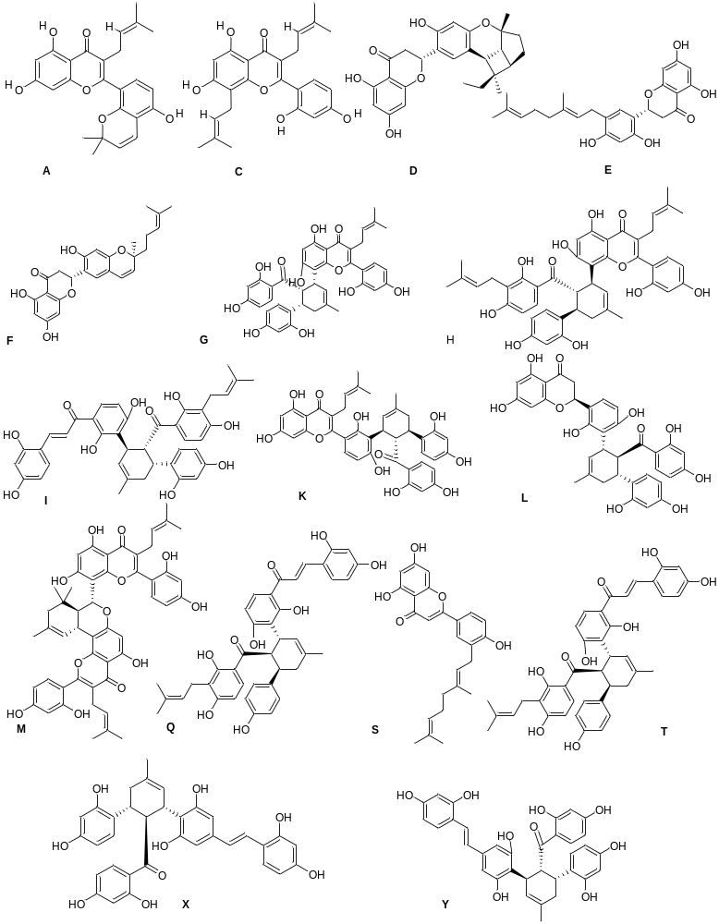
Figure S1 Structures of designed kuwanons

