Supplementary Material
Supplement to: T_root: A Comprehensive Closed-Form Statistic for Independence in Sparse and Heterogeneous Contingency Tables
William J. Dwyer, MD, MPH, FAAP
Department of Mathematics and Statistics, University of Massachusetts Lowell, Lowell, MA, USA · ORCID 0009-0004-0855-7222
Contents
S1. The full eighteen-test comparison
S2. Recalibrating the underperforming statistics
S3. The Renyi normalization correction
S4. The calibrated-lambda surface
S5. The two superseded recalibration routes
S6. Choosing the screen by evidence, and the marginal-generator correction
S7. The off-diagonal cumulant terms, and the delta-method linearization
S8. The non-square study: aspect ratio at fixed cell count
S9. The resolved heterogeneity axis: null size and injectability by shape
S10. Size-adjusted power in the Mielke-Berry-liberal overlap
S11. Reproducibility
The main paper carries the eighteen-test comparison only as a landscape: a brief survey whose purpose is to establish that no member of the existing battery is comprehensive across the plane of table shape, sparsity, and marginal balance, and thereby to motivate a new statistic. This Supplement is where that comparison lives in full, together with the substantial recalibration work (the Williams correction, the moment correction, the Zelterman D-squared, the Renyi normalization fix, and the calibrated-lambda surface) that was carried out on the underperforming statistics before the decision was taken to rebuild the statistic rather than to keep repairing the reference. Every number reported here is reproduced verbatim from the deposited simulation output; nothing in this Supplement is new evidence, and nothing in it is required to use T_root. It is the record of what was tried, what worked, what did not, and why the answer had to come from somewhere else.

S1. The full eighteen-test comparison

S1.1 Scope of the battery
Eighteen statistics for independence in a two-way table were compared on a single uniform Monte Carlo grid. The battery is built around the Cressie-Read (1984) power-divergence family,
I^lambda = [2 / (lambda (lambda + 1))] * sum_ij O_ij [ (O_ij / E_ij)^lambda - 1 ],
evaluated at its six named members: Neyman (lambda = -2), the modified G-squared (lambda = -1), Freeman-Tukey (lambda = -1/2), the G-test (lambda -> 0, giving 2 sum O ln(O/E)), Cressie-Read 2/3 (lambda = 2/3), and Pearson's chi-square (lambda = 1, giving sum (O - E)^2 / E). To these are added three chi-square variants (the uncorrected form, the Yates-corrected form for 2x2 tables, and Campbell's (2007) N-1 chi-square, [(N-1)/N] X^2); Fisher's (1922) exact test in three calibrations (standard, mid-p, and exact-calibrated with randomized rejection); Barnard's (1945) and Boschloo's (1970) exact tests for 2x2 tables; and five novel or rarely-evaluated corrections, namely the Williams-corrected G-squared, a moment-corrected Cressie-Read 2/3, two Renyi divergence tests (orders alpha = 5/3 and alpha = 3/2), and the Zelterman D-squared.
Barnard's and Boschloo's tests were restricted to tables with minimum expected count at least 5.0 because extreme marginals drive the nuisance-parameter search to intractability, with individual calls exceeding 30 seconds. All statistics are referred to chi-square with (R-1)(C-1) degrees of freedom unless otherwise noted.

S1.2 Table shapes
Every R x C shape satisfying 2 <= R <= C <= 40 was evaluated, giving 780 unique shapes. Each shape appears at two balance levels (per-shape and per-column balance), generating 1,560 conditions per average-cell-count level in the Original Phase. The 780 shapes span 1 degree of freedom (2x2) to 1,521 degrees of freedom (40x40). A higher-replication extension additionally covers every square shape to 100x100 and eleven representative rectangular shapes.

S1.3 Expected cell counts
The average expected cell count N / (R x C) ranges over 30 levels: 5, 10, 15, ..., 100, then 110, 120, ..., 200. This corresponds to total sample sizes from N = 20 (a 2x2 table at count 5) to N = 320,000 (a 40x40 table at count 200). The range captures both the sparse regime, where the asymptotic approximations are known to break down, and the dense regime, where all tests converge.

S1.4 Effect sizes
Under the alternative, cell probabilities are perturbed to achieve a target Cramer's V using the Perturbation Matrix method. The Original Phase uses V in {0, 0.1, 0.2, 0.3}; Phase 2 adds V = 0.05 and V = 0.15 for finer resolution. V = 0 is the null and yields the Type I error.

S1.5 Marginal heterogeneity
Marginal heterogeneity is parameterized through the coefficient of variation of the expected cell counts, CVe = SD(E_ij) / mean(E_ij), decomposed as
CVe^2 = (1 + CVr^2)(1 + CVc^2) - 1,
with symmetric row and column CVs, CVm = sqrt(1 + CVe^2) - 1. Marginals are drawn from a Dirichlet distribution with concentration parameter alpha = (1 - CV^2) / (k CV^2). Five CVe levels are used: 0.00, 0.25, 0.50, 0.75, 1.00.

S1.6 The three phases
Phase | Design | Conditions
Phase 0 (Original) | 780 shapes x 30 average expected counts x 4 effect sizes (V = 0, 0.1, 0.2, 0.3), uniform marginals; 93,600 conditions per balance level | 187,200
Phase 1 | 780 shapes x 30 counts x 5 CVe levels (0.00, 0.25, 0.50, 0.75, 1.00) at V = 0 only, isolating the size effect | 117,000
Phase 2 | 3 CVe levels (0.0, 0.5, 1.0) x 6 effect sizes (V = 0, 0.05, 0.10, 0.15, 0.20, 0.30), giving 18 treatment combinations per shape | 421,200
Total |  | 725,400

The deposited master summary uses 99 Monte Carlo replications per condition (per-condition standard error near 0.022 for a true 5% rate); because every rate reported below is a pooled mean over thousands of conditions, the pooled standard error is near 0.001. The three phases amount to roughly 7.2 x 10^7 table generations and approximately 160 wall-clock hours on a 32-core workstation, dominated by Phase 2. All simulations were executed in Python 3.11 with NumPy 1.24 and SciPy 1.10.
A higher-replication extension reaches every square shape from 2x2 to 100x100 plus eleven representative rectangles up to 40x100 (110 shapes in all), six average expected-count levels (5 to 200), and nineteen CVe levels from 0 to 1, for both the null and a Cramer's V = 0.15 alternative, at 4,000 Monte Carlo replications per cell (25,080 cells; size standard error about 0.0035).

S1.7 Type I error at the sparse threshold
Table S1 gives the Type I error at alpha = 0.05 under uniform marginals at the critical sparse threshold, an average expected cell count of 5, averaged across all 780 table shapes. The deviation column is the signed departure from the nominal 0.05.
Table S1. Type I error rates at alpha = 0.05, average expected count = 5, uniform marginals, pooled over all 780 shapes. Values computed by the deposited script make_tableS1.py.
Test statistic | Rejection rate | Deviation from nominal | Rank
Cressie-Read 2/3 | 0.0504 | +0.0004 | 1
Zelterman D-squared | 0.0483 | -0.0017 | 2
Chi-square (uncorrected) | 0.0483 | -0.0017 | 3
Chi-square (Yates) | 0.0483 | -0.0017 | 4
Chi-square (N-1) | 0.0474 | -0.0026 | 5
Mid-p Fisher | 0.0278 | -0.0222 | 6
Fisher exact | 0.0277 | -0.0223 | 7
Williams G-squared | 0.0747 | +0.0247 | 8
Moment-corrected CR 2/3 | 0.1016 | +0.0516 | 9
G-test | 0.1775 | +0.1275 | 10
Modified G-squared | 0.2003 | +0.1503 | 11
Freeman-Tukey | 0.5714 | +0.5214 | 12
Neyman | 0.8108 | +0.7608 | 13
Renyi 3/2 (naive coefficient) | 0.9046 | +0.8546 | 14
Renyi 5/3 (naive coefficient) | 0.9368 | +0.8868 | 15
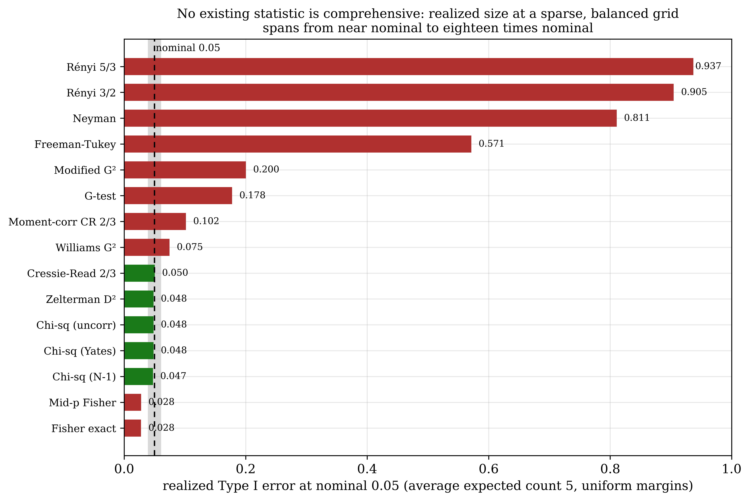
Figure S1. The landscape at a glance (Table S1) as a ranked bar. Realized Type I error at nominal 0.05, average expected count 5, uniform margins, pooled over 780 shapes, for the fifteen statistics poolable over all shapes. Green bars fall inside the 0.04 to 0.06 band; red bars fall outside it, whether liberal (the Renyi, Neyman and Freeman-Tukey statistics, up to nineteen times nominal) or conservative (Fisher and mid-p Fisher, near 0.028). Only the Cressie-Read 2/3, Zelterman and chi-square statistics sit at nominal, and none of them holds there once the margins become heterogeneous. Generated by rerun/make_supplement_landscape_figures.py.

The three remaining members of the eighteen-test battery are not poolable over all 780 shapes and so do not appear in Table S1. The exact-calibrated Fisher test attains nominal size by construction (its randomized rejection rule computes gamma = (p - alpha) / P(T = t_obs) and rejects with probability gamma), at the cost of non-reproducibility; Barnard's and Boschloo's exact tests are defined for 2x2 tables only and were further restricted to minimum expected count at least 5.0. Because they are not defined over the same set of conditions as the other fifteen, no pooled count-5 rate is reported for them here; their per-shape rates are given in the deposited output.
The hierarchy is clear. The Cressie-Read 2/3 statistic is the most accurately calibrated asymptotic test in the sparse regime, at 0.0504, within 0.0004 of nominal. Zelterman's D-squared, Pearson's chi-square, and the Yates-corrected chi-square all land at 0.0483. The G-test inflates by a factor of 3.6, the modified G-squared by 4.0, the Freeman-Tukey statistic by more than 11, and the Neyman statistic rejects over sixteen times too often. The naively normalized Renyi tests reject at 90.5% and 93.7%, which Section S3 shows to be a correctable scaling error rather than an inherent failure of the divergence.
Fisher's exact test shows its characteristic conservatism, 0.0277, a 45% loss of nominal size. That conservatism, routinely described as "safe," is paid for in power: at an average expected count of 20 with V = 0.1, the well-calibrated asymptotic tests (Pearson's chi-square, the G-test, Cressie-Read 2/3, Williams G-squared, and Zelterman D-squared) all achieve power between 0.946 and 0.949, differing among themselves by less than 0.003, while Fisher's exact test achieves only 0.405, a loss of 0.541. At V = 0.3, Fisher reaches 0.457 while the asymptotic tests reach 0.999. The textbook advice to reach for the exact test when expected counts are small is therefore backwards: the exact test is most conservative, and so most power-deficient, precisely in the sparse regime where detecting a real effect is hardest.

S1.8 Convergence with increasing cell count
Table S2. Rejection rates by average expected cell count, uniform marginals, alpha = 0.05. Values computed by the deposited script make_tableS2.py.
Average count N/k | G-test | Williams G-squared | CR 2/3 | Moment-corrected CR | Zelterman D-squared | Chi-square
5 | 0.1775 | 0.0747 | 0.0504 | 0.1016 | 0.0483 | 0.0483
10 | 0.0873 | 0.0532 | 0.0504 | 0.0707 | 0.0497 | 0.0497
20 | 0.0664 | 0.0523 | 0.0515 | 0.0607 | 0.0509 | 0.0509
50 | 0.0553 | 0.0499 | 0.0498 | 0.0535 | 0.0497 | 0.0497
100 | 0.0522 | 0.0494 | 0.0495 | 0.0513 | 0.0494 | 0.0494
200 | 0.0515 | 0.0501 | 0.0503 | 0.0512 | 0.0503 | 0.0503
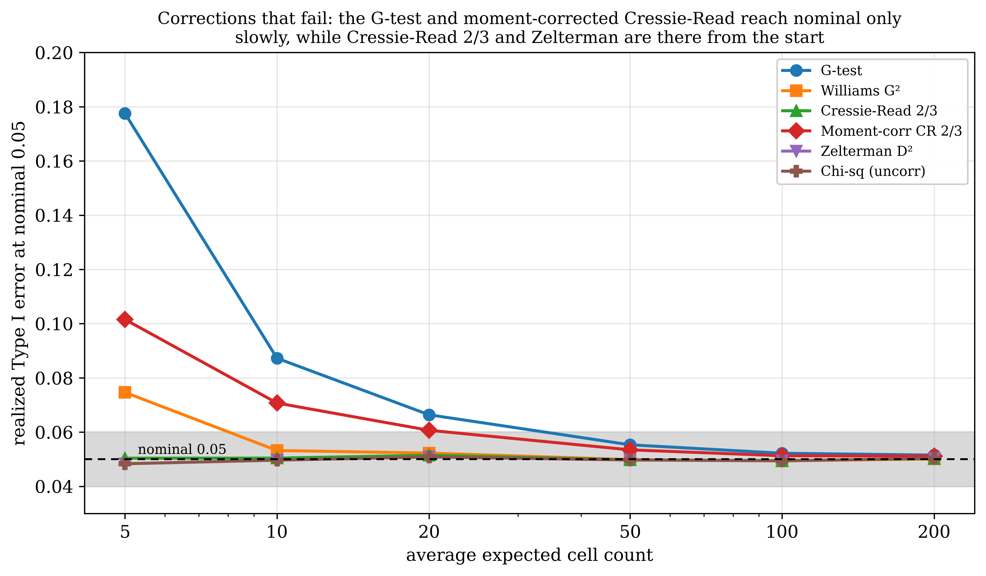
Figure S2. The convergence record for the corrected statistics (Table S2). Realized Type I error against the average expected cell count, uniform margins. The G-test enters at 0.178 and the moment-corrected Cressie-Read at 0.102, and both reach the 0.04 to 0.06 band only by an average count near 50; the Williams correction is faster but still enters above the band; the uncorrected Cressie-Read 2/3, Zelterman and Pearson chi-square are inside it from an average count of 5. A correction that needs a large sample to reach nominal is not a solution to the sparse-table problem. Generated by rerun/make_supplement_landscape_figures.py.

Table S2 is the convergence record for the corrected statistics, and it is the table on which Section S2 rests. Three things happen in it. The Williams correction pulls the G-test down from 0.1775 to 0.0747 at count 5 and lands on 0.0499 by count 50. The moment-corrected Cressie-Read 2/3 moves in the wrong direction at count 5, inflating an already-calibrated 0.0504 to 0.1016, and does not settle until 0.0512 at count 200. Zelterman's D-squared tracks Pearson's chi-square value for value at every count, which is exactly what the algebraic identity D-squared = X-squared - sum(O/E) + k predicts.

S1.9 Type I error under heterogeneous marginals
Phase 1 isolates the marginal-heterogeneity effect at V = 0. Table S3 shows the result at an average expected count of 20, and it is the single most consequential table in the entire comparison.
Table S3. Type I error rates by CVe level at average expected count = 20, alpha = 0.05. Values computed by the deposited script make_tableS3.py.
Test | CVe = 0 | CVe = 0.25 | CVe = 0.50 | CVe = 0.75 | CVe = 1.00
Chi-square (uncorrected) | 0.0490 | 0.0507 | 0.0079 | 0.0012 | 0.0005
G-test | 0.0643 | 0.0797 | 0.0052 | 0.0011 | 0.0004
Cressie-Read 2/3 | 0.0495 | 0.0331 | 0.0042 | 0.0009 | 0.0004
Williams G-squared | 0.0502 | 0.0240 | 0.0025 | 0.0005 | 0.0002
Zelterman D-squared | 0.0490 | 0.0424 | 0.0048 | 0.0008 | 0.0003
Fisher exact | 0.0228 | 0.0216 | 0.0054 | 0.0010 | 0.0004

At CVe = 0.50, the chi-square test, which held near-perfect calibration under uniform marginals, drops to 0.0079, an 84% loss of nominal size. The G-test drops to 0.0052 and even the Cressie-Read 2/3 statistic falls to 0.0042. At CVe = 1.00, every test in the battery rejects at a rate below 0.001 and is, for practical purposes, inert. This is not the failure of an individual statistic. It is the breakdown of the asymptotic approximation when cell expectations span orders of magnitude: with CVe = 1.0 in a 10x10 table, some cells may have expected counts below 0.01 while others exceed 100, and the chi-square distribution, calibrated for a sum of squared standardized residuals, cannot accommodate that degree of structural inhomogeneity.
The nineteen-level CVe axis of the higher-replication extension resolves a feature that the five-level axis of the master grid could not. In the moderate-heterogeneity band around CVe = 0.2, Pearson's chi-square becomes liberal, with a pooled size near 0.085 (median 0.059, exceeding 0.06 for about half of all shapes and reaching 0.106 at an average count of 10), exactly where the Cressie-Read 2/3 statistic turns conservative (0.022). The two default recommendations therefore fail in opposite directions in the same band. This is the observation that no exponent within the family can fix, and it is the observation from which T_root proceeds.

S1.10 Power
Under uniform marginals, all well-calibrated asymptotic tests achieve virtually identical power, and the power differences among them are negligible. Under heterogeneous marginals, the power collapse is even more dramatic than the size collapse.
Table S4. Power at Cramer's V = 0.1, average expected count = 50, alpha = 0.05, by marginal heterogeneity. Values computed by the deposited script make_tableS4.py.
Test | CVe = 0.0 | CVe = 0.5 | CVe = 1.0
Chi-square (uncorrected) | 0.9848 | 0.0422 | 0.0022
G-test | 0.9851 | 0.0390 | 0.0029
Cressie-Read 2/3 | 0.9849 | 0.0362 | 0.0022
Williams G-squared | 0.9849 | 0.0331 | 0.0020
Zelterman D-squared | 0.9848 | 0.0366 | 0.0020
Fisher exact | 0.3976 | 0.0364 | 0.0022
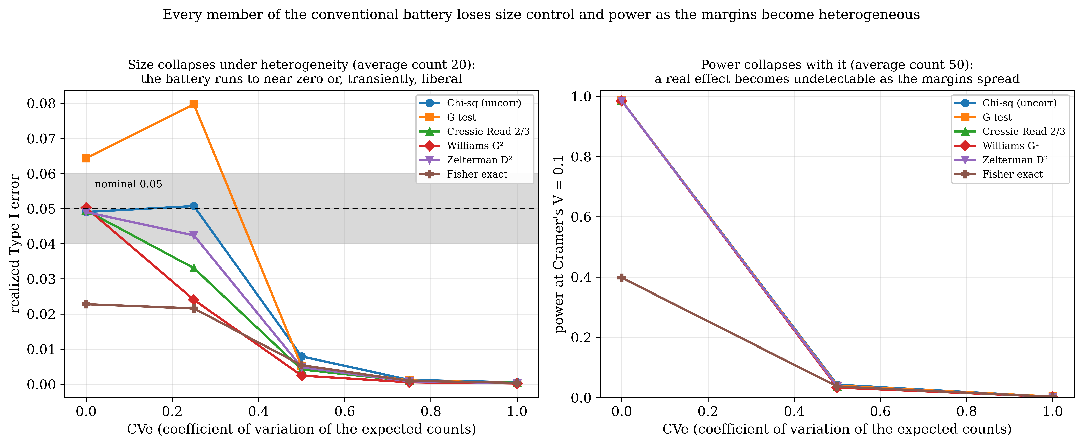
Figure S3. The whole conventional battery collapses under heterogeneity (Tables S3 and S4). Left: realized Type I size against CVe at average expected count 20; the six-member battery runs to near zero as the margins spread, after a transient liberal excursion for the G-test in the moderate band. Right: power at Cramer's V = 0.1 against CVe at average expected count 50; a real effect becomes undetectable, every member falling toward zero. Where the main paper's heterogeneity figure follows three statistics, this follows the full battery, and none of them holds either size or power as the margins become uneven. Generated by rerun/make_supplement_battery_figure.py.

At CVe = 0.0, chi-square achieves 98.5% power to detect V = 0.1 at an average count of 50. At CVe = 0.5 that plummets to 4.2%, barely above the suppressed Type I rate at the same condition. At CVe = 1.0 it drops to 0.22%, at which point the distinction between size and power has vanished and testing has become meaningless. Fisher's exact test, at CVe = 0.0, achieves 0.3976, a loss of roughly 54 percentage points against the asymptotic tests, entirely attributable to its conservative size.

S1.11 Why this matters for real data
To situate the comparison in practice, 441 public datasets (Rdatasets) were scanned and 5,568 two-way contingency tables formed from pairs of categorical variables. Of these, 60.9% have a minimum expected count below 5 and 90.8% have heterogeneous marginals (CVe at least 0.30, median 0.90), so 93.8% lie in the sparsity or heterogeneity regime this comparison maps; the default and the calibrated analysis disagree at alpha = 0.05 in 11.0% of the sparse tables. Eighty percent of the real tables sit at CVe at least 0.5, that is, in the zone where Table S3 and Table S4 show every one of the eighteen tests failing. The conditions under which the defaults are least reliable are the common case, not the exception.

S2. Recalibrating the underperforming statistics
Three of the eighteen statistics in the battery are corrections: attempts to take a statistic that is known to misbehave and repair it in place. They deserve their own accounting, both because two of the three are novel or rarely evaluated and because the pattern of their success and failure is the argument for T_root. What follows is the full assessment of each.

S2.1 The Williams-corrected G-squared: a success that does not go far enough
Williams (1976) proposed dividing the G-test by a correction factor
q = 1 + [ ((sum N/r_i) - 1) ((sum N/c_j) - 1) ] / (6 N dof),
which shrinks G-squared toward chi-square and so removes the upward bias that inflates the likelihood-ratio statistic in sparse tables. It is worth noting that only the G-test, and not Pearson's X-squared, is Bartlett-correctable in this sense (Baggerly, 1998); the correction is available precisely because the log-likelihood-ratio statistic has an expansion whose leading bias term is a multiplicative constant.
The correction achieves its design goal. At an average expected count of 5, Williams G-squared rejects at 7.47% against the uncorrected G-test's 17.75%, a 58% reduction in excess inflation. By count 50 it reaches 0.0499, the closest-to-nominal rejection rate of any statistic in the battery at that sparsity level; and it holds there, at 0.0494 at count 100 and 0.0501 at count 200 (Table S2). If the G-test is the statistic one wants, for instance because additivity in a log-linear model is the object of interest, the Williams correction should be applied, and for tables with an average count of 20 or more it is an excellent choice.
But the correction does not eliminate the sparse-table problem. At count 5 the corrected statistic still inflates by +0.0247, roughly half again the nominal rate, which places it eighth in Table S1, behind the uncorrected Pearson chi-square and behind Cressie-Read 2/3, neither of which needed correcting. A multiplicative Bartlett-type factor calibrated on a first-order expansion cannot fully repair a statistic in the regime where the expansion is least trustworthy; it can only reduce the damage. And Table S3 shows that the Williams correction offers no protection at all in the direction that actually matters for real data: at CVe = 0.25 the corrected statistic is already the most conservative in the battery at 0.0240, and at CVe = 0.50 it has fallen to 0.0025, the worst collapse of any of the six tests shown. The correction fixes a sparsity problem it was designed to fix and is silent on the heterogeneity problem it was not.
Verdict: success, but partial, and confined to the balanced-margin axis.

S2.2 The moment-corrected Cressie-Read 2/3: an overcorrection
The moment correction is novel to this program. The expected value of I^(2/3) under the null carries a bias term of order 1/N,
bias = -(1/(9N)) * (sum 1/p_j - 2RC),
where the product structure sum 1/p_j = (sum N/r_i)(sum N/c_j) simplifies the computation, and the corrected statistic is
T_corr = T_(2/3) * dof / (dof + bias).
The idea is sound and the algebra is correct. The correction nevertheless fails, and it fails in an instructive way. At an average expected count of 5 the corrected statistic rejects at 0.1016, more than double the nominal rate, against the uncorrected Cressie-Read 2/3 statistic's 0.0504 (Table S1, Table S2). The correction has taken a statistic that was already the best-calibrated member of the entire battery and made it the second-worst of the six statistics in Table S2.
The mechanism is transparent from the formula. The bias term is negative and, in the sparse regime, large in magnitude, so the denominator dof + bias is smaller than dof and the ratio dof / (dof + bias) exceeds one. The correction therefore amplifies the statistic exactly where the intent was to dampen it. The deeper point is that the first-order asymptotic expansion from which the bias term is derived breaks down in precisely the regime where a correction is needed. An O(1/N) expansion evaluated at an average cell count of 5 is being asked to do work outside the neighborhood in which it is valid, and the size of the correction it returns is a measure of its own unreliability rather than a measure of the bias.
The overcorrection diminishes as the tables fill in, from 0.1016 at count 5 to 0.0707 at count 10, 0.0607 at count 20, 0.0535 at count 50, 0.0513 at count 100, and finally 0.0512 at count 200. But at every one of those counts the uncorrected Cressie-Read 2/3 statistic is closer to nominal (0.0504, 0.0504, 0.0515, 0.0498, 0.0495, 0.0503). The corrected statistic is uniformly dominated by the statistic it was intended to improve.
Verdict: failure. The correction overcorrects at every sparsity level, and the uncorrected Cressie-Read 2/3 should be preferred without exception.

S2.3 The Zelterman D-squared: a correct correction with nothing to correct
Zelterman (1987) defined
D-squared = X-squared - sum_ij (O_ij / E_ij) + k,
where k = RC is the number of cells. In the goodness-of-fit setting, with fully specified expected counts, E[D-squared] = k - 1 exactly, and the statistic is a genuine improvement on Pearson's X-squared for large sparse multinomials. The independence setting is different, and the difference is the whole story. With margins estimated from the table, E[sum O_ij / E_ij] = k, so the correction term -sum(O/E) + k has expectation zero under the null, and E[D-squared] equals the degrees of freedom (R-1)(C-1), which is exactly the first moment of Pearson's X-squared. The correction term also has small variance. D-squared and X-squared are therefore asymptotically equivalent in the independence setting, and the simulation confirms it to the fourth decimal place.
Zelterman's D-squared rejects at 0.0483 at count 5, 0.0497 at count 50, and 0.0500 at count 200. Pearson's chi-square rejects at 0.0483, 0.0497, and 0.0503 at the same three counts. The two statistics are indistinguishable at the pooled standard error of the study (near 0.001). This is not a defect of Zelterman's construction; it is the predicted consequence of applying, in the estimated-margin setting, a correction derived for the fully-specified-margin setting, where the term it removes no longer has anything to remove.
The consequence is what matters here. Because D-squared matches Pearson's X-squared essentially exactly, it inherits Pearson's behavior everywhere, including everywhere Pearson fails. It collapses with Pearson under heterogeneous marginals (Table S3: 0.0490, 0.0424, 0.0048, 0.0008, 0.0003 across the CVe ladder, against Pearson's 0.0490, 0.0507, 0.0079, 0.0012, 0.0005) and its power collapses with Pearson's (Table S4). A statistic that reproduces the default cannot rescue the default.
Verdict: correct but inert in this setting. D-squared offers no practical advantage over the simpler Pearson statistic, and it inherits Pearson's failures rather than fixing them.

S2.4 What the three corrections tell us together
One correction succeeded partially (Williams, on the sparsity axis only, and not completely even there). One failed outright by overcorrecting in the regime it targeted (the moment-corrected Cressie-Read 2/3, whose first-order expansion is invalid exactly where it is invoked). One is algebraically sound and empirically null (Zelterman, which reproduces Pearson and therefore reproduces Pearson's collapse).
The common thread is that all three are corrections to a statistic evaluated against a fixed chi-square reference, and none of them touches the reason the reference is wrong. The Williams factor rescales; the moment correction rescales; the Zelterman term recenters. None of them changes the per-cell metric that generates the problem. For an expected count E, the Pearson kernel (O - E)^2 / E has null variance 2 + 1/E, and the 1/E term blows up as cells empty. That term does not depend on the Cressie-Read exponent, so no member of the family can remove it, and it does not depend on a multiplicative or additive bias correction, so no correction of the kind assessed in this section can remove it either.
The result of all this recalibration work, then, is a negative one and it is worth stating plainly: none of these corrections produces a statistic that is comprehensive across the plane of shape, sparsity, and marginal balance. The best-calibrated statistic on the balanced axis (Cressie-Read 2/3) turns conservative under moderate heterogeneity; the default (Pearson) turns liberal in the same band; the corrections either help on one axis and not the other, or actively hurt, or do nothing at all. That is the finding that motivates T_root, which changes the metric rather than the exponent or the constant, and which is developed in the main paper.

S3. The Renyi normalization correction

S3.1 The error
The Renyi divergence of order alpha between the observed and expected distributions yields the test statistic, as commonly written,
R_alpha = [2N / (alpha - 1)] * log( sum_ij (O_ij/N)^alpha (E_ij/N)^(1 - alpha) ),
which for alpha = 5/3 gives the coefficient 3N and for alpha = 3/2 gives the coefficient 4N. Referred to chi-square on (R-1)(C-1) degrees of freedom, this statistic is a disaster. In the master grid at an average expected count of 5, R_(5/3) rejects at 93.7% and R_(3/2) at 90.5% under the null at a nominal 5% (Table S1). Worse, the over-rejection does not vanish as the expected counts grow: at count 50 the two statistics reject at 0.9395 and 0.9055 respectively, essentially unchanged. It grows instead with the degrees of freedom. On the wider 100x100 grid at 4,000 replications per cell, the naive coefficient's over-rejection climbs from 0.13 at 2x2 to essentially 1.00 for every shape of 20x20 and larger, with a pooled mean of 0.95.
This pattern (an over-rejection that scales with the degrees of freedom and is invariant to sample size) is the signature of a location error, not of a distributional failure. And that is exactly what it is.

S3.2 The fix
Under the null, 2N times the Renyi divergence does not converge to a chi-square variate. It converges to alpha times a chi-square variate. Its mean is therefore approximately alpha * (R-1)(C-1) rather than (R-1)(C-1). This was confirmed directly in simulation: the mean of R_(5/3) is within about 4% of (5/3) * (R-1)(C-1) across shapes. Referring a statistic whose mean is 5/3 times the degrees of freedom to a chi-square distribution centered on the degrees of freedom will reject nearly always once the degrees of freedom are large enough to make the shift many standard deviations wide, which is precisely why the naive test's rejection rate climbs to 1.00 as the table grows.
The remedy is a single coefficient. Replacing 2N / (alpha - 1) with the Cressie-Read-consistent
2N / [ alpha (alpha - 1) ]
divides out the offending factor of alpha and recovers the chi-square limit. The corrected coefficient restores near-nominal size. On the wider 100x100 grid the corrected statistic controls size across the whole range, with a pooled mean of 0.026, drifting gently from 0.048 at 2x2 to 0.017 at 100x100 as a fixed average expected count spreads a fixed divergence over ever more cells. A focused null-only ladder at 8,000 replications reproduces the contrast on small shapes, where the two versions can be compared directly.
Table S3a. Renyi divergence test, null rejection rate at alpha = 0.05, by shape. Focused null-only ladder, 8,000 replications.
Shape | Corrected coefficient 2N/[alpha(alpha-1)] | Naive coefficient 2N/(alpha-1)
2x2 | 0.051 | 0.123
3x3 | 0.041 | 0.224
4x4 | 0.030 | 0.327
6x6 | 0.030 | 0.572
10x10 | 0.019 | 0.934

(Balanced margins, alpha = 5/3, from the deposited `renyi_shapes.csv`. The naive coefficient's over-rejection grows monotonically with table size, from 0.123 at 2x2 to 0.934 at 10x10, and reaches essentially 1.00 for every shape of 20x20 and larger on the wider grid; the corrected coefficient stays near nominal at the small shapes and drifts mildly conservative as the table grows.)
Table S3b. Renyi divergence test, pooled null rejection rate on the higher-replication 100x100 grid (4,000 replications per cell).
Coefficient | 2x2 | 20x20 and larger | 100x100 | Pooled mean
Corrected, 2N/[alpha(alpha-1)] | 0.048 | (declining) | 0.017 | 0.026
Naive, 2N/(alpha-1) | 0.13 | approx. 1.00 | approx. 1.00 | 0.95

S3.3 What this does and does not establish
Two conclusions follow, and they must be kept separate.
The first is that this is a normalization error, not an inherent failure of the Renyi family. The Renyi divergence is a perfectly serviceable measure of departure from independence; the statistic built on it is not defective. What is defective is the coefficient with which it is customarily written, which is off by a factor of alpha. The literature's 2N / (alpha - 1) form must not be referred to a chi-square distribution. With the coefficient 2N / [alpha (alpha - 1)] the family is brought into calibration and a Renyi divergence test becomes usable. The practical instruction is exact and narrow: use the corrected coefficient, or do not use the chi-square reference.
The second conclusion is the one that matters for the argument of the main paper. Even corrected, the Renyi tests hold only at balanced margins. The corrected coefficient recovers the chi-square limit, and the chi-square limit is what collapses under heterogeneity. Bringing the Renyi family back into calibration on the balanced axis does not, and cannot, make it comprehensive; it simply promotes it from unusable to no-better-than-the-others. The Renyi correction is a genuine contribution and it belongs in the record, but it is a contribution to the landscape, not an escape from it. Like the Williams correction, it fixes one axis and leaves the other untouched.

S4. The calibrated-lambda surface

S4.1 Construction
Cressie and Read (1984) observed that the optimal exponent lambda may vary with the characteristics of the table. If that is so, then the natural response to the failures documented in S1 through S3 is not to pick one exponent but to solve for one: for each (R, C, N) condition, find the lambda* that achieves exactly 5% rejection under the null. This was done by interpolating across the six named Cressie-Read family members and solving for the exponent that produces a 0.050 rejection rate, then fitting a regression surface to lambda* as a function of log(N), log(dof), 1/N, and R/C.
Table S5. Calibrated-lambda surface summary across phases. Values computed by the deposited script make_tableS5.py.
Phase | Marginals | Median lambda* | Mean lambda* | Conditions solved
Original | Uniform | +0.109 | -0.172 | 40,058 / 46,800
Phase 1 | Heterogeneous | -0.963 | -0.908 | 27,114 / 93,600
Phase 2 | Heterogeneous + power | -0.883 | -0.839 | 4,615 / 46,800

The fitted regression surface for uniform marginals is
lambda_cal = 1.922 - 0.418 log(N) + 0.030 log(dof) - 37.889/N + 0.176 (R/C) + 0.016 [log(N)]^2 + 0.008 [log(dof)]^2 - 39.081 log(dof)/N.

S4.2 What the surface shows
The shift in the calibrated exponent across phases is the whole result. Under uniform marginals the median lambda* is +0.109, sitting near the G-test end of the interval between the G-test (lambda = 0) and Cressie-Read's recommendation (lambda = 2/3) and comfortably consistent with using lambda = 2/3 as a default. Under heterogeneous marginals the median shifts to -0.963, well into the negative-lambda region toward the Neyman corner of the family (lambda = -2). Phase 2, which crosses heterogeneity with effect size, gives a median of -0.883, similar to Phase 1. The swing is shown in Figure S4.
The direction of the shift is interpretable: when cell expectations are highly unequal, statistics that weight the small cells more heavily (lambda < 0) are needed to reach a nominal rejection rate, because it is the small cells that are carrying the miscalibration. The magnitude of the shift is the problem. A move of about a full unit in lambda, from just above the G-test well into the negative range toward Neyman, is a move across much of the useful range of the family, and it is driven by nothing more than the balance of the margins.
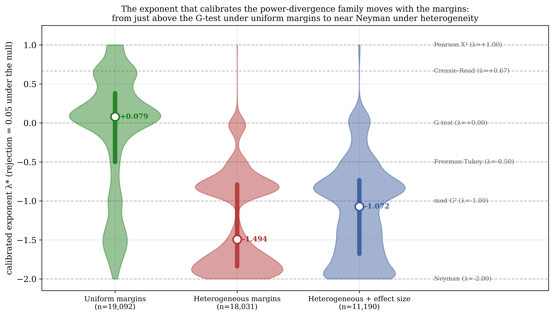
Figure S4. No single member of the power-divergence family of tests is honest across all tables. The family is really one test with a dial, the exponent lambda: at lambda = 1 it is Pearson's chi-square, at 0 the G-test, at 2/3 Cressie-Read, at -2 Neyman (the dashed lines mark where each named test sits). For every table condition we solved for the dial setting lambda* that makes the test reject a true null exactly 5 percent of the time. Each violin shows the spread of that required setting across thousands of conditions, with the median as the white dot. The setting you need moves with the table: near the G-test (median +0.079) when the margins are even, but all the way down toward Neyman (median -1.494) when they are lopsided, and -1.072 in between. Because the honest setting depends on the table's margins, no fixed member of the family works everywhere, which is the case for replacing the family with T_root. Generated by rerun/make_supplement_lambda_figure.py from the deposited calibrated-lambda surfaces.
The low R-squared values (0.022, 0.049, 0.218) say the rest. The regression surface, given log(N), log(dof), 1/N, and the aspect ratio R/C, explains only a small fraction of the variance in lambda*. That is not a defect of the fit; it is a statement about what lambda* depends on. The calibrated exponent depends on the specific marginal structure of the table, not on any summary of its size and shape. A fully adaptive power-divergence test would therefore require either a tabulated lambda* surface indexed by something much richer than (R, C, N), or a bootstrap calibration, both of which are computationally expensive and neither of which is closed-form.

S4.3 The conclusion that matters
The calibrated-lambda analysis was undertaken as a possible solution and it turned out to be a diagnosis. Its conclusion is the pivot of the whole program:
The best exponent itself must move with the margins. Therefore no fixed member of the Cressie-Read family is comprehensive, and a routing surface over lambda is not a solution but a symptom.
If the exponent that calibrates a table can only be known once the table's marginal structure is known, then choosing an exponent is not a specification of a method but a deferral of the problem. The routing surface is an honest instrument for reporting that deferral (it tells you which member of the family is least wrong for your table), and as an instrument it does its job. But a statistic whose defining parameter must be looked up from a surface fitted to the null behavior of the very table under test is not a closed-form statistic in any useful sense, and the low R-squared says that even the lookup will not be reliable.
The reason no exponent works is now clear from Section S2.4: every power-divergence member carries the same per-cell null variance 2 + 1/E, and the 1/E term does not depend on lambda. Moving lambda cannot remove a term that is invariant to lambda; it can only trade one direction of miscalibration for another, which is exactly what Table S5 records as a swing from +0.08 to -1.49.
This surface is superseded by T_root. T_root does not move within the family; it changes the metric in which the cells are aggregated (the Anscombe variance-stabilizing root, the count-domain analog of the log), so that the per-cell variance is of order one regardless of E and no small cell can dominate. There is then nothing left to route: one statistic, one reference, one p-value, across the plane. The calibrated-lambda surface remains deposited and reproducible, and it remains the cleanest available demonstration that the family cannot be fixed from within.

S5. The two superseded recalibration routes
Before T_root, the heterogeneous-marginal collapse was attacked from the other side. If the statistic is not at fault, then the reference is; and the reference can be repaired without touching the statistic. Two such routes were developed and validated, and both work. They are recorded here in full because they are the standard against which T_root must be judged, because one of them survives as the fallback for the extreme corner, and because the reason they were superseded is itself the argument for the main paper.

S5.1 The diagnosis they share
Both routes start from the same two-moment diagnosis. Under heterogeneous marginals the null distribution of the Pearson statistic departs from its nominal chi-square in both moments. The mean falls, because empty and near-empty cells cut the effective degrees of freedom below the nominal (R-1)(C-1), so a reference sized for the nominal degrees of freedom is too large a yardstick. And the variance inflates ten- to a hundred-fold, driven by a few small non-zero cells through the heavy 1/E tail of the per-cell variance 2 + 1/E. Because the two departures act in opposite directions on the tail probability, the fixed chi-square reference miscalibrates conservatively for some margin structures and liberally for others, which is why Table S3 shows collapse while the wider grid shows Pearson turning liberal at CVe = 0.2. At the most extreme heterogeneity, entire rows or columns are empty and the realized table is smaller than R x C, at which point the nominal degrees of freedom are simply the wrong count.
The screen-and-route discipline that follows is: report CVe; when it is large, (i) collapse all-zero rows and columns to the realized table, and (ii) replace the chi-square reference with one computed conditional on the observed margins.

S5.2 Route A: the exact margin-conditional permutation reference
The first route replaces the chi-square reference with the exact conditional null distribution, obtained by a margin-conditional Monte Carlo, equivalently by permuting the labels among the N units and recomputing the statistic on each permuted table.
This was validated over sixteen shapes from 5x5 to 40x40 at average counts of 5, 10, and 20 with an exact margin-conditional (permutation) reference (deposited as run_hetero_solution.py, full 32-core run). In the collapse zone (CVe at least 0.5) it restores the size from a mean of 0.031 to 0.049, essentially the nominal level, and recovers power from 0.043 to 0.068, exactly where the default had fallen to near zero. Across the whole heterogeneity range the exact conditional reference is well calibrated, holding size between 0.048 and 0.050, with a calibration error of at most 0.002. A fast parametric bootstrap is a close surrogate and is considerably cheaper, but it can run slightly liberal in the sparsest realized tables and is not the reference of record.
The cost is the obvious one and it is not negotiable: the route requires resampling. Every p-value is the output of a Monte Carlo, so it carries a Monte Carlo error, it is not deterministic without a fixed seed, its cost scales with the number of permutations, and it cannot be written down. For a method intended as a default for the most common test in applied statistics, that is a real barrier.

S5.3 Route B: the analytic, permutation-free recalibration in the log/power domain
The second route reaches the same end analytically. Rather than sampling the conditional null distribution, it computes the table's own null moments from the margins and matches a reference to them. Specifically: a scaled chi-square is moment-matched to the table's own null mean and variance (the Patnaik-Satterthwaite construction, applied here not with generic asymptotic moments but with the exact null moments of the observed margin configuration), and the result is normalized with the Wilson-Hilferty cube-root transform, which carries a chi-square variate into near-normality and defines the log/power domain in which the recalibration is performed.
The gain is large. Across shapes from 8x8 to 30x30, the calibration error falls from a peak of 0.12 to about 0.015. The route is faster than the permutation, requires no resampling at all, is fully deterministic, and, importantly, adapts to whichever direction the chi-square happens to miscalibrate: where the chi-square reference runs liberal (in the validation, up to a size of 0.17 at CVe = 0.75) the moment-matched reference pulls it down, and where it runs conservative the same construction pulls it up. It is the right idea, executed on the reference.
Its limit is that a residual of about 0.015 remains, and the exact permutation remains the better-calibrated reference for a final p-value.

S5.4 Why T_root supersedes both
Both routes repair the reference of an existing statistic. They take Pearson's X-squared (or Cressie-Read 2/3), leave it exactly as it is, and change the yardstick against which it is measured, either by sampling the correct yardstick (Route A) or by computing it from the margins (Route B). Both work. Neither is a statistic.
The consequences of that architecture are three. First, the repair has to be redone for every table, because the correct reference depends on the observed margins; there is no single reference to state. Second, the repair protects size but recovers power only to the extent that the underlying statistic had power to recover, and the underlying statistic is still the one whose per-cell variance 2 + 1/E is blowing up. Third, the analytic route is a second-order fix layered on a first-order defect: it is matching moments of a distribution whose shape is wrong because the metric is wrong.
T_root inverts this. It builds the calibration into the statistic rather than repairing the reference. Each cell is recast in the Anscombe variance-stabilizing metric A(x) = 2 sqrt(x + 3/8), the count-domain analog of the log, so that the residual variance is of order one regardless of E and no small cell can dominate the sum; each residual is centered at its own mean under the exact margin-conditional null, mu_ij = E[A(O_ij) | margins], which removes the small-count bias that sinks the plain Freeman-Tukey root; and the sum of squared residuals is referred to a three-moment chi-square built from the cumulants of that same conditional null. Conditioning is what does the work: because each cell is centered at its own conditional mean, the reference mean is an identity, E[S] = sum_ij Var(A(O_ij)), so nothing has to be corrected afterward. The reference is then fixed, the p-value is deterministic, and there is no permutation and no bootstrap. Because the statistic keeps its significance budget where Cressie-Read 2/3 turns conservative, it also recovers roughly double the power in the collapse zone, which neither reference-repair route can do.
Route B is therefore fully superseded: the analytic moment-matching it performs on the reference is done better, and one level lower, inside T_root's own three-moment construction. Route A survives as the single fallback for the extreme corner. At extreme CVe, or on a realized table that has collapsed to a few non-empty cells, so little association information survives that no closed-form construction can be trusted, and the exact margin-conditional permutation is preferred. That is the one remaining reference of record, and it is one fallback rather than a routing table.

S6. Choosing the screen by evidence, and the marginal-generator correction
The reporting standard needs one screen: the reading of the table that decides when T_root yields to the exact margin-conditional test. We chose it by evidence rather than by inheritance from the earlier CVe-routing proposal.
The confirmation study. At 20,000 replications per cell, averaged over independent marginal draws (rerun/confirm_study.py; locked output confirm_count_vs_cve.csv), we measured T_root's actual size over a dense grid of average expected counts (2 to 50) and true CVe levels (0 to 2.5), across shapes from 2x2 to 20x20, recording for every cell the realized CVe, the minimum expected count, and the fraction of replications whose realized table collapsed.
Table S6. T_root's actual size by average expected cell count, pooled over shapes and heterogeneity. Values computed by the deposited script make_tableS6.py.
Average expected count | 2 | 3 | 4 | 5 | 6 | 8 | 10 | 15 | 20 | 50
T_root actual size | 0.065 | 0.061 | 0.056 | 0.054 | 0.051 | 0.050 | 0.051 | 0.049 | 0.049 | 0.048

Table S7. T_root's actual size by true CVe, pooled over shapes and counts. It is essentially flat. Values computed by the deposited script make_tableS7.py.
CVe | 0.0 | 0.5 | 1.0 | 1.5
T_root actual size | 0.057 | 0.057 | 0.057 | 0.060

Table S8. Candidate screen variables, ranked by rank correlation with T_root's actual size. Values computed by the deposited script make_tableS8.py.
Candidate screen | Spearman correlation with T_root size | Verdict
Average expected cell count | -0.69 | Best predictor; this is the screen
Minimum expected cell count | -0.52 | Weaker
Collapse fraction | +0.35 | Weaker still
CVe | +0.24 | Worst of the candidates; a diagnostic, not a router

The conclusion is that CVe is a diagnostic of when the default tests fail, not of when T_root fails. It is above CVe of about 1.5 that Pearson's chi-square turns liberal, reaching 0.127 by CVe = 4.0, and about 21 percent of real two-way tables sit there. What tells you that T_root itself needs help is the expected count. The screen is therefore an expected-count screen with a collapse check, and it is a single binary test.
The degenerate corner. The one place the exact test is required rather than preferred is a small table at extreme heterogeneity, in which the realized table collapses below 2x2 once empty rows and columns are removed, so that no asymptotic test can be formed. Every such cell in the study was a 2x2. This is structural: CVe has a shape-dependent ceiling of sqrt(k^2 - 1), so for a 2x2 it is sqrt(3) = 1.732, and the realized CVe in those cells saturated at exactly 1.732 with the minimum expected count driven to zero.
The marginal-generator correction. Reproducing that theoretical ceiling to three decimals is itself a check on the marginal generator, and it is worth recording that an earlier version of it was wrong. To draw margins with a target coefficient of variation cv from a symmetric Dirichlet(alpha, k), the concentration must be alpha = (k - 1 - cv^2) / (k * cv^2), because a Dirichlet draw has E[cv^2] = (k - 1)/(k * alpha + 1). An earlier version used alpha = (1 - cv^2) / (k * cv^2), omitting the (k - 1). The realized CVe was then 2 to 8 times the requested value and, because the inflation grew with k, the heterogeneity axis was not comparable across table shapes. The generator is corrected, every run now records the realized CVe alongside the requested one, and the heterogeneity results in this Supplement and in the parent paper are on the corrected scale, anchored to the real-data CVe distribution (median 0.90, 90th percentile 2.03, 99th percentile 3.50, maximum 6.66).

S7. The off-diagonal cumulant terms, and the delta-method linearization
Section 3 of the main paper builds the second and third cumulants of the T_root statistic as a hybrid: the per-cell terms exactly from the conditional moment table, and the cell-to-cell covariance terms from the quadratic-form trace identity, with those traces made affordable by the diagonal-plus-low-rank structure of the conditional covariance. Two claims in that construction are backed here. First, the off-diagonal covariance terms are the larger part of both cumulants, so omitting them, as the earlier Poisson-plus-projection reference did, is the mechanism that made the statistic liberal (Figure 4 of the main paper). Second, the low-rank trace computation reaches the transformed residuals only through a delta-method linearization, and that linearization does not introduce a hidden error larger than the Gaussian off-diagonal approximation the reference already carries. The second claim is the one a referee is most likely to press, so it is separated into its two sources here.
For each of seven verification cases, the off-diagonal contribution to the variance and to the third cumulant of S is computed three ways against the exact margin-conditional null sampled by permutation at 200,000 draws per case: the shipped linearized value from the low-rank traces; the same Gaussian identity applied to the exact sample covariance of the transformed residuals, which removes only the linearization; and the Monte Carlo truth (Figure S5). The linearized value sits on the exact-covariance value in every case, so the delta-method step costs almost nothing; the only place either departs from the truth is the sparse 3x3 at N = 18, far below the expected-count screen, and there it is the Gaussian assumption that slips, not the linearization. Attributed relative to the cumulant, the delta-method linearization is 2.7 to 11.0 percent on the variance and 4.8 to 34.2 percent on the third cumulant, against 2.0 to 4.9 percent and 0.4 to 43.1 percent for the Gaussian off-diagonal term: the two are of the same order and neither dominates. Derivation and the per-case numbers are in the companion (D13.4); the figure and its data regenerate from rerun/make_linearization_split_figure.py and rerun/verify_linearization_split.py.
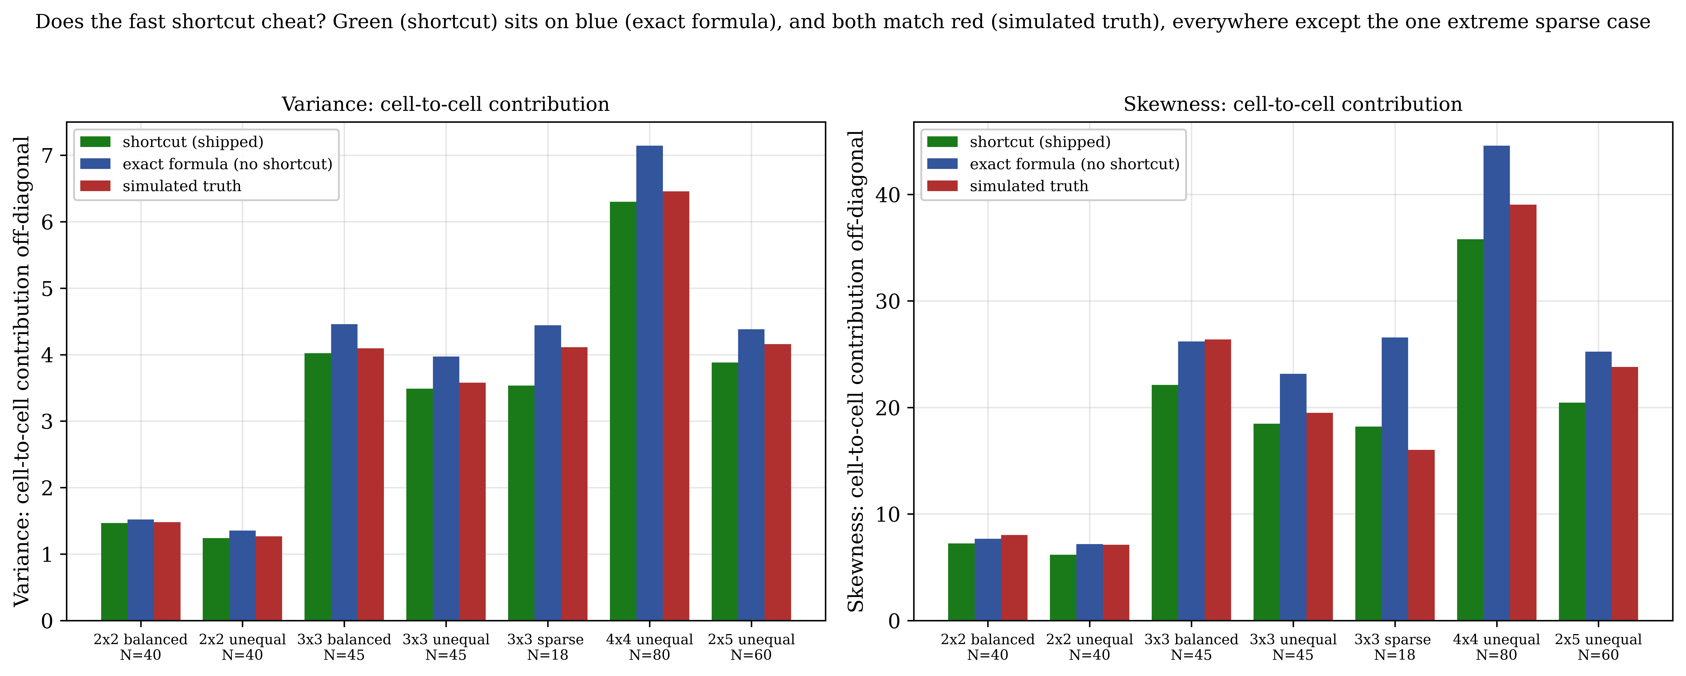
Figure S5. The fast shortcut T_root uses to compute its variance and skewness does not cheat. T_root's variance and skewness each combine a per-cell part and a cell-to-cell (off-diagonal) part; the off-diagonal part is large, and T_root computes it with a fast approximation. This figure checks that approximation for seven test cases, for the variance (left) and the skewness (right). Each case is shown three ways: the shipped shortcut (green), the same formula without the shortcut (blue), and the brute-force simulated truth (red). Green sitting on blue means the shortcut adds essentially nothing; both matching red means the whole calculation is right. They agree everywhere except one deliberately extreme case, a 3x3 table with only 18 counts, which is far sparser than any table the method is used on. Generated by rerun/make_linearization_split_figure.py.

S8. The non-square study: aspect ratio at fixed cell count
The size results in the main paper are developed on square tables, where the degrees of freedom (R-1)(C-1) and the cell count RC move together and cannot be separated. A dedicated non-square study varies the aspect ratio at a fixed cell count to break that collinearity. Sixteen shapes, from square through sixteen to one elongated, were run at eight average expected counts from 5 to 500 and six heterogeneity levels, with the Mielke-Berry conditional moments computed exactly and one million replications per cell (Monte Carlo standard error 0.000218). The conditional skewness g of the statistic was recorded for every cell. Of the 768 cells, 497 ran and 271 screened out, the latter exactly the strongly elongated high-CVe corner that no practical sample size can reach.
Two things follow, and they are shown together in Figure S6. First, at CVe 2.0, the one heterogeneity level where every aspect ratio is still reachable, the miscalibration of the fixed chi-square reference is ordered by the conditional skewness, not by the degrees of freedom or the cell count: across the reachable cells its realized size correlates with g at 0.86, with the degrees of freedom at only 0.11, and with the cell count at -0.01 (Table S9). Within a fixed cell count the elongated member has the lowest skewness and runs conservative, while the square member has the highest and runs liberal; a 2x18 table runs at 0.038 and a 6x6 at 0.069 at the same cell count. The exact three-moment Mielke-Berry reference and T_root both hold nominal across every aspect ratio, between 0.046 and 0.050 and between 0.050 and 0.055 respectively. Second, the heterogeneity a shape can reach collapses with its aspect ratio and not with its degrees of freedom: square shapes reach CVe 3.5, whereas the two-row shapes cannot pass CVe 2.0 regardless of their degrees of freedom, because an elongated table cannot realize extreme marginal imbalance without collapsing an empty margin. The high-CVe regime where a three-moment reference is stressed is therefore reachable only by near-square, high-skewness tables, and T_root holds nominal across the entire reachable non-square plane. This confirms on non-square shapes the near-square argument the main paper makes analytically.
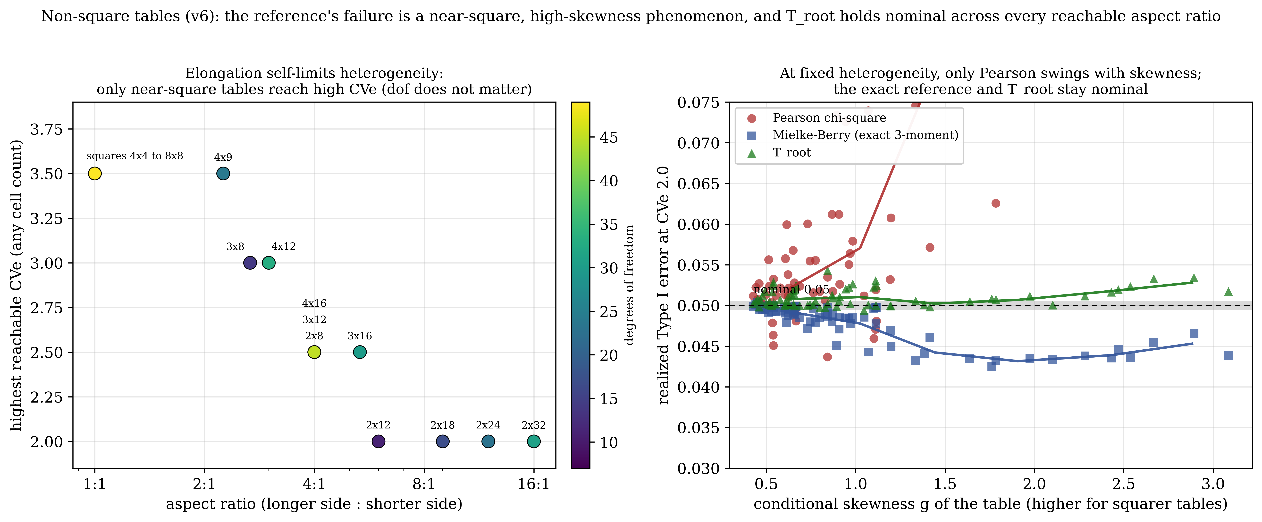
Figure S6. The non-square study. Left: the highest CVe a shape can reach at any cell count, against the aspect ratio, colored by degrees of freedom; the reachable ceiling collapses from 3.5 at a square table to 2.0 at sixteen to one, and the degrees of freedom (color) do not order it. Right: at CVe 2.0, realized Type I size against the conditional skewness g for Pearson's chi-square, the exact Mielke-Berry three-moment reference, and T_root; only Pearson swings with g, from 0.037 to above 0.07, while the exact reference and T_root stay at nominal. Generated by rerun/v6/make_v6_figure.py from troot_mb_cve_v6_analyzed.csv.
Table S9. The non-square decomposition at CVe 2.0. For each shape: the cell count RC, degrees of freedom, aspect ratio, conditional skewness g, and realized Type I size of Pearson's chi-square, the exact Mielke-Berry reference, and T_root, pooled over the reachable cell counts. Within each fixed cell count the size of Pearson tracks g, not the degrees of freedom. Values computed by the deposited script make_tableS9.py.
Shape | RC | dof | Aspect | g | Pearson | Mielke-Berry | T_root
2x8 | 16 | 7 | 4.00:1 | 1.090 | 0.0455 | 0.0498 | 0.0528
4x4 | 16 | 9 | 1.00:1 | 1.884 | 0.0688 | 0.0458 | 0.0509
2x12 | 24 | 11 | 6.00:1 | 0.839 | 0.0400 | 0.0499 | 0.0548
3x8 | 24 | 14 | 2.67:1 | 0.928 | 0.0568 | 0.0488 | 0.0516
5x5 | 25 | 16 | 1.00:1 | 1.429 | 0.0685 | 0.0464 | 0.0507
2x18 | 36 | 17 | 9.00:1 | 0.669 | 0.0378 | 0.0500 | 0.0539
3x12 | 36 | 22 | 4.00:1 | 0.656 | 0.0479 | 0.0498 | 0.0521
4x9 | 36 | 24 | 2.25:1 | 0.815 | 0.0648 | 0.0492 | 0.0506
6x6 | 36 | 25 | 1.00:1 | 1.165 | 0.0687 | 0.0468 | 0.0506
2x24 | 48 | 23 | 12.00:1 | 0.573 | 0.0371 | 0.0496 | 0.0521
3x16 | 48 | 30 | 5.33:1 | 0.538 | 0.0440 | 0.0494 | 0.0522
4x12 | 48 | 33 | 3.00:1 | 0.609 | 0.0554 | 0.0492 | 0.0508
7x7 | 49 | 36 | 1.00:1 | 0.986 | 0.0689 | 0.0472 | 0.0504
2x32 | 64 | 31 | 16.00:1 | 0.492 | 0.0377 | 0.0501 | 0.0547
4x16 | 64 | 45 | 4.00:1 | 0.481 | 0.0501 | 0.0497 | 0.0516
8x8 | 64 | 49 | 1.00:1 | 0.855 | 0.0691 | 0.0474 | 0.0501

S9. The resolved heterogeneity axis: null size and injectability by shape
Figure 6 of the main paper reports the size comparison pooled over shapes against target CVe. A dense sweep resolves it by shape: seven shapes at twenty-nine CVe levels from 0 to 3.5 and four counts, one million replications per cell, with exact Mielke-Berry moments. Three things separate at this resolution (Figure S7, at average count 50). Pearson's chi-square goes liberal first, from about CVe 1.5 to 2.0, reaching 0.11 to 0.13 at the larger shapes. The exact three-moment Mielke-Berry reference goes liberal later, and both its onset and its severity grow with table size: the liberal-onset CVe climbs from 2.38 at 3x3 to 2.62 at 4x4, 2.88 at 5x5, 3.00 at 6x6 and 3.12 at 8x8, and the peak null size rises from 0.10 at 3x3 to 0.165 at 4x4 and 0.163 at 5x5. T_root holds nominal across the whole axis for moderate and larger shapes, within 0.0496 to 0.0638 at 4x4 and tighter above. Its only departure is a small residual at the smallest shape and the lowest counts, up to 0.078 at 3x3 and 0.099 at average count 5, which is the tilt the expected-count screen already routes to the exact test and not a heterogeneity failure of the kind Mielke-Berry shows.
The dashed curve on each panel is the largest Cramer's V still injectable at that CVe, the geometric ceiling at fixed margins. The shaded band marks where Mielke-Berry is liberal and an effect of at least 0.10 can still be placed. That overlap is large at 3x3, shrinks through 4x4 and 6x6, and is absent by 8x8, where injectability has collapsed before Mielke-Berry turns liberal. The overlap is the region where the size-versus-power question is measurable rather than rhetorical, and it is taken up by the size-adjusted power analysis in the companion run.
Figure S7. The resolved heterogeneity axis by shape (average count 50, one million replications per cell, exact Mielke-Berry moments). For 3x3, 4x4, 6x6 and 8x8: realized null size against CVe for Mielke-Berry, T_root and Pearson, with two-standard-error bands, and the largest injectable Cramer's V on the right axis (dashed). Pearson fails from CVe about 1.5; Mielke-Berry fails later and worse as the table grows (onset marked); T_root holds nominal for moderate and larger shapes. The shaded band is the overlap where Mielke-Berry is liberal and an effect of at least 0.10 is still injectable. Generated by rerun/make_nullsize_dense_figure.py from troot_mb_nullsize_dense_analyzed.csv.

S10. Size-adjusted power in the Mielke-Berry-liberal overlap
Section S9 locates the overlap where the exact Mielke-Berry reference is liberal and a real effect can still be injected. Raw power there is not a fair comparison, because Mielke-Berry rejects more partly by rejecting too often under the null. A companion run removes that confound. On the overlap cells, at each shape's high-CVe window from 2.4 to 3.75, average counts 50 to 500 and injected Cramer's V of 0.10 and 0.15 reached by a multi-direction search, it scores size-adjusted power: each statistic is recalibrated to its own 0.05 null quantile before detection is measured, so every statistic is judged at a true five percent false-positive rate. The design is 160 cells at 500,000 replications per phase, of which 154 solved. In the 88 cells where Mielke-Berry is liberal, its realized null size has median 0.147 and reaches 0.283, while T_root holds nominal at median 0.052 and at most 0.076. The raw power gap in Mielke-Berry's favor is a median 0.345; size-adjustment removes about 0.10 of it, the part that is only its over-rejection, and leaves a median size-adjusted gap of 0.239. Pearson's chi-square, recalibrated to its own null, shows a similar residual edge of 0.271. By shape the size-adjusted deficit is 0.13 at 3x3, 0.36 at 4x4, 0.39 at 5x5, 0.26 at 6x6 and 0.15 at 8x8, largest in the middle shapes and smallest at the extremes (Figure S8).
This is a real cost of the Anscombe root, reported rather than hidden. The variance-stabilizing root equalizes the null variance across a heterogeneous table by compressing its large expected cells, which is exactly why its null size stays flat where the raw chi-square summand grows too skewed for even a three-moment fit. But under the alternative at fixed margins the effect signal lives disproportionately in those same large cells, so the compression that buys flat size costs sensitivity in the extreme-heterogeneity corner. The recommendation is therefore the one the reporting standard already makes, stated with its price: T_root is the honest default because its size is the size one is told, and it is nominal precisely where the exact three-moment reference is not, but in the extreme-heterogeneity, effect-injectable corner it carries a genuine detection cost of roughly a quarter in size-adjusted power against the chi-square reference. That corner is near-square and narrow, bounded below by the Mielke-Berry liberal onset and above by the collapse of injectability, and a practitioner reaches it only with a near-square table at high realized heterogeneity.
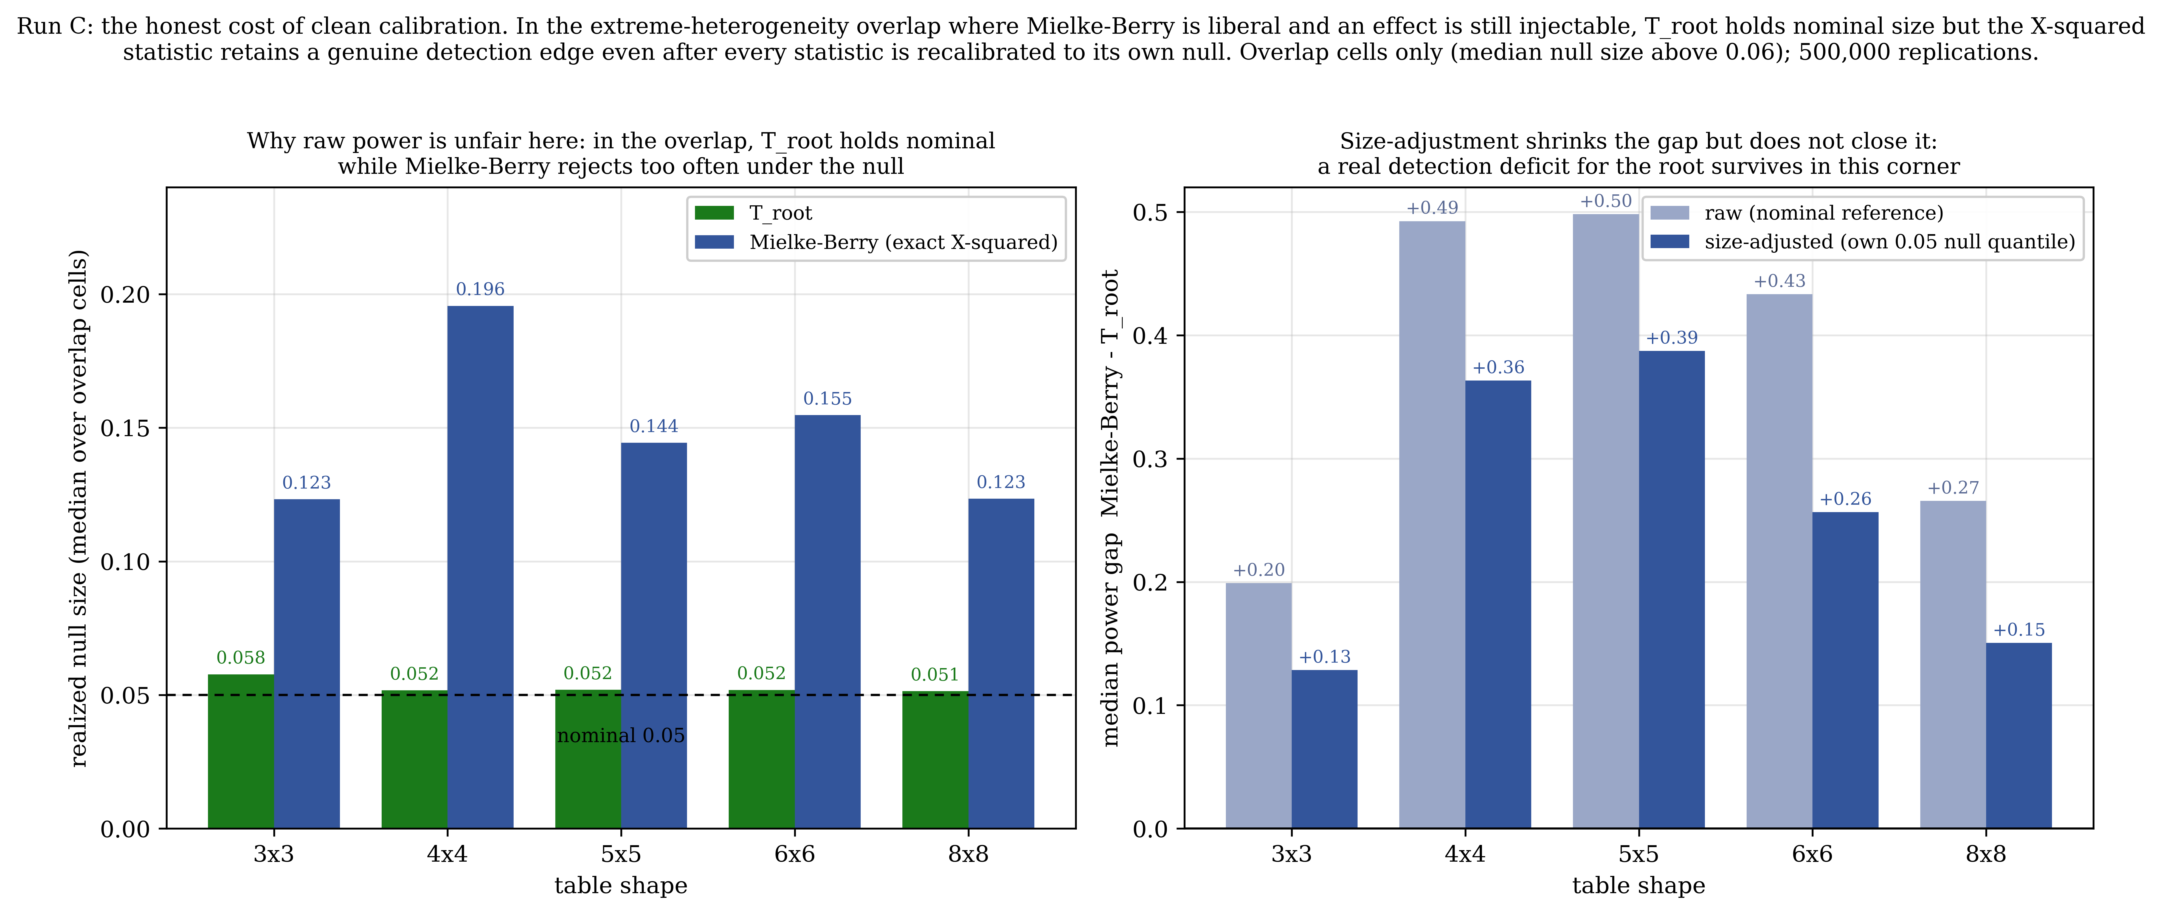
Figure S8. Size-adjusted power in the overlap, by shape (overlap cells only, median null size above 0.06; 500,000 replications per phase). Left: realized null size in the overlap, T_root against Mielke-Berry, showing why raw power is unfair there; T_root is nominal, Mielke-Berry liberal. Right: the median power gap Mielke-Berry minus T_root per shape, raw against size-adjusted; recalibrating each statistic to its own null shrinks the gap but leaves a real residual detection deficit for the root, largest at 4x4 and 5x5. Generated by rerun/make_runC_sizeadj_figure.py from runC_clean.csv (reconciled from troot_mb_power_sizeadj_analyzed.csv).

S11. Reproducibility
All numerical results in this Supplement are produced by deterministic, human-reviewed code with fixed seeds. Every reported number regenerates from the deposited scripts and locked outputs; no value in Tables S1 through S9 was computed by hand, transcribed from another source, or produced by a generative model.
Simulation code and locked outputs. The three-phase master grid (725,400 conditions, 99 replications per condition), the higher-replication extension (110 shapes to 100x100, six average counts, nineteen CVe levels, 4,000 replications per cell, 25,080 cells), and the focused null-only Renyi ladder (8,000 replications) are all deposited with their locked output files. The specific scripts underlying the results in this Supplement include run_hetero_solution.py (the exact margin-conditional permutation route of Section S5.2, full 32-core run, with locked outputs rerun/hetero_solution_results.csv and rerun/hetero_solution_full.csv), the analytic log/power-domain recalibration of Section S5.3 (locked output rerun/hetero_analytic_results.json), and hetero_newstat_validate.py (the T_root validation, locked output rerun/hetero_newstat_results.csv). Type I error and heterogeneity results are locked in rerun/typeI_rerun.csv and rerun/hetero_rerun.csv; the prevalence scan of 5,568 real tables from 441 public datasets is locked in rerun/prevalence_tables.csv. The non-square study of Section S8 (sixteen shapes from square to sixteen to one, eight average expected counts, six CVe levels, exact Mielke-Berry moments, one million replications per cell) is deposited as troot_mb_cve_v6_analyzed.csv with its two shards, the generator rerun/v6/make_v6_figure.py, and the two derived tables rerun/v6/v6_decomposition_cve2.csv and rerun/v6/v6_reachability_ceiling.csv. The dense null-size sweep of Section S9 is deposited as troot_mb_nullsize_dense_analyzed.csv with rerun/make_nullsize_dense_figure.py and rerun/injectability_curve.csv; the size-adjusted power run of Section S10 as troot_mb_power_sizeadj_analyzed.csv, reconciled to rerun/runC_clean.csv, with rerun/make_runC_sizeadj_figure.py.
Figures. Every figure in the parent paper and in this Supplement is rendered by the deposited Python script named in its legend, from the locked simulation output. No generative-AI image tools were used to create or alter any figure.
Provenance manifest. A dataset provenance manifest accompanies the deposit, recording the origin of every public dataset used in the prevalence scan and the seed, script, and output file for every simulated result. The reproducibility package (simulation code, locked results, provenance manifest, figures) is openly archived on Zenodo under the MIT License (concept DOI 10.5281/zenodo.21522471).
Derivations. The full derivations are given in the derivation companion, M0_Derivations.md. D13 derives the current construction: the Anscombe transform, centering at the exact margin-conditional cell mean, the first-cumulant identity E[S] = sum_ij Var(A(O_ij)) that conditioning delivers, and the hybrid second and third cumulants, in which the per-cell terms are taken exactly from the conditional moments and the cell-to-cell covariance terms from the quadratic-form trace identity. Those off-diagonal terms carry 36 to 70 percent of the variance of S and 53 to 87 percent of its third cumulant, and omitting them under-predicts both, which thins the upper tail and makes the test liberal. D13 also states what is not exact: the per-cell conditional moments are read from a two-parameter table whose error is 7.8 percent at two expected counts per cell and under 1 percent above six, which is where the expected-count screen comes from. D9 derives an earlier reference for the same statistic, built on Poisson moments reduced by a margin-fitting leverage projection h_ij = E_ij (1/r_i + 1/c_j - 1/N) and secured by a closed-form finite-cell correction. It is retained and marked superseded. Conditioning on the margins is the constraint the projection approximated, so the projection is not improved but removed, and the finite-cell correction, which existed only to repair the projection's double-counting, goes with it. In hindsight that correction was an empirical widening standing in for the missing off-diagonal cumulant terms, which is why it had to be fitted and why it never fully worked.
Use of AI. Generative-AI tools were used only as a writing and coding aid. They were not used to generate, alter, or manipulate any data, result, or figure. The author verified every result and takes full responsibility for the accuracy, integrity, and originality of the work.
References
Agresti, A. (2002). Categorical Data Analysis, 2nd ed. Wiley.
Anscombe, F. J. (1948). The transformation of Poisson, binomial and negative-binomial data. Biometrika, 35, 246-254.
Baggerly, K. A. (1998). Empirical likelihood as a goodness-of-fit measure. Biometrika, 85(3), 535-547.
Barnard, G. A. (1945). A new test for 2x2 tables. Nature, 156, 177.
Beh, E. J., & Lombardo, R. (2014). Correspondence Analysis: Theory, Practice and New Strategies. Wiley.
Boschloo, R. D. (1970). Raised conditional level of significance for the 2x2 table. Statistica Neerlandica, 24, 1-35.
Campbell, I. (2007). Chi-squared and Fisher-Irwin tests of two-by-two tables with small sample recommendations. Statistics in Medicine, 26(19), 3661-3675.
Cressie, N., & Read, T. R. C. (1984). Multinomial goodness-of-fit tests. Journal of the Royal Statistical Society, Series B, 46(3), 440-464.
Fisher, R. A. (1922). On the interpretation of chi-squared from contingency tables, and the calculation of P. Journal of the Royal Statistical Society, 85(1), 87-94.
Freeman, G. H., & Halton, J. H. (1951). Note on an exact treatment of contingency, goodness of fit and other problems of significance. Biometrika, 38, 141-149.
Freeman, M. F., & Tukey, J. W. (1950). Transformations related to the angular and the square root. Annals of Mathematical Statistics, 21, 607-611.
Koehler, K. J., & Larntz, K. (1980). An empirical investigation of goodness-of-fit statistics for sparse multinomials. Journal of the American Statistical Association, 75, 336-344.
Larntz, K. (1978). Small-sample comparisons of exact levels for chi-squared goodness-of-fit statistics. Journal of the American Statistical Association, 73(362), 253-263.
Patnaik, P. B. (1949). The non-central chi-square and F-distributions and their applications. Biometrika, 36, 202-232.
Pearson, K. (1900). On the criterion that a given system of deviations from the probable in the case of a correlated system of variables is such that it can be reasonably supposed to have arisen from random sampling. Philosophical Magazine, 50(302), 157-175.
Read, T. R. C., & Cressie, N. (1988). Goodness-of-Fit Statistics for Discrete Multivariate Data. Springer.
Renyi, A. (1961). On measures of entropy and information. Proceedings of the Fourth Berkeley Symposium on Mathematical Statistics and Probability, 1, 547-561.
Satterthwaite, F. E. (1946). An approximate distribution of estimates of variance components. Biometrics Bulletin, 2, 110-114.
Williams, D. A. (1976). Improved likelihood ratio tests for complete contingency tables. Biometrika, 63(1), 33-37.
Wilson, E. B., & Hilferty, M. M. (1931). The distribution of chi-square. Proceedings of the National Academy of Sciences, 17, 684-688.
Zelterman, D. (1987). Goodness-of-fit tests for large sparse multinomial distributions. Journal of the American Statistical Association, 82(398), 624-629.

