Supplementary information
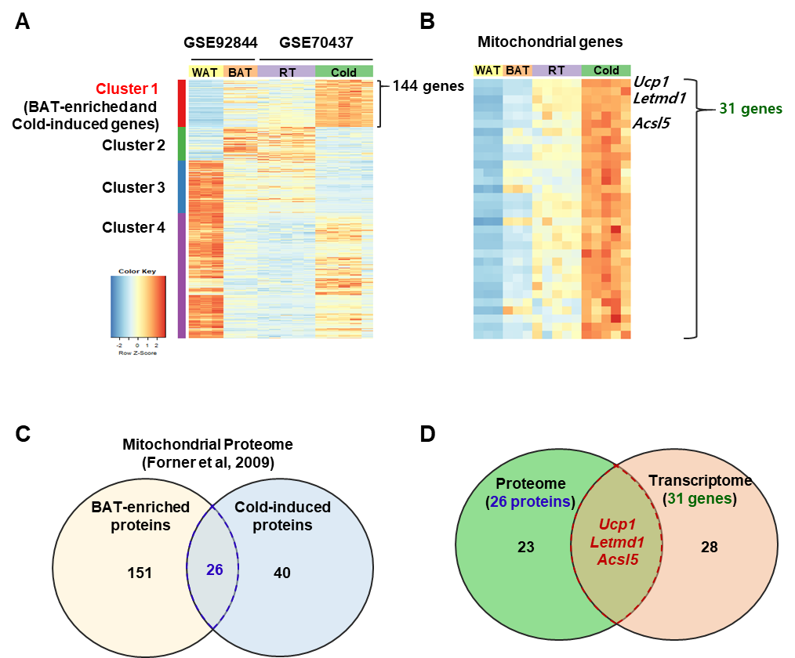
Park et al., Mitochondrial matrix protein Letmd1 maintains thermogenic capacity of brown adipose tissue
Figure S1. Identification of cold-inducible mitochondrial proteins in brown adipose tissue by transcriptome and proteome analysis
(A) Cluster analysis of differentially expressed genes in BAT (GSE92844, (Mo et al., 2017) and cold exposed conditions (GSE70437, (Marcher et al., 2015)). (B) Heat map of 31 mitochondrial genes in cluster 1. (C) Venn diagram showing the number of mitochondrial proteins highly expressed in BAT and cold exposed BAT in proteomics studies (Forner et al., 2009). (D) Venn diagram showing selected genes from proteome analysis and transcriptome analysis

