Supplementary Information for
Improvements of CMIP6 over CMIP5 for Simulating Indian Summer Monsoon Rainfall and Indian Ocean Teleconnections
Anmol Yadav¹ G. P. Singh*¹ Pradeep Kumar Rai²
¹Department of Geophysics, Institute of Science, Banaras Hindu University, Varanasi 221005, India.
²Indian Institute of Tropical Meteorology (Ministry of Earth Sciences), Pune-411 008, Maharashtra, India
Corresponding Author: Email*: gps67@bhu.ac.in

Contents of this file
Figure S1 to S10
Tables S1 to S2
Supplementary text information

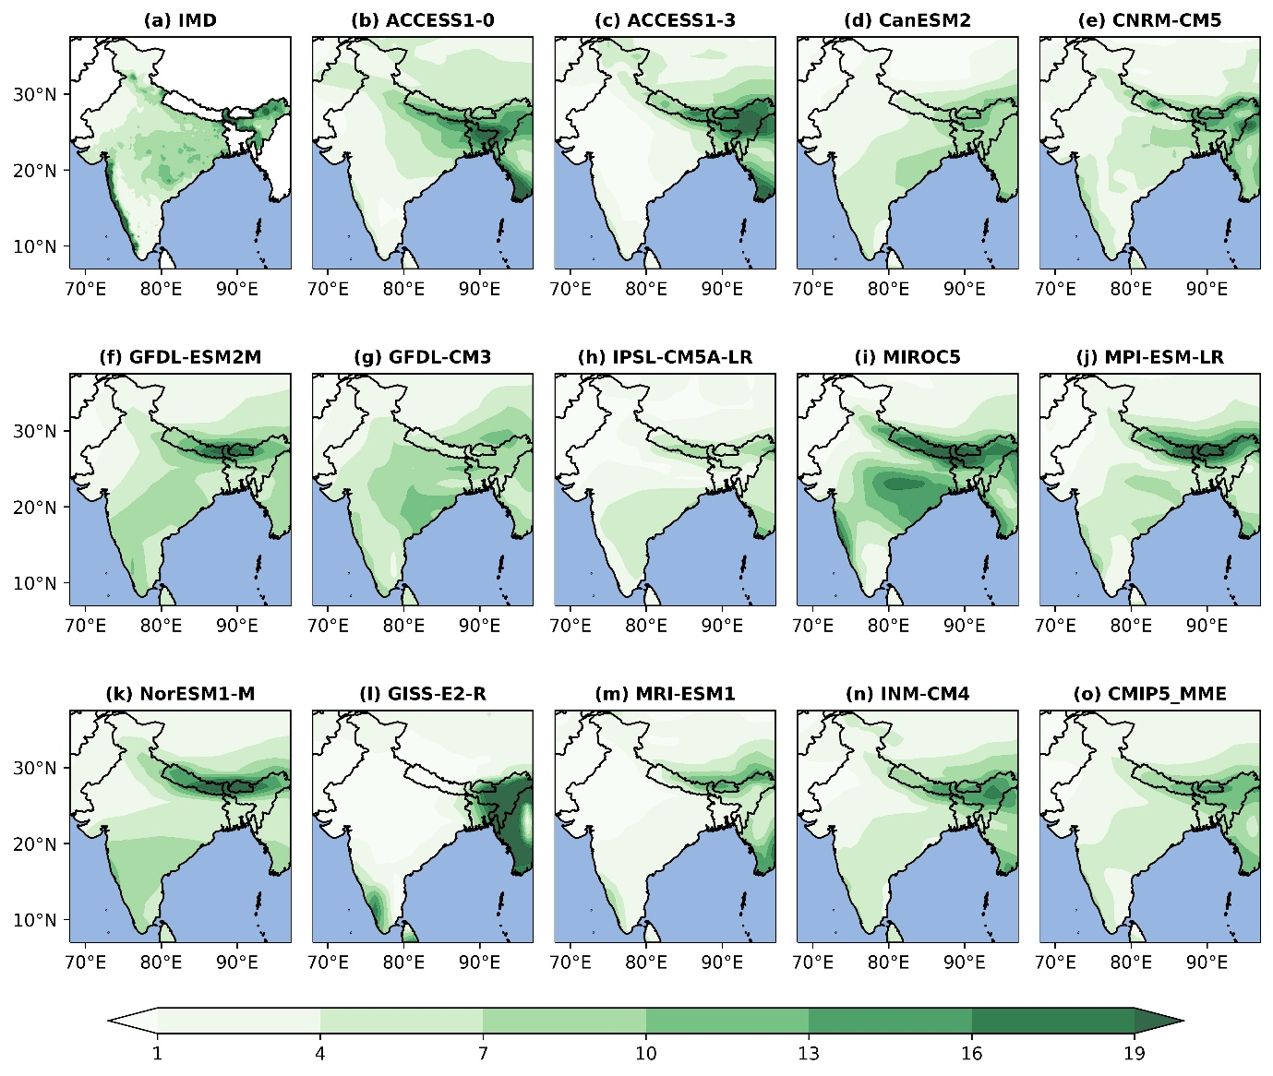
Fig. S1 Mean monthly precipitation (mm/day) for the period 1975 to 2005 from observations, individual CMIP5 models, and the CMIP5 multi-model ensemble mean (MME).

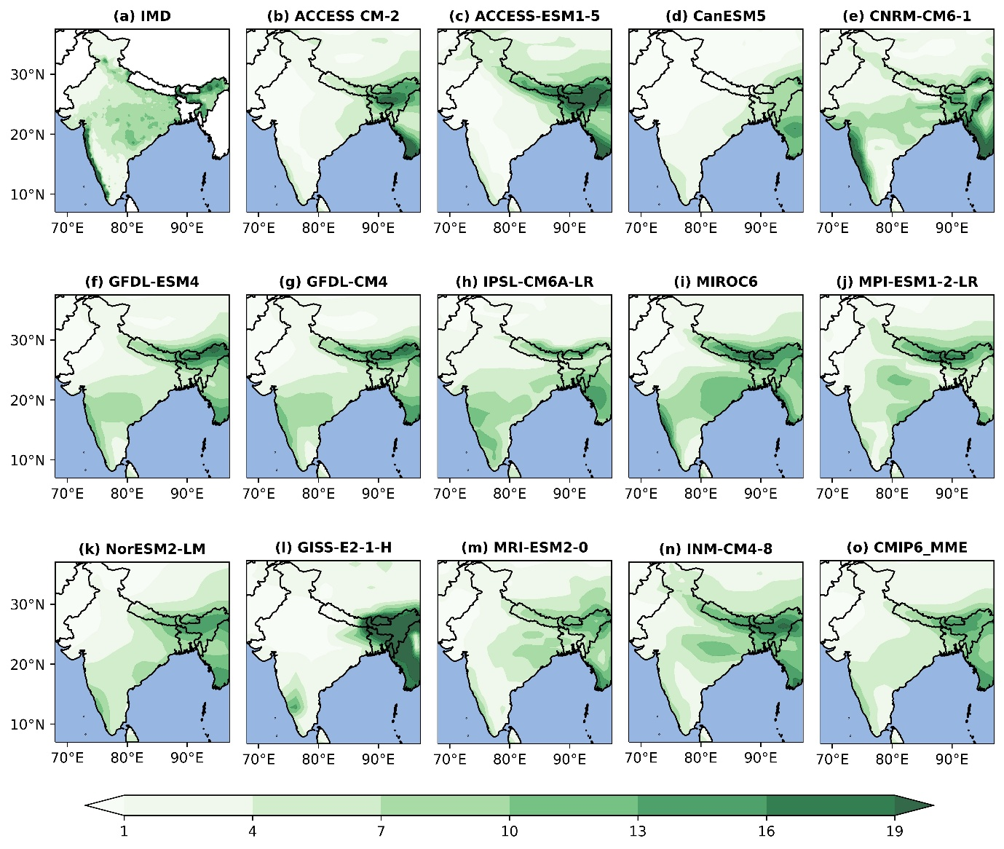
Fig. S2 Mean monthly precipitation (mm/day) for the period 1975 to 2005 from observations, individual CMIP6 models, and the CMIP6 multi-model ensemble mean (MME).

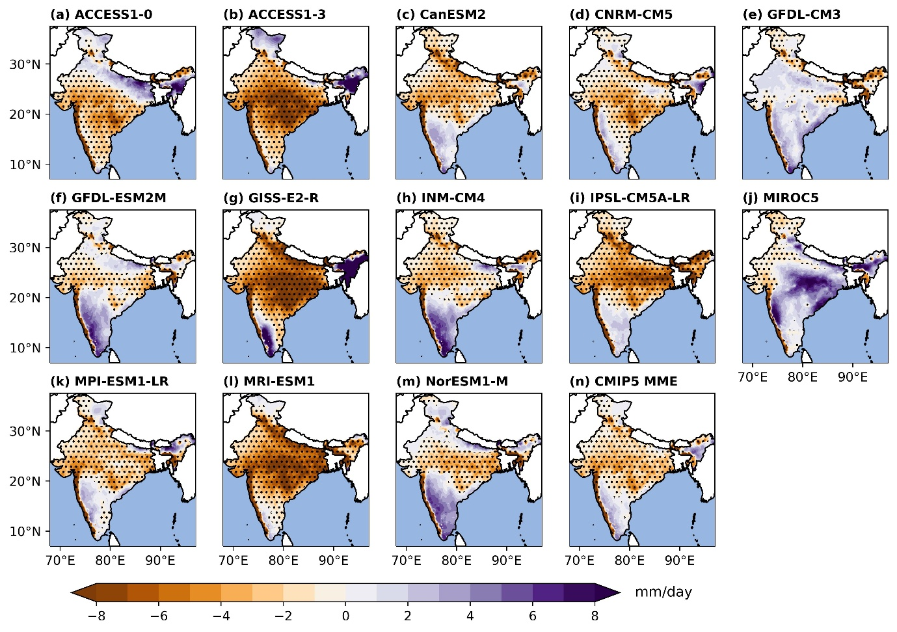
Fig. S3 Monthly mean precipitation bias (mm/day) patterns over India, showing the relative bias between each individual GCM (including the CMIP5 MME) and observations from the IMD dataset. Dot indicate statistically significant correlations at the 95% confidence level.

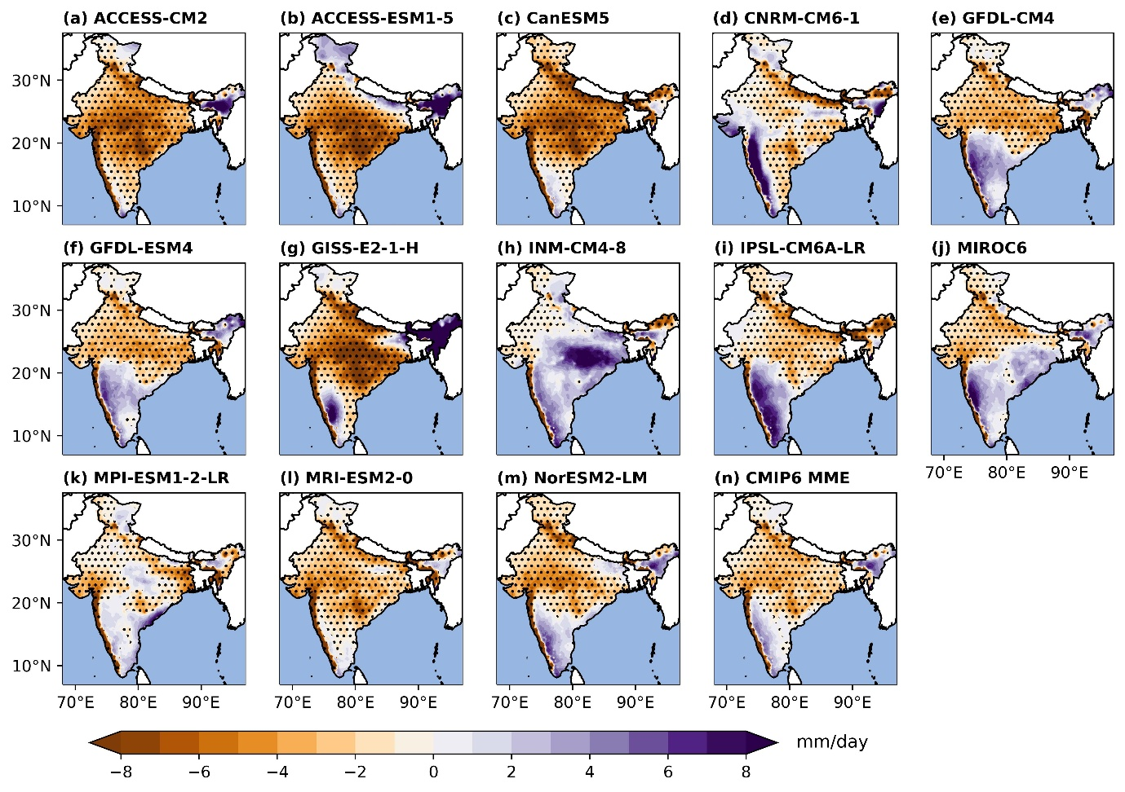
Fig. S4 Monthly mean precipitation bias (mm/day) patterns over India, showing the relative bias between each individual GCM (including the CMIP6 MME) and observations from the IMD dataset. Dot indicate statistically significant correlations at the 95% confidence level.

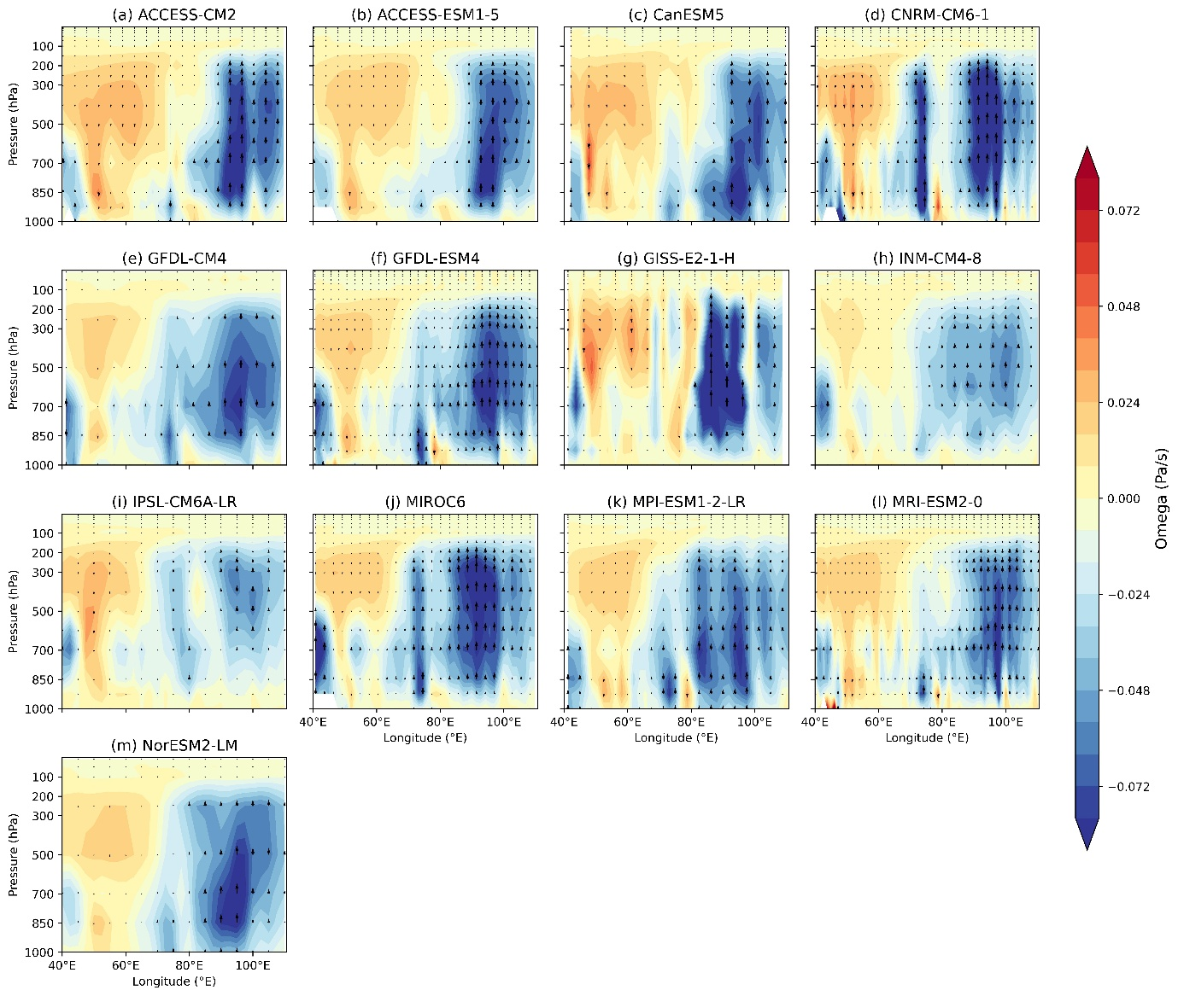
Fig. S5 Vertical Velocity(ω) averaged over 5°–30°N across the India, showing x axis Longitude and y axis is Pressure from 1000 hPa to 10hPa for different CMIP6 models from (a to m).

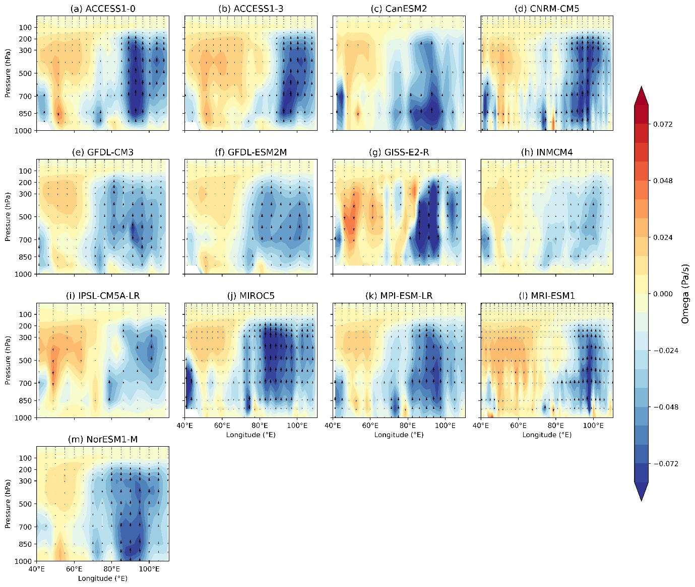
Fig. S6 Vertical Velocity(ω) averaged over 5°–30°N across the India, showing x axis Longitude and y axis is Pressure from 1000 hPa to 10hPa for different CMIP5 models from (a to m).

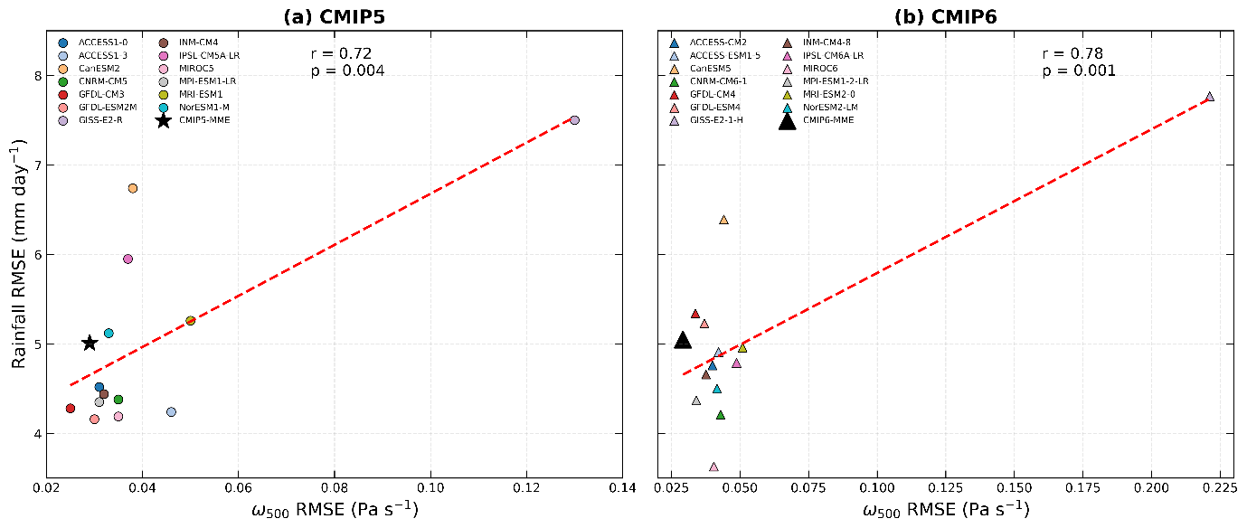
Fig. S7 Relationship between rainfall RMSE and vertical velocity (ω₅₀₀) RMSE across individual (a) CMIP5 and (b) CMIP6 models during the JJAS season over India.
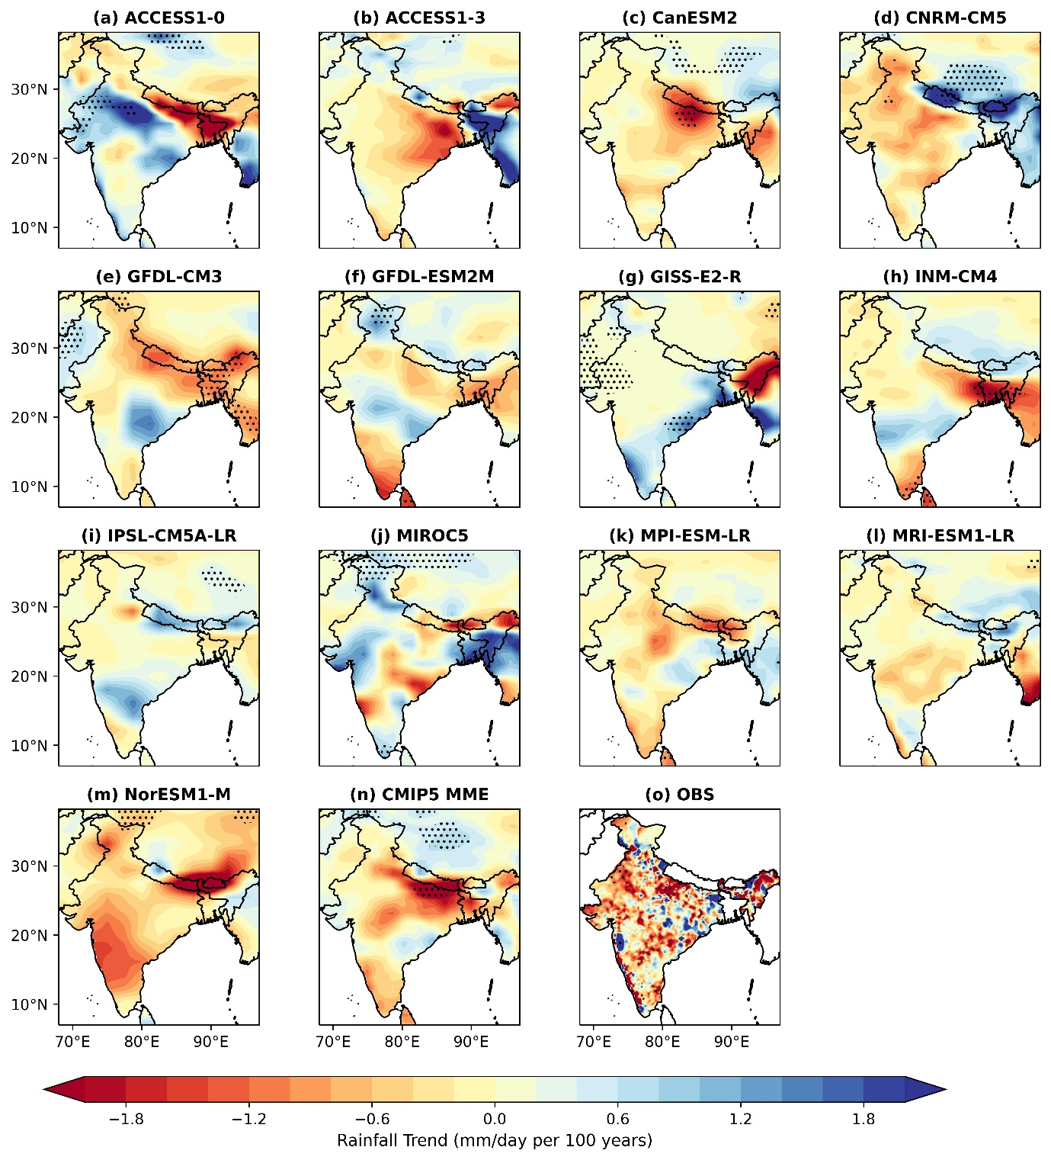

Fig. S8 Spatial linear trends of annual rainfall (mm/year/100 year) over India during 1975 to 2005 for individual CMIP5 models, the CMIP5 multi-model ensemble, and the observational dataset (IMD). Trends are calculated using linear regression, and black dot indicate statistically significant trends at the 95% confidence level.
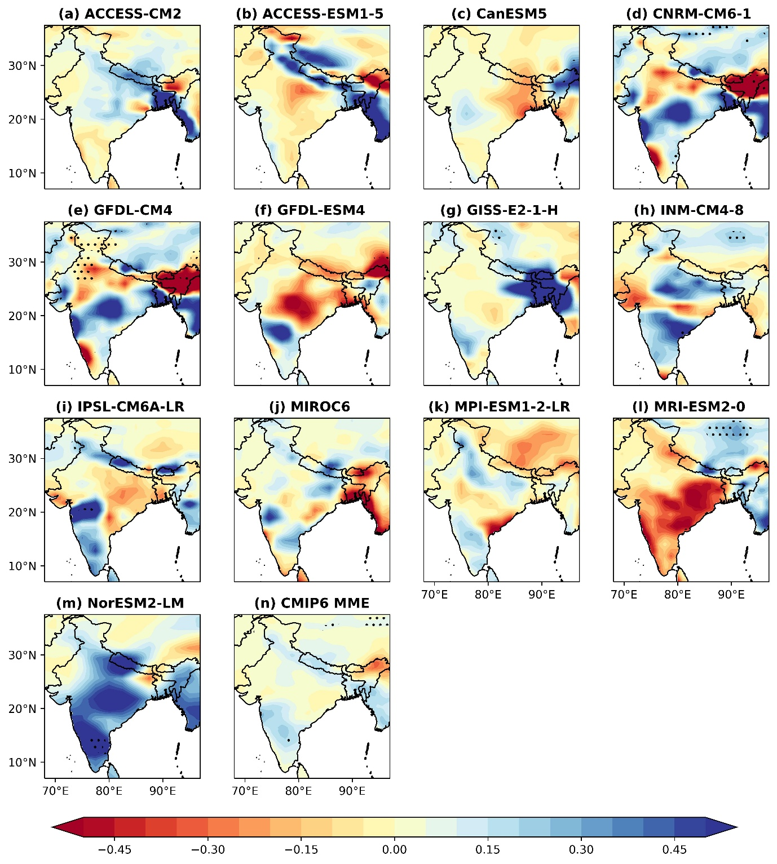
Fig. S9 Spatial linear trends of annual rainfall (mm/year/100 years) over India during 1975 to 2005 for individual CMIP6 models, the CMIP6 multi-model ensemble mean, and the observational dataset (IMD). Trends are calculated using linear regression, and black dot indicate statistically significant trends at the 95% confidence level.

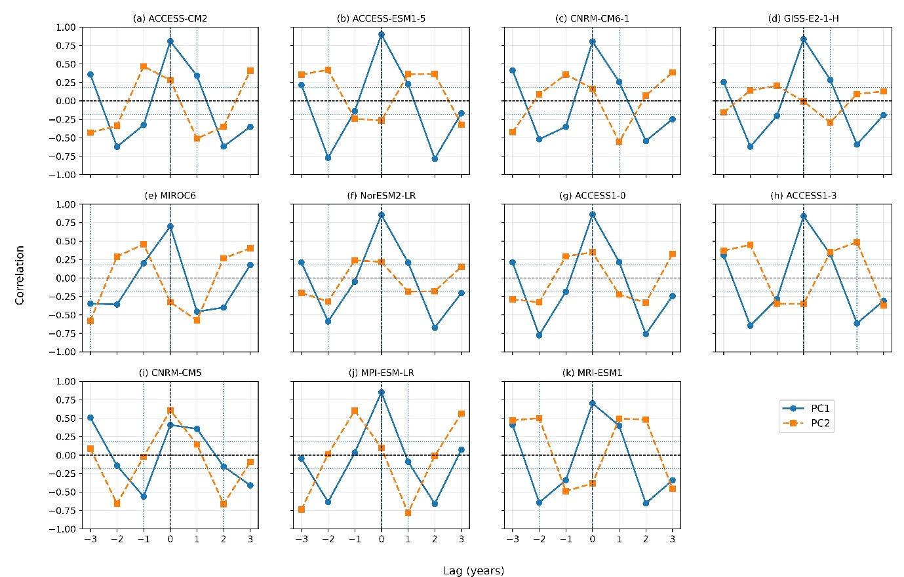
Fig. S10 Lead and Lag correlation between Principal Components(PCs) and Zonal Wind (850hPa) for different CMIP6 and CMIP5 Models form (a to k).

Tables

Table S1 List of 13 CMIP6 models used in this study, including their modelling centres, atmospheric resolution, and availability of historical simulations for the period 1975 to 2005.

Models | Institute / Modelling Centre | Resolution
ACCESS-CM2  ACCESS-ESM1-5  CanESM5  CNRM-CM6-1  GFDL-CM4  GFDL-ESM4  GISS-E2-1-H  INM-CM4-8  IPSL-CM6A-LR  MIROC6  MPI-ESM-1-2-LR  MRI-ESM2-0  NorESM2-LM | CSIRO (Commonwealth Scientific and Industrial Research Organisation) and ARCCSS (Australian Research Council Centre of Excellence for Climate System Science), Australia  CSIRO and ARCCSS, Australia  CCCma (Canadian Centre for Climate Modelling and Analysis), Canada  CNRM (Centre National de Recherches Météorologiques) – CERFACS, France  NOAA-GFDL (Geophysical Fluid Dynamics Laboratory), USA  NOAA-GFDL (Geophysical Fluid Dynamics Laboratory), USA  NASA-GISS (Goddard Institute for Space Studies), USA  INM (Institute for Numerical Mathematics), Russia  IPSL (Institute Pierre-Simon Laplace), France  MIROC Consortium: JAMSTEC (Japan Agency for Marine-Earth Science and Technology), AORI (Atmosphere and Ocean Research Institute, The University of Tokyo), and NIES (National Institute for Environmental Studies), Japan  MPI-M (Max Planck Institute for Meteorology), Germany  MRI (Meteorological Research Institute), Japan  NCC (Norwegian Climate Centre), Norway | 192 x 144 (1.85x1.25)  192 x 145 (1.85 x 1.25)  128 x 64 (2.8 x 2.8)  256 x 128 (1.4 x 1.4)  288 x 180 (1.25x 1.0)  288 x 180 (1.25x 1.0)  144 × 90 (2.5x 2.0)  180 x 120 (2 x 1.5)  144 × 143 (2.5 x 1.3)  256 × 128 (1.4x1.4)  192 × 96 (1.86 x 1.86)  320×160 (1.125 x 1.12)  144 x 96 (2.5 x 1.89)

Table S2 List of 13 CMIP5 models used in this study, including their modelling centres, atmospheric resolution, and availability of historical simulations for the period 1975 to 2005.

Models | Institute | Resolution
ACCESS1-0  ACCESS1-3  CanESM2  CNRM-CM5  GFDL-CM3  GFDL-ESM4  GISS-E2-R  INMCM4  IPSL-CM5A-LR  MIROC5  MPI-ESM-LR  MRI-ESM1  NoRESM1-M | CSIRO-BOM (Commonwealth Scientific and Industrial Research Organisation and Bureau of Meteorology), Australia  CSIRO-BOM, Australia  CCCma (Canadian Centre for Climate Modelling and Analysis), Canada  CNRM-CERFACS (Centre National de Recherches Météorologiques and CERFACS), France  NOAA-GFDL (Geophysical Fluid Dynamics Laboratory), USA  NOAA-GFDL (Geophysical Fluid Dynamics Laboratory), USA  NASA-GISS, USA  NASA-GISS (Goddard Institute for Space Studies), USA  INM (Institute for Numerical Mathematics), Russia  IPSL (Institute Pierre-Simon Laplace), France  MIROC Consortium (JAMSTEC, AORI, NIES), Japan  MPI-M (Max Planck Institute for Meteorology), Germany  MRI (Meteorological Research Institute), Japan  NCC (Norwegian Climate Centre), Norway | 192 x 145 (1.88 x 1.25)  192 ×145 (1.88 x 1.25)  128 × 64 (2.8 x 2.8)  256 x 128 (1.4 x 1.4)  144 × 90 (2.5 x 2.0)  144 x 90 (2.5x 2.0)  144 × 90 (2.5 x 2.0)  180 × 120 (2.0 x 1.5)  96 × 96 (3.75 x 1.89)  256 × 128 (1.4 x 1.4)  192 ×96 (1.8 x 1.8)  320 x 160(1.13 x 1.12)  144 x 96 (2.5 x 1.9)

