Supplementary Information
HistoSeek links histology image recognition to teacher-authored formative guidance

Contents: 5 supplementary figures and 8 supplementary tables

Supplementary Figure 1 | Model-ready ROI split by organ
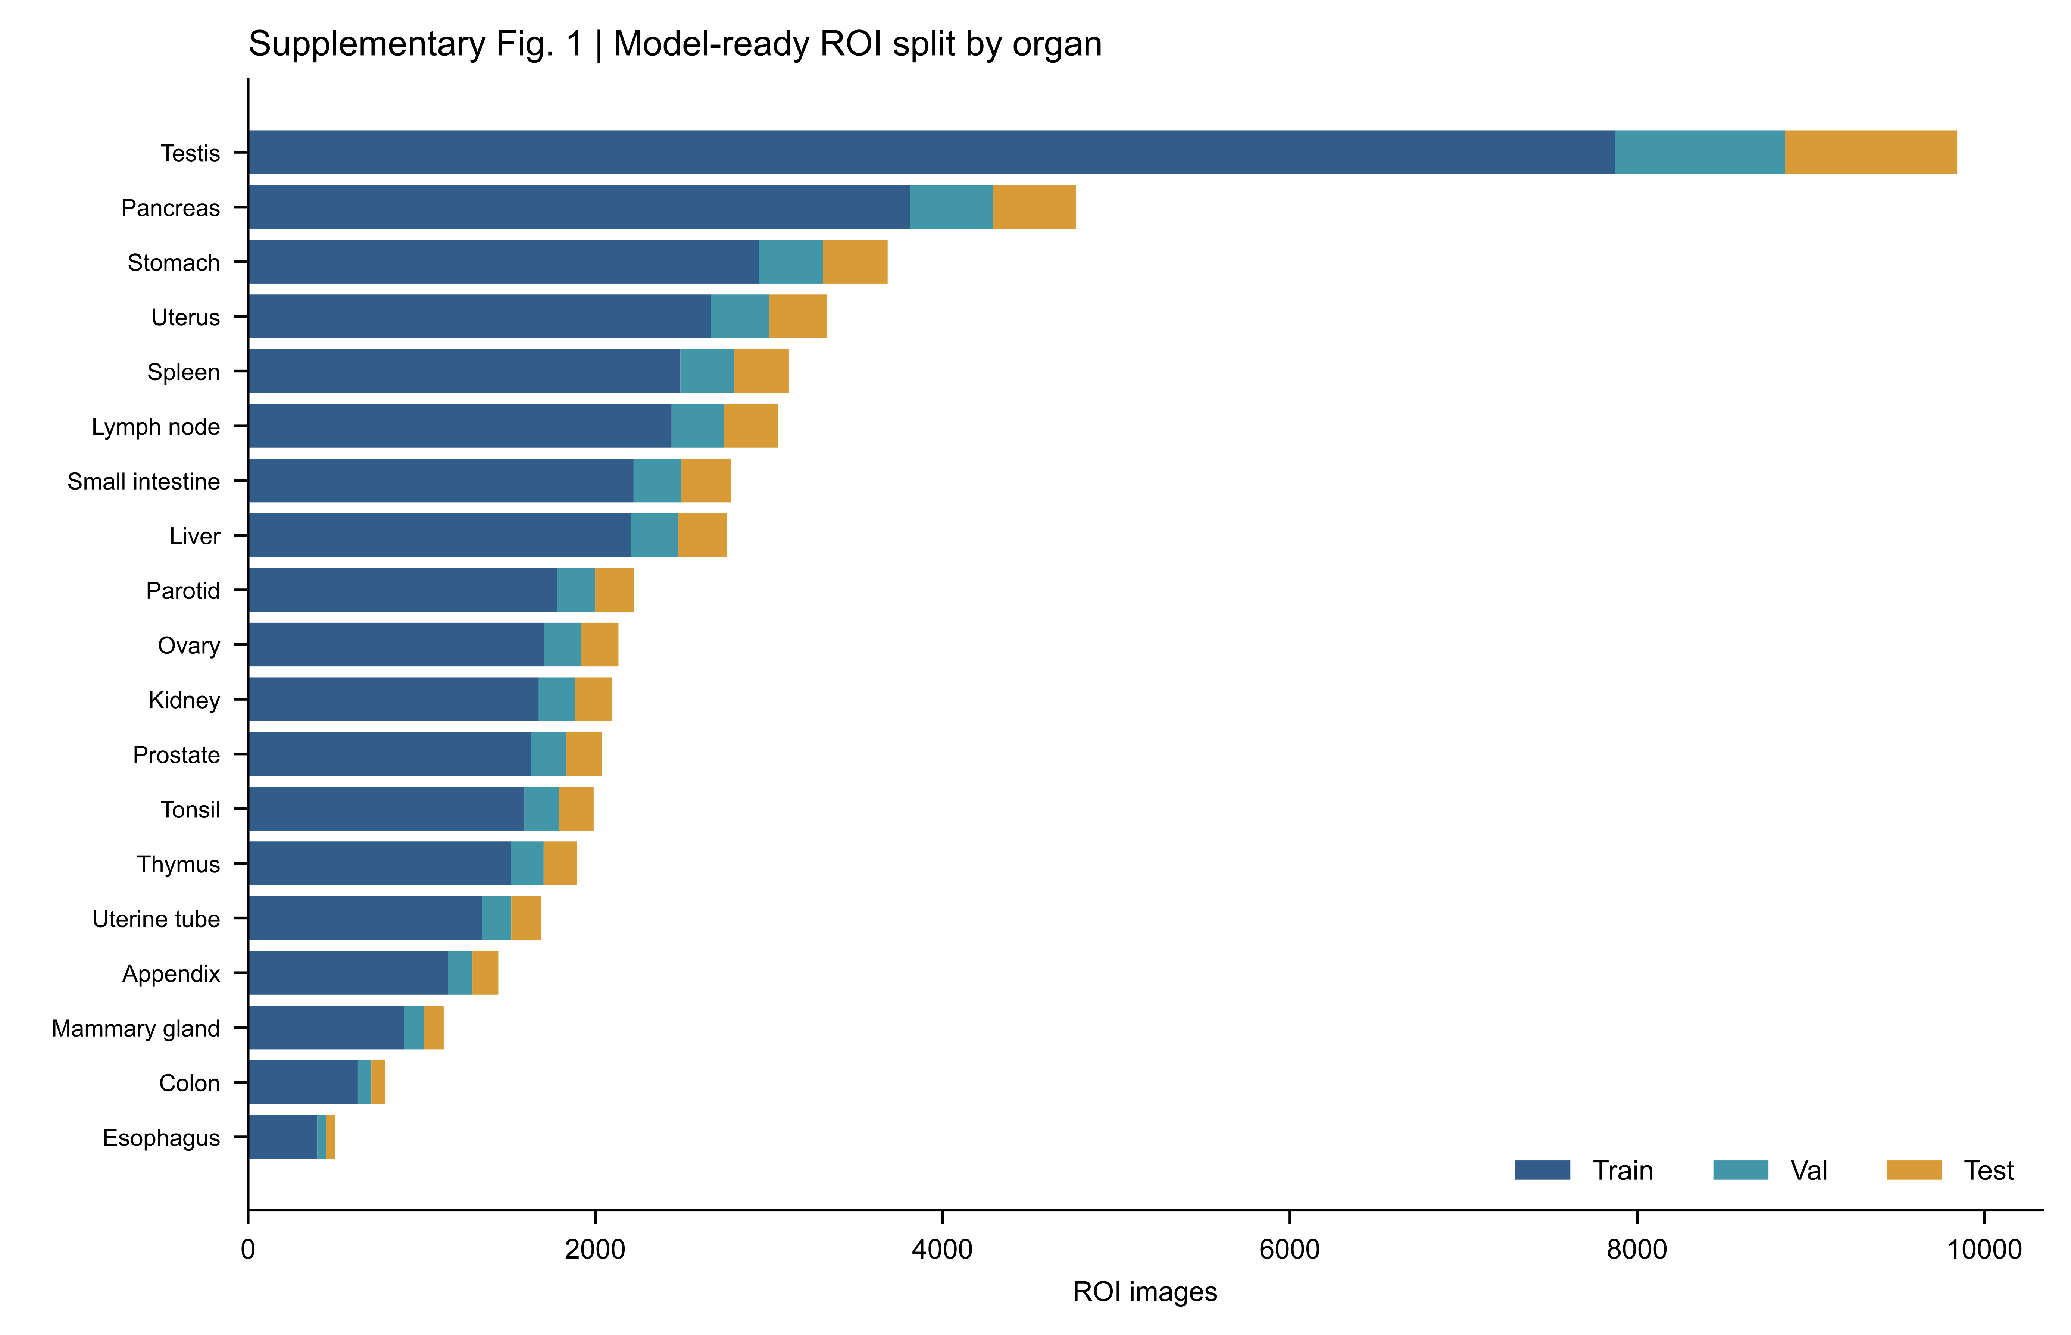
Supplementary Figure 1 | Model-ready ROI split by organ. Numbers of ROI images assigned to the training, validation and internal test partitions for each of the 19 organ-specific tasks. Splitting was performed at ROI-file level without grouping by source slide or specimen; the figure therefore documents the retained development partition rather than source-slide-independent validation.

Supplementary Figure 2 | Representative retained training histories and internal confusion matrices
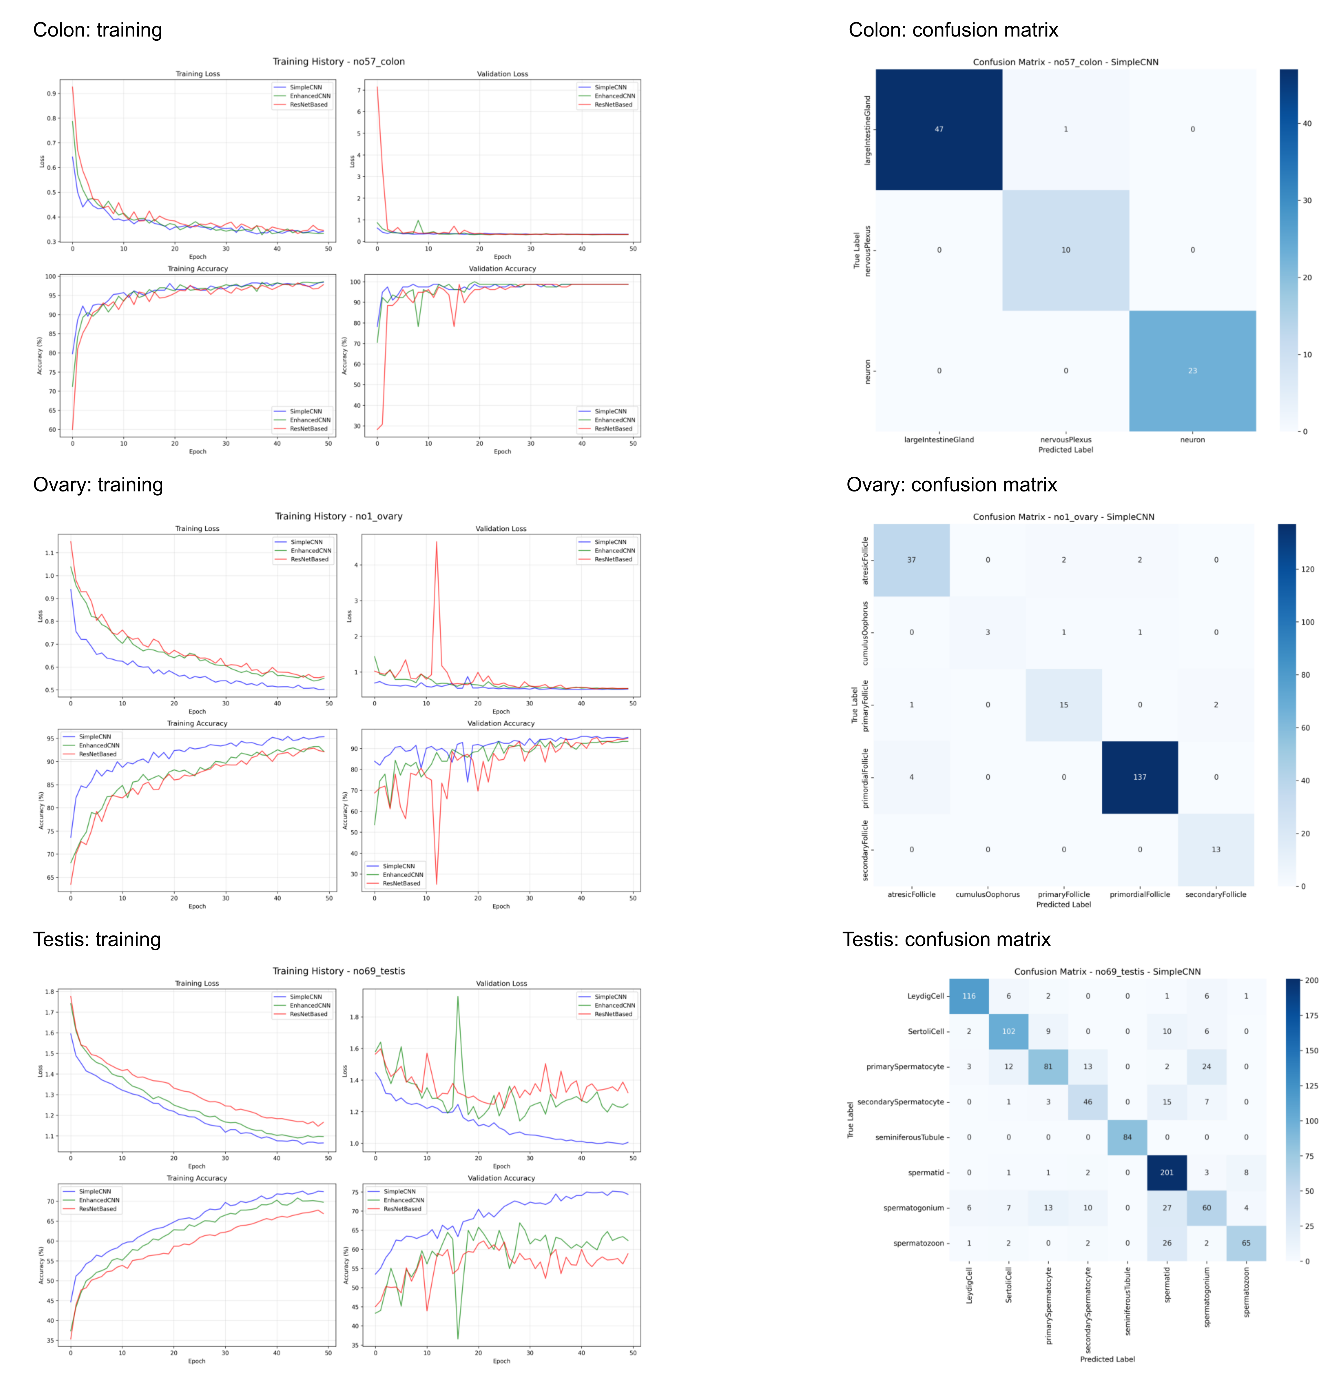
Supplementary Figure 2 | Representative retained training histories and internal confusion matrices. Training loss, validation loss, training accuracy and validation accuracy across 50 retained epoch positions are shown for the three CNN architectures in the colon, ovary and testis tasks. The corresponding SimpleCNN confusion matrices use the internal ROI-level test partitions. The examples illustrate task heterogeneity and do not provide source-slide-independent or external validation.

Supplementary Figure 3 | Questionnaire item-level agreement-or-neutral responses
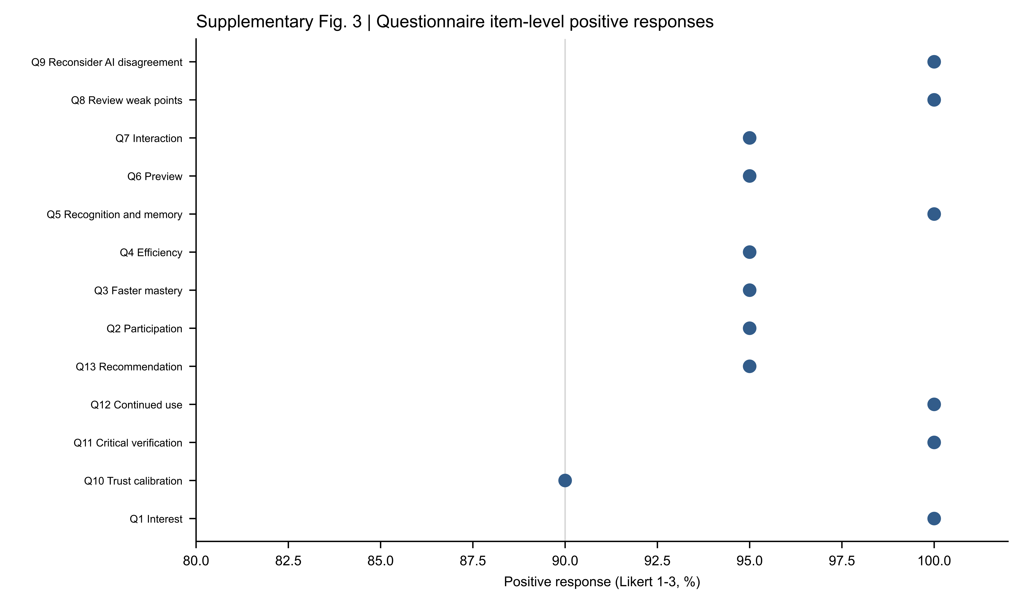
Supplementary Figure 3 | Questionnaire item-level agreement-or-neutral responses. Percentage of the 20 HistoSeek-class students selecting agreement or neutral (scores 1–3) for each post-use questionnaire item. On the five-point response scale, 1 represented strongest agreement and 5 strongest disagreement. The item labels are abbreviated; complete English wording and response distributions are provided in Supplementary Tables 5 and 6.

Supplementary Figure 4 | Student-facing HistoSeek web interface
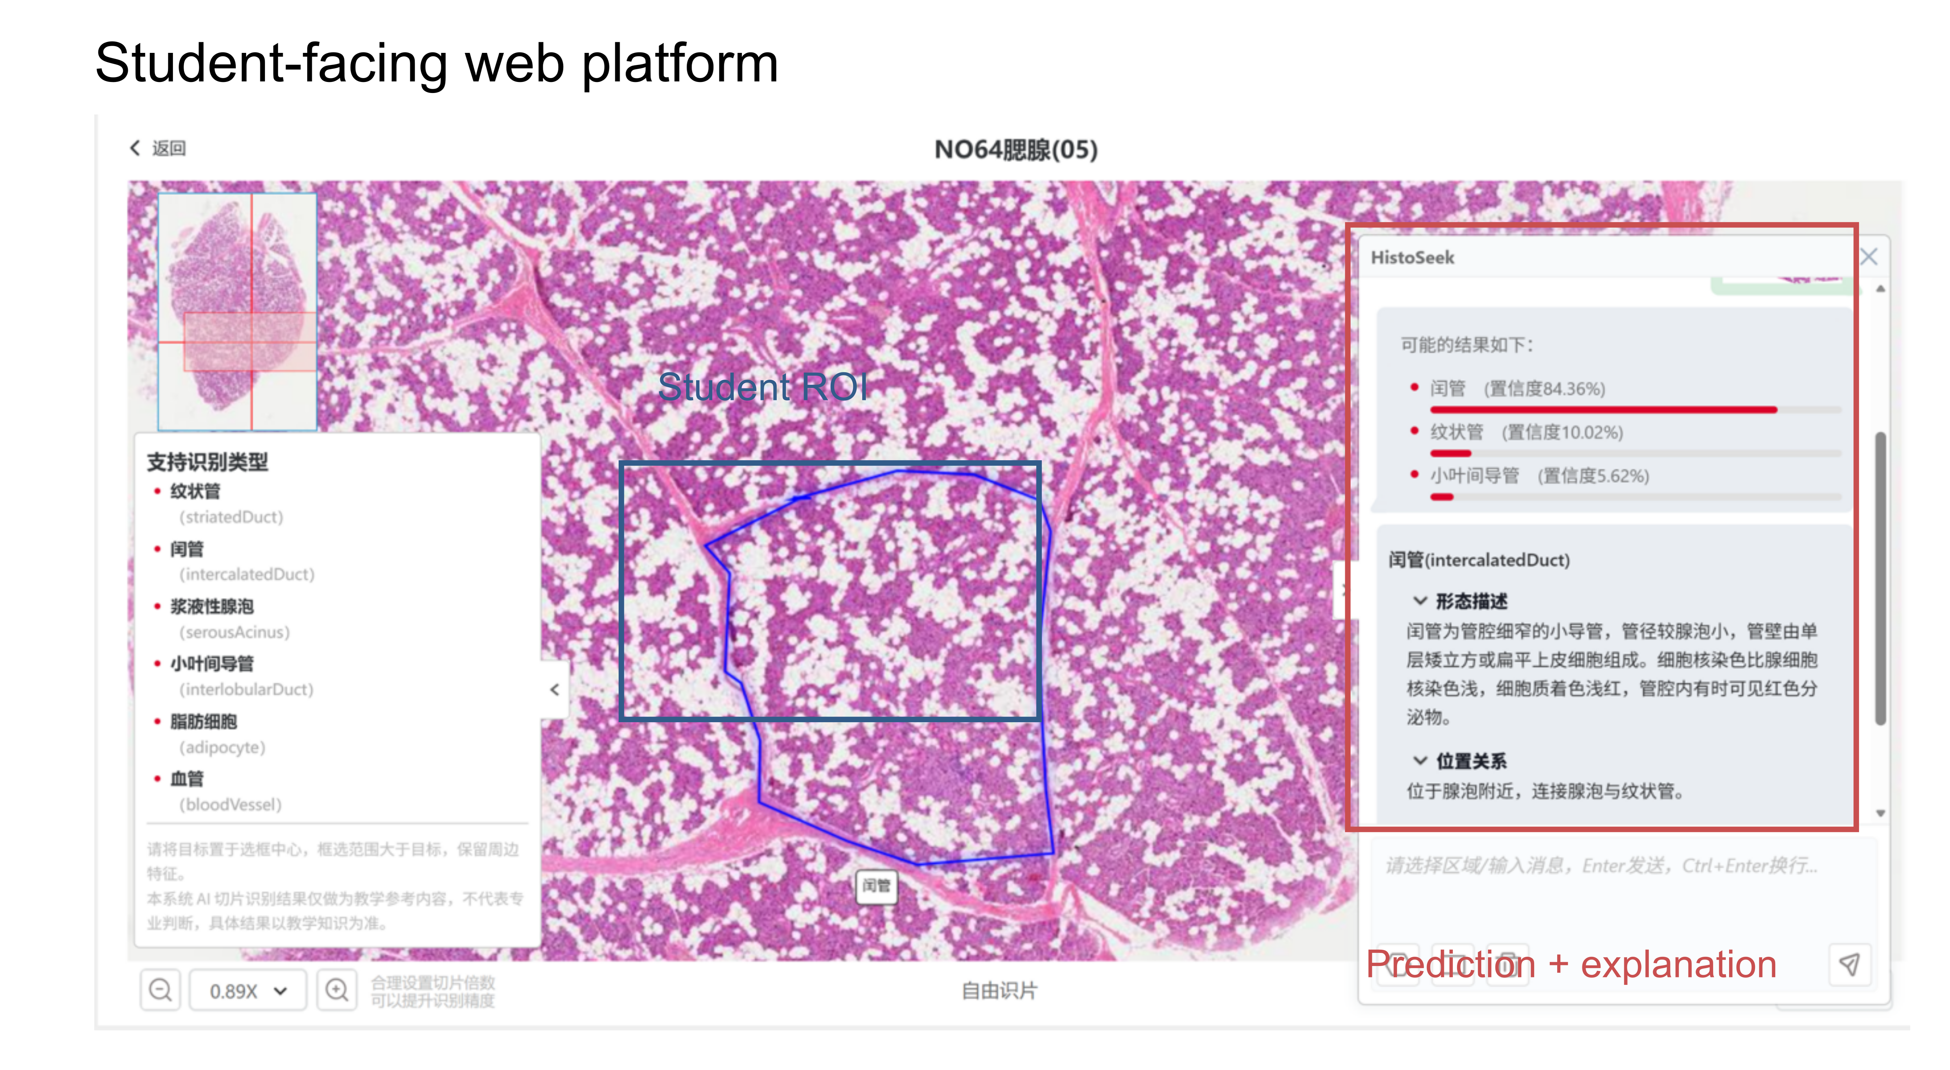
Supplementary Figure 4 | Student-facing HistoSeek web interface. Annotated screenshot of the deployed student-facing page. The learner-drawn ROI is visible on the digital slide. The interface lists supported structures for the selected organ, returns ranked candidate labels and uncalibrated model scores, and displays teacher-authored morphology and anatomical-location content linked to the highest-ranked label. The screenshot documents implementation and does not evaluate learning effects or model calibration.

Supplementary Figure 5 | Example questionnaire format in English
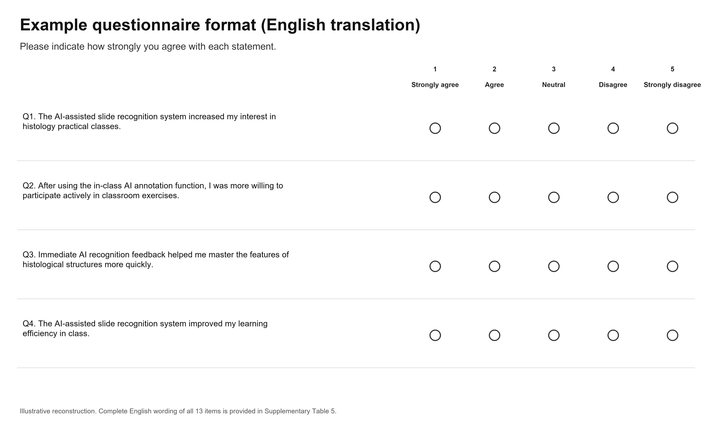
Supplementary Figure 5 | Example questionnaire format in English. English-language reconstruction of the response layout used for the study-specific post-use questionnaire. Four example items are shown with the five ordered response options. This is a reconstruction for reporting and not an original platform screenshot. Complete wording of all 13 translated items is provided in Supplementary Table 5.

Supplementary Table 1 | Seven-university HistoSeek co-development collaboration
At the time of manuscript preparation, seven Chinese universities had joined the collaborative co-development of HistoSeek. Peking University was the site of the current single-centre pilot; the other six institutions did not contribute participants, examination outcomes or questionnaire data to the present analysis.
Institution | Current collaboration status | Included in current analysis
Peking University | Project lead and current pilot site | Yes — current single-centre pilot
Sun Yat-sen University | Joined project co-development | No
Central South University | Joined project co-development | No
Hebei Medical University | Joined project co-development | No
Shantou University | Joined project co-development | No
Hainan Medical University | Joined project co-development | No
Ningxia Medical University | Joined project co-development | No
Note: The collaboration is intended to support harmonised prospective multicentre implementation and educational evaluation in subsequent semesters. Participation in future studies will be contingent on local institutional review and common study protocols.

Supplementary Table 2 | Model-ready dataset and internal test accuracy across 19 organ-specific tasks
Task-level counts and the retained internal test accuracies for the three CNN architectures are reported below.
Organ task | Classes | Train | Validation | Test | Total | SimpleCNN (%) | EnhancedCNN (%) | ResNetBased (%)
Ovary | 5 | 1,704 | 211 | 218 | 2,133 | 93.58 | 91.74 | 93.12
Lymph node | 7 | 2,439 | 303 | 309 | 3,051 | 87.70 | 81.23 | 82.85
Appendix | 5 | 1,151 | 141 | 149 | 1,441 | 99.33 | 98.66 | 98.66
Tonsil | 2 | 1,592 | 198 | 200 | 1,990 | 99.50 | 99.50 | 99.50
Thymus | 3 | 1,515 | 187 | 193 | 1,895 | 98.96 | 95.85 | 95.34
Spleen | 4 | 2,490 | 309 | 315 | 3,114 | 90.16 | 86.67 | 84.76
Stomach | 4 | 2,944 | 367 | 372 | 3,683 | 98.39 | 97.58 | 98.66
Small intestine | 5 | 2,220 | 275 | 284 | 2,779 | 96.83 | 97.89 | 98.94
Colon | 3 | 632 | 78 | 81 | 791 | 100.00 | 100.00 | 100.00
Liver | 8 | 2,203 | 271 | 284 | 2,758 | 88.03 | 82.75 | 81.34
Pancreas | 4 | 3,813 | 475 | 481 | 4,769 | 97.71 | 97.51 | 97.92
Parotid | 3 | 1,778 | 221 | 225 | 2,224 | 98.67 | 99.56 | 97.33
Kidney | 7 | 1,674 | 207 | 214 | 2,095 | 96.26 | 92.52 | 94.39
Testis | 8 | 7,871 | 979 | 993 | 9,843 | 75.73 | 61.23 | 59.42
Prostate | 1 | 1,628 | 203 | 205 | 2,036 | 100.00 | 100.00 | 100.00
Uterine tube | 2 | 1,348 | 168 | 171 | 1,687 | 85.96 | 80.12 | 79.53
Uterus | 2 | 2,667 | 332 | 335 | 3,334 | 99.40 | 97.91 | 98.81
Mammary gland | 2 | 900 | 112 | 114 | 1,126 | 95.61 | 94.74 | 92.98
Esophagus | 2 | 399 | 49 | 51 | 499 | 98.04 | 98.04 | 98.04
Note: Counts refer to ROI images. The task label spaces are organ specific; the class entries are not globally unique histological structures. Accuracies use the retained ROI-level internal test partitions.

Supplementary Table 3 | Structure-level results of the limited separate-slide internal checks
Each structure–organ check comprised ten recognition trials on digestive-system slides that were separate from the training material and were not sources of training ROIs.
Module | Organ | Structure | Correct | Wrong | Total | Accuracy (%)
Digestive tract | — | Surface mucous cell | 8 | 2 | 10 | 80.0
Digestive tract | — | Gastric pit | 10 | 0 | 10 | 100.0
Digestive tract | — | Parietal cell | 10 | 0 | 10 | 100.0
Digestive tract | — | Chief cell | 10 | 0 | 10 | 100.0
Digestive tract | — | Intestinal villus | 10 | 0 | 10 | 100.0
Digestive tract | — | Small intestinal gland | 10 | 0 | 10 | 100.0
Digestive tract | — | Paneth cell | 10 | 0 | 10 | 100.0
Digestive tract | — | Nervous plexus | 10 | 0 | 10 | 100.0
Digestive tract | — | Neuron | 10 | 0 | 10 | 100.0
Digestive gland | Liver | Portal area | 10 | 0 | 10 | 100.0
Digestive gland | Liver | Interlobular artery | 10 | 0 | 10 | 100.0
Digestive gland | Liver | Interlobular vein | 9 | 1 | 10 | 90.0
Digestive gland | Liver | Interlobular bile duct | 10 | 0 | 10 | 100.0
Digestive gland | Liver | Central vein | 9 | 1 | 10 | 90.0
Digestive gland | Liver | Hepatic cord | 8 | 2 | 10 | 80.0
Digestive gland | Liver | Hepatocyte | 10 | 0 | 10 | 100.0
Digestive gland | Pancreas | Serous acinus | 10 | 0 | 10 | 100.0
Digestive gland | Pancreas | Intercalated duct | 10 | 0 | 10 | 100.0
Digestive gland | Pancreas | Pancreatic islet | 10 | 0 | 10 | 100.0
Digestive gland | Pancreas | Centroacinar cell | 10 | 0 | 10 | 100.0
Digestive gland | Pancreas | Intralobular duct | 10 | 0 | 10 | 100.0
Digestive gland | Parotid | Serous acinus | 10 | 0 | 10 | 100.0
Digestive gland | Parotid | Intercalated duct | 10 | 0 | 10 | 100.0
Digestive gland | Parotid | Striated duct | 10 | 0 | 10 | 100.0
Digestive gland | Parotid | Interlobular duct | 9 | 1 | 10 | 90.0
Digestive gland | Parotid | Adipocyte | 10 | 0 | 10 | 100.0
Digestive gland | Parotid | Blood vessel | 10 | 0 | 10 | 100.0
Note: The retained files did not contain slide identifiers, trial identifiers or the sampling protocol. The trials were therefore not assumed to be independent, and confidence intervals based on independent Bernoulli observations are not reported.

Supplementary Table 4 | Descriptive summaries and exploratory student-level comparisons for the four educational outcomes
The HistoSeek class comprised 20 students and the comparator class 21 students.
Outcome (scale) | HistoSeek mean ± s.d. | Comparator mean ± s.d. | Mean difference (95% CI) | Normalised difference, % (95% CI) | Cohen's d | Welch P | Mann–Whitney P
Theory (100) | 67.65 ± 14.01 | 60.14 ± 20.55 | 7.51 (-2.71 to 18.17) | 7.51 (-2.71 to 18.17) | 0.425 | 0.179 | 0.279
Terminal specimen (13) | 12.55 ± 0.69 | 11.05 ± 3.34 | 1.50 (0.24 to 3.10) | 11.56 (1.88 to 23.87) | 0.617 | 0.056 | 0.176
Total score (100) | 79.72 ± 8.92 | 73.56 ± 15.03 | 6.15 (-1.12 to 13.57) | 6.15 (-1.12 to 13.57) | 0.495 | 0.118 | 0.262
Practical total (20) | 19.28 ± 0.85 | 17.76 ± 3.43 | 1.51 (0.21 to 3.10) | 7.57 (1.03 to 15.49) | 0.599 | 0.063 | 0.189
Note: Percentile-bootstrap intervals were based on 5,000 within-class resamples using seed 20260710. Because one intact class received each condition, these student-level intervals and tests describe only the two observed classes and do not estimate a class-level intervention effect. P values are unadjusted and are not used to support efficacy claims.

Supplementary Table 5 | Complete English translation of the 13-item post-use questionnaire
The original questionnaire was administered in Chinese. The English wording below is a faithful reporting translation. The response scale was 1, strongly agree; 2, agree; 3, neutral; 4, disagree; and 5, strongly disagree.
Item | Domain | English item wording
Q1 | Interest | The AI-assisted slide recognition system increased my interest in histology practical classes.
Q2 | Participation | After using the in-class AI annotation function, I was more willing to participate actively in classroom exercises.
Q3 | Faster mastery | Immediate AI recognition feedback helped me master the features of histological structures more quickly.
Q4 | Efficiency | The AI-assisted slide recognition system improved my learning efficiency in class.
Q5 | Recognition and memory | The in-class AI annotation approach helped me identify and remember histological structures.
Q6 | Preview | The AI-assisted slide recognition system helped me preview key structures before class.
Q7 | Interaction | The AI-assisted slide recognition system promoted teacher–student interaction and peer discussion in class.
Q8 | Review weak points | The AI-assisted slide recognition system enabled independent review after class and consolidation of areas of weakness.
Q9 | Reconsider AI disagreement | When the AI recognition result differed from my own judgement, I re-examined the slide and considered the reason for the disagreement.
Q10 | Self-reported verification | After using the AI-assisted slide recognition system, I gradually learned when to rely on AI and when to verify the result independently.
Q11 | Critical verification | The AI-assisted slide recognition system strengthened my awareness of the need to critically verify machine-generated outputs.
Q12 | Continued use | I would be willing to continue using the AI-assisted slide recognition system in subsequent learning.
Q13 | Recommendation | I would recommend the AI-assisted slide recognition system to other students.
Note: Open-ended item: 'Do you have any additional suggestions or comments about the AI-assisted slide recognition system?'

Supplementary Table 6 | Complete item-level questionnaire response distributions
All 20 HistoSeek-class students answered all 13 items, yielding 260 item responses.
Item | Score 1, n | Score 2, n | Score 3, n | Score 4, n | Score 5, n | Mean ± s.d. | Scores 1–2 (%) | Scores 1–3, including neutral (%)
Q1 | 7 | 8 | 5 | 0 | 0 | 1.90 ± 0.79 | 75.0 | 100.0
Q2 | 8 | 5 | 6 | 1 | 0 | 2.00 ± 0.97 | 65.0 | 95.0
Q3 | 7 | 5 | 7 | 1 | 0 | 2.10 ± 0.97 | 60.0 | 95.0
Q4 | 7 | 8 | 4 | 1 | 0 | 1.95 ± 0.89 | 75.0 | 95.0
Q5 | 8 | 5 | 7 | 0 | 0 | 1.95 ± 0.89 | 65.0 | 100.0
Q6 | 5 | 6 | 8 | 1 | 0 | 2.25 ± 0.91 | 55.0 | 95.0
Q7 | 9 | 7 | 3 | 1 | 0 | 1.80 ± 0.89 | 80.0 | 95.0
Q8 | 8 | 4 | 8 | 0 | 0 | 2.00 ± 0.92 | 60.0 | 100.0
Q9 | 11 | 4 | 5 | 0 | 0 | 1.70 ± 0.86 | 75.0 | 100.0
Q10 | 8 | 6 | 4 | 2 | 0 | 2.00 ± 1.03 | 70.0 | 90.0
Q11 | 8 | 7 | 5 | 0 | 0 | 1.85 ± 0.81 | 75.0 | 100.0
Q12 | 7 | 7 | 6 | 0 | 0 | 1.95 ± 0.83 | 70.0 | 100.0
Q13 | 9 | 5 | 5 | 1 | 0 | 1.90 ± 0.97 | 70.0 | 95.0
Note: Lower scores indicate stronger agreement. Scores 1–3 include neutral responses and should not be interpreted as uniformly positive. Cronbach's alpha across the 13 items was 0.960 in this sample. The instrument was study specific and was not independently validated.

Supplementary Table 7 | English version of the structured teacher knowledge-collection form
The original collection workbook was completed in Chinese. Required fields in the original form are identified below. The form separated slide information, structure-specific knowledge, common student questions and organ-level knowledge.
Form section | Required | Field | Guidance for completion
Slide image information | Yes | Subject or organ | Select the relevant curriculum subject or organ from the controlled list.
Slide image information | Yes | Slide filename | Record the exact filename of the source digital slide or image.
Slide image information | Yes | Objective magnification | Select the magnification used for the representative view.
Slide image information | No | Staining method | Record the staining method, for example haematoxylin and eosin.
Slide image information | No | Key identifying features | Describe the slide-level features used to identify the organ or tissue.
Slide image information | No | Commonly confused with | List organs or tissues that students may confuse with this slide.
Slide image information | No | Distinguishing features | State the practical cues used to resolve the differential identification.
Slide image information | No | Notes | Record provenance, teaching suitability or other relevant information.
Structure-specific knowledge | Yes | Subject or organ | Select the relevant curriculum subject or organ.
Structure-specific knowledge | Yes | Structure name in English | Use the controlled English label from the model registry.
Structure-specific knowledge | Yes | Structure name in Chinese | Use the corresponding controlled Chinese display label.
Structure-specific knowledge | Yes | Morphological description | Describe characteristic shape, lining cells, staining and lumen or tissue architecture.
Structure-specific knowledge | No | Anatomical location and relationships | State where the structure lies and which structures surround or connect to it.
Structure-specific knowledge | No | Function | Summarise the structure's normal histological or physiological role.
Structure-specific knowledge | No | Common student errors | Record recurring omissions, misidentifications or misconceptions.
Structure-specific knowledge | No | Mimics and distinguishing features | Identify look-alike structures and the cues used to distinguish them.
Structure-specific knowledge | No | Teaching prompt | Record how an experienced teacher directs students to locate or recognise the structure.
Structure-specific knowledge | No | Notes | Record source, revision or quality-control information.
Common student questions | Yes | Subject or organ | Select the associated subject or organ.
Common student questions | Yes | Associated structure | Select the linked structure from the controlled label list.
Common student questions | Yes | Student question | Record the question in the student's original wording when available.
Common student questions | Yes | Question type | Classify the question, for example recognition, differentiation, function or staining.
Common student questions | Yes | Standard teacher response | Provide the response used by the specialist histology teacher.
Common student questions | No | Differential structure | Record the structure or concept that must be distinguished.
Common student questions | No | Image feature to verify | Direct the learner to the region or feature that should be re-examined.
Common student questions | No | Likely follow-up question | Record a common follow-up question.
Common student questions | No | Follow-up response | Provide the corresponding teacher-authored answer.
Common student questions | No | Frequency | Select the observed frequency category when available.
Common student questions | No | Notes | Record source or review information.
Organ-level knowledge | Yes | Subject or organ | Select the curriculum organ or subject.
Organ-level knowledge | Yes | Standard organ introduction | Provide the textbook-aligned description of the organ and its principal functions.
Organ-level knowledge | Yes | Macroscopic slide-identification features | Describe the low-magnification features that identify the organ on a whole-slide image.
Organ-level knowledge | No | Notes | Record source, revision or teaching-use information.
Note: The form was used to structure teacher-authored content. Completion of a field did not by itself establish independent review, version control or knowledge-base completeness.

Supplementary Table 8 | Representative completed teacher-authored knowledge entry in English
The entry below is the English translation of the parotid intercalated-duct record used in the learner-facing example.
Field | Teacher-authored content
Subject or organ | Parotid gland
Structure name | intercalatedDuct (intercalated duct)
Morphological description | A narrow, small-calibre duct whose diameter is smaller than that of an acinus. It is lined by simple low cuboidal or squamous epithelium. The nuclei stain more lightly than those of acinar cells, the cytoplasm is pale eosinophilic, and eosinophilic secretion may be visible in the lumen.
Anatomical location and relationships | Located near the acini and connecting the acini to striated ducts.
Function | Transports acinar secretion from the acinus to the striated-duct system.
Common student errors | The lumen is extremely narrow and may be overlooked or mistaken for a cleft in connective tissue.
Mimics and distinguishing features | Distinguish the intercalated duct from a striated duct. Intercalated ducts have simple squamous or low cuboidal epithelium, whereas striated ducts have taller columnar cells with more cytoplasm between the nucleus and the apical and basal surfaces.
Teaching prompt | Search between acini for the narrowest duct profiles; the lumen may be difficult to appreciate.
Note: The source record was authored from specialist teaching experience and was independent of model-error analysis. The English translation is provided for reporting; the deployed learner-facing interface displayed Chinese text.

