Supplementary Material

Supplemetary Fig. 1 Peak-assignments depicted in expanded regions of representative ¹H-NMR spectrum. (1) glucose, (2) glucose 6-phosphate, (3) glucose 1-phosphate, (4) fructose, (5) sucrose, (6) cellobiose, (7) trehalose, (8) glycerol, (9) glycerate, (10) 2-phosphoglycerate, (11) 1,3-dihydroxyacetone, (12) N-acetylglucosamine, (13) fatty acid (-CH₃), (14) fatty acid (-CH₂), (15) 2-octenoate, (16) lipid (-CH-CH₂-COO), (17) lipid (-CH₂-CH=CH), (18) lipid (-CH₂-CH₂-CO-O), (19) lipid (-CH=CH-CH₂-CH=CH₂), (20) choline, (21) O-acetylcholine, (22) O-phosphocholine, (23) glycerol 3-phosphocholine, (24) O-Phosphoethanolamine, (25) betaine, (26) sterol, (27) pyruvate, (28) citrate, (29) malate, (30) fumarate, (31) trigonelline.

Supplementary Fig. 2 Partial least square discriminant analysis (PLS-DA) of target metabolites in transgenic lines and wild type. The components explaining variances used in the PLS-DA model (a) the 3D score plot (b); loading plot of PLS-DA (c). The eclipse shows the covariance group. The metabolites outside the eclipse represent the outliers.

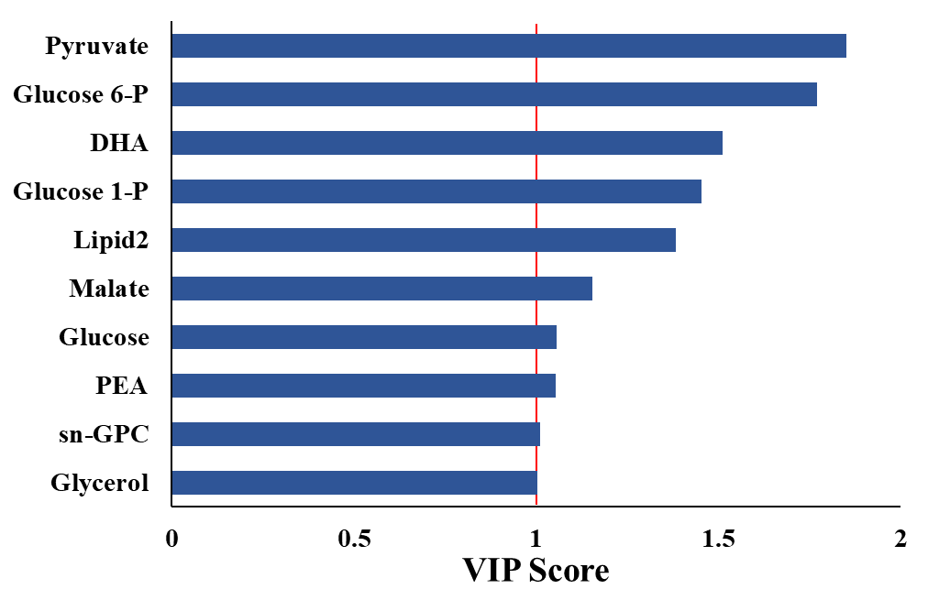

Supplementary Fig. 3 VIP score plot derived from the PLS-DA analysis displaying discriminant features of transgenic lines of Jatropha curcas and the control samples.

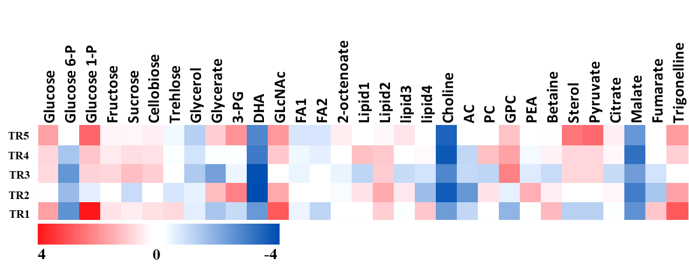
Supplementary Fig. 4 The fold change of metabolites in response to overexpression of ArabidopsisDGAT1 intransgenic Jatropha.The cut-off value for significant log2 fold change was chosen.

Supplementary Table 1. List of top 15 statistically significant datasets and their features.
S.N. | Metabolites/ functional groups | ANOVA |  |  | Random Forest Feature Selection | PLS-DAVIP Scores
S.N. | Metabolites/ functional groups | f-value | p-value | FDR* | Mean Decrease Accuracy | Comp. 1 | Comp. 2 | Comp. 3
1 | Glucose 1-P | 109.04 | 1.42E-09 | 4.41E-08 | 0.027 | 1.00 | 0.88 | 0.87
2 | Trehalose | 21.23 | 1.40E-05 | 3.11E-05 | 0.019 | 1.52 | 1.28 | 1.27
3 | Cellobiose | - | - | - | 0.021 | 1.23 | 1.07 | 1.06
4 | DHA | 49.82 | 1.30E-07 | 1.00E-06 | 0.022 | 1.35 | 1.15 | 1.18
5 | GlcNAc | 24.77 | 6.19E-06 | 1.60E-05 | 0.025 | 1.59 | 1.34 | 1.32
6 | 2-octenoate | 15.04 | 8.26E-05 | 0.00016 | 0.019 | - | - | -
7 | Lipid1 | 37.29 | 6.62E-07 | 2.28E-06 | 0.023 | - | - | -
8 | Lipid4 | 38.15 | 5.83E-07 | 2.28E-06 | 0.021 | - | - | -
9 | AC | 43.25 | 2.89E-07 | 1.49E-06 | 0.017 | 1.27 | 1.39 | 1.39
10 | PC | 37.34 | 6.57E-07 | 2.28E-06 | 0.026 | - | - | -
11 | GPC | 84.86 | 6.13E-09 | 9.49E-08 | 0.022 | - | - | -
12 | Betaine | - | - | - | 0.017 | 1.34 | 1.15 | 1.14
13 | Sterol | 66.76 | 2.45E-08 | 2.53E-07 | 0.024 | - | - | -
14 | Pyruvate | 47.96 | 1.61E-07 | 1.00E-06 | 0.019 | - | - | -
15 | Trigonelline | 25.82 | 4.95E-06 | 1.39E-05 | 0.029 | - | - | -
*FDR: False discovery rate

