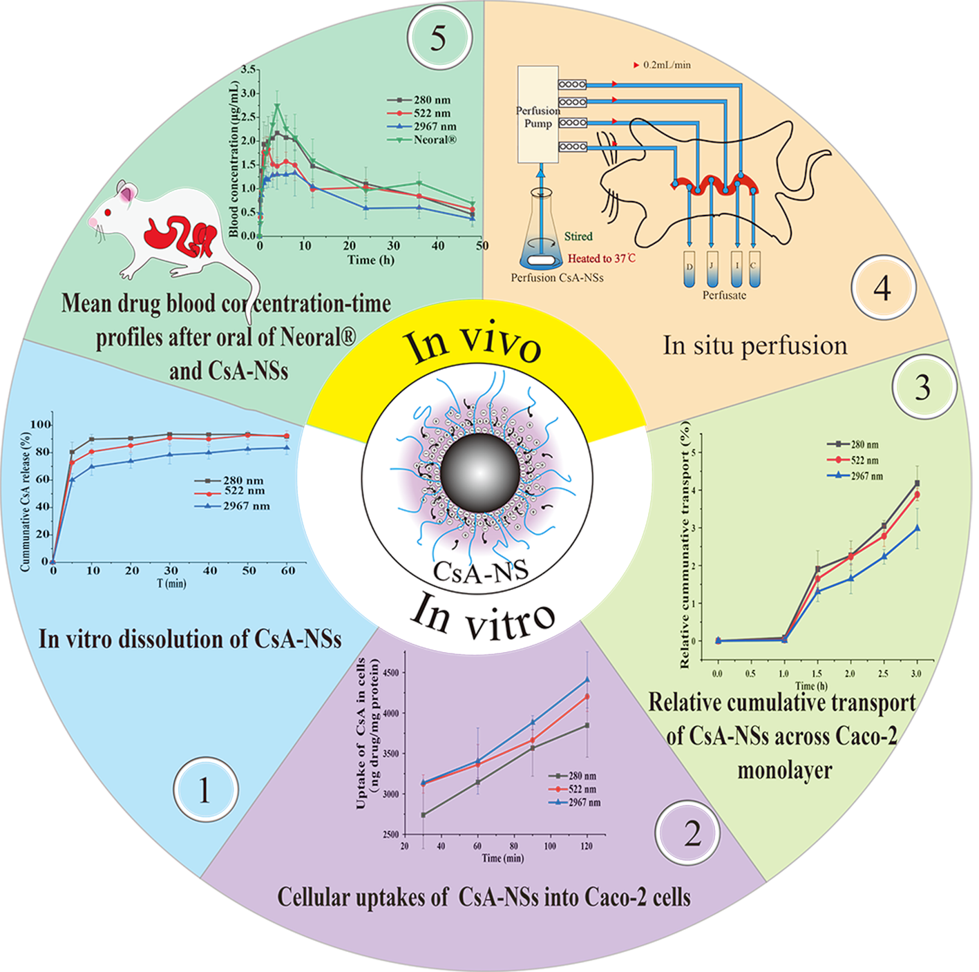
Schematic showing that dissolution rate in vitro, cellular uptake, transmembrane permeation, transport properties in the small intestine and bioavailability in rats were systematically evaluated.

