Supplementary Information
Eliminating catalyst-membrane interfacial discontinuity for alkaline water electrolysis
Shukai Diao^{1,2,3}, Senlin Li^{1,2,3}, Zhonghao Li^{1,2,3}, Ying Liu^{1,2,3}, Tianrang Yang^{1,2*}, Jianguo Liu^{1,2*}
¹Beijing Laboratory of New Energy Storage Technology, Institute of Energy Power Innovation, North China Electric Power University, Beijing 102206, P.R. China
²Beijing Key Laboratory of Electrochemical Hydrogen Production and Fuel Cells, North China Electric Power University, Beijing 102206, China
³School of Energy Power and Mechanical Engineering, North China Electric Power University, Beijing 102206, PR China
*Corresponding author: tianrangyang@ncepu.edu.cn; jianguoliu@ncepu.edu.cn

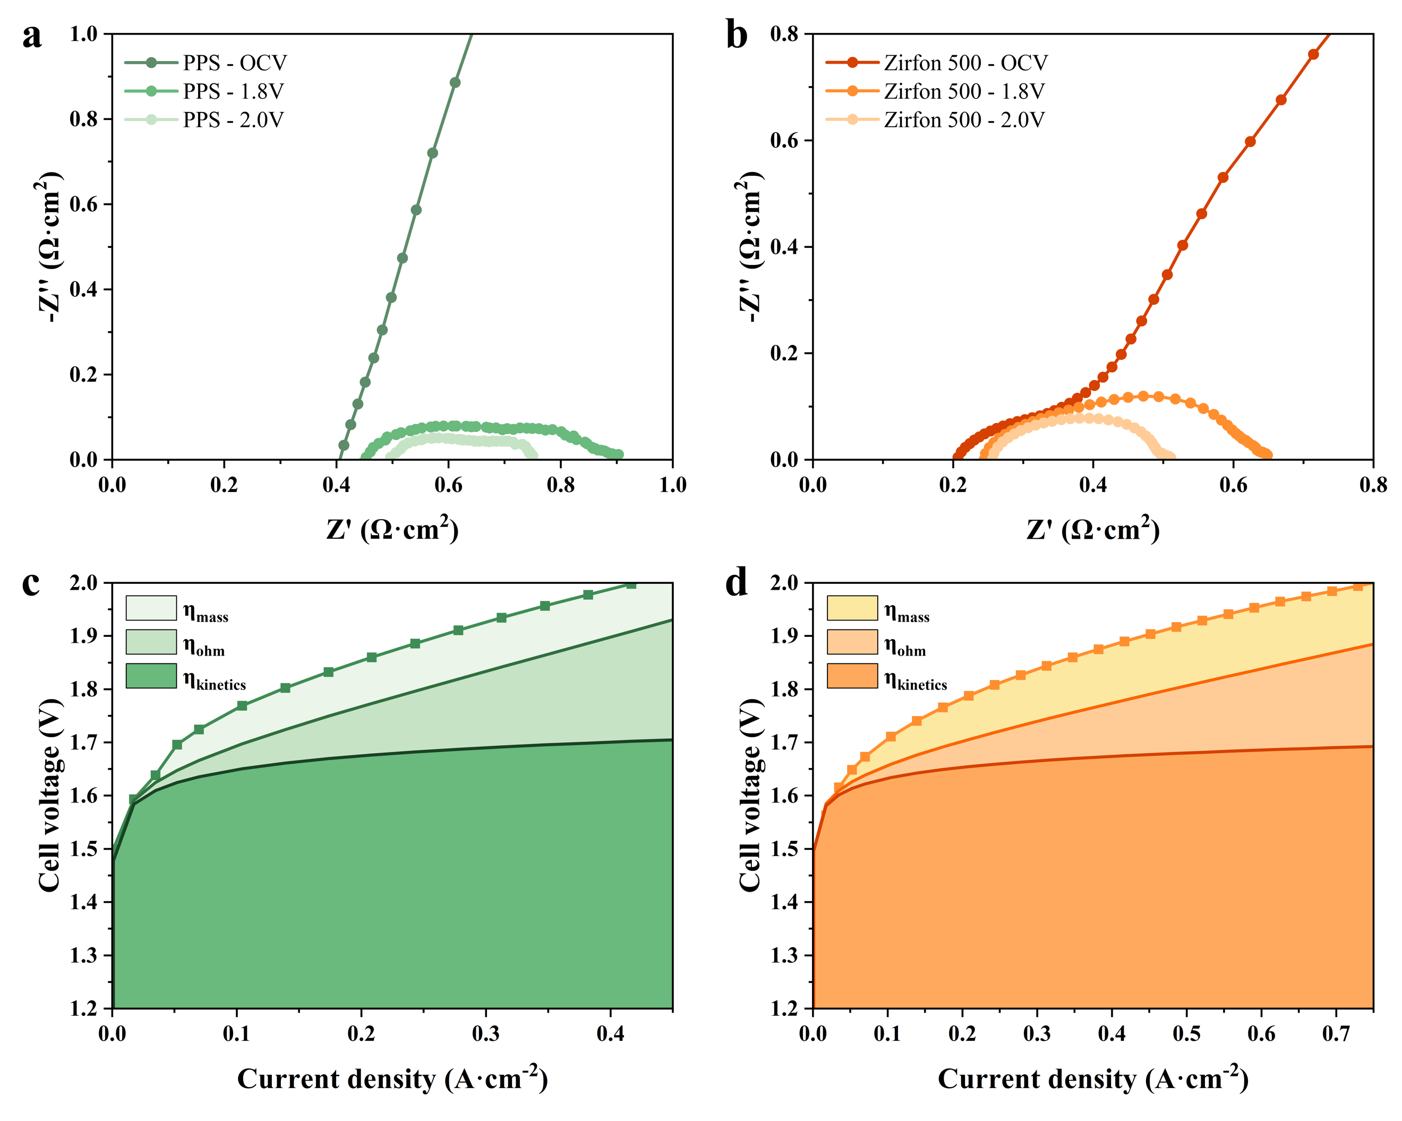
Fig. S1 Electrochemical characteristics of alkaline water electrolyzers assembled with commercial membranes. a, b, Nyquist plots of alkaline water electrolyzers using a PPS membrane (a) and a Zirfon 500 membrane (b) measured at open-circuit voltage (OCV), 1.8 V and 2.0 V. c, d, IV polarization curves and the corresponding deconvolution into kinetic, ohmic and mass-transport overpotentials for alkaline water electrolyzers using the PPS membrane (c) and Zirfon 500 membrane (d).

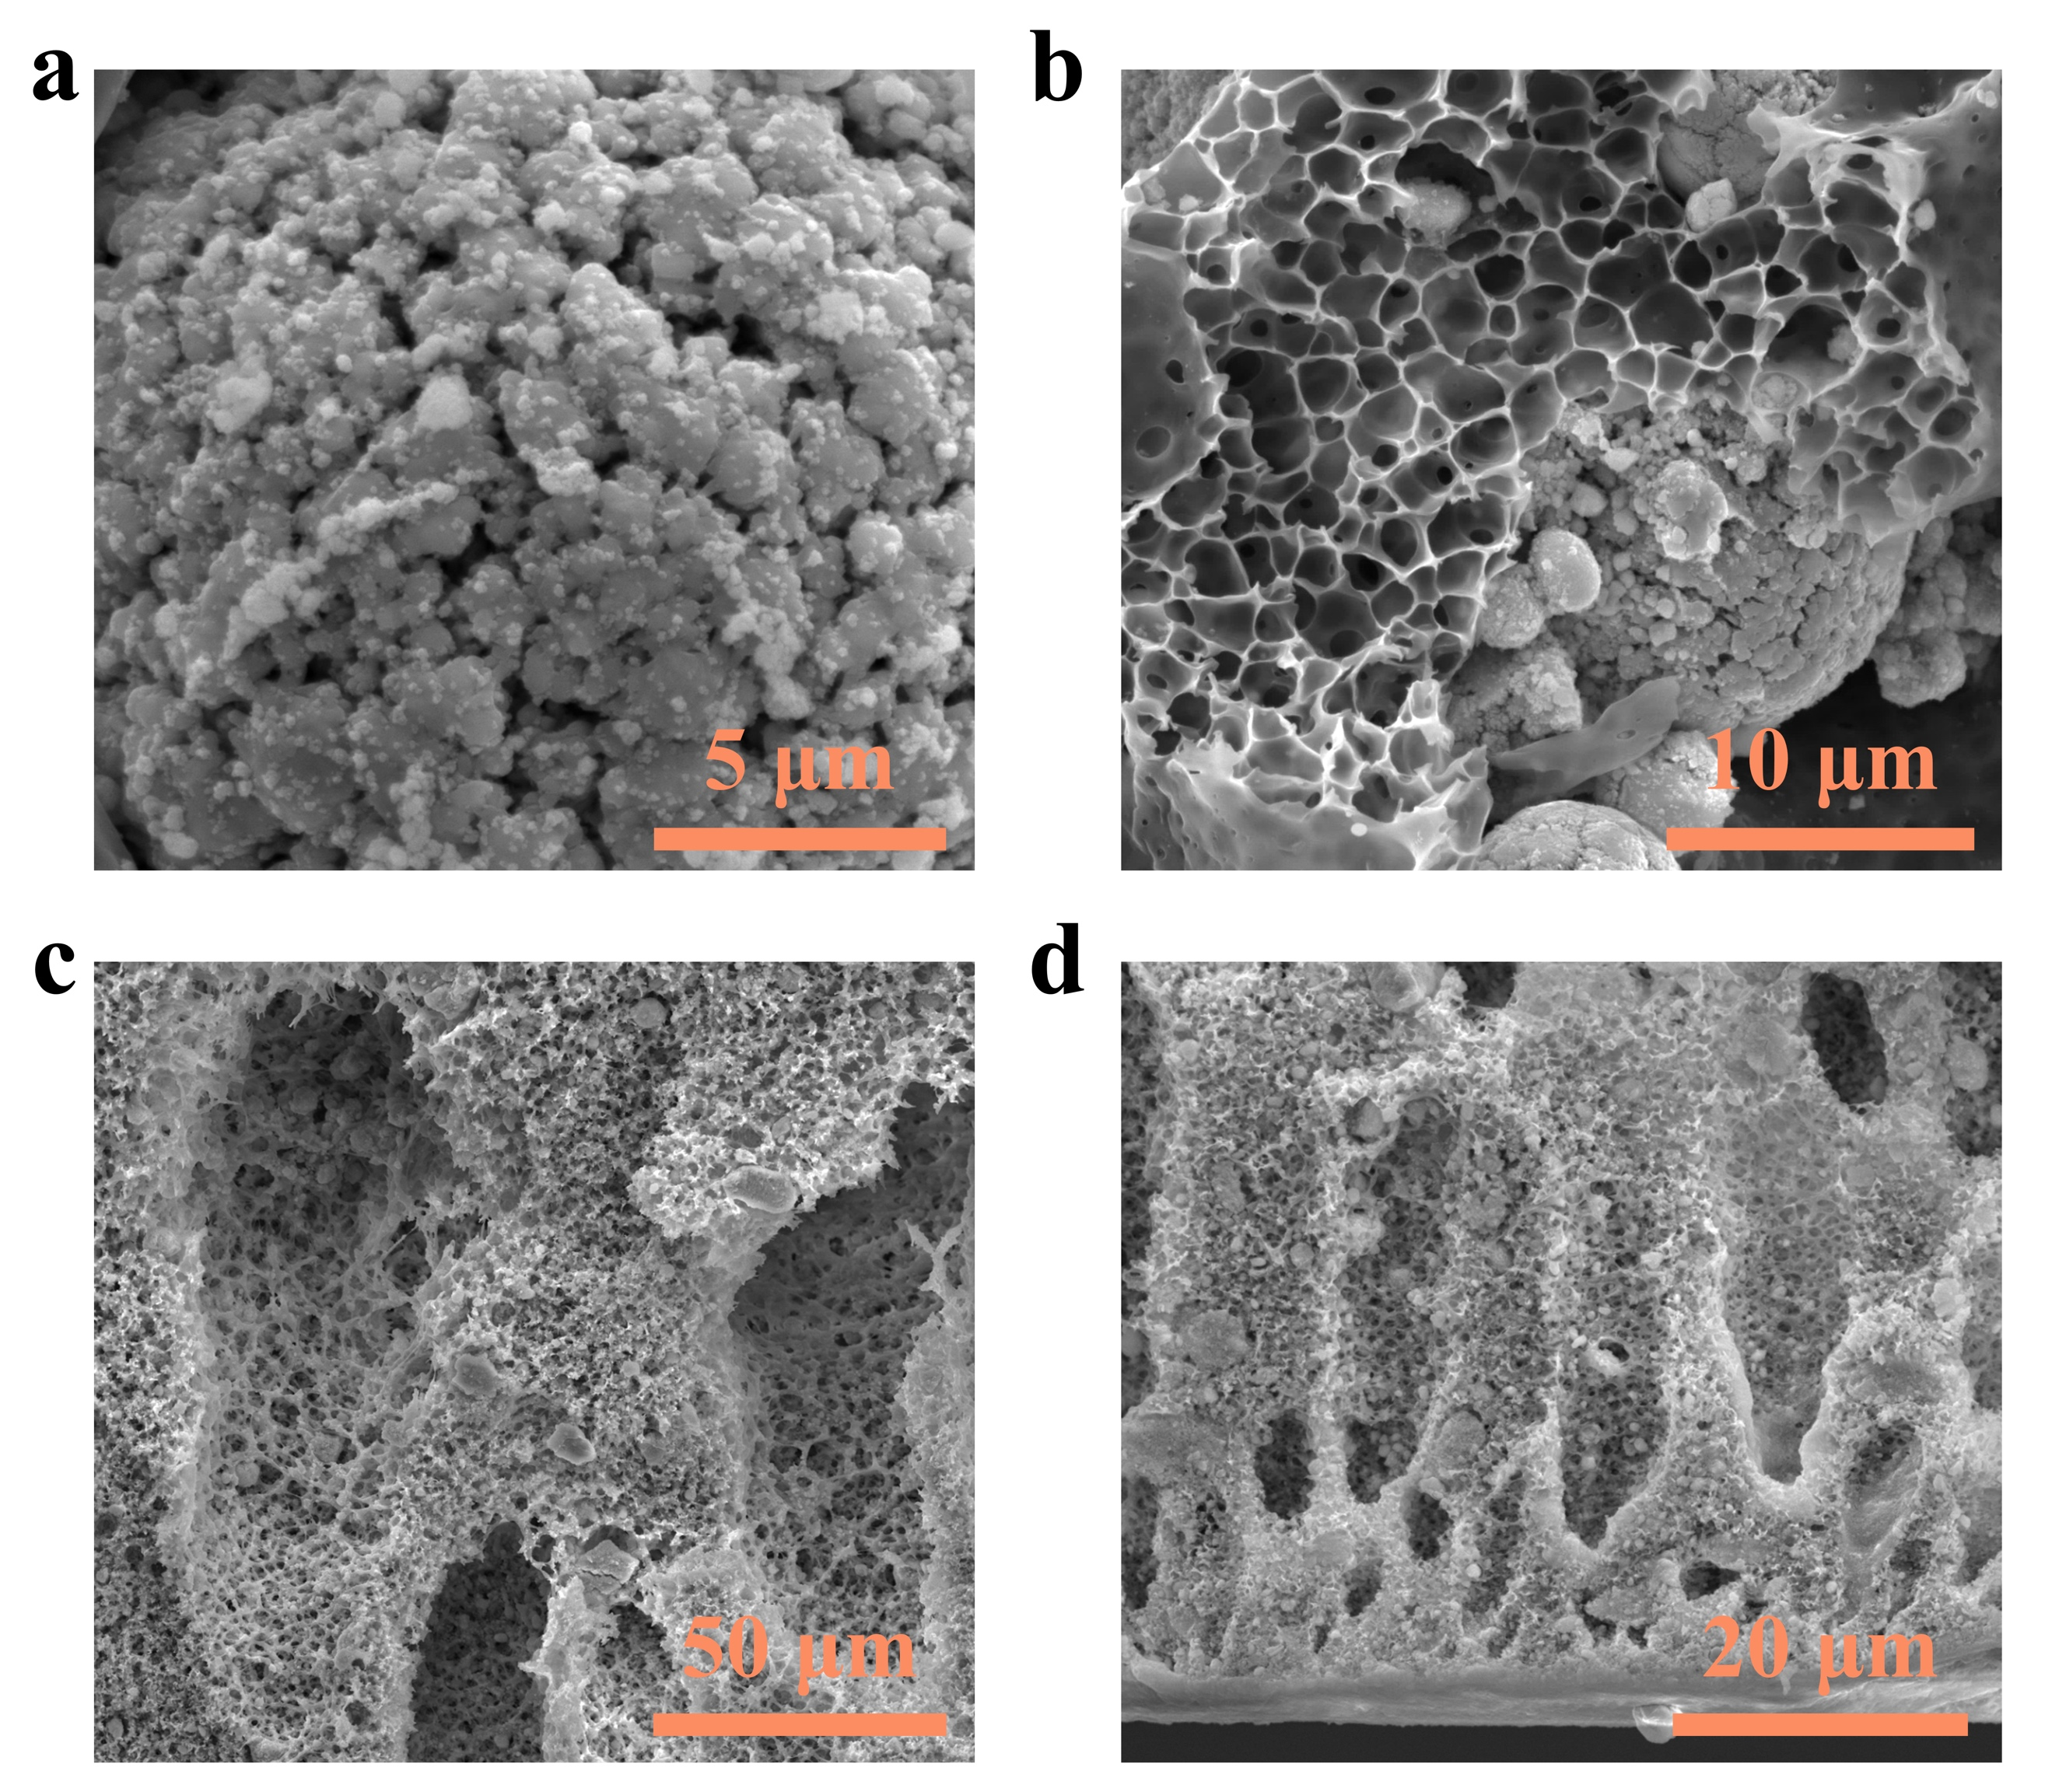
Fig. S2 Magnified cross-sectional SEM images of the ICM architecture. a, NiAl catalyst particles embedded in the catalyst layer of the ICM. b, Porous framework interconnecting the catalyst particles within the catalyst layer. c, Finger-like pores in the intermediate membrane region. d, Dense skin layer at the membrane surface.

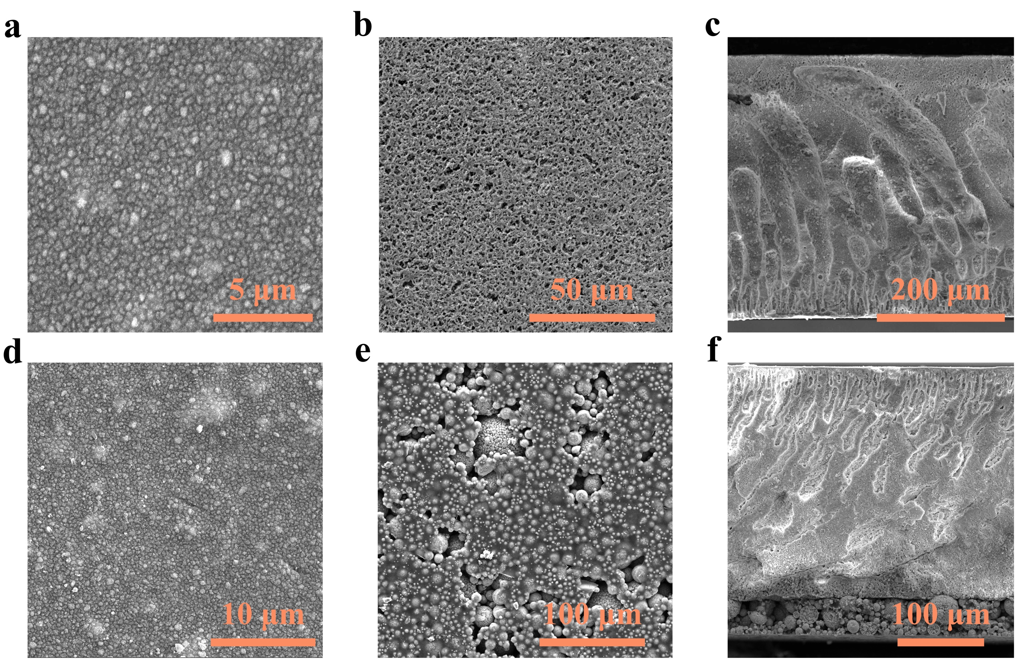
Fig. S3 Surface and cross-sectional morphologies of the ZP and CLM. a, b, Top-view SEM images of the upper surface (a) and the glass-contacting surface (b) of the membrane prepared by casting on a glass substrate followed by phase inversion in a water bath. c, Cross-sectional SEM image of the ZP showing the asymmetric porous structure. d, e, Top-view SEM images of the membrane-side skin surface (d) and catalyst-layer surface (e). f, Cross-sectional SEM image of the CLM.

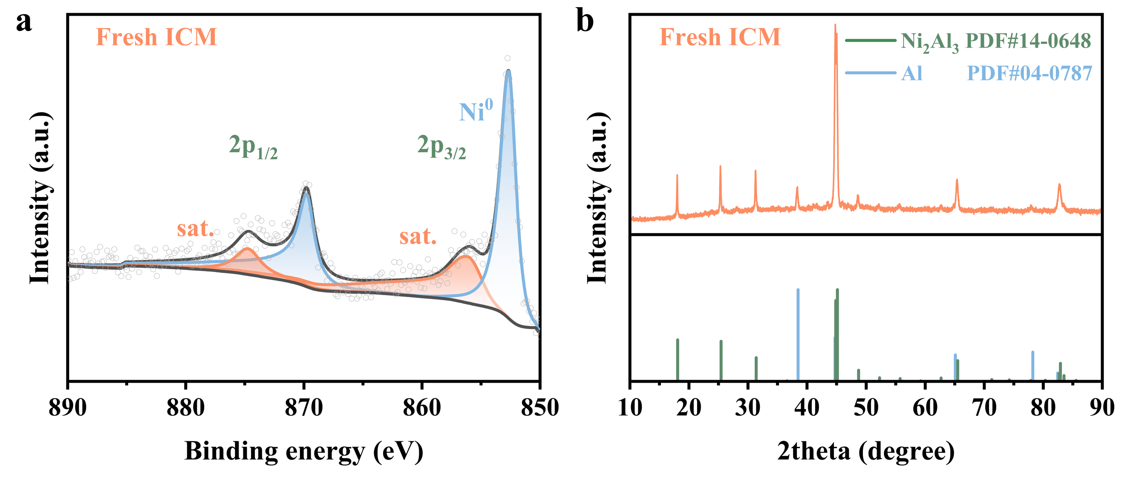
Fig. S4 Phase composition and Ni chemical states of the ICM before and after alkaline activation. a, X-ray diffraction pattern collected from the catalyst-layer side of the fresh ICM, together with the corresponding reference patterns. b, High-resolution Ni 2p XPS spectrum of the fresh ICM.

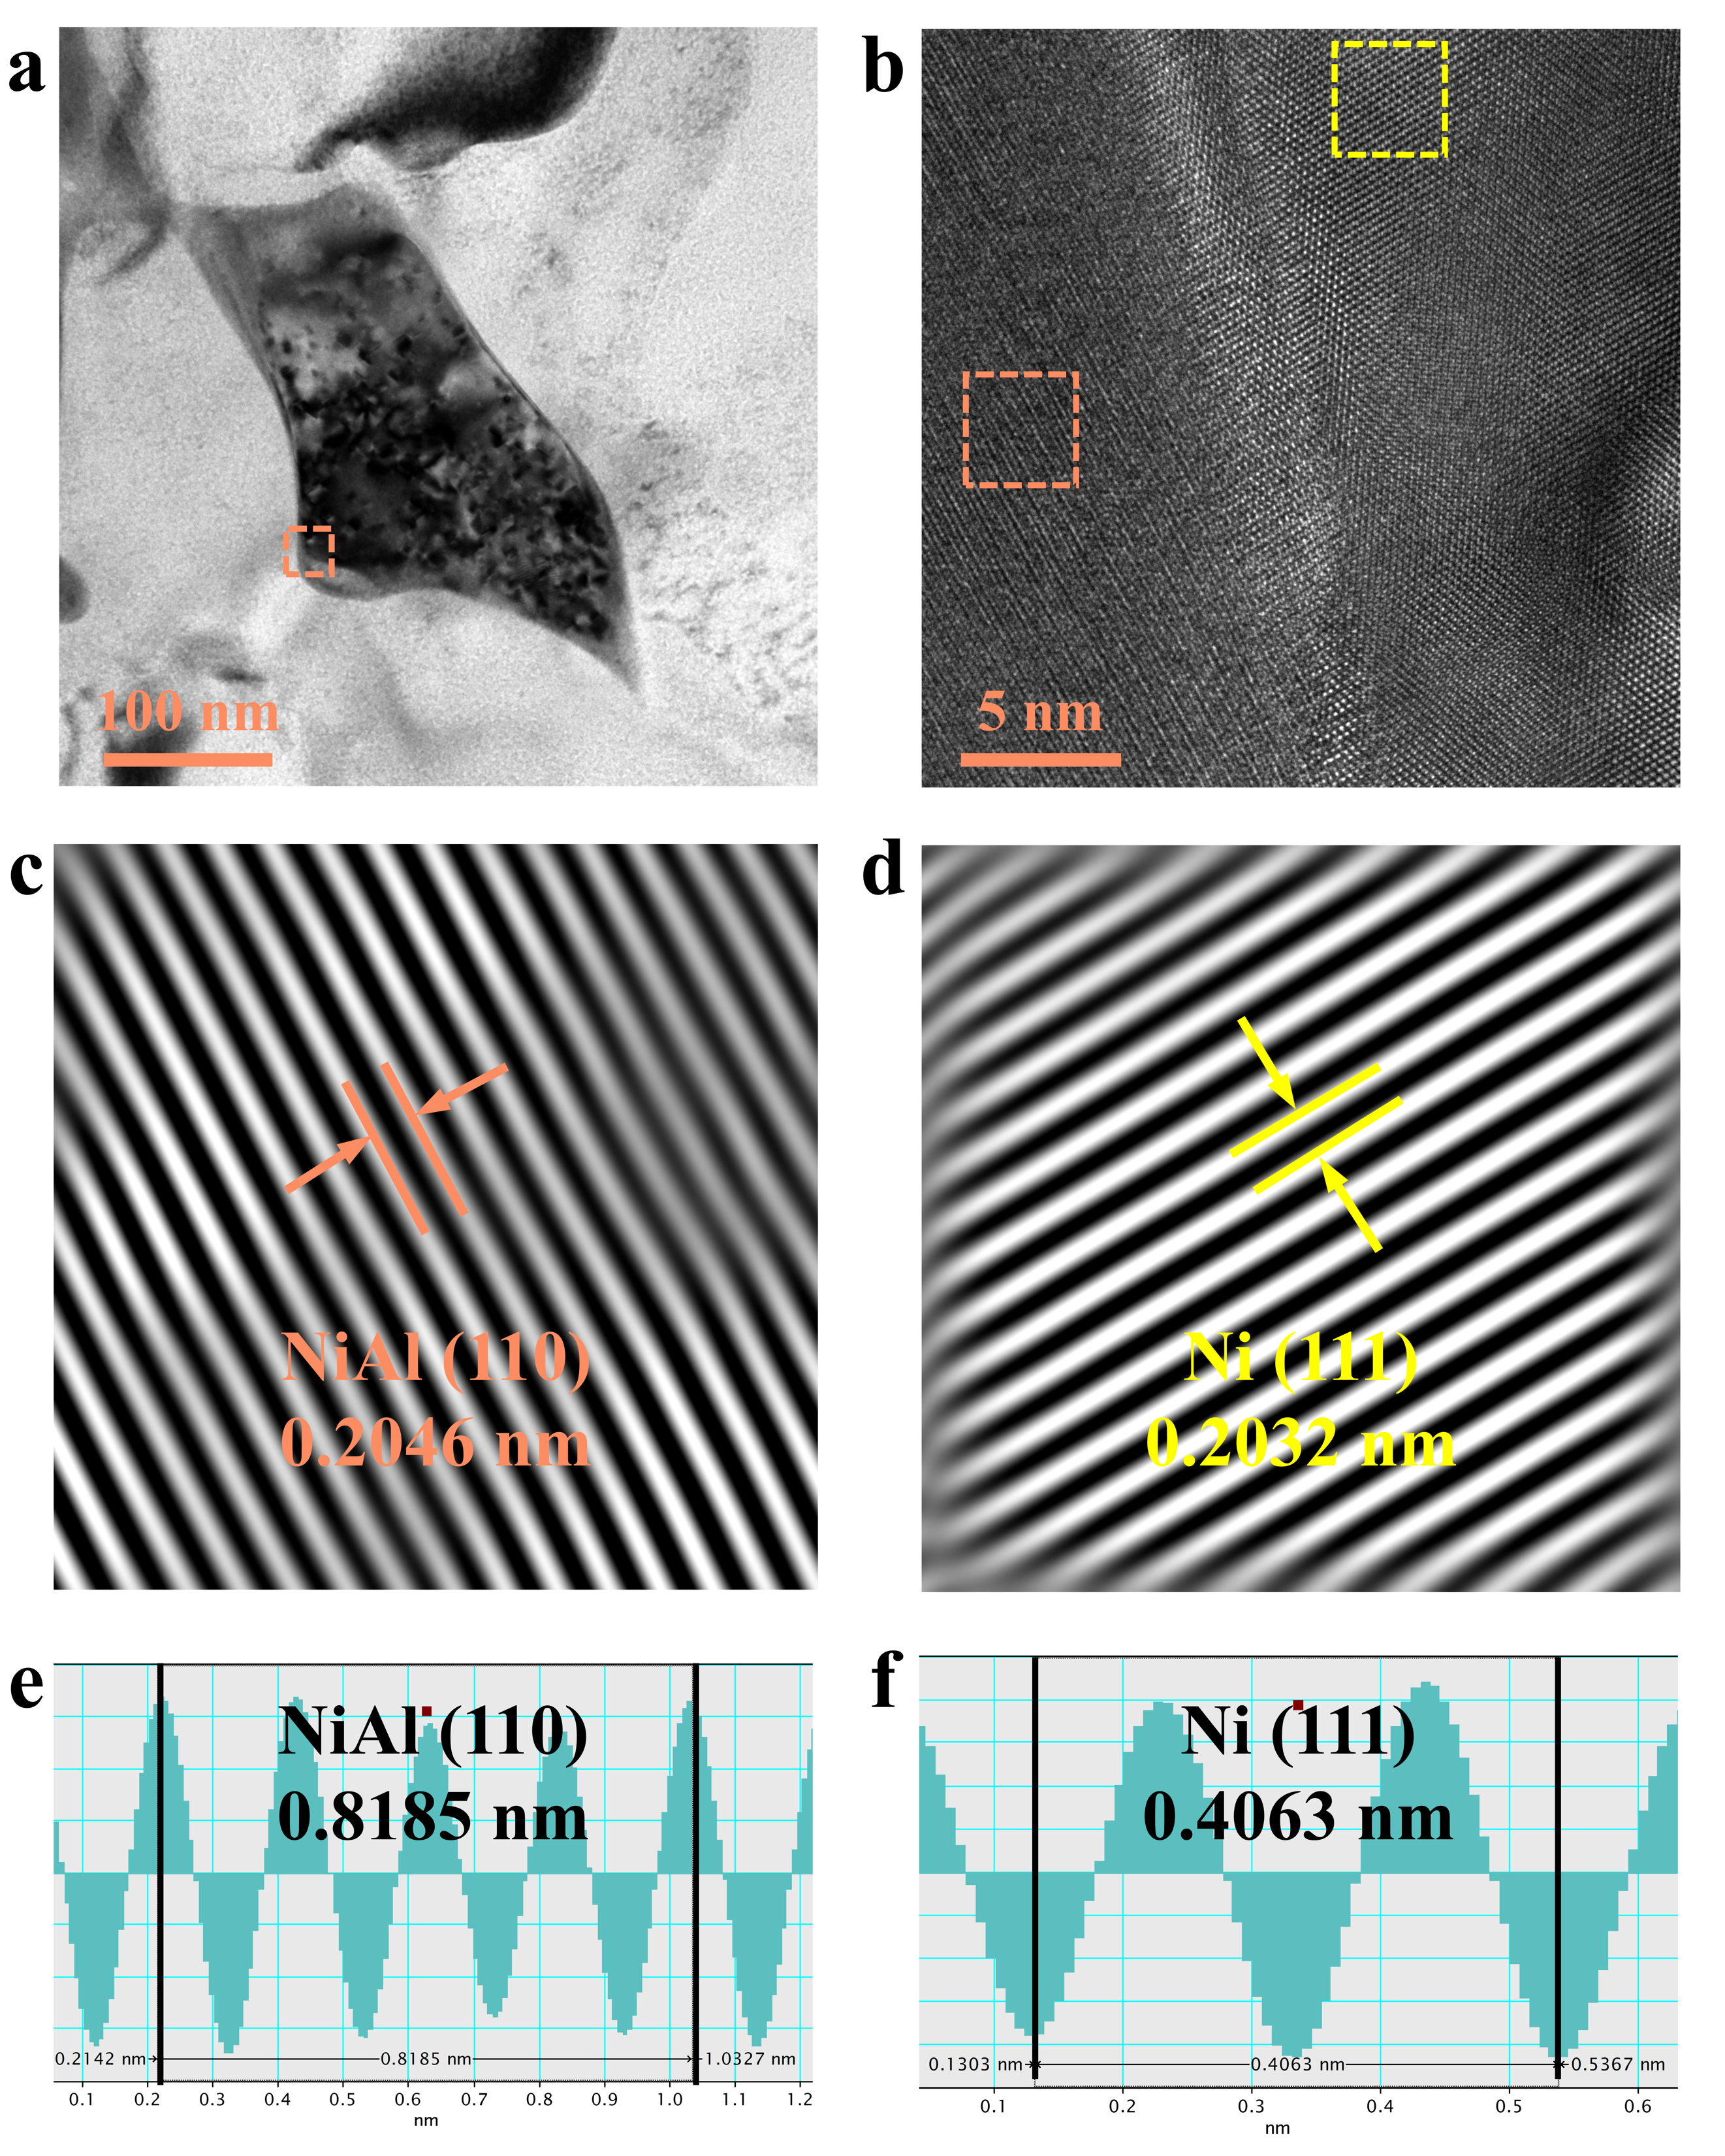
Fig. S5 TEM characterization of the catalyst layer after KOH activation. a, TEM image of the catalyst recovered from the KOH-activated ICM. b, High-resolution TEM image of the region marked in a. c, d, Enlarged lattice-fringe images corresponding to the orange (c) and yellow (d) regions in b, assigned to the NiAl (110) and Ni (111) planes, respectively. e, f, Corresponding line-intensity profiles used to determine the lattice spacings of NiAl (110) (e) and Ni (111) (f).

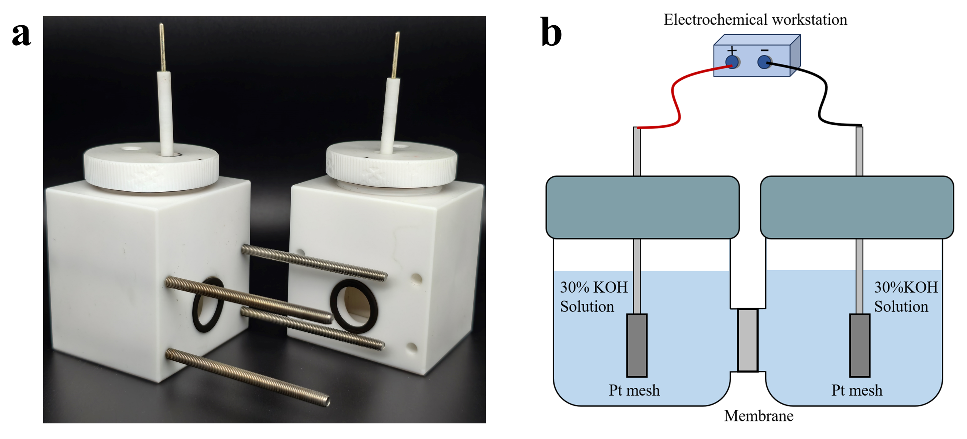
Fig. S6 H-type cell used for membrane area-resistance measurements. a, Photograph of the H-type electrolysis cell. b, Schematic illustration of the measurement configuration, comprising two compartments filled with 30 wt% KOH, Pt-mesh electrodes connected to an electrochemical workstation and the membrane mounted between the compartments.

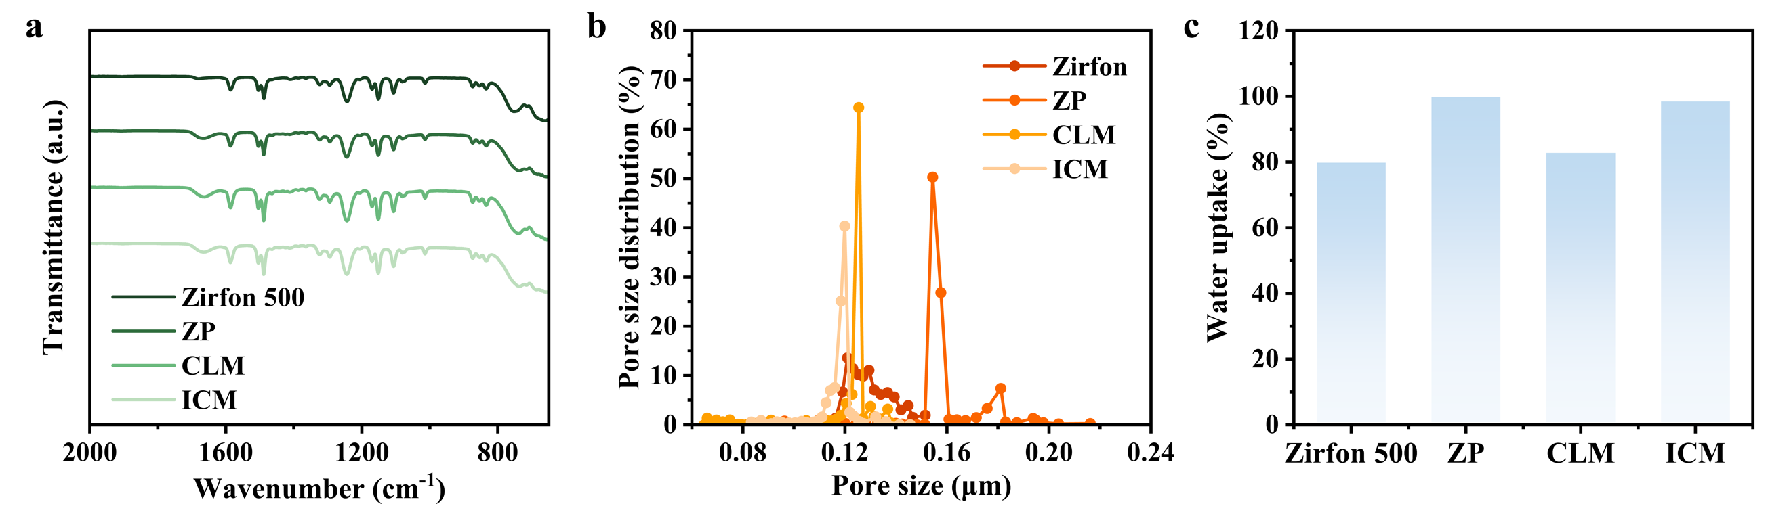
Fig. S7 Chemical composition, pore-size distribution and water uptake of the membrane samples. a, FTIR spectra collected from the membrane-side surfaces of Zirfon 500, ZP, CLM and ICM. b, Pore-size distributions of Zirfon 500, ZP, CLM and ICM, expressed as the percentage of pores within each pore-size interval. c, Water uptake of Zirfon 500, ZP, CLM and ICM.

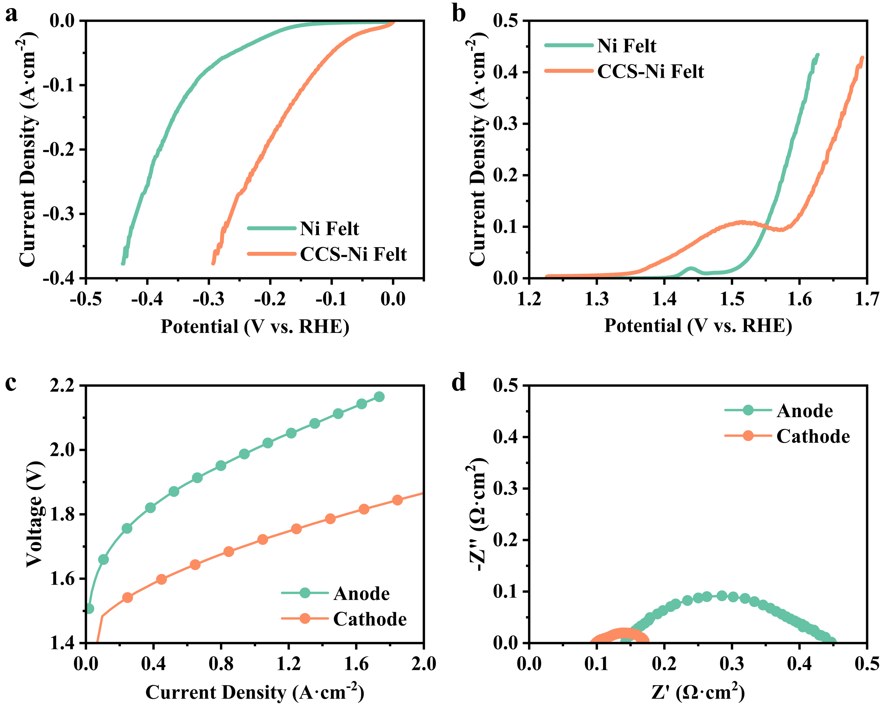
Fig. S8 Electrocatalytic activity of the catalyst layer and optimization of the ICM orientation. a, b, HER (a) and OER (b) polarization curves of bare Ni felt and Ni felt coated with the catalyst layer (CCS-Ni felt). c, Polarization curves of alkaline water electrolyzers assembled with the ICM catalyst layer facing the anode or cathode. d, Corresponding Nyquist plots measured at 1.8 V.

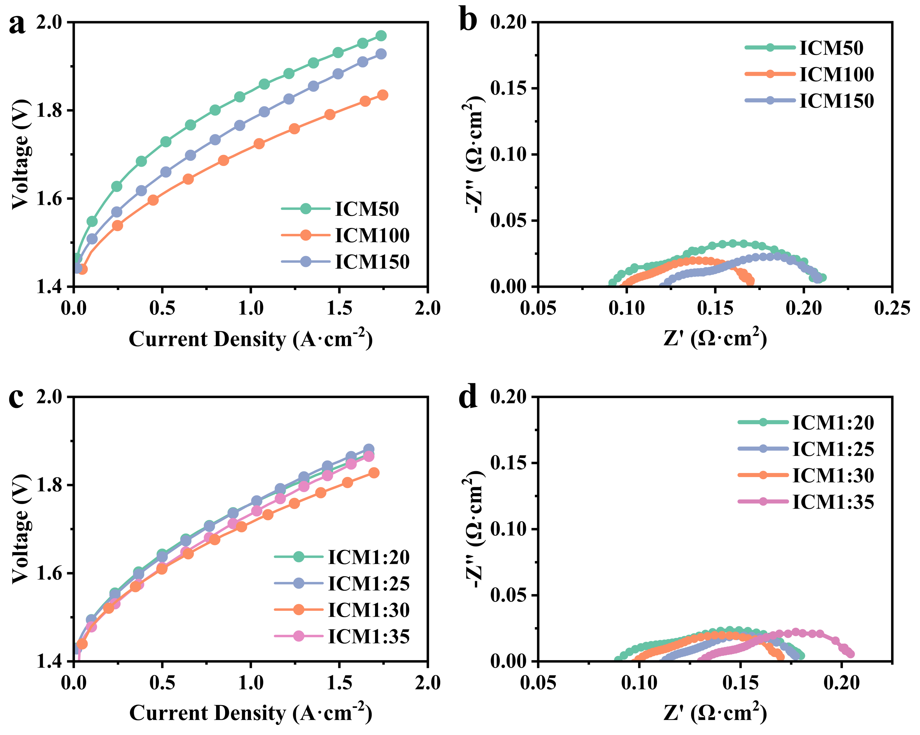
Fig. S9 Optimization of the catalyst-layer composition and casting thickness. a, b, Polarization curves (a) and Nyquist plots measured at 1.8 V (b) of ICMs with catalyst-layer casting thicknesses of 50, 100 and 150 μm. c, d, Polarization curves (c) and Nyquist plots measured at 1.8 V (d) of ICMs with different polysulfone to NiAl mass ratios.

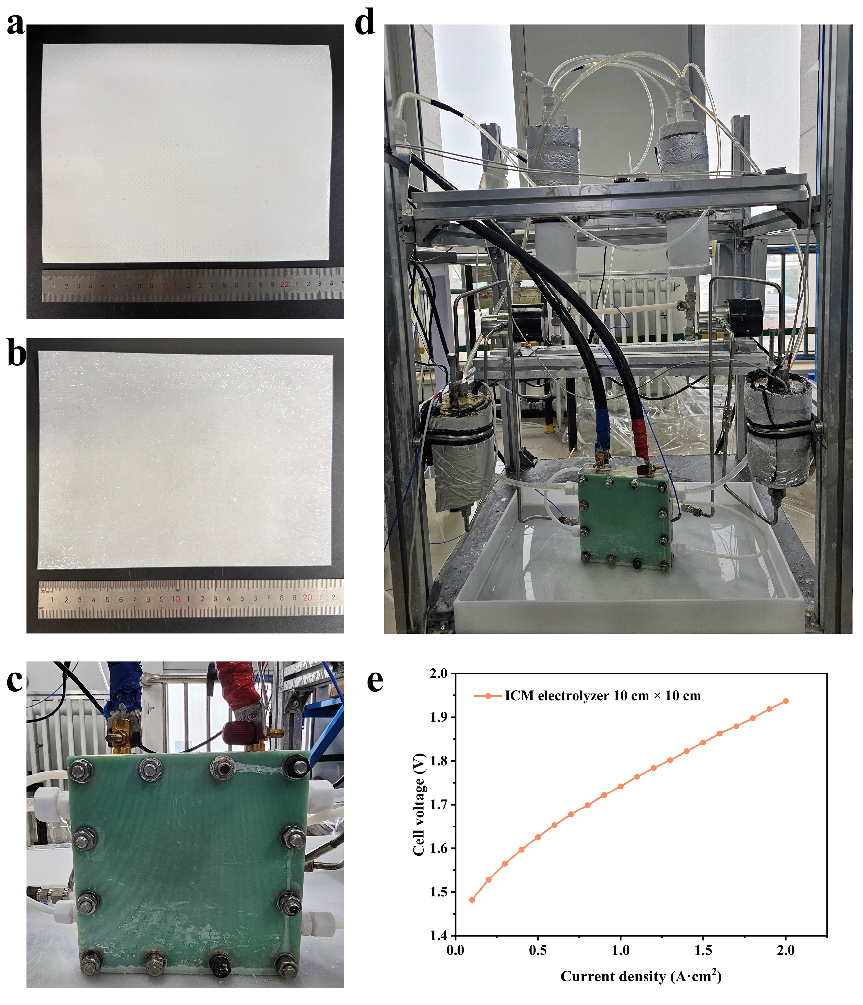

Fig. S10 Scale-up validation of the ICM-based electrolyzer. a,b, Photographs of the membrane and catalyst sides of the enlarged ICM, respectively. c,d Photograph of the test platform for the electrolyzer with a 10 cm × 10 cm active area. e, Polarization curve of the scaled ICM-based electrolyzer.

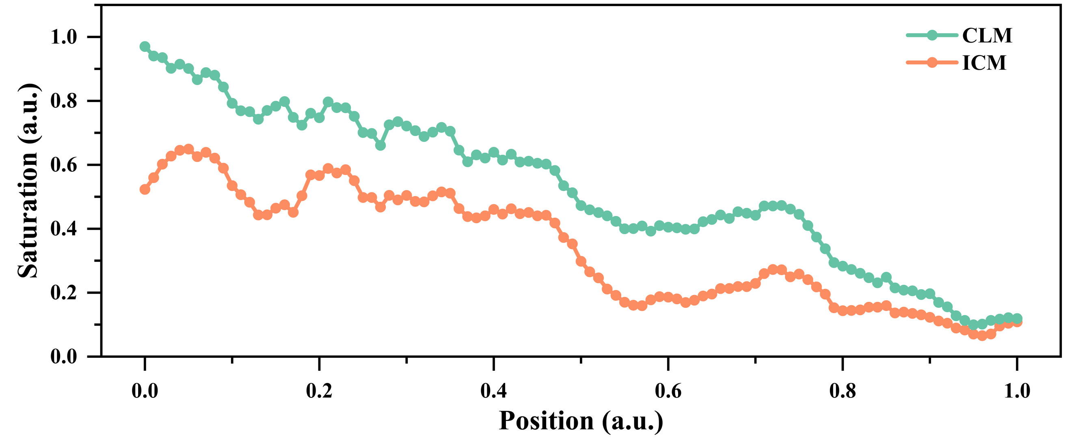
Fig. S11 Gas saturation along the Y direction.

Supplementary Table S1. Electrolysis performance comparison of ICM with reported alkaline water electrolysis.
Membrane | Anode//Cathode | Current Densty  (A cm⁻²) | Cell Voltage  (V) | Stability  (h) | Ref.
ICM | CoNiFe//Ni foam | 2.05 | 1.8 | \ | This work
ICM | Ni foam | 1.5 | 1.8 | 8000 | This work
CLM | Ni foam | 1 | 1.8 | 500 | This work
PMCM-2 | NiFe//NiCoP | 1 | 1.71 | 4576 | ¹
Z80C5 | NiFe//Raney Ni | 0.6 | 1.65 | 300 | ²
YSZNPs-15 | Ni foam | 0.5 | 1.85 | 500 | ³
PTEE/LDH | IrO₂//Pt/C | 1 | 1.8 | 180 | ⁴
ZLDH10 | H1//Raney Ni | 1.4 | 2 | 240 | ⁵
TFC | NiFe//Raney Ni | 1.16 | 1.8 | 1000 | ⁶
PTFE/PBI | NiAl//NiAlMo | 1.8 | 1.8 | 1000 | ⁷
APCM-0.15 | NiFe//NiMo | 1.057 | 2 | 600 | ⁸
Porous PES membrane | NM/PN/NiFeO_{x}//NM/PN/Ru@NiMoCu₂₀ | 0.6 | 1.74 | 600 | ⁹
Zirfon | TPE | 0.91 | 1.8 | 1500 | ¹⁰
Zirfon | NiMO//Ni | 0.8 | 1.76 | 1534 | ¹¹
Porous PES membrane | Ws/Moi-Ni₃S₂@CoSe/NF | 0.5 | 1.75 | 1000 | ¹²
Zirfon | Fe₄₀Ni₄₀P₁₄B₆//Pt/C | 1.5 | 1.93 | 300 | ¹³
Zirfon | Fe_{2.5}Co_{2.5}Ni₁₀O_{y}H_{z}@NFF//FeCoCrCuO_{x}@CF | 0.5 | 1.8 | 1100 | ¹⁴
5%PZ-K30 | NiCoMo//Raney Ni | 1.32 | 2 | 1300 | ¹⁵
SSCM-8 | NiFe//NiMo | 1.9 | 2 | 1700 | ¹⁶
Zirfon | SS316//Ru@Cu-TiO₂/Cu | 1 | 1.77 | 200 | ¹⁷
PPS | Ni//NiMo/CoMn/Ni | 0.37 | 2 | 50 | ¹⁸
PPS | Eu₂O₃/NiS₂//NiS₂ | 0.3 | 2 | 240 | ¹⁹

Reference
1 You, J. et al. A rationally thin composite membrane with differentiated pore structure for industrial-scale alkaline water electrolysis. Nature Communications 16 (2025).
2 Lee, J. et al. Cellulose nanocrystals-blended zirconia/polysulfone composite separator for alkaline electrolyzer at low electrolyte contents. Chemical Engineering Journal 428 (2022).
3 Gao, H. et al. High-Performance Composite Membranes: Embedding Yttria-Stabilized Zirconia in Polyphenylene Sulfide Fabric for Enhanced Alkaline Water Electrolysis Efficiency. Small 21 (2025).
4 Wan, L., Xu, Z. & Wang, B. Green preparation of highly alkali-resistant PTFE composite membranes for advanced alkaline water electrolysis. Chemical Engineering Journal 426 (2021).
5 Luo, X. et al. Surface self-assembled multi-level NiFe-LDHs integrated super-hydrophilic diaphragms enabling efficient alkaline water electrolysis for high current density and durability. Chemical Engineering Journal 510 (2025).
6 Choi, J. et al. Thin Film Composite Membranes as a New Category of Alkaline Water Electrolysis Membranes. Small 19 (2023).
7 Trisno, M. et al. Reinforced gel-state polybenzimidazole hydrogen separators for alkaline water electrolysis. Energy & Environmental Science 15, 4362–4375 (2022).
8 Song, W. et al. Novel high-safety composite separator: Achieving efficient alkaline water electrolysis by compositing microporous polysulfone membrane on one side of complete structure polyphenylene sulfide fabric. Chemical Engineering Journal 503 (2025).
9 Bi, S. et al. Construction of Efficient Ru@NiMoCu Porous Electrode for High Current Alkaline Water Electrolysis. Advanced Energy Materials 14 (2024).
10 Kuang, W. et al. Self-Supported Ni/Ni(OH)­₂ Electrodes for High-Performance Alkaline and AEM Water Electrolysis. Advanced Energy Materials 15 (2025).
11 Egert, F. et al. Intensification of Alkaline Electrolyzer with Improved Two-Phase Flow. Advanced Energy Materials 15 (2025).
12 Hoa, V. et al. Synergistic phase modulation of interstitial Mo and substitutional W single atom in Ni₃S₂ lattice-integrated CoSe heterostructure for industrial water electrolyzers. Applied Catalysis B-Environment and Energy 380 (2026).
13 Zhu, Z. et al. Multilayer catalysts with glass-crystal dual-phase heterostructures for exceptional alkaline water electrolysis under industrial conditions. Nano Energy 143 (2025).
14 Liu, C. et al. Electrodeposited Ternary Metal (Oxy)Hydroxide Achieves Highly Efficient Alkaline Water Electrolysis Over 1000 h Under Industrial Conditions. Carbon Energy 7 (2025).
15 Luo, X. et al. Porous PVA skin-covered thin Zirfon-type separator as a new approach boosting high-rate alkaline water electrolysis beyond 1000 hours' lifespan. Escience 4 (2024).
16 Liao, Y., Deng, G., Wu, H., Ding, L. & Wang, H. A Porous Skeleton-Supported Organic/Inorganic Composite Membrane for High-Efficiency Alkaline Water Electrolysis. Advanced Functional Materials 34 (2024).
17 Zuo, Y. et al. Ru-Cu Nanoheterostructures for Efficient Hydrogen Evolution Reaction in Alkaline Water Electrolyzers. Journal of the American Chemical Society 145, 21419–21431 (2023).
18 Cao, X. et al. Multilayered NiMo/CoMn/Ni Cathodic Electrodes with Enhanced Activity and Stability toward Alkaline Water Electrolysis. Acs Applied Materials & Interfaces 15, 34181–34194 (2023).
19 Shen, W. et al. Rare-Earth-Modified NiS₂ Improves OH Coverage for an Industrial Alkaline Water Electrolyzer. Journal of the American Chemical Society 146, 5324–5332 (2024).

