Supplementary information
This concise supplement contains Supplementary Figs. 1-6 and Supplementary Tables 1-6. Statistical fields retain their English variable names. The six grouped supplementary tables contain 15 component tables. Omitted intermediate analyses and complete machine-readable results remain available in the reproducibility archive.

Supplementary Fig. 1. Disease-expression context and candidate GAS6/TAM-SPP1 genes
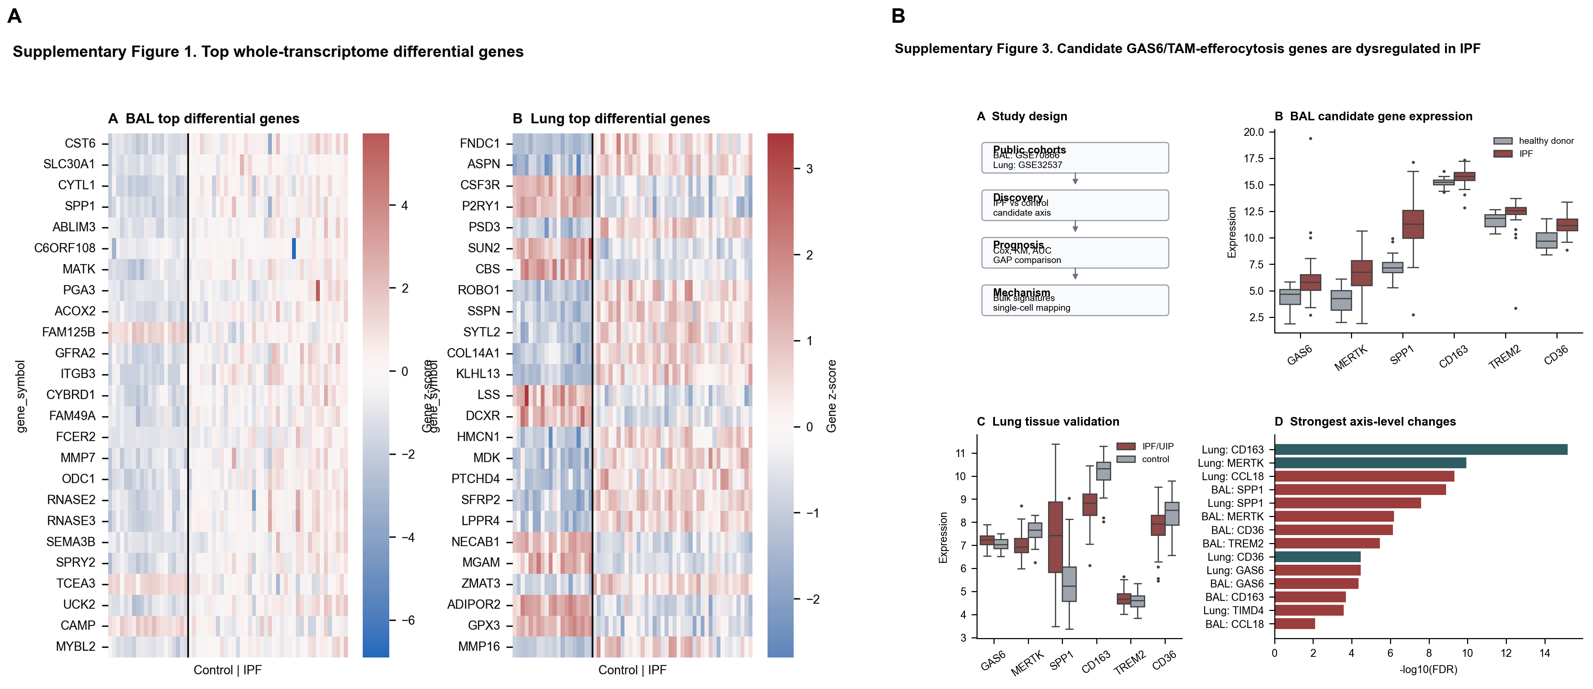
Supplementary Fig. 1. A, Major case-control expression differences in GSE70866 BAL cells and GSE32537 lung tissue. B, Candidate-gene distributions and a summary of differential expression in BAL and lung tissue. These findings provide disease-expression context only and were not used as outcome-based evidence for model selection.

Supplementary Fig. 2. Censoring-aware performance and proportional-hazards diagnostics
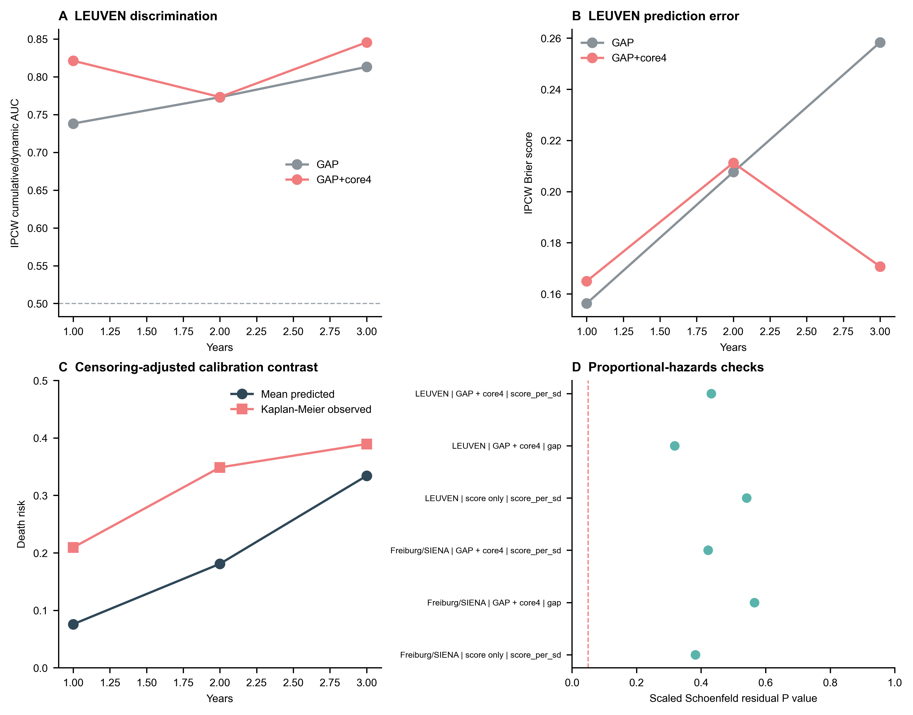
Supplementary Fig. 2. A and B, IPCW cumulative or dynamic AUC and Brier scores in LEUVEN. C, Mean predicted mortality risk from GAP plus core4 compared with Kaplan-Meier observed risk. D, Tests based on scaled Schoenfeld residuals for the primary association models.

Supplementary Fig. 3. General random four-gene negative-control benchmark
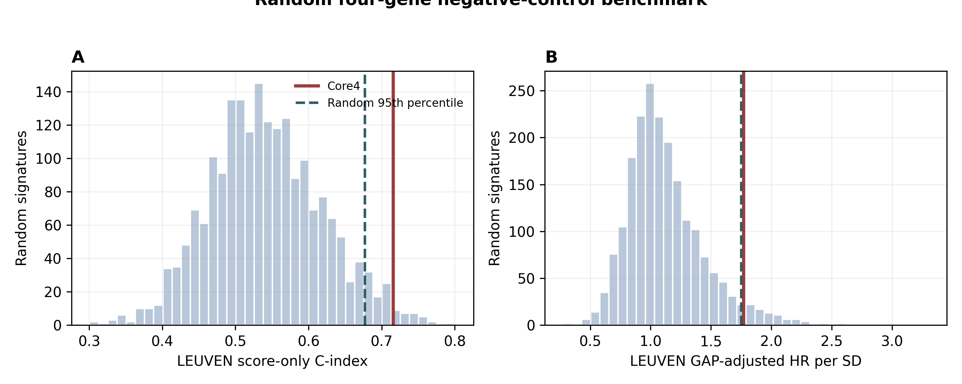
Supplementary Fig. 3. The frozen core4 signature is compared with 2,000 arbitrary four-gene signatures fitted in Freiburg/SIENA and transferred to LEUVEN. Random genes were not matched for expression level, variance, or macrophage specificity. This is therefore a general null check and cannot establish pathway specificity.

Supplementary Fig. 4. Donor-level check of reference-annotated macrophage states
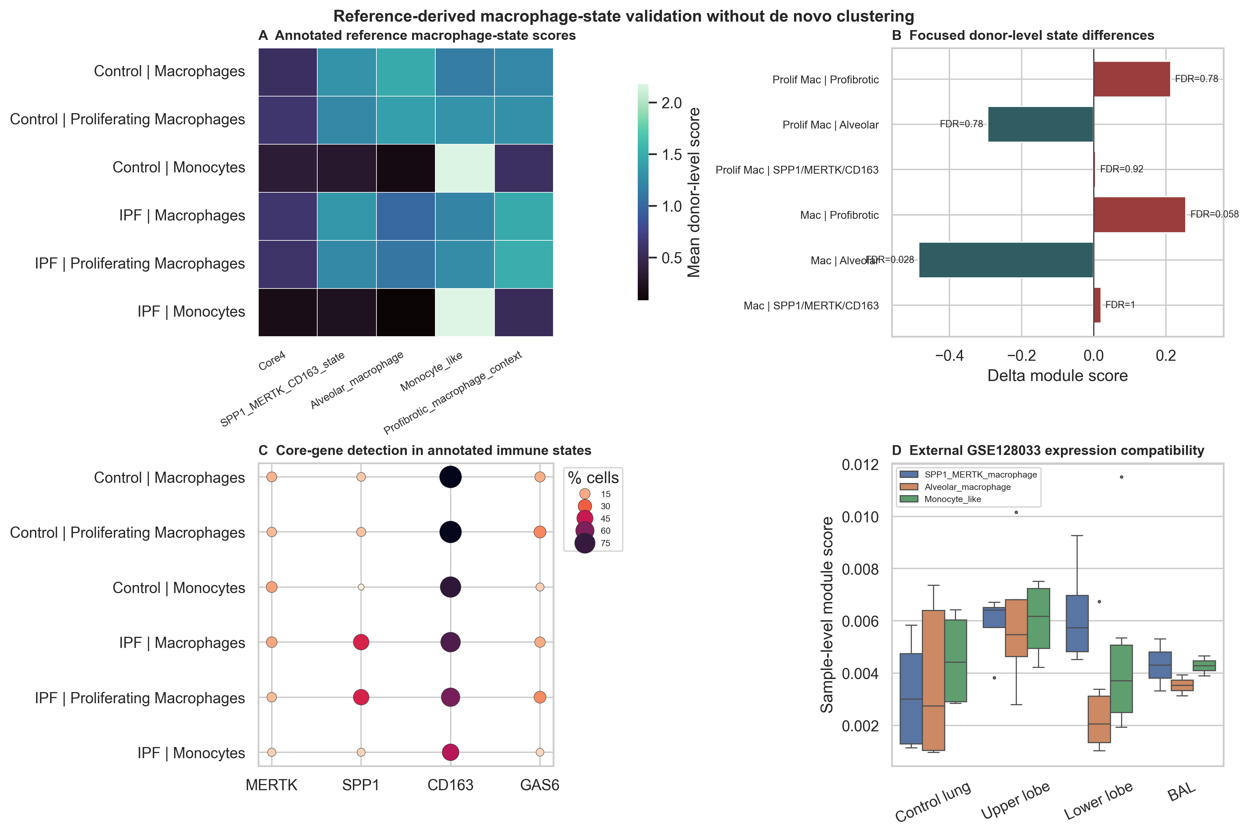
Supplementary Fig. 4. Existing GSE135893 annotations were used to summarize curated macrophage-state modules and core-gene detection by donor. The findings are compatible with an SPP1-shifted injury-remodeling state but do not validate the complete four-gene program or establish specificity to IPF.

Supplementary Fig. 5. Core-gene-excluded proxies and reference-based NNLS composition sensitivity
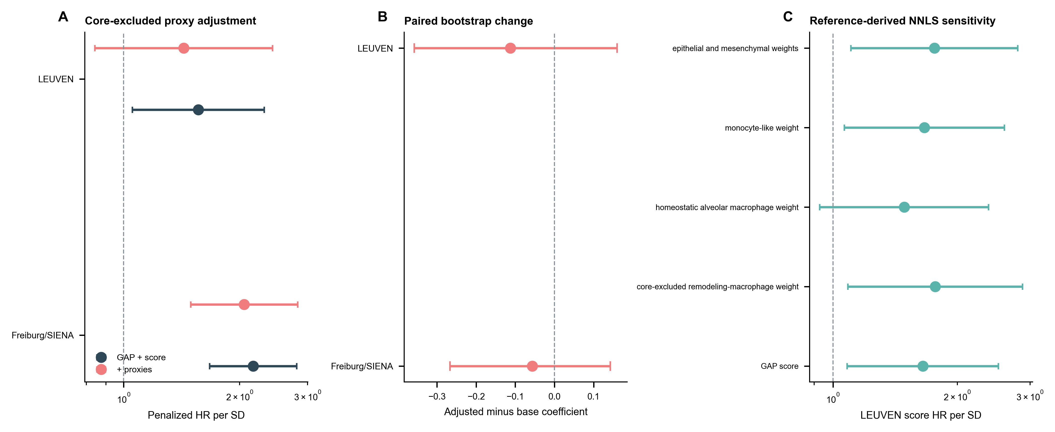
Supplementary Fig. 5. A, Models containing GAP plus the score before and after adjustment for core-gene-excluded proxies. B, Paired bootstrap changes in the score coefficient. C, Reference-based NNLS sensitivity analysis in LEUVEN. Cross-platform proxies have not been validated against measured BAL differential cell counts.

Supplementary Fig. 6. Eligibility of public datasets and analytic sample flow
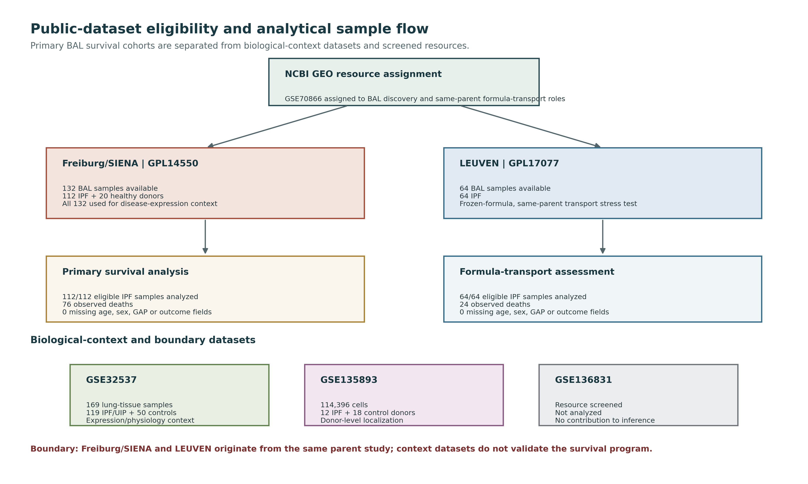
Supplementary Fig. 6. Resource screening, cohort allocation, and analytical roles. LEUVEN served as a parent-study stress-test cohort for transfer of the frozen formula, not as an independent confirmatory validation cohort.

Supplementary tables
Complete numerical results are also provided in the concise Supplementary Tables XLSX file.

Supplementary Table 1. Model contract, primary association, and training-only audit

A. Locked core4 formula and coefficient stability
Gene | Median beta | Beta 2.5% | Beta 97.5% | Positive sign | Locked beta
CD163 | 0.33137 | 0.0031299 | 0.64656 | 0.975 | 0.33598
GAS6 | 0.17398 | -0.053127 | 0.33023 | 0.958 | 0.16238
MERTK | 0.40259 | 0.11201 | 0.70645 | 0.997 | 0.40484
SPP1 | 0.30705 | 0.026312 | 0.61461 | 0.984 | 0.29955

B. Primary GAP-consistent Cox models
Analysis | Cohort | Model | N | Events | Score HR per SD | 95% CI low | 95% CI high | Score P value
primary Cox association | Freiburg/SIENA | score only | 112 | 76 | 2.8371 | 2.1093 | 3.816 | 5.382e-12
primary Cox association | Freiburg/SIENA | GAP + core4 | 112 | 76 | 2.6071 | 1.9353 | 3.5121 | 2.924e-10
primary Cox association | LEUVEN | score only | 64 | 24 | 2.0554 | 1.3192 | 3.2025 | 0.0014503
primary Cox association | LEUVEN | GAP + core4 | 64 | 24 | 1.7709 | 1.1218 | 2.7958 | 0.01416

C. Training-only documented-variant audit
Model | Selected outer folds | Selection rate | N genes
core4 | 105 | 0.42 | 4
core5 | 26 | 0.104 | 5
axis8 | 119 | 0.476 | 8

Supplementary Table 2. Censoring-aware performance and absolute calibration

A. Primary discrimination and prediction error
Cohort | Model | Horizon, days | Uno C-index, 3 y | IPCW AUC | IPCW Brier score
Freiburg/SIENA | GAP | 1095 | 0.63512 | 0.73158 | 0.18528
Freiburg/SIENA | GAP+core4 | 1095 | 0.7448 | 0.85545 | 0.1418
LEUVEN | GAP | 365 | 0.73649 | 0.73814 | 0.15626
LEUVEN | GAP | 730 | 0.73649 | 0.77297 | 0.20764
LEUVEN | GAP | 1095 | 0.73649 | 0.81308 | 0.25835
LEUVEN | GAP+core4 | 365 | 0.75742 | 0.82122 | 0.16496
LEUVEN | GAP+core4 | 730 | 0.75742 | 0.77321 | 0.21125
LEUVEN | GAP+core4 | 1095 | 0.75742 | 0.84558 | 0.17074

B. Paired incremental performance
Cohort | Metric | Horizon, days | Delta | 95% CI, low | 95% CI, high
Freiburg/SIENA | Uno IPCW C-index | 1095 | 0.10967 | 0.046438 | 0.17455
LEUVEN | Uno IPCW C-index | 1095 | 0.020927 | -0.083514 | 0.11488
LEUVEN | ipcw_auc | 365 | 0.083085 | -0.055922 | 0.21858
LEUVEN | ipcw_brier | 365 | 0.0086966 | -0.02685 | 0.047828
LEUVEN | ipcw_auc | 730 | 0.00024437 | -0.14375 | 0.13932
LEUVEN | ipcw_brier | 730 | 0.0036107 | -0.072666 | 0.0919
LEUVEN | ipcw_auc | 1095 | 0.032505 | -0.1131 | 0.19377
LEUVEN | ipcw_brier | 1095 | -0.087608 | -0.1901 | 0.013151

C. Censoring-adjusted calibration
Horizon, days | Mean predicted risk | KM-observed risk | Calibration intercept | Calibration slope | Maximum IPCW weight | Successful bootstraps
365 | 0.075833 | 0.20936 | 1.3052 | 1.3392 | 1.1245 | 1000
730 | 0.18092 | 0.34873 | 1.0164 | 1.3959 | 1.8122 | 1000
1095 | 0.33414 | 0.38943 | 0.31176 | 1.9225 | 2.6051 | 1000

Supplementary Table 3. Donor-level single-cell and macrophage-state evidence

A. Population-level disease comparisons
Population | Gene | IPF donors | Control donors | Delta | FDR
Immune | GAS6 | 12 | 18 | 0.022042 | 0.99331
Immune | MERTK | 12 | 18 | 0.018784 | 0.99331
Immune | SPP1 | 12 | 18 | 0.58178 | 0.018061
Immune | CD163 | 12 | 18 | -0.28457 | 0.99331

B. Reference-derived macrophage-state statistics
Celltype | Feature | Feature type | IPF donors | Control donors | IPF-control delta | BH FDR
Macrophages | Core4 | module_score | 12 | 10 | 0.062912 | 0.85914
Macrophages | SPP1_MERTK_CD163_state | module_score | 12 | 10 | 0.0202 | 1
Macrophages | Alveolar_macrophage | module_score | 12 | 10 | -0.48579 | 0.027856
Macrophages | Profibrotic_macrophage_context | module_score | 12 | 10 | 0.25566 | 0.057727
Macrophages | pct_SPP1_positive | pct_positive | 12 | 10 | 32.999 | 0.023459
Macrophages | pct_CD163_positive | pct_positive | 12 | 10 | -17.818 | 0.049677
Proliferating Macrophages | Core4 | module_score | 12 | 9 | -0.025386 | 0.77561
Proliferating Macrophages | SPP1_MERTK_CD163_state | module_score | 12 | 9 | 0.0054597 | 0.91937
Proliferating Macrophages | Alveolar_macrophage | module_score | 12 | 9 | -0.29436 | 0.77561
Proliferating Macrophages | Profibrotic_macrophage_context | module_score | 12 | 9 | 0.21343 | 0.77561
Proliferating Macrophages | pct_SPP1_positive | pct_positive | 12 | 9 | 31.676 | 0.027856
Proliferating Macrophages | pct_CD163_positive | pct_positive | 12 | 9 | -25.274 | 0.057727
Monocytes | Core4 | module_score | 12 | 10 | -0.16702 | 0.057727
Monocytes | SPP1_MERTK_CD163_state | module_score | 12 | 10 | -0.064236 | 0.20853
Monocytes | Alveolar_macrophage | module_score | 12 | 10 | -0.078214 | 0.027856
Monocytes | Profibrotic_macrophage_context | module_score | 12 | 10 | -0.039547 | 0.77561
Monocytes | pct_MERTK_positive | pct_positive | 12 | 10 | -9.9604 | 0.078447
Monocytes | pct_SPP1_positive | pct_positive | 12 | 10 | 5.6938 | 0.10786
Monocytes | pct_CD163_positive | pct_positive | 12 | 10 | -28.926 | 0.057727

Supplementary Table 4. Generic random four-gene negative-control benchmark
Metric | Observed core4 | Random median | Random 2.5% | Random 97.5% | Empirical P
training_cindex_score_only | 0.74545 | 0.59401 | 0.51727 | 0.69591 | 0
leuven_cindex_score_only | 0.71595 | 0.53643 | 0.40335 | 0.70539 | 0.015
training_adjusted_hr_per_sd | 2.6071 | 1.3697 | 1.1024 | 1.9689 | 0.0015
leuven_adjusted_hr_per_sd | 1.7709 | 1.0703 | 0.6425 | 1.9318 | 0.047
training_adjusted_cindex | 0.75544 | 0.65714 | 0.63237 | 0.71788 | 0
leuven_adjusted_cindex | 0.75924 | 0.717 | 0.68849 | 0.76769 | 0.038

Supplementary Table 5. BAL composition and reference-derived NNLS sensitivity

A. BAL compartment-proxy correlations
Cohort | Signature | Rho | N | FDR
Training | Alveolar macrophage | -0.16325 | 112 | 0.10877
Training | SPP1 macrophage | 0.78841 | 112 | 8.220e-24
Training | Monocyte-like | 0.2471 | 112 | 0.015091
Training | T cell | -0.22636 | 112 | 0.025505
Training | Epithelial injury | 0.5979 | 112 | 1.583e-11
Training | Fibroblast/ECM | 0.40199 | 112 | 3.126e-05
Training | GAS6/TAM-efferocytosis | 0.50292 | 112 | 5.583e-08
LEUVEN | Alveolar macrophage | -0.014469 | 64 | 0.90965
LEUVEN | SPP1 macrophage | 0.84785 | 64 | 6.846e-18
LEUVEN | Monocyte-like | 0.35229 | 64 | 0.0086098
LEUVEN | Fibroblast/ECM | 0.5119 | 64 | 3.583e-05

B. Core-gene-excluded composition sensitivity
Cohort | Primary setting | Base HR per SD | Adjusted HR per SD | Beta difference | Beta attenuation, % | Beta difference ci95 low | Beta difference ci95 high
Freiburg/SIENA | Yes | 2.1686 | 2.0543 | -0.054153 | 6.9956
LEUVEN | Yes | 1.5615 | 1.4319 | -0.086624 | 19.438
Freiburg/SIENA |  |  |  |  |  | -0.26674 | 0.14287
LEUVEN |  |  |  |  |  | -0.35761 | 0.15994

C. Reference-derived NNLS compartment correlations
Cohort | Compartment | Spearman rho | N | BH FDR
Freiburg/SIENA | Remodeling_macrophage_core_excluded | 0.14792 | 112 | 0.19135
Freiburg/SIENA | Homeostatic_alveolar_macrophage | -0.54615 | 112 | 3.771e-09
Freiburg/SIENA | Monocyte_like | 0.27406 | 112 | 0.0092136
Freiburg/SIENA | T_cell | -0.26074 | 112 | 0.012554
Freiburg/SIENA | Epithelial | 0.64721 | 112 | 2.009e-13
Freiburg/SIENA | Mesenchymal | 0.3264 | 112 | 0.0017773
LEUVEN | Remodeling_macrophage_core_excluded | 0.58387 | 64 | 2.187e-06
LEUVEN | Homeostatic_alveolar_macrophage | -0.40323 | 64 | 0.0030531
LEUVEN | Mesenchymal | 0.29437 | 64 | 0.032392
LEUVEN | B_or_plasma_cell | -0.30678 | 64 | 0.027356

D. Reference-derived NNLS survival-model sensitivity
Cohort | Model | N | Events | Score HR per SD | 95% CI low | 95% CI high | Score P value
Freiburg/SIENA | GAP + score | 112 | 76 | 2.3518 | 1.7835 | 3.1011 | 1.362e-09
Freiburg/SIENA | + core-excluded remodeling-macrophage weight | 112 | 76 | 2.3524 | 1.7738 | 3.1198 | 2.864e-09
Freiburg/SIENA | + homeostatic alveolar macrophage weight | 112 | 76 | 2.0103 | 1.4609 | 2.7664 | 1.808e-05
LEUVEN | GAP + score | 64 | 24 | 1.6494 | 1.0821 | 2.5143 | 0.019978
LEUVEN | + core-excluded remodeling-macrophage weight | 64 | 24 | 1.7677 | 1.0871 | 2.8745 | 0.021641
LEUVEN | + homeostatic alveolar macrophage weight | 64 | 24 | 1.4873 | 0.92883 | 2.3814 | 0.098415

Supplementary Table 6. Lung-tissue physiological and candidate-gene expression context

A. Gene and physiological correlations
Feature | Clinical variable | N | Rho | FDR
MERTK | fvc_pre_bronchodilator_predicted | 117 | -0.50076 | 2.323e-07
risk_axis_score | fvc_pre_bronchodilator_predicted | 117 | -0.43361 | 1.354e-05
MERTK | dlco_predicted | 99 | -0.45095 | 2.437e-05
risk_axis_score | dlco_predicted | 99 | -0.39421 | 0.00035145
CD163 | fvc_pre_bronchodilator_predicted | 117 | -0.34879 | 0.00060424
CD163 | dlco_predicted | 99 | -0.30369 | 0.0097276
SPP1 | fvc_pre_bronchodilator_predicted | 117 | -0.23209 | 0.043844

B. Candidate-gene differential expression
Dataset | Gene | Cases | Controls | Approximate log2 FC | FDR
GSE70866-GPL14550 | SPP1 | 112 | 20 | 4.0559 | 1.296e-09
GSE70866-GPL14550 | MERTK | 112 | 20 | 2.5604 | 6.441e-07
GSE70866-GPL14550 | GAS6 | 112 | 20 | 1.5686 | 4.392e-05
GSE70866-GPL14550 | CD163 | 112 | 20 | 0.56834 | 0.00020345
GSE32537 | CD163 | 119 | 50 | -1.3454 | 6.449e-16
GSE32537 | MERTK | 119 | 50 | -0.6159 | 1.145e-10
GSE32537 | SPP1 | 119 | 50 | 1.9244 | 2.524e-08
GSE32537 | GAS6 | 119 | 50 | 0.22437 | 3.432e-05

