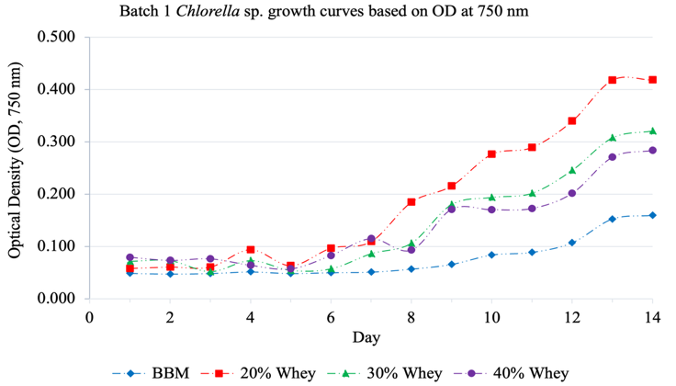
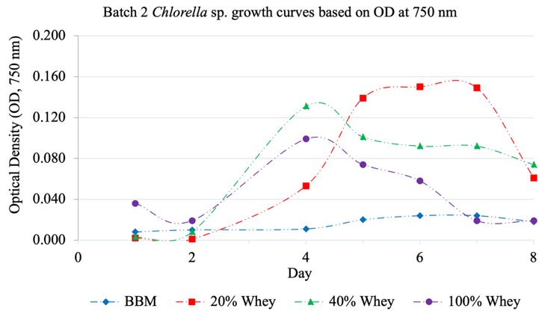
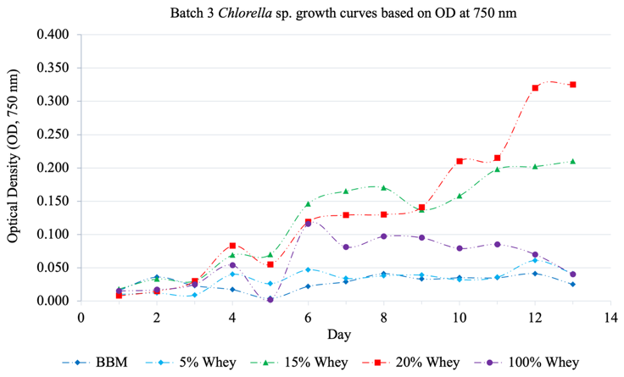
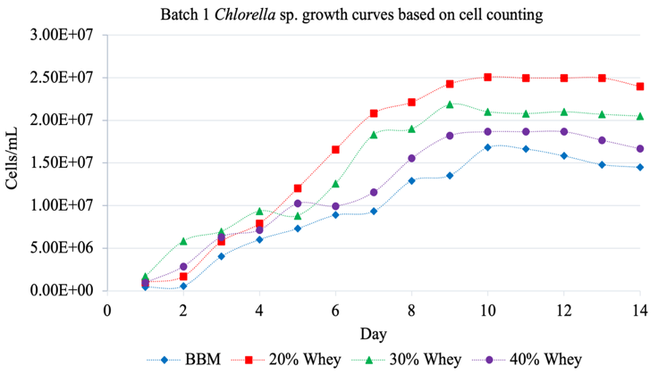
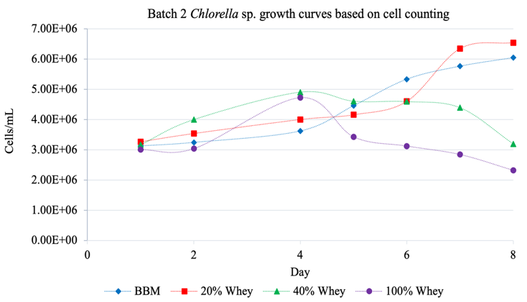
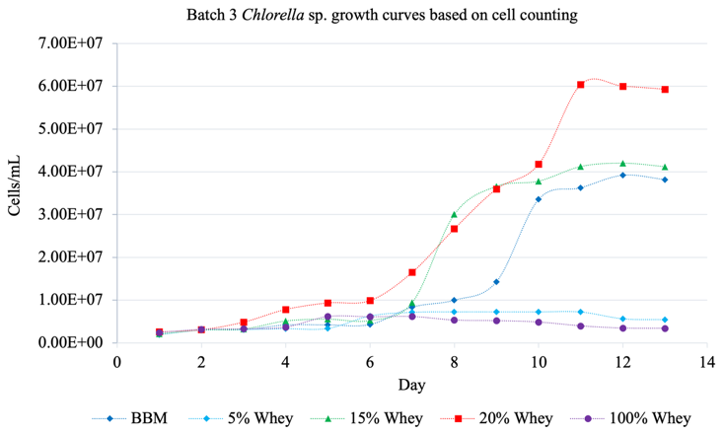
Figure. S1 Chlorella sp. growth across three independent batches, each testing different whey concentrations against a BBM (Bold's Basal Medium) control, measured two ways: cell counts (cells/mL) and optical density (OD at 750 nm).
Batch 1 (BBM, 20%, 30%, 40% whey; 14 days): The growth of microalgae in 20%, 30%, 40% cheese whey and in BBM was observed by daily O.D measurement and cell counting. The graphs of O.D. and cell counting were plotted against the corresponding days. Both analyses showed better growth of microalgae at 20% whey as compared to 30%, 40%, and BBM.
Batch 2 (BBM, 20%, 40%, 100% whey; 8 days): Comparing 20%, 30%, and 40% cheese whey and BBM, we found that the maximum growth of Chlorella sp. was shown by 20% cheese whey as compared with other concentrations and BBM. The microalgae in 40% and 100% whey were started declining after 4 days while the microalgae in 20% whey and BBM reached stationary phase within 8 days.
Batch 3 (BBM, 5%, 15%, 20%, 100% whey; 13 days): In this study, the growth of Chlorella in 5%, 15%, 20%, 100% cheese whey was compared with BBM. 20% whey showed the highest growth of Chlorella sp. via both O.D and cell counting.
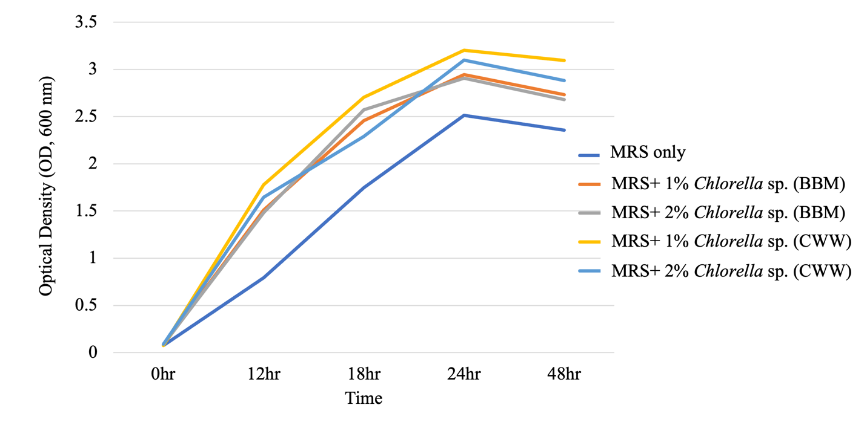
Figure. S2 Growth profile of Lactobacillus sp. under MRS medium supplemented with different concentration of Chlorella sp. biomass
The optical density at 600 nm of Lactobacillus sp. cultured in MRS supplemented with 1% Chlorella sp. biomass showed higher turbidity than the other supplementations and MRS alone.

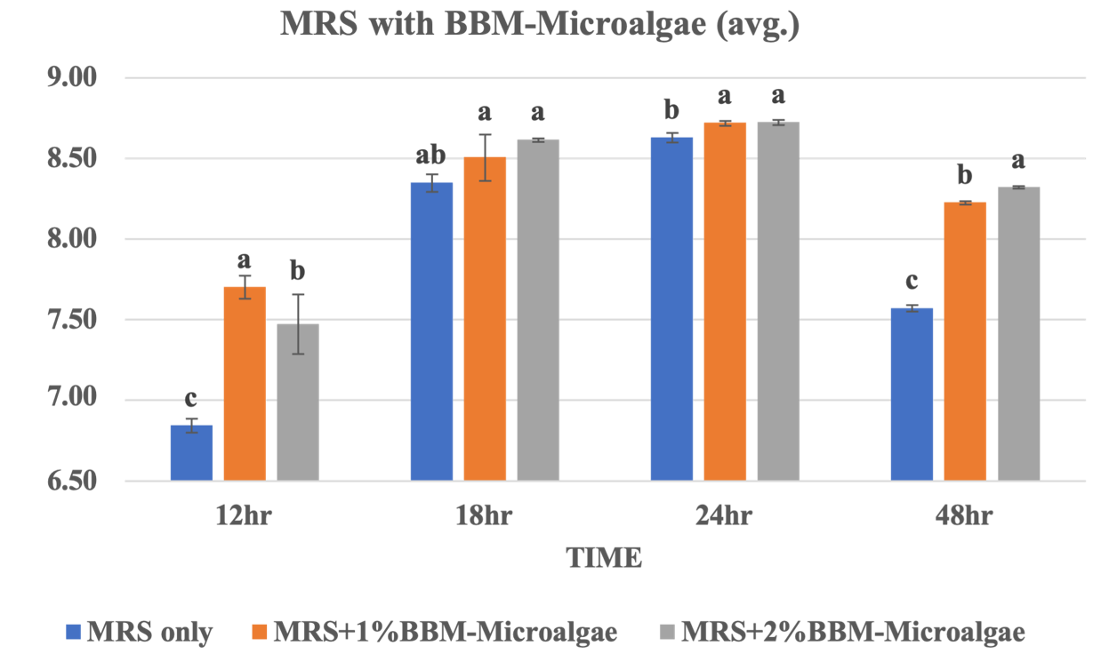
Figure. S3 MRS supplemented with BBM Chlorella sp. biomass (CFU/ml vs Time) bar diagram
Table S1. Lactobacillus sp. colonies count log (CFU/mL)
Time | MRS only | MRS+ 1% Chlorella sp. (CWW) | MRS+ 2% Chlorella sp. (CWW)
12hr | 7.52 | 8.41 | 7.08
18hr | 8.01 | 8.81 | 7.66
24hr | 8.69 | TNTC | TNTC
48hr | 7.51 | TNTC | TNTC

Table S2. Specific growth rate and doubling time of Lactobacillus sp.
Growth parameters | MRS only | MRS+ 1% Chlorella sp. (BBM) | MRS+ 2% Chlorella sp. (BBM) | MRS+ 1% Chlorella sp. (CWW) | MRS+ 2% Chlorella sp. (CWW)
Specific growth rate (hr⁻¹) | 0.0957 ± 0.006 | 0.149 ± 0.002 | 0.147 ± 0.002 | 0.155 ± 0.001 | 0.147 ± 0.001
Doubling time (hr) | 7.24 ± 0.08 | 4.64 ± 0.15 | 4.73 ± 0.08 | 4.46 ± 0.01 | 4.70 ± 0.01

The Figure. S3, Table S1., and Table S2. demonstrates that the supplementation of 1% Chlorella sp. biomass grown in CWW resulted in higher CFU/mL, a greater specific growth rate, and a shorter doubling time.
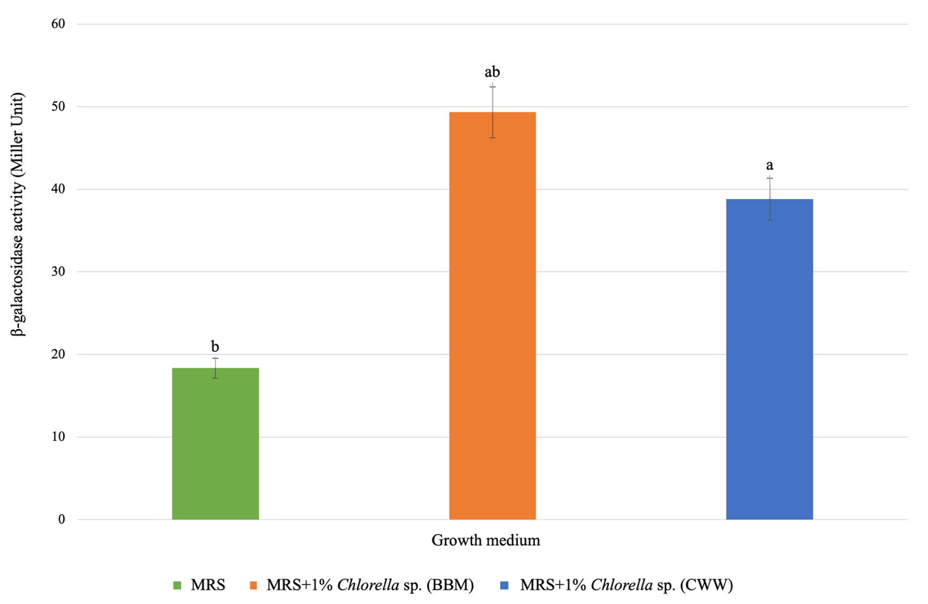 Figure. S4 This bar chart compares enzyme activity (Miller Units) of LpG3 grown in: MRS alone, MRS + 1% Chlorella biomass sourced from BBM cultures, and MRS + 1% Chlorella biomass sourced from CWW (whey) cultures.
- MRS alone: ~18 MU
- MRS + BBM-grown Chlorella sp.: ~49 MU
- MRS + CWW-grown Chlorella sp.: ~39 MU

