Supplemental Information
Carbon abatement costs are negative for many electric vehicles across U.S. cities
Maxwell Woody and Gregory A. Keoleian
85 Pages
87 Figures
25 Tables
-----------------------------------------------------------------------------------------------------------------------------
Supplemental Note 1: Results 2
Cost and Emissions Breakdowns by Component for Each City 2
Heatmaps for Each City 22
Total Cost and Emissions for Each Vehicle Class 29
Breakeven Times for Each City 34
Charging Strategies for Each Vehicle Class 36
Abatement Costs by Charging Strategy 42
Abatement Costs for Sensitivity Analyses 49
Supplemental Note 2: Parameters 52
Vehicle Parameters 52
Vehicle Lifetimes 55
Fuel Economy Adjustments 58
Supplemental Note 3: Life Cycle Greenhouse Gas Emissions 61
Home Charger 61
Vehicle Cycle 62
Fuel Cycle 63
Grid Emissions Factors 63
Supplemental Note 4: Total Cost of Ownership 66
Upfront Cost 66
Down Payment 66
Taxes and Fees 66
Home Charger 67
Recurring Cost 68
Fuel 68
Insurance 75
Financing 76
Maintenance 77
Repairs 79
Annual Fees 80
Supplemental References 84

Supplemental Note 1: Results
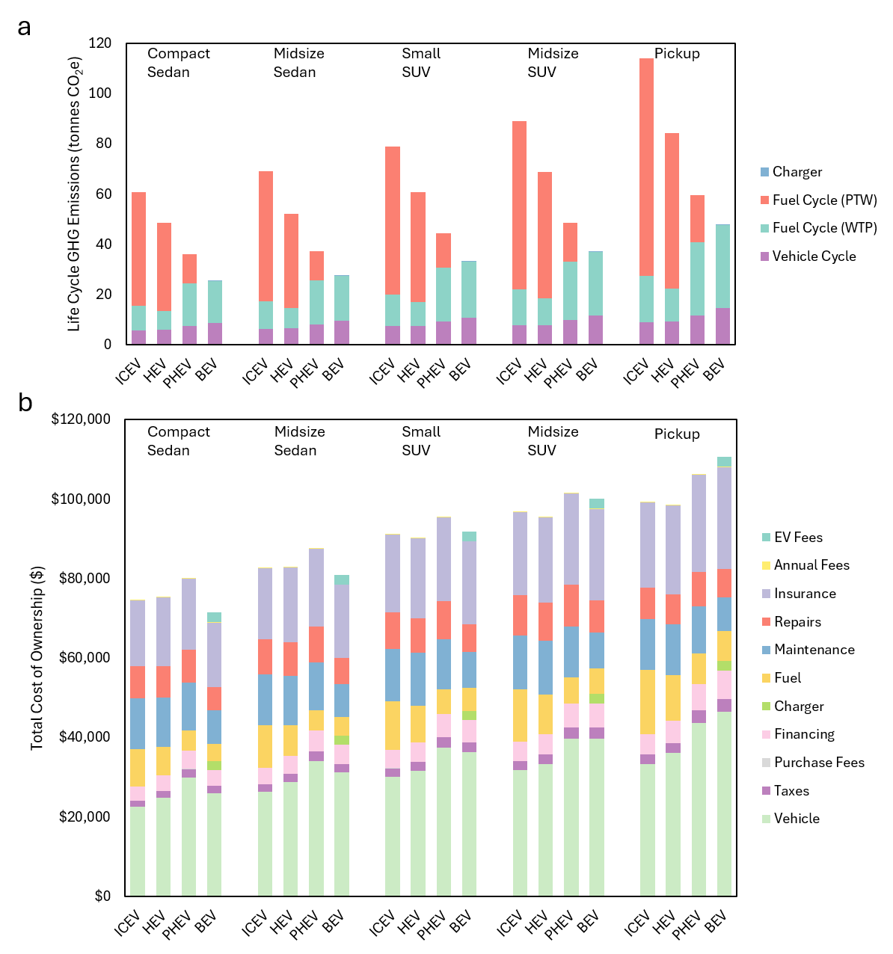
Supplemental Fig. 1. Life cycle greenhouse gas emissions and total cost of ownership by component
a-b, Over the entire vehicle lifespan, the life cycle greenhouse gas emissions broken down by stage (a), the total cost of ownership broken down by cost component (b), in Atlanta
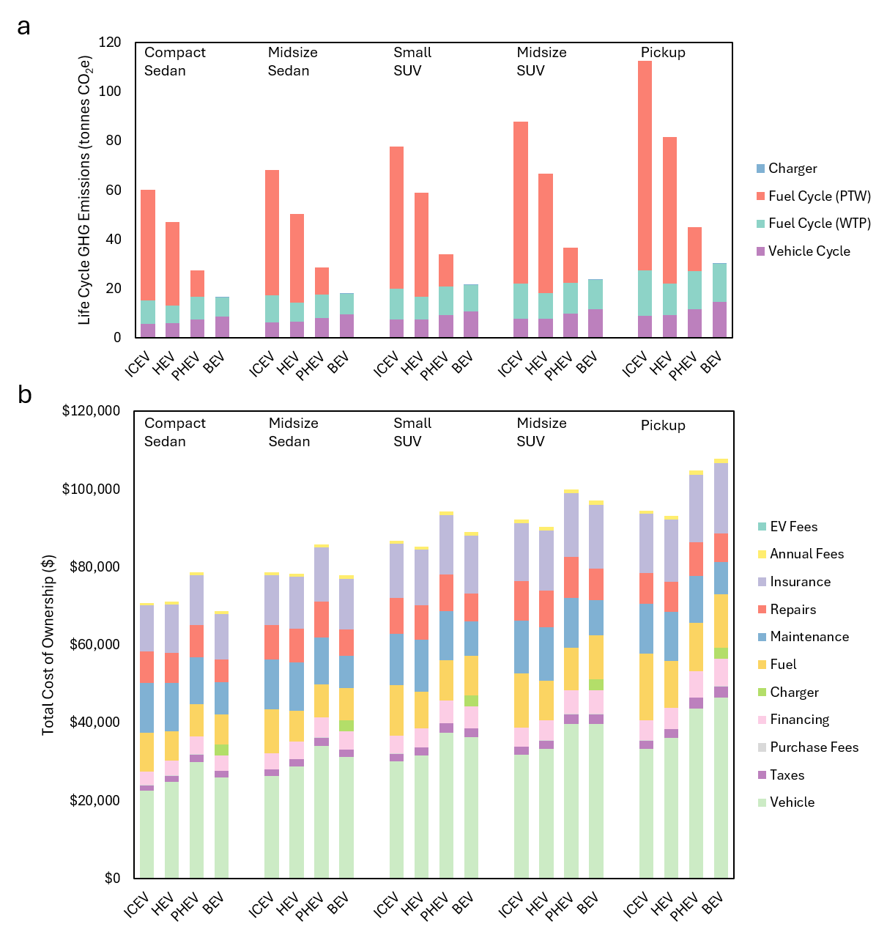
Supplemental Fig. 2. Life cycle greenhouse gas emissions and total cost of ownership by component
a-b, Over the entire vehicle lifespan, the life cycle greenhouse gas emissions broken down by stage (a), the total cost of ownership broken down by cost component (b), in Boston

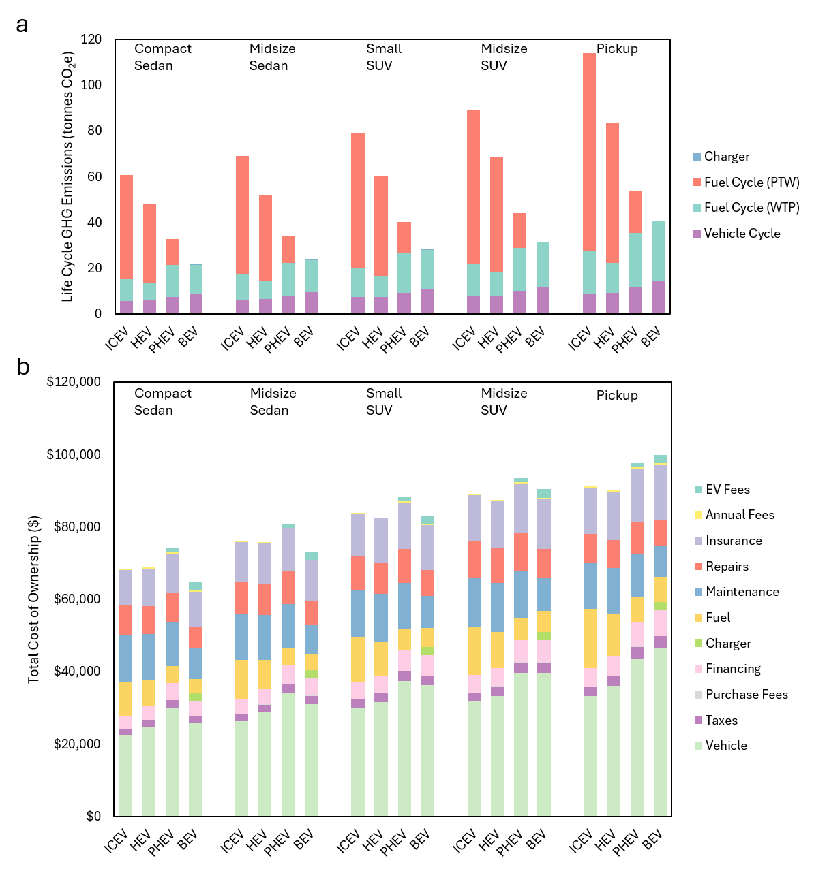
Supplemental Fig. 3. Life cycle greenhouse gas emissions and total cost of ownership by component
a-b, Over the entire vehicle lifespan, the life cycle greenhouse gas emissions broken down by stage (a), the total cost of ownership broken down by cost component (b), in Charlotte

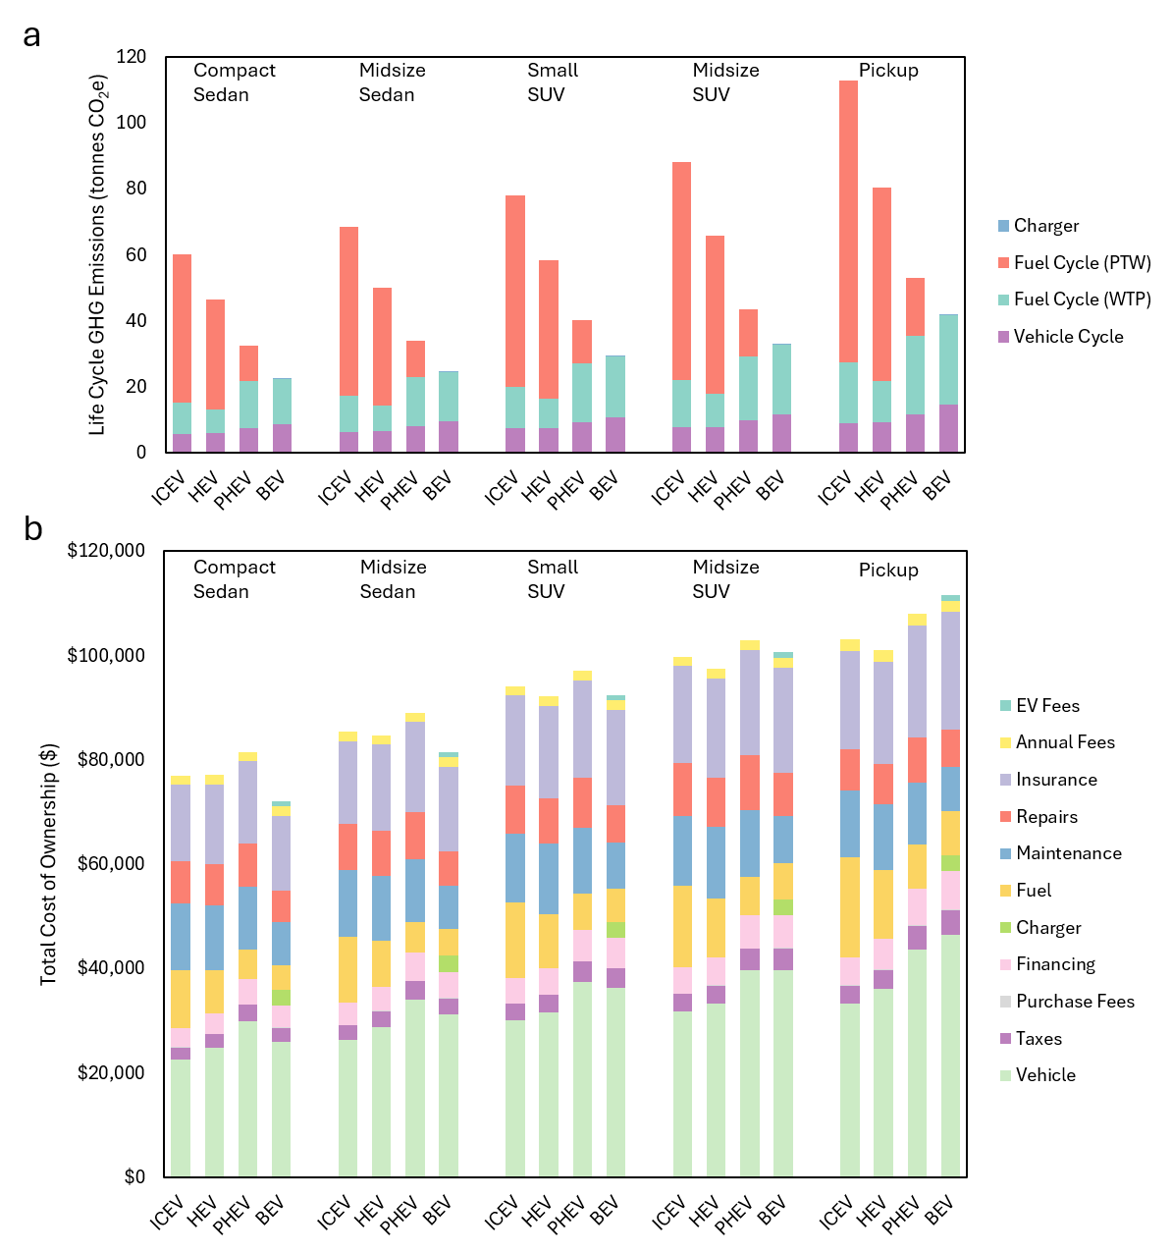
Supplemental Fig. 4. Life cycle greenhouse gas emissions and total cost of ownership by component
a-b, Over the entire vehicle lifespan, the life cycle greenhouse gas emissions broken down by stage (a), the total cost of ownership broken down by cost component (b), in Chicago

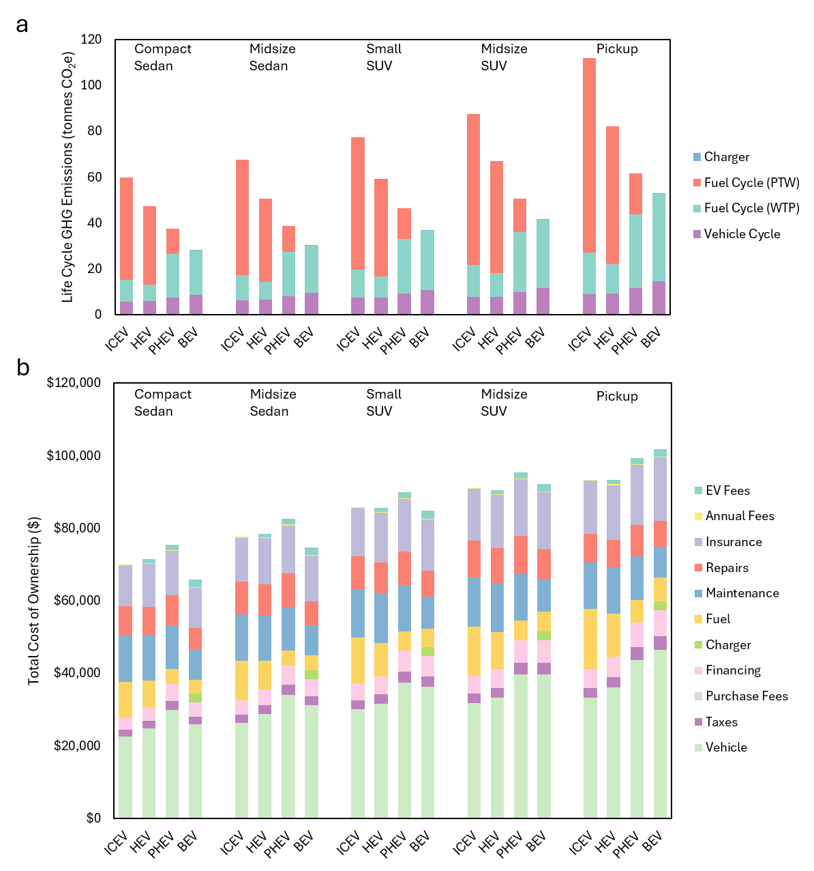
Supplemental Fig. 5. Life cycle greenhouse gas emissions and total cost of ownership by component
a-b, Over the entire vehicle lifespan, the life cycle greenhouse gas emissions broken down by stage (a), the total cost of ownership broken down by cost component (b), in Cleveland
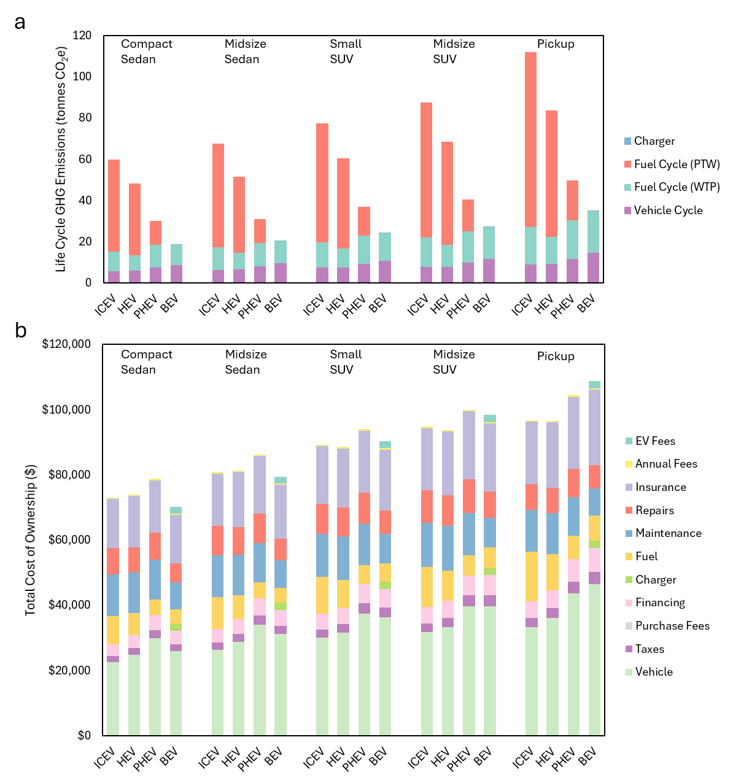
Supplemental Fig. 6. Life cycle greenhouse gas emissions and total cost of ownership by component
a-b, Over the entire vehicle lifespan, the life cycle greenhouse gas emissions broken down by stage (a), the total cost of ownership broken down by cost component (b), in Dallas

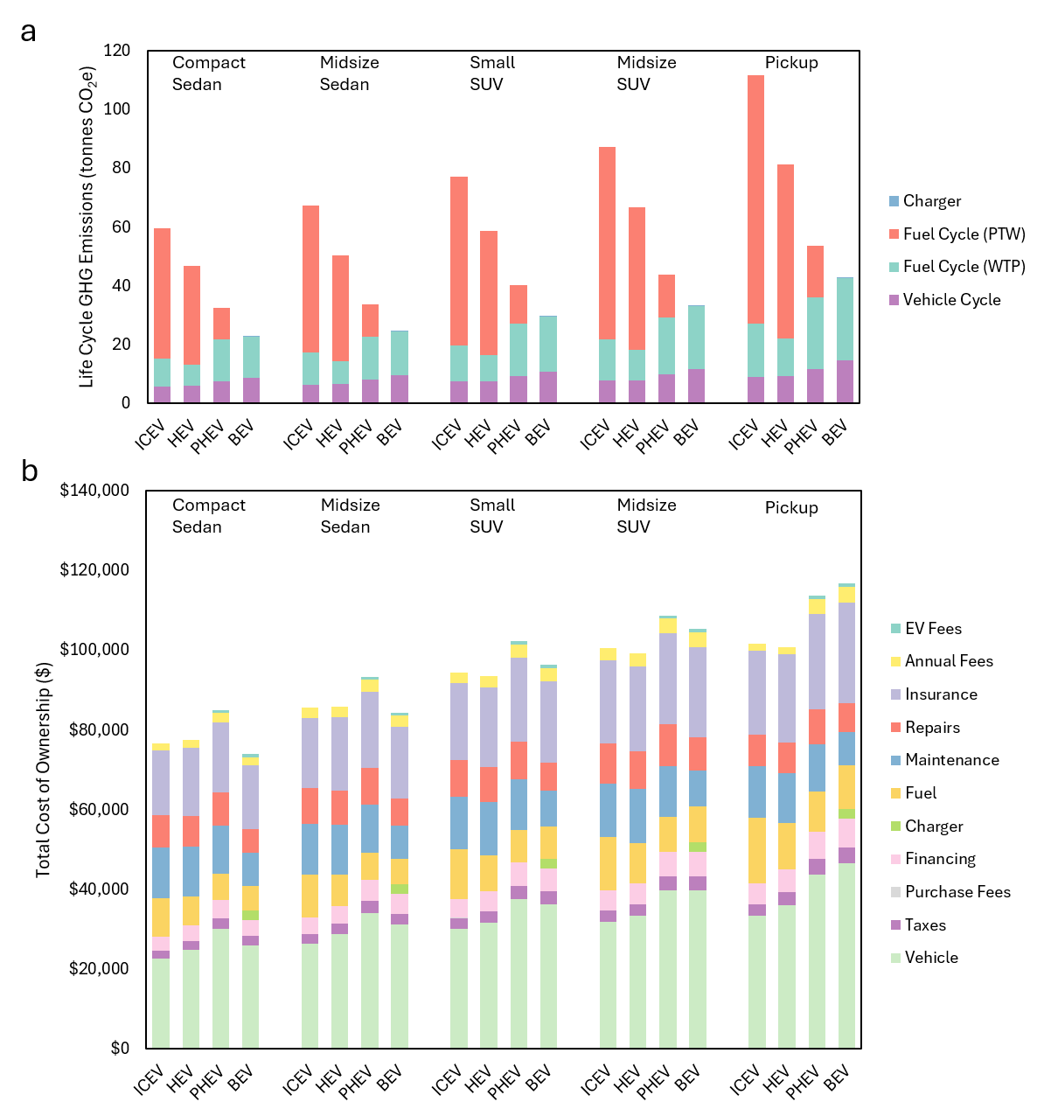
Supplemental Fig. 7. Life cycle greenhouse gas emissions and total cost of ownership by component
a-b, Over the entire vehicle lifespan, the life cycle greenhouse gas emissions broken down by stage (a), the total cost of ownership broken down by cost component (b), in Denver

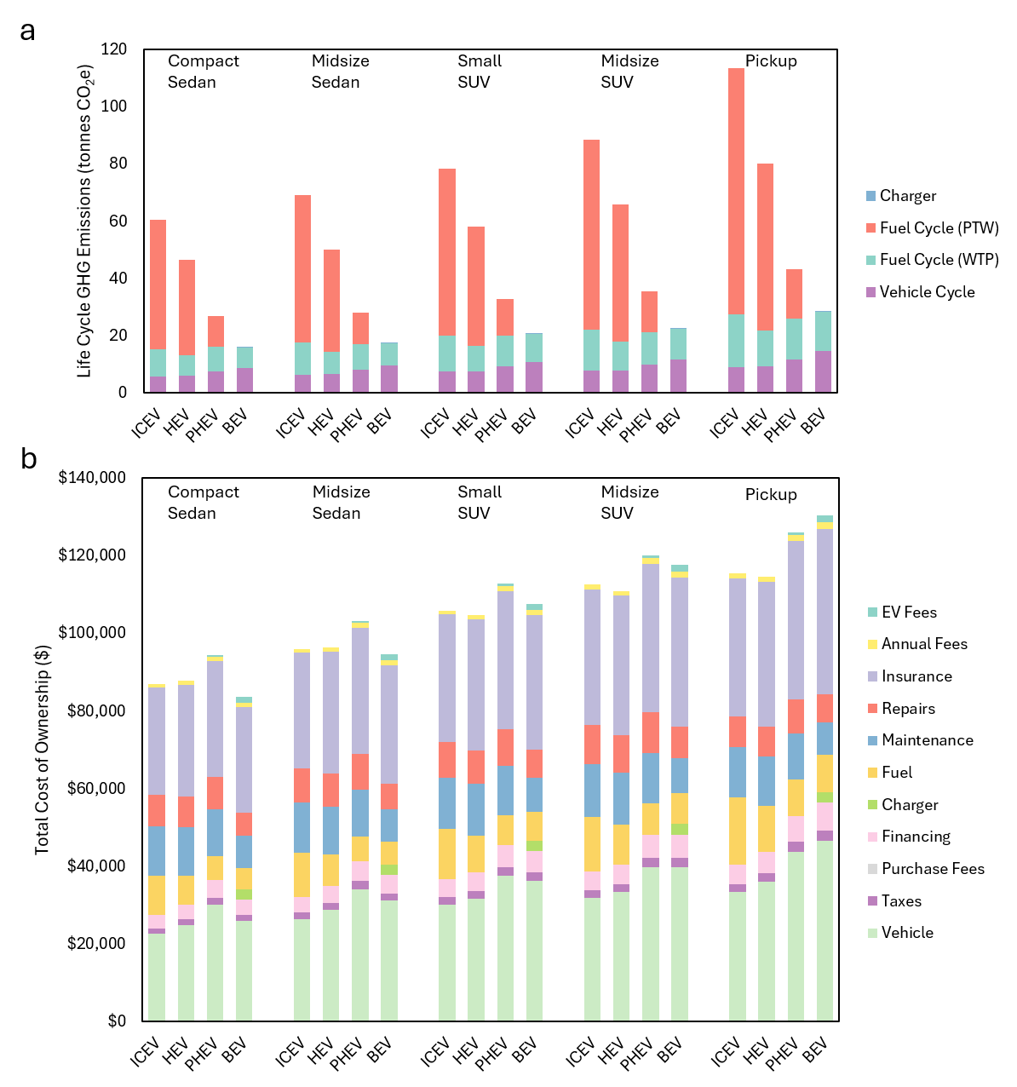
Supplemental Fig. 8. Life cycle greenhouse gas emissions and total cost of ownership by component
a-b, Over the entire vehicle lifespan, the life cycle greenhouse gas emissions broken down by stage (a), the total cost of ownership broken down by cost component (b), in Detroit

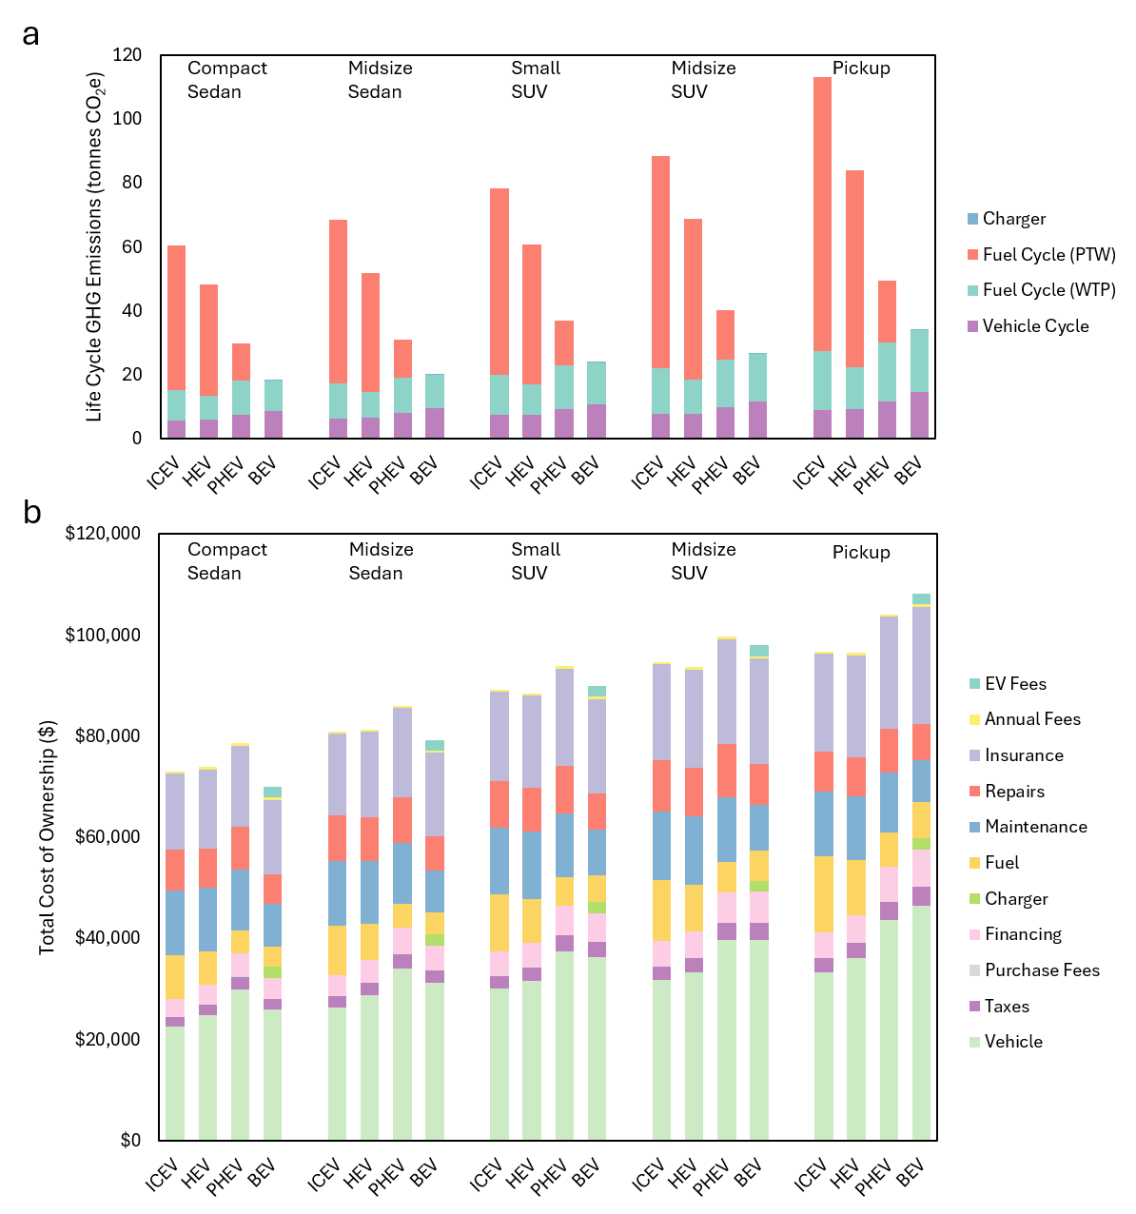
Supplemental Fig. 9. Life cycle greenhouse gas emissions and total cost of ownership by component
a-b, Over the entire vehicle lifespan, the life cycle greenhouse gas emissions broken down by stage (a), the total cost of ownership broken down by cost component (b), in Houston

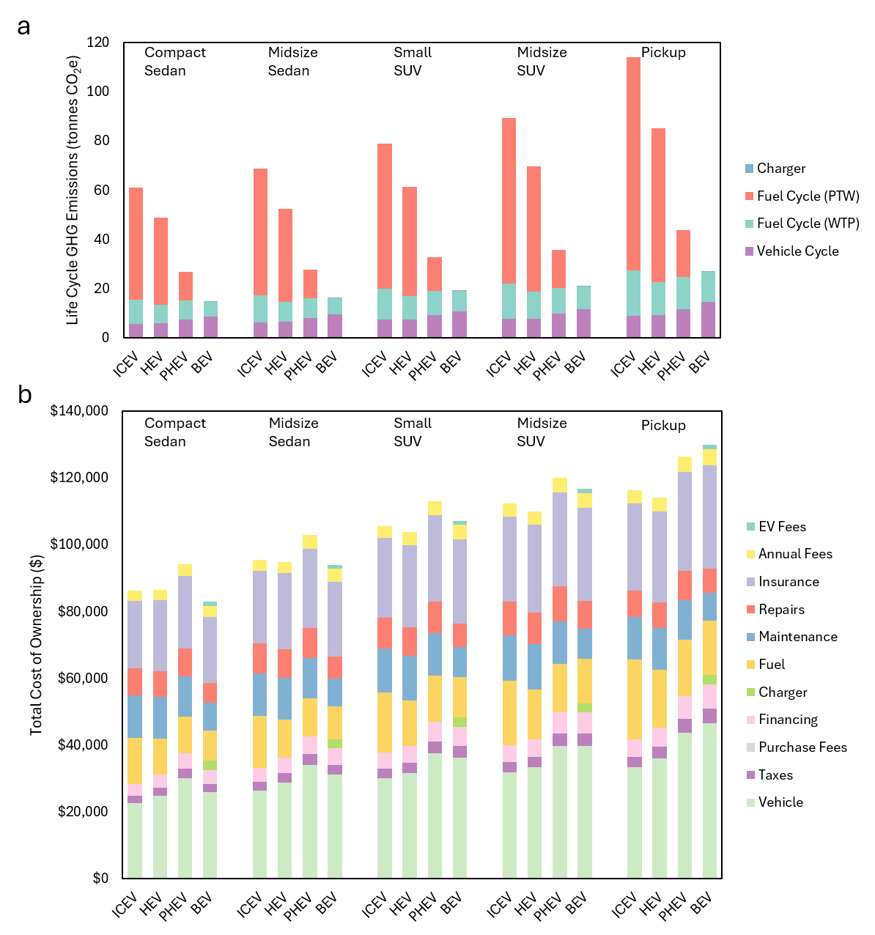
Supplemental Fig. 10. Life cycle greenhouse gas emissions and total cost of ownership by component
a-b, Over the entire vehicle lifespan, the life cycle greenhouse gas emissions broken down by stage (a), the total cost of ownership broken down by cost component (b), in Los Angeles
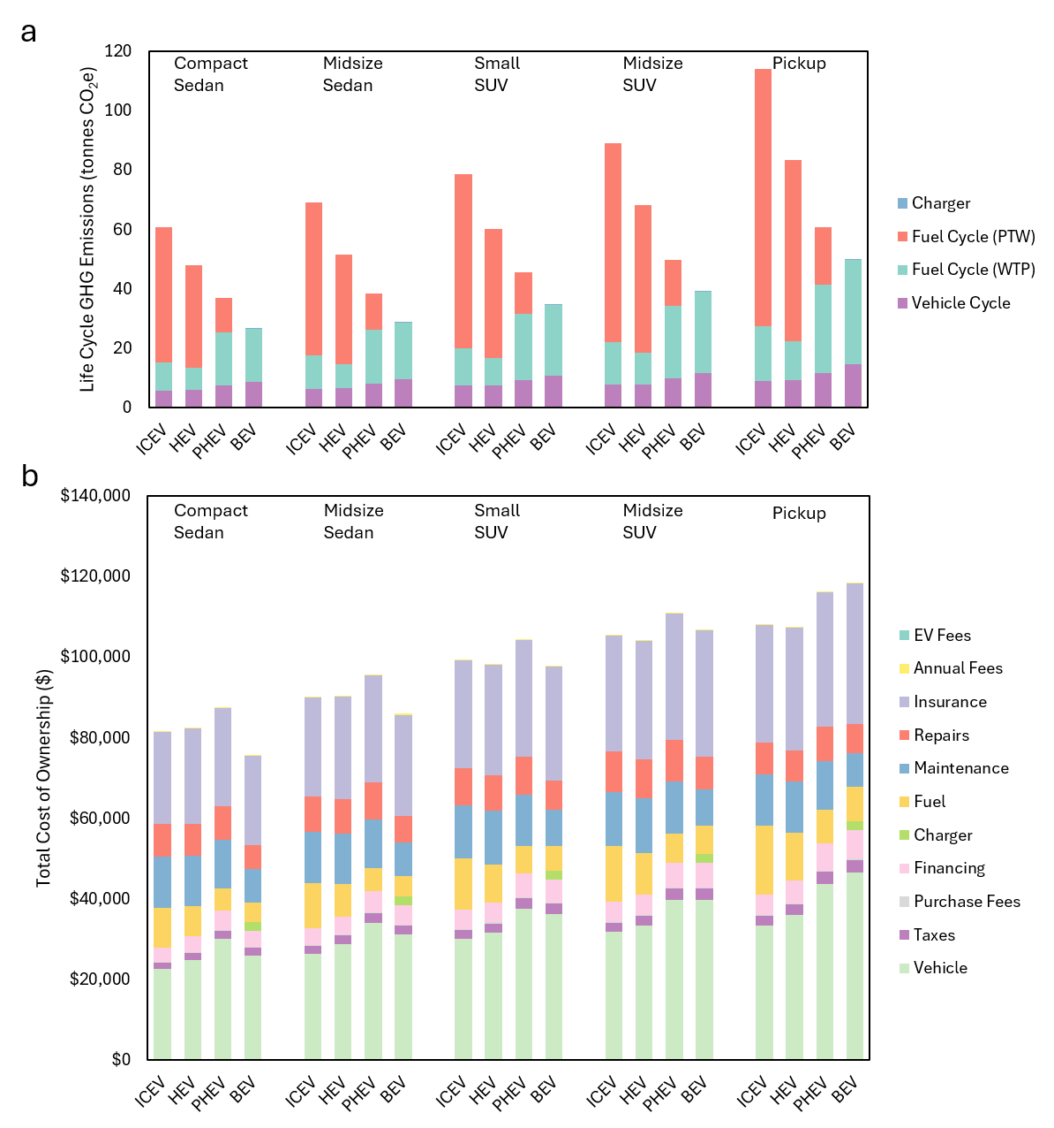
Supplemental Fig. 11. Life cycle greenhouse gas emissions and total cost of ownership by component
a-b, Over the entire vehicle lifespan, the life cycle greenhouse gas emissions broken down by stage (a), the total cost of ownership broken down by cost component (b), in Miami

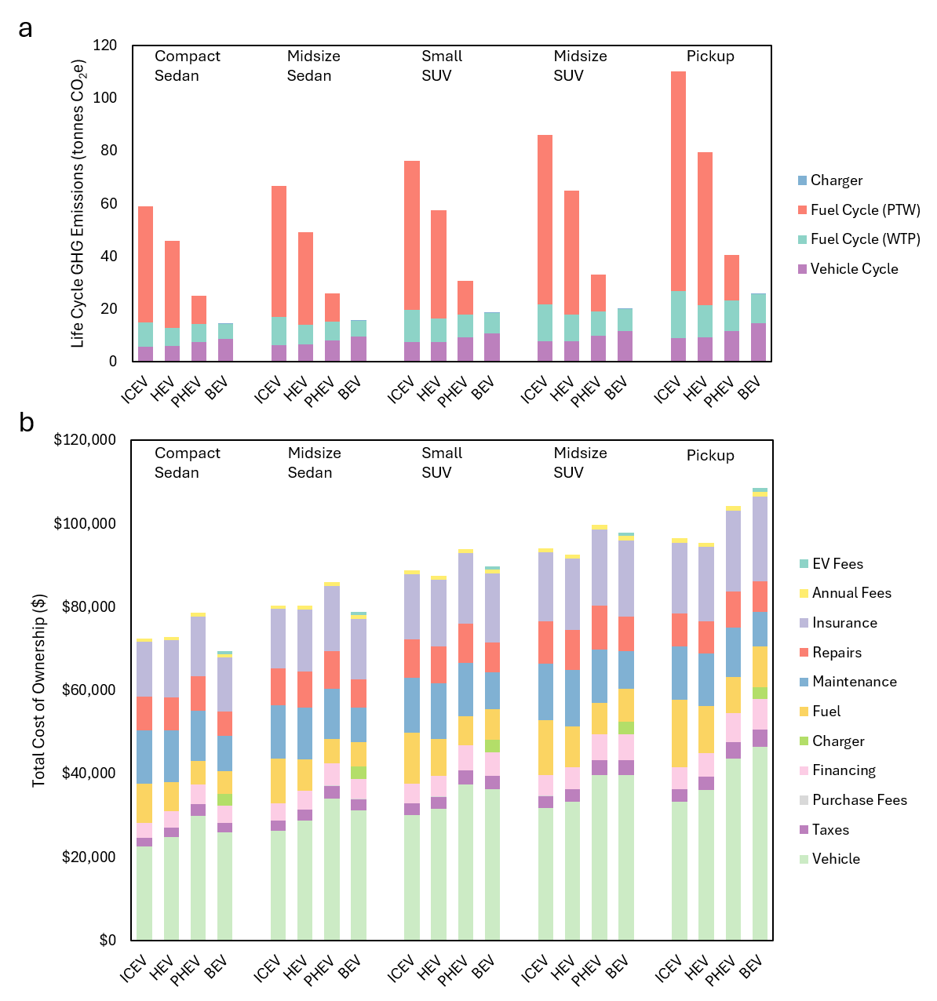
Supplemental Fig. 12. Life cycle greenhouse gas emissions and total cost of ownership by component
a-b, Over the entire vehicle lifespan, the life cycle greenhouse gas emissions broken down by stage (a), the total cost of ownership broken down by cost component (b), in Minneapolis

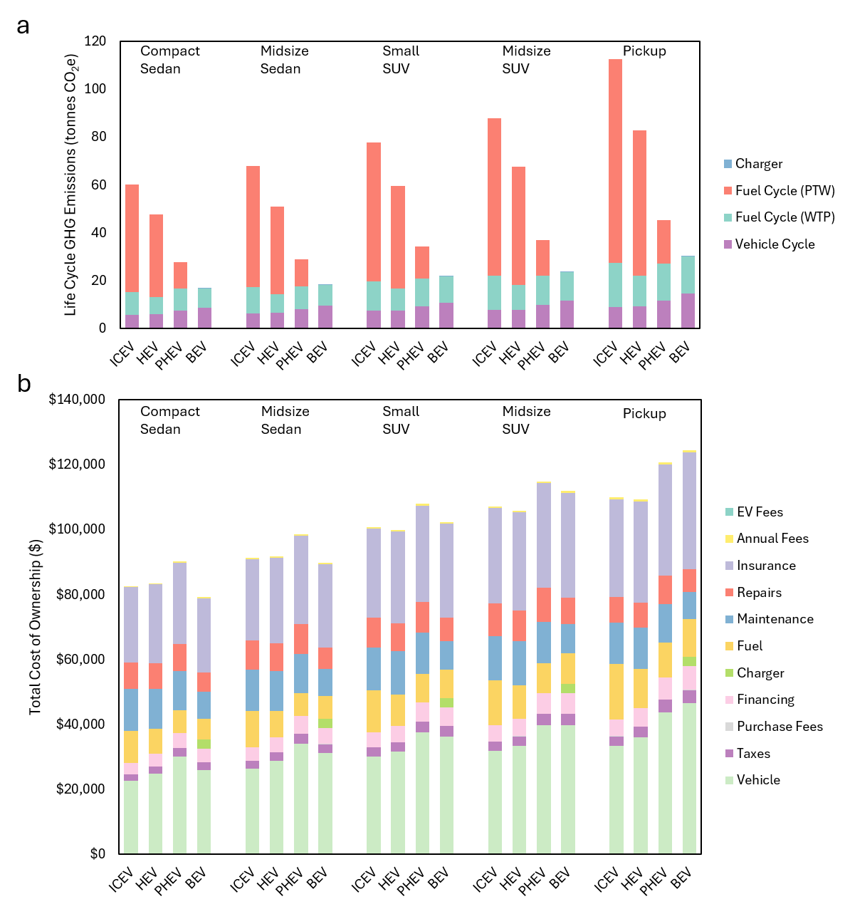
Supplemental Fig. 13. Life cycle greenhouse gas emissions and total cost of ownership by component
a-b, Over the entire vehicle lifespan, the life cycle greenhouse gas emissions broken down by stage (a), the total cost of ownership broken down by cost component (b), in New York City

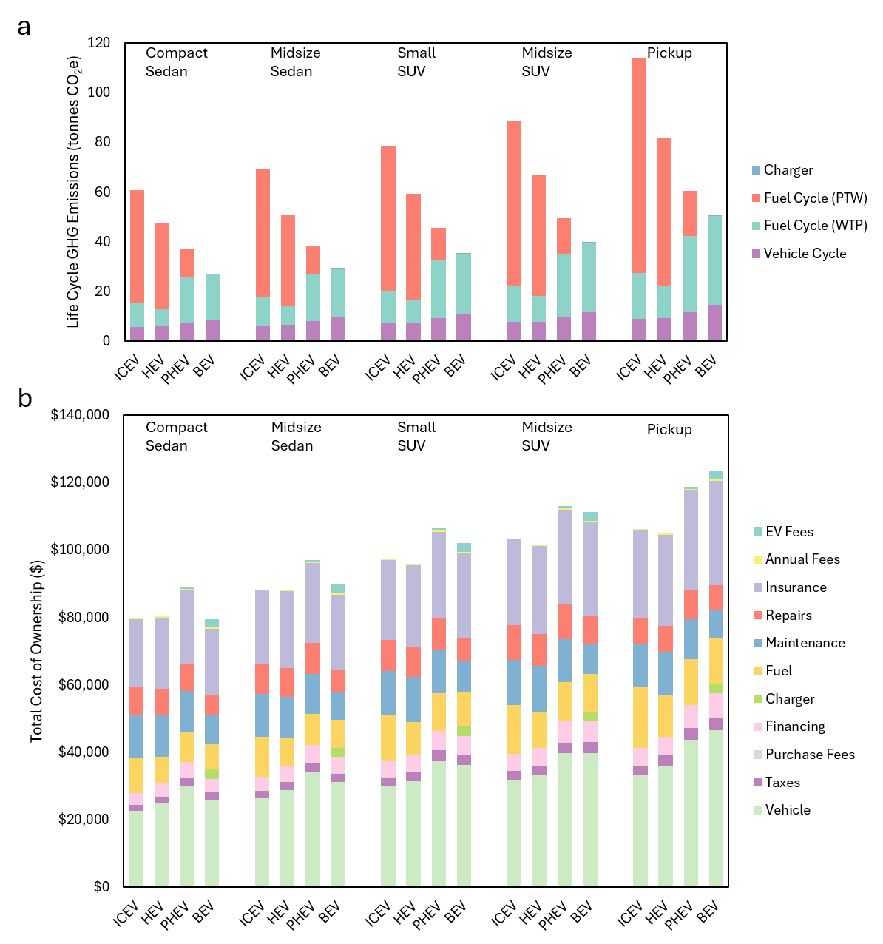
Supplemental Fig. 14. Life cycle greenhouse gas emissions and total cost of ownership by component
a-b, Over the entire vehicle lifespan, the life cycle greenhouse gas emissions broken down by stage (a), the total cost of ownership broken down by cost component (b), in Philadelphia

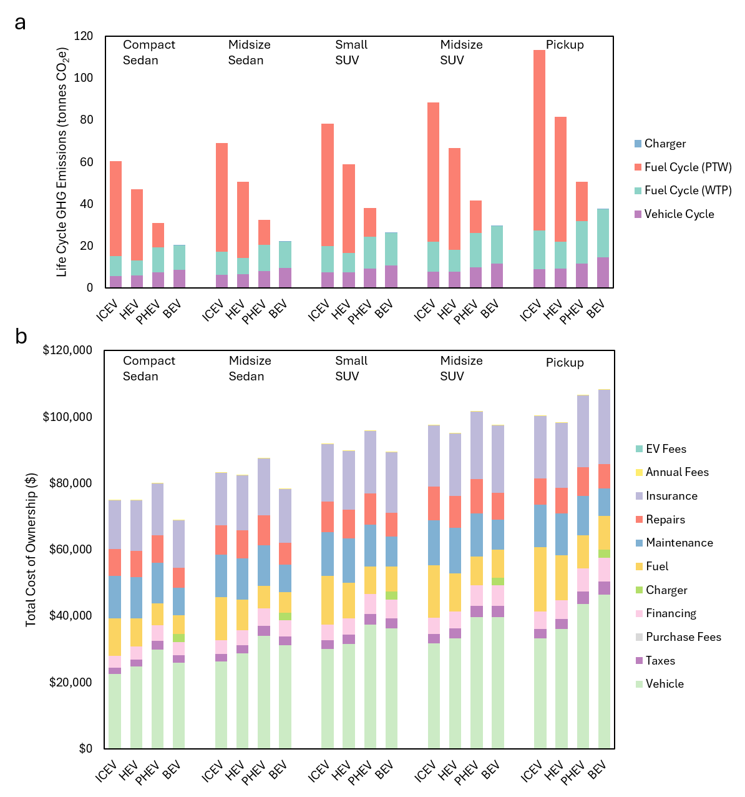
Supplemental Fig. 15. Life cycle greenhouse gas emissions and total cost of ownership by component
a-b, Over the entire vehicle lifespan, the life cycle greenhouse gas emissions broken down by stage (a), the total cost of ownership broken down by cost component (b), in Phoenix

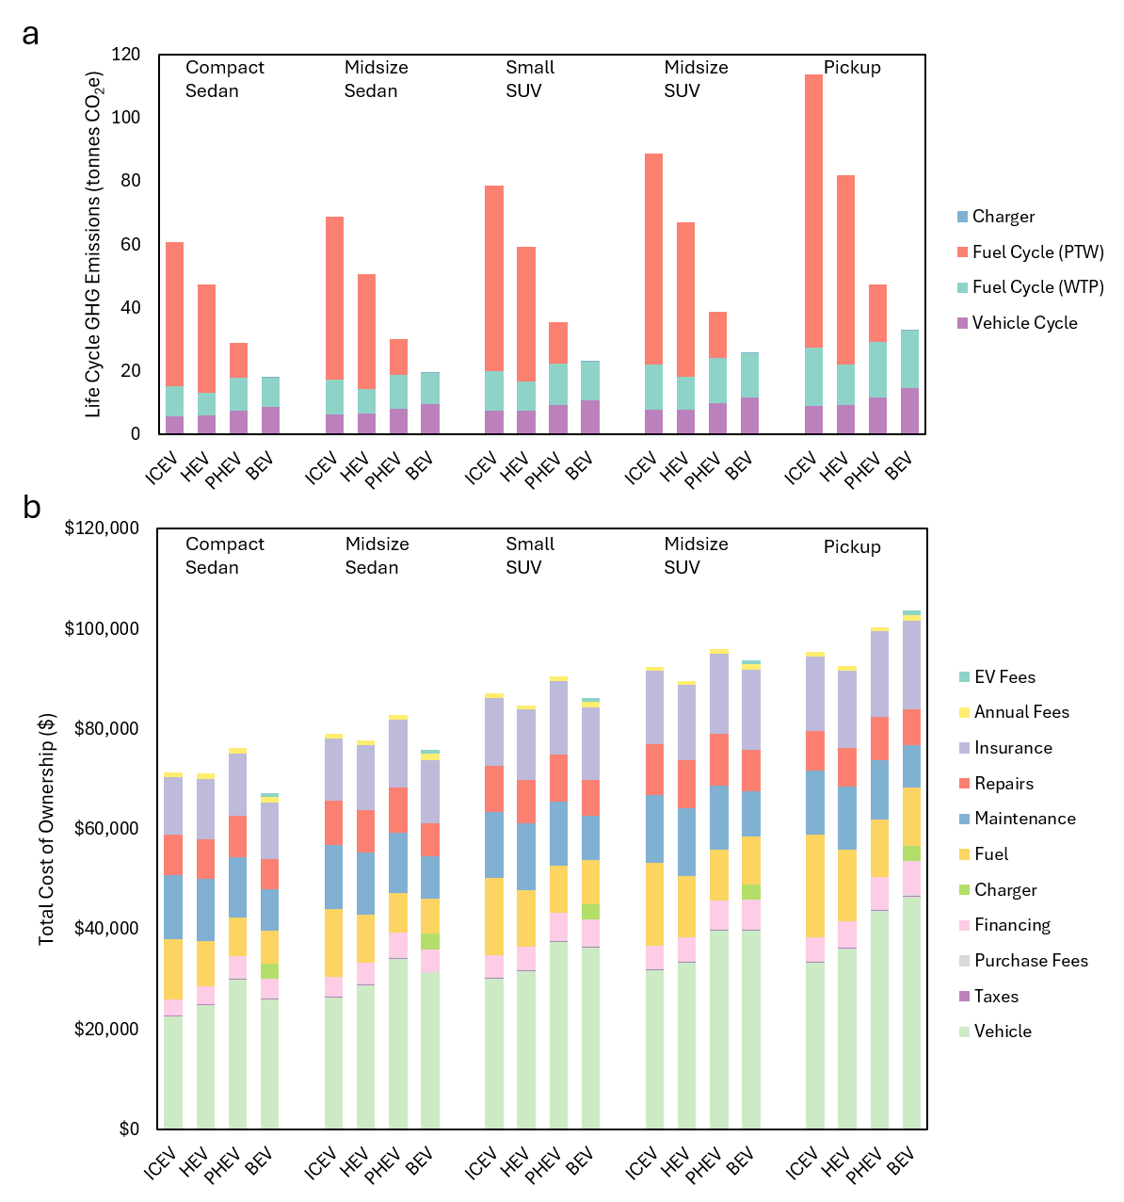
Supplemental Fig. 16. Life cycle greenhouse gas emissions and total cost of ownership by component
a-b, Over the entire vehicle lifespan, the life cycle greenhouse gas emissions broken down by stage (a), the total cost of ownership broken down by cost component (b), in Portland

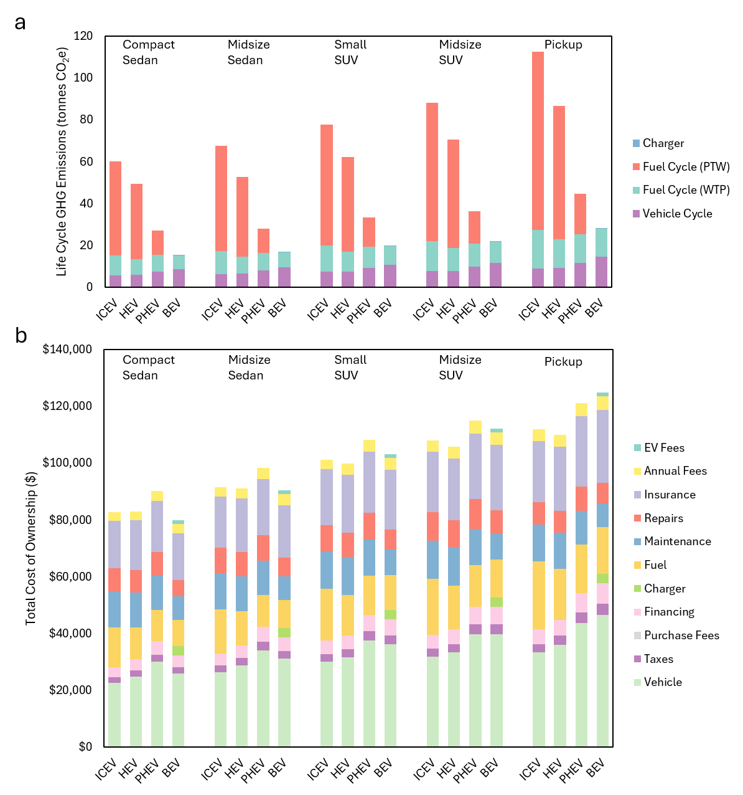
Supplemental Fig. 17. Life cycle greenhouse gas emissions and total cost of ownership by component
a-b, Over the entire vehicle lifespan, the life cycle greenhouse gas emissions broken down by stage (a), the total cost of ownership broken down by cost component (b), in San Francisco

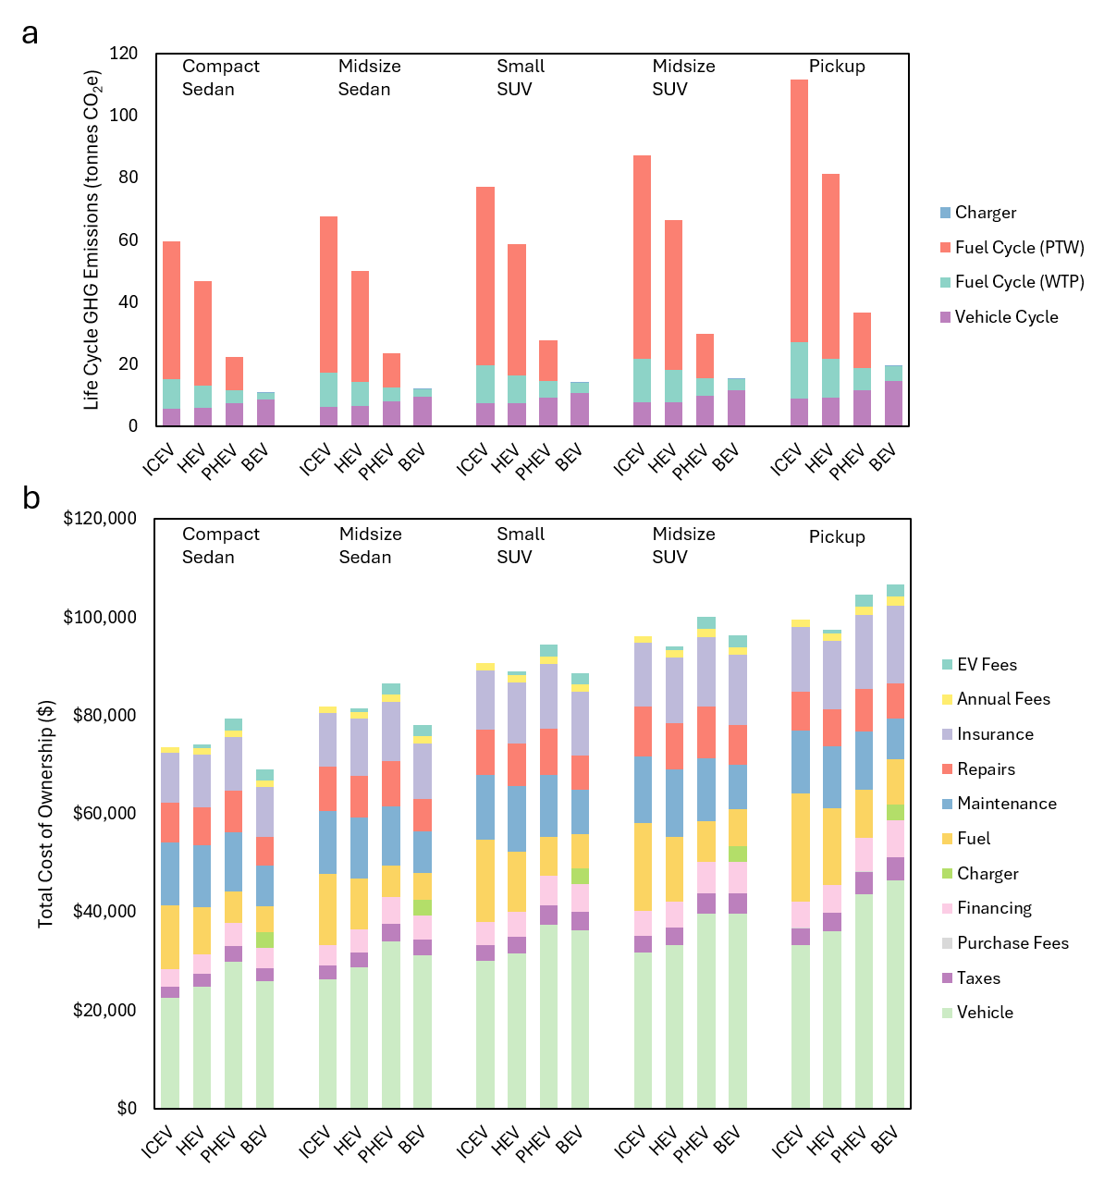
Supplemental Fig. 18. Life cycle greenhouse gas emissions and total cost of ownership by component
a-b, Over the entire vehicle lifespan, the life cycle greenhouse gas emissions broken down by stage (a), the total cost of ownership broken down by cost component (b), in Seattle

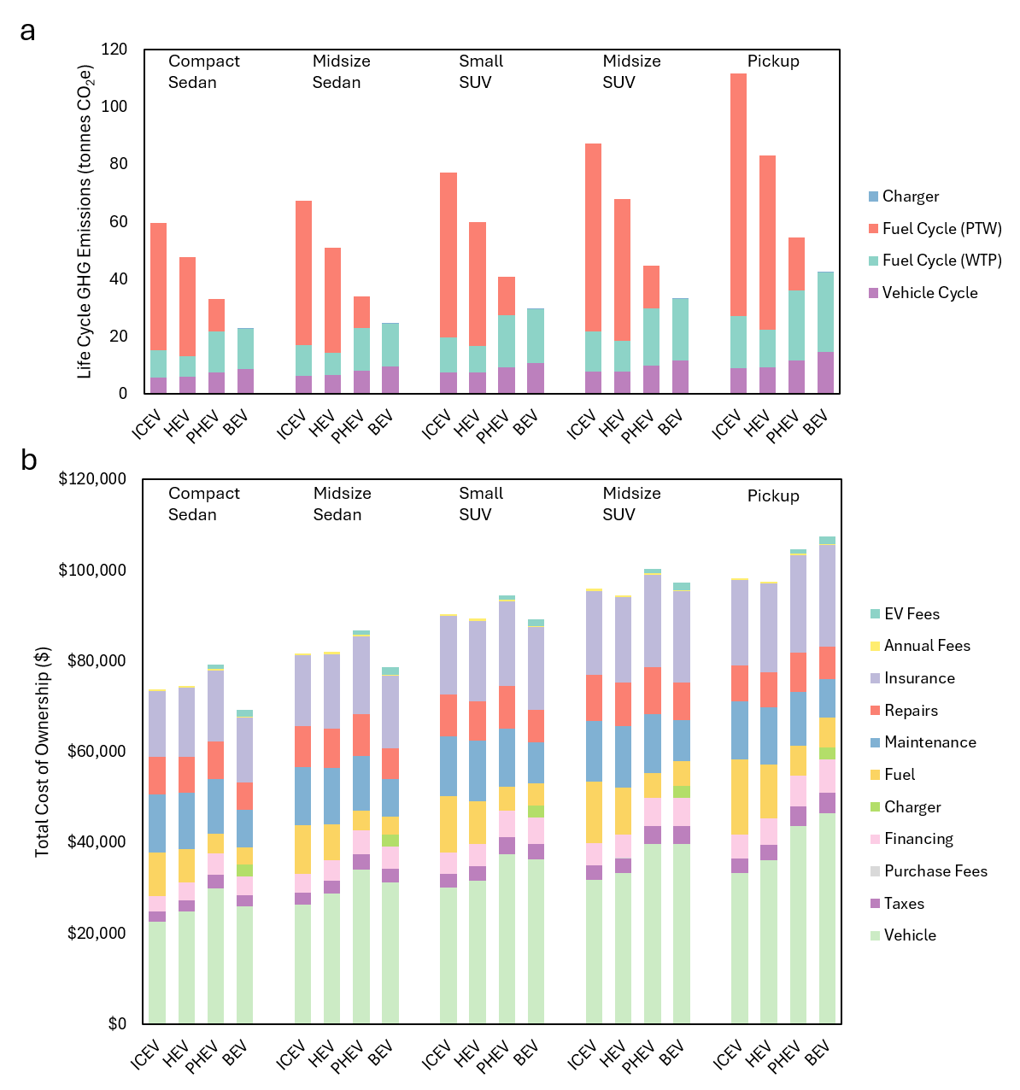
Supplemental Fig. 19. Life cycle greenhouse gas emissions and total cost of ownership by component
a-b, Over the entire vehicle lifespan, the life cycle greenhouse gas emissions broken down by stage (a), the total cost of ownership broken down by cost component (b), in St. Louis

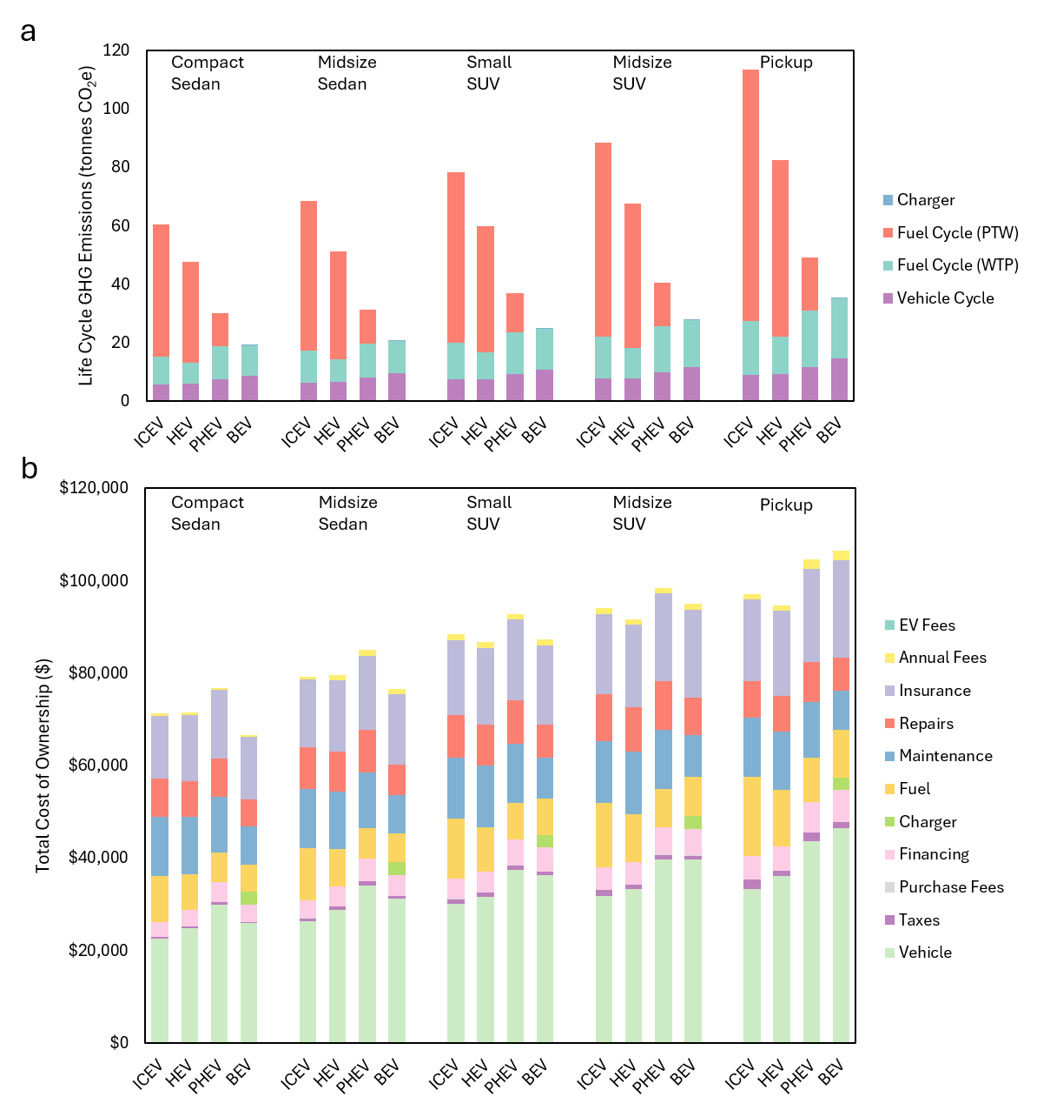
Supplemental Fig. 20. Life cycle greenhouse gas emissions and total cost of ownership by component
a-b, Over the entire vehicle lifespan, the life cycle greenhouse gas emissions broken down by stage (a), the total cost of ownership broken down by cost component (b), in Washington, DC

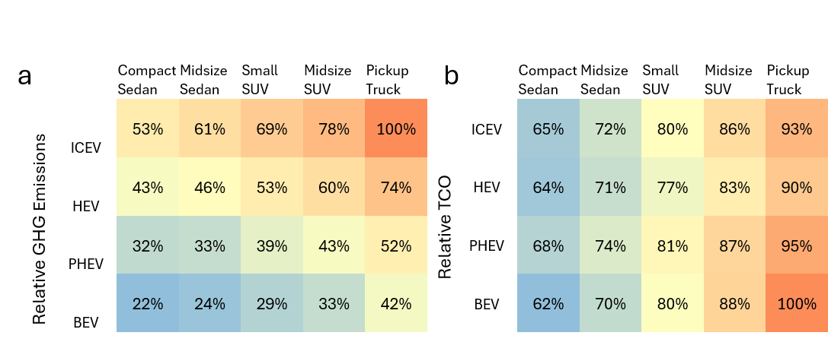
Supplemental Fig. 21. Relative cost and emissions in Atlanta
a-b, The life cycle GHG emissions relative to the highest emitting vehicle (a), and the total cost of ownership relative to the most costly vehicle (b), in Atlanta
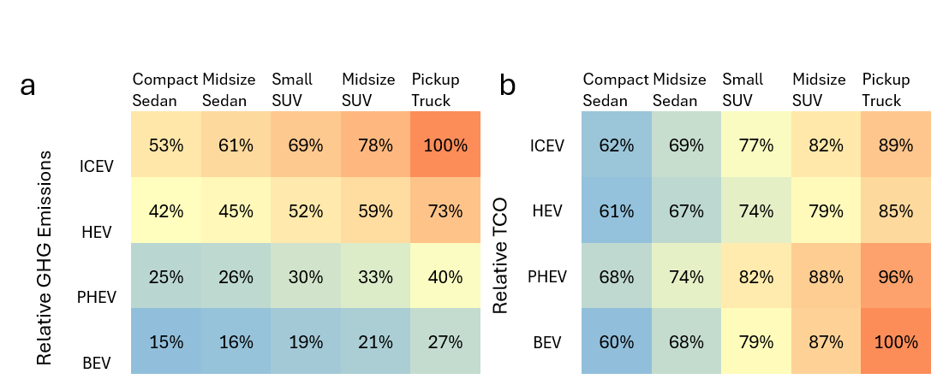
Supplemental Fig. 22. Relative cost and emissions in Boston
a-b, The life cycle GHG emissions relative to the highest emitting vehicle (a), and the total cost of ownership relative to the most costly vehicle (b), in Boston
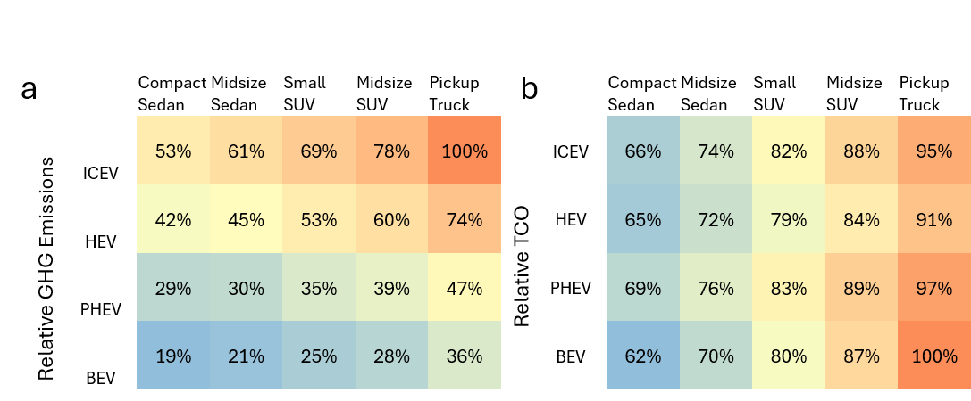
Supplemental Fig. 23. Relative cost and emissions in Charlotte
a-b, The life cycle GHG emissions relative to the highest emitting vehicle (a), and the total cost of ownership relative to the most costly vehicle (b), in Charlotte
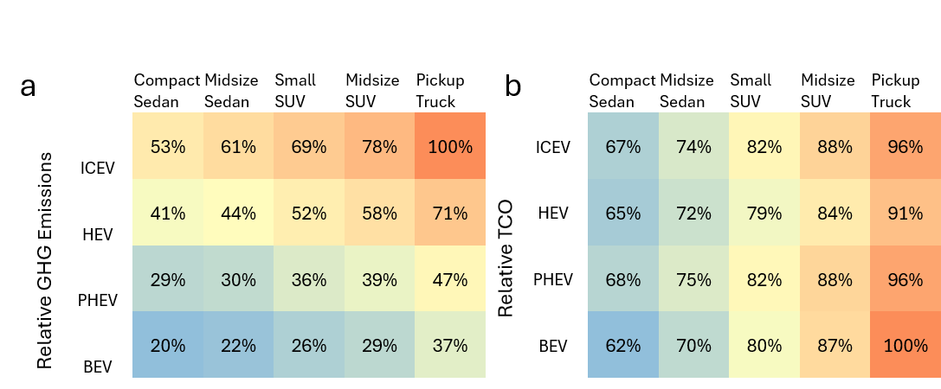
Supplemental Fig. 24. Relative cost and emissions in Chicago
a-b, The life cycle GHG emissions relative to the highest emitting vehicle (a), and the total cost of ownership relative to the most costly vehicle (b), in Chicago
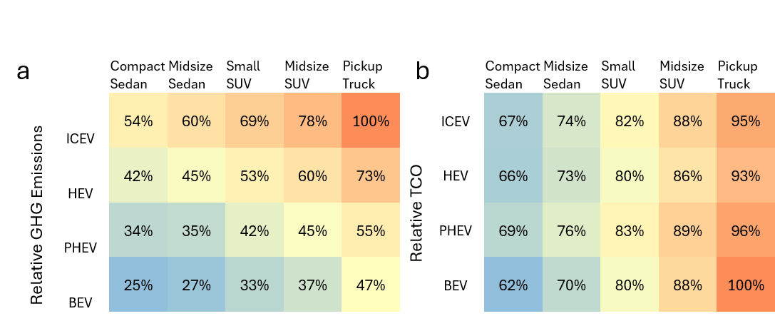
Supplemental Fig. 25. Relative cost and emissions in Cleveland
a-b, The life cycle GHG emissions relative to the highest emitting vehicle (a), and the total cost of ownership relative to the most costly vehicle (b), in Cleveland
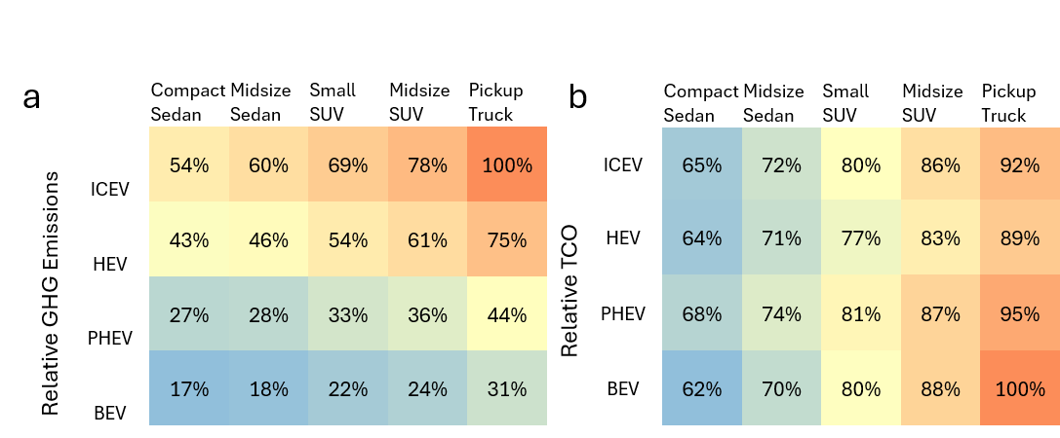
Supplemental Fig. 26. Relative cost and emissions in Dallas
a-b, The life cycle GHG emissions relative to the highest emitting vehicle (a), and the total cost of ownership relative to the most costly vehicle (b), in Dallas
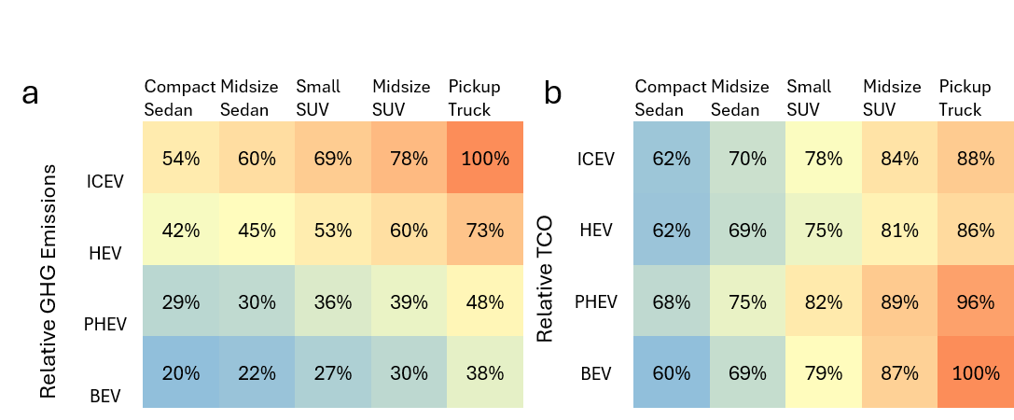
Supplemental Fig. 27. Relative cost and emissions in Denver
a-b, The life cycle GHG emissions relative to the highest emitting vehicle (a), and the total cost of ownership relative to the most costly vehicle (b), in Denver
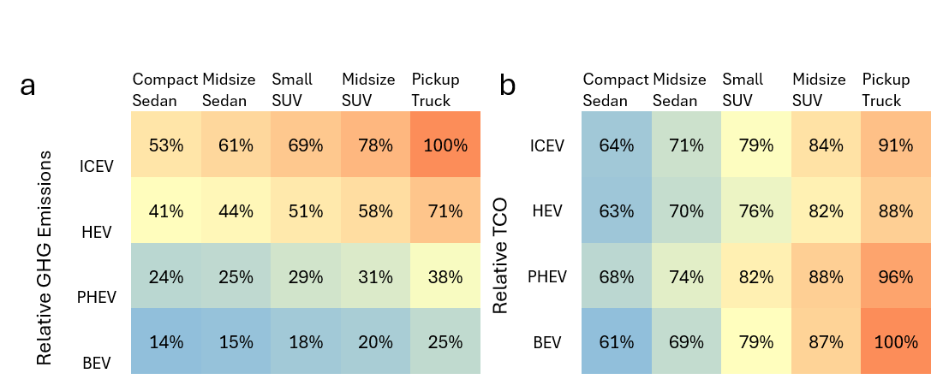
Supplemental Fig. 28. Relative cost and emissions in Detroit
a-b, The life cycle GHG emissions relative to the highest emitting vehicle (a), and the total cost of ownership relative to the most costly vehicle (b), in Detroit
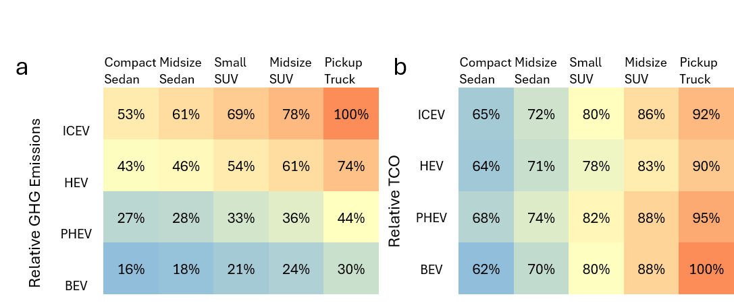
Supplemental Fig. 29. Relative cost and emissions in Houston
a-b, The life cycle GHG emissions relative to the highest emitting vehicle (a), and the total cost of ownership relative to the most costly vehicle (b), in Houston
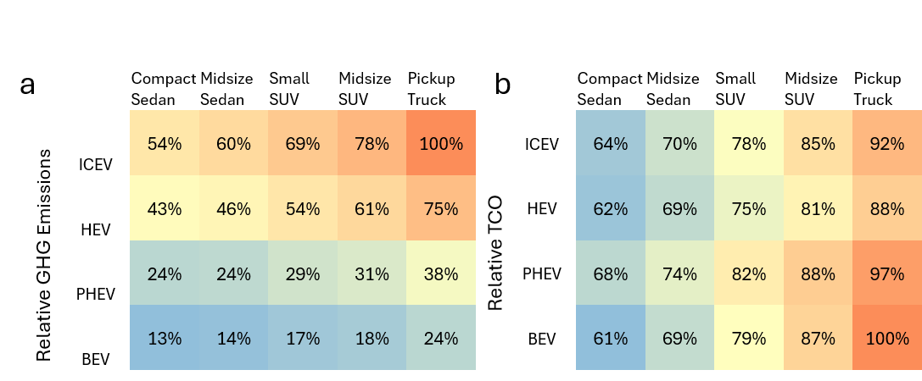
Supplemental Fig. 30. Relative cost and emissions in Los Angeles
a-b, The life cycle GHG emissions relative to the highest emitting vehicle (a), and the total cost of ownership relative to the most costly vehicle (b), in Los Angeles
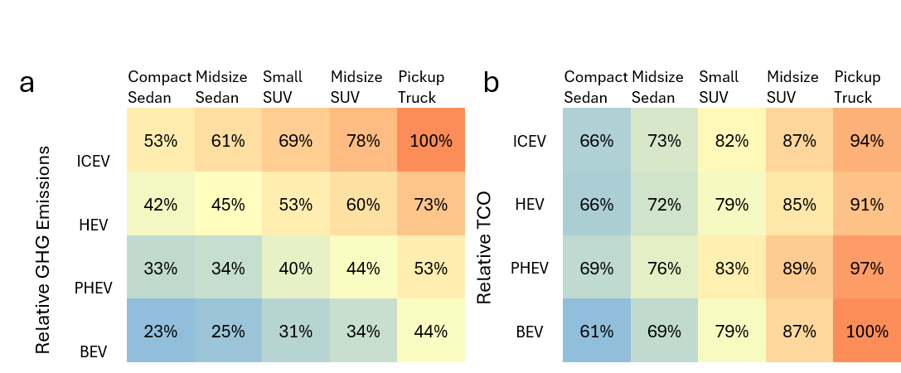
Supplemental Fig. 31. Relative cost and emissions in Miami
a-b, The life cycle GHG emissions relative to the highest emitting vehicle (a), and the total cost of ownership relative to the most costly vehicle (b), in Miami
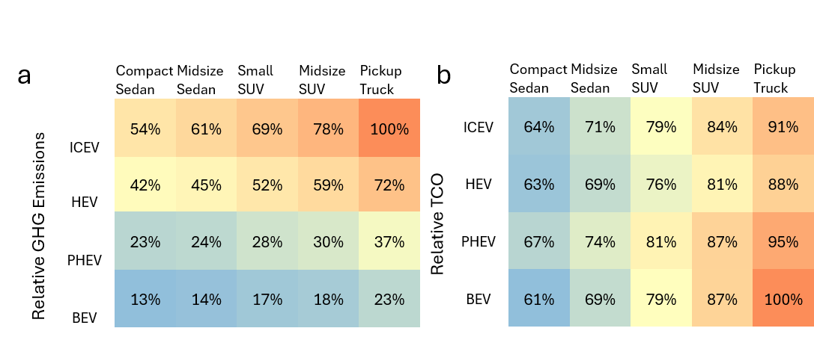
Supplemental Fig. 32. Relative cost and emissions in Minneapolis
a-b, The life cycle GHG emissions relative to the highest emitting vehicle (a), and the total cost of ownership relative to the most costly vehicle (b), in Minneapolis
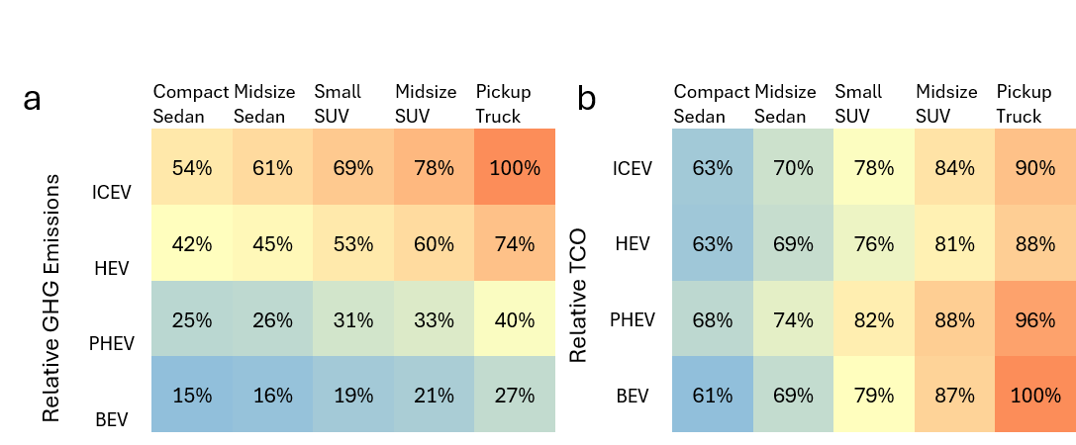
Supplemental Fig. 33. Relative cost and emissions in New York City
a-b, The life cycle GHG emissions relative to the highest emitting vehicle (a), and the total cost of ownership relative to the most costly vehicle (b), in New York City
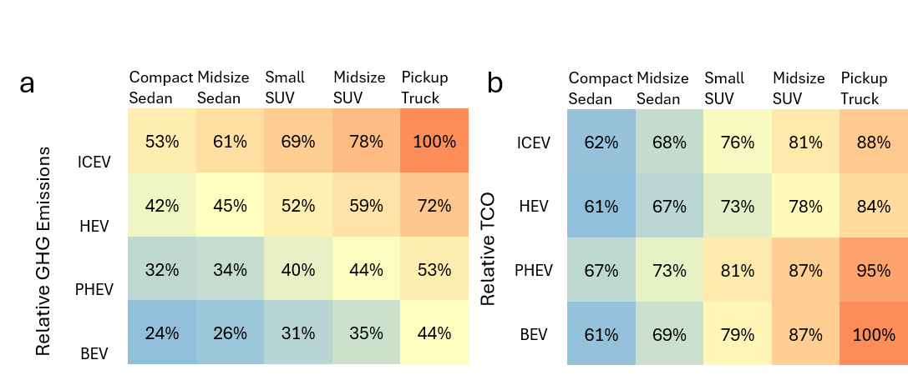
Supplemental Fig. 34. Relative cost and emissions in Philadelphia
a-b, The life cycle GHG emissions relative to the highest emitting vehicle (a), and the total cost of ownership relative to the most costly vehicle (b), in Philadelphia
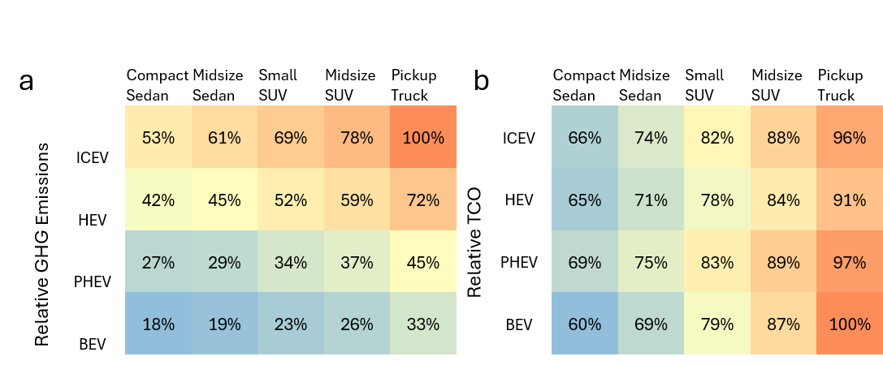
Supplemental Fig. 35. Relative cost and emissions in Phoenix
a-b, The life cycle GHG emissions relative to the highest emitting vehicle (a), and the total cost of ownership relative to the most costly vehicle (b), in Phoenix
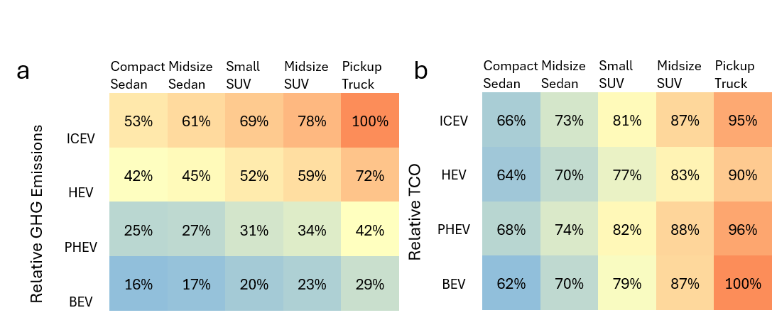
Supplemental Fig. 36. Relative cost and emissions in Portland
a-b, The life cycle GHG emissions relative to the highest emitting vehicle (a), and the total cost of ownership relative to the most costly vehicle (b), in Portland
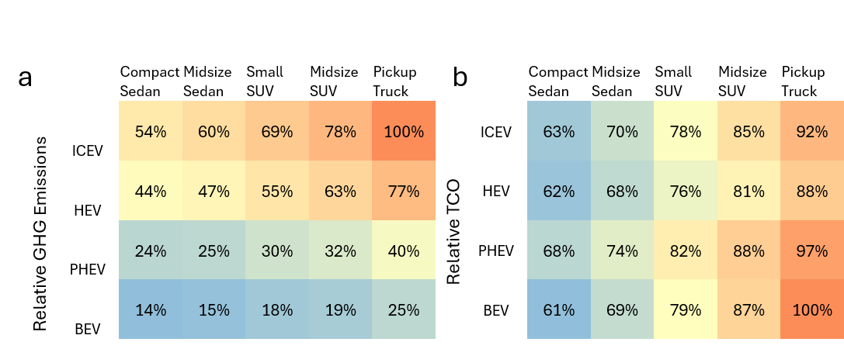
Supplemental Fig. 37. Relative cost and emissions in San Francisco
a-b, The life cycle GHG emissions relative to the highest emitting vehicle (a), and the total cost of ownership relative to the most costly vehicle (b), in San Francisco
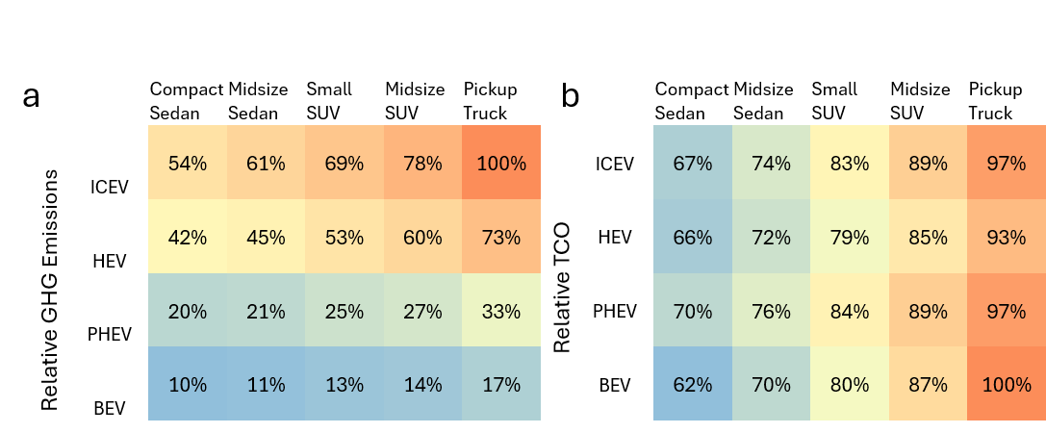
Supplemental Fig. 38. Relative cost and emissions in Seattle
a-b, The life cycle GHG emissions relative to the highest emitting vehicle (a), and the total cost of ownership relative to the most costly vehicle (b), in Seattle
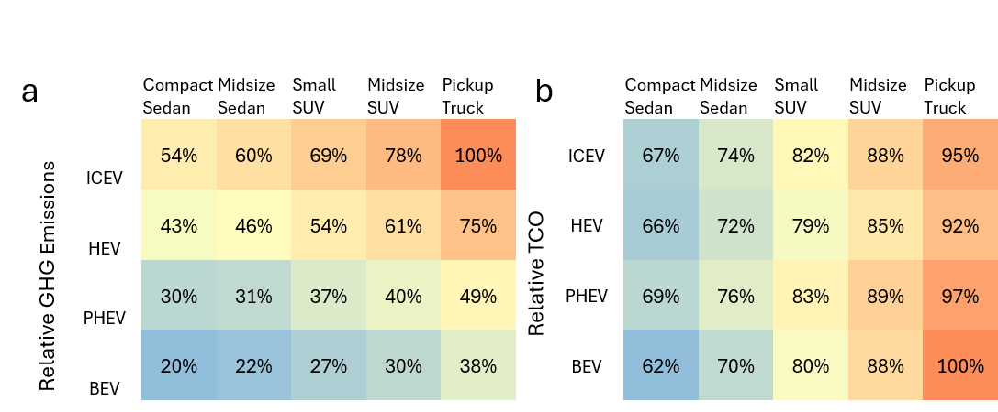
Supplemental Fig. 39. Relative cost and emissions in St. Louis
a-b, The life cycle GHG emissions relative to the highest emitting vehicle (a), and the total cost of ownership relative to the most costly vehicle (b), in St. Louis
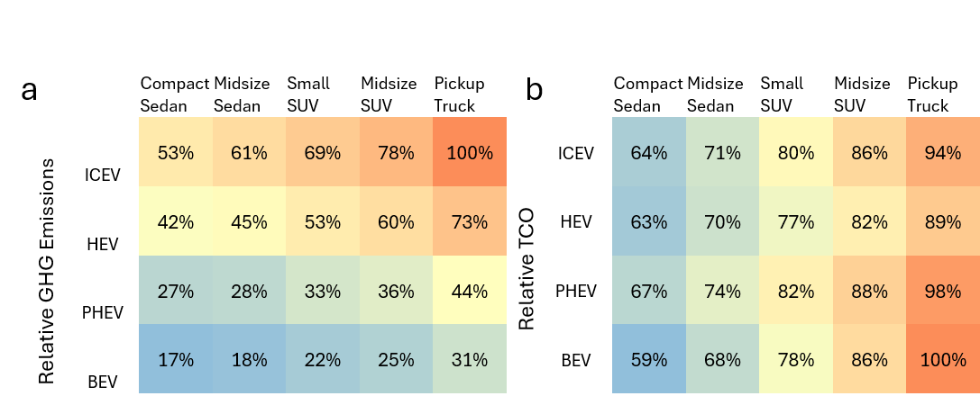
Supplemental Fig. 40. Relative cost and emissions in Washington, DC
a-b, The life cycle GHG emissions relative to the highest emitting vehicle (a), and the total cost of ownership relative to the most costly vehicle (b), in Washington DC
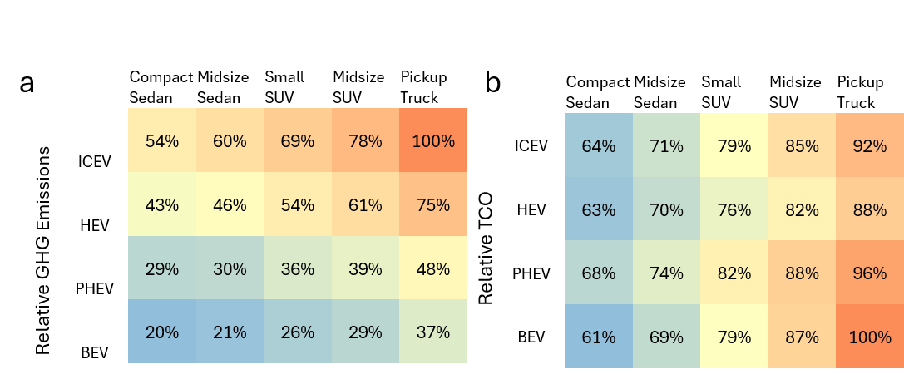
Supplemental Fig. 41. Relative cost and emissions U.S. average
a-b, The life cycle GHG emissions relative to the highest emitting vehicle (a), and the total cost of ownership relative to the most costly vehicle (b), using U.S. average values (as in Figure 1 c,d)
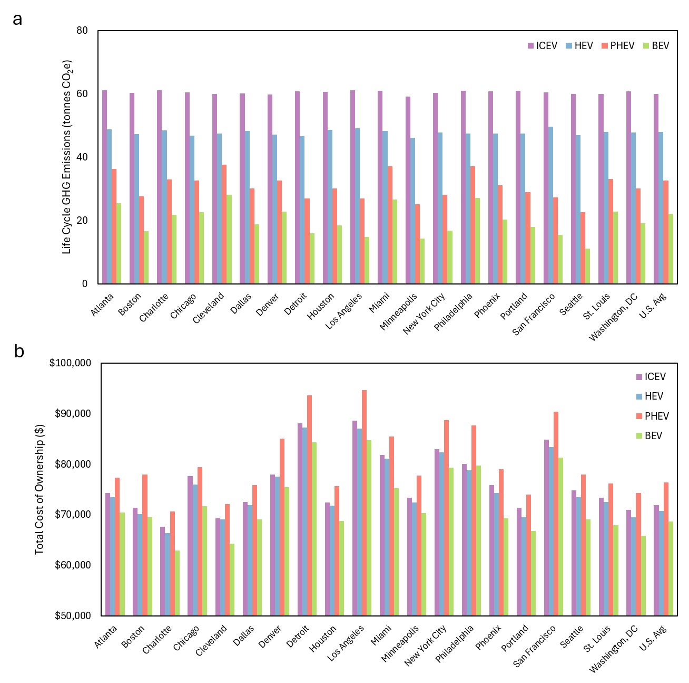
Supplemental Fig. 42. Compact sedan life cycle greenhouse gas emissions and total cost of ownership by location
a-b, Over the entire vehicle lifespan, the life cycle greenhouse gas emissions (a) and the total cost of ownership (b) for internal combustion engine vehicles (ICEV), hybrid electric vehicles (HEV), plug-in hybrid electric vehicles (PHEV), and battery electric vehicles (BEV) for a compact sedan.

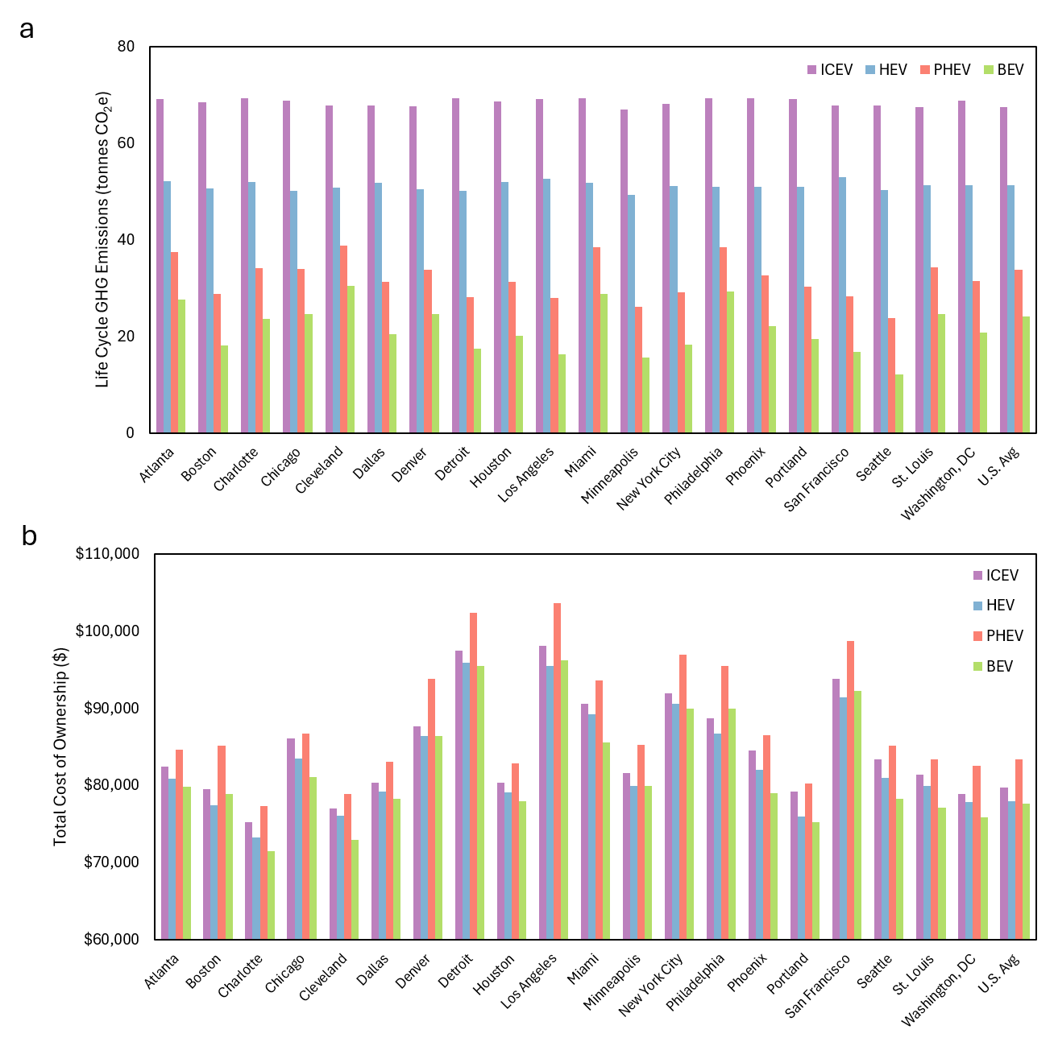
Supplemental Fig. 43. Midsize sedan life cycle greenhouse gas emissions and total cost of ownership by location
a-b, Over the entire vehicle lifespan, the life cycle greenhouse gas emissions (a) and the total cost of ownership (b) for internal combustion engine vehicles (ICEV), hybrid electric vehicles (HEV), plug-in hybrid electric vehicles (PHEV), and battery electric vehicles (BEV) for a midsize sedan.

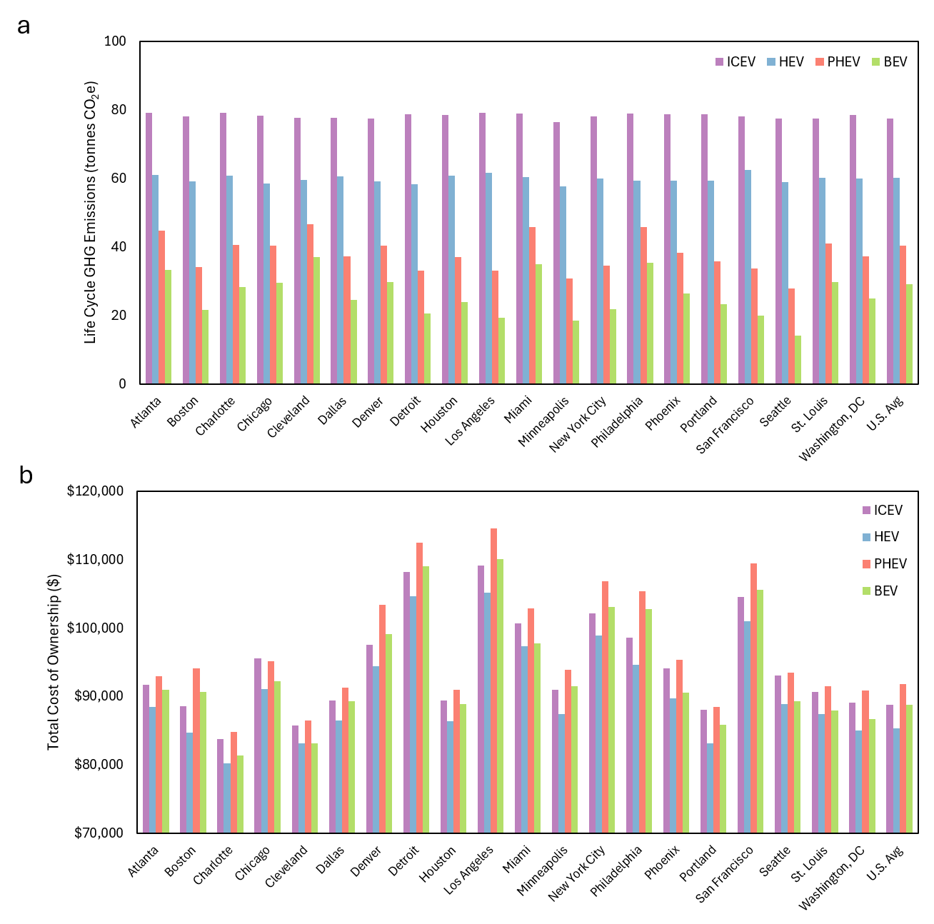
Supplemental Fig. 44. Small SUV life cycle greenhouse gas emissions and total cost of ownership by location
a-b, Over the entire vehicle lifespan, the life cycle greenhouse gas emissions (a) and the total cost of ownership (b) for internal combustion engine vehicles (ICEV), hybrid electric vehicles (HEV), plug-in hybrid electric vehicles (PHEV), and battery electric vehicles (BEV) for a small SUV. Note this is the same as Fig. 2 in the main text, and is recreated here for ease of comparison with other vehicle classes
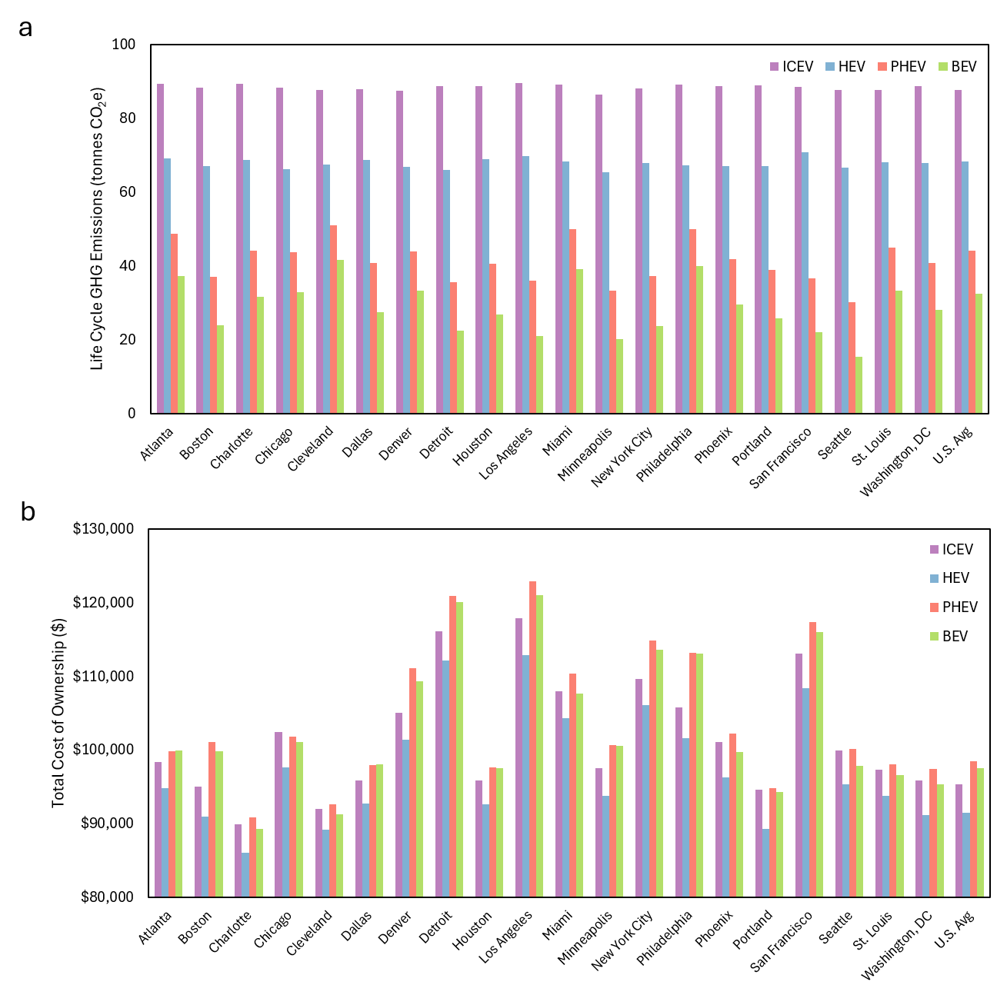
Supplemental Fig. 45. Midsize SUV life cycle greenhouse gas emissions and total cost of ownership by location
a-b, Over the entire vehicle lifespan, the life cycle greenhouse gas emissions (a) and the total cost of ownership (b) for internal combustion engine vehicles (ICEV), hybrid electric vehicles (HEV), plug-in hybrid electric vehicles (PHEV), and battery electric vehicles (BEV) for a midsize SUV.

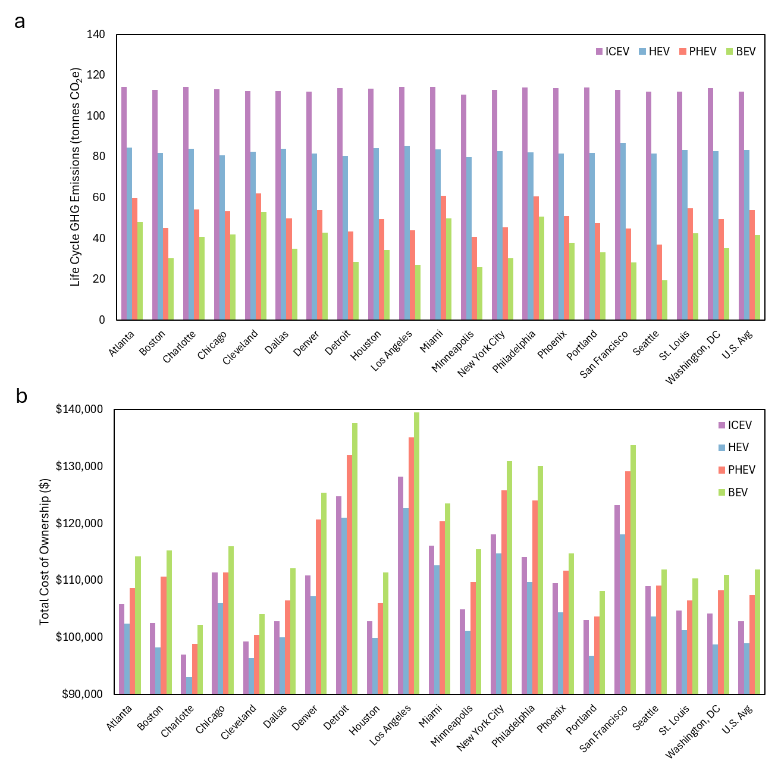
Supplemental Fig. 46. Pickup truck life cycle greenhouse gas emissions and total cost of ownership by location
a-b, Over the entire vehicle lifespan, the life cycle greenhouse gas emissions (a) and the total cost of ownership (b) for internal combustion engine vehicles (ICEV), hybrid electric vehicles (HEV), plug-in hybrid electric vehicles (PHEV), and battery electric vehicles (BEV) for a pickup truck.

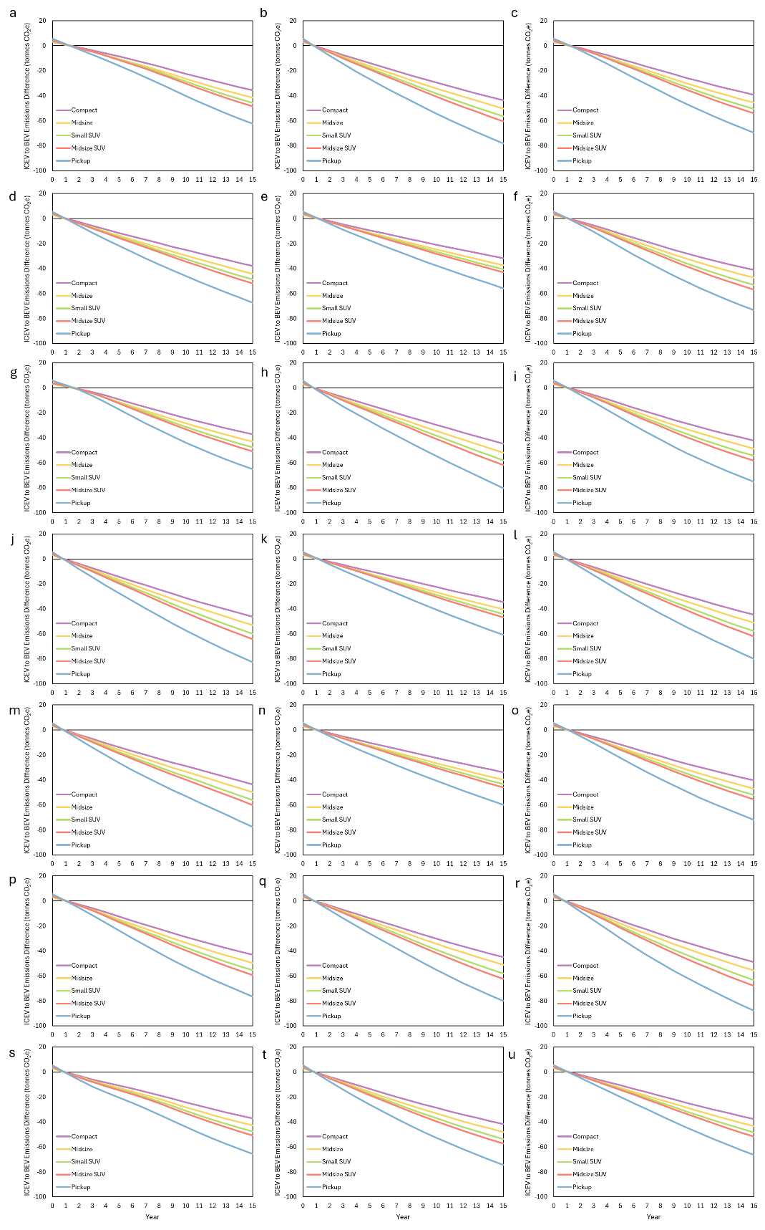
Supplemental Fig. 47. ICEV to BEV GHG emissions breakeven times in each city
a-u, The time required to break even in terms of greenhouse gas emissions when comparing an ICEV to a BEV in Atlanta (a), Boston (b), Charlotte (c), Chicago (d), Cleveland (e), Dallas (f), Denver (g), Detroit (h), Houston (i), Los Angeles (j), Miami (k), Minneapolis (l), New York City (m), Philadelphia (n), Phoenix (o), Portland (p), San Francisco (q), Seattle (r), St. Louis (s), Washington, DC (t), and with U.S. average values (u).
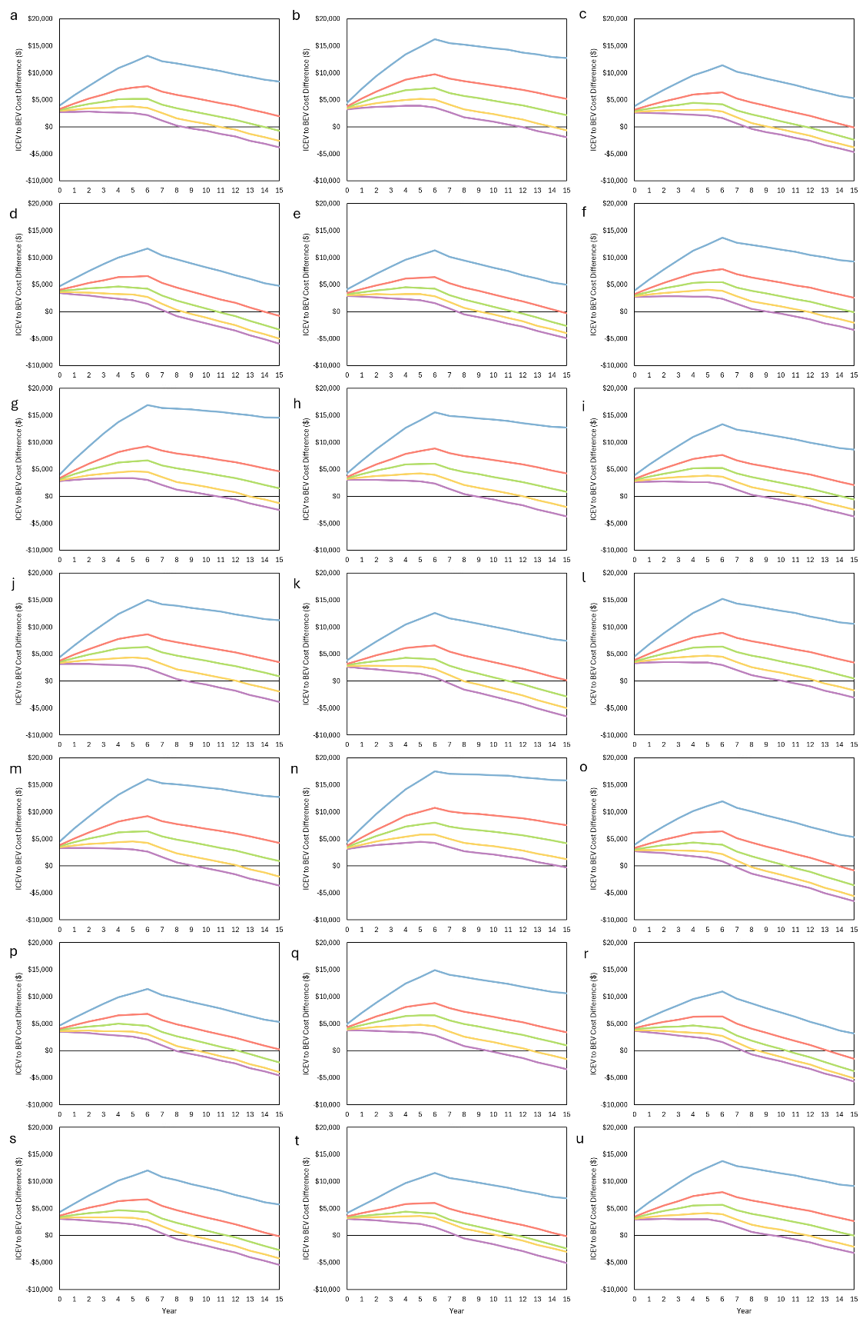
Supplemental Fig. 48. ICEV to BEV TCO breakeven times in each city
a-u, The time required to break even in terms of and total cost of ownership when comparing an ICEV to a BEV in Atlanta (a), Boston (b), Charlotte (c), Chicago (d), Cleveland (e), Dallas (f), Denver (g), Detroit (h), Houston (i), Los Angeles (j), Miami (k), Minneapolis (l), New York City (m), Philadelphia (n), Phoenix (o), Portland (p), San Francisco (q), Seattle (r), St. Louis (s), Washington, DC (t), and with U.S. average values (u).
Supplemental Table 1. Charging Strategies
No Public Charing | Home Charging |  |  |  | Public Charging
No Public Charing | 100% |  |  |  | 0%
No Public Charing | Off-Peak | Part-Peak | On-Peak |  | Level 2 | DC Fast Charging
No Public Charing | 80% | 10% | 10% |  | - | -
Rare Public Charging | Home Charging |  |  |  | Public Charging
Rare Public Charging | 90% |  |  |  | 10%
Rare Public Charging | Off-Peak | Part-Peak | On-Peak |  | Level 2 | DC Fast Charging
Rare Public Charging | 80% | 10% | 10% |  | 50% | 50%
Occasional Public Charging (Base Case) | Home Charging |  |  |  | Public Charging
Occasional Public Charging (Base Case) | 80% |  |  |  | 20%
Occasional Public Charging (Base Case) | Off-Peak | Part-Peak |  | On-Peak | Level 2 | DC Fast Charging
Occasional Public Charging (Base Case) | 50% | 25% |  | 25% | 50% | 50%
Frequent Public Charing | Home Charging |  |  |  | Public Charging
Frequent Public Charing | 60% |  |  |  | 40%
Frequent Public Charing | Off-Peak | Part-Peak | On-Peak |  | Level 2 | DC Fast Charging
Frequent Public Charing | 50% | 25% | 25% |  | 75% | 25%
All Public Charging | Home Charging |  |  |  | Public Charging
All Public Charging | 0% |  |  |  | 100%
All Public Charging | Off-Peak | Part-Peak | On-Peak |  | Level 2 | DC Fast Charging
All Public Charging | - | - | - |  | 75% | 25%

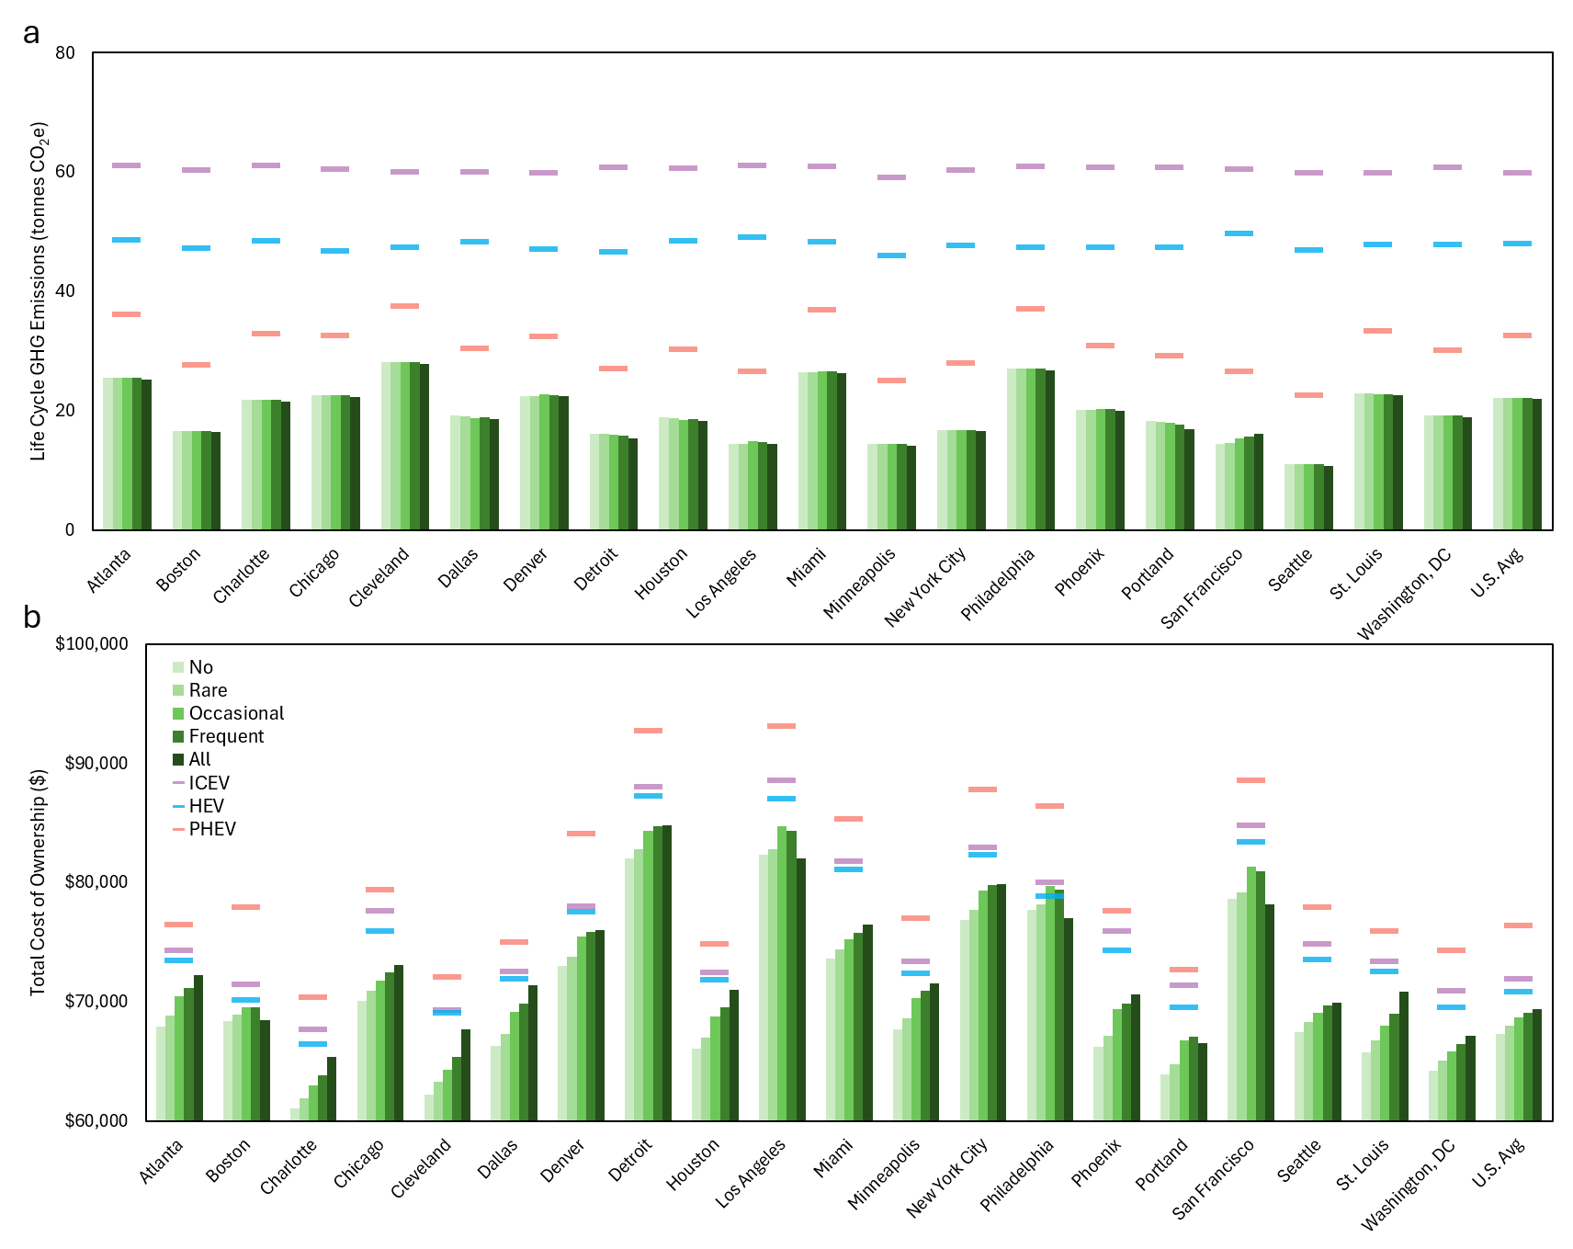
Supplemental Fig. 49. Compact sedan cost and emissions depending on charging strategies
a-b, For five different charging strategies, the life cycle greenhouse gas emissions (a) and the total cost of ownership (b) for a compact sedan in each city
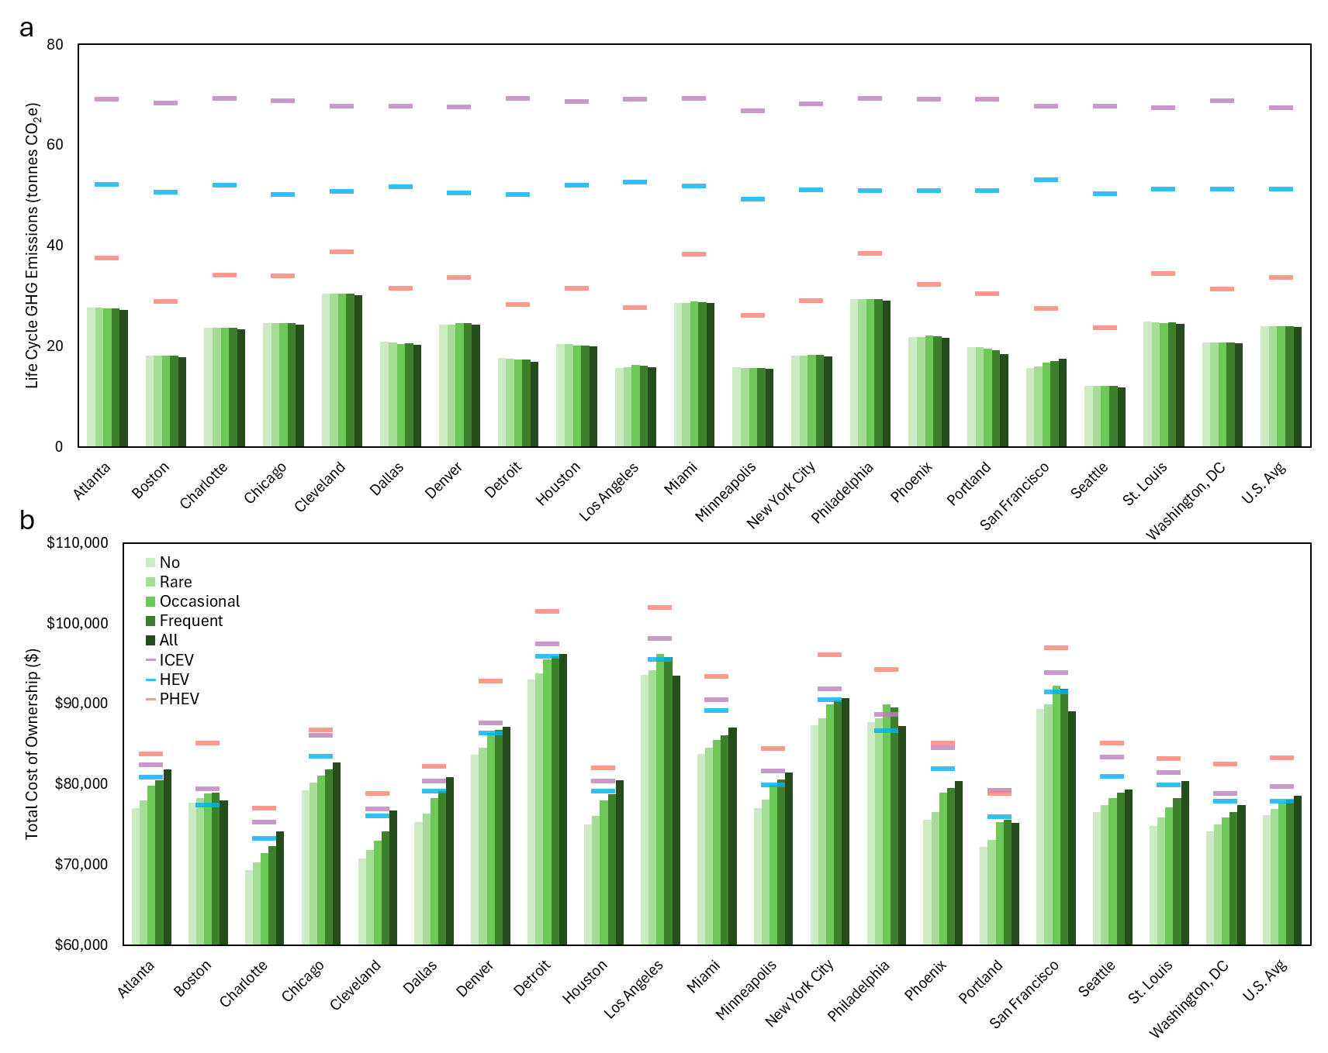
Supplemental Fig. 50. Midsize sedan cost and emissions depending on charging strategies
a-b, For five different charging strategies, the life cycle greenhouse gas emissions (a) and the total cost of ownership (b) for a midsize sedan in each city
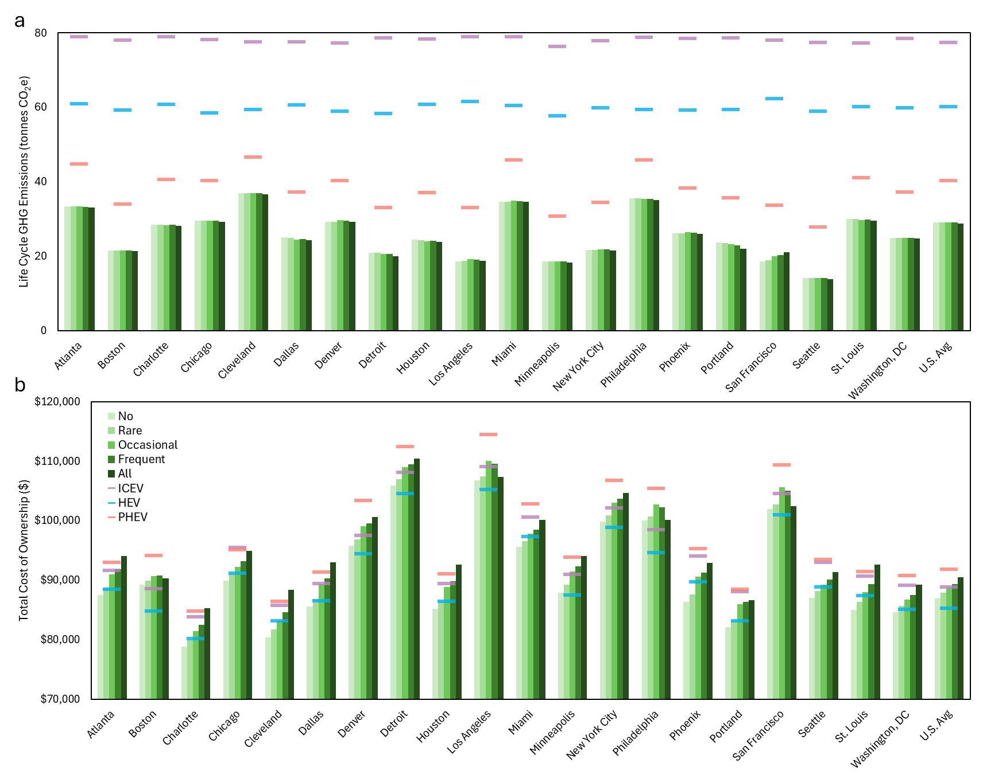
Supplemental Fig. 51. Small SUV cost and emissions depending on charging strategies
a-b, For five different charging strategies, the life cycle greenhouse gas emissions (a) and the total cost of ownership (b) for a small SUV in each city (also shown in Figure 5 a,b)
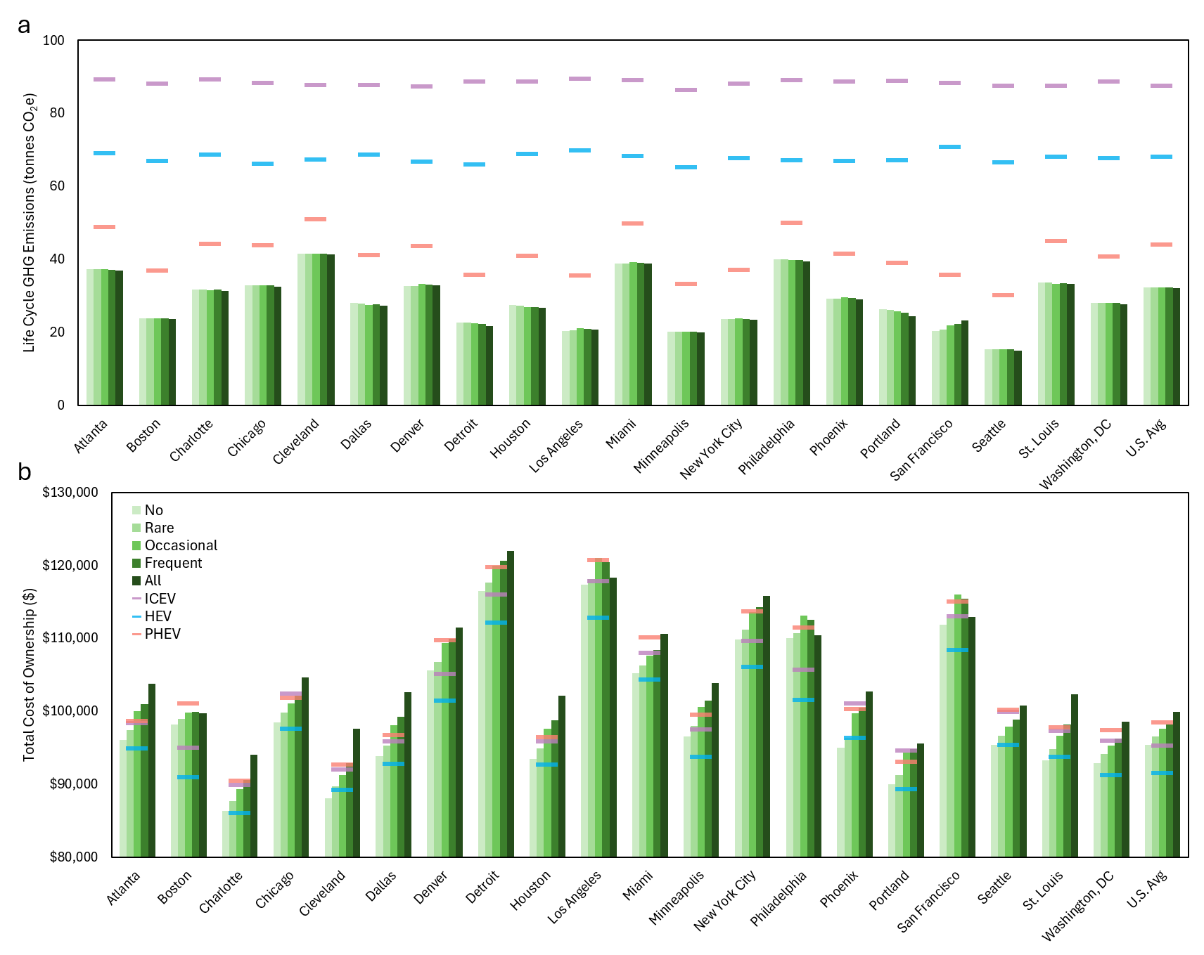
Supplemental Fig. 52. Midsize SUV cost and emissions depending on charging strategies
a-b, For five different charging strategies, the life cycle greenhouse gas emissions (a) and the total cost of ownership (b) for a midsize SUV in each city
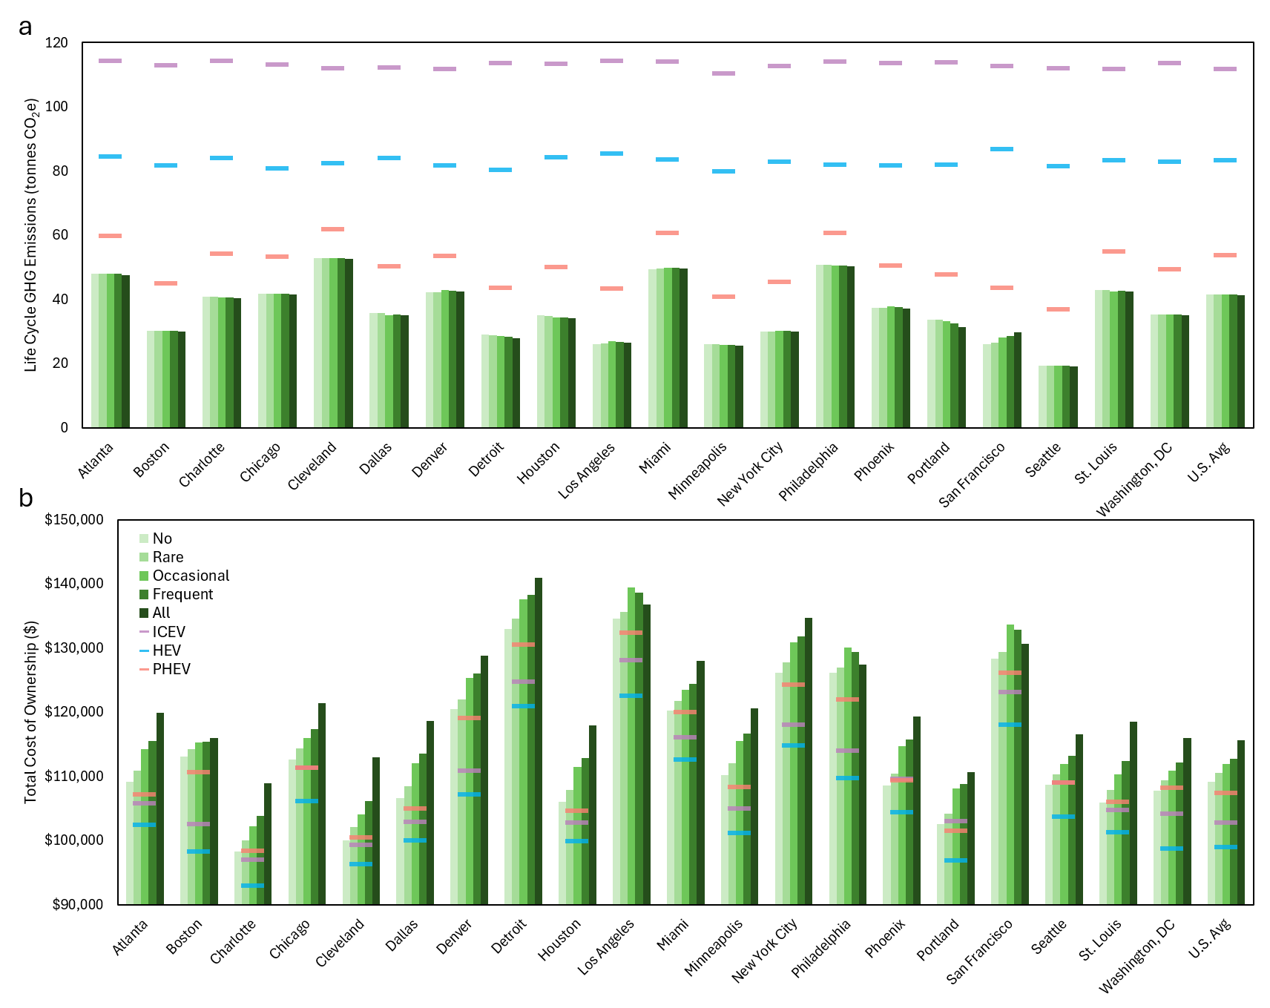
Supplemental Fig. 53. Pickup truck cost and emissions depending on charging strategies
a-b, For five different charging strategies, the life cycle greenhouse gas emissions (a) and the total cost of ownership (b) for a pickup truck in each city

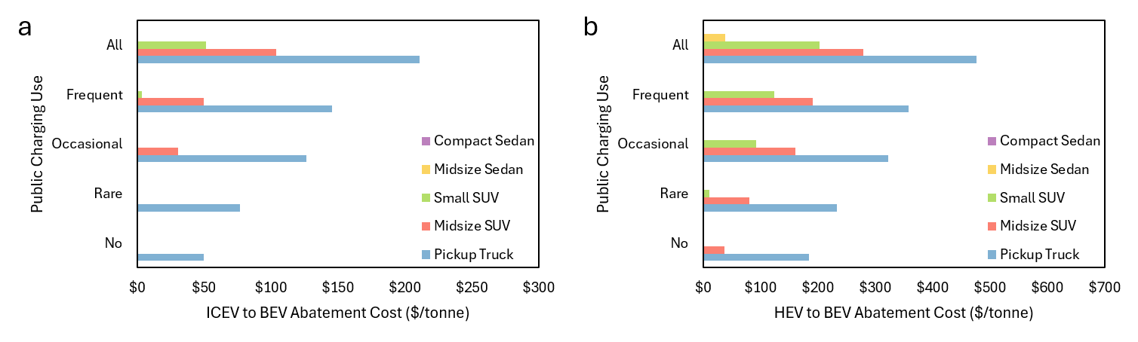
Supplemental Fig. 54. Abatement costs by charging strategy in Atlanta
a-b, For five charging strategies, the abatement cost when comparing an ICEV and a BEV (a), the abatement cost when comparing an HEV and a BEV (b), in Atlanta. Bars are not shown for negative abatement costs as the metric no longer measures cost-effectiveness when costs are negative.
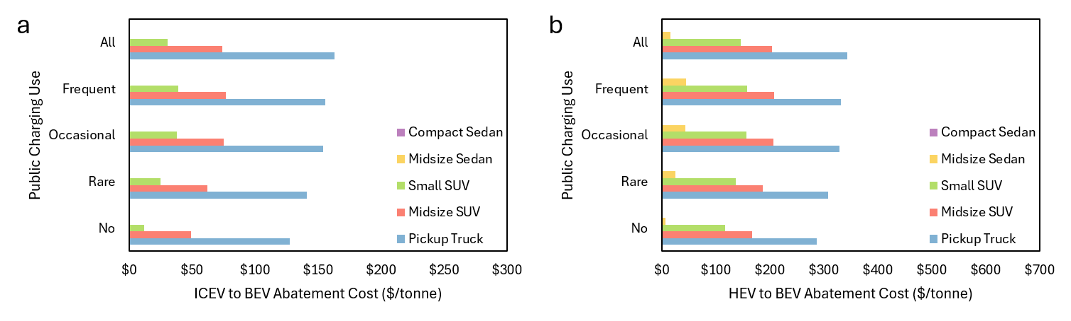
Supplemental Fig. 55. Abatement costs by charging strategy in Boston
a-b, For five charging strategies, the abatement cost when comparing an ICEV and a BEV (a), the abatement cost when comparing an HEV and a BEV (b), in Boston. Bars are not shown for negative abatement costs as the metric no longer measures cost-effectiveness when costs are negative.
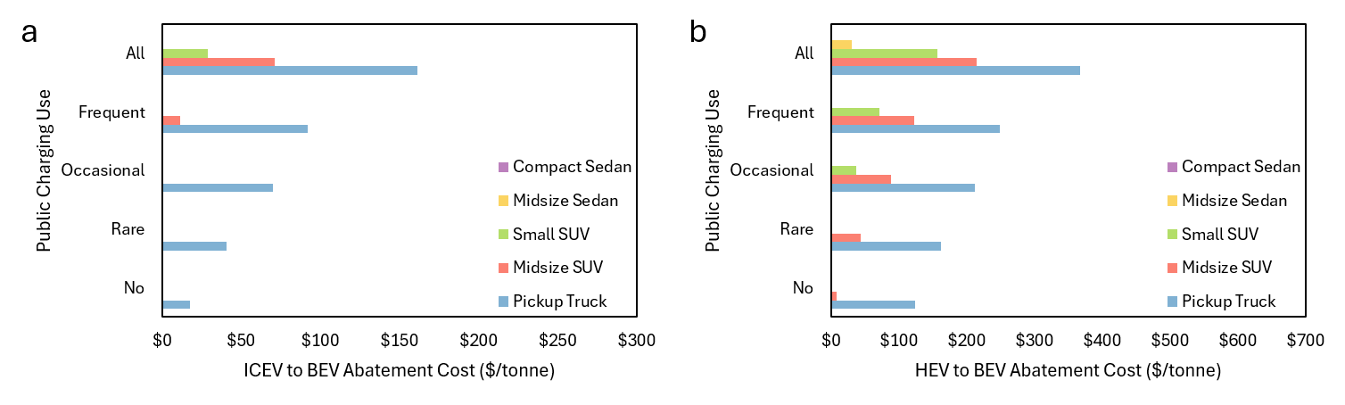
Supplemental Fig. 56. Abatement costs by charging strategy in Charlotte
a-b, For five charging strategies, the abatement cost when comparing an ICEV and a BEV (a), the abatement cost when comparing an HEV and a BEV (b), in Charlotte. Bars are not shown for negative abatement costs as the metric no longer measures cost-effectiveness when costs are negative.
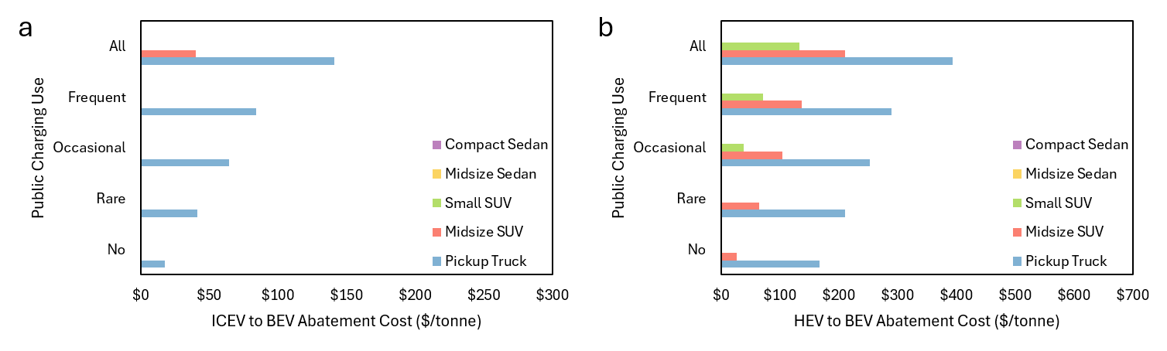
Supplemental Fig. 57. Abatement costs by charging strategy in Chicago
a-b, For five charging strategies, the abatement cost when comparing an ICEV and a BEV (a), the abatement cost when comparing an HEV and a BEV (b), in Chicago. Bars are not shown for negative abatement costs as the metric no longer measures cost-effectiveness when costs are negative.
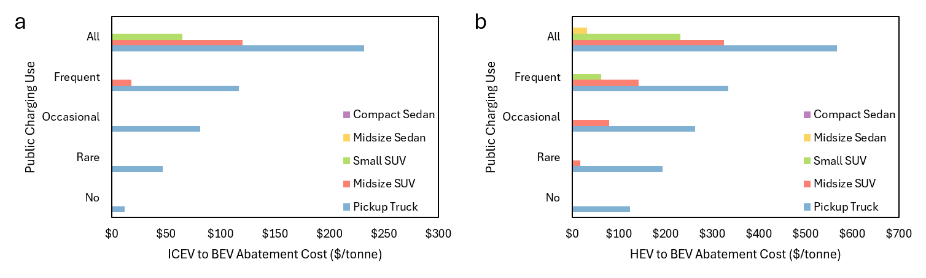
Supplemental Fig. 58. Abatement costs by charging strategy in Cleveland
a-b, For five charging strategies, the abatement cost when comparing an ICEV and a BEV (a), the abatement cost when comparing an HEV and a BEV (b), in Cleveland. Bars are not shown for negative abatement costs as the metric no longer measures cost-effectiveness when costs are negative.
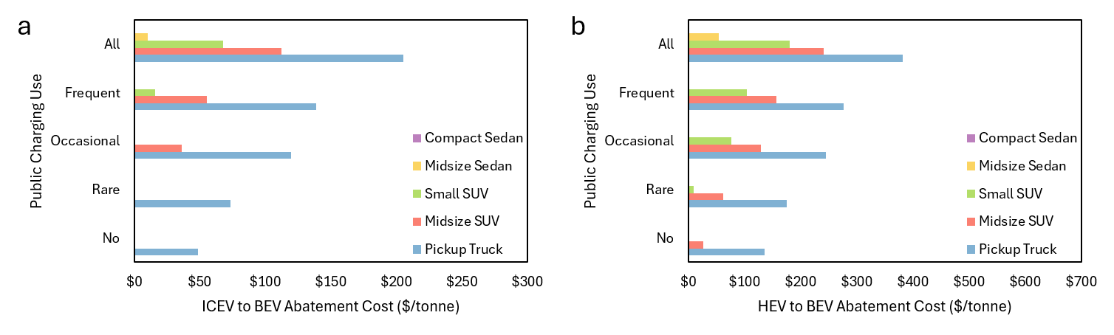
Supplemental Fig. 59. Abatement costs by charging strategy in Dallas
a-b, For five charging strategies, the abatement cost when comparing an ICEV and a BEV (a), the abatement cost when comparing an HEV and a BEV (b), in Dallas. Bars are not shown for negative abatement costs as the metric no longer measures cost-effectiveness when costs are negative.
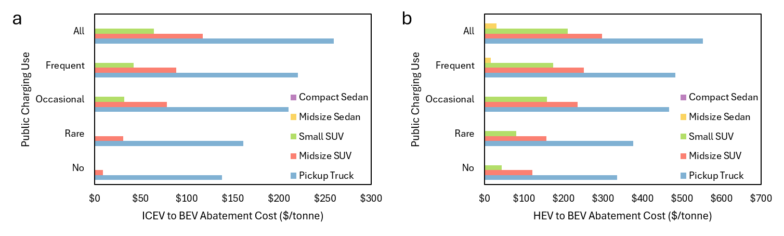
Supplemental Fig. 60. Abatement costs by charging strategy in Denver
a-b, For five charging strategies, the abatement cost when comparing an ICEV and a BEV (a), the abatement cost when comparing an HEV and a BEV (b), in Denver. Bars are not shown for negative abatement costs as the metric no longer measures cost-effectiveness when costs are negative.
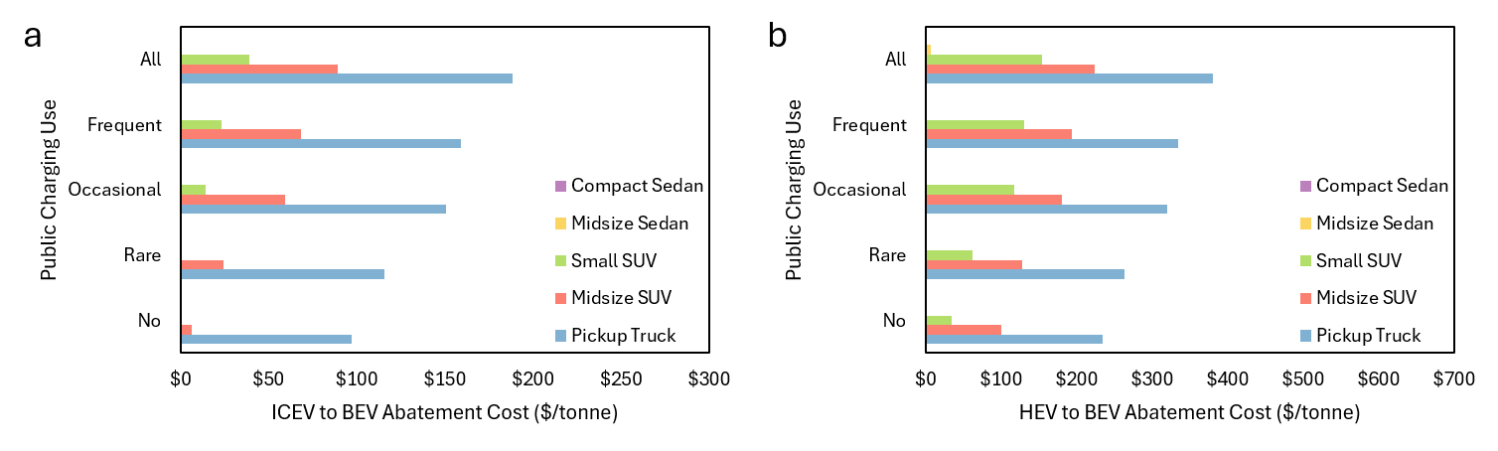
Supplemental Fig. 61. Abatement costs by charging strategy in Detroit
a-b, For five charging strategies, the abatement cost when comparing an ICEV and a BEV (a), the abatement cost when comparing an HEV and a BEV (b), in Detroit. Bars are not shown for negative abatement costs as the metric no longer measures cost-effectiveness when costs are negative.
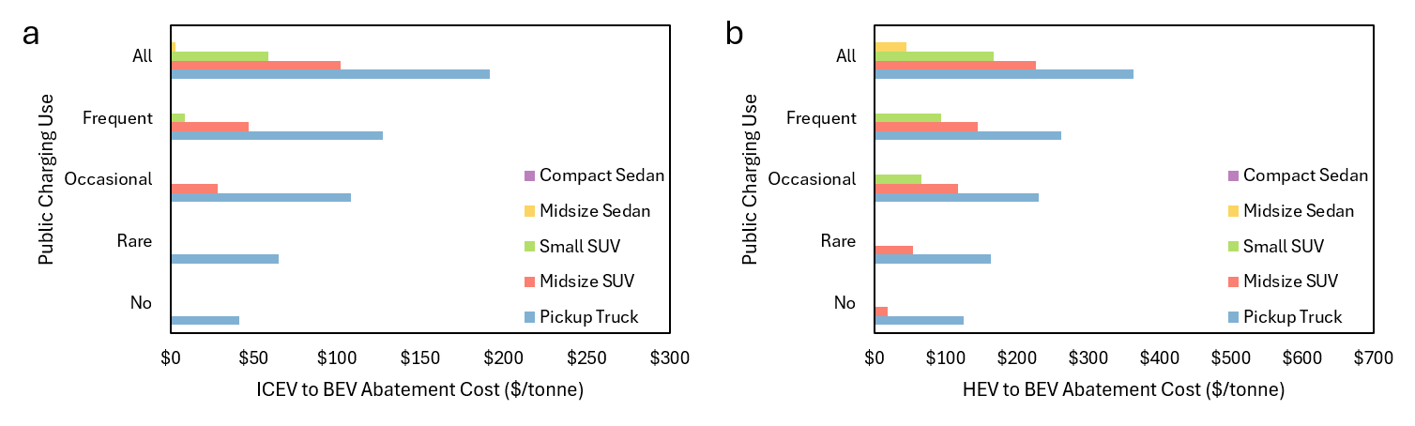
Supplemental Fig. 62. Abatement costs by charging strategy in Houston
a-b, For five charging strategies, the abatement cost when comparing an ICEV and a BEV (a), the abatement cost when comparing an HEV and a BEV (b), in Houston. Bars are not shown for negative abatement costs as the metric no longer measures cost-effectiveness when costs are negative.
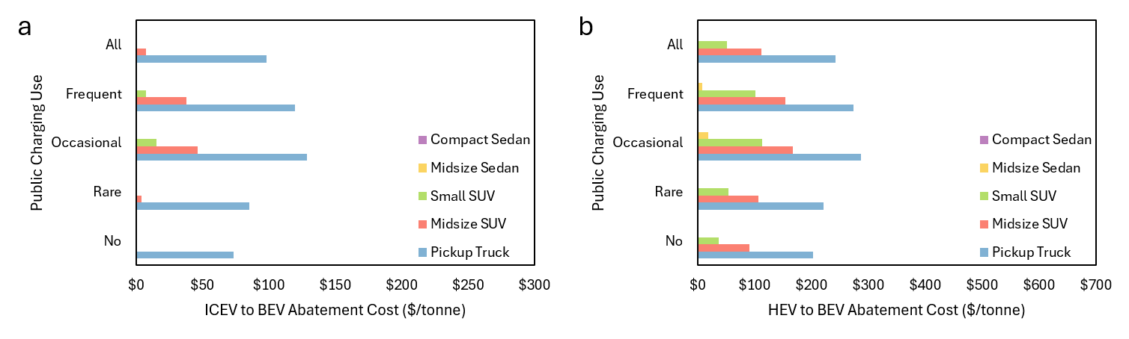
Supplemental Fig. 63. Abatement costs by charging strategy in Los Angeles
a-b, For five charging strategies, the abatement cost when comparing an ICEV and a BEV (a), the abatement cost when comparing an HEV and a BEV (b), in Los Angeles. Bars not shown for negative abatement costs as the metric no longer measures cost-effectiveness when costs are negative.
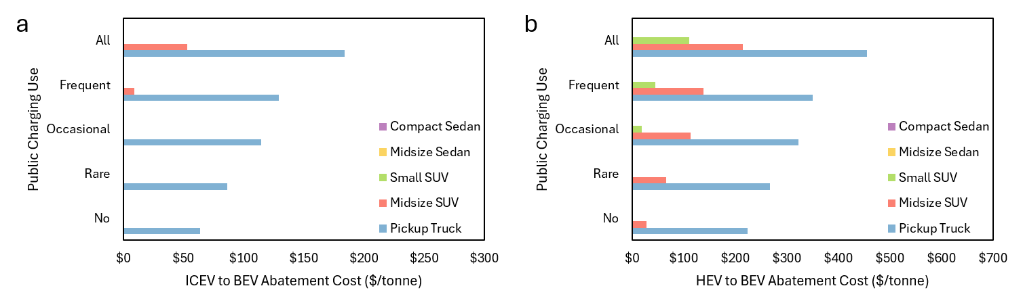
Supplemental Fig. 64. Abatement costs by charging strategy in Miami
a-b, For five charging strategies, the abatement cost when comparing an ICEV and a BEV (a), the abatement cost when comparing an HEV and a BEV (b), in Miami. Bars are not shown for negative abatement costs as the metric no longer measures cost-effectiveness when costs are negative.
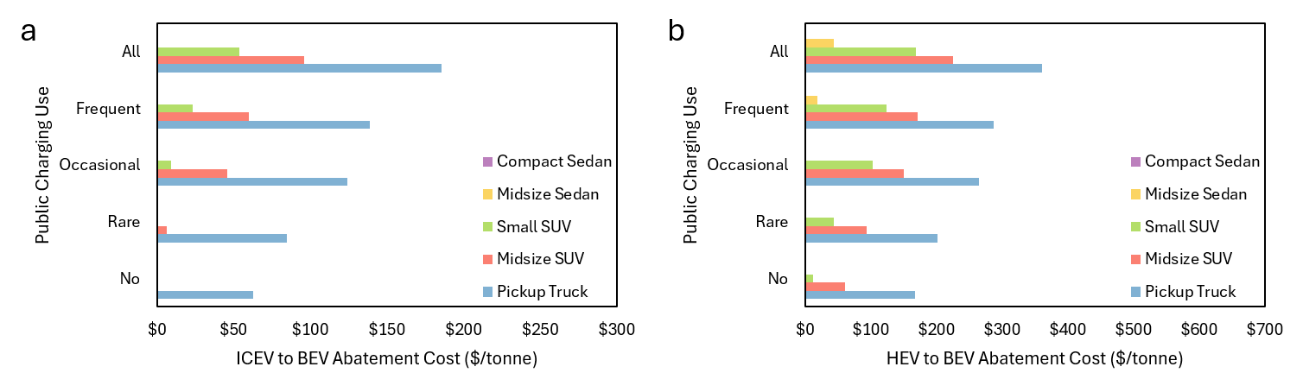
Supplemental Fig. 65. Abatement costs by charging strategy in Minneapolis
a-b, For five charging strategies, the abatement cost when comparing an ICEV and a BEV (a), the abatement cost when comparing an HEV and a BEV (b), in Minneapolis. Bars are not shown for negative abatement costs as the metric no longer measures cost-effectiveness when costs are negative.
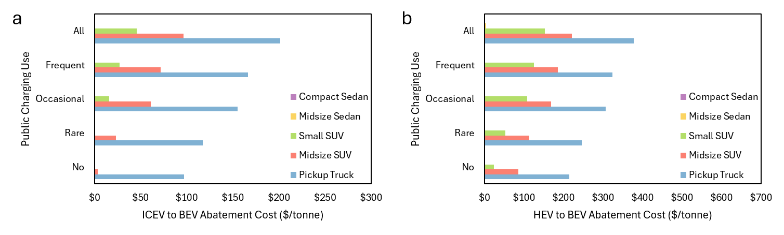
Supplemental Fig. 66. Abatement costs by charging strategy in New York City
a-b, For five charging strategies, the abatement cost when comparing an ICEV and a BEV (a), the abatement cost when comparing an HEV and a BEV (b), in New York City. Bars are not shown for negative abatement costs as the metric no longer measures cost-effectiveness when costs are negative.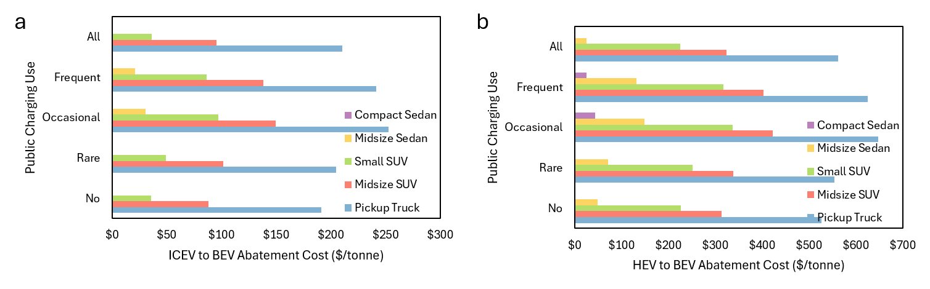
Supplemental Fig. 67. Abatement costs by charging strategy in Philadelphia
a-b, For five charging strategies, the abatement cost when comparing an ICEV and a BEV (a), the abatement cost when comparing an HEV and a BEV (b), in Philadelphia. Bars not shown for negative abatement costs as the metric no longer measures cost-effectiveness when costs are negative.
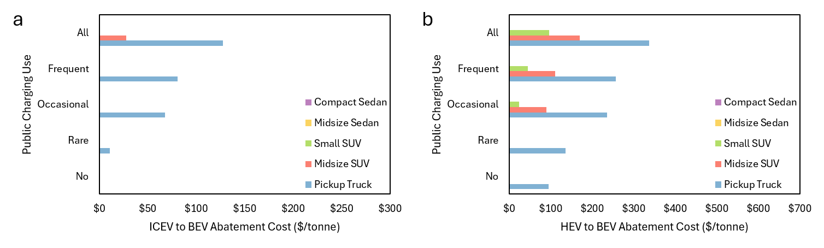
Supplemental Fig. 68. Abatement costs by charging strategy in Phoenix
a-b, For five charging strategies, the abatement cost when comparing an ICEV and a BEV (a), the abatement cost when comparing an HEV and a BEV (b), in Phoenix. Bars are not shown for negative abatement costs as the metric no longer measures cost-effectiveness when costs are negative.
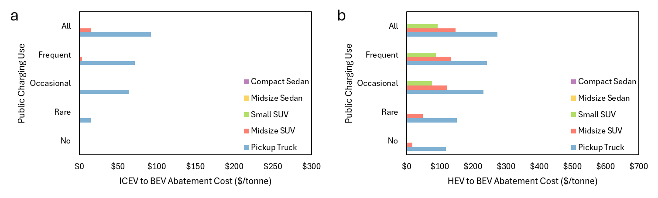
Supplemental Fig. 69. Abatement costs by charging strategy in Portland
a-b, For five charging strategies, the abatement cost when comparing an ICEV and a BEV (a), the abatement cost when comparing an HEV and a BEV (b), in Portland. Bars are not shown for negative abatement costs as the metric no longer measures cost-effectiveness when costs are negative.
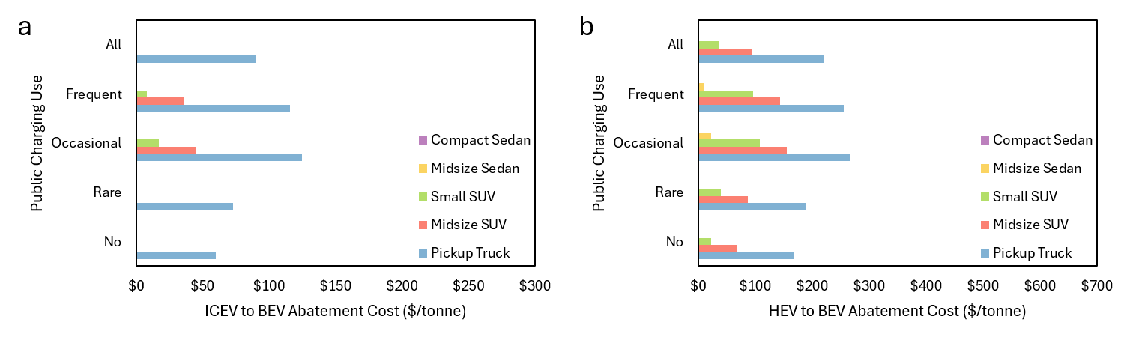
Supplemental Fig. 70. Abatement costs by charging strategy in San Francisco
a-b, For five charging strategies, the abatement cost when comparing an ICEV and a BEV (a), the abatement cost when comparing an HEV and a BEV (b), in San Francisco. Bars are not shown for negative abatement costs as the metric no longer measures cost-effectiveness when costs are negative.
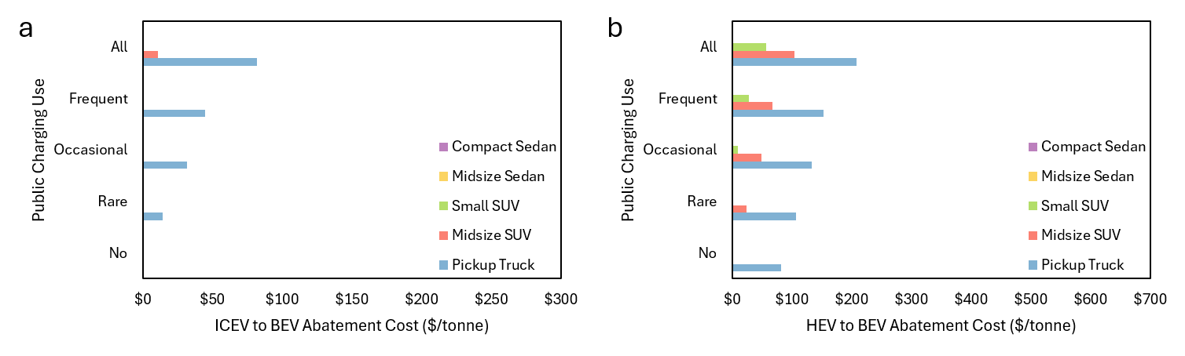
Supplemental Fig. 71. Abatement costs by charging strategy in Seattle
a-b, For five charging strategies, the abatement cost when comparing an ICEV and a BEV (a), the abatement cost when comparing an HEV and a BEV (b), in Seattle. Bars are not shown for negative abatement costs as the metric no longer measures cost-effectiveness when costs are negative.
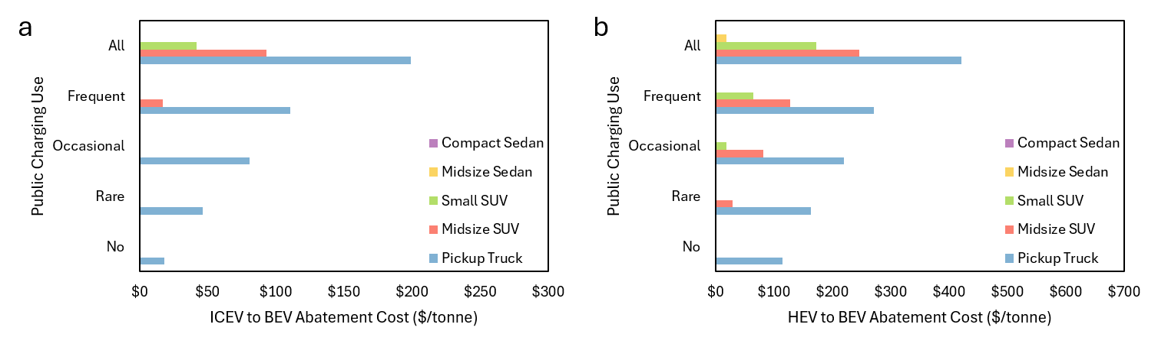
Supplemental Fig. 72. Abatement costs by charging strategy in St. Louis
a-b, For five charging strategies, the abatement cost when comparing an ICEV and a BEV (a), the abatement cost when comparing an HEV and a BEV (b), in St. Louis. Bars are not shown for negative abatement costs as the metric no longer measures cost-effectiveness when costs are negative.
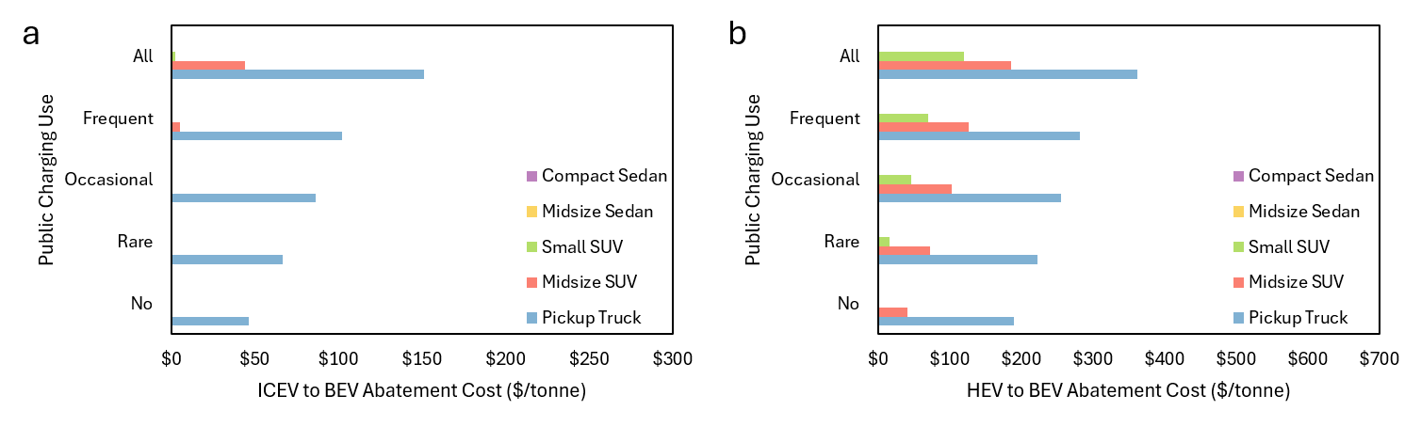
Supplemental Fig. 73. Abatement costs by charging strategy in Washington, DC
a-b, For five charging strategies, the abatement cost when comparing an ICEV and a BEV (a), the abatement cost when comparing an HEV and a BEV (b), in Washington, DC. Bars not shown for negative abatement costs as the metric no longer measures cost-effectiveness when costs are negative.
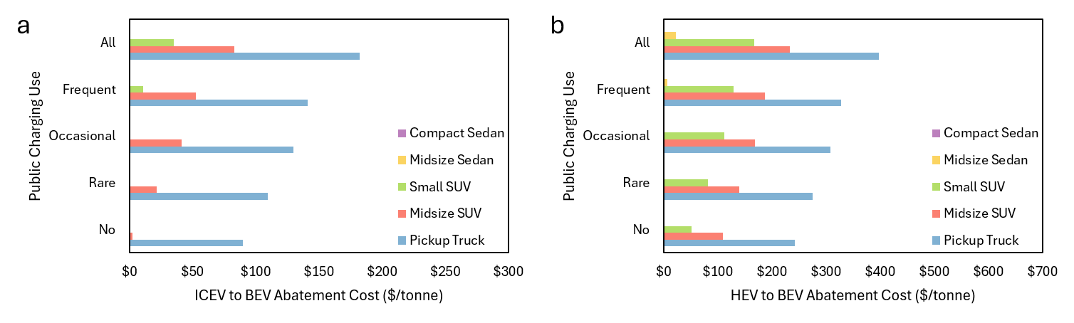
Supplemental Fig. 74. Abatement costs by charging strategy with U.S. average values
a-b, For five charging strategies, the abatement cost when comparing an ICEV and a BEV (a), the abatement cost when comparing an HEV and a BEV (b), with U.S. average values (also shown in Figure 5c,d). Bars are not shown for vehicle classes with negative abatement costs

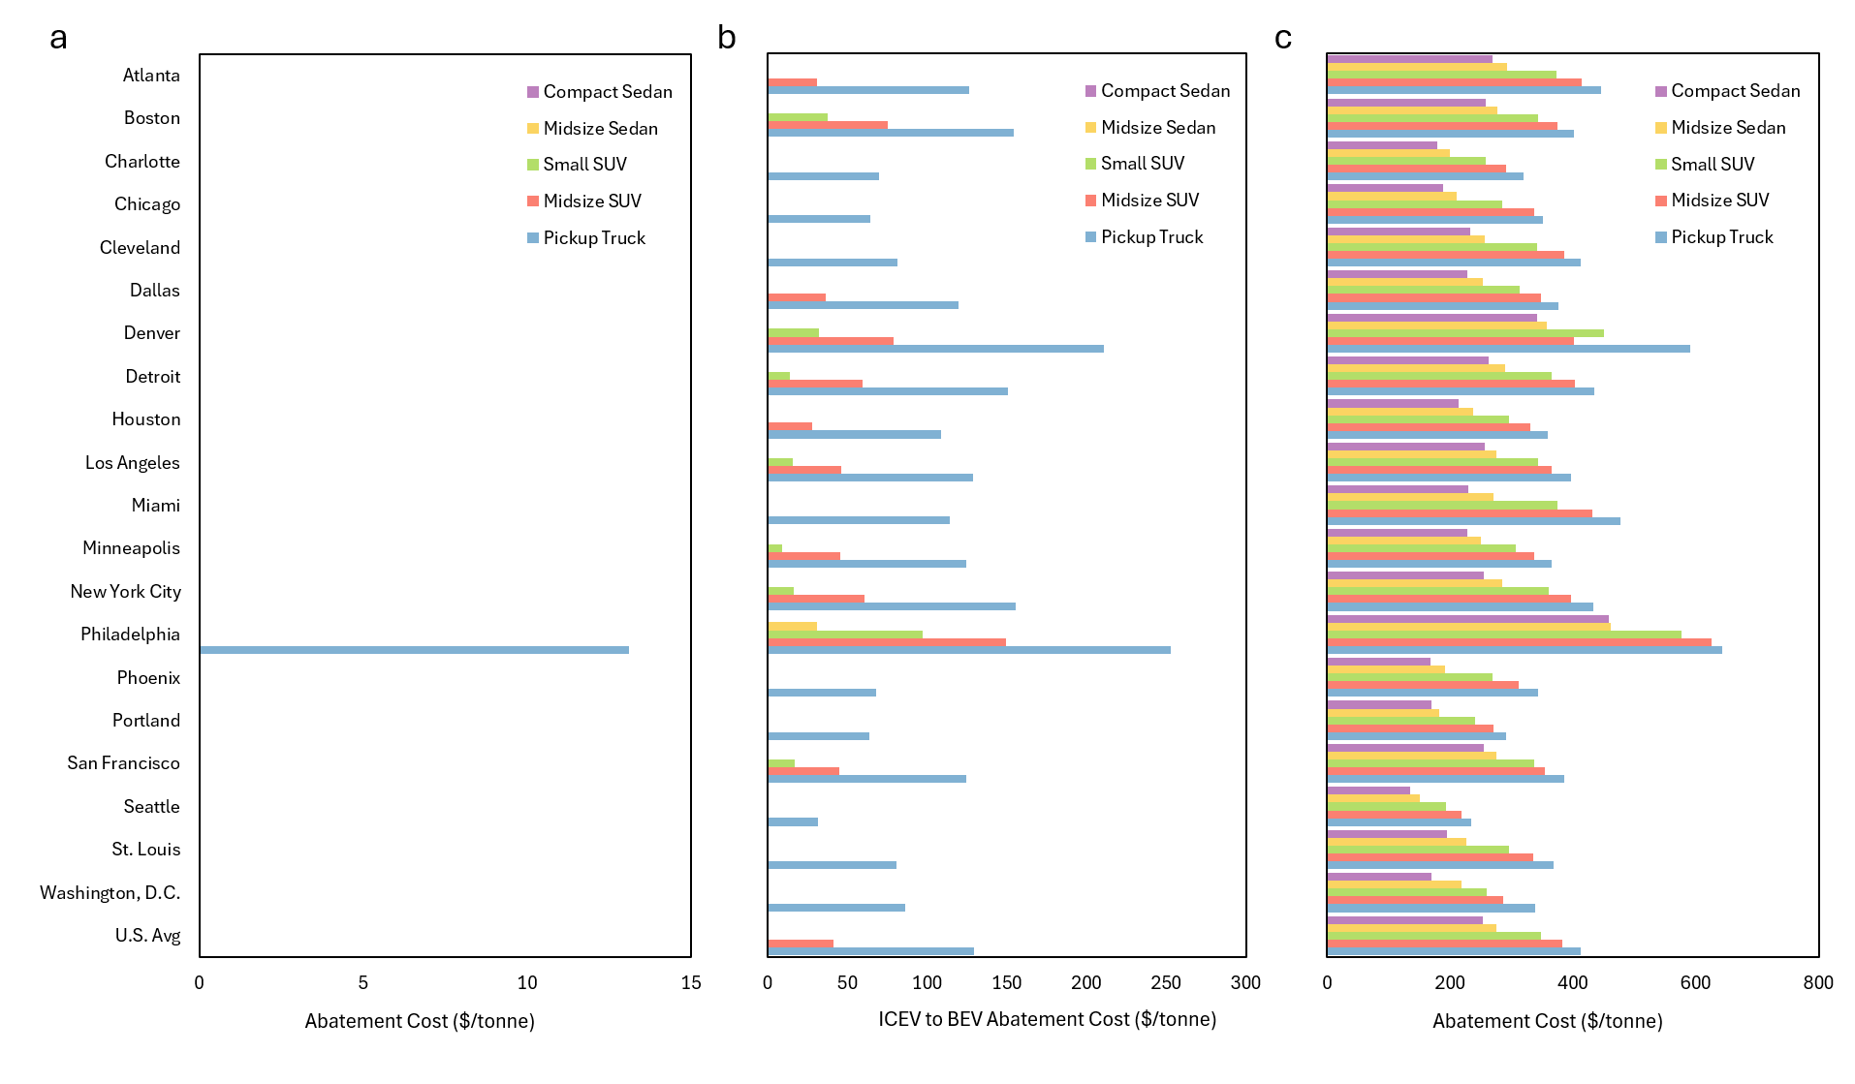
Supplemental Fig. 75. Abatement cost with different BEV ranges
a-c, ICEV to BEV abatement cost in each city with a 200-mile range BEV (a), a 300-mile range BEV, which is the base case presented in the paper (b), and a 400-mile range BEV (c). Note different x-axes are used in each subfigure. Bars are not shown for negative abatement costs as the metric no longer measures cost-effectiveness when costs are negative.

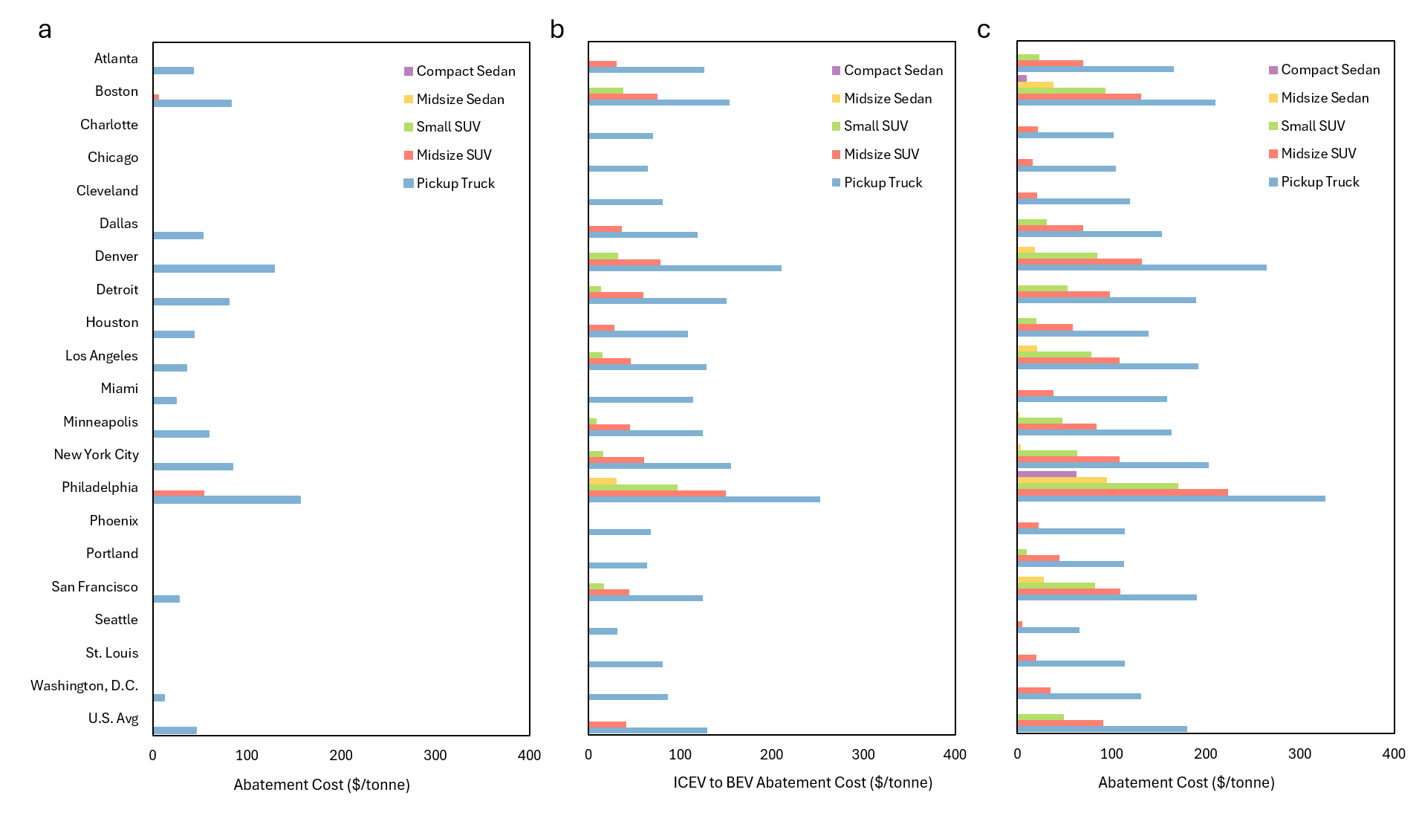
Supplemental Fig. 76. Abatement cost with different fuel prices
a-c, ICEV to BEV abatement cost in each city with a 25% increase in gasoline prices (a), the base case fuel prices presented in the paper (b), and with a 25% increase in electricity prices (c). Bars are not shown for negative abatement costs as the metric no longer measures cost-effectiveness when costs are negative.

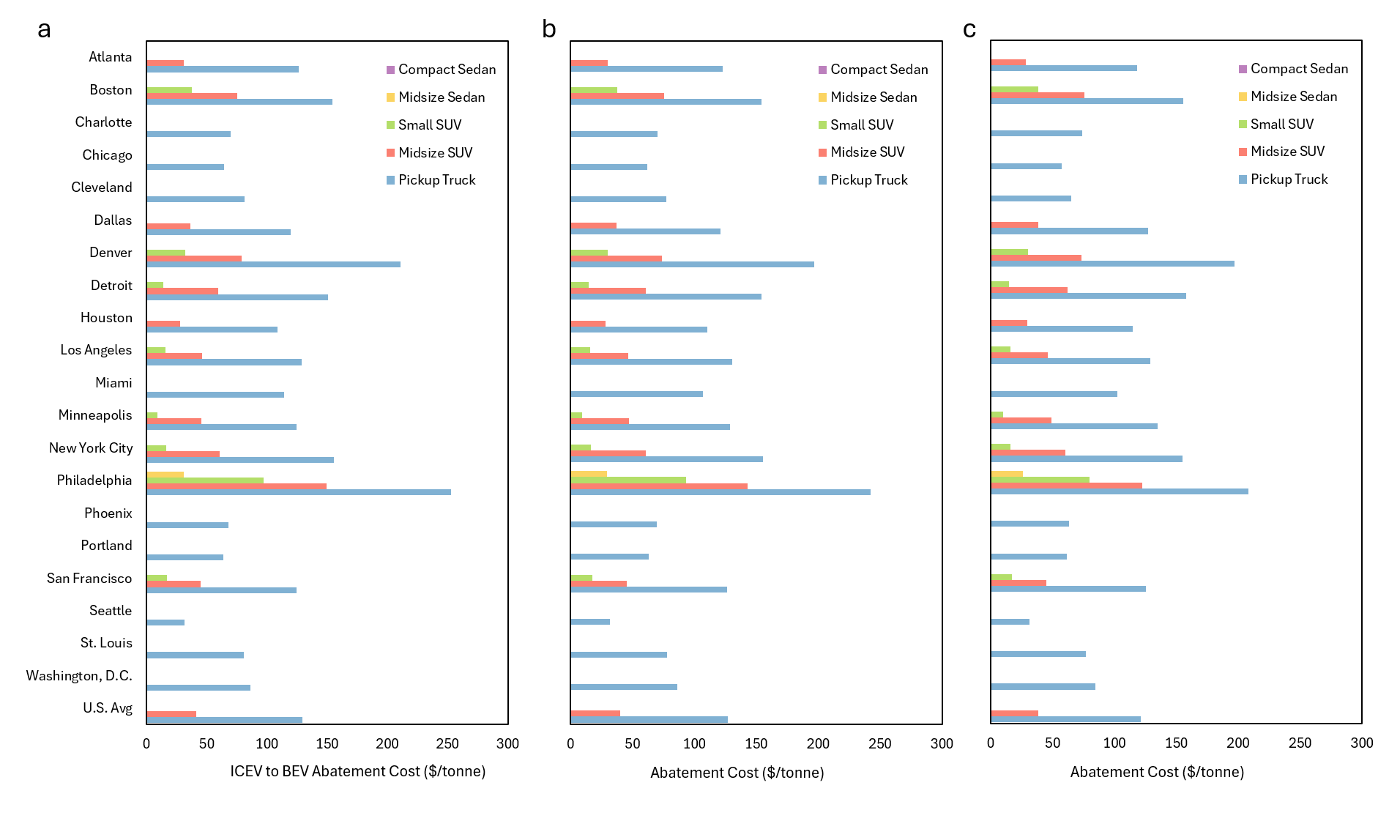
Supplemental Fig. 77. Abatement cost with different grid scenarios
a-c, ICEV to BEV abatement cost in each city with Cambium’s low natural gas price and high renewables price grid scenario (the base case presented in the paper) (a), with Cambiums midcase grid scenario (b), and with Cambium’s high natural gas price and low renewables price grid scenario (c). Bars are not shown for negative abatement costs as the metric no longer measures cost-effectiveness when costs are negative.

Supplemental Note 2: Parameters
Vehicle Parameters
Vehicle parameters are obtained from Argonne National Laboratory’s Autonomie model¹. For the ICEV we use the ‘Conventional SI Turbo’ powertrain. For the HEV we use the ‘Parallel HEV SI Turbo’ powertrain. For the PHEV we use the ‘Parallel PHEV 50’ which has a 50-mile electric range. For the BEV we use the 300-mile range option as the base case, with 200- and 400-mile range options explored in the sensitivity analysis. For all vehicles we use the model year 2025, low technology development scenario. MSRPs are adjusted from $2023 to $2026 for use in our modeling. Curb weight, battery size, fuel economy, and MSRP parameters are shown for each of these vehicles in Supplemental Tables 2-5.

Supplemental Table 2. ICEV Parameters
Vehicle Class | Battery Weight: (Kg) | Vehicle Curb Weight: (Kg) | Unadjusted City Fuel Economy (MPG) | Unadjusted Highway Fuel Economy (MPG) | Adjusted Fuel Economy, Combined 43/57 (MPG) | Vehicle MSRP (2023$)
Compact | 22 | 1293 | 41 | 53 | 34 | 24130
Midsize | 22 | 1552 | 35 | 48 | 30 | 28245
Small SUV | 22 | 1622 | 33 | 42 | 27 | 32258
Midsize SUV | 22 | 1767 | 30 | 38 | 25 | 34069
Pickup | 22 | 2183 | 24 | 30 | 20 | 35666

Supplemental Table 3. HEV Parameters
Vehicle Class | Battery Size (Wh) | High-Voltage Battery Weight (Kg) | Vehicle Curb Weight: (Kg) | Unadjusted City Fuel Economy on UDDS (MPG) | Unadjusted Highway Fuel Economy (MPG) | Adjusted Fuel Economy, Combined 43/57 (MPG) | Vehicle MSRP (2023$)
Compact | 972 | 10 | 1383 | 60 | 62 | 42 | 26563
Midsize | 1080 | 11 | 1607 | 55 | 58 | 39 | 30850
Small SUV | 1080 | 11 | 1674 | 50 | 50 | 35 | 33881
Midsize SUV | 1080 | 11 | 1761 | 46 | 45 | 32 | 35693
Pickup | 1296 | 13 | 2174 | 38 | 37 | 27 | 38601

Supplemental Table 4. PHEV Parameters
Vehicle Class | Battery Size (Wh) | High-Voltage Battery Weight (Kg) | Vehicle Curb Weight (Kg) | Unadjusted City Fuel Economy (MPG) | Unadjusted Highway Fuel Economy (MPG) | Unadjusted City Electrical Energy Consumption (Wh/mile) | Unadjusted Highway Electrical Energy Consumption (Wh/mile) | Adjusted Fuel Economy, Combined 43/57 (MPG) | Adjusted Electricity Consumption, Combined 43/57 (Wh/mi) | Vehicle MSRP {2023$}
Compact | 18962 | 146 | 1485 | 57 | 58 | 180.8 | 200.1 | 40 | 274.0 | 32075
Midsize | 19953 | 153 | 1716 | 54 | 58 | 191.7 | 195.8 | 39 | 277.2 | 36459
Small SUV | 22614 | 174 | 1813 | 49 | 49 | 214.1 | 244.6 | 35 | 330.7 | 40129
Midsize SUV | 24346 | 187 | 1908 | 48 | 46 | 222.1 | 261.0 | 33 | 349.0 | 42508
Pickup | 29256 | 225 | 2356 | 39 | 37 | 257.0 | 309.9 | 28 | 410.2 | 46783

Supplemental Table 5. BEV Parameters
Vehicle Class | BEV Range (miles) | Battery Size (Wh) | High-Voltage Battery Weight (Kg) | Vehicle Curb Weight (Kg) | Unadjusted City Electrical Energy Consumption (Wh/mile) | Unadjusted Highway Electrical Energy Consumption on (Wh/mile) | Adjusted Electricity Consumption, Combined 43/57 (Wh/mi) | Vehicle MSRP (2023$)
Compact | 200 | 44409 | 202 | 1319 | 127.5 | 159.7 | 208.4 | 23717
Midsize | 200 | 45283 | 206 | 1513 | 132.4 | 163.3 | 214.3 | 28347
Small SUV | 200 | 53792 | 245 | 1622 | 154.5 | 201.9 | 259.3 | 33207
Midsize SUV | 200 | 59374 | 270 | 1748 | 167.9 | 224.1 | 285.6 | 36271
Pickup | 200 | 73303 | 333 | 2187 | 207.6 | 280.4 | 355.8 | 41404
Compact | 300 | 65235 | 297 | 1414 | 126.8 | 163.0 | 210.6 | 27761
Midsize | 300 | 70778 | 322 | 1629 | 138.2 | 172.1 | 225.0 | 33316
Small SUV | 300 | 82347 | 374 | 1752 | 159.8 | 210.0 | 269.2 | 38809
Midsize SUV | 300 | 91439 | 416 | 1894 | 173.7 | 232.3 | 295.8 | 42519
Pickup | 300 | 115692 | 526 | 2381 | 213.0 | 289.9 | 366.9 | 49699
Compact | 400 | 101770 | 463 | 1581 | 153.6 | 177.2 | 238.6 | 34828
Midsize | 400 | 110362 | 502 | 1810 | 166.4 | 187.2 | 254.7 | 41010
Small SUV | 400 | 128755 | 585 | 1963 | 189.8 | 225.2 | 300.0 | 47846
Midsize SUV | 400 | 142014 | 646 | 2126 | 205.4 | 247.2 | 327.4 | 52398
Pickup | 400 | 168662 | 767 | 2623 | 246.4 | 305.3 | 399.9 | 60057

We use Autonomie vehicles, rather than real makes and models, because we are primarily concerned with differences inherent to each powertrain. For example, in quarter 3 of 2023, 13% of ICEV sales were considered luxury vehicles. For BEVs at that time, 83% of sales were considered luxury vehicles². That fell to 71% by quarter 3 of 2024, but the BEV market still has a much higher proportion of luxury vehicles than the ICEV market. For this reason, comparisons that use average prices for each powertrain, or comparisons that use the prices of the highest selling model of each powertrain, may not accurately represent the inherent differences between ICEVs and BEVs, and may conflate that with price differences based on luxury vs non-luxury characteristics.
The purchase price premium for BEV has changed significantly in recent years. Woodley et al. (2024) compared a model year 2018 Toyota Camry and Chevrolet Bolt³. At that time the ICEV (Camry) was $23,645, and the BEV (Bolt) was $36,620 (approximately $13,000 difference). In our model, using Autonomie parameters, the ICEV to BEV cost difference for a midsize sedan is reduced to approximately $5,000. For those exact vehicle models, a 2026 Camry starts at $29,000 and a 2026 Bolt starts at $27,600. A comparison of currently available vehicles, of the same model name where possible, is shown in Supplemental Table 6. The MSRP differences between powertrains can be compared with the values in Supplemental Table 2-5, to show that the Autonomie values fairly represent the purchase price differences between powertrains.
Supplemental Table 6. MSRP comparison with real makes and models
Class | Powertrain | Make and Model | MSRP ($)
Midsize Sedan | ICEV | Hyundai Sonata | 27,450
Midsize Sedan | BEV | Hyundai Ioniq 6 | 37,850
Small SUV | ICEV | Hyundai Kona | 25,500
Small SUV | BEV | Hyundai Kona Electric | 32,975
Small SUV | HEV | Kia Niro Hybrid | 27,390
Small SUV | BEV | Kia Niro EV | 39,700
Small SUV | ICEV | Chevrolet Equinox | 28,800
Small SUV | BEV | Chevrolet Equinox EV | 34,995
Small SUV | BEV | Chevrolet Bolt | 27,600
Small SUV | BEV | Nissan Leaf | 29,990
Midsize SUV | ICEV | Chevrolet Blazer | 34,300
Midsize SUV | BEV | Chevrolet Blazer EV | 45,495
Midsize SUV | ICEV | Kia Telluride | 39,190
Midsize SUV | BEV | Kia EV9 | 54,900
Pickup Truck | ICEV | Ford F-150 | 36,507
Pickup Truck | BEV | Ford F-150 Lightning | 50,646
Pickup Truck | ICEV | Chevrolet Silverado | 36,900
Pickup Truck | BEV | Chevrolet Silverado EV | 55,895

Vehicle Lifetimes
We use the average vehicle lifetimes for cars (15.11 years) and light trucks (16.04 years) from the Transportation Energy Data Book⁴ (Table 3-15), rounded down to the nearest year. The car lifetime is applied to compact sedans, midsize sedans, and small SUVs, while the light truck lifetime is applied to midsize SUVs and pickup trucks.
We use the annual VMT for cars (for compact and midsize sedans), SUVs (for small and midsize SUVs), and pickup trucks (for pickup trucks) from the NHTSA (Table 4-12)⁵, applied to the lifetimes from TEDB (Supplemental Table 7). We apply a percentage of annual miles to each month based on data from AFDC⁶ (Supplemental Table 8). This results in the monthly VMTs shown in Supplemental Tables 9-12.
Supplemental Table 7. Vehicle Lifetimes
 | Compact | Midsize Sedan | Small SUV | Midsize SUV | Pickup Truck
Lifetime (years) | 15 | 15 | 15 | 16 | 16
Lifetime (miles) | 192,933 | 192,933 | 201,400 | 212,877 | 218,951

Supplemental Table 8. Percentage of annual mileage by month
Jan | Feb | Mar | Apr | May | Jun | Jul | Aug | Sep | Oct | Nov | Dec
7.6% | 7.2% | 8.4% | 8.2% | 8.7% | 8.7% | 8.9% | 8.9% | 8.3% | 8.7% | 8.1% | 8.2%

Supplemental Table 9. Monthly VMT for compact and midsize sedans
 | Jan | Feb | Mar | Apr | May | Jun | Jul | Aug | Sep | Oct | Nov | Dec | Annual
1 | 1211 | 1144 | 1334 | 1308 | 1386 | 1391 | 1422 | 1417 | 1324 | 1391 | 1288 | 1308 | 15922
2 | 1169 | 1105 | 1289 | 1264 | 1338 | 1343 | 1373 | 1368 | 1279 | 1343 | 1244 | 1264 | 15379
3 | 1130 | 1068 | 1245 | 1221 | 1294 | 1298 | 1327 | 1322 | 1236 | 1298 | 1202 | 1221 | 14864
4 | 1093 | 1033 | 1205 | 1181 | 1251 | 1256 | 1284 | 1279 | 1195 | 1256 | 1163 | 1181 | 14378
5 | 1058 | 1000 | 1166 | 1144 | 1211 | 1216 | 1243 | 1238 | 1157 | 1216 | 1126 | 1144 | 13917
6 | 1025 | 968 | 1130 | 1108 | 1173 | 1178 | 1204 | 1199 | 1121 | 1178 | 1090 | 1108 | 13481
7 | 994 | 939 | 1095 | 1074 | 1137 | 1141 | 1167 | 1163 | 1087 | 1141 | 1057 | 1074 | 13068
8 | 964 | 910 | 1062 | 1042 | 1103 | 1107 | 1132 | 1128 | 1054 | 1107 | 1025 | 1042 | 12677
9 | 936 | 884 | 1031 | 1011 | 1071 | 1075 | 1099 | 1095 | 1023 | 1075 | 995 | 1011 | 12305
10 | 909 | 858 | 1001 | 982 | 1040 | 1044 | 1067 | 1063 | 994 | 1044 | 967 | 982 | 11952
11 | 883 | 834 | 973 | 954 | 1011 | 1015 | 1037 | 1033 | 966 | 1015 | 939 | 954 | 11615
12 | 859 | 811 | 946 | 928 | 983 | 987 | 1008 | 1005 | 939 | 987 | 913 | 928 | 11294
13 | 835 | 789 | 921 | 903 | 956 | 960 | 981 | 977 | 913 | 960 | 889 | 903 | 10986
14 | 813 | 768 | 896 | 878 | 930 | 934 | 955 | 951 | 889 | 934 | 865 | 878 | 10690
15 | 791 | 747 | 872 | 855 | 906 | 909 | 929 | 926 | 865 | 909 | 842 | 855 | 10405

Supplemental Table 10. Monthly VMT for small SUVs
 | Jan | Feb | Mar | Apr | May | Jun | Jul | Aug | Sep | Oct | Nov | Dec | Annual
1 | 1234 | 1166 | 1360 | 1334 | 1413 | 1418 | 1450 | 1444 | 1350 | 1418 | 1313 | 1334 | 16234
2 | 1202 | 1135 | 1324 | 1299 | 1375 | 1381 | 1411 | 1406 | 1314 | 1381 | 1278 | 1299 | 15805
3 | 1170 | 1105 | 1289 | 1264 | 1339 | 1344 | 1374 | 1369 | 1279 | 1344 | 1244 | 1264 | 15383
4 | 1138 | 1075 | 1254 | 1230 | 1302 | 1307 | 1336 | 1331 | 1244 | 1307 | 1210 | 1230 | 14966
5 | 1107 | 1046 | 1220 | 1196 | 1267 | 1272 | 1300 | 1295 | 1210 | 1272 | 1177 | 1196 | 14557
6 | 1076 | 1016 | 1186 | 1163 | 1232 | 1236 | 1264 | 1259 | 1177 | 1236 | 1145 | 1163 | 14153
7 | 1046 | 988 | 1153 | 1130 | 1197 | 1202 | 1228 | 1224 | 1144 | 1202 | 1113 | 1130 | 13756
8 | 1016 | 960 | 1120 | 1098 | 1163 | 1168 | 1193 | 1189 | 1111 | 1168 | 1081 | 1098 | 13366
9 | 987 | 932 | 1088 | 1067 | 1130 | 1134 | 1159 | 1155 | 1079 | 1134 | 1050 | 1067 | 12982
10 | 958 | 905 | 1056 | 1036 | 1097 | 1101 | 1126 | 1121 | 1048 | 1101 | 1019 | 1036 | 12605
11 | 930 | 879 | 1025 | 1005 | 1065 | 1069 | 1092 | 1088 | 1017 | 1069 | 989 | 1005 | 12234
12 | 902 | 853 | 995 | 975 | 1033 | 1037 | 1060 | 1056 | 987 | 1037 | 960 | 975 | 11870
13 | 875 | 827 | 965 | 946 | 1002 | 1006 | 1028 | 1024 | 957 | 1006 | 931 | 946 | 11512
14 | 849 | 802 | 935 | 917 | 971 | 975 | 997 | 993 | 928 | 975 | 903 | 917 | 11161
15 | 822 | 777 | 906 | 889 | 941 | 945 | 966 | 962 | 899 | 945 | 875 | 889 | 10816

Supplemental Table 11. Monthly VMT for midsize SUVs
 | Jan | Feb | Mar | Apr | May | Jun | Jul | Aug | Sep | Oct | Nov | Dec | Annual
1 | 1234 | 1166 | 1360 | 1334 | 1413 | 1418 | 1450 | 1444 | 1350 | 1418 | 1313 | 1334 | 16234
2 | 1202 | 1135 | 1324 | 1299 | 1375 | 1381 | 1411 | 1406 | 1314 | 1381 | 1278 | 1299 | 15805
3 | 1170 | 1105 | 1289 | 1264 | 1339 | 1344 | 1374 | 1369 | 1279 | 1344 | 1244 | 1264 | 15383
4 | 1138 | 1075 | 1254 | 1230 | 1302 | 1307 | 1336 | 1331 | 1244 | 1307 | 1210 | 1230 | 14966
5 | 1107 | 1046 | 1220 | 1196 | 1267 | 1272 | 1300 | 1295 | 1210 | 1272 | 1177 | 1196 | 14557
6 | 1076 | 1016 | 1186 | 1163 | 1232 | 1236 | 1264 | 1259 | 1177 | 1236 | 1145 | 1163 | 14153
7 | 1046 | 988 | 1153 | 1130 | 1197 | 1202 | 1228 | 1224 | 1144 | 1202 | 1113 | 1130 | 13756
8 | 1016 | 960 | 1120 | 1098 | 1163 | 1168 | 1193 | 1189 | 1111 | 1168 | 1081 | 1098 | 13366
9 | 987 | 932 | 1088 | 1067 | 1130 | 1134 | 1159 | 1155 | 1079 | 1134 | 1050 | 1067 | 12982
10 | 958 | 905 | 1056 | 1036 | 1097 | 1101 | 1126 | 1121 | 1048 | 1101 | 1019 | 1036 | 12605
11 | 930 | 879 | 1025 | 1005 | 1065 | 1069 | 1092 | 1088 | 1017 | 1069 | 989 | 1005 | 12234
12 | 902 | 853 | 995 | 975 | 1033 | 1037 | 1060 | 1056 | 987 | 1037 | 960 | 975 | 11870
13 | 875 | 827 | 965 | 946 | 1002 | 1006 | 1028 | 1024 | 957 | 1006 | 931 | 946 | 11512
14 | 849 | 802 | 935 | 917 | 971 | 975 | 997 | 993 | 928 | 975 | 903 | 917 | 11161
15 | 822 | 777 | 906 | 889 | 941 | 945 | 966 | 962 | 899 | 945 | 875 | 889 | 10816
16 | 873 | 824 | 962 | 943 | 999 | 1003 | 1025 | 1021 | 954 | 1003 | 928 | 943 | 11477

Supplemental Table 12. Monthly VMT for pickup trucks
 | Jan | Feb | Mar | Apr | May | Jun | Jul | Aug | Sep | Oct | Nov | Dec | Annual
1 | 1442 | 1362 | 1589 | 1558 | 1650 | 1657 | 1693 | 1687 | 1577 | 1657 | 1534 | 1558 | 18964
2 | 1367 | 1292 | 1507 | 1478 | 1565 | 1571 | 1606 | 1600 | 1495 | 1571 | 1455 | 1478 | 17986
3 | 1298 | 1226 | 1431 | 1403 | 1486 | 1492 | 1525 | 1519 | 1420 | 1492 | 1381 | 1403 | 17076
4 | 1234 | 1166 | 1360 | 1334 | 1413 | 1418 | 1449 | 1444 | 1350 | 1418 | 1313 | 1334 | 16231
5 | 1175 | 1110 | 1294 | 1270 | 1344 | 1349 | 1379 | 1374 | 1285 | 1349 | 1250 | 1270 | 15449
6 | 1120 | 1058 | 1234 | 1210 | 1282 | 1286 | 1315 | 1310 | 1224 | 1286 | 1191 | 1210 | 14726
7 | 1069 | 1010 | 1178 | 1155 | 1224 | 1228 | 1255 | 1251 | 1169 | 1228 | 1137 | 1155 | 14060
8 | 1022 | 966 | 1127 | 1105 | 1170 | 1175 | 1201 | 1196 | 1118 | 1175 | 1088 | 1105 | 13448
9 | 980 | 925 | 1080 | 1059 | 1121 | 1126 | 1151 | 1146 | 1071 | 1126 | 1042 | 1059 | 12886
10 | 941 | 889 | 1037 | 1017 | 1077 | 1081 | 1105 | 1101 | 1029 | 1081 | 1001 | 1017 | 12372
11 | 905 | 855 | 997 | 978 | 1036 | 1040 | 1063 | 1059 | 990 | 1040 | 963 | 978 | 11903
12 | 872 | 824 | 962 | 943 | 999 | 1002 | 1025 | 1021 | 954 | 1002 | 928 | 943 | 11476
13 | 843 | 796 | 929 | 911 | 965 | 969 | 990 | 986 | 922 | 969 | 897 | 911 | 11088
14 | 816 | 771 | 900 | 882 | 934 | 938 | 959 | 955 | 893 | 938 | 868 | 882 | 10737
15 | 792 | 748 | 873 | 856 | 907 | 910 | 930 | 927 | 866 | 910 | 843 | 856 | 10418
16 | 770 | 728 | 849 | 833 | 882 | 885 | 905 | 901 | 842 | 885 | 819 | 833 | 10131

Fuel Economy Adjustments
Fuel economy adjustments are based on the work of Wu et al.⁷ First, the on-road fuel economy, which reflects the fuel economy in real operating conditions, is calculated for city and highway driving, based on the Urban Dynamometer Driving Schedule (UDDS) or the Highway Fuel Economy Test (HWFET) driving tests, respectively.
For ICEVs and HEVs (with fuel economy in miles/gallon):
$$FE_{g,city}^{OR}=\frac{1}{0.003259+\left(\frac{1.1805}{FE_{UDDS}}\right)}$$
$$FE_{g,highway}^{OR}=\frac{1}{0.001376+\left(\frac{1.3466}{FE_{HWFET}}\right)}$$
For BEVs (with fuel economy in Wh/mile):
$$FE_{e,city}^{OR}=\frac{FE_{UDDS}}{0.7}$$
$$FE_{e, highway}^{OR}=\frac{FE_{HWFET}}{0.7}$$
In order to apply the temperature adjustment, the on-road fuel economies must be modified to exclude the impact of temperature.
For ICEVs and HEVs (with fuel economy in miles/gallon):
$$FE_{g,city}^{No T}=\frac{1}{0.00187+\left(\frac{1.134}{FE_{UDDS}}\right)}$$
$$FE_{g,highway}^{No T}=\frac{1}{0.00269+\left(\frac{1.235}{FE_{HWFET}}\right)}$$
For BEVs (with fuel economy in Wh/mile):
$$FE_{e,city}^{No T}=FE_{UDDS}+h_{city}\left(FE_{city}^{OR}-FE_{UDDS}\right)$$
$$FE_{e,highway}^{No T}=FE_{HWFET}+h_{highway}\left(FE_{highway}^{OR}-FE_{HWFET}\right)$$
Where $h_{city}=0.67$ and $h_{highway}=0.87$.
Once the fuel economies without the temperature adjustment factor have been obtained the fuel economy accounting for local temperatures can be calculated.

The fuel economy, $FE$, for each vehicle, $gas \left(g\right) or electric (e)$, in each location, $l$, in each month, $m$, for ICEVs and HEVs (with fuel economy in miles/gallon) is:
$$FE_{g,l,m}=\left(u_{l}*FE_{city}^{No T}+\left(1-u_{l}\right)*FE_{highway}^{No T}\right) / r_{p,l,m}$$
and for BEVs (with fuel economy in Wh/mile) is:
$$FE_{e,l,m}=\left(u_{l}*FE_{city}^{No T}+\left(1-u_{l}\right)*FE_{highway}^{No T}\right)*r_{p,l,m}$$
Where $u_{l}$ represents the percentage of city driving in each location, $l$ (Supplemental Table 13) from the Federal Highway Administration⁸, and $r_{p,l,m}$ represents the temperature adjustment factor for each powertrain, $p$, for each location, $l$, in each month, $m$.
Supplemental Table 13. Percentage of highway driving, and city driving ${(u}_{l})$ in each city
 | Percentage of Total Daily VMT served by Freeways | City driving percentage $u_{l}$
Atlanta | 49% | 51%
Boston | 47% | 53%
Charlotte | 48% | 52%
Chicago | 41% | 59%
Cleveland | 52% | 48%
Dallas | 55% | 45%
Denver | 51% | 49%
Detroit | 38% | 62%
Houston | 49% | 51%
Los Angeles | 52% | 48%
Miami | 43% | 57%
Minneapolis | 50% | 50%
New York City | 51% | 49%
Philadelphia | 42% | 58%
Phoenix | 38% | 62%
Portland | 43% | 57%
San Francisco | 64% | 36%
Seattle | 50% | 50%
St. Louis | 56% | 44%
Washington D.C. | 47% | 53%
U.S. Avg | 57% | 43%

For PHEVs the weighted average of the gasoline and electric formulas are used. For a 50-mile range PHEV 69% electric driving is used.
Temperature adjustment factors are determined by the following equation:
$r_{p,l,m}= \left\{\begin{aligned}α_{p},_{T_{H}}*\left(T_{l,m}-T_{H}\right)+1, \\ 1, \\ α_{p},_{T_{C}}*\left(T_{C}-T_{l,m}\right)+1, \end{aligned}\right.$ $\begin{matrix}where T_{l,m}>T_{H} \\ where T_{c}≤T_{l,m}≤T_{H} \\ where T_{l,m}<T_{C}\end{matrix}$
Where $T_{l,m}$ is the monthly average temperature in each location, $T_{H}$ is the hot temperature threshold, and $T_{C}$ is the cold temperature threshold. The constants $α_{p},_{T_{H}}$ and $α_{p},_{T_{C}}$ represent how sensitive the fuel economy is to temperature and have different values for different powertrains (Supplemental Table 14).
Supplemental Table 14. Temperature Adjustment Factor Formula Values
$$T_{C}$$ | $$15.5 ℃ (60 ℉)$$ | $$T_{H}$$ | $$23.9 ℃ (75 ℉)$$
$$α_{ICEV},_{T_{C}}$$ | $$0.0064 ℃^{-1}$$ | $$α_{ICEV},_{T_{H}}$$ | $$0.0129 ℃^{-1}$$
$$α_{HEV},_{T_{C}}$$ | $$0.0123 ℃^{-1}$$ | $$α_{HEV},_{T_{H}}$$ | $$0.0171 ℃^{-1}$$
$$α_{PHEV},_{T_{C}}$$ | $$0.0154 ℃^{-1}$$ | $$α_{PHEV},_{T_{H}}$$ | $$0.0183 ℃^{-1}$$
$$α_{BEV},_{T_{C}}$$ | $$0.0242 ℃^{-1}$$ | $$α_{BEV},_{T_{H}}$$ | $$0.0210 ℃^{-1}$$

Monthly temperatures for each city $T_{l,m}$ are the 5-year average (2019-2023) for each month for each county in which the various cities are located, with data from NOAA⁹. For New York City, New York County (Manhattan) is used.

Supplemental Note 3: Life Cycle GHG Emissions
Home Charger Emissions
We include both the emissions and cost of a level 2 home charger in our modeling. For the emissions, we use material mass per charger from Zhang et al.¹⁰ and apply the life cycle GHG emissions values for those materials from GREET (Supplemental Table 15).
Supplemental Table 15. Home Charger Greenhouse Gas Emissions
Material (Zhang et al.) | Amount used in a L2 Charger (Zhang et al.) | Material Category used within GREET | Carbon Intensity of the material from GREET  (g CO₂e/kg)
Iron | 24.50 | Final iron product combined | 888.91
Aluminum | 2.07 | Primary aluminum production in the US | 7891.19
Copper | 2.49 | Final copper Product, US Consumption Mix | 3841.11
Rubber | 0.73 | Final Average Rubber Product Combined | 3717.35
Plastic | 0.73 | PC Resin | 4065.66

Multiplying the amount of each material by the carbon intensity of each material gives a total value of 53.34 kg CO₂e from the materials used to produce a level 2 charger. We then add 197 kg CO₂e for L2 charger installation, from Mulrow and Grubert¹¹ to give a total value of 250.34 kg CO₂e for a level 2 home charger.

Vehicle Cycle Emissions
Vehicle cycle emissions are calculated by applying the parameters from Autonomie (battery mass, capacity, and energy density; vehicle curb weight) to the 2025 GREET model¹². Results for each vehicle, broken down by component, are shown in Supplemental Figure 78.
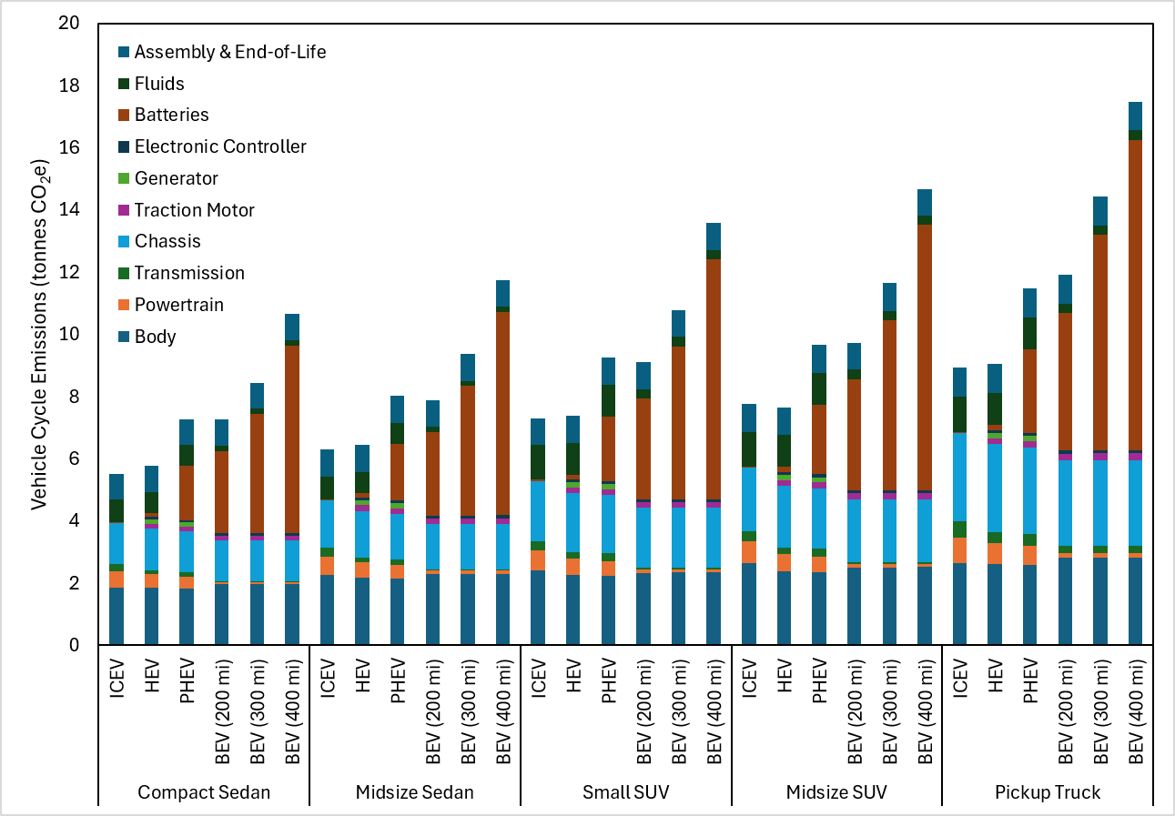
Supplemental Figure 78. Vehicle cycle emission by component

Fuel Cycle Emissions
Fuel cycle emissions are the product of the miles driven by the vehicle, the fuel consumption of the vehicle per mile, and the life cycle carbon intensity of the fuel. For gasoline, the life cycle carbon intensity is 10.498 kg CO₂e/gallon. This includes 8.644 kg CO₂e/gallon from combustion (which is considered for the pump to wheel (PTW) emissions) and 1.854 kg CO₂e/gallon from upstream fuel processing (which is considered for the well to pump (WTP) emissions)¹³. For electricity, the carbon intensity depends on the location, the time of day, and the year.
Grid Emissions Factors
We use projections from the National Renewable Energy Laboratory’s Cambium model for grid emissions over the lifetime of the vehicles in each location. The balancing area used for each city is shown in Supplemental Table 16. We use monthly-hourly emissions factors, which are averaged according to the charging strategy (percentage of off-peak, part-peak, and on-peak charging in each location) to obtain an effective emissions factor. We use the long-run marginal emissions factors. Our base case uses the most conservative scenario available: the “low natural gas cost and high renewables cost” scenario. The effective monthly grid emissions factors, for each five-year time step, for each location are shown in Supplemental Figure 79.

Supplemental Table 16. Balancing area from Cambium used for each city
City | Balancing Area (Cambium) | City | Balancing Area (Cambium)
Atlanta | 94 | Miami | 102
Boston | 131 | Minneapolis | 43
Charlotte | 97 | New York City | 127
Chicago | 80 | Philadelphia | 122
Cleveland | 111 | Phoenix | 28
Dallas | 63 | Portland | 5
Denver | 33 | San Francisco | 9
Detroit | 103 | Seattle | 1
Houston | 67 | St. Louis | 72
Los Angeles | 10 | Washington, DC | 123

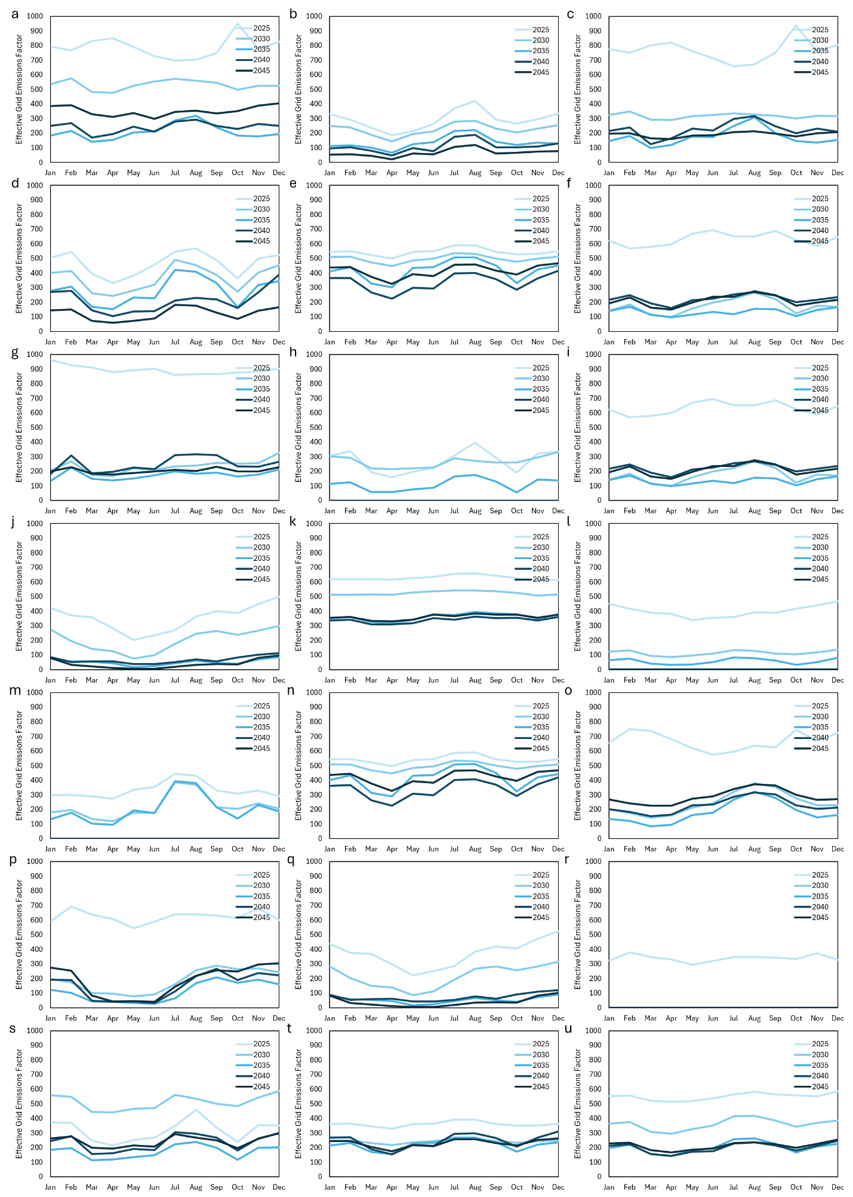
Supplemental Figure 79. Effective grid emissions factors
a-u, The effective grid emissions factor for BEVs, obtained from hourly off-peak, part-peak, and on-peak prices under our base case charging scenario, for each month of each year in Atlanta (a), Boston (b), Charlotte (c), Chicago (d), Cleveland (e), Dallas (f), Denver (g), Detroit (h), Houston (i), Los Angeles (j), Miami (k), Minneapolis (l), New York City (m), Philadelphia (n), Phoenix (o), Portland (p), San Francisco (q), Seattle (r), St. Louis (s), Washington, DC (t), and with U.S. average values (u).

Supplemental Note 4: Total Cost of Ownership
Upfront Cost
Down Payment
We use a down payment of 10% of the vehicle price, including sales tax and fees. The MSRP is adjusted for inflation from $2023 to $2026.
$$Down Payment= \left(MSRP+\left(MSRP*Sales Tax Percentage\right)+Fees\right)*10\%$$
Taxes and Fees
The sales tax rate combines state, local, and special purpose (e.g., to fund local public transit) taxes within each city (Supplemental Figure 80). Note that DC tax shown in the figure is 7% but in reality (and in our model) it is a formula that varies based on vehicle powertrain and curb weight, and values range from 1% to 7%. Title and license plate fees are shown in Supplemental Figure 81.
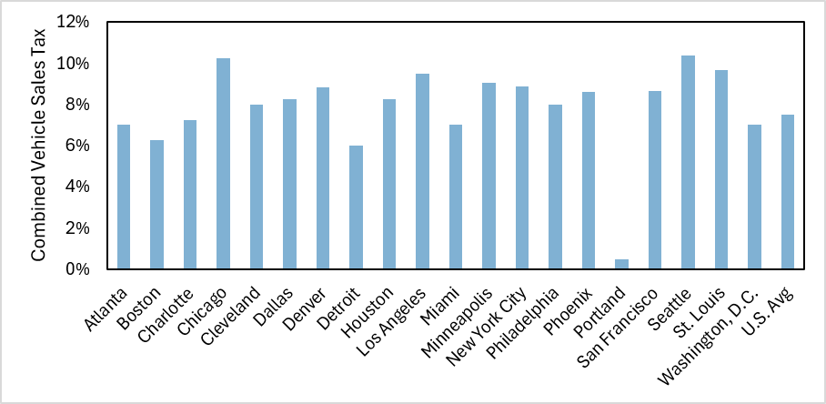
Supplemental Figure 80. Sales tax rates in each city
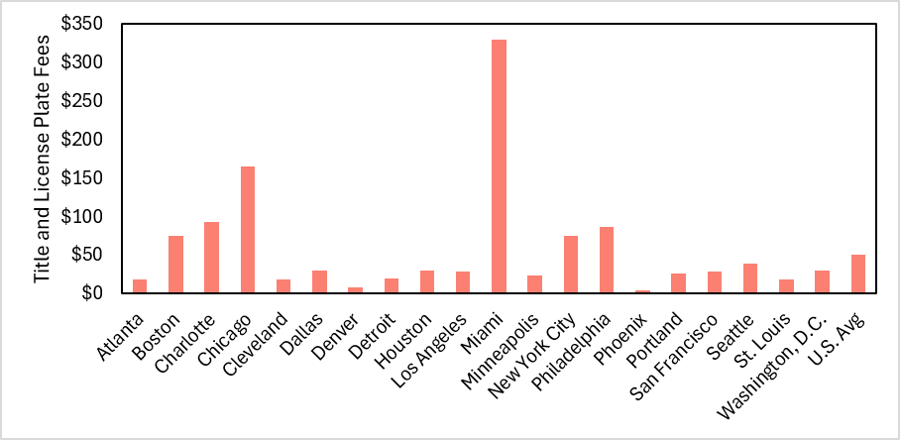
Supplemental Figure 81. Title and license plate fees in each city
Home Charger
Charger costs are the sum of the cost of charging equipment, the cost of installation, and the cost of permitting (Supplemental Figure 82).
$$Charger=Equipment Cost+Installation Cost+Permitting Cost$$
The cost of charging equipment depends on the type of charger (level 1 or level 2) and whether or not the home has a 240 Volt outlet available. Our values are based on the Borlaug et al.¹⁴ values of $550 for equipment and $1286 for installation (labor), factoring in 27.6% inflation from 2020 to 2026 to give U.S. average values of $702 for equipment and $1641 for installation. For the installation cost, we modify this value to account for variation in the cost of labor in different cities. The labor cost for each city is determined by multiplying the U.S. average installation cost by the ratio of the mean wage for electricians in each metro area to the U.S. average mean wage for electricians (Supplemental Figure 83) from the Bureau of Labor Statistics¹⁵. This results in labor costs ranging from $1350 (Charlotte) to $2,457 (San Francisco). We use a fixed $150 permitting cost in each location.
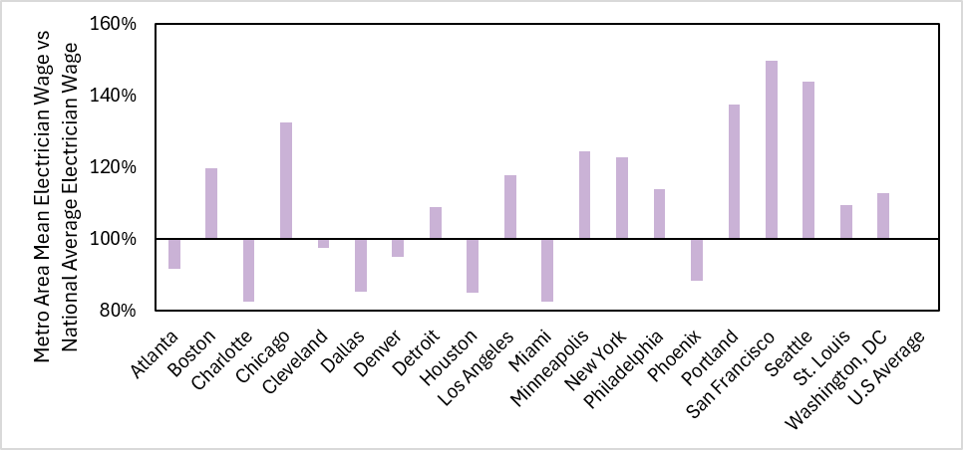
Supplemental Figure 82. Mean electrician wages by metro area versus the national average
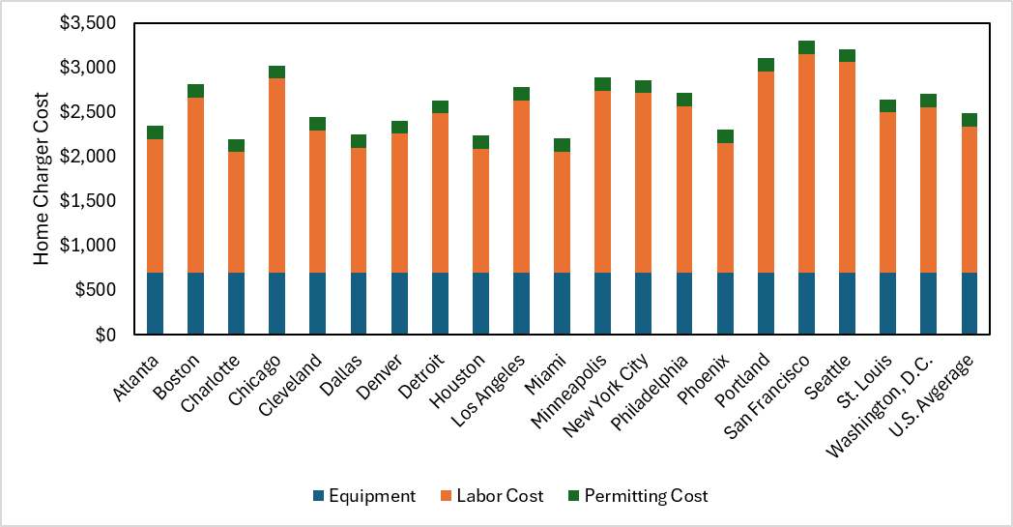
Supplemental Figure 83. Home charger costs by city
Recurring Cost
Recurring costs consist of fuel, insurance, financing, maintenance, repairs, and annual fees.
Fuel
Fuel cost refers to gasoline costs (for ICEVs and HEVs), electricity costs (for BEVs), or both (for PHEVs).
Gasoline Prices
We use the average monthly price for regular (i.e., not including premium) gasoline over the previous five years (2021-2025) from EIA. Where available we use city level data (Boston, Chicago, Cleveland, Denver, Houston, Los Angeles, Miami, New York City, San Francisco, and Seattle). We use state level data for Dallas (Texas) and Minneapolis (Minnesota). We use regional data for Atlanta (Lower Atlantic), Detroit (Midwest), Philadelphia (Central Atlantic), Phoenix (West Coast less California), and Washington DC (Central Atlantic). For these cities we compared the EIA state or regional prices with city level prices that used to be maintained for these cities by the Bureau of Labor and Statistics (BLS). In each of these states or regions, the prices were within 5% of the BLS city level data. We multiply by the ratio of BLS city data to EIA city or regional data (e.g., the BLS city data for Detroit was 3.3% greater than the EIA Midwest data in a previous year, so we use the current EIA Midwest data, multiplied by 1.033, to represent Detroit gasoline prices). For the last 3 cities there is no BLS data to compare against. We use regional data for Charlotte (Lower Atlantic), St. Louis (Midwest), and Portland (West Coast less California) without any adjustment. These prices are shown in Supplemental Figure 84.
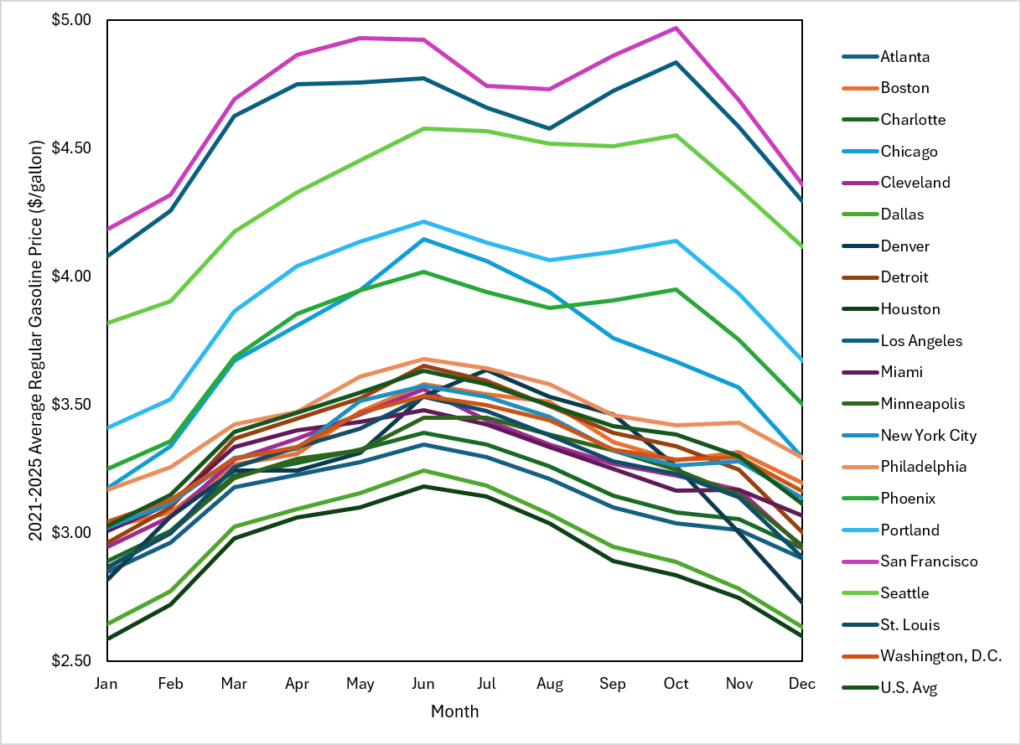
Supplemental Fig. 84. Gasoline prices
Monthly gasoline prices in each city, from average monthly prices from 2021-2025.

Electricity Prices
Electricity rate plans are found using the OpenEI U.S. Utility Rate Database¹⁶, and verified with publicly available documents from the utility where possible. Where multiple rate plans are available, we select one designed for electric vehicle owners whenever possible. The specific utilities and rate plans are shown in Supplemental Table 17. The definitions of peak hours and different seasons for each utility are shown in Supplemental Table 18. The electricity rates for each rate plan are shown in Supplemental Table 19.
Public charging prices are based on publicly available data from various charging networks^{17–19}. Rather than distributing public charging to different hours of the day, we use part-peak pricing for Level 2 charging and on-peak pricing for Level 3 charging. These rates are shown in Supplemental Table 20.

Supplemental Table 17. Utilities and Rate Plans for Each City
City | Utility | Rate Plan
Atlanta | Georgia Power Co | Schedule TOU-OA-14 Time of Use - Overnight Advantage
Boston | NSTAR Electric Company | Greater Boston Residential R-1 (A1)
Charlotte | Progress Energy Carolinas Inc | Residential Time of Use EV(R-TOU-EV) Three Phase
Chicago | Commonwealth Edison Co | BES - Residential Single Family Without Electric Space Heat Delivery Class
Cleveland | City of Cleveland, Ohio (Utility Company) | Residential
Dallas | TXU/Oncor | TXU Energy Free Nights & Solar Days 12
Denver | Public Service Co of Colorado | Residential Energy Time Of Use (Schedule RE-TOU)
Detroit | DTE Electric | Overnight Savers
Houston | TXU/Centerpoint | TXU Energy Free Nights & Solar Days 12
Los Angeles | Southern California Edison Co | TOU-D-Prime
Miami | Florida Power & Light Co. | RTR-1 Residential Service TOU
Minneapolis | Northern States Power Co - Minnesota | Residential Electric Vehicle Service (A08)
New York City | Consolidated Edison Co -NY | SC-1 Residential & Religious Voluntary TOD (Rate III) - Zone I [NYC]
Philadelphia | PECO Energy Co | Residential Service (R) - TOU
Phoenix | Arizona Public Service Co | Residential Electric Vehicle Time-of-Use (R-EV)
Portland | Portland General Electric Co | Residential Time-Of-Use Service (Rate 7-TOU of EV)
San Francisco | Pacific Gas & Electric Co | Electric Vehicle EV2 (Sch)
Seattle | City of Seattle, Washington (Utility Company) | Schedule RSC - Residential: Seattle
St. Louis | Union Electric Co | 1(M) Residential Overnight Saver Service
Washington, D.C. | PEPCO | Residential Schedule R

Supplemental Table 18. Rate Plan Definitions for Each City
City | Winter Definition | Off-Peak Definition | Part-Peak Definition | On-Peak Definition
Atlanta | Oct-May | 11pm-7am | 7am-11pm | 2pm-7pm Summer Only
Boston | - | - | - | -
Charlotte | - | 11pm-5am | - | 5am-11pm
Chicago | Oct-May | - | - | -
Cleveland | Nov-May | - | - | -
Dallas | - | 8pm-5am | - | 5am-8pm
Denver | Oct-May | 9pm-5pm | - | 5pm-9pm (Weekday Only)
Detroit | Oct-May | 1am-7am | 7pm-1am & 7am-3pm | 3pm-7pm (Weekday Only)
Houston | - | 8pm-5am | - | 5am-8pm
Los Angeles | Oct-May | 9pm-4pm | 4pm-9pm (Summer Weekend Only) | 4pm-9pm
Miami | Nov-Mar | 10pm-6am & 10am-6pm (W), 9pm-12pm (S) | - | 6am-10am & 6pm-10pm (W), 12pm-9pm (S) (Weekday Only)
Minneapolis | Oct-May | 9pm-9am | - | 9am-9pm (Weekday Only)
New York City | Oct-May | 12am-8am | - | 8am-12am
Philadelphia | - | 12am-6am | 6am-2pm, 6pm-12am | 2pm-6pm
Phoenix | November-April | 11pm-5am | 5am-4pm & 7pm-11pm | 4pm-7pm
Portland | - | 9pm-7am | 7am-5pm | 5pm-9pm
San Francisco | Oct-May | 12am-3pm | 3pm-4pm & 9pm-12am | 4pm-9pm
Seattle | - | - | - | -
St. Louis | Oct-May | 10pm-6am | - | 6am-10pm
Washington, D.C. | Nov-May | - | - | -

Supplemental Table 19. Electricity prices ($/kWh)
City | Winter |  |  | Summer
 | Off-Peak | Part-Peak | On-Peak | Off-Peak | Part-Peak | On-Peak
Atlanta | 0.067439 |  | 0.158906 | 0.067439 | 0.158906 | 0.408168
Boston | 0.252200 |  |  | 0.252200
Charlotte | 0.086450 |  | 0.151930 | 0.086450 |  | 0.151930
Chicago | 0.124910 |  |  | 0.129280
Cleveland | 0.063200 |  |  | 0.095650
Dallas | 0.056183 |  | 0.271183 | 0.056183 |  | 0.271183
Denver | 0.121650 |  | 0.328320 | 0.139260 |  | 0.381090
Detroit | 0.117400 | 0.155500 | 0.190600 | 0.117400 | 0.254600 | 0.355600
Houston | 0.049993 |  | 0.264993 | 0.049993 |  | 0.264993
Los Angeles | 0.240000 |  | 0.560000 | 0.260000 | 0.400000 | 0.590000
Miami | 0.132580 |  | 0.174485 | 0.132580 |  | 0.174485
Minneapolis | 0.095540 |  | 0.259500 | 0.095540 |  | 0.304650
New York City | 0.151020 |  | 0.270120 | 0.151020 |  | 0.491920
Philadelphia | 0.208010 | 0.231220 | 0.474870 | 0.208010 | 0.231220 | 0.474870
Phoenix | 0.064781 | 0.133926 | 0.378031 | 0.114511 | 0.153281 | 0.398071
Portland | 0.132130 | 0.189500 | 0.384440 | 0.132130 | 0.189500 | 0.384440
San Francisco | 0.225580 | 0.394280 | 0.410990 | 0.225580 | 0.427600 | 0.538090
Seattle | 0.139200 |  |  | 0.139200
St. Louis | 0.063280 |  | 0.098780 | 0.072180 |  | 0.169480
Washington, D.C. | 0.160520 |  |  | 0.192920

Supplemental Table 20. Public Charging Prices ($/kWh)
 | Level 2 |  |  | Level 3
 | Off | Part | On | Off | Part | On | Combined
Atlanta | 0.24 | 0.25 | 0.295 | 0.48 | 0.5 | 0.59 | 0.42
Boston | 0.265 | 0.29 | 0.32 | 0.53 | 0.58 | 0.64 | 0.465
Charlotte | 0.205 | 0.26 | 0.28 | 0.41 | 0.52 | 0.56 | 0.41
Chicago | 0.205 | 0.26 | 0.295 | 0.41 | 0.52 | 0.59 | 0.425
Cleveland | 0.205 | 0.26 | 0.295 | 0.41 | 0.52 | 0.59 | 0.425
Dallas | 0.24 | 0.25 | 0.295 | 0.48 | 0.5 | 0.59 | 0.42
Denver | 0.205 | 0.26 | 0.295 | 0.41 | 0.52 | 0.59 | 0.425
Detroit | 0.24 | 0.25 | 0.295 | 0.48 | 0.5 | 0.59 | 0.42
Houston | 0.24 | 0.25 | 0.295 | 0.48 | 0.5 | 0.59 | 0.42
Los Angeles | 0.26 | 0.31 | 0.345 | 0.52 | 0.62 | 0.69 | 0.5
Miami | 0.24 | 0.25 | 0.295 | 0.48 | 0.5 | 0.59 | 0.42
Minneapolis | 0.24 | 0.25 | 0.295 | 0.48 | 0.5 | 0.59 | 0.42
New York City | 0.29 | 0.3 | 0.32 | 0.58 | 0.6 | 0.64 | 0.47
Philadelphia | 0.24 | 0.25 | 0.295 | 0.48 | 0.5 | 0.59 | 0.42
Phoenix | 0.24 | 0.29 | 0.32 | 0.48 | 0.58 | 0.64 | 0.465
Portland | 0.24 | 0.29 | 0.32 | 0.48 | 0.58 | 0.64 | 0.465
San Francisco | 0.26 | 0.295 | 0.345 | 0.52 | 0.59 | 0.69 | 0.4925
Seattle | 0.205 | 0.255 | 0.295 | 0.41 | 0.51 | 0.59 | 0.4225
St. Louis | 0.205 | 0.26 | 0.28 | 0.41 | 0.52 | 0.56 | 0.41
Washington, D.C. | 0.285 | 0.3 | 0.32 | 0.57 | 0.6 | 0.64 | 0.47
U.S. Avg | 0.205 | 0.26 | 0.295 | 0.41 | 0.52 | 0.59 | 0.425

As highlighted in the paper, many of the cities with the highest gasoline prices also have the highest electricity prices (e.g., San Francisco, Los Angeles). Many cities with the lowest gasoline prices also have low electricity prices (e.g., Dallas, Houston, St. Louis, Cleveland). The cities that are most cost-favorable to electric vehicles have a mix of both above average gasoline prices, and average electricity prices (Seattle, Phoenix, Chicago), whereas the cities that are least cost-favorable for electric vehicles have high electricity prices and average gasoline prices (Boston, Philadelphia). These can be seen in Supplemental Figure 85.
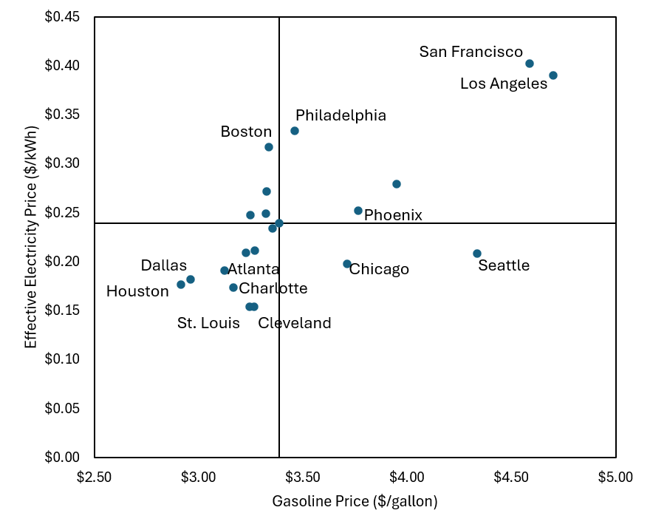
Supplemental Figure 85. Effective electricity prices and gasoline prices in each city.
Effective electricity prices in each city using the base case charging strategy paired with each rate plan, and gasoline prices in each city. The horizontal and vertical lines mark the national average values.

Insurance
We developed a formula based on Liu et al.²⁰, including the base price, based on the MSRP of the vehicle, and the powertrain (ICEV, HEV, or BEV) to determine the insurance cost for each year, $n$, in each location, $l$.
$$Insurance_{n,l}=Base Price*VMT Adjustment_{n}*Location Adjustment_{l}$$
$$Base Price= \left\{\begin{aligned}0.023*MSRP+682.61, for ICEVs and HEVs \\ 0.026*MSRP+479.71, for BEVs\end{aligned}\right.$$
We modify these equations with adjustment factors based on how many miles the car is driven each year from Parker et al.²¹
$$VMT Adjustemnt_{n}=\left(1+0.04*\frac{VMT_{n}-12,000}{1,000}\right)$$
The location adjustment is determined by dividing the average insurance cost in each metro area by the nationwide average, using data from bankrate.com²² . Location adjustment factors are shown in Supplemental Figure 86. Most of these values are greater than 1, sometimes by substantial margins, as insurance rates tend to be higher in urban areas.
$$Location Adjustment=\frac{Average Insurance Cost in City}{Nationwide Average Insurance Cost}$$
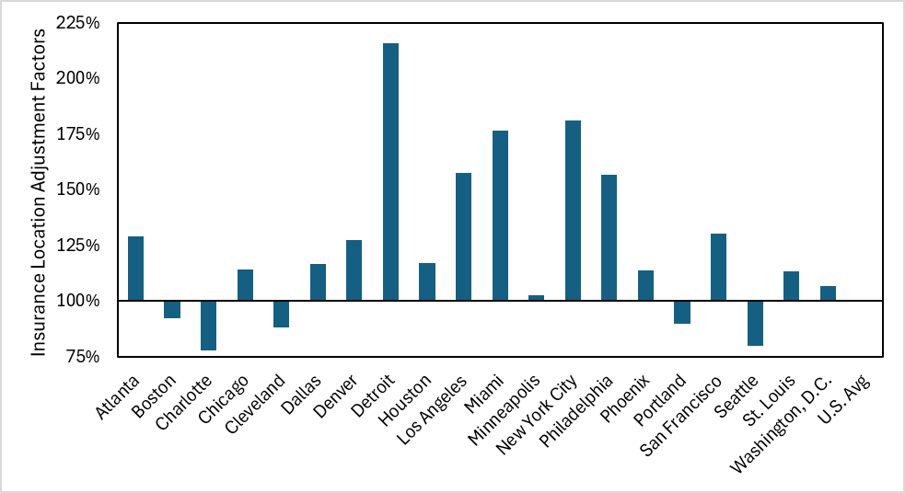
Supplemental Figure 86. Location Adjustment Factors for Insurance Costs

Financing
We use a down payment of 10% of the MSRP, a 6-year loan term, and a 5% annual interest rate, which reflects a relatively high credit score. The amount paid each year, $n$, is given by the following:
$$Financing_{n}= \left\{\begin{aligned} 12*\frac{Loan*r*{\left(1+r\right)}^{t}}{{\left(1+r\right)}^{t}-1}, if n≤T \\ 0, if n>T\end{aligned}\right.$$
$$Loan=MSRP+\left(MSRP*Sales Tax Percentage\right)+Fees-Down Payment$$
$$r=\frac{R}{12}, R=annual interest rate (5\%)$$
$$t=T*12, T=loan term in years (6)$$

Maintenance
The maintenance schedule and cost are from Argonne National Laboratory’s BEAN model²³ and are shown in Supplemental Table 21. We multiply the tire cost (which was the same for all powertrains) by 1.5 for BEVs. BEV tires are generally more expensive due to the vehicle’s greater weight and torque. We do not adjust any other individual values from the BEAN model; however the total maintenance cost is multiplied by 1.084 to adjust for inflation.
The maintenance schedule is then applied to the VMT schedule shown in Supplemental Tables 9-12 to determine when each maintenance event takes place within the vehicle’s lifetime. This maintenance schedule results in large spikes in maintenance costs when mileage thresholds (e.g., 100,000 miles) are reached. To approximate more realistic consumer behavior in which these schedules are not followed exactly, and large purchases may be spread out, we set the maintenance cost each year to be the average of the scheduled cost for that year and scheduled cost for the preceding and following years.
Supplemental Table 21. Vehicle maintenance schedule and costs
 | Repeat VMT (every X miles) | ICEV | HEV | PHEV | BEV
Engine Oil* | 7500 | 65 | 65
Engine Oil* | 9000 |  |  | 65
Oil Filter* | 7500 | 20 | 20
Oil Filter* | 9000 |  |  | 20
Tire Rotation | 7500 | 50 | 50 | 50 | 50
Wiper Blades | 15000 | 45 | 45 | 45 | 45
Cabin Air Filter | 20000 | 50 | 50 | 50 | 50
Multi-point Inspection | 20000 | 110 | 110 | 110 | 80
Engine Air Filter* | 30000 | 40
Engine Air Filter* | 66666.67 |  | 40
Engine Air Filter* | 83333.33 |  |  | 40
Brake Fluid | 37500 | 150 | 150 | 150 | 150
Tires Replaced*** | 50000 | 525 | 525 | 525 | 787.5
Brake Pads*** | 50000 | 350
Brake Pads*** | 66666.67 |  | 350
Brake Pads*** | 75000 |  |  | 350 | 350
Pb-Ac Battery | 50000 | 175 | 175 | 175 | 175
Spark Plugs* | 60000 | 225
Spark Plugs* | 120000 |  | 225 | 225
Oxygen Sensor | 80000 | 350 | 350 | 350
Headlight Bulbs | 80000 | 90 | 90 | 90 | 90
Transmission Service* | 90000 | 200
Transmission Service* | 110000 |  | 200 | 200
Timing Belt* | 90000 | 750
Timing Belt* | 110000 |  | 750 | 750
Accessory Drive Belt* | 90000 | 165
Accessory Drive Belt* | 110000 |  | 165 | 165
HVAC Service | 100000 | 50 | 50 | 50 | 50
Brake Rotors*** | 100000 | 500
Brake Rotors*** | 125000 |  | 500
Brake Rotors*** | 150000 |  |  | 500 | 500
Shocks and Struts | 100000 | 1000 | 1000 | 1000 | 1000
Engine Coolant* | 125000 | 190 | 190 | 190
EV Battery Coolant* | 125000 |  | 210 | 210 | 210
Fuel Filter* | 150000 | 110
Fuel Filter* | 200000 |  | 110 | 110
Brake Calipers*** | 150000 | 1000
Brake Calipers*** | 187500 |  | 1000 | 1000
Brake Calipers*** | 225000 |  |  |  | 1000

Repairs
Repair costs are from the BEAN model²³. Per mile repair costs in each year, $n$, are represented by the equation:
$$Repair_{n}=Powertrain Multiplier*Class Multiplier*Repair Cost Coefficient_{n}*e^{0.0002*MSRP}$$
This per mile cost is then multiplied by the VMT each year. Values used in the repair cost equation are shown in Supplemental Tables 22-24. Since the repair cost is a function of MSRP, and MSRP is already adjusted for inflation, we do not make further adjustments to the repair cost.
Supplemental Table 22. Repair Cost Coefficients
Year | Repair Cost Coefficient | Year | Repair Cost Coefficient
1 | 0.00000 | 14 | 0.04667
2 | 0.00000 | 15 | 0.05000
3 | 0.00333 | 16 | 0.05333
4 | 0.01000 | 17 | 0.05666
5 | 0.01670 | 18 | 0.05999
6 | 0.02003 | 19 | 0.06332
7 | 0.02336 | 20 | 0.06665
8 | 0.02669 | 21 | 0.06998
9 | 0.03002 | 22 | 0.07331
10 | 0.03335 | 23 | 0.07664
11 | 0.03668 | 24 | 0.07997
12 | 0.04001 | 25 | 0.08330
13 | 0.04334

Supplemental Table 23. Powertrain Multipliers
ICEV | HEV | BEV
1.00 | 0.91 | 0.67

Supplemental Table 24. Class Multipliers
Sedan | SUV | Pickup
1.00 | 0.91 | 0.70

Recurring Fees
Annual fees include fees for registering the vehicle (which apply to all powertrains), and separate electric vehicle fees, which many states have enacted for alternative powertrains to make up for reduced gasoline tax revenues. The structure and value of registration fees vary greatly by state, with some having a flat rate for all vehicles and others having fees that depend on the vehicle’s city of primary residence, original value, age, curb weight, fuel economy, horsepower, or combinations thereof. Registration fees for each city are shown in Supplemental Table 25, and alternative powertrain fees for each state are shown in Supplemental Figure 87.

Supplemental Table 25. Recurring Vehicle Registration Fees in Each City (Annual)
Atlanta | $$\$20$$
Boston | $$\$30+X*25*\frac{MSRP}{1000} where X=\left\{\begin{aligned}0.90 when vehicle age=0 \\ 0.60 when vehicle age=1 \\ 0.40 when vehicle age=2 \\ 0.25 when vehicle age=3 \\ 0.10 when vehicle age≥4\end{aligned}\right.$$
Charlotte | $$\left\{\begin{aligned}\$46.25 when curb weight<5000 lbs \\ \$70.00 when 5000≤curb weight<6000 lbs \\ \$83.00 when curb weight≥6000 lbs\end{aligned}\right.$$
Chicago | $$\$151+ \left\{\begin{aligned}\$100.17 when curb weight<4500 lbs \\ \$159.12 when curb weight≥4500 lbs\end{aligned}\right.$$
Cleveland | $$\$36$$
Dallas | $$\$61.75$$
Denver | $$\left\{\begin{aligned}\$6 when curb weight<2000 lbs \\ \$6+0.2*\left(curb weight-2000\right) when 2000≤curb weight<4500 \\ 12.50+0.6*\left(curb weight-4500\right)when curb weight≥4500\end{aligned}+\left\{\$\begin{aligned}\$9 if vehicle age<7 \\ 7 if &≤vehicle age≤9 \\ \$5 if vheicle age>9\end{aligned}\right.\right.$$  $$+ MSRP*0.85*X where\left\{\begin{aligned}X=0.021 when vehicle age=0 \\ X=0.015 when vehicle age=1 \\ X=0.012 when vehicle age=2 \\ X=0.009 when vehicle age=3 \\ X=0.0045 when 4≤vehicle age<10\end{aligned}+ \left\{\begin{aligned}\$6 when vehicle age<10 \\ \$9 when vehicle age≥10\end{aligned}\right.\right.$$
Detroit | $$\$4+\frac{MSRP}{1000}*6*X where\left\{\begin{aligned}X=1.000 when vehicle age=0 \\ X=0.900 when vehicle age=1 \\ X=0.810 when vehicle age=2 \\ X=0.729 when vehicle age≥3\end{aligned}\right.$$
Houston | $$\$61.75$$
Los Angeles | $$\$76+\$34+\$11+0.0065*MSRP+\left\{\begin{aligned}\$33 when MSRP<5000 \\ \$66 when 5000≤MSRP<25000 \\ \$132 when 25000≤MSRP<35000 \\ \$198 when 35000≤MSRP<60000 \\ \$231 when MSRP≥60000\end{aligned}\right.$$
Miami | $$\left\{\begin{aligned}\$14.50 when curb weight<2500 \\ \$22.50 when 2500≤curb weight<3500 \\ \$32.50 when curb weight≥3500\end{aligned}\right.$$
Minneapolis | $$\$30+\left\{\begin{aligned}0.01575*MSRP*1.00 when vehicle age=0 \\ 0.01575*MSRP*0.95 when vehicle age=1 \\ 0.01575*MSRP*0.90 when vehicle age=2 \\ 0.01575*MSRP*0.80 when vehicle age=3 \\ 0.01575*MSRP*0.70 when vehicle age=4 \\ 0.01575*MSRP*0.60 when vehicle age=5 \\ 0.01575*MSRP*0.50 when vehicle age=6 \\ 0.01575*MSRP*0.40 when vehicle age=7 \\ 0.01575*MSRP*0.25 when vehicle age=8 \\ 0.01575*MSRP*0.15 when vehicle age=9 \\ \$20 when vehicle age≥10\end{aligned}\right.$$
New York City | $$+\$30+\$50, every 2 years$$
  Weight | Fee |  | Weight | Fee
  0000 - 1,650 lbs. | $26.00 |  | 4,351 - 4,450 lbs. | $78.50
  1,651 - 1,750 lbs. | $27.50 |  | 4,451 - 4,550 lbs. | $81.00
  1,751 - 1,850 lbs. | $29.00 |  | 4,551 - 4,650 lbs. | $83.50
  1,851 - 1,950 lbs. | $31.00 |  | 4,651 - 4,750 lbs. | $85.50
  1,951 - 2,050 lbs. | $32.50 |  | 4,751 - 4,850 lbs. | $88.00
  2,051 - 2,150 lbs. | $34.00 |  | 4,851 - 4,950 lbs. | $90.50
  2,151 - 2,250 lbs. | $35.50 |  | 4,951 - 5,050 lbs. | $93.00
  2,251 - 2,350 lbs. | $37.50 |  | 5,051 - 5,150 lbs. | $95.50
  2,351 - 2,450 lbs. | $39.00 |  | 5,151 - 5,250 lbs. | $98.00
  2,451 - 2,550 lbs. | $40.50 |  | 5,251 - 5,350 lbs. | $100.50
  2,551 - 2,650 lbs. | $42.00 |  | 5,351 - 5,450 lbs. | $102.50
  2,651 - 2,750 lbs. | $43.50 |  | 5,451 - 5,550 lbs. | $105.00
  2,751 - 2,850 lbs. | $45.50 |  | 5,551 - 5,650 lbs. | $107.50
  2,851 - 2,950 lbs. | $47.00 |  | 5,651 - 5,750 lbs. | $110.00
  2,951 - 3,050 lbs. | $48.50 |  | 5,751 - 5,850 lbs. | $112.50
  3,051 - 3,150 lbs. | $50.00 |  | 5,851 - 5,950 lbs. | $115.00
  3,151 - 3,250 lbs. | $52.00 |  | 5,951 - 6,050 lbs. | $117.00
  3,251 - 3,350 lbs. | $53.50 |  | 6,051 - 6,150 lbs. | $119.50
  3,351 - 3,450 lbs. | $55.00 |  | 6,151 - 6,250 lbs. | $122.00
  3,451 - 3,550 lbs. | $56.50 |  | 6,251 - 6,350 lbs. | $124.50
  3,551 - 3,650 lbs. | $59.00 |  | 6,351 - 6,450 lbs. | $127.00
  3,651 - 3,750 lbs. | $61.50 |  | 6,451 - 6,550 lbs. | $129.50
  3,751 - 3,850 lbs. | $64.00 |  | 6,551 - 6,650 lbs. | $131.50
  3,851 - 3,950 lbs. | $66.50 |  | 6,651 - 6,750 lbs. | $134.00
  3,951 - 4,050 lbs. | $69.00 |  | 6,751 - 6,850 lbs. | $136.50
  4,051 - 4,150 lbs. | $71.00 |  | 6,851 - 6,950 lbs. | $139.00
  4,151 - 4,250 lbs. | $73.50 |  | 6,951 lbs. or more | $140.00
  4,251 - 4,350 lbs. | $76.00 |  | Every 2 years
Philadelphia | $$\$48$$
Phoenix | $$\$9.50+2.8*\frac{MSRP*X}{100}where\left\{\begin{aligned}X=0.6000 when vehicle age=0 \\ X=0.5025 when vehicle age=1 \\ X=0.3075 when vehicle age=2 \\ X=0.2100 when vehicle age=3 \\ X=0.1125 when vehicle age=4 \\ X=0.0150 when vehicle age=5\end{aligned}\right.$$  $$\$10 when vehicle age≥6$$
Portland | $$\$56+\left\{\begin{aligned}\$63 when fuel economy<19.5 \\ \$68 when 19.5≤fuel economy<39.5 \\ \$108 when fuel economy≥39.5\end{aligned}\right.$$
San Francisco | $$\$76+\$34+\$14+0.0065*MSRP+\left\{\begin{aligned}\$33 when MSRP<5000 \\ \$66 when 5000≤MSRP<25000 \\ \$132 when 25000≤MSRP<35000 \\ \$198 when 35000≤MSRP<60000 \\ \$231 when MSRP≥60000\end{aligned}\right.$$
Seattle | $$\$30+\$50+0.011*MSRP*X where\left\{\begin{aligned}X=1.00 when vehicle age=0 \\ X=0.95 when vehicle age=1 \\ X=0.89 when vehicle age=2 \\ X=0.83 when vehicle age=3 \\ X=0.74 when vehicle age=4 \\ X=0.65 when vehicle age=5 \\ X=0.57 when vehicle age=6 \\ X=0.48 when vehicle age=7 \\ X=0.40 when vehicle age=8 \\ X=0.31 when vehicle age=9 \\ X=0.22 when vehicle age=10 \\ X=0.14 when vehicle age=11 \\ X=0.10 when vehicle age≥12\end{aligned}\right.$$
St. Louis | $$\left\{\begin{aligned}60.25 when engine horsepower≥72 \\ 54.25 when 60≤engine horsepower<72 \\ \$48.25 when engine horsepower<60 \\ \$27.25 for BEVs\end{aligned}\right.$$
Washington, DC | $$\left\{\begin{aligned}\$70 when curb weight<3500 \\ \$175 when 3500≤curb weight<5000 \\ \$300 whend 5000≤curb weight<6000 \\ \$550 when curb weight≥6000\end{aligned}\right.$$  $$(reduced to \$40 for BEVs under 5000 lbs for first two vehicle years)$$
U.S. Average | $$\$100$$

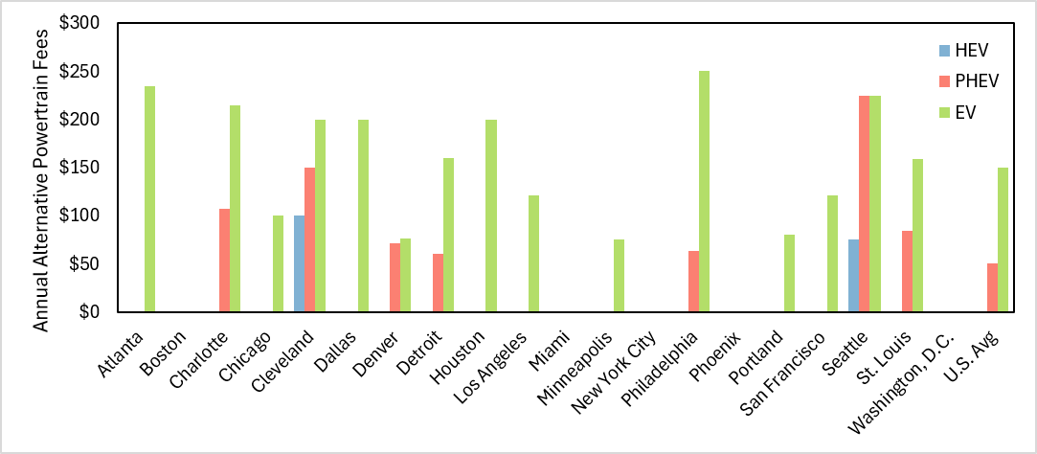
Supplemental Figure 87. Annual Fees for alternative powertrains

Supplemental References
1. Islam, E. S. et al. A Detailed Vehicle Modeling & Simulation Study Quantifying Energy Consumption and Cost Reduction of Advanced Vehicle Technologies Through 2050. (2021).
2. U.S. Energy Information Administration. U.S. share of electric and hybrid vehicle sales reached a record in the third quarter . https://www.eia.gov/todayinenergy/detail.php/detail.php?id=63904 (2024).
3. Woodley, L., Santos, V. C. & Nunes, A. Which state is the cleanest of them all? Pricing long run heterogeneity in carbon abatement costs across America. J. Clean. Prod. 467, (2024).
4. Davis, S. C. & Boundy, R. G. Transportation Energy Data Book: Edition 40. https://tedb.ornl.gov/wp-content/uploads/2022/03/TEDB_Ed_40.pdf (2022).
5. National Highway Traffic Safety Administration. Technical Support Document: Corporate Average Fuel Economy Standards for Passenger Cars and Light Trucks for Model Years 2027 and Beyond and Fuel Efficiency Standards for Heavy-Duty Pickup Trucks and Vans for Model Years 2030 and Beyond. https://www.nhtsa.gov/sites/nhtsa.gov/files/2024-07/NHTSA-final-technical-support-document-cafe.pdf (2024).
6. Alternative Fuels Data Center: Maps and Data - Average Monthly Fluctuation in U.S. Vehicle Miles Traveled. https://afdc.energy.gov/data/10316.
7. Wu, D. et al. Regional Heterogeneity in the Emissions Benefits of Electrified and Lightweighted Light-Duty Vehicles. Environ. Sci. Technol. 53, 10560–10570 (2019).
8. Federal Highway Administration. Table HM-72 - Highway Statistics 2022. https://www.fhwa.dot.gov/policyinformation/statistics/2022/hm72.cfm (2024).
9. National Oceanic and Atmospheric Administration. Climate at a Glance | National Centers for Environmental Information (NCEI). https://www.ncdc.noaa.gov/cag/county/mapping/110/tavg/202106/36/value (2021).
10. Zhang, Z., Sun, X., Ding, N. & Yang, J. Life cycle environmental assessment of charging infrastructure for electric vehicles in China. J. Clean. Prod. 227, 932–941 (2019).
11. Mulrow, J. & Grubert, E. Greenhouse gas emissions embodied in electric vehicle charging infrastructure: a method and case study of Georgia, US 2021–2050. Environmental Research: Infrastructure and Sustainability 3, 015013 (2023).
12. Argonne National Laboratory. GREET 2 Model. Preprint at (2023).
13. Argonne National Laboratory. GREET 1 Model. Preprint at https://greet.es.anl.gov/ (2023).
14. Borlaug, B., Salisbury, S., Gerdes, M. & Muratori, M. Levelized Cost of Charging Electric Vehicles in the United States. Joule 4, 1470–1485 (2020).
15. Bureau of Labor Statistics. May 2024 Metropolitan and Nonmetropolitan Area Occupational Employment and Wage Estimates. https://www.bls.gov/oes/2024/may/oessrcma.htm (2025).
16. OpenEI. United States Utility Rate Data Base. 2023 https://apps.openei.org/USURDB/.
17. EVgo. EV Charging Costs: Pricing and Plan for EV Charging. https://www.evgo.com/pricing/ (2023).
18. Electrify America. Pricing and Plans for EV Charging. https://www.electrifyamerica.com/pricing/ (2023).
19. Chargepoint. ChargePoint - Station Map. https://driver.chargepoint.com/.
20. Liu, Z. et al. Comparing total cost of ownership of battery electric vehicles and internal combustion engine vehicles. Energy Policy 158, 112564 (2021).
21. Parker, N. et al. Who saves money buying electric vehicles? Heterogeneity in total cost of ownership. Transp. Res. D Transp. Environ. 96, 102893 (2021).
22. Bankrate. Car Insurance Rates by State for 2025. https://www.bankrate.com/insurance/car/states/ (2025).
23. Burnham, A. et al. Comprehensive Total Cost of Ownership Quantification for Vehicles with Different Size Classes and Powertrains. https://www.osti.gov/biblio/1780970-comprehensive-total-cost-ownership-quantification-vehicles-different-size-classes-powertrains (2021).

