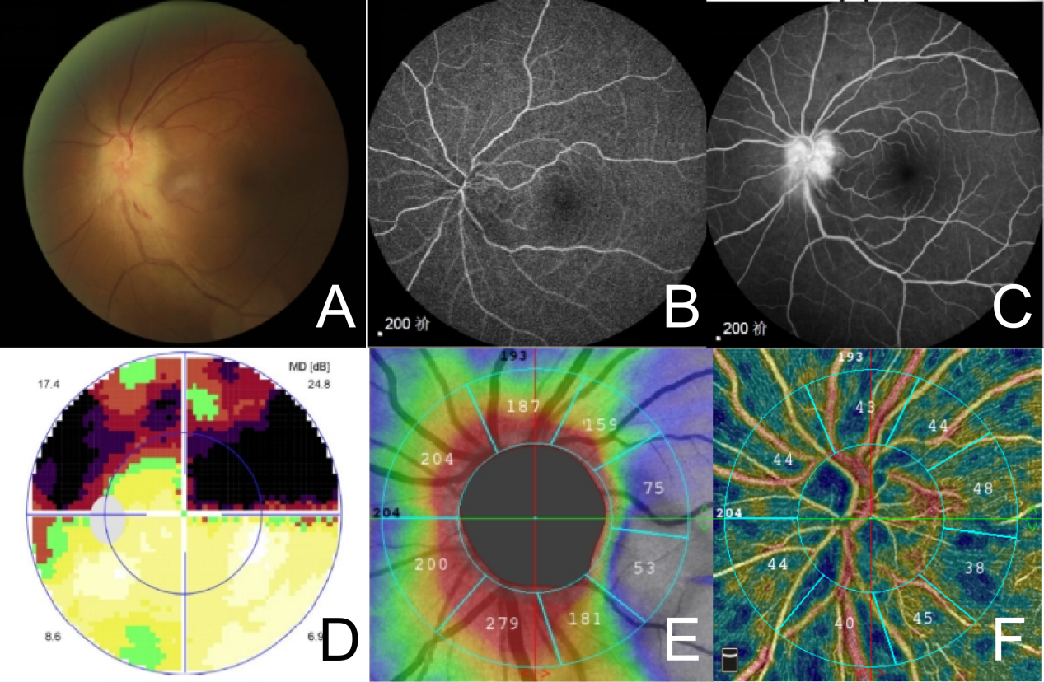
FIGURE 1
A 43-year-old male presenting with a 16-day history of occlusion sensation in the superior left visual field. (A) Fundus color Doppler imaging reveals segmental edema with linear hemorrhages in the inferior left eye. (B) FFA demonstrates localized delayed perfusion in the temporal-inferior optic disc during early contrast enhancement. (C) FFA shows heightened fluorescence in the optic disc during late contrast enhancement. (D) Visual field examination reveals a superior visual field defect connecting the left superior eye to the physiological blind spot, bypassing the central fixation point. (E) OCTA demonstrates swelling of the optic nerve fiber layer in the inferior left eye. (F) OCTA shows essentially normal peripherally retinal capillary blood flow density (RPC) during the acute phase of the disease.

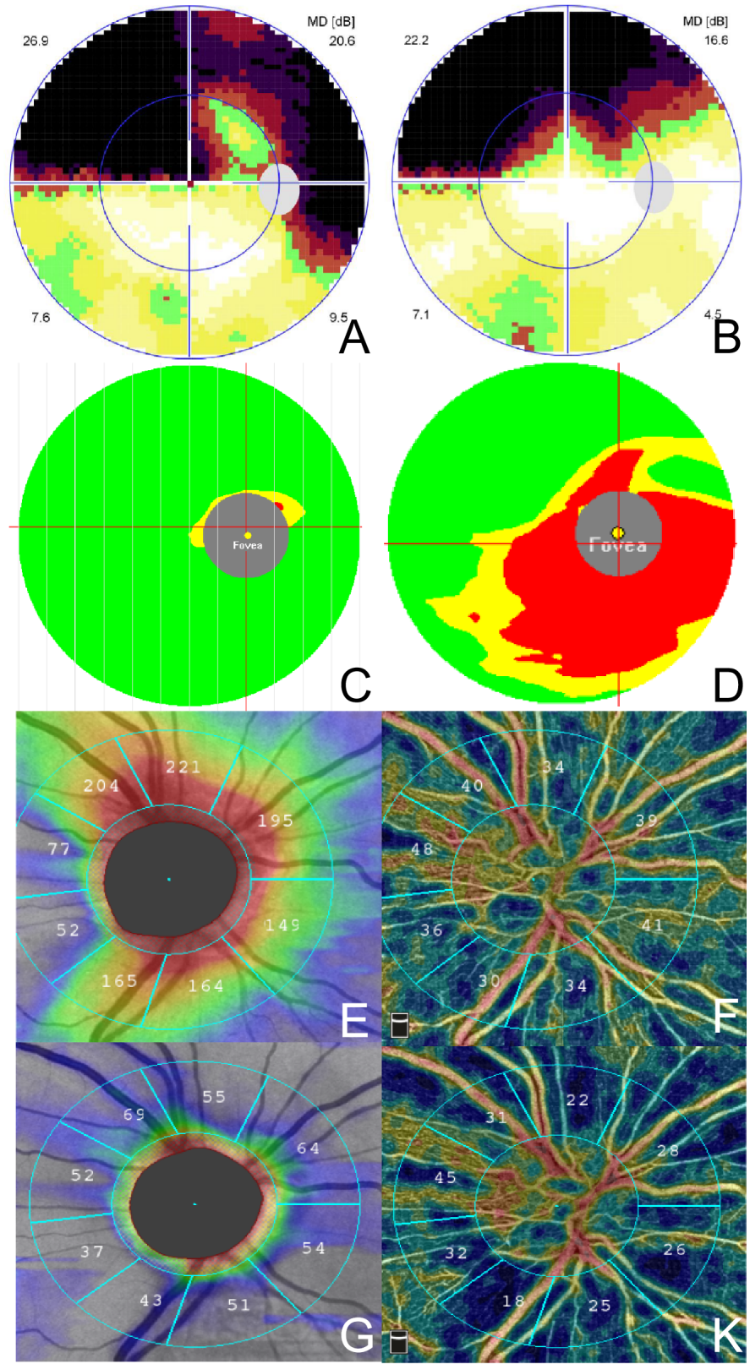
FIGURE 2
A 50-year-old male patient presenting with a sensation of occlusion above the right eye for one month. (A) Right upper visual field defect (B) After 5 months, the arcuate visual field defect above the right eye showed no significant improvement compared to before, while central vision improved markedly. (C) During the acute phase, the medial glabellar crest (mGCC) of the right eye showed no significant thinning. (D) After 5 months, the mGCC beneath the right eye exhibited marked thinning. (E) At one month post-onset, thinning was observed beneath the optic nerve fiber layer in the right eye, with a slight reduction in the optic disc RPC. (F) At 5 months, the visual nerve fiber layer of the right eye shows diffuse thinning. the optic disc blood flow density decreases significantly, particularly below (IN, IT), while the temporal optic disc blood flow density (RPC [TS+TI]) shows minimal reduction.

