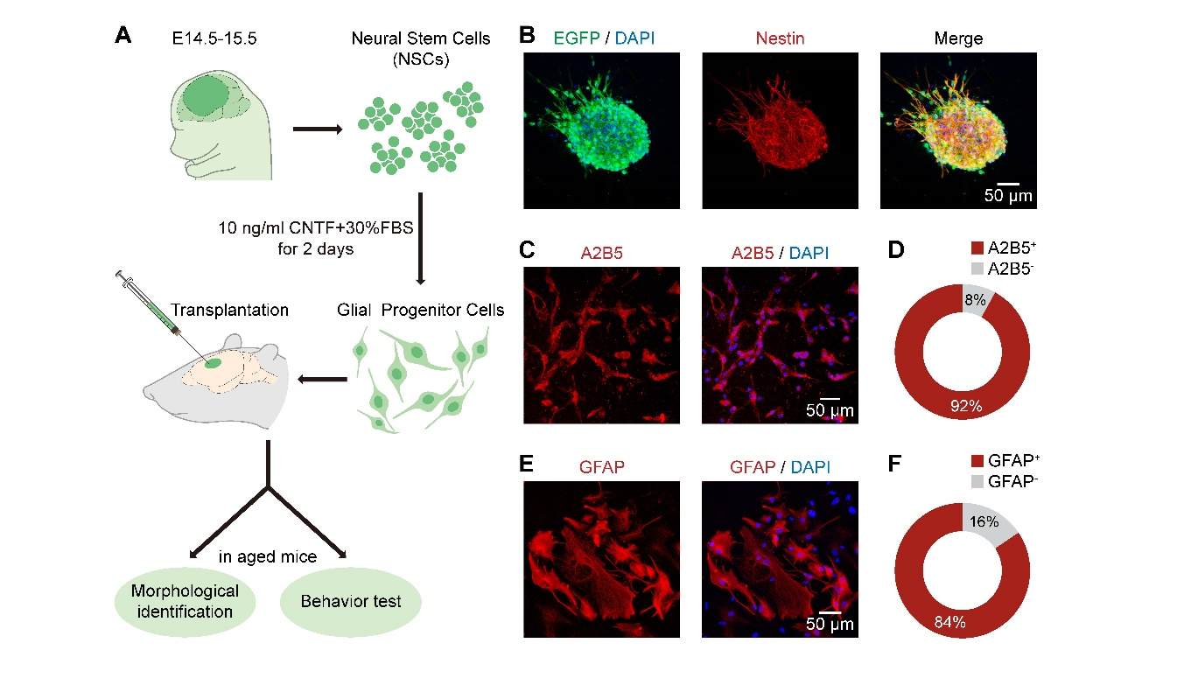
Supplementary Fig. 1 The identity of glial progenitor cells and astrocytes derived from embryonic NSCs. (A) Schematic outlining the procedure used for NSCs isolation, glial progenitor cell (GPCs) induction, cell transplantation, morphological identification, and behavioral testing after transplantation. (B) Neurospheres (EGFP⁺, green), expressing nestin (red), formed by dissociated NSCs 4–5 days after being isolated and cultured. (C) Cultured mouse GPCs, labeled with A2B5 (red) and DAPI (blue), 2 days after being cultured in medium with CNTF and FBS. (D) Pie chart showing the fraction of A2B5 positive and negative cells (n=687 cells in 5 field of view). (E) Cultured mouse astrocytes derived from GPCs, labeled with GFAP (red) and DAPI (blue), 9 days after being cultured in medium with B27, FBS, and CNTF. (F) Pie chart showing the fraction of GFAP positive and negative cells (n=200 cells in 6 field of view).

