The structure-activity relationship between precursor fine structure and cathodes performance in Ni-rich layered oxide
Lang Qiu¹, Mengke Zhang¹, Kanghui Hu¹, Yang Song^{1*}, Zhenguo Wu¹, Luchao Yue^{1, 2}, Wei Xiang³, Yong Ming⁴, Yuxia Liu⁵, Gongke Wang⁶, Yan Sun⁷, Jun Zhang^{1, 8}, Bin Zhang⁹, Xiaodong Guo^{1*}
¹ College of Chemical Engineering, Sichuan University, Chengdu, 610065, PR China.
² University of Electronic Science and Technology of China.
³ College of Materials and Chemistry & Chemical Engineering, Chengdu University of Technology, Chengdu, 610059, PR China.
⁴ School of Chemical Engineering, Sungkyunkwan University (SKKU), Suwon 16419 Republic of Korea.
⁵ School of Materials Science and Engineering, Henan Normal University.
⁶ The Key Laboratory of Life-Organic Analysis, Key Laboratory of Pharmaceutical, Intermediates and Analysis of Natural Medicine, School of Chemistry and Chemical Engineering, Qufu Normal University, Qufu, 273165, Shandong, China.
⁷ School of Mechanical Engineering, Chengdu University, Chengdu, 610106, China.
⁸ Ruyuan Dongyang Guangcixing Material Limited Company, Shaoguan, Guangdong 512710,PR China.
⁹ Yibin Libao New Material Co., Ltd, Yibin, China.
* Corresponding authors:
* E-mail addresses: songyang@scu.edu.cn
* E-mail addresses: xiaodong2009@scu.edu.cn

Section 1
1. Reaction process analysis of Ni-Co-Mn hydroxide precursor
In the ammonia system, the mass balance of the reaction concentration calculation is as follows:^{[1, 2]}
A + B ⇌ AB, K_{sp}= [A] × [B] (S1)
${\text{C}}_{{\text{NH}}_{\text{3}}}$ = ${\text{NH}}_{\text{3}}$ + ${{\text{[NH}}_{\text{4}}\text{]}}^{\text{+}}$ + $\sum_{\text{i=1}}^{\text{6}}{{\text{[iNi(}{\text{NH}}_{\text{3}}\text{)}}_{\text{i}}^{\text{2+}}\text{]}}$ + $\sum_{\text{i=1}}^{\text{6}}{{\text{[iCo(}{\text{NH}}_{\text{3}}\text{)}}_{\text{i}}^{\text{2+}}\text{]}}$ (S2)
${\text{C}}_{{\text{[Ni}}^{\text{2+}}\text{]}}$= $\text{[}{\text{Ni}}^{\text{2+}}\text{]}$ + $\sum_{\text{i=1}}^{\text{6}}{{\text{[Ni(}{\text{NH}}_{\text{3}}\text{)}}_{\text{i}}^{\text{2+}}\text{]}}$ + $\sum_{\text{i=1}}^{\text{3}}{{\text{[Ni(OH)}}_{\text{i}}^{\text{(2-i)+}}\text{]}}$ (S3)
${\text{C}}_{{\text{[Co}}^{\text{2+}}\text{]}}$= $\text{[}{\text{Co}}^{\text{2+}}\text{]}$ + $\sum_{\text{i=1}}^{\text{6}}{{\text{[Co(}{\text{NH}}_{\text{3}}\text{)}}_{\text{i}}^{\text{2+}}\text{]}}$ + $\sum_{\text{i=1}}^{\text{4}}{{\text{[Co(OH)}}_{\text{i}}^{\text{(2-i)+}}\text{]}}$ (S4)
${\text{C}}_{{\text{[}\text{Mn}}^{\text{2+}}\text{]}}$= $\text{[}{\text{Mn}}^{\text{2+}}\text{]}$ + $\sum_{\text{i=1}}^{\text{2}}{{\text{[}\text{Mn}\text{(}{\text{NH}}_{\text{3}}\text{)}}_{\text{i}}^{\text{2+}}\text{]}}$ + $\text{[Mn}{\text{(OH)}}^{\text{+}}\text{]}$ + [$\text{Mn}{\text{(OH)}}_{\text{3}}^{\text{-}}$] (S5)
A + B ⇌ AB, K_{sp}= [A] × [B] (S6)
${\text{C}}_{{\text{[Ni}}^{\text{2+}}\text{]}}$=10^(16.1-2*pH)*[NH₃]+10^(18.34-2*pH)*[NH₃]^2+10^(20.07-2*pH)*[NH₃]^3+10^(21.26-2*pH)*[NH₃]^4+10^(22.01-2*pH)*[NH₃]^5+10^(22.04-2*pH)*[NH₃]^6+(10^(13.3-2*pH)+10^(4.27-pH)+10^(-6.15)+10^(pH-17.37)) (S7)
${\text{C}}_{{\text{[Co}}^{\text{2+}}\text{]}}$=10^(15.31-2*pH)*[NH₃]+10^(16.94-2*pH)*[NH₃]^2+10^(17.99-2*pH)*[NH₃]^3+10^(18.75-2*pH)*[NH₃]^4+10^(18.93-2*pH)*[NH₃]^5+10^(18.31-2*pH)*[NH₃]^6+(10^(13.2-2*pH)+10^(3.5-pH)+10^(-6.4)+10^(pH-32.3)+10^(2*pH-45.8)) (S8)
${\text{C}}_{{\text{[}\text{Mn}}^{\text{2+}}\text{]}}$=10^(16.08-2*pH)*[NH₃]+10^(16.94-2*pH)*[NH₃]²+(10^(15.28-2*pH)+10^(5.18-pH)+10^(pH-18.24)) (S9)
${\text{C}}_{{\text{[Ni}}^{\text{2+}}\text{]}}$, ${\text{C}}_{{\text{[Co}}^{\text{2+}}\text{]}}$, ${\text{C}}_{{\text{[}\text{Mn}}^{\text{2+}}\text{]}}$ represent the free ion concentration of Ni²⁺, Co²⁺, Mn²⁺ respectively. Figure S2 is obtained by calculating the correlation value based on the assumption of ammonia concentration. It can be seen that the complexation of transition metal ions increases with the increase of ammonia concentration. Among them, the change of Mn²⁺ concentration is small.

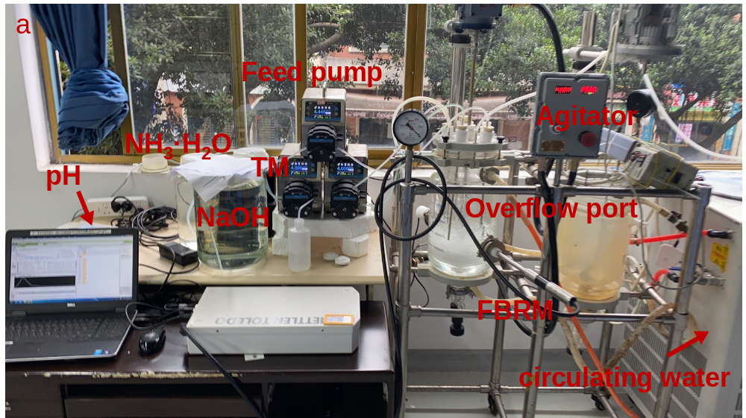
Figure S1 Experimental device diagram of hydroxide coprecipitation.

Figure S2. The change of transition metal free ion concentration with ammonia concentration at pH = 11.2.

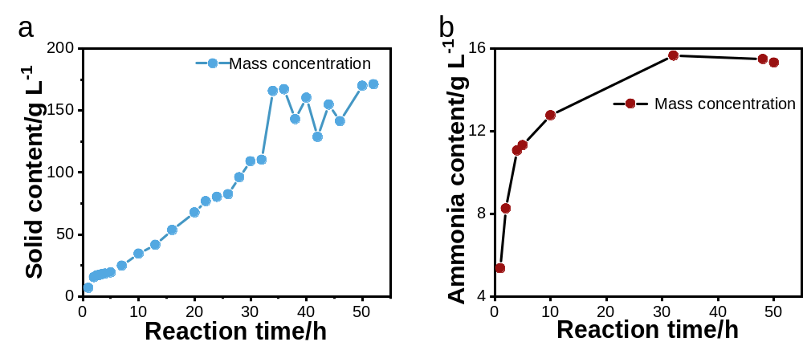
Figure S3 (a) Solid content and (b) ammonia content change curve of Ni_{0.92}Co_{0.04}Mn_{0.04}(OH)₂ during the cocipitaion process (A1 sample).
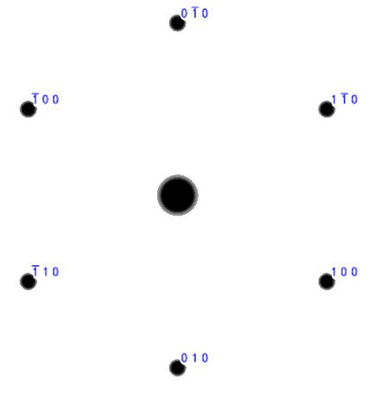
Figure S4 (a) Crystal structure model of the hexagonal nanosheet.

Figure S5 (a-g) SEM images of Ni_{0.92}Co_{0.04}Mn_{0.04}(OH)₂ in various time (A1 sample), primary particle size statistics (h). Scale bars, 500 nm (a-g), 200 nm (illustrations in (d))

Figure S6 (a-g) SEM images of Ni_{0.92}Co_{0.04}Mn_{0.04}(OH)₂ in various time (A2 sample), primary particle size statistics (h). Scale bars, 200 nm (a), 500m (b-d), 1μm (e-g).

Figure S7 (a-g) SEM images of Ni_{0.92}Co_{0.04}Mn_{0.04}(OH)₂ in various time (A4 sample), primary particle size statistics (h). Scale bars, 500 nm (a-c), 1 μm (d-g).

Figure S8 (a-d) FIB-SEM images of Ni_{0.92}Co_{0.04}Mn_{0.04}(OH)₂ in various time (A3 sample). Scale bars, 2 μm (a), 500 nm (b-d).

Figure S9. (a-d) EDS mapping images of Ni_{0.92}Co_{0.04}Mn_{0.04}(OH)₂ (A3 sample). Scale bars, 5 μm (a-d).

Figure S10 (a-d) SEM and HAADF-EDS mapping images of Ni_{0.92}Co_{0.04}Mn_{0.04}(OH)₂ (A3 sample). Scale bars, 40 μm (a), 10 μm (b), 1 μm (c), 2 μm (d).

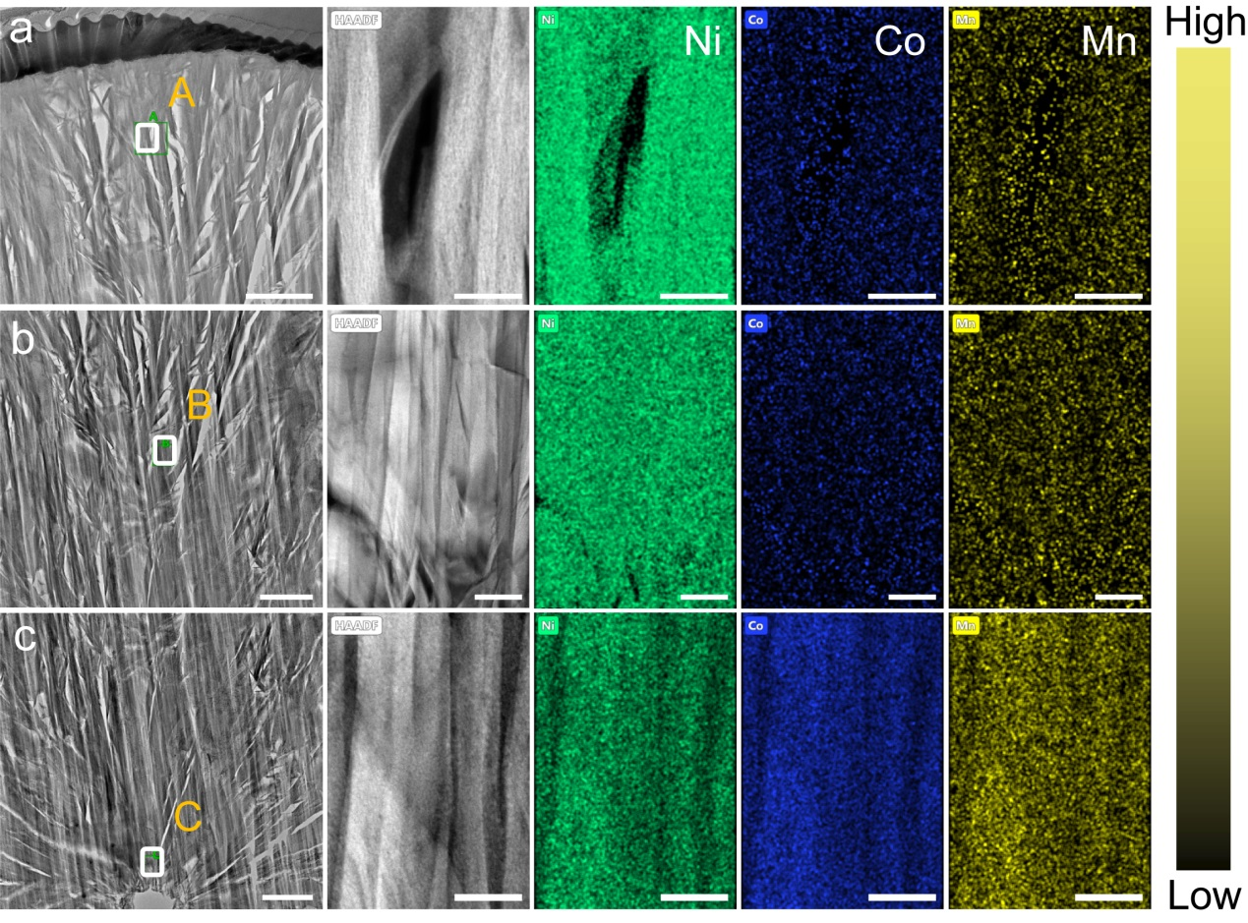
Figure S11. (a-c) The FIB-SEM profile and HAADF-EDS mapping images of A, B and C region for Ni_{0.92}Co_{0.04}Mn_{0.04}(OH)₂ precursor, (a), (b) and (c) are partial enlarged drawings of illustrations (A3 sample). Scale bars, 500 nm (a-c), 50 nm ((a, c) corresponding local amplification region), 100 nm ((b) corresponding local amplification region).

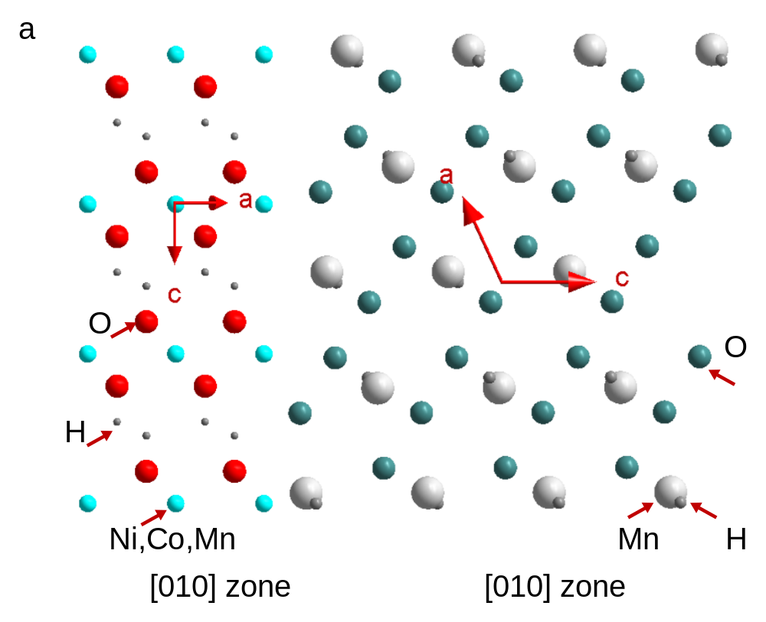
Figure S12 Corresponding atomic structure at the interface between Ni(OH)₂ and MnOOH.

Figure S13 (a-d) SEM images of Ni_{0.92}Co_{0.04}Mn_{0.04}(OH)₂ in various reaction condition, (e) primary particle size of Ni_{0.92}Co_{0.04}Mn_{0.04}(OH)₂ under various reaction condition. Scale bars, 500 nm (a, b), 1 μm ((c, d) and illustration in (a)), 5 μm (illustrations in (b, c)), 10 μm (illustration in (d)).

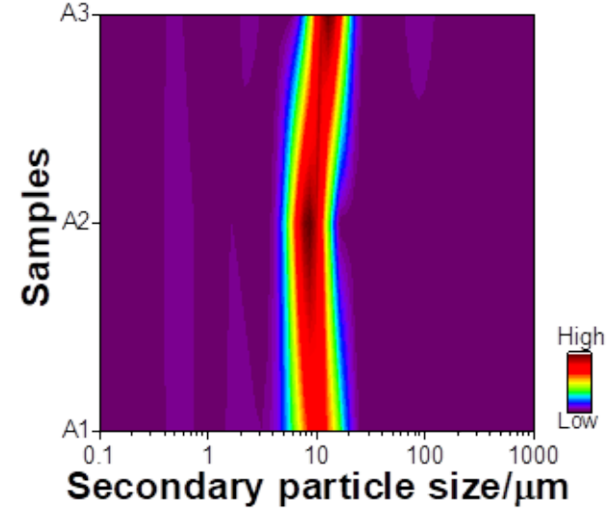
Fig. S14 Particle size distribution curve of Ni_{0.92}Co_{0.04}Mn_{0.04}(OH)₂ (A1, A2 and A3 samples).

Fig. S15. Structure observed in LiNi_{0.92}Co_{0.04}Mn_{0.04}O₂ lithiated at 745 °C. XRD images: (a) A1, (b) A2, (c) A3. High resolution TEM images: (d) A1, (e) A2 and (f) A3 samples. Scale bars, 10 nm (d-f).

Figure S16. Charge-discharge curves at cycling. (a) A1, (b) A2, (c) A3.

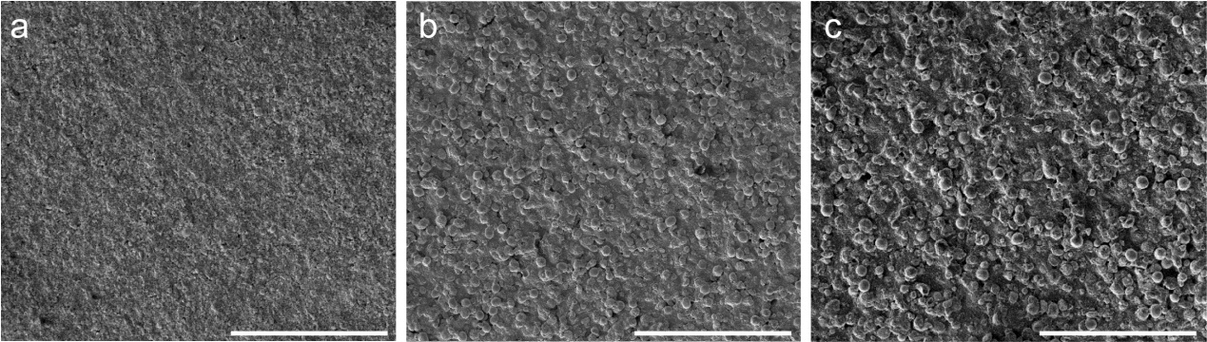
Figure S17. Morphology observation after cycling. SEM images: A1 (a), A2 (b), A3 (c). Scale bars, 200 μm (a-c)

Fig. S18. Observations of premature cracks, dislocations and microstructures after 200 cycles at 0.5 C. Cross section high resolution TEM images and corresponding FFT of A2 sample (a-c). Scale bars, 10 nm (a-c), 2 nm (local enlarged drawings of corresponding area in (a-c)).

Fig. S19. Observations of dislocations and microstructures after 200 cycles at 0.5 C. Cross section high resolution TEM images and corresponding FFT of A3 sample (a-c). Scale bars, 10 nm (a-c), 2 nm (local enlarged drawings of corresponding area in (a-c)).

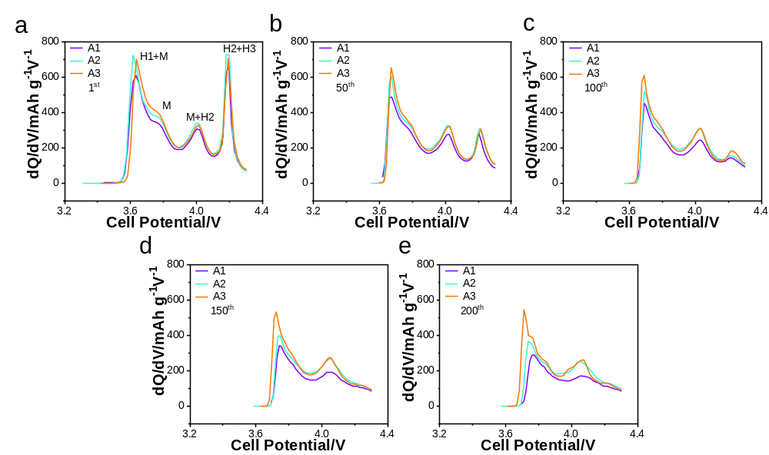
Fig. S20. (a-e) The dQ/dV curves of A1, A2 and A3 samples under different number of cycles.

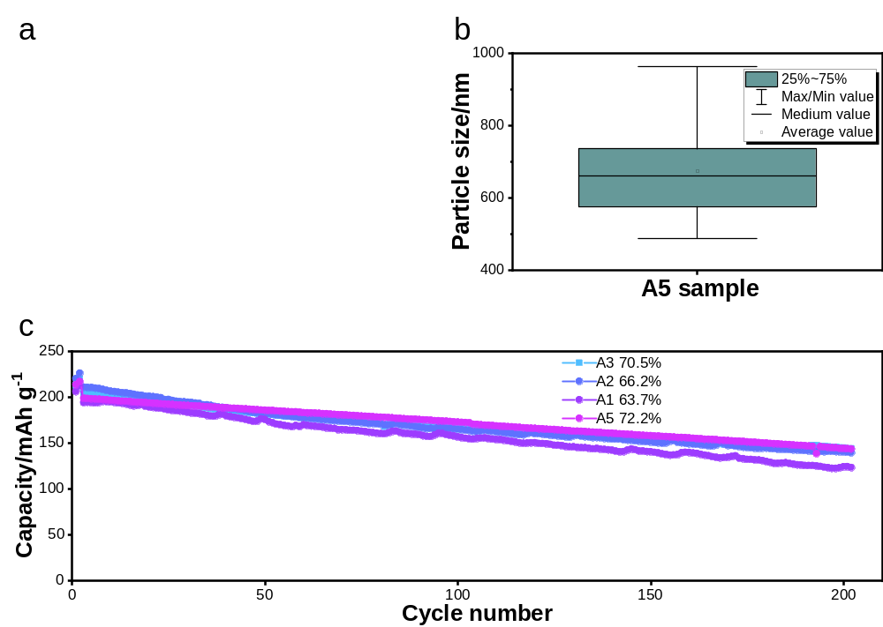
Fig. S21 (a) SEM images of LiNi_{0.92}Co_{0.04}Mn_{0.04}O₂ (A5 sample). (b) Primary particle size statistics. (c) Cycling performance at 1 C. Scale, 500 nm (a), 1um (Inset (a)).
Table S1 The elements distribution of Ni-rich Ni-Co-Mn hydroxide precursors under different condition.
Samples | pH | Stirring speed | NH₃·H₂O | Temperature(°C) | Ni | Co | Mn
A1 | 11.2 | 800 rpm | 2 M | 50 | 0.9166 | 0.0383 | 0.0451
A2 | 11.2 | 800 rpm | 4 M | 50 | 0.9201 | 0.0410 | 0.0389
A3 | 11.2 | 600 rpm | 4 M | 50 | 0.9180 | 0.0399 | 0.0421
A4 | 11.2 | 1000 rpm | 4 M | 50 | 0.9199 | 0.0381 | 0.0420
A5 | 11.2 | 800 rpm | 4 M | 50 | 0.9181 | 0.0405 | 0.0414

Table S2. Chemical Reaction equilibrium equation and equilibrium constant (K) (T = 298 K)
Equilibrium Equation | K | Log K
Equilibrium Equation | K | Ni | Co | Mn
H₂O ⇌ H⁺ + OH⁻ | K_{w} | -14 | -14 | -14
NH₃ + H₂O ⇌ NH₄⁺ + OH⁻ | K_{b} | -4.8 | -4.8 | -4.8
TM(OH)_{2(s)} ⇌ TM²⁺ + 2OH⁻ | K_{sp} | -14.7 | -14.8 | -12.72
TM(OH)⁺ ⇌ TM²⁺ + OH⁻ | K₁ | -4.97 | -4.3 | -3.9
TM(OH)_{2(aq)} ⇌ TM²⁺ + 2OH⁻ | K₂ | -8.55 | -8.4 | /
TM(OH)₃⁻ ⇌ TM²⁺ + 3OH⁻ | K₃ | -11.33 | -9.7 | -8.3
TM(OH)₄²⁻ ⇌ TM²⁺ + 4OH⁻ | K₄ |  | -10.2 | /
TM(NH₃)²⁺ ⇌ TM²⁺ + NH₃ | K₅ | -2.8 | -2.11 | -0.8
TM(NH₃)₂²⁺ ⇌ TM²⁺ + 2NH₃ | K₆ | -5.04 | -3.74 | -1.3
TM(NH₃)₃²⁺ ⇌ TM²⁺ + 3NH₃ | K₇ | -6.77 | -4.79 | /
TM(NH₃)₄²⁺ ⇌ TM²⁺ + 4NH₃ | K₈ | -7.96 | -5.55 | /
TM(NH₃)₅²⁺ ⇌ TM²⁺ + 5NH₃ | K₉ | -8.71 | -5.73 | /
TM(NH₃)₆²⁺ ⇌ TM²⁺ + 5NH₃ | K₁₀ | -8.74 | -5.11 | /

Table S3 Rietveld refinement results of XRD data for A1 sample.
Sample | a(Å) | c(Å) | Volume(Å³) | Site |  | x | y | z | Occupancy | R_{wp} | R_{p}
A1 | 2.8724(2) | 14.1916(9) | 100.400(1) | Li | 3a | 0 | 0 | 0 | 0.984(1) | 4.05 | 3.18
 |  |  |  | Ni | 3a | 0 | 0 | 0 | 0.016(1) | 4.05 | 3.18
 |  |  |  | Ni | 3b | 0 | 0 | 0.5 | 0.904(1) | 4.05 | 3.18
 |  |  |  | Co | 3b | 0 | 0 | 0.5 | 0.04 | 4.05 | 3.18
 |  |  |  | Li | 3b | 0 | 0 | 0.5 | 0.016(1) | 4.05 | 3.18
 |  |  |  | Mn | 3b | 0 | 0 | 0.5 | 0.04 | 4.05 | 3.18
 |  |  |  | O | 6c | 0 | 0 | 0.2581(3) | 1.0 | 4.05 | 3.18

Table S4 Rietveld refinement results of XRD data for A2 sample.
Sample | a(Å) | c(Å) | Volume(Å³) | Site |  | x | y | z | Occupancy | R_{wp} | R_{p}
A2 | 2.8730(1) | 14.1945(1) | 101.468(1) | Li | 3a | 0 | 0 | 0 | 0.974(1) | 4.16 | 3.24
 |  |  |  | Ni | 3a | 0 | 0 | 0 | 0.026(1) | 4.16 | 3.24
 |  |  |  | Ni | 3b | 0 | 0 | 0.5 | 0.894(1) | 4.16 | 3.24
 |  |  |  | Co | 3b | 0 | 0 | 0.5 | 0.04 | 4.16 | 3.24
 |  |  |  | Li | 3b | 0 | 0 | 0.5 | 0.026(1) | 4.16 | 3.24
 |  |  |  | Mn | 3b | 0 | 0 | 0.5 | 0.04 | 4.16 | 3.24
 |  |  |  | O | 6c | 0 | 0 | 0.2574(3) | 1.0 | 4.16 | 3.24

Table S5 Rietveld refinement results of XRD data for A3 sample.
Sample | a(Å) | c(Å) | Volume(Å³) | Site |  | x | y | z | Occupancy | R_{wp} | R_{p}
A3 | 2.8760(1) | 14.2039(9) | 101.749(9) | Li | 3a | 0 | 0 | 0 | 0.944(1) | 3.77 | 2.98
 |  |  |  | Ni | 3a | 0 | 0 | 0 | 0.056(1) | 3.77 | 2.98
 |  |  |  | Ni | 3b | 0 | 0 | 0.5 | 0.864(1) | 3.77 | 2.98
 |  |  |  | Co | 3b | 0 | 0 | 0.5 | 0.04 | 3.77 | 2.98
 |  |  |  | Li | 3b | 0 | 0 | 0.5 | 0.056(1) | 3.77 | 2.98
 |  |  |  | Mn | 3b | 0 | 0 | 0.5 | 0.04 | 3.77 | 2.98
 |  |  |  | O | 6c | 0 | 0 | 0.2571(2) | 1.0 | 3.77 | 2.98

[1] Bommel A. v., Dahn J. R. Analysis of the Growth Mechanism of Coprecipitated Spherical and Dense Nickel, Manganese, and Cobalt-Containing Hydroxides in the Presence of Aqueous Ammonia. Chem. Mater. 21, 1500-1503 (2009).
[2] Qiu L., et al. Exposing microstructure evolution of Ni-Rich Ni-Co-Al hydroxide precursor. Chem. Eng. Sci. 233, 116337-116348 (2021).

