Supplemental Figure 1.
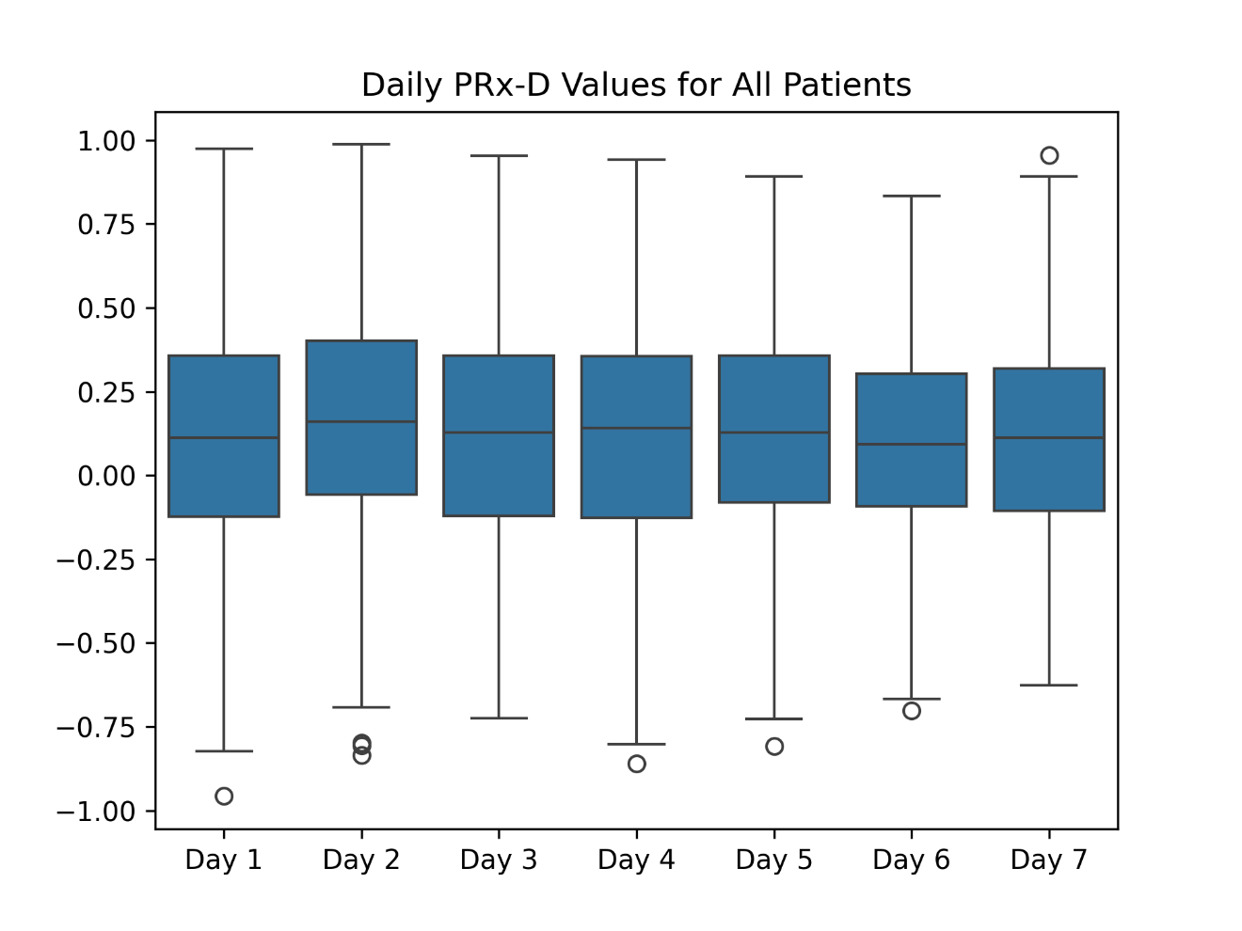
Distribution of PRx-D values for every day.

Supplemental Table 1. PRx-D for All Patients
PRx-D | Median | 1st Quartile | 3rd Quartile | n
Day 1 | 0.113 | -0.124 | 0.356 | 976
Day 2 | 0.160 | -0.058 | 0.401 | 903
Day 3 | 0.127 | -0.121 | 0.357 | 801
Day 4 | 0.141 | -0.128 | 0.355 | 670
Day 5 | 0.128 | -0.081 | 0.357 | 542
Day 6 | 0.093 | -0.091 | 0.302 | 444
Day 7 | 0.112 | -0.106 | 0.318 | 366

Distributions of PRx-D values for every day. Day 2 contains the highest median value.

Supplementary figure 2. PRx-D Missing Values

Frequency of missing values in days that met threshold for PRx-D calculation. A minimum of ten values were required for calculation of PRx-D on that day.

Supplemental Figure 3.
Maximum PRx-D, found to be independently associated with poor outcome, had an optimal cut-off of 0.59. 3-day maximum PRx-D, found to be independently associated with poor outcome in the sensitivity analysis, also had an optimal cut-off of 0.59.

Supplemental Figure 4. Individual Patient Trends Comparing DGOS-E
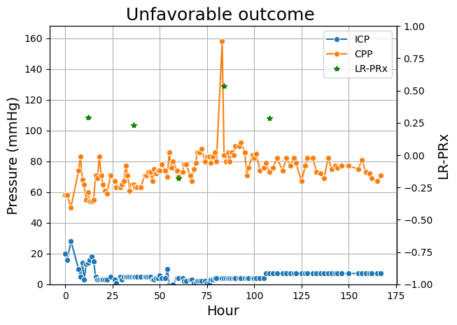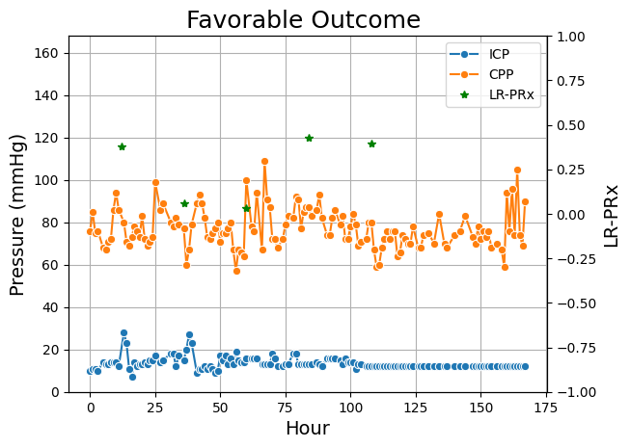
These are hourly ICP and CPP trends and daily PRx-D trends for two patients, unfavorable outcome on the left and favorable outcome on the right. The y-axis on the left indicates the ICP and CPP while the y-axis on the right represents the PRx-D values which are indicated as green stars. The patient on the left has a maximum PRx-D of 0.534 and had a poor outcome while the patient on the right has a maximum PRx-D of 0.428 and had a good outcome. These two patients’ maximum PRx-D values were around the 50th percentile of their respective groups.

Supplemental Figure 5.

Median PRx-D and Minimum PRx-D, found to be independently associated with death, had optimal cut-offs of 0.24, and 0.06, respectively. 3-day Median PRx-D and 3-day Maximum PRx-D, found to be independently associated with death in the sensitivity analysis, had optimal cut-offs of 0.24 and 0.51, respectively.

Supplemental Figure 6. Individual Patient Trends Comparing Hospital Death
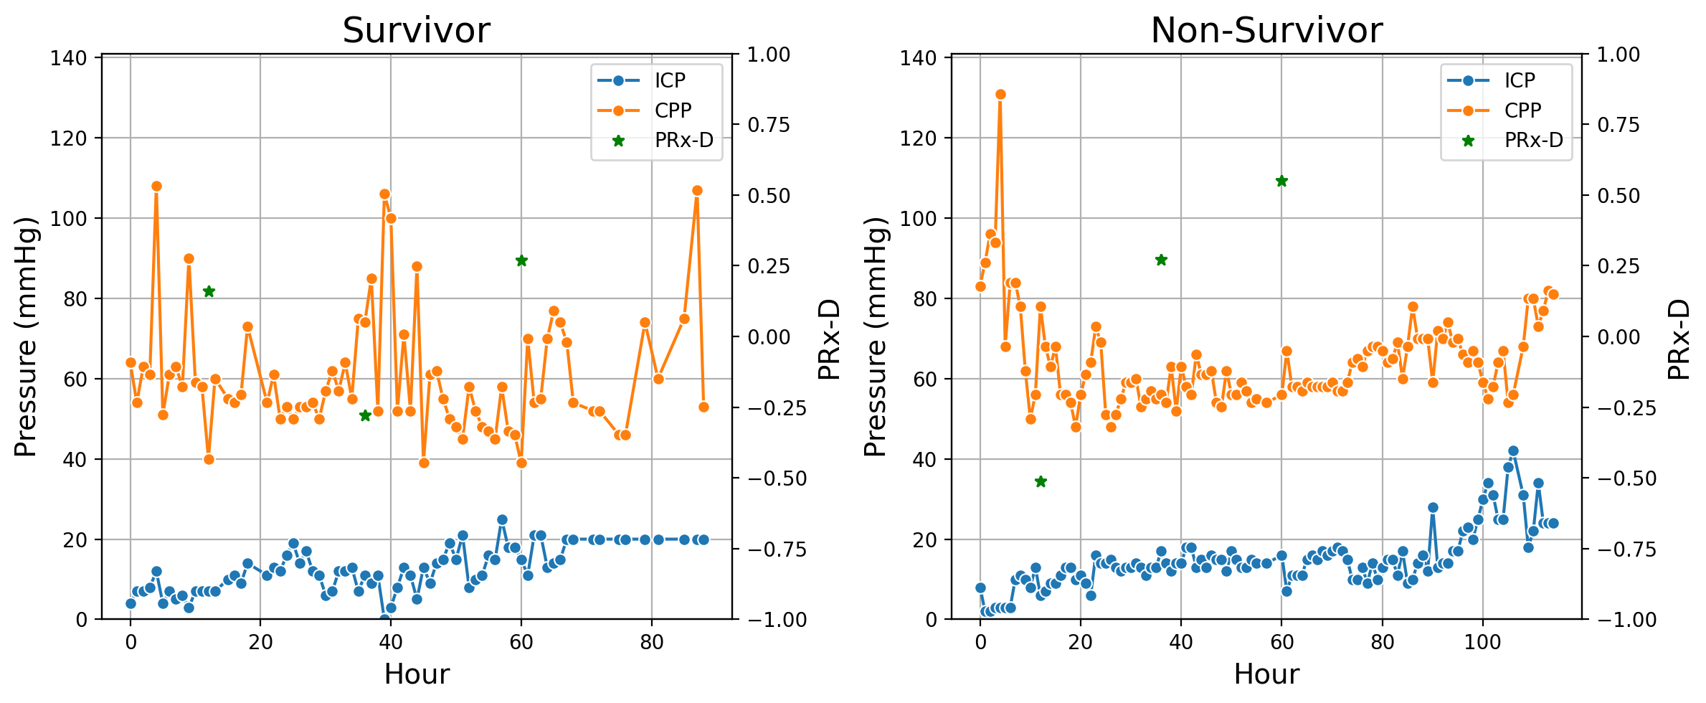
These are hourly ICP and CPP and daily PRx-D trends for two patients. The y-axis on the left indicates the ICP and CPP while the y-axis on the right represents the PRx-D values which are indicated as green stars. The patient on the left died while the patient on the right survived. The patient on the left had a median 3-day PRx-D of 0.16 while the patient on the right had a median 3-day PRx-D of 0.27. These two patients median PRx-D values were around the 50th percentile for their respective groups.

Supplemental Table 2. 3-Day Maximum PRx-D vs. Outcome Multivariable Binary Logistic Regression Sensitivity Analysis
Variable | Odds Ratio | Lower 95% CI | Upper 95% CI
3 Day Maximum PRx-D | 1.98 | 1.04 | 3.78
Age | 1.01 | 0.97 | 1.05
Sex | 0.87 | 0.63 | 1.20
Race
Other vs. White | 1.49 | 0.88 | 2.54
Asian vs. White | 0.64 | 0.39 | 1.04
Black vs. White | 1.09 | 0.71 | 1.69
Seizure | 0.70 | 0.41 | 1.2
Hypoxia | 1.50 | 0.65 | 3.47
Hypotension | 1.43 | 0.97 | 2.10
Cardiac Arrest | 2.67 | 0.73 | 9.73
Abuse | 2.57 | 1.47 | 4.49
GCS
GCS 3 vs 4-5 | 1.07 | 0.65 | 1.76
GCS 3 vs. 6-8 | 0.50 | 0.35 | 0.73
Median ICP (mmHg) | 1.06 | 1.03 | 1.08
Median CPP (mmHg) | 1.00 | 0.98 | 1.02

Supplemental Table 3. 3-Day Median PRx-D vs. Outcome Multivariable Binary Logistic Regression Sensitivity Analysis
Variable | Odds Ratio | Lower 95% CI | Upper 95% CI
3 Day Median PRx-D | 1.42 | 0.72 | 2.8
Age | 1.01 | 0.97 | 1.05
Sex | 0.86 | 0.62 | 1.19
Race
Other vs. White | 1.52 | 0.9 | 2.58
Asian vs. White | 0.63 | 0.39 | 1.03
Black vs. White | 1.08 | 0.7 | 1.67
Seizure | 0.7 | 0.41 | 1.21
Hypoxia | 1.5 | 0.65 | 3.47
Hypotension | 1.44 | 0.98 | 2.11
Cardiac Arrest | 2.66 | 0.73 | 9.71
Abuse | 2.59 | 1.49 | 4.52
GCS
GCS 3 vs 4-5 | 1.07 | 0.65 | 1.76
GCS 3 vs. 6-8 | 0.49 | 0.34 | 0.71
Median ICP (mmHg) | 1.06 | 1.03 | 1.09
Median CPP (mmHg) | 1 | 0.98 | 1.02

Supplemental Table 4. 3-Day Minimum PRx-D vs. Outcome Multivariable Binary Logistic Regression Sensitivity Analysis
Variable | Odds Ratio | Lower 95% CI | Upper 95% CI
3 Day Minimum PRx-D | 1 | 0.55 | 1.8
Age | 1.01 | 0.97 | 1.05
Sex | 0.87 | 0.63 | 1.2
Race
Other vs. White | 1.52 | 0.89 | 2.57
Asian vs. White | 0.63 | 0.39 | 1.04
Black vs. White | 1.09 | 0.71 | 1.68
Seizure | 0.7 | 0.41 | 1.21
Hypoxia | 1.53 | 0.66 | 3.53
Hypotension | 1.46 | 0.99 | 2.14
Cardiac Arrest | 2.73 | 0.75 | 9.97
Abuse | 2.63 | 1.51 | 4.59
GCS
GCS 3 vs 4-5 | 1.08 | 0.66 | 1.77
GCS 3 vs. 6-8 | 0.49 | 0.34 | 0.71
Median ICP (mmHg) | 1.06 | 1.03 | 1.09
Median CPP (mmHg) | 1 | 0.98 | 1.02

Supplemental Table 5. 3-Day Maximum PRx-D vs. Hospital Death Multivariable Binary Logistic Regression Sensitivity Analysis

Variable | Odds Ratio | Lower 95% CI | Upper 95% CI
3 Day Maximum PRx-D | 2.68 | 1.05 | 6.84
Age | 1.03 | 0.97 | 1.09
Sex | 1.09 | 0.67 | 1.79
Race
Other vs. White | 0.91 | 0.42 | 1.98
Asian vs. White | 1.05 | 0.46 | 2.42
Black vs. White | 0.85 | 0.45 | 1.61
Seizure | 0.66 | 0.28 | 1.52
Hypoxia | 1.28 | 0.45 | 3.61
Hypotension | 0.67 | 0.37 | 1.22
Cardiac Arrest | 7.14 | 2.50 | 20.39
Abuse | 1.00 | 0.49 | 2.03
GCS
GCS 3 vs 4-5 | 0.80 | 0.44 | 1.47
GCS 3 vs. 6-8 | 0.32 | 0.19 | 0.57
Median ICP (mmHg) | 1.07 | 1.04 | 1.11
Median CPP (mmHg) | 0.96 | 0.93 | 0.99

Supplemental Table 6. 3-Day Median PRx-D vs. Hospital Death Multivariable Binary Logistic Regression Sensitivity Analysis

Variable | Odds Ratio | Lower 95% CI | Upper 95% CI
3 Day Median PRx-D | 2.96 | 1.15 | 7.62
Age | 1.03 | 0.97 | 1.09
Sex | 1.10 | 0.67 | 1.79
Race
Other vs. White | 0.95 | 0.44 | 2.07
Asian vs. White | 1.01 | 0.44 | 2.34
Black vs. White | 0.85 | 0.45 | 1.61
Seizure | 0.67 | 0.29 | 1.55
Hypoxia | 1.27 | 0.44 | 3.62
Hypotension | 0.66 | 0.36 | 1.21
Cardiac Arrest | 6.76 | 2.37 | 19.29
Abuse | 0.98 | 0.48 | 2.01
GCS
GCS 3 vs 4-5 | 0.78 | 0.43 | 1.44
GCS 3 vs. 6-8 | 0.32 | 0.19 | 0.56
Median ICP (mmHg) | 1.07 | 1.04 | 1.11
Median CPP (mmHg) | 0.96 | 0.93 | 0.99

Supplemental Table 7. 3-Day Minimum PRx-D vs. Hospital Death Multivariable Binary Logistic Regression Sensitivity Analysis

Variable | Odds Ratio | Lower 95% CI | Upper 95% CI
3 Day Minimum PRx-D | 1.84 | 0.81 | 4.14
Age | 1.03 | 0.97 | 1.09
Sex | 1.10 | 0.67 | 1.79
Race
Other vs. White | 0.96 | 0.45 | 2.09
Asian vs. White | 0.99 | 0.43 | 2.31
Black vs. White | 0.87 | 0.46 | 1.63
Seizure | 0.69 | 0.3 | 1.58
Hypoxia | 1.27 | 0.44 | 3.64
Hypotension | 0.69 | 0.38 | 1.26
Cardiac Arrest | 6.96 | 2.45 | 19.72
Abuse | 1.06 | 0.52 | 2.13
GCS
GCS 3 vs 4-5 | 0.79 | 0.43 | 1.45
GCS 3 vs. 6-8 | 0.32 | 0.18 | 0.55
Median ICP (mmHg) | 1.07 | 1.04 | 1.11
Median CPP (mmHg) | 0.96 | 0.93 | 0.99

