
Supplementary figure 1: Forest plot for All-cause mortality


Suplementary figure 2: Forest plot for repeat vascularization

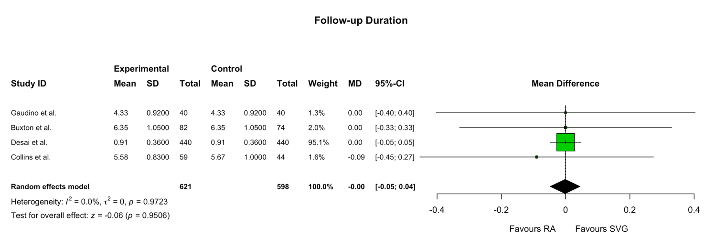
Supplementary figure 3: Forest plot for Follow-up Duration

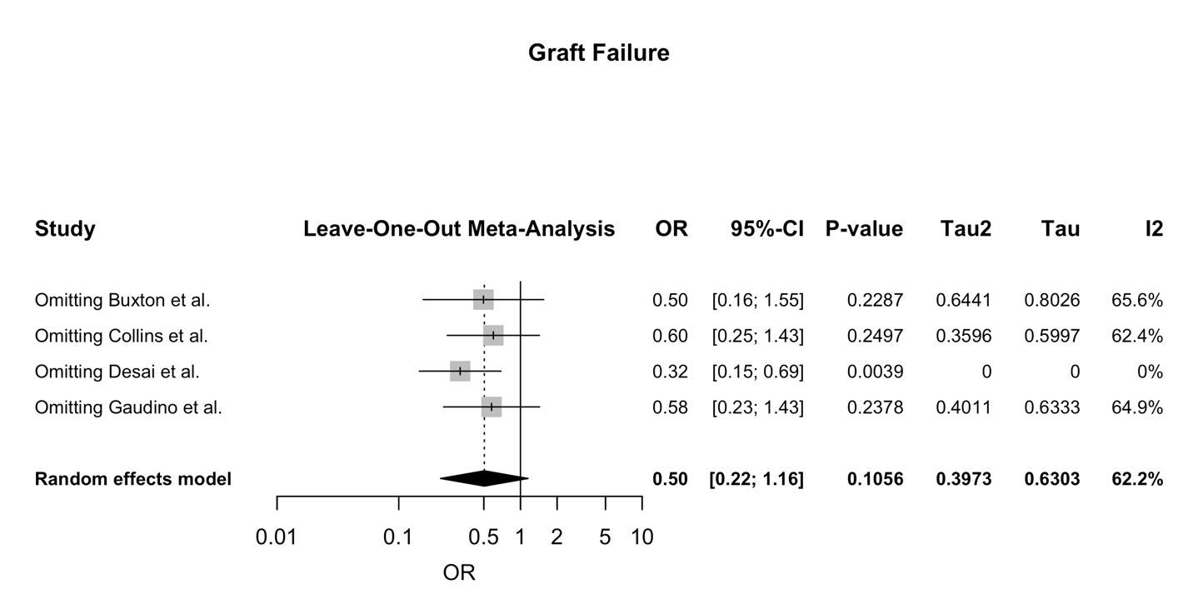
Supplementary figure 4: Leave one out plot for Graft Failure


Supplementary figure 5: Leave one out plot for Complete Occlusion


Supplementary figure 6: Leave one out plot for String Sign

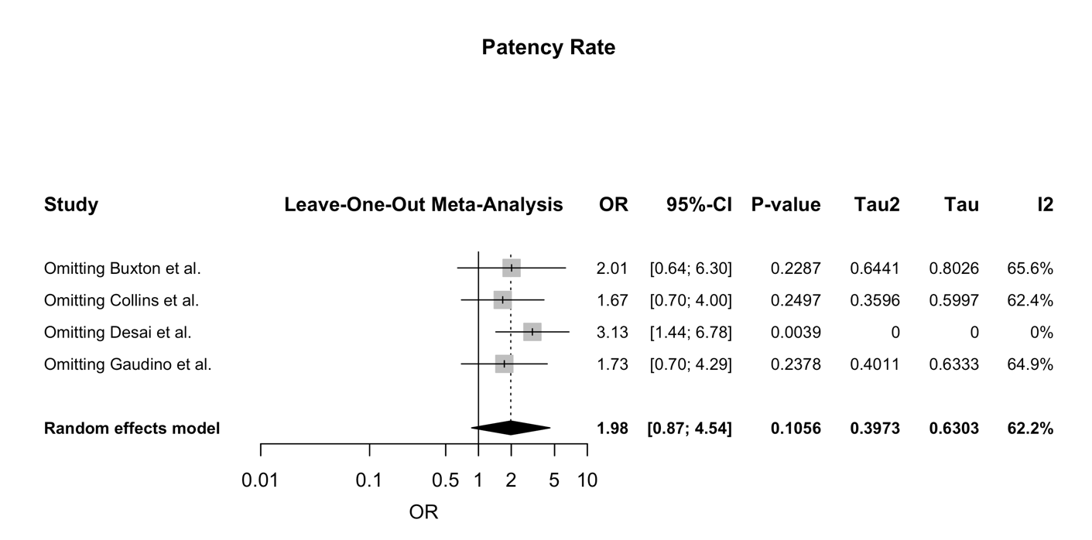
Supplementary figure 7: Leave one out for Patency Rate


Supplementary figure 8: Leave one out plot for All-cause Mortality


Supplementary figure 9: Leave one out plot for Repeat Revascularization


Supplementary figure 10: Leave one out plot for Follow-up Duration
Database | Search Strategy | Results
PubMed | (  "Coronary Artery Bypass"[Mesh] OR  "coronary artery bypass grafting"[tiab] OR  "coronary artery bypass surgery"[tiab] OR  "CABG"[tiab] OR  "coronary revascularization"[tiab]  )  AND  (  "Radial Artery"[Mesh] OR  "radial artery"[tiab] OR  "radial artery graft"[tiab] OR  "radial artery grafts"[tiab] OR  "RA graft"[tiab] OR  "RA grafts"[tiab]  )  AND  (  "Saphenous Vein"[Mesh] OR  "saphenous vein graft"[tiab] OR  "saphenous vein grafts"[tiab] OR  "saphenous graft"[tiab] OR  "saphenous grafts"[tiab] OR  "SVG"[tiab]  )  AND  (  "Randomized Controlled Trial"[Publication Type] OR  "randomized controlled trial"[tiab] OR  "randomized controlled trials"[tiab] OR  "randomised controlled trial"[tiab] OR  "randomized"[tiab] OR  "randomised"[tiab] OR  "placebo"[tiab] OR  "clinical trials as topic"[Mesh:NoExp] OR  "randomly"[tiab] OR  "trial"[ti]  )  NOT  (  "Animals"[Mesh] NOT "Humans"[Mesh]  ) | 89
Scopus | (  TITLE-ABS-KEY("coronary artery bypass" OR "coronary bypass" OR "CABG" OR "coronary revasculari*")  )  AND  (  TITLE-ABS-KEY("radial artery" W/2 "graft*") OR TITLE-ABS-KEY("radial artery")  )  AND  (  TITLE-ABS-KEY("saphenous vein" W/2 "graft*") OR TITLE-ABS-KEY("saphenous graft*") OR TITLE-ABS-KEY("SVG")  )  AND  (  TITLE-ABS-KEY("randomi* control* trial*" OR "randomi* trial*" OR "rct" OR "randomly" OR "placebo")  ) | 61
Cochrane CENTRAL | #1 [mh "Coronary Artery Bypass"]  #2 ("coronary artery bypass grafting" or "coronary artery bypass surgery" or "CABG" or "coronary revascularization"):ti,ab,kw  #3 #1 or #2  #4 [mh "Radial Artery"]  #5 ("radial artery" or "radial artery graft" or "radial artery grafts" or "RA graft" or "RA grafts"):ti,ab,kw  #6 #4 or #5  #7 [mh "Saphenous Vein"]  #8 ("saphenous vein graft" or "saphenous vein grafts" or "saphenous graft" or "saphenous grafts" or "SVG"):ti,ab,kw  #9 #7 or #8  #10 #3 and #6 and #9 | 16

Supplementary Table 1: Search Strategies for Databases and Their Results

Certainty assessment |  |  |  |  |  |  | № of patients |  | Effect |  | Certainty | Importance
№ of studies | Study design | Risk of bias | Inconsistency | Indirectness | Imprecision | Other considerations | [intervention] | [comparison] | Relative  (95% CI) | Absolute  (95% CI) | Certainty | Importance
Graft Failure
4 | randomised trials | seriousª | very serious^{b} | not serious | serious^{c} | none | 77/621 (12.4%) | 89/598 (14.9%) | OR 0.50  (0.22 to 1.16) | 68 fewer per 1,000  (from 112 fewer to 20 more) | ⨁◯◯◯  Very low^{a,b,c} | IMPORTANT
Complete Occlusion
3 | randomised trials | seriousª | serious^{d} | not serious | serious^{c} | none | 38/539 (7.1%) | 73/524 (13.9%) | OR 0.29  (0.08 to 0.98) | 94 fewer per 1,000  (from 127 fewer to 2 fewer) | ⨁◯◯◯  Very low^{a,c,d} | IMPORTANT
String Sign
3 | randomised trials | seriousª | not serious | not serious | very serious^{e} | none | 33/539 (6.1%) | 4/524 (0.8%) | OR 6.77  (2.61 to 17.58) | 42 more per 1,000  (from 12 more to 111 more) | ⨁◯◯◯  Very low^{a,e} | IMPORTANT
Patency Rate
4 | randomised trials | seriousª | very serious^{b} | not serious | very serious^{e} | none | 544/621 (87.6%) | 509/598 (85.1%) | OR 1.98  (0.87 to 4.54) | 68 more per 1,000  (from 19 fewer to 112 more) | ⨁◯◯◯  Very low^{a,b,e} | NOT IMPORTANT
CI: confidence interval; OR: odds ratio

Explanations
a. Risk of Bias due to outcome measurement
b. Significant Heterogeneity.
c. Relatively Wide Confidence Interval.
d. Considerable Heterogeneity.
e. Wide Confidence Intervals.
Supplementary Table 2: GRADE Certainty Assessment

