Supplementary Information

A Wheatstone Bridge-Inspired Microfluidic Trap For Precise Tuning of the Content of an Immobilized Droplet
Damian Zaremba, Barbara Kupikowska-Stobba, Slawomir Blonski, Piotr M. Korczyk

Table S1. Structure depths used for fabricating microfluidic devices via CNC milling. This information is related to Figures S1–S6.
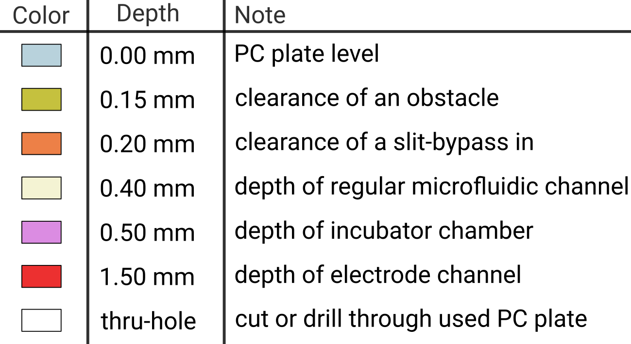
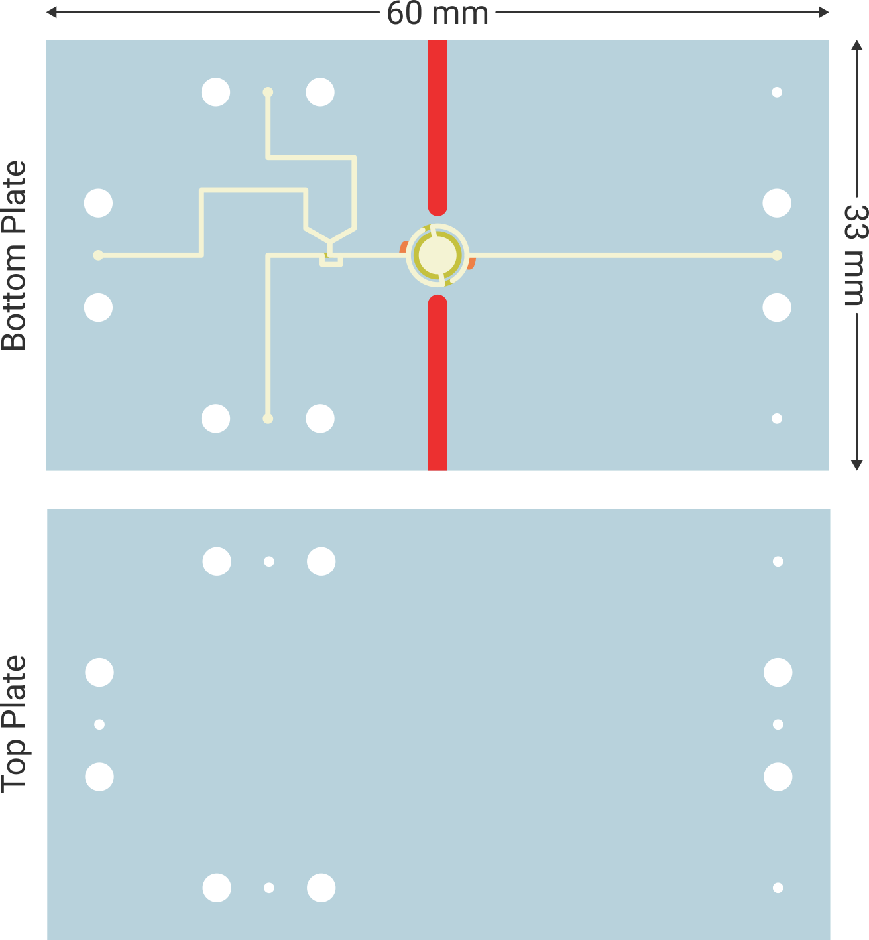
Fig. S1. Design of the microfluidic device used for the basic mechanism studies. The overall dimensions of the microfluidic device were 60 mm × 33 mm, and all structural widths and heights in the design were scaled accordingly. Tool trajectories are provided in file device 1.dxf
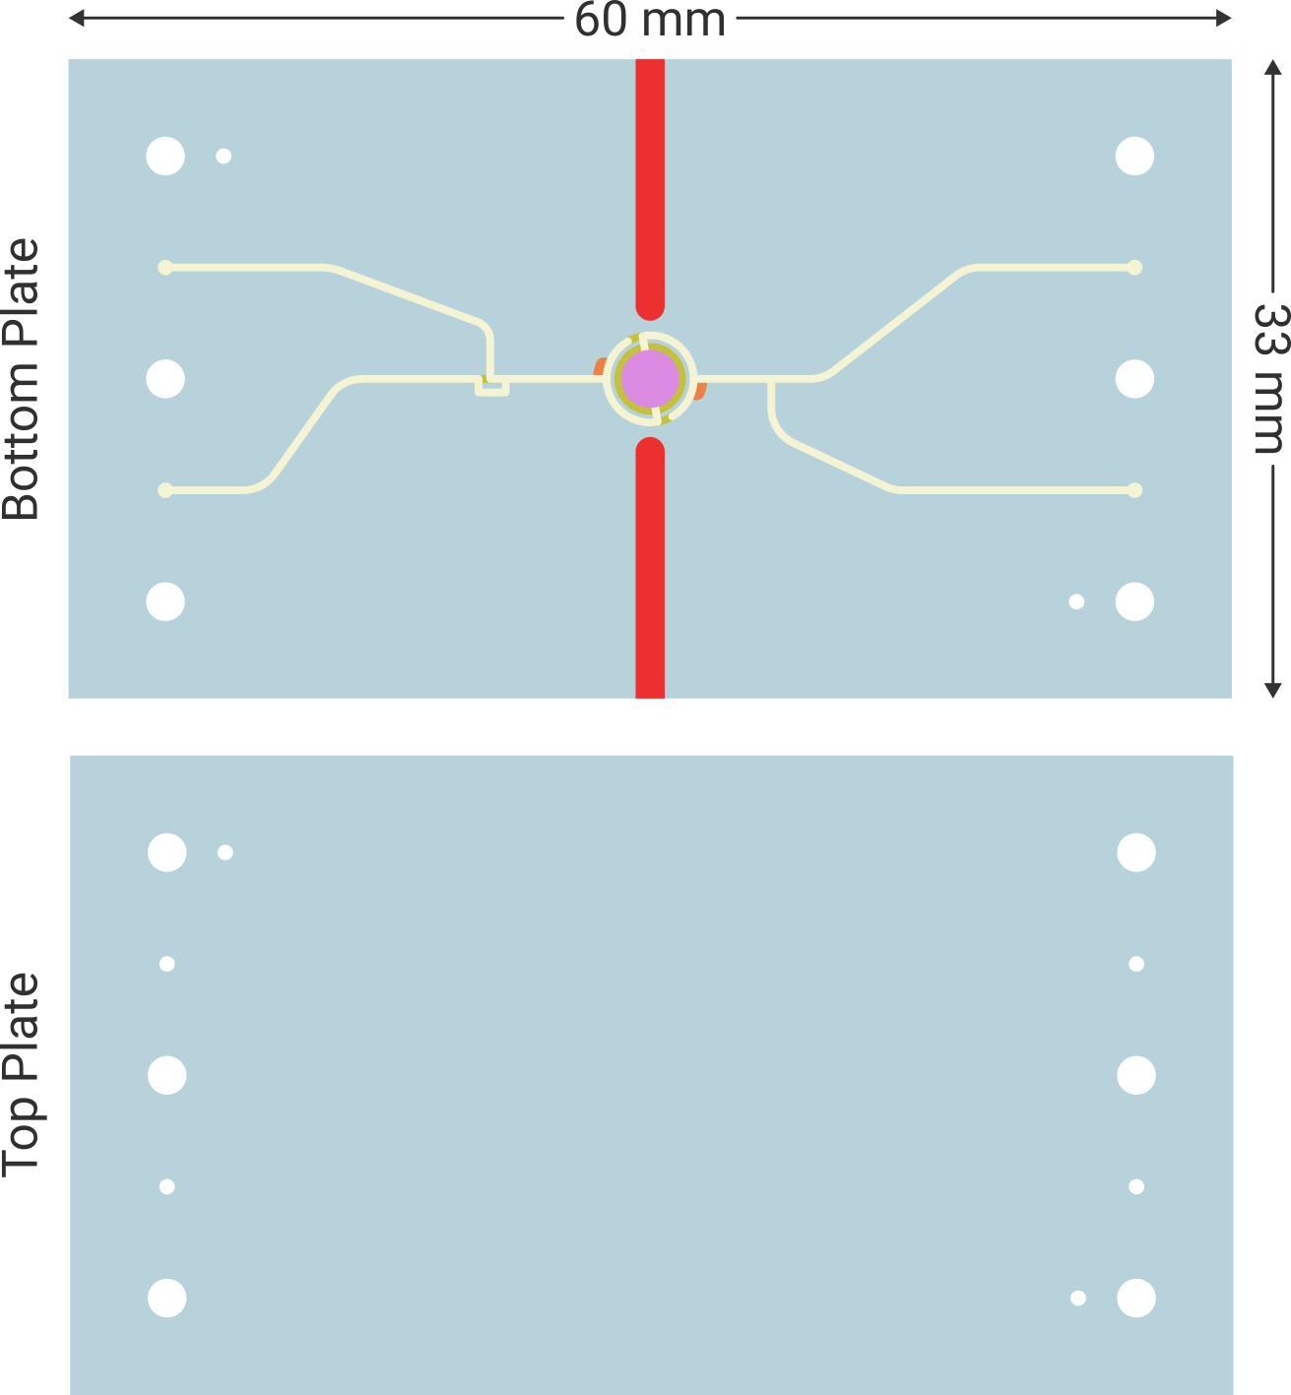
Fig. S2: Design of the microfluidic device used for E. coli culture. The overall dimensions of the microfluidic device were 60 mm × 33 mm, and all structural widths and heights in the design were scaled accordingly. Tool trajectories are provided in file device 2.dxf
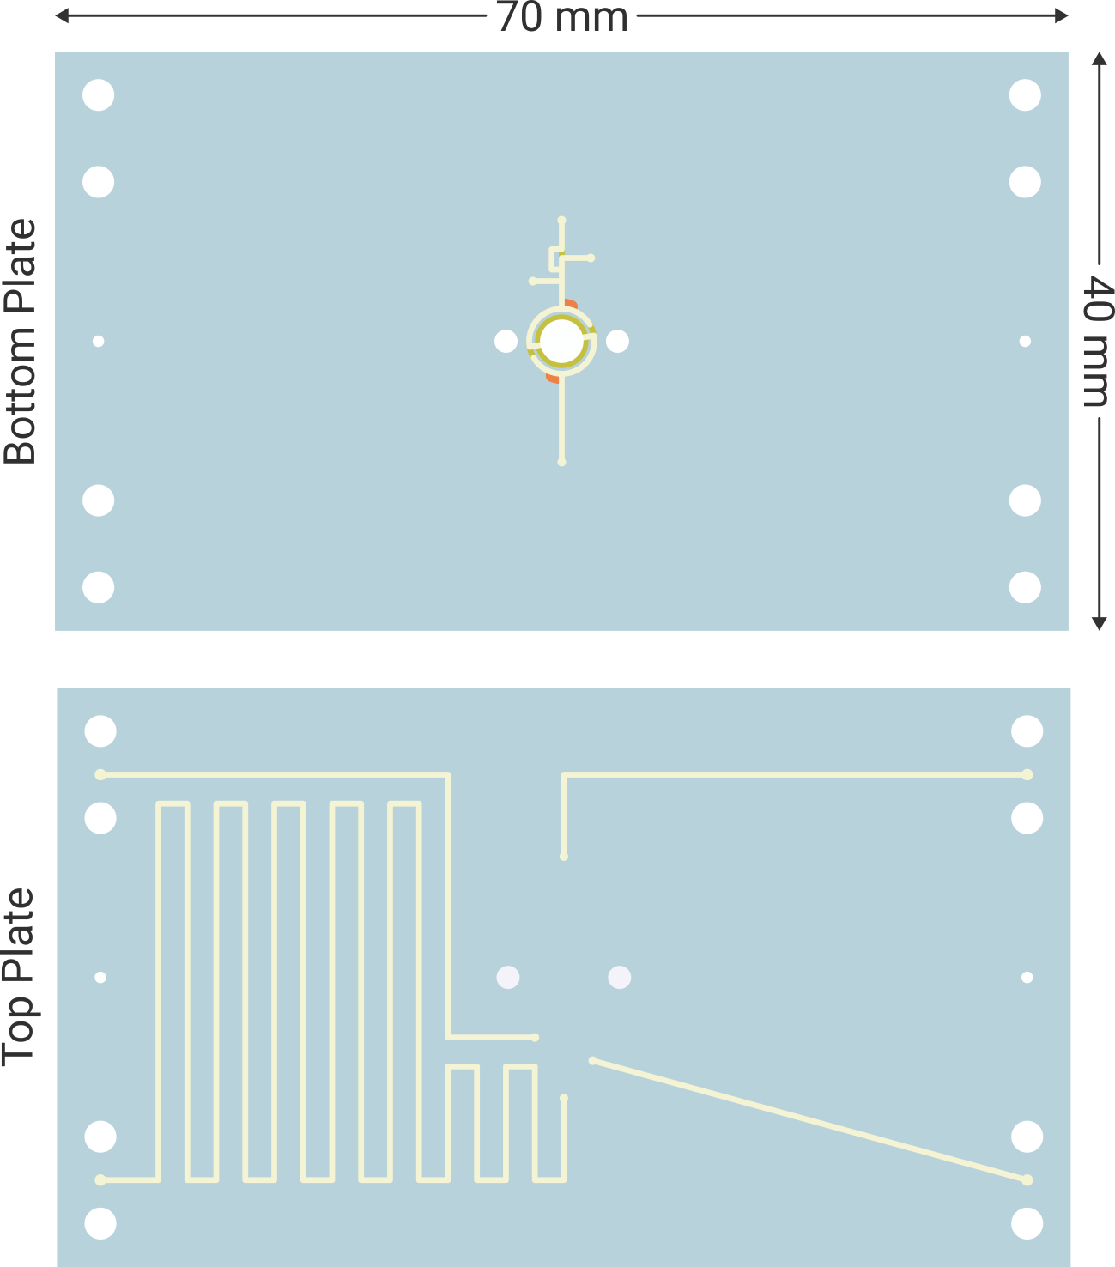
Fig. S3: Design of the microfluidic device used for A549 cell culture. The overall dimensions of the microfluidic device were 70 mm × 40 mm, and all structural widths and heights in the design were scaled accordingly. The height of the incubator chamber was regulated by the thickness of the PC plates used. Tool trajectories are provided in file device 3.dxf
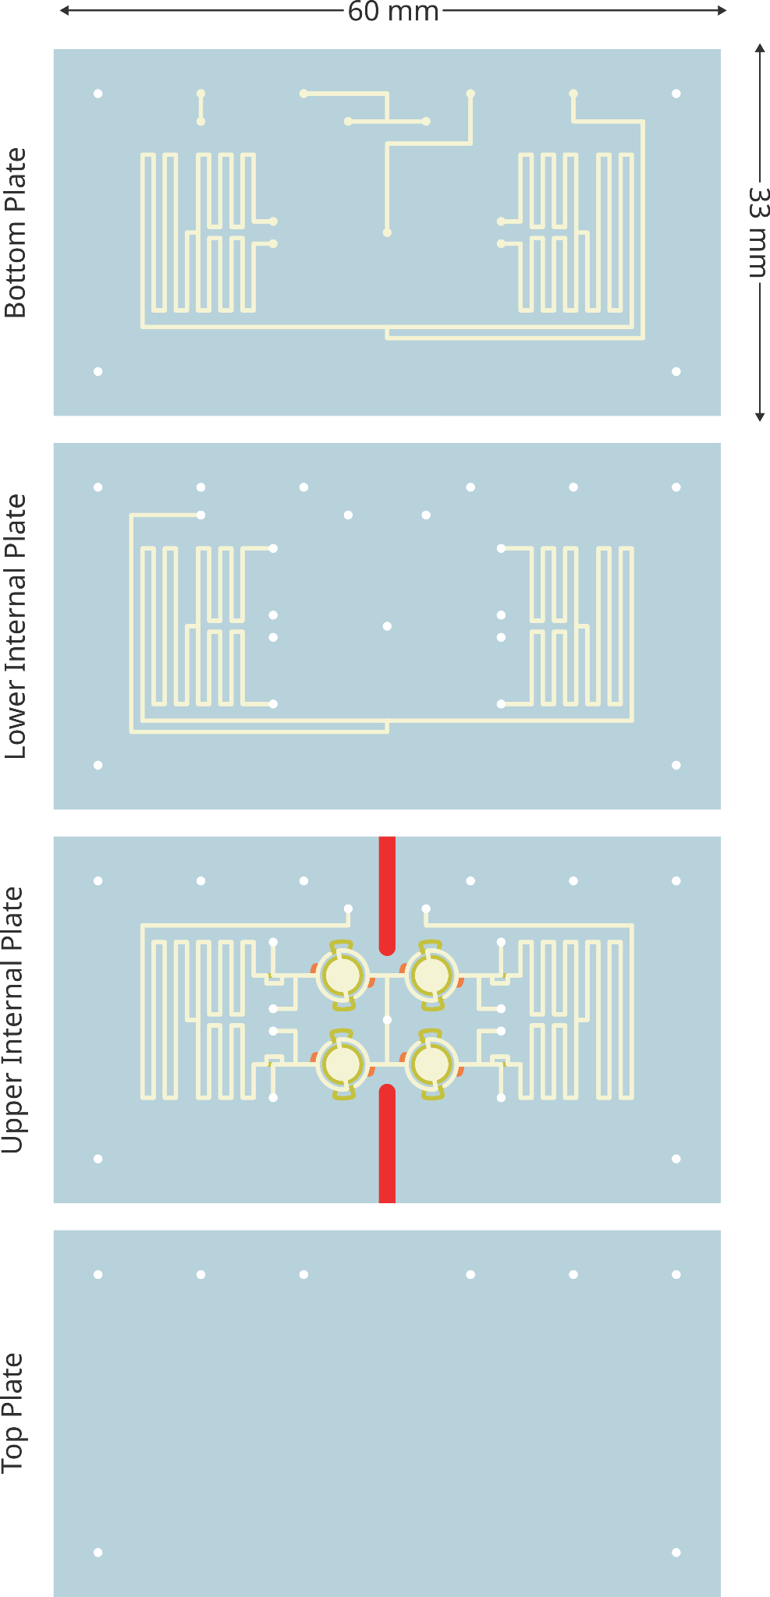
Fig. S4: Design of the microfluidic device used to demonstrate a 2x2 array of microfluidic traps. The overall dimensions of the microfluidic device were 63 mm × 33 mm, and all structural widths and heights in the design were scaled accordingly. The device contains a modified microfluidic trap design shown in Fig. S6. Tool trajectories are provided in the file device 4.dxf
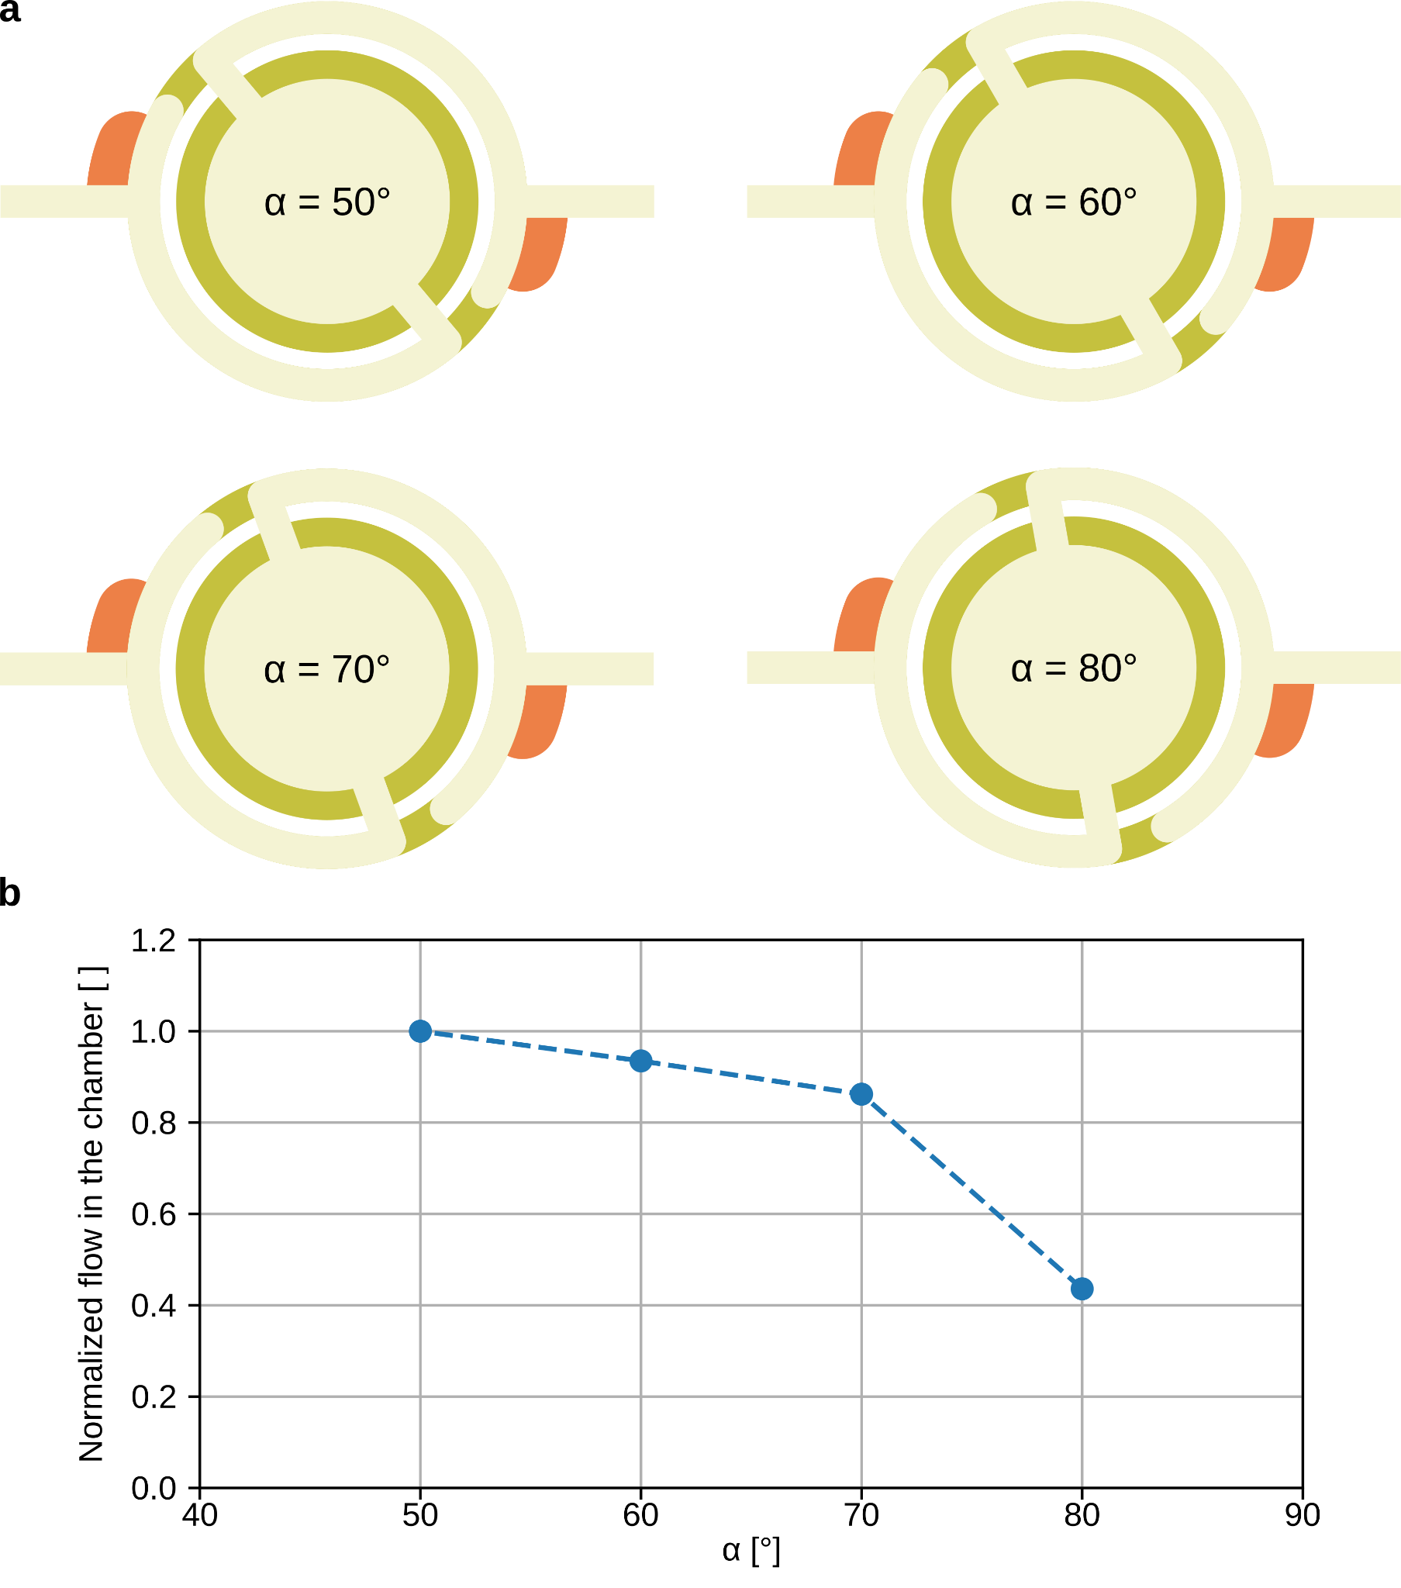
Fig. S5: Exploration of equilibrium in a Wheatstone bridge-inspired microfluidic trap by varying the inclination angle α, using single-phase flow, and measuring particle velocity with the uPIV technique. a) Designs of the microfluidic trap with a different angle of the bridge. The angle determines the ratio between Rx and Ry. b) Average flow of the particles within the center of the chamber, normalized to the version of the trap with α = 50°. An ideal equilibrium should indicate no flow.
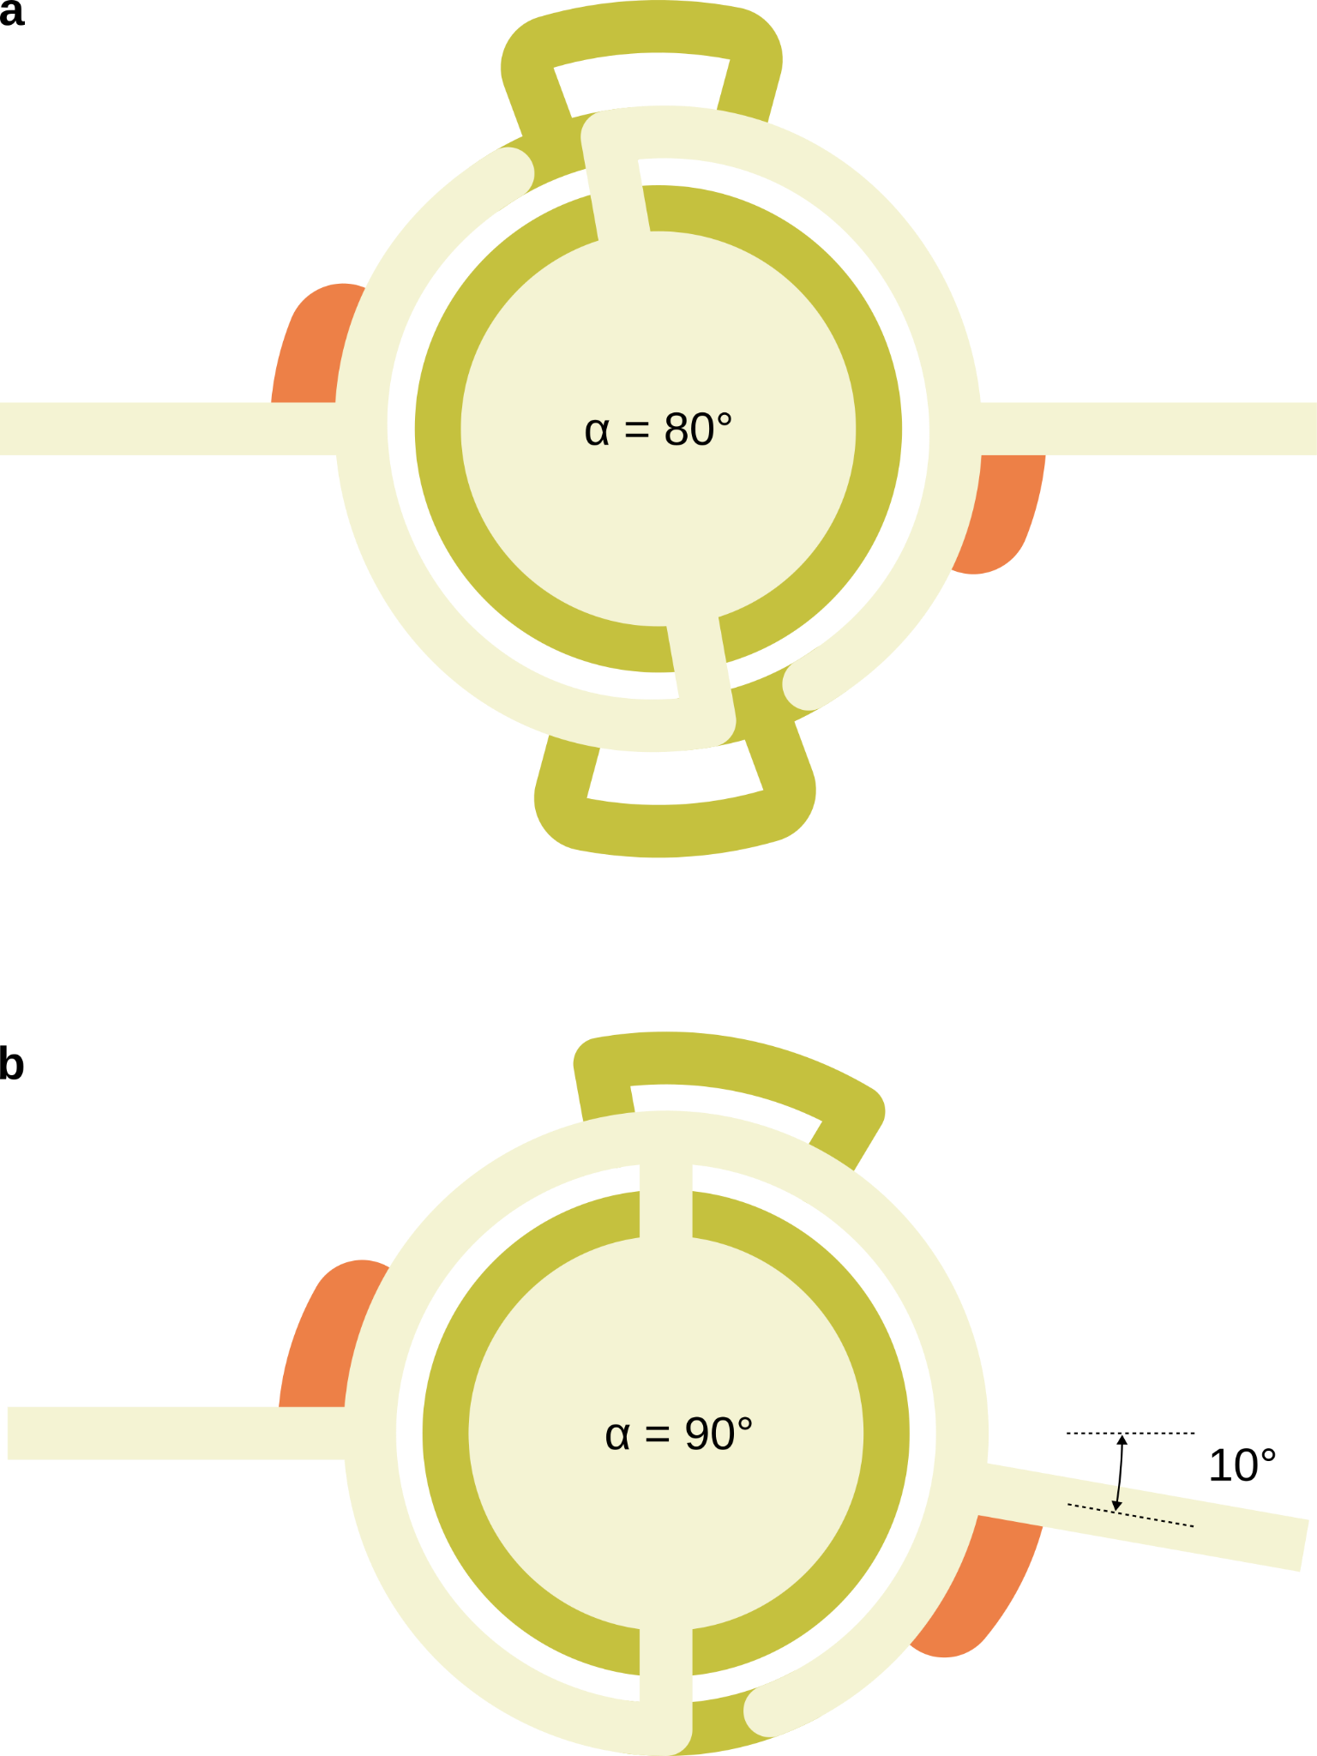
Fig. S6: Example modifications of the Wheatstone bridge-inspired microfluidic trap. a) The microfluidic trap used in Movie 6 (see Fig. S4) with additional bypasses on the inlet and outlet of the chamber. For very long droplets, as the protrusion exits the chamber, it can split into several smaller droplets. An additional bypass enables a block-and-brake mechanism and maintains the output droplet size at the input droplet size. b) Reducing one obstacle in the loop surrounding the chamber to allow transfer of the output droplet into the trap's input by bypassing the chamber. Additionally, rather than manipulating the bridge angle, the outlet channel angle was adjusted to maintain trap operation.
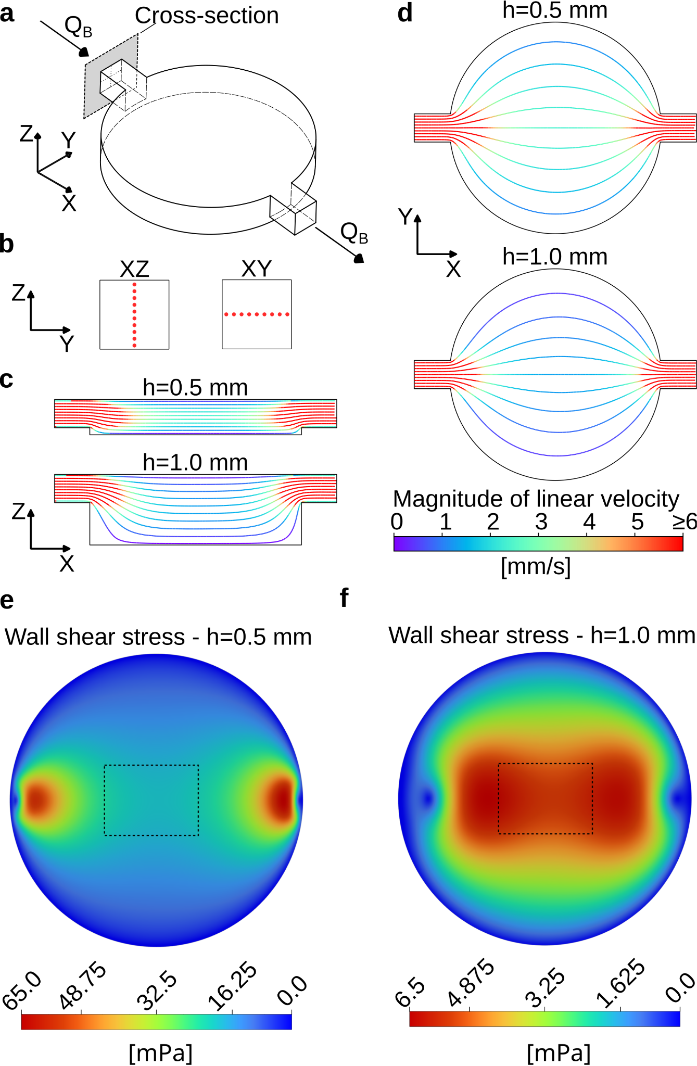
Fig. S7: Analysis of the flow inside the immobilized droplet in translational flow mode: numerical simulations of stationary flow at Q_{B}=6 mL h⁻¹. a) Geometry used in the simulations (example shown for h=0.5 mm). The marked cross-section indicates the plane where streamlines were initiated. b) Cross-sections with red points marking the initial positions of streamlines in the XZ and XY projections. c) Side view of XZ streamlines for chambers with h=0.5 mm (top) and h=1.0 mm (bottom). d) Top view of XY streamlines for chambers with h=0.5 mm (top) and h=1.0 mm (bottom). e), f) Colormaps showing the shear stress distribution at the bottom surface of the incubator (note that separate color scales are used for each case). The dashed rectangles at the center of the chamber represent the areas of interest (0.97 mm × 0.73 mm) used for microscopic observation of the A549 cells, as shown in Fig. 7 in the article and Figs. S12, S13. The average magnitude of shear stress over the area of interest was 19.6 mPa for h=0.5 mm and 5.51 mPa for h=1.0 mm, with standard deviations of 1.4 mPa and 0.37 mPa, respectively.
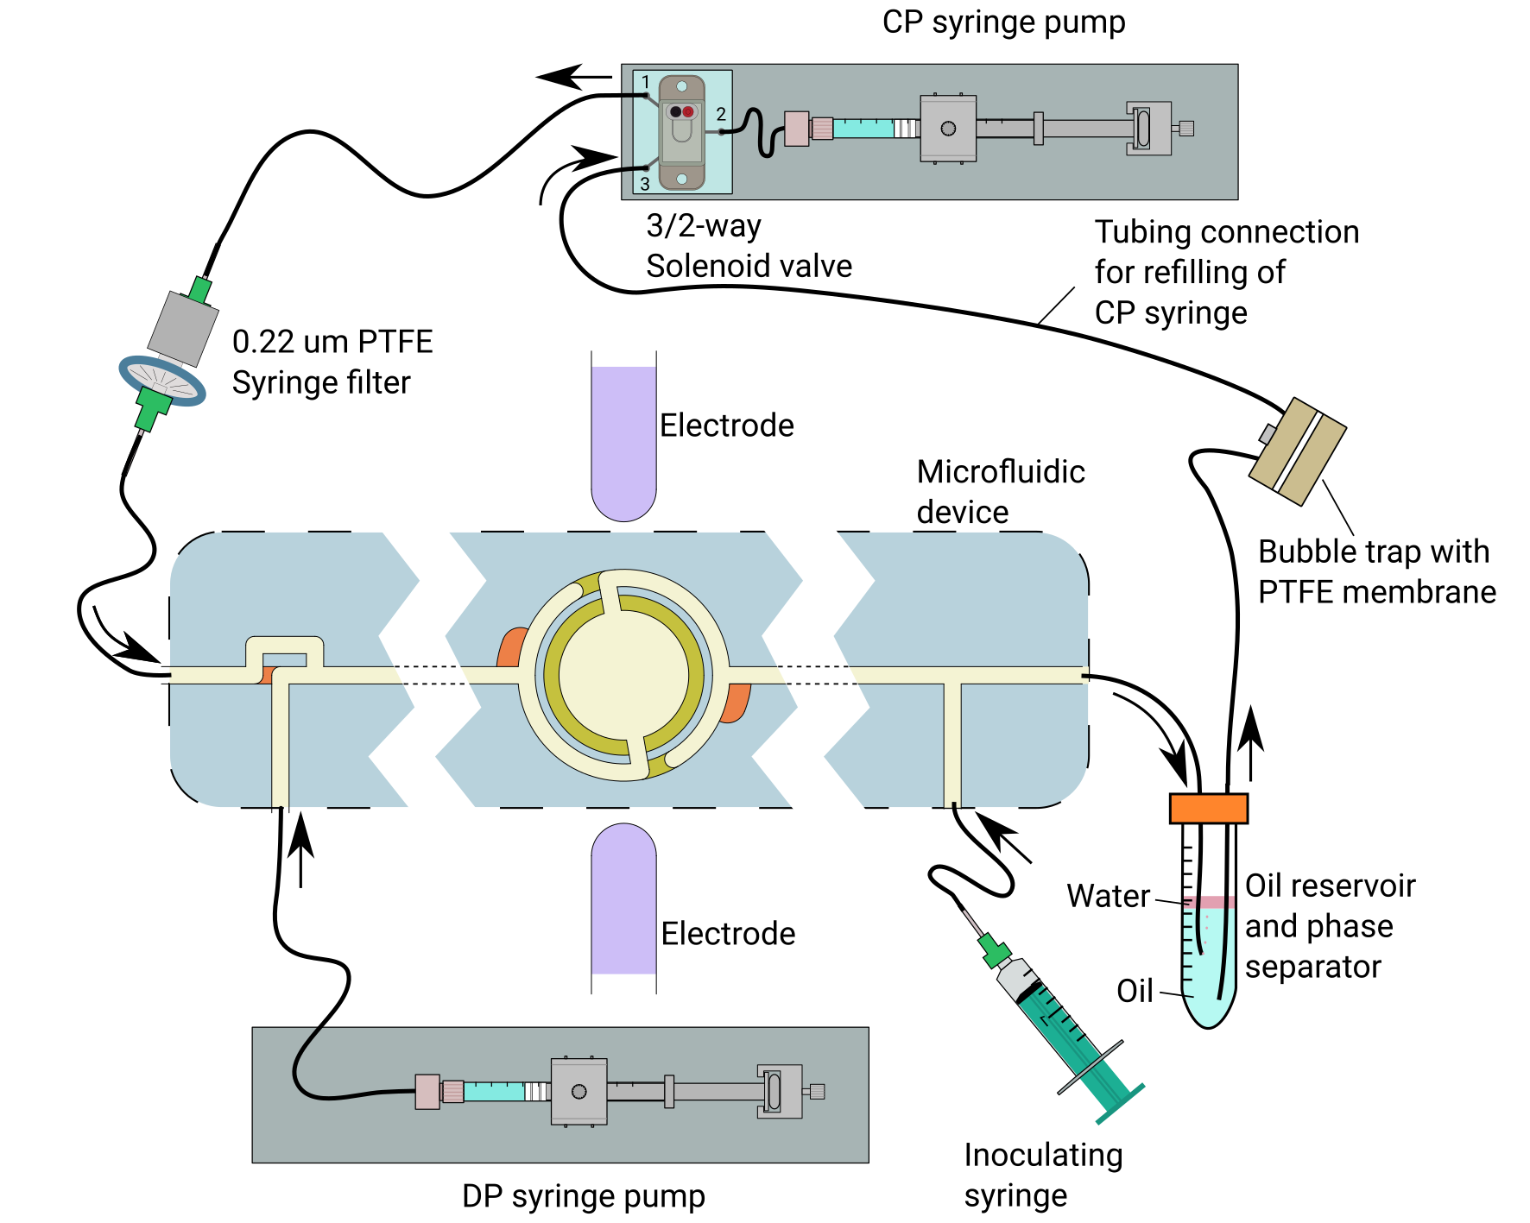
Fig. S8: A simplified schematic of the experimental setup used for E. coli culture in the microfluidic droplet incubator.
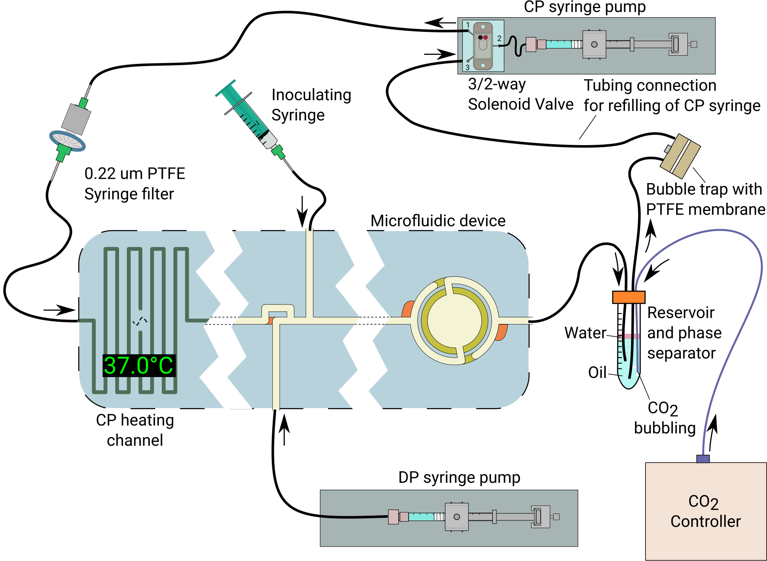
Fig. S9: Simplified schematic of the experimental setup used for A549 cell culture in the droplet-based microfluidic incubator. The diagram shows the microfluidic device, with channel depths indicated by color, connected to auxiliary components: syringe pumps, a 3/2-way solenoid valve, a syringe filter, a bubble trap with a PTFE membrane, a reservoir with a phase separator, and a CO₂ controller for medium conditioning and droplet incubation at 37.0 °C.
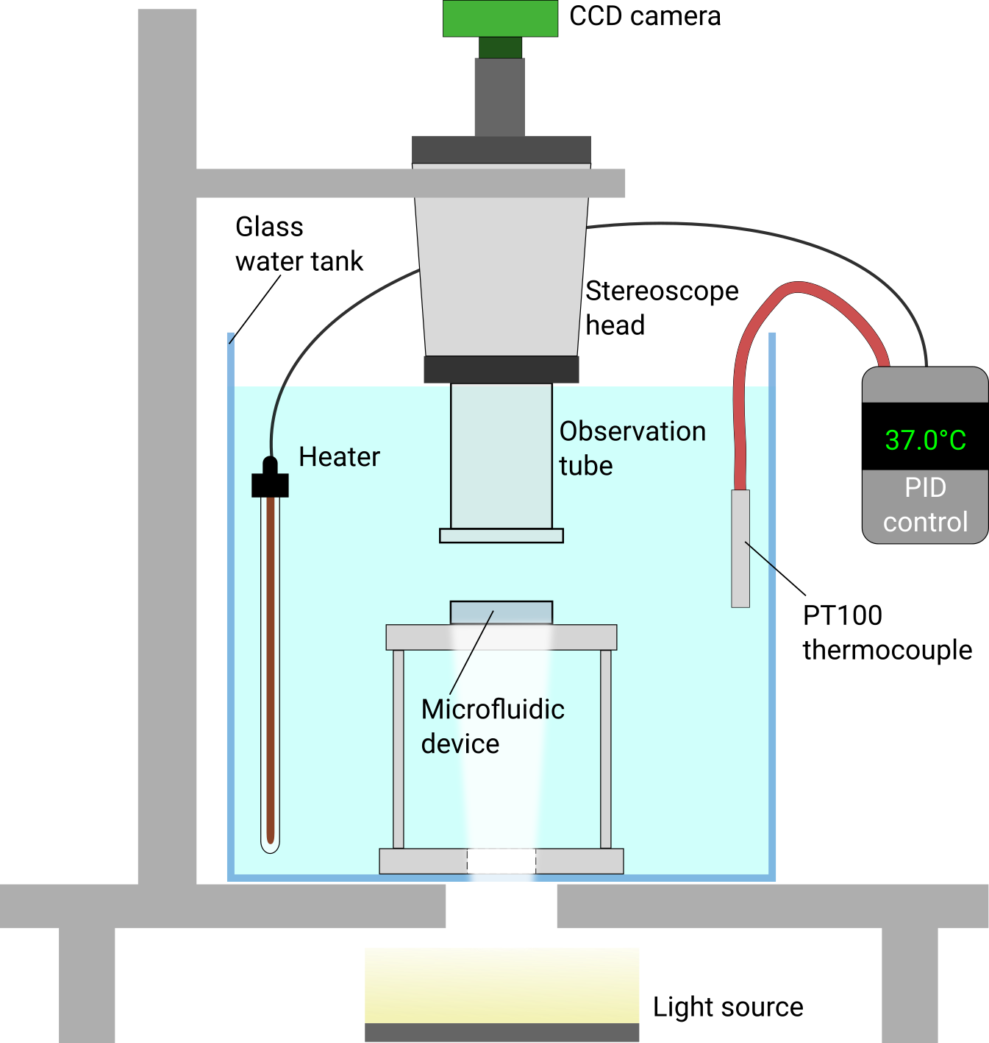
Fig. S10: Overview of the experimental station used for bacterial culture, showing the microfluidic device submerged in water inside the observation chamber. The setup includes a heater with PID temperature control (set to 37.0 °C) and an optical system for real-time imaging.
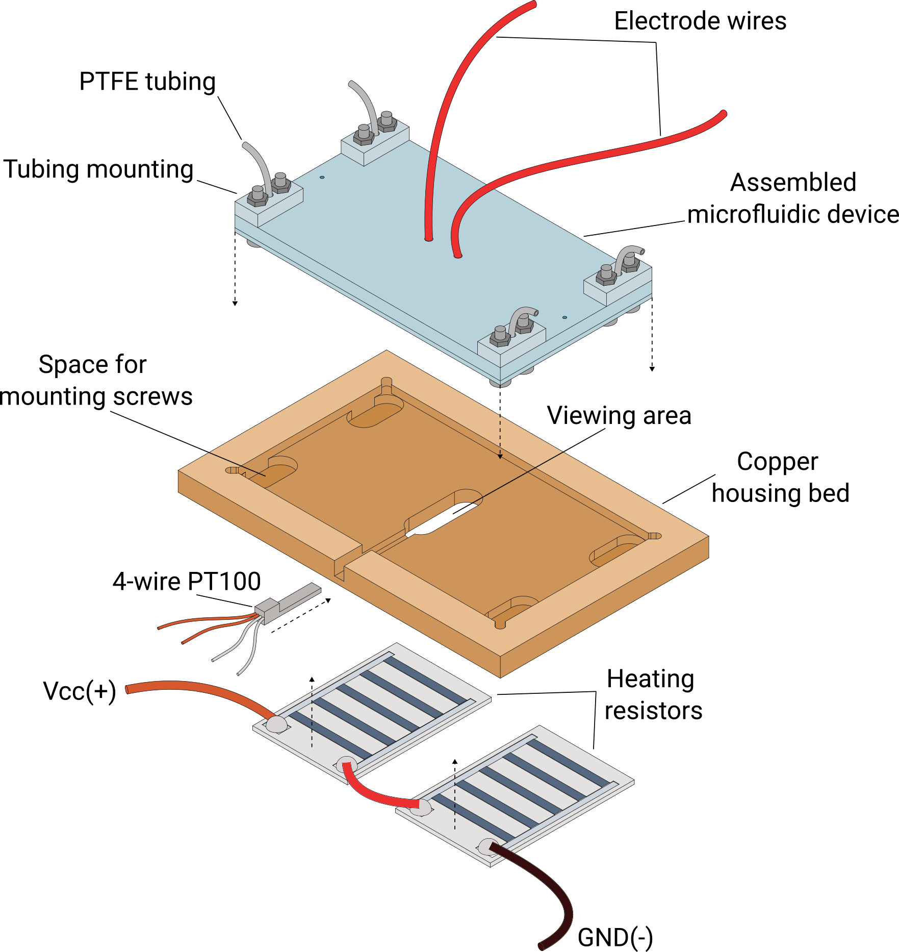
Fig. S11: Overview of the temperature stabilization system used for A549 culture studies in the droplet-based microfluidic incubator. The microfluidic device is inserted into a copper housing bed heated by two thick-film resistors bonded to the bottom of the bed. The 4-wire PT100 sensor is inserted near the incubator to ensure accurate temperature control by a PID controller. The entire assembly is enclosed in a polycarbonate-plate case to thermally isolate it from the metal microscope components and improve heat dissipation.
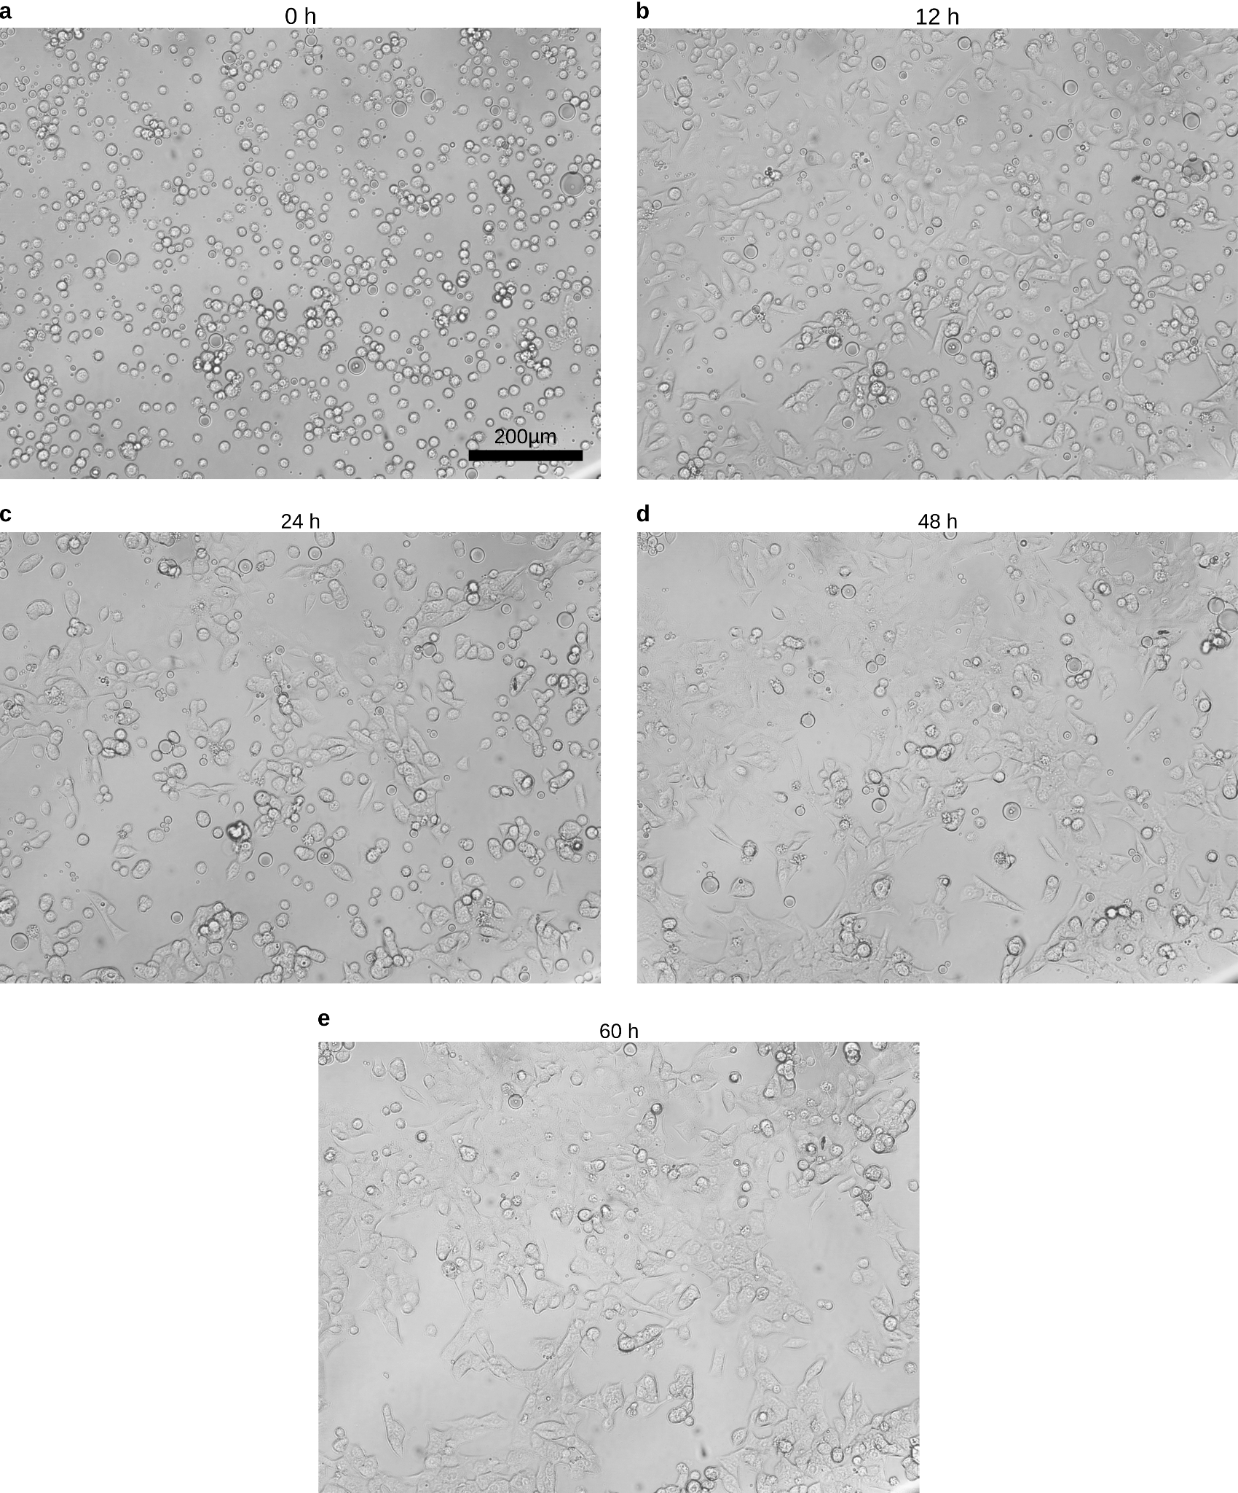
Fig. S12: Changes in the morphology and confluence of A549 cells cultured in the microfluidic trap (h=0.5 mm) operated in the continuous droplet train mode (Q_{DP} = 0.05 mL h⁻¹, Q_{CP} = 6.0 mL h⁻¹) over time. The initial cell density was approximately 1 × 10⁶ cells mL⁻¹. The scale bar in panel (a) applies to all panels. We observed oil droplets among A549 cells in our experiments because the media are nutrient-rich and can contain surfactants. When a droplet-based microfluidic system has both hydrophilic and hydrophobic zones and dynamic processes occur, such as DP adhesion to a hydrophilic surface, a potential problem is the formation of oil droplets in water despite the use of oil-soluble surfactants and the intended presence of only water dispersed in oil droplets.
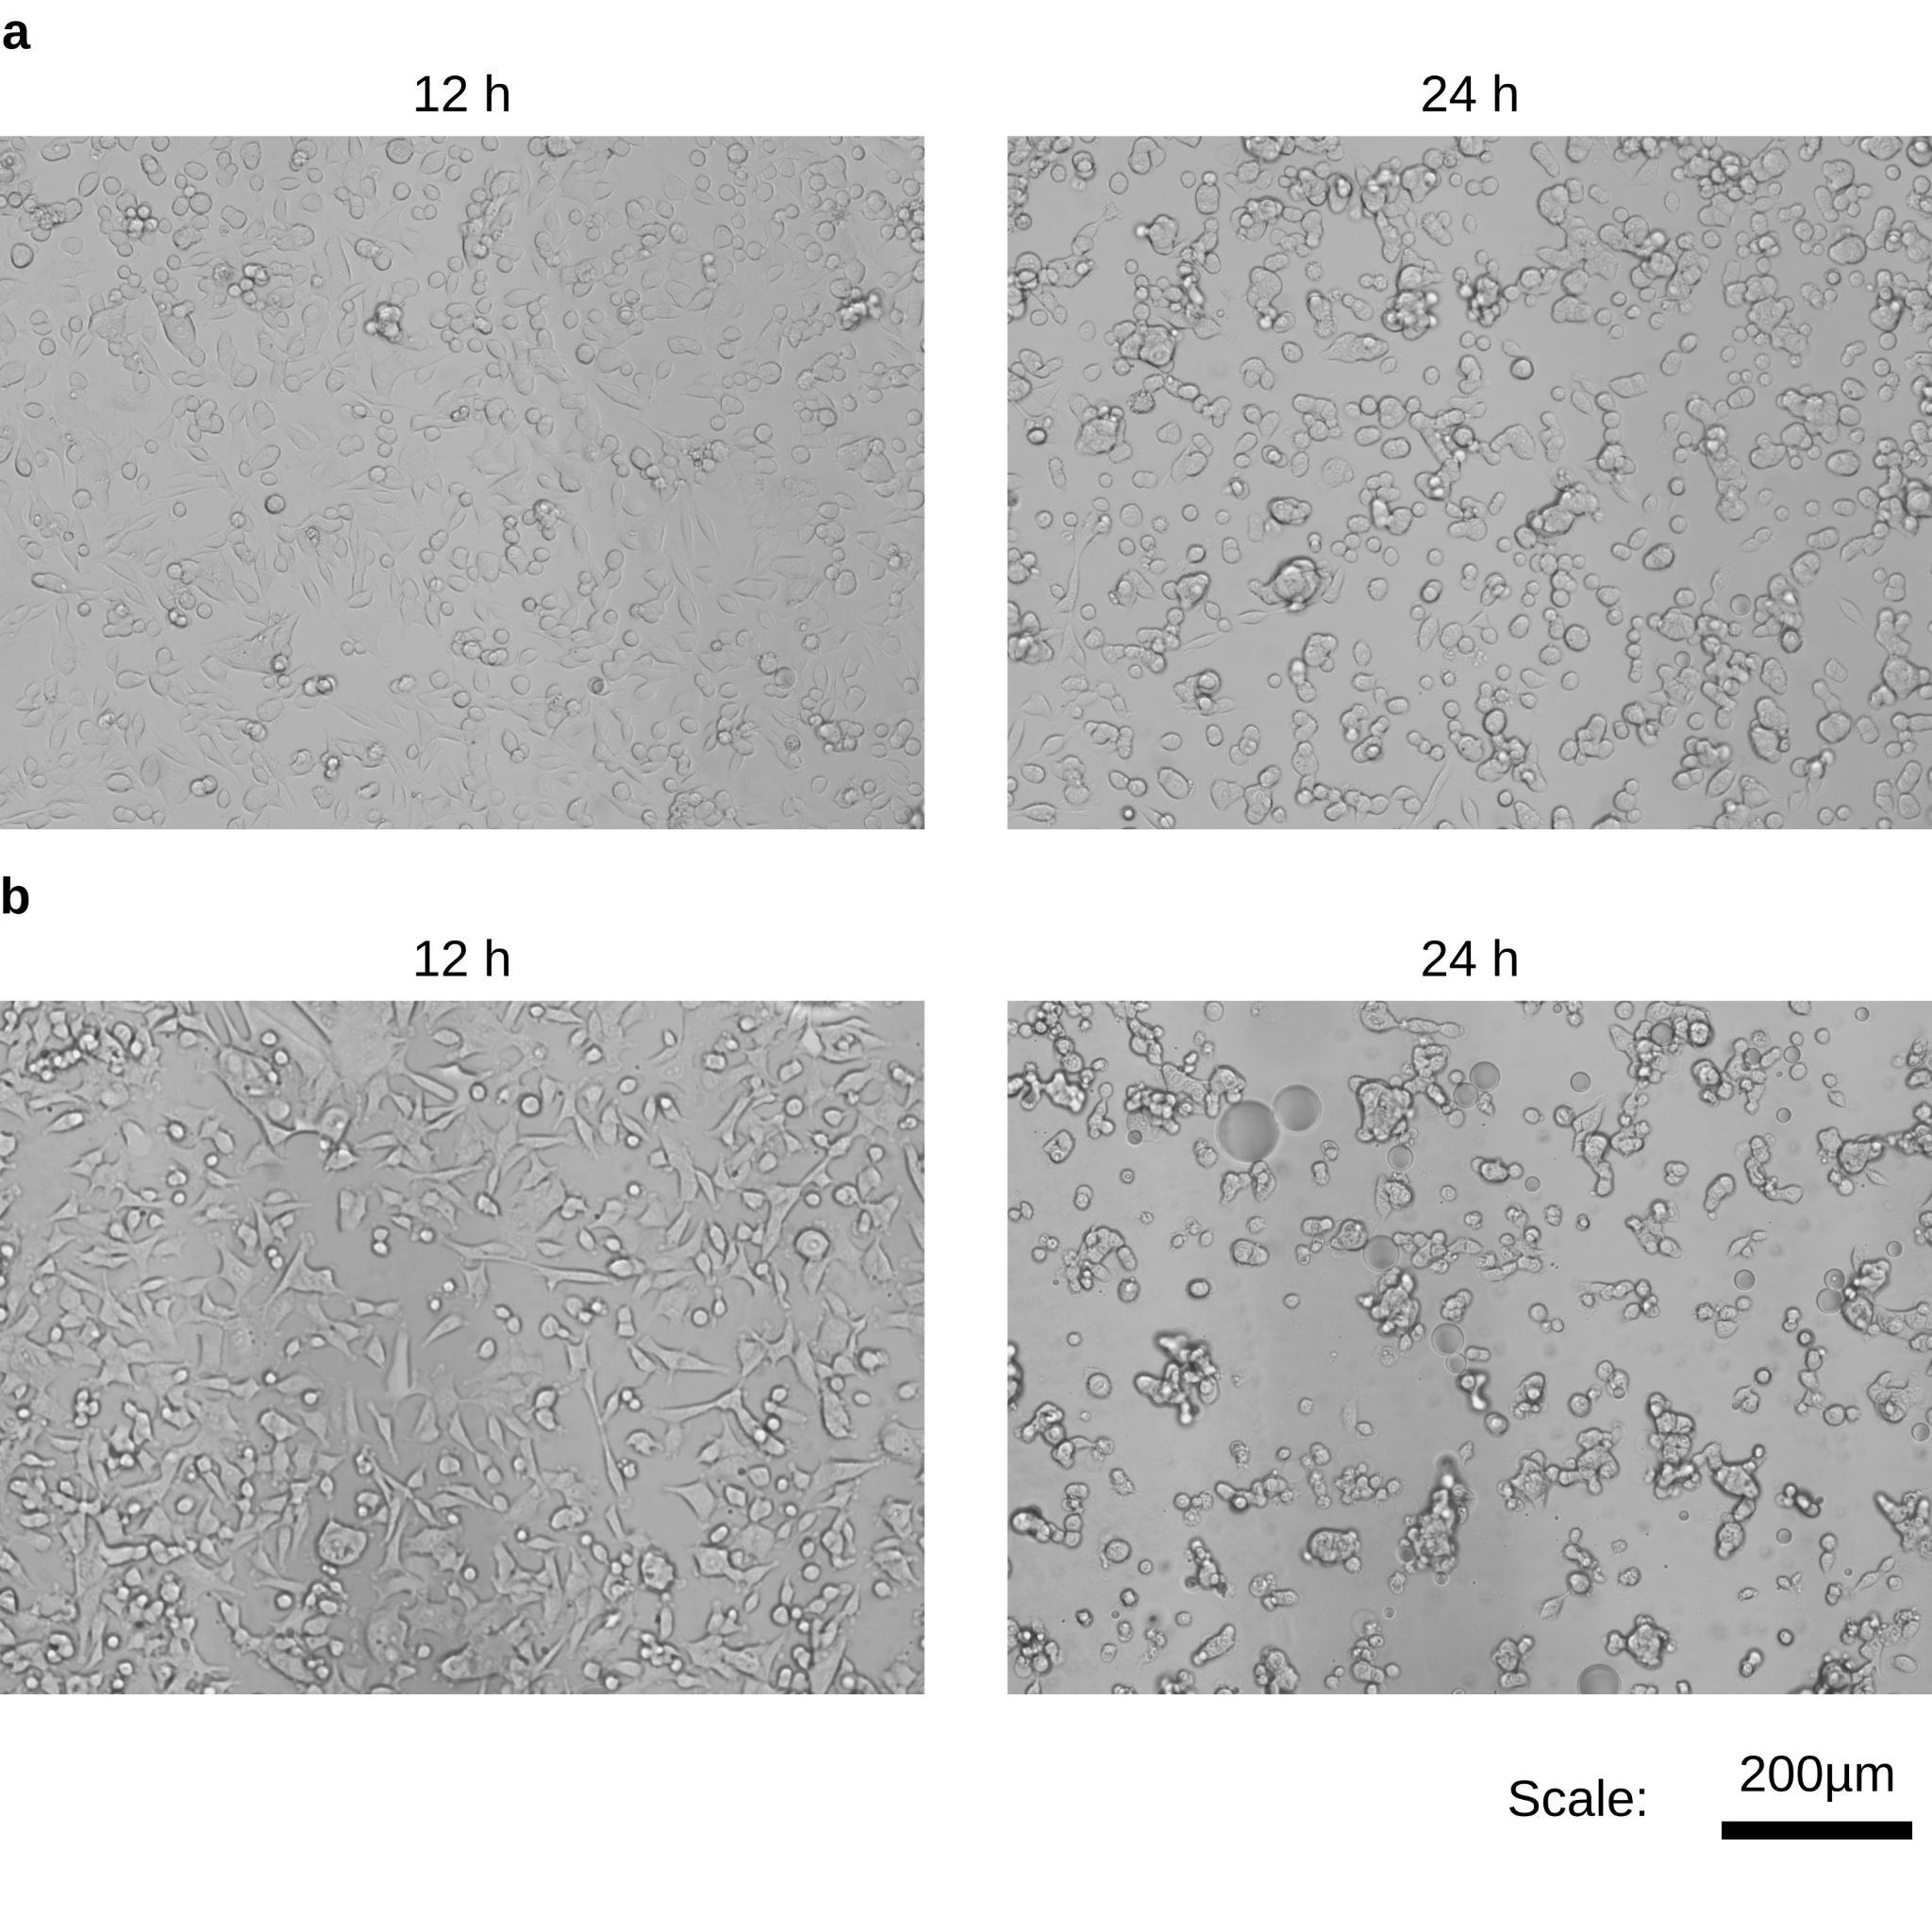
Fig. S13: Microscopy images of A549 cells cultured in the 0.5 mm-depth microfluidic trap in intermittent droplet train mode (Q_{DP}=0.2 mL h⁻¹, Q_{CP}=6.0 mL h⁻¹). The initial cell density in all the cases was approximately 1 × 10⁶ cells mL⁻¹. a) The medium exchanges were performed at 30 min intervals. b) The medium exchanges were performed at 60 min intervals.

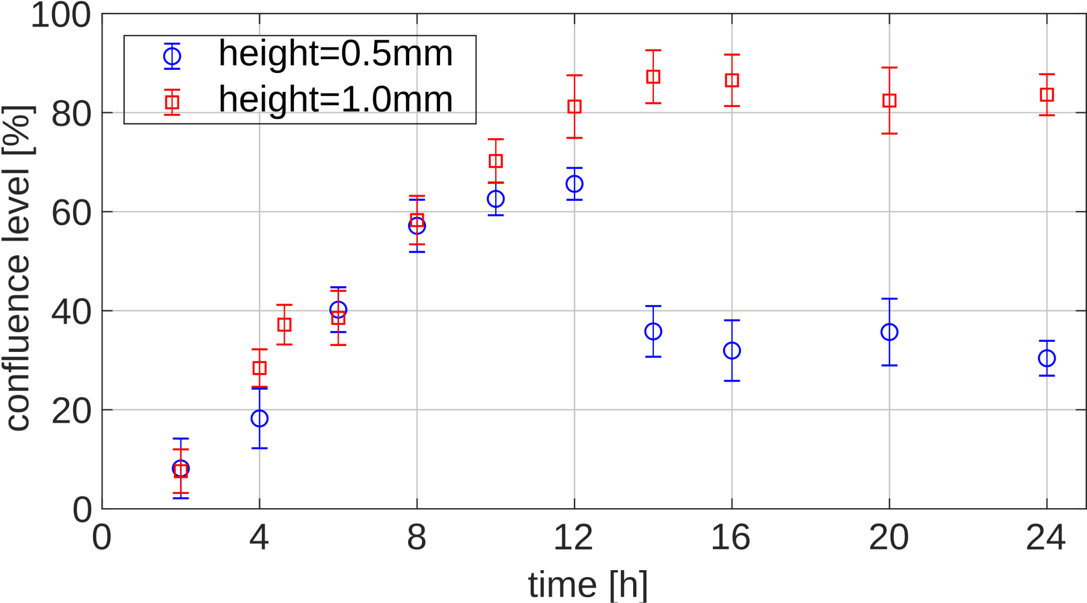
Fig. S14: Comparison of A549 cell confluence under conditions that promote monolayer formation in the microfluidic trap at chamber depths of 0.5 mm and 1.0 mm. The blue symbols correspond to cultures maintained in the 0.5 mm-high chamber operated in continuous droplet train mode (Q_{DP}=0.05 mL h⁻¹, Q_{CP}=6.0 mL h⁻¹; see Fig. 9). The red symbols correspond to cultures maintained in the 1.0 mm-high chamber operated in intermittent droplet train mode (Q_{DP}=0.2 mL h⁻¹, Q_{CP}=6.0 mL h⁻¹) with a medium exchange after approximately 5 hours and 16 hours after cell seeding. The error bars represent standard deviations obtained from at least three independent measurements.

