Appendix

This chapter attempts to add the step ionization effect from the excited atoms to the Brophy Model. The collision cross-section for the step ionization is given by Ref.11 and is more than twice the value of the ionization cross-section. Specifically, the following six reactions are considered.

Ionization by collision between the primary electrons and the neutrals.
$J_{P}^{PN}=en_{0}n_{P}{σ_{+}^{'}v}_{P}V$ (17)
Generation of the excited atoms by collision between the primary electrons and the neutrals.
$ΣJ_{J}=en_{0}n_{P}σ_{j}^{'}v_{P}V$ (18)
Ionization by collision between the primary electrons and the excited atoms.
$J_{P}^{PX}=en_{X}n_{P}σ_{S}^{'}v_{P}V$ (19)
Ionization by collision between the Maxwellian electrons and the neutrals.
$J_{P}^{MN}=en_{0}n_{M}〈σ_{+}v_{M}〉V$ (20)
Generation of the excited atoms by collision between the Maxwellian electrons and the neutrals.
$J_{X}^{MN}=en_{0}n_{M}〈σ_{j}v_{M}〉V$ (21)
Ionization by collision between the Maxwellian electrons and the excited atoms.
$J_{P}^{MX}=en_{X}n_{M}〈σ_{S}v_{M}〉V$ (22)

In the Brophy Model, Eqs. 17, 18, and 20 were used. We will now attempt to add three new reaction equations. Equations 19 and 22 represent ionization from excited atoms, which is the step ionization. The energy and current flow of the new model are shown in Fig.10. The production rates of the ion, the excited atoms and the step ionization are formulated as follows.

$J_{P}=J_{P}^{PN}+J_{P}^{MN}+J_{P}^{PX}+J_{P}^{MX}=J_{P}^{PN}+J_{P}^{MN}+J_{S}$
$= en_{0}n_{M}\left[\frac{n_{P}}{n_{M}}{σ_{+}^{'}v}_{P}+〈σ_{+}v_{M}〉+\frac{n_{X}}{n_{0}}\frac{n_{P}}{n_{M}}σ_{S}^{'}v_{P}+\frac{n_{X}}{n_{0}}〈σ_{S}v_{M}〉\right]V$ (23)
$J_{X}=ΣJ_{J}+J_{X}^{MN}-J_{P}^{PX}-J_{P}^{MX}=ΣJ_{J}+J_{X}^{MN}-J_{S}$
$= en_{0}n_{M}\left[\frac{n_{P}}{n_{M}}{σ_{j}^{'}v}_{P}+〈σ_{j}v_{M}〉-\frac{n_{X}}{n_{0}}\frac{n_{P}}{n_{M}}{σ_{S}^{'}v}_{P}-\frac{n_{X}}{n_{0}}〈σ_{S}v_{M}〉\right]V$ (24)
$J_{S}=J_{P}^{PX}+J_{P}^{MX}= en_{X}n_{M}\left(\frac{n_{P}}{n_{M}}{σ_{S}^{'}v}_{P}+ 〈σ_{S}v_{M}〉\right)V$ (25)

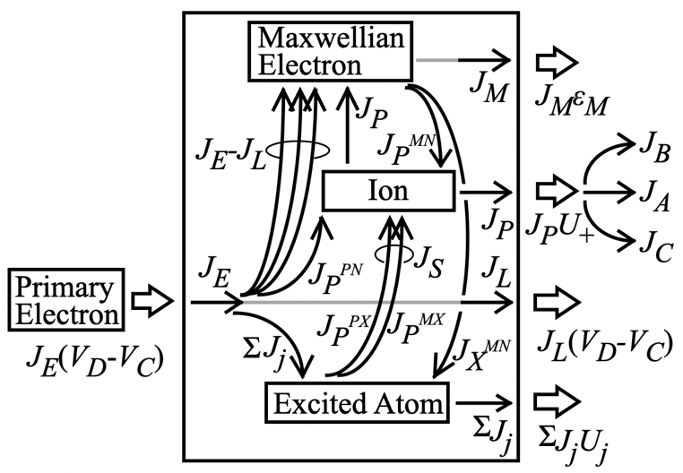
Fig.10 Energy and current flows of DC discharge with step ionization

The following two equations are derived to calculate ε_{P}*.

${ε_{P}}^{*}=\frac{U_{+}+\frac{J_{X}}{J_{P}}U_{ex}+{\frac{J_{S}}{J_{P}}U_{S}+ε}_{M}}{1-\frac{V_{C}+ε_{M}}{V_{D}}}$ (26)
${ε_{P}}^{*}=\frac{\frac{σ_{+}^{'}+σ_{j}^{'}+{\frac{n_{X}}{n_{0}}σ}_{S}^{'}}{σ_{+}^{'}}V_{D}}{1+\left(〈σ_{+}v_{M}〉+\frac{n_{X}}{n_{0}}\frac{n_{P}}{n_{M}}σ_{S}^{'}v_{P}+\frac{n_{X}}{n_{0}}〈σ_{S}v_{M}〉\right)/\frac{n_{P}}{n_{M}}σ_{+}^{'}v_{P}}$ (27)

Compared to Eq.8, the step ionization energy U_{S} appears in the numerator of Eq.26. Furthermore, it is necessary to introduce the excited atom density n_{X}/n₀ relative to the neutral particle density. An example calculation is shown in Fig.11 under the assumption of U_{S} = 3.8 eV. The case of n_{X}/n₀ = 0 is equivalent to the Brophy Model. For the case of n_{X}/n₀ = 0.01, represented by the thick line, the breakdowns of the four components of the numerator of Eq.26 are also shown. It can be seen that ε_{P}* decreases by introducing the step Ionization. In the figure, in the low electron temperature region, the component due to excited atoms, represented by the dashed line, and ε_{P}*, represented by the thick line, intersect each other around 1.5eV of the temperature of the Maxwellian electron. This means that as the n_{X}/n₀ value increases, Eq.24 becomes negative, and the physical phenomenon is no longer correctly represented. The calculation results in the electron temperature region below 2 or 3 eV are no longer correct.

Introducing the step Ionization effect into the Brophy Model resulted in a decrease of ε_{P}* because of reducing loss of the excited atom with an energy U_{ex}=10.3eV even after consuming the step ionization energy U_{s}=3.8eV. But the extent of this decrease was small. The step Ionization shows positive effect for reducing ε_{P}*, but remains a secondary contribution. Its macroscopic impact on the Brophy Model's simple yet sophisticated theory was minimal. There may be some local effects considering factors such as generation location. Reference 12 argues that step ionization occurring in a waveguide interferes with the microwave transmission and is detrimental to the microwave discharge ion engines.

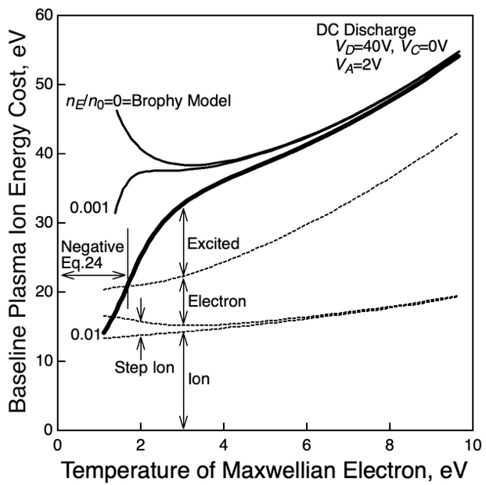
Fig.11 Baseline plasma ion energy cost considering step ionization.

