Supplementary materials

Potential megathrust earthquakes and tsunamis off the southern coast of West Java, Indonesia
Pepen Supendi^{1,2}, Sri Widiyantoro^{3,4}, Abdul Muhari⁵, Nicholas Rawlinson⁶, Supriyanto Rohadi¹, Dwikorita Karnawati¹, Nuraini Rahma Hanifa^{2,7}, Iswandi Imran⁸, Endra Gunawan^{2,3}, Lutfi Faizal^{7,9}

¹Agency for Meteorology, Climatology and Geophysics, Jakarta 10610, Indonesia
²Center for Earthquake Science and Technology, Research Center for Disaster Mitigation, Institut Teknologi Bandung, Bandung 40132, Indonesia
³Global Geophysics Research Group, Faculty of Mining and Petroleum Engineering, Institut Teknologi Bandung, Bandung 40132, Indonesia
⁴Faculty of Engineering, Maranatha Christian University, Bandung 40 164, Indonesia
⁵National Disaster Management Authority, Jl. Pramuka No. 38, Jakarta 13120, Indonesia
⁶Department of Earth Sciences – Bullard Labs, University of Cambridge, Cambridge CB30EZ, United Kingdom
⁷National Center for Earthquake Studies, Jalan Turangga No. 3-5, Bandung 40263, Indonesia
⁸Structural Engineering Research Group, Faculty of Civil and Environmental Engineering, Institut Teknologi Bandung, Bandung 40132, Indonesia
⁹Ministry of Public Work and Housing, Jakarta 12110, Indonesia

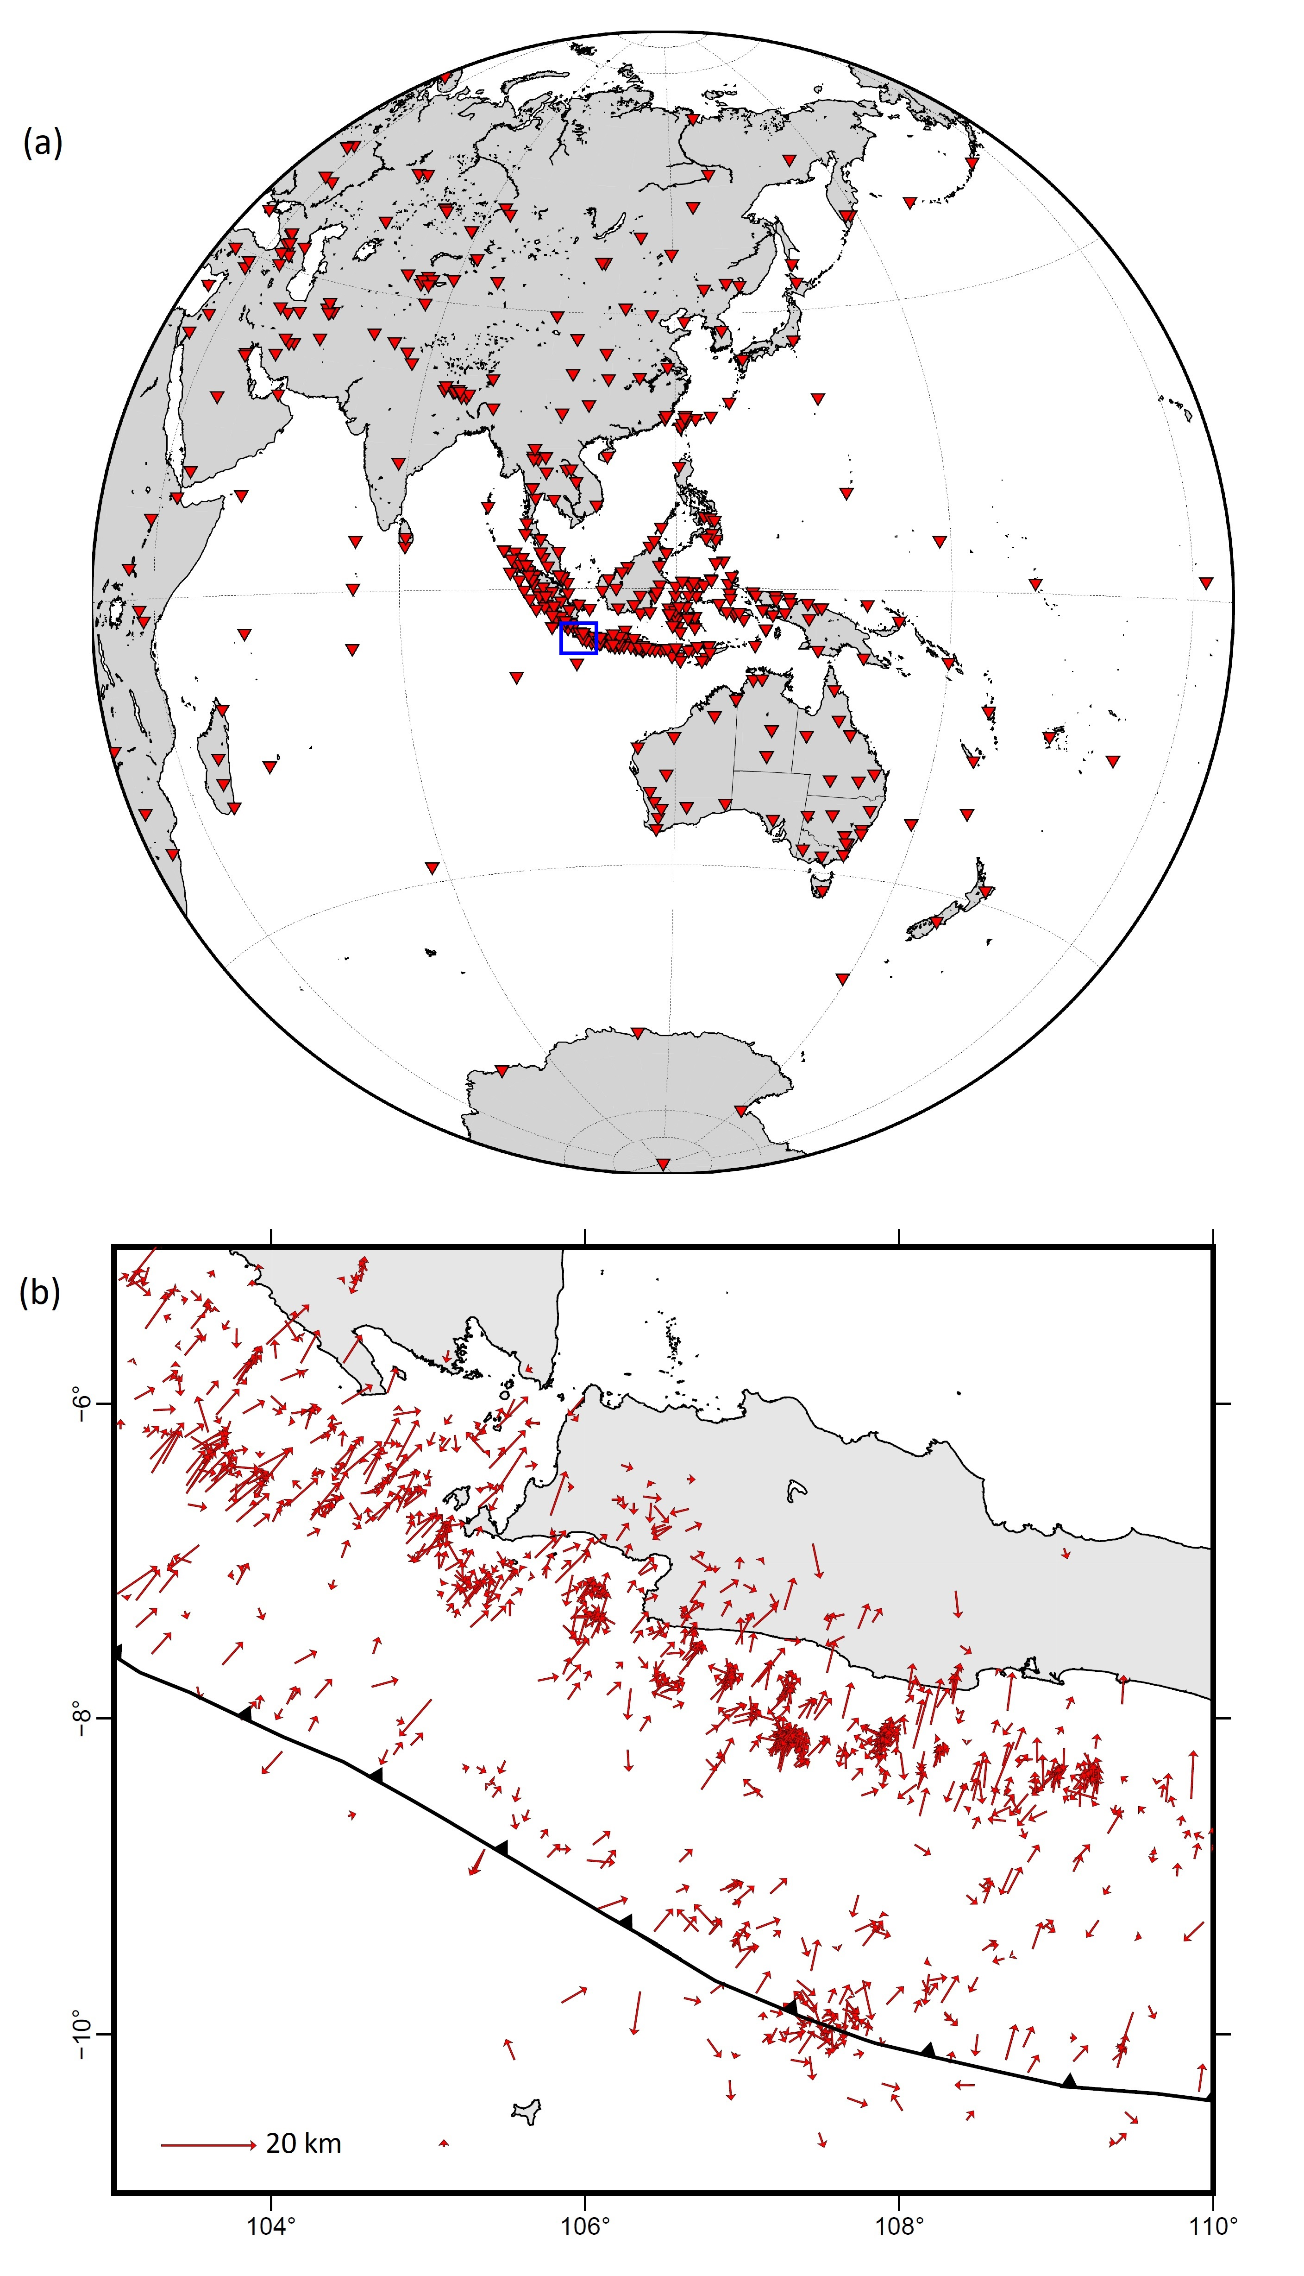
Figure S1. (a) Distribution of seismic stations used by BMKG to locate events including those from outside Indonesia; the blue box depicts the study area shown in (b), (b) Epicenter shifts due to the teletomoDD locations relative to the initial locations taken from the BMKG catalog; the mean epicenter shift is 9.38 km

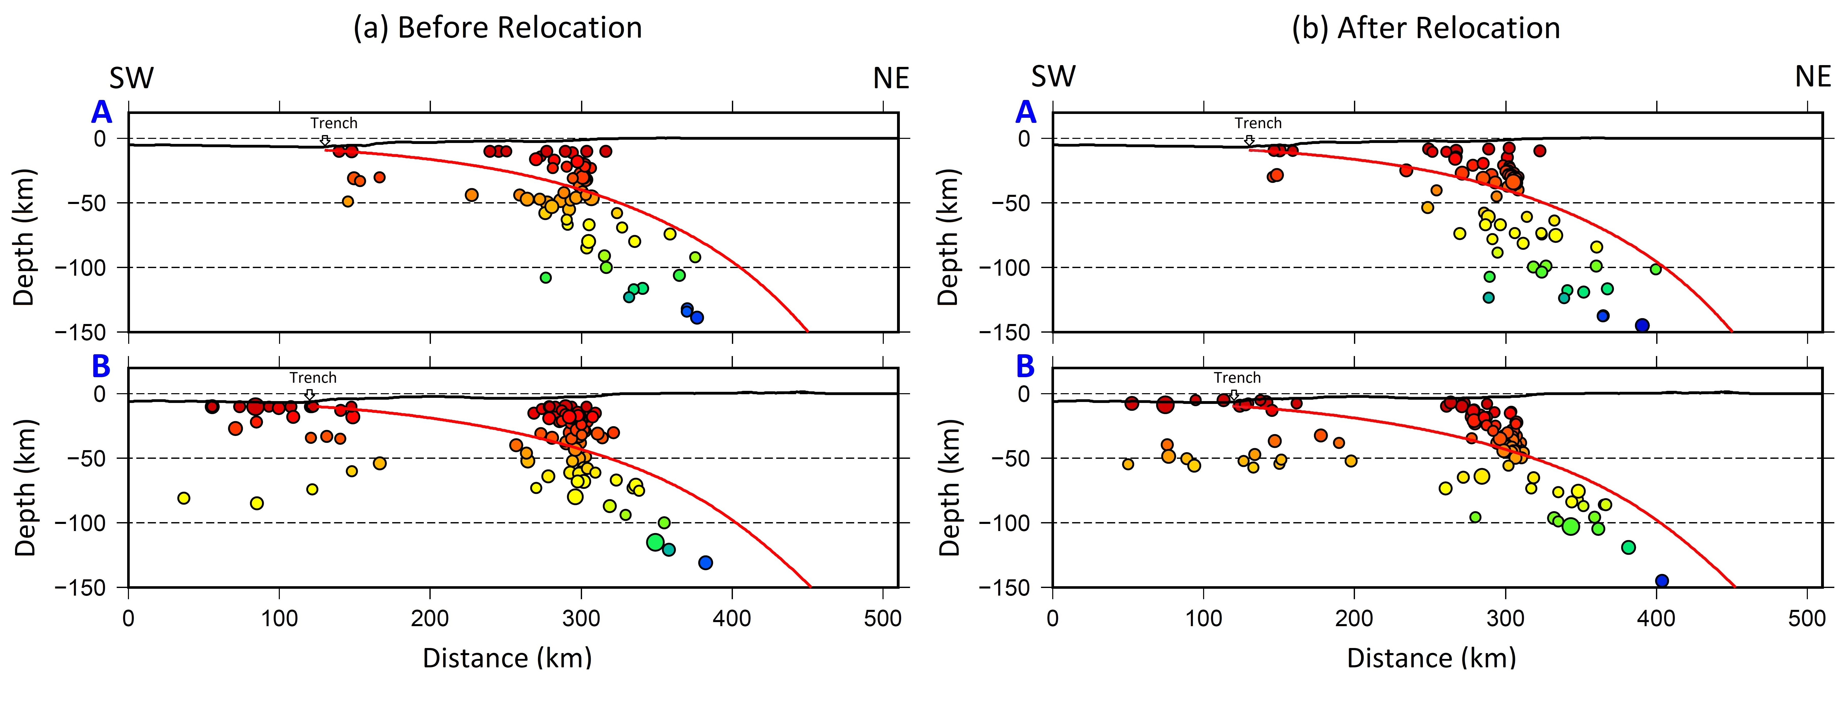
Figure S2. Comparison of cross sections showing hypocenters from (a) the BMKG catalog and (b) the teletomoDD relocation result. Red lines depict the upper surface of the subducting Indo-Australian slab according to the Slab 2 model (Hayes, 2018). The location of each cross section (A and B) is shown in Fig. 2 (a).

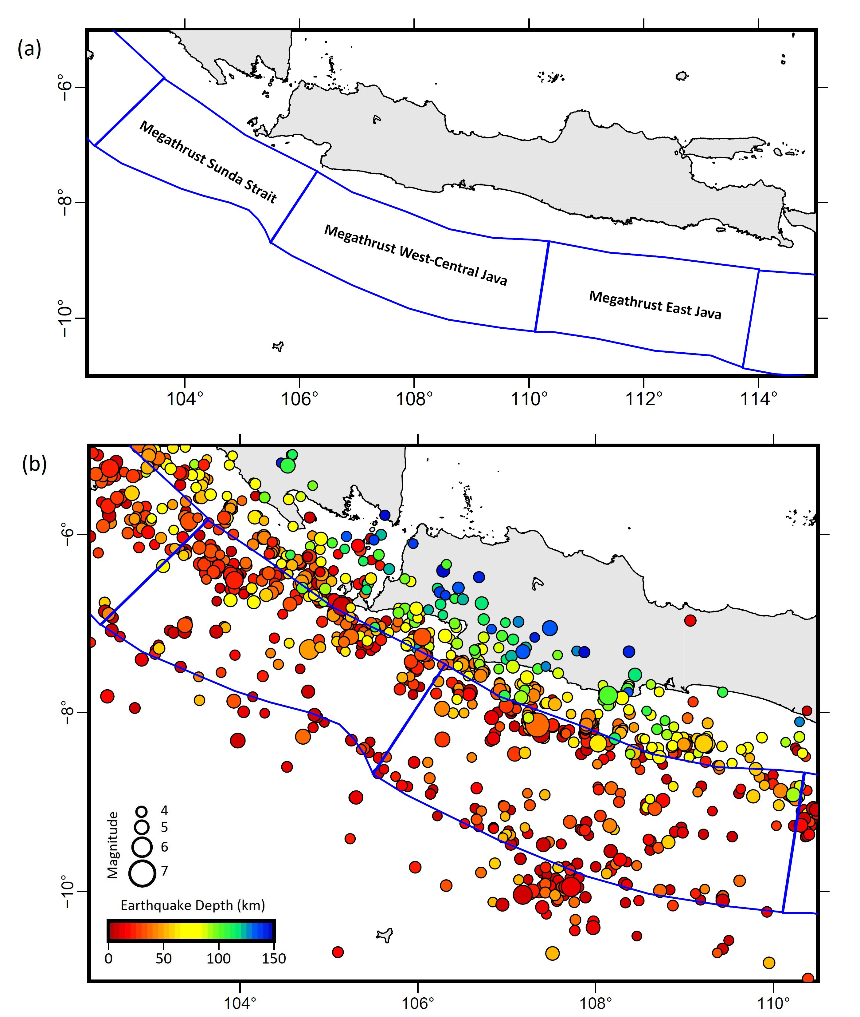
Figure S3. (a) The hypothetical segmentation of the megathrust along the southern edge of Java extracted from Irsyam et al. (2020); (b) The epicenter distribution overlaid on the megathrust segments.

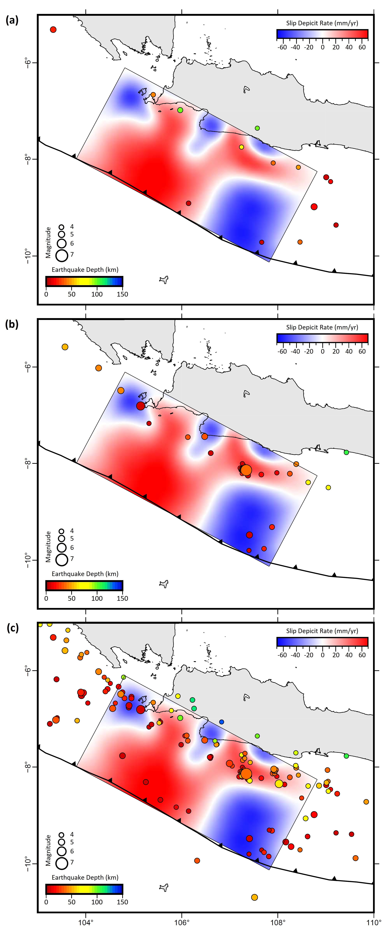
Figure S4. The epicenter distribution for time period (a) before September 2009, (b) September to December 2009, (c) 2008 to 2010; all overlaid on the slip deficit model.
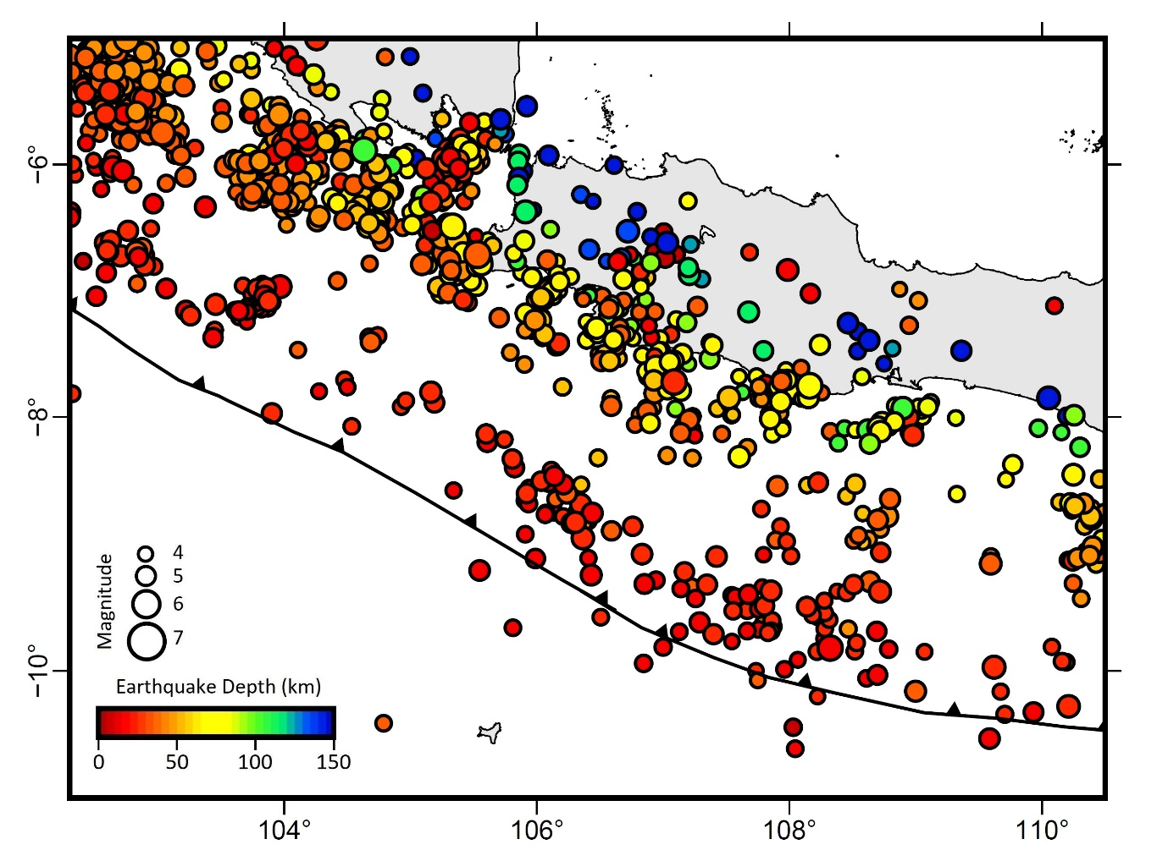
Figure S5. Epicentral distribution of relocated earthquakes taken from the ISC-EHB catalogue between 1964 to 2008.
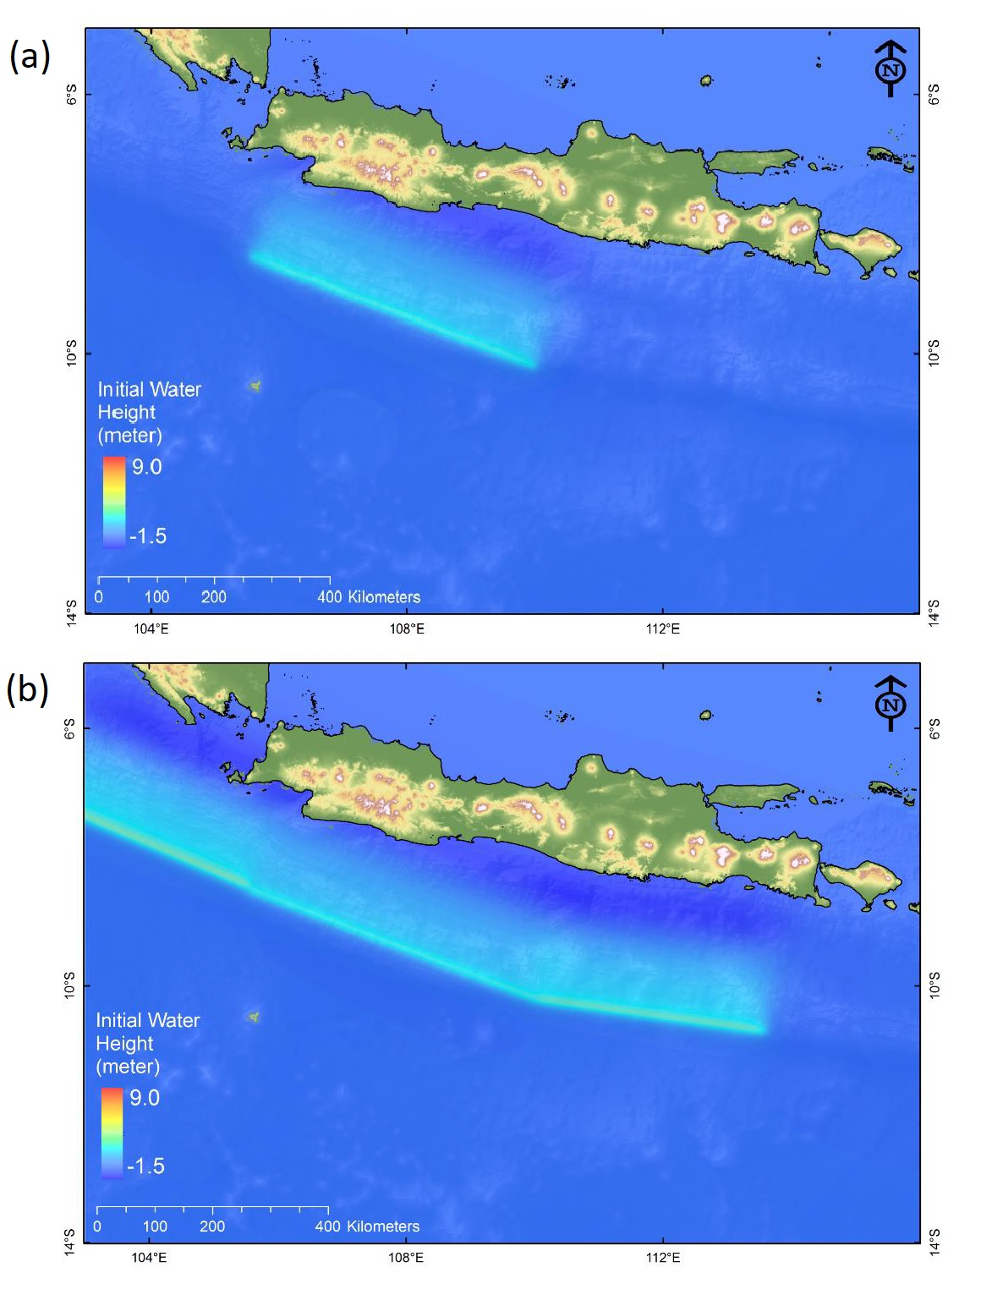
Figure S6. Modeled tsunami source off the south coast of West Java for (a) Scenario 1, (b) Scenario 2.

