Supplementary Figures:
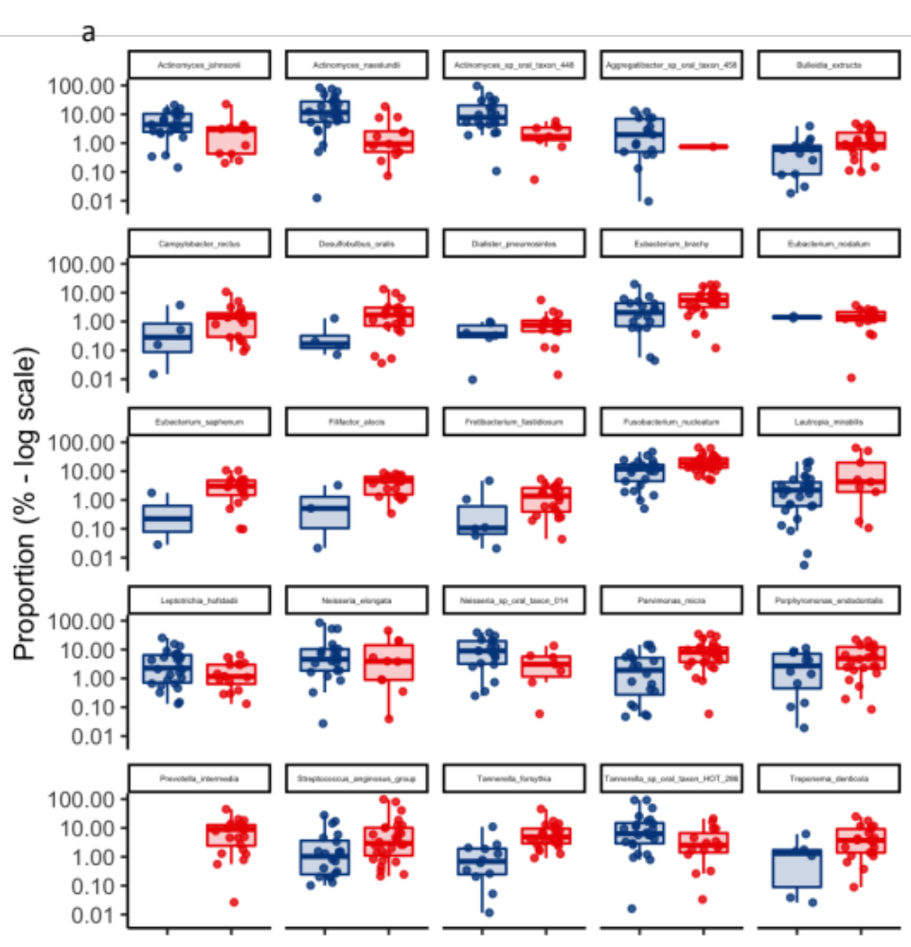
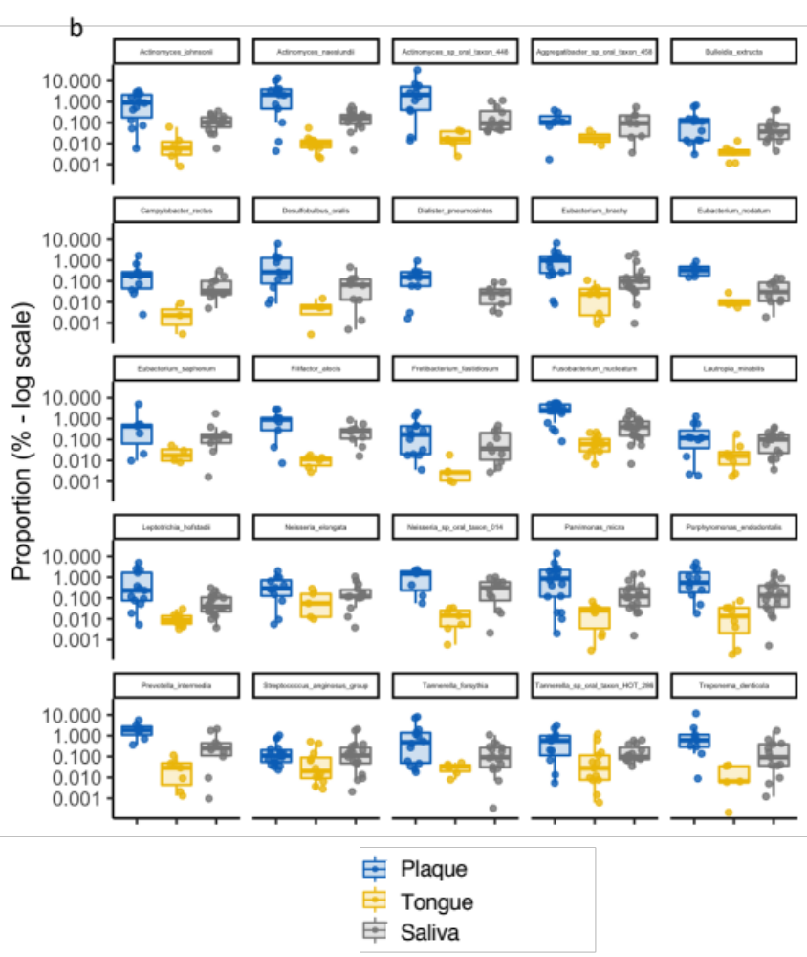
Fig. S1. Species differentially abundant between: A) healthy patients and patients with periodontitis disease. B) oral sites. Statistical tests were run on all the samples. Sample denotation: Red: periodontitis, dark blue: oral health, light blue: plaque, yellow: tongue and grey: saliva. Boxplots display first quartile, median, third quartile and whiskers represent 1.5 times the interquartile range from the first and third quartiles. Microbial taxonomy based on metaphlan v3.0.1 - default – ALDEx2::aldex.kw, denom="iqlr”. Only significant results are displayed FDRA adjusted p. value <0.05.

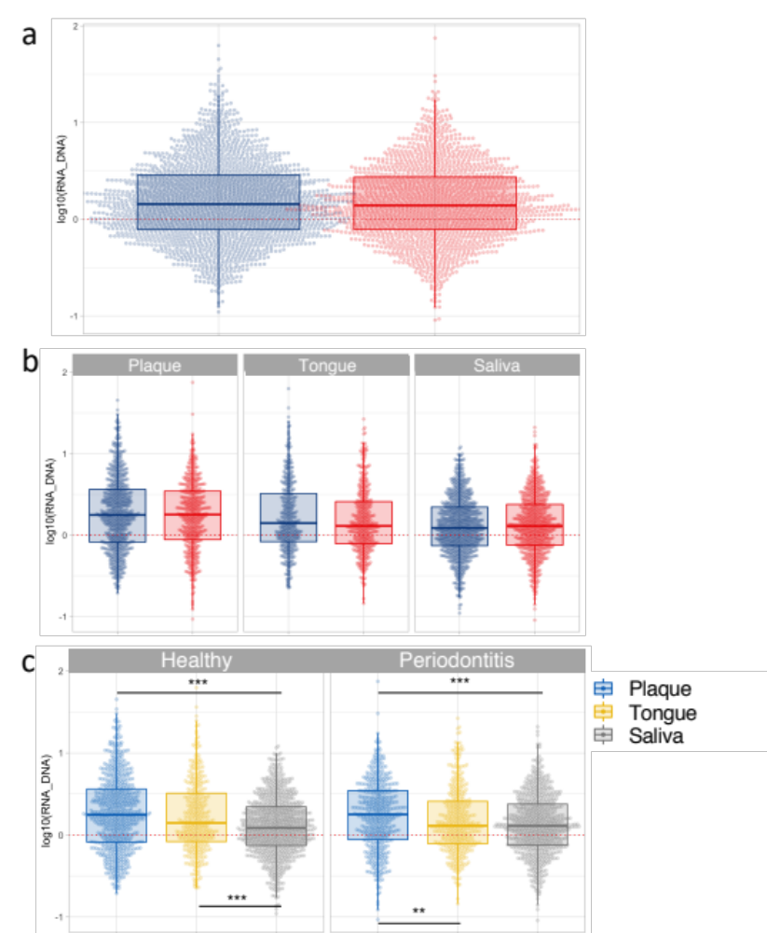
Fig. S2. Pathway-level species metatranscriptomic activity:
A) healthy patients and patients with periodontitis disease - overall, B) healthy patients and patients with periodontitis disease on each site, and C) among the different oral sites in healthy patients and patients with periodontitis disease. Each point represents the pathway transcriptional activity as measured by log10(RNA/DNA). Sample denotation: Red: periodontitis, dark blue: oral health, light blue: plaque, yellow: tongue and grey: saliva. Boxplots display first quartile, median, third quartile and whiskers represent 1.5 times the interquartile range from the first and third quartiles. Significant differences were determined using Kruskall-Wallis tests. Significant FDR-adjusted p.values were indicated as followed. * 0.05<p<0.01 ** 0.01 <p<0.001 *** p<0.001.

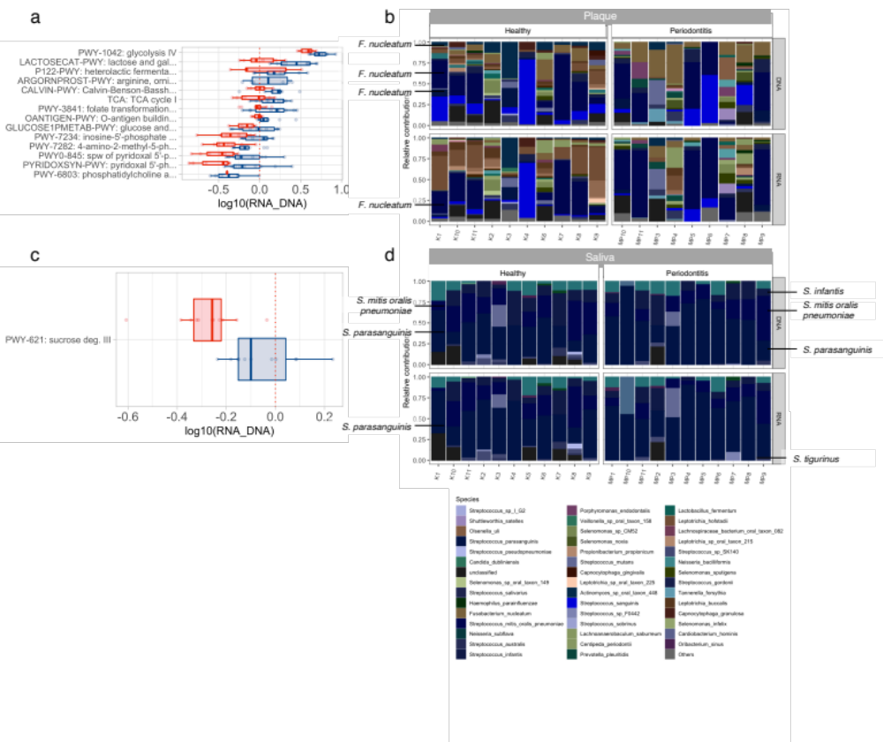
Fig. S3. Differentially expressed pathways and contributing species in Plaque and Saliva sites:
Pathways exhibiting significant differential expression between healthy and periodontitis patients as identified using MaAsLin2 in A) plaque and C) saliva site. Colour indicates heath status (blue: healthy controls vs red: periodontitis group), and shape reflects oral site. Species relative contribution to the differentially expressed pathways (identified in Fig. S3C) in B) plaque and D) saliva. Species are coloured similarly as in Fig. 3. Boxplots display first quartile, median, third quartile and whiskers represent 1.5 times the interquartile range from the first and third quartiles.

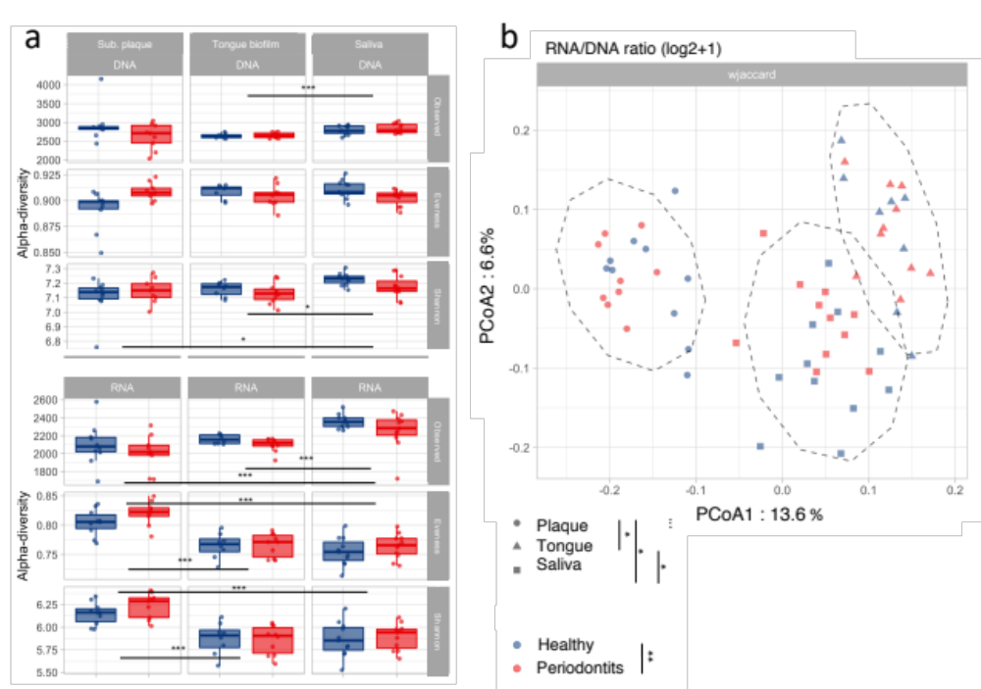
Fig S4. Diversity of microbial genes associated with associated with KEGG’s Orthologs : A) Alpha-diversity of gene families found in metagenomes (DNA) and metatranscriptomes (RNA) in plaque, tongue biofilm and saliva expressed as number of Observed gene families (i.e., richness), Evenness and Shannon’s diversity index. Boxplots display first quartile, median, third quartile and whiskers represent 1.5 times the interquartile range from the first and third quartiles. B) Beta diversity of gene expression visualized as measured by log RNA/DNA ratio quantified using weighted Jaccard distance and visualized on PCoA. Sample denotation: Red: periodontitis, Blue: oral health, Circle: plaque, Triangle: tongue biofilm, Square: saliva. Significant differencies were assessed using Kruskall-Wallis and PERMANOVAS tests for alpha and beta-diversity, respectively. Significant FDR-adjusted p.values were indicated as followed : * 0.05>p>0.01 ** 0.01>p>0.001 *** p<0.001.

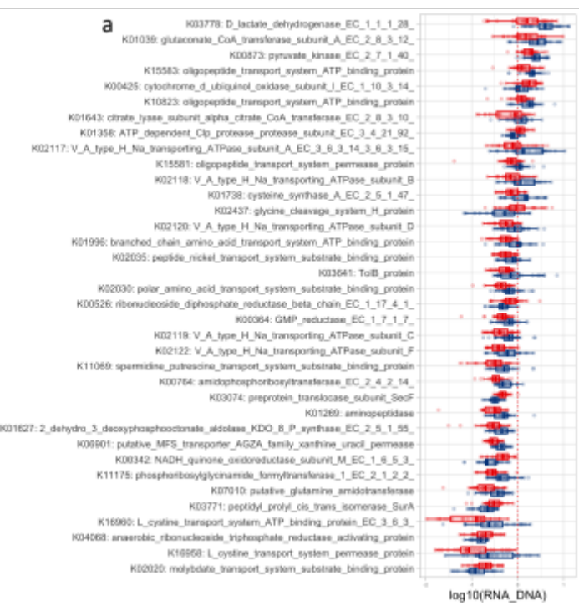
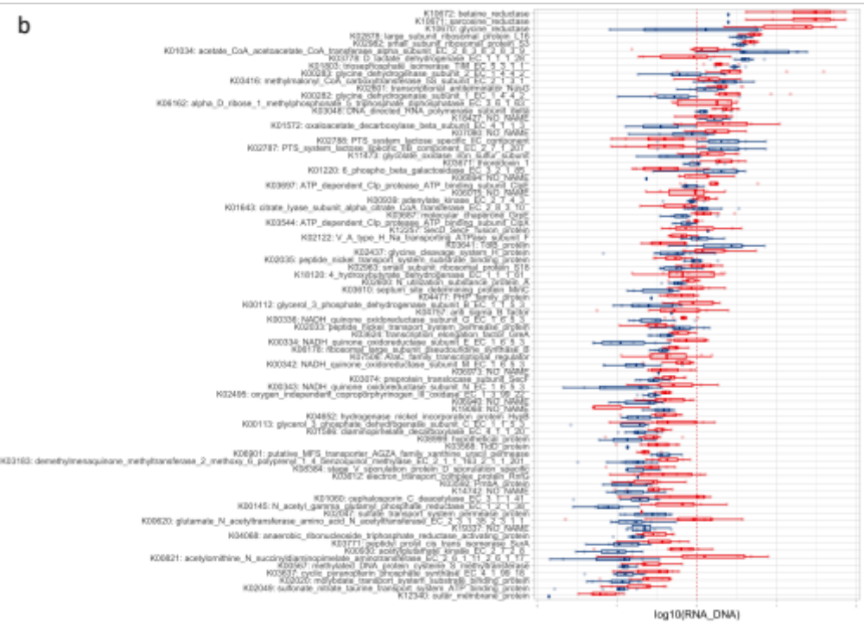
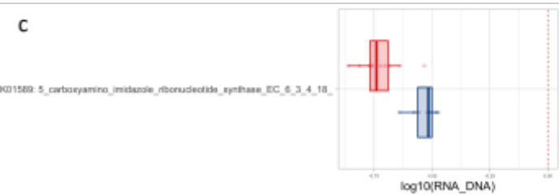
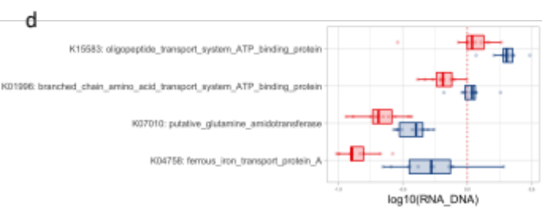
Fig S5. Genes (mapping KEGG’s orthologs) differentially expressed (RNA/DNA ratio) between healthy patient and patient with periodontal diseases: A) overall, B) plaque, C) saliva and D) tongue site. Boxplots display first quartile, median, third quartile and whiskers represent 1.5 times the interquartile range from the first and third quartiles.

