Global non-cropland soil organic carbon loss risk under multi-level warming scenarios
Keqiang Wang^{a,b}, Zipeng Zhangª , Xiangyu Geª, Lijing Han^{c}, Jingzhe Wang^{d}, Jianli Ding^{e,f}, Lei Zhang^{g}
ª College of Geographical and Remote Sciences, Xinjiang University, Urumqi, 830017, China
^{b} College of Earth and Environmental Sciences, Lanzhou University, Lanzhou, 266590, China
^{c} College of Geodesy and Geomatics, Shandong University of Science and Technology, Qingdao, 266590, China
^{d} School of Artificial Intelligence, Shenzhen Polytechnic University, Shenzhen, 518055, China
^{e} Xinjiang Institute of Technology, Aksu, 843099, China
^{f} Institute for Beautiful China, Xinjiang University, Urumqi, 830017, China
^{g}Climate and Ecosystem Science Division, Lawrence Berkeley National Laboratory, Berkeley, CA, USA
* Corresponding author: College of Geographical and Remote Sciences, Xinjiang University, Urumqi, 830017, China; zp_zhang@xju.edu.cn
Climate and Ecosystem Science Division, Lawrence Berkeley National Laboratory, Berkeley, CA, USA; lei.zhang@lbl.gov

Supplementary caption:
Fig. S1. Spatial patterns of temperature changes in global terrestrial non-cropland areas at the 0–20 cm soil depth under six warming scenarios. Panels (a)–(f) correspond to the T5, T10, T15, T20, T25, and T30 scenarios, respectively.
Fig. S2. SHAP-based interpretation of key covariate effects on ΔSOC predictions under six warming scenarios (T5–T30). Each row corresponds to one warming scenario. The left, middle, and right columns show the SHAP beeswarm plot, variable importance ranking based on mean absolute SHAP values, and partial dependence plots for the top five important variables, respectively. These plots illustrate the contribution direction and dispersion of feature values, the relative importance of covariates, and the nonlinear responses of ΔSOC along environmental gradients.
Fig. S3. Model accuracy scatter plot under the temperature-unchanged scenario. Accuracy metrics are shown in the lower-right corner. The black dashed line indicates the 1:1 line, and the red dashed line indicates the fitted regression line.
Fig. S4. Spatial distribution of predicted SOC and its uncertainty under the temperature-unchanged scenario. Panel (a) shows the predicted mean SOC stock (kg C m⁻²) in global terrestrial non-cropland areas at the 0–20 cm soil depth, with the lower-left inset showing the area proportions of different SOC levels. Panel (b) shows the mean prediction uncertainty of SOC, quantified using the prediction interval ratio derived from quantile regression forest, with the lower-left inset showing the area proportions of different uncertainty levels.
Fig. S5. SOC stock changes in global terrestrial non-cropland areas at the 0–20 cm soil depth under six warming scenarios. Bars indicate SOC stock changes under each scenario, blue numbers denote the corresponding SOC losses, and black numbers above the bars represent standard deviations.

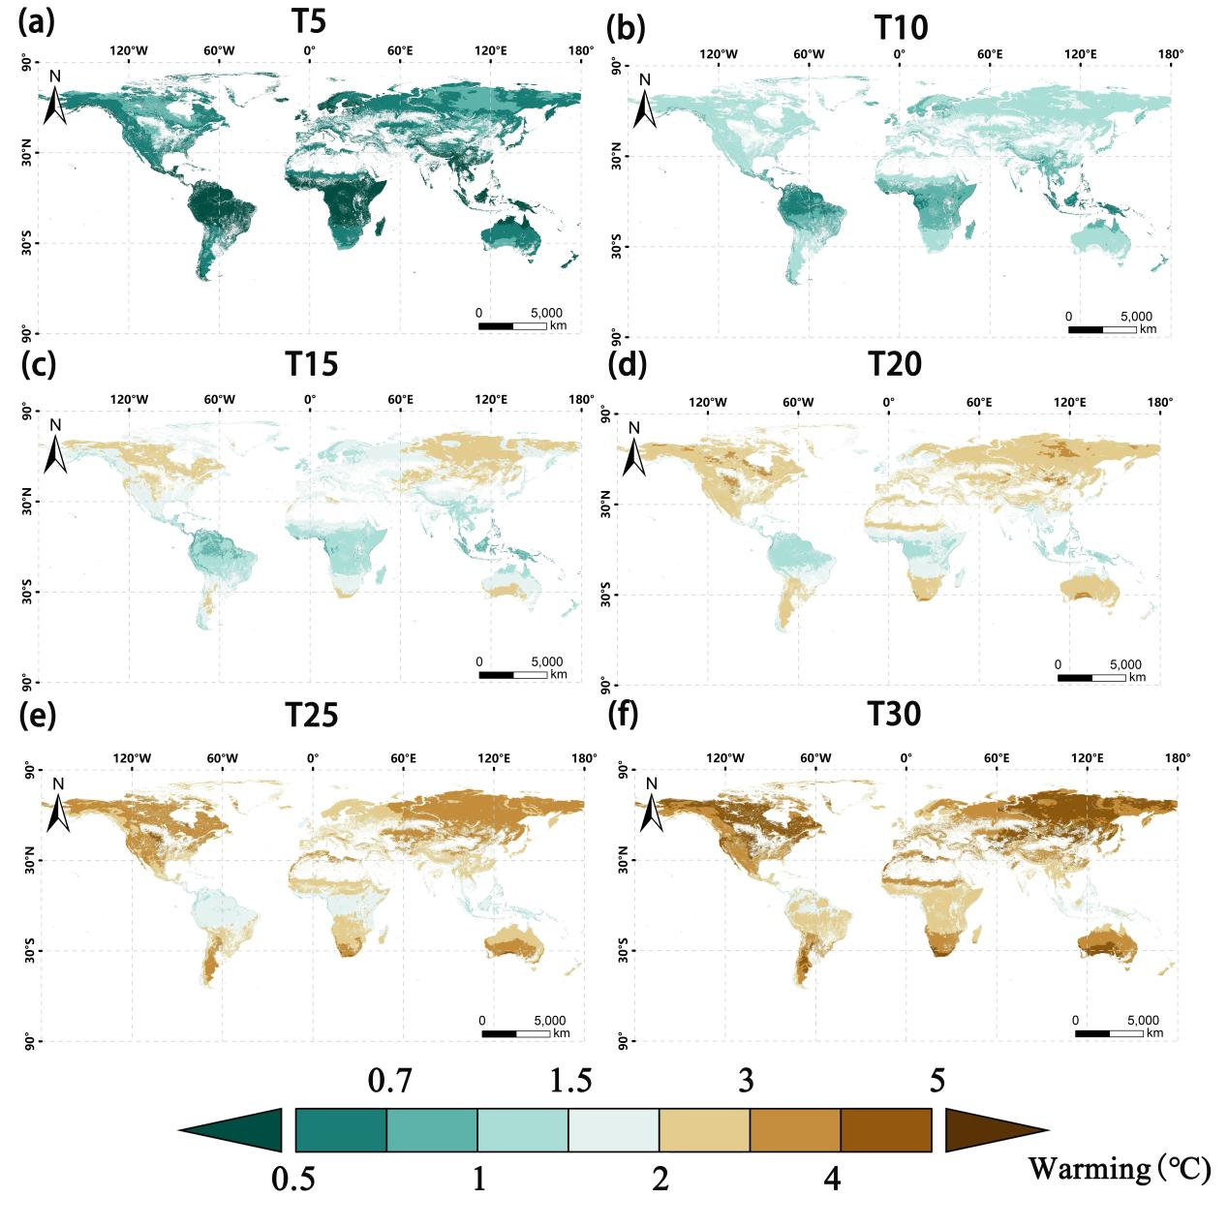
Fig. S1. Spatial patterns of temperature changes in global terrestrial non-cropland areas at the 0–20 cm soil depth under six warming scenarios. Panels (a)–(f) correspond to the T5, T10, T15, T20, T25, and T30 scenarios, respectively.
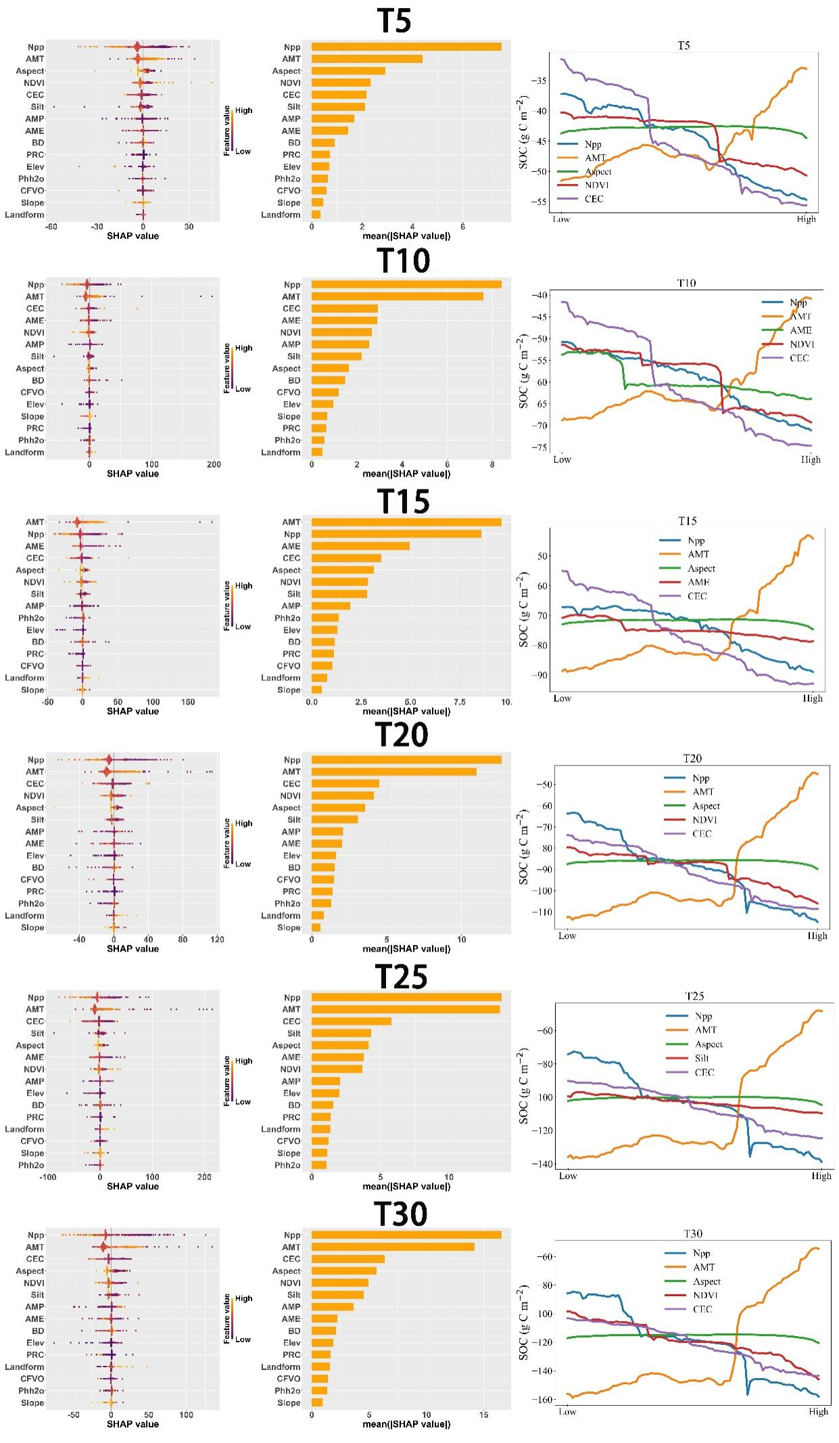
Fig. S2. SHAP-based interpretation of key covariate effects on ΔSOC predictions under six warming scenarios (T5–T30). Each row corresponds to one warming scenario. The left, middle, and right columns show the SHAP beeswarm plot, variable importance ranking based on mean absolute SHAP values, and partial dependence plots for the top five important variables, respectively. These plots illustrate the contribution direction and dispersion of feature values, the relative importance of covariates, and the nonlinear responses of ΔSOC along environmental gradients.
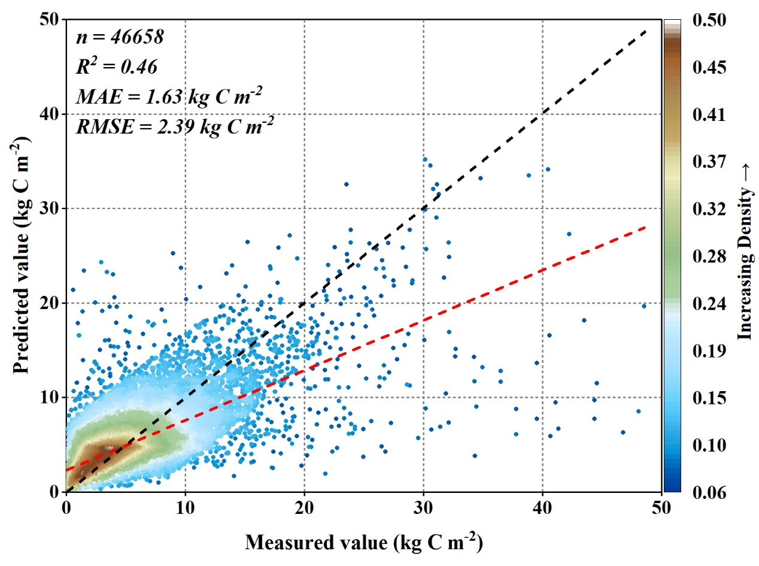
Fig. S3. Model accuracy scatter plot under the temperature-unchanged scenario. Accuracy metrics are shown in the lower-right corner. The black dashed line indicates the 1:1 line, and the red dashed line indicates the fitted regression line.

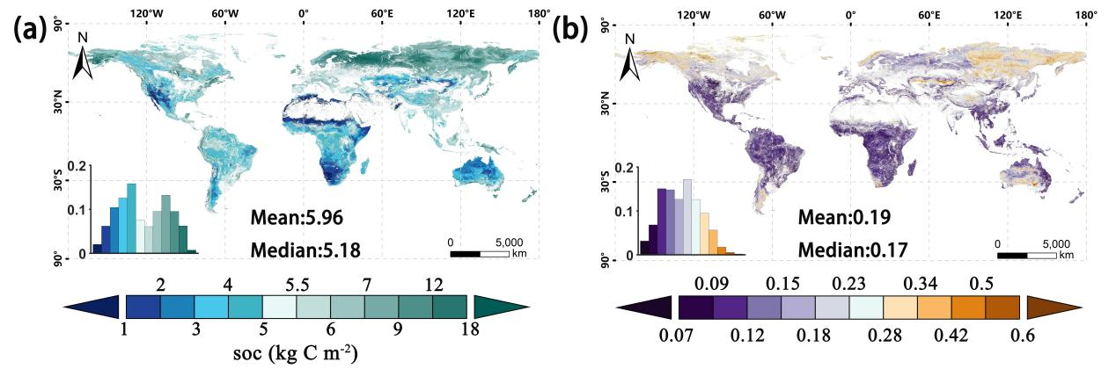
Fig. S4. Spatial distribution of predicted SOC and its uncertainty under the temperature-unchanged scenario. Panel (a) shows the predicted mean SOC stock (kg C m⁻²) in global terrestrial non-cropland areas at the 0–20 cm soil depth, with the lower-left inset showing the area proportions of different SOC levels. Panel (b) shows the mean prediction uncertainty of SOC, quantified using the prediction interval ratio derived from quantile regression forest, with the lower-left inset showing the area proportions of different uncertainty levels.
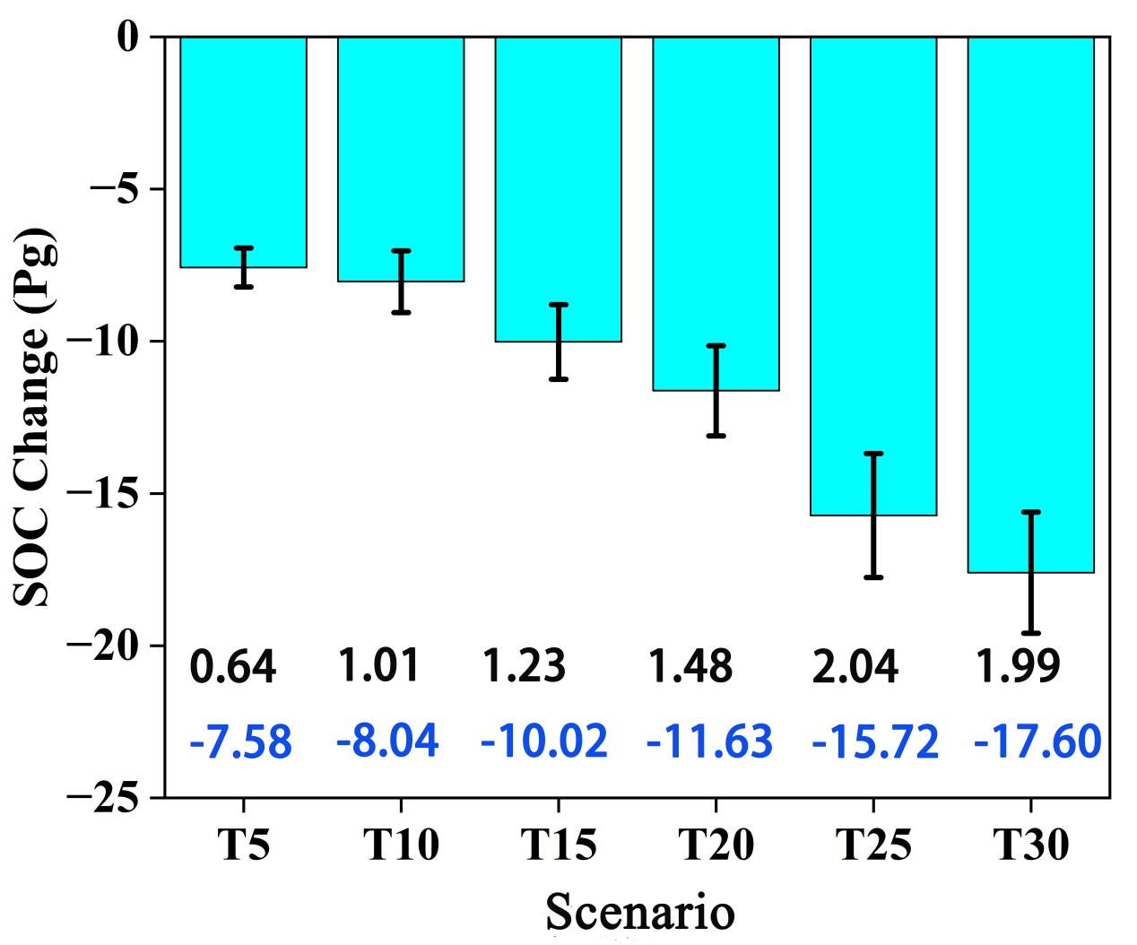
Fig. S5. SOC stock changes in global terrestrial non-cropland areas at the 0–20 cm soil depth under six warming scenarios. Bars indicate SOC stock changes under each scenario, blue numbers denote the corresponding SOC losses, and black numbers above the bars represent standard deviations.

