Supplementary Material
How common is ureteral stricture after laser ureteroscopy, and what drives it? A systematic review and meta-analysis
Supplementary File 1. Search strategy for each database.
Section A. PRISMA-S reporting checklist
Item | PRISMA-S element | Reported for this review
1 | Database name | PubMed (National Library of Medicine); Wiley Online Library; Cochrane Library (Wiley); Google Scholar.
2 | Multi-database searching | Four sources were searched. The strategy was developed in PubMed and adapted to the syntax of each platform. Line-by-line strings with per-line result counts are given in Section B.
3 | Study registries | No trial registry was searched as a separate source. Records from ClinicalTrials.gov and the WHO International Clinical Trials Registry Platform were covered through the Cochrane Central Register of Controlled Trials (CENTRAL) within the Cochrane Library search reported in Section B.
4 | Online resources and browsing | Google Scholar was searched as a web search engine using the phrase-based string in Section B. No other websites were browsed and no grey-literature sources were searched.
5 | Citation searching | Reference lists of the included studies and of the prior reviews by Moretto et al. and Tonyali et al. were screened. No additional eligible studies were identified beyond those retrieved by the database searches, so citation searching contributed no records to the study flow.
6 | Contacts | No study authors were contacted. All data required for extraction were reported in the source publications.
7 | Other methods | No hand-searching of journals or conference abstracts was performed.
8 | Full search strategies | Complete strategies for all four sources, with result counts for every line, are reported in Section B.
9 | Limits and restrictions | No language restriction was applied. No date restriction was applied; coverage ran from database inception to 5 July 2026. No publication-type, species, or age filter was applied at the search stage. Restriction to adult populations was applied at screening, not in the search.
10 | Search filters | No published or validated methodological search filter, such as a randomised-trial or observational-study filter, was applied.
11 | Prior work | The strategy was not developed de novo. It was adapted from the search strategies of two prior reviews of ureteral stricture after endoscopic stone treatment, by Moretto et al. and Tonyali et al., and was then extended to require confirmation of the laser as the energy source.
12 | Updates | The search was run once and was not updated after 5 July 2026.
13 | Dates of searches | Searches were run between 1 and 5 July 2026. The last search was performed on 5 July 2026.
14 | Peer review | No formal peer review of the search strategy using a validated instrument, such as the Peer Review of Electronic Search Strategies (PRESS) checklist, was undertaken. The strategy was developed and cross-checked by two review authors (A.A.S. and S.K.L.).
15 | Total records | 693 records were identified: PubMed 212, Wiley Online Library 143, Google Scholar 335, and Cochrane Library 3.
16 | Deduplication | Records were imported into Zotero and duplicates were removed using its duplicate-detection function. 320 duplicate records were removed before screening. Titles, abstracts, and full texts were subsequently screened in Microsoft Excel.
Section B. Full search strategies
PubMed
Line | Query | Results
#1 | ("Ureteroscopy"[Mesh] OR ureteroscop*[tiab] OR ureterorenoscop*[tiab] OR "retrograde intrarenal surgery"[tiab] OR RIRS[tiab] OR URS[tiab] OR URSL[tiab]) | 2,414
#2 | ("Urinary Calculi"[Mesh] OR stone*[tiab] OR calcul*[tiab] OR urolithiasis[tiab] OR ureterolithiasis[tiab] OR nephrolithiasis[tiab] OR renal calcul*[tiab] OR ureteral calcul*[tiab]) | 130,748
#3 | ("Ureteral Obstruction"[Mesh] OR stricture*[tiab] OR stenosis[tiab] OR obstruction[tiab] OR narrowing[tiab]) | 67,980
#4 | #1 AND #2 AND #3 | 212
Wiley Online Library.
Line | Query | Results
#1 | (ureteroscopy OR ureteroscopic OR ureterorenoscopy OR "retrograde intrarenal surgery" OR RIRS OR URS OR URSL) | —
#2 | (stone OR stones OR calculi OR urolithiasis OR ureterolithiasis OR nephrolithiasis) | —
#3 | (stricture OR strictures OR stenosis OR obstruction OR narrowing) | —
#4 | #1 AND #2 AND #3 | 143
Google Scholar
Line | Query | Results
#1 | "ureteral stricture" "ureteroscopic lithotripsy" "reconstruction" | 335
Cochrane Library
Line | Query | Results
#1 | MeSH descriptor: [Ureteroscopy] explode all trees OR ureteroscop*,ab,kw OR ureterorenoscop*,ab,kw OR "retrograde intrarenal surgery",ab,kw OR RIRS,ab,kw OR URS,ab,kw OR URSL,ab,kw | 2,766
#2 | MeSH descriptor: [Urinary Calculi] explode all trees OR stone*,ab,kw OR calcul*,ab,kw OR urolithiasis,ab,kw OR ureterolithiasis,ab,kw OR nephrolithiasis,ab,kw OR "ureteral stone",ab,kw OR "ureteric stone",ab,kw OR "renal stone",ab,kw | 4,820
#3 | laser*,ab,kw OR holmium,ab,kw OR "Ho",ab,kw OR HoYAG,ab,kw OR thulium,ab,kw OR "thulium fiber laser",ab,kw OR "thulium fibre laser",ab,kw OR TFL,ab,kw | 11,198
#4 | MeSH descriptor: [Ureteral Obstruction] explode all trees OR stricture*,ab,kw OR stenosis,ab,kw OR obstruction,ab,kw OR narrowing,ab,kw | 155
#5 | #1 AND #2 AND #3 AND #4 | 3
Section C. Records removed before screening
Of the 693 records identified, 609 were removed before screening: 320 duplicate records and 289 records removed for other reasons. The 289 comprised records judged clearly irrelevant from the title alone, principally wrong disease, wrong patient population, or no laser lithotripsy. A per-reason count was not recorded at this stage.
Records were imported into Zotero for deduplication and were screened in Microsoft Excel. Titles and abstracts were screened independently by two reviewers, and disagreements were resolved by consensus between A.A.S. and S.K.L., under the supervision of I.W.

Supplementary File 2. Excluded full-text studies with reasons.
Wrong population (n = 2)
1. Shroff S, Watson GM, Parikh A, Thomas R, Soonawalla PF, Pope A. The holmium:YAG laser for ureteric stones. Br J Urol. 1996;78:836-839. Reason: mixed adult and paediatric data not separable.
2. Mahajan A, Yamajala SS, Mahajan S, Chirlikar G. Evaluation of the safety and efficacy of thulium fiber laser lithotripsy for ureteric stones during semi-rigid ureteroscopy. Cureus. 2026;18(3):e105755. Reason: mixed adult and paediatric data not separable.
Wrong intervention or exposure (n = 4)
3. Sofer M, Watterson JD, Wollin TA, Nott L, Razvi H, Denstedt JD. Holmium:YAG laser lithotripsy for upper urinary tract calculi in 598 patients. J Urol. 2002;167:31-34. Reason: laser and electrohydraulic exposure not separable.
4. Ulvik Ø, Harneshaug JR, Gjengstø P. Ureteral strictures following ureteroscopic stone treatment. J Endourol. 2021. doi:10.1089/end.2020.0421. Reason: laser-treated denominator not separable.
5. Stern KL, Loftus CJ, Doizi S, Traxer O, Monga M. A prospective study analyzing the association between high-grade ureteral access sheath injuries and the formation of ureteral strictures. Urology. 2019;128:38-41. Reason: selected access-sheath-injury cohort with laser exposure not confirmed.
6. Tonyali S, Pietropaolo A, Emiliani E, et al. Factors associated with ureteral strictures following ureteroscopy for impacted ureteral stones? A multicenter study by EAU-YAU endourology and urolithiasis working party. Actas Urol Esp. 2023;47:631-637. Reason: lithotripsy modality not specified, so strictures not confirmed as post-laser.
Wrong outcome (n = 4)
7. Chandramohan V, Siddalinga Swamy PM, Ramakrishna P, et al. Ureteroscopic lithotripsy by thulium fiber laser versus holmium laser: a single-center prospective randomized study. Urol Ann. 2023;15:285-288. Reason: no ureteral stricture outcome reported.
8. Panthier F, Solano C, Chicaud M, et al. Thulium fiber laser versus pulsed Thulium:YAG for laser lithotripsy during flexible ureteroscopy. Lasers Med Sci. 2024;39:294. Reason: no ureteral stricture outcome reported.
9. Usman M, Li Z, Zheng Q, et al. Efficacy and safety of super-pulse thulium fiber laser compared to holmium:YAG laser for ureteral and renal stones: a multicenter retrospective study. Urolithiasis. 2026;54:23. Reason: no ureteral stricture outcome reported.
10. Yang L, Lou Y, Li R, et al. Thulium fiber laser versus holmium:YAG laser for ureteroscopic lithotripsy: a single-center retrospective cohort study. Front Surg. 2026;13:1880083. Reason: no ureteral stricture outcome reported.
Insufficient follow-up (n = 1)
11. Gupta PK. Is the holmium:YAG laser the best intracorporeal lithotripter for the ureter? A 3-year retrospective study. J Endourol. 2007;21(3):305-309. Reason: insufficient follow-up for stricture ascertainment.
Ineligible report (n = 1)
12. Mundada A, Nath R, Barua SK, et al. Risk factors for the development of ureteric stricture post ureteroscopic lithotripsy: a retrospective analysis from a tertiary care centre. Annals of Urology. 2025;11(1). Reason: journal credibility and indexing could not be reliably verified.
Supplementary File 3. Risk-of-bias assessment (ROBINS-I and RoB 2) with figures..
Randomised trials (RoB 2), k = 6
Study (Year) | D1 | D2 | D3 | D4 | D5 | Overall | Main concern
Binbay (2011)²⁵ | S | L | S | S | L | Some concerns | Randomisation detail limited; stricture a secondary outcome with modest follow-up.
Li L (2015)²⁷ | S | L | S | S | L | Some concerns | Stricture secondary to efficacy endpoints; randomisation detail limited.
Aykanat (2022)³⁴ | L | L | L | L | L | Low | Well conducted; 12-month CT-urography ascertainment. Renal cohort affects applicability, not bias.
Ulvik (2022)³⁶ | L | L | S | L | L | Some concerns | Imaging-confirmed; complete within a short (3-month) follow-up window; zero events.
Para (2023)⁸ | S | L | L | L | S | Some concerns | Randomised with a CONSORT flow diagram, but sequence generation and allocation concealment are not reported, and no protocol or registration is available. Imaging-confirmed outcome; 11 of 489 lost to follow-up.
Aesoy (2026)⁴⁹ | L | L | L | L | L | Low | Computer-generated sequence with permuted blocks, allocation concealed by sequentially numbered opaque sealed envelopes prepared by staff not involved in enrolment; surgeons blinded until allocation. Radiologists blinded to allocation. No losses to follow-up. Registered (NCT05697250). Renal cohort with 3-month follow-up affects applicability, not bias.
RoB 2 domains: D1, randomisation process; D2, deviations from intended interventions; D3, missing outcome data; D4, measurement of the outcome; D5, selection of the reported result. Judgements: L, low; S, some concerns; H, high. Two trials were rated low and four raised some concerns.
Non-randomised studies (ROBINS-I), k = 25
Study (Year) | D1 | D2 | D3 | D4 | D5 | D6 | D7 | Overall | Main concern
Cheung (2001)²¹ | L | L | L | L | M | L | L | Moderate | Prospective, imaging ascertainment; 3-month primary imaging window.
Parker (2004)²² | L | M | L | L | M | M | L | Moderate | Retrospective cost study; stricture ascertained incidentally.
Jiang (2007)²³ | L | L | L | L | M | L | L | Moderate | Prospective; mixed follow-up windows.
Gdor (2008)²⁴ | M | M | L | L | M | M | L | Moderate | Small retrospective management series; within-stratum success is descriptive.
Fam (2015)²⁶ | L | L | L | L | M | M | L | Moderate | Prospective impacted-stone cohort; 6-month follow-up.
Srougi (2015)²⁸ | M | M | L | L | M | M | L | Moderate | Retrospective, but the incidence denominator is the full consecutive surgical volume.
Hu (2017)²⁹ | L | M | L | L | M | M | L | Moderate | Retrospective; median 30-month follow-up.
Darwish (2019)³⁰ | L | L | Se | L | M | M | L | Serious | Mixed laser and pneumatic exposure; laser not cleanly separable.
Xiong (2020)³¹ | M | M | L | L | M | M | L | Moderate | Retrospective management data; within-stratum success reported descriptively.
Al-Nabulsi (2021)³² | L | M | L | L | M | M | L | Moderate | Data complete within a short (3-month) follow-up window.
Shen (2021)³³ | L | M | L | L | M | M | L | Moderate | Retrospective, propensity-matched.
Li X (2022)³⁵ | M | M | L | L | M | M | L | Moderate | Retrospective reconstruction series.
Hamamoto (2023)³⁷ | L | M | L | L | M | L | L | Moderate | Small prospective robotic reconstruction series.
Yang (2023)³⁸ | M | M | L | L | M | M | L | Moderate | Small retrospective reconstruction series.
He (2024)³⁹ | L | M | L | L | M | M | L | Moderate | Retrospective risk-model derivation cohort.
Inoue (2024)⁴⁰ | Se | Se | Se | L | Se | M | L | Serious | Registry survey; per-case laser not recorded; follow-up not reported; dominant sample.
Li P (2024)⁴¹ | L | M | L | L | M | M | L | Moderate | Retrospective risk-model derivation cohort.
Ai (2025)⁴² | L | M | L | L | M | M | L | Moderate | Small retrospective cohort.
Castellani (2025)⁴³ | L | M | L | L | M | M | L | Moderate | Prospective renal RIRS cohort; 3-month follow-up; zero events.
Coman (2025)⁴⁴ | M | M | M | L | M | M | L | Moderate | Small reconstruction series; 1 of 9 non-lithotripsy aetiology, identified and separable.
Patil (2025)⁴⁵ | L | L | L | L | M | L | L | Moderate | Prospective, ultrasound ascertainment; follow-up limited to 3 months.
Villani (2025)⁹ | L | M | L | L | M | M | L | Moderate | Retrospective TFL cohort; complete within a short follow-up window.
Li G (2026)⁴⁶ | M | Se | L | L | Se | M | L | Serious | Referral-centre nomogram cohort; follow-up not reported; case enrichment.
Mohapatra (2026)⁴⁷ | L | M | M | L | Se | M | L | Serious | Retrospective comparative cohort; follow-up not reported.
Nyheim (2026)⁴⁸ | L | M | M | L | M | M | L | Moderate | Management series; index laser not reported (affects applicability, not the success proportion).
ROBINS-I domains: D1, confounding; D2, selection of participants; D3, classification of interventions; D4, deviations from intended interventions; D5, missing data; D6, measurement of outcomes; D7, selection of the reported result. Judgements: L, low; M, moderate; Se, serious; C, critical; NI, no information. For single-arm incidence estimates, confounding (D1) and intervention deviations (D4) are generally not applicable and are rated low. Twenty-one studies were rated moderate and four serious.
Risk-of-bias sensitivity analysis
To test the influence of higher risk-of-bias studies on the primary estimate, the primary incidence pool was re-pooled after excluding the single serious-rated study within it (Li G 2026). The pooled incidence moved from 2.97% (95% CI 1.82 to 4.82, k = 11) to 2.61% (95% CI 1.5 to 4.6, k = 10), with heterogeneity essentially unchanged. The estimate remained within the original confidence interval, indicating that the primary result is robust to exclusion of the highest risk-of-bias study. No study was excluded from the main analysis on the basis of risk of bias.
Risk-of-bias figures
Figure S1. Traffic-light plot, randomised trials (RoB 2).
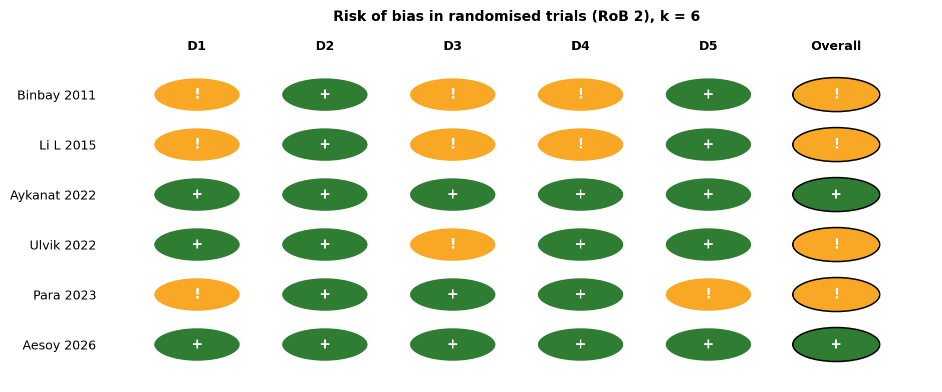
Figure S2. Domain-level summary, randomised trials (RoB 2).
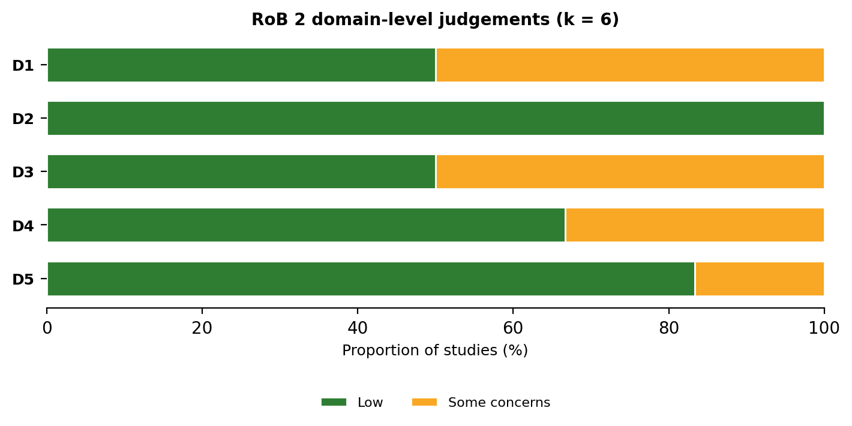
Figure S3. Traffic-light plot, non-randomised studies (ROBINS-I).
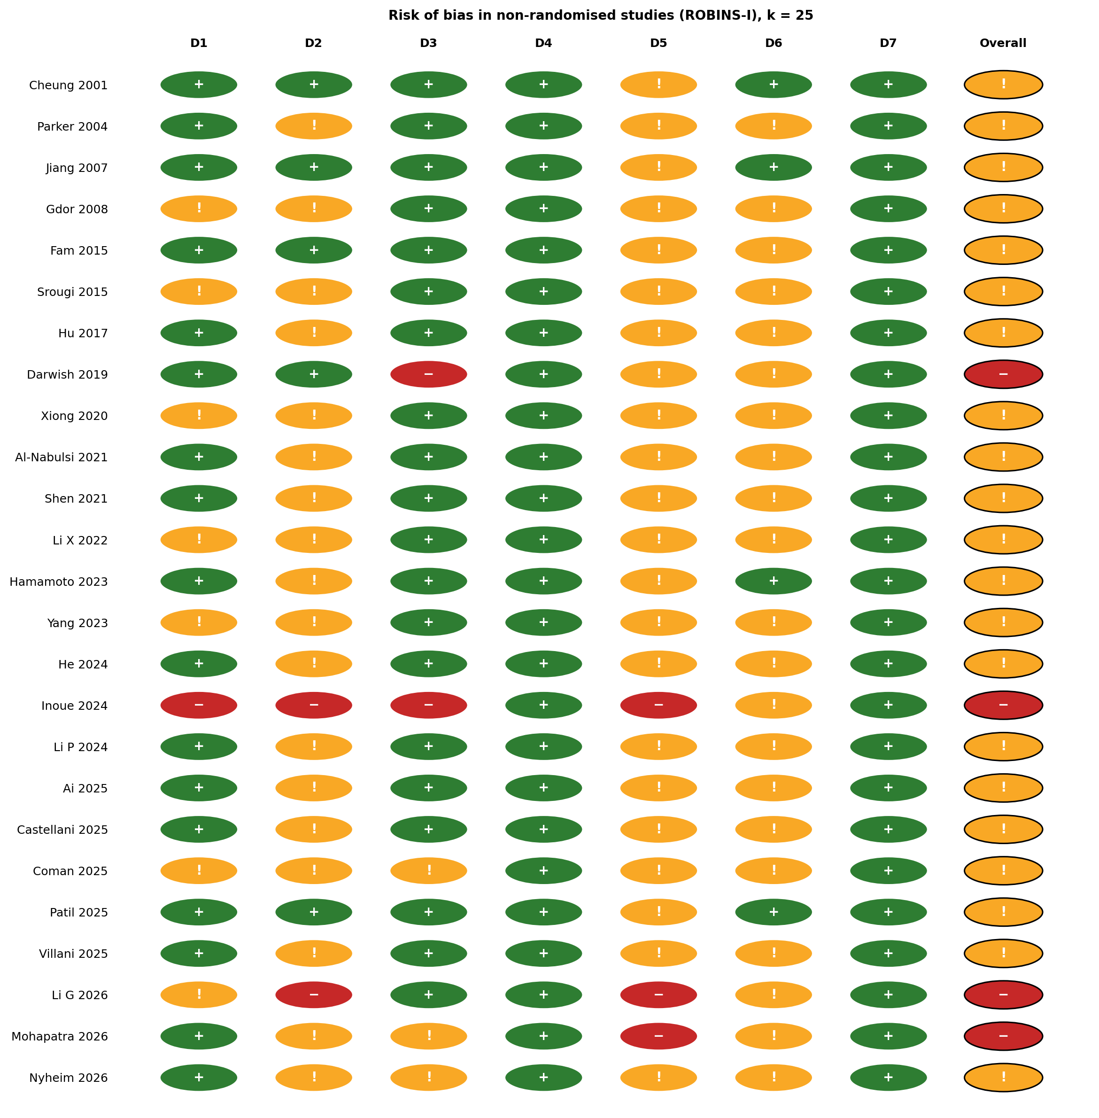
Figure S4. Domain-level summary, non-randomised studies (ROBINS-I).
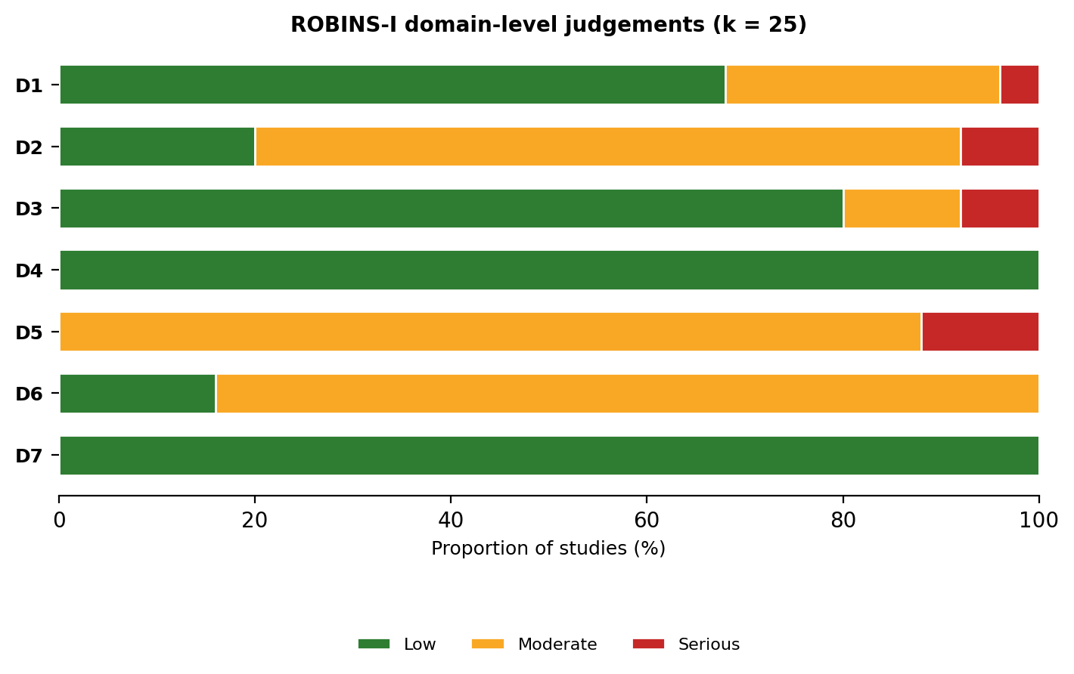
Supplementary File 4. GRADE Summary of Findings table.
GRADE Summary of Findings: de novo ureteral stricture after ureteroscopic laser lithotripsy
Outcome | Part icip ants (st udie s) | Pooled estimate (95% CI) | Cer tainty (GR ADE) | Comments and reasons for the rating
Incidence of de novo ureteral stricture (primary pool, ure teral-stone cohorts) | 3097 (11) | 2.97% (1.82 to 4.82); 30 per 1000 | ⊕⊕⊕◯  MODE RATE | Started high (frequency and prognosis framework). Downgraded one level for inconsistency (I² = 78.8%, 95% prediction interval 0.4 to 18.0%). Not downgraded for risk of bias (mostly moderate, robust on sensitivity analysis), imprecision, indirectness, or publication bias (Peters p = 0.64).
Incidence by laser type (Ho:YAG versus TFL) | 5649 (22 a rms) | Ho:YAG 2.68% (1.77 to 4.05); TFL 1.76% (0.35 to 8.34); no significant difference (χ² = 0.25, p = 0.61) | ⊕⊕◯◯  - *LOW** | Downgraded two levels: risk of bias (follow-up confounding, all TFL cohorts 3-month follow-up) and imprecision (TFL k = 4, two zero-event studies, CI 0.35 to 8.34). Not downgraded for inconsistency, because the within-subgroup I² reflects variation in underlying incidence rather than inconsistency of the comparison, and the test for subgroup difference was consistent (χ² = 0.25, p = 0.61). Supports no demonstrable difference, not equivalence.
Endoscopic management success | 92 (4) | 60.87% (50.6 to 70.3) | ⊕⊕⊕◯  MODE RATE | Consistent (I² = 0%, p = 0.80). Downgraded one level for imprecision (4 studies, 92 patients, CI 50.6 to 70.3). Not downgraded for risk of bias: the ROBINS-I concerns in these series relate to confounding by indication across strata, which this review does not compare. The within-stratum success proportion is descriptive and not subject to that confounding.
Rec onstruction success | 125 (7) | 95.20% (89.7 to 97.8) | ⊕⊕⊕◯  MODE RATE | Consistent (I² = 0%, p = 0.52). Downgraded one level for imprecision (7 studies, 125 patients). Not downgraded for risk of bias: as above, the within-stratum success proportion is descriptive and not subject to confounding by indication.
GRADE certainty of evidence: High (⊕⊕⊕⊕), very confident the true value lies close to the estimate; Moderate (⊕⊕⊕◯), moderately confident; Low (⊕⊕◯◯), limited confidence; Very low (⊕◯◯◯), very little confidence. Publication bias for the primary outcome was assessed by Peters' test (p = 0.64) and was not assessable for the other outcomes owing to few studies. CI, confidence interval; Ho:YAG, holmium:YAG; TFL, thulium fibre laser; I², inconsistency statistic.
Supplementary File 5. Characteristics of included studies
Study (Year) | Type of study | Laser (Approach) | Patients (n) | Stone site | Follow-up (mo)
Cheung (2001)*²¹ | Prospective | Ho:YAG (semirigid) | 134 | Ureteral | 8.9
Parker (2004)*²² | Retrospective | Ho:YAG (URS) | 109 | Ureteral | ≥6
Jiang (2007)*²³ | Prospective | Ho:YAG (semirigid) | 692 | Ureteral | 6
Gdor (2008)²⁴ | Retrospective | Ho:YAG (endoureterotomy) | 13 | Ureteral | 21
Binbay (2011)*²⁵ | RCT | Ho:YAG (semirigid) | 40 | Ureteral | 16
Fam (2015)²⁶ | Prospective | Ho:YAG (URS) | 64 | Ureteral | 6
Li L (2015)*²⁷ | RCT | Ho:YAG (semirigid) | 493 | Ureteral | 12
Srougi (2015)²⁸ | Retrospective | Ho:YAG (URS) | 1101 | Ureteral | 18.5
Hu (2017)*²⁹ | Retrospective | Ho:YAG (URS) | 158 | Ureteral | 30 (med)
Darwish (2019)³⁰ | Prospective | Mixed (URS) | 251 | Ureteral | 12
Xiong (2020)³¹ | Retrospective | Ho:YAG (management) | 95 | NR | 24 (med)
Al-Nabulsi (2021)³² | Retrospective | Ho:YAG (URS) | 297 | Ureteral | 3
Shen (2021)*³³ | Retrospective | Ho:YAG (fURS) | 447 | Ureteral | 36 (med)
Aykanat (2022)³⁴ | RCT | Ho:YAG (RIRS) | 320 | Renal | 12
Li X (2022)³⁵ | Retrospective | Ho:YAG (reconstruction) | 42 | NR | 27.3 (med)
Ulvik (2022)³⁶ | RCT | Mixed (URS/RIRS) | 119 | Renal+ureteral | 3
Para (2023)*⁸ | RCT | Mixed (URS) | 240 | Ureteral | 3
Hamamoto (2023)³⁷ | Prospective | NR (reconstruction) | 14 | Ureteral | 12.8
Yang (2023)³⁸ | Retrospective | NR (reconstruction) | 11 | NR | 15 (med)
He (2024)*³⁹ | Retrospective | Ho:YAG (URS) | 106 | Ureteral | 12
Inoue (2024)⁴⁰ | Retrospective | Mixed (URS) | 14,125 | Renal+ureteral | NR
Li P (2024)*⁴¹ | Retrospective | Ho:YAG (URS) | 427 | Ureteral | 12
Ai (2025)⁴² | Retrospective | Ho:YAG (URS) | 67 | Ureteral | 6
Castellani (2025)⁴³ | Prospective | Mixed (RIRS) | 179 | Renal | 3 (med)
Coman (2025)⁴⁴ | Retrospective | NR (reconstruction) | 9 | NR | 38 (med)
Patil (2025)⁴⁵ | Prospective | TFL (semirigid) | 91 | Ureteral | 3
Villani (2025)⁹ | Retrospective | TFL (URS) | 158 | Renal+ureteral | 3
Aesoy (2026)⁴⁹ | RCT | TFL (RIRS) | 148 | Renal | 3
Li G (2026)*⁴⁶ | Retrospective | Ho:YAG (semirigid) | 251 | Ureteral | NR
Mohapatra (2026)⁴⁷ | Retrospective | Ho:YAG (semirigid) | 97 | Ureteral | NR
Nyheim (2026)⁴⁸ | Retrospective | NR (management) | 40 | NR | 51.6 (med)
* Primary study in incidence pool. NR, not reported; Ho:YAG, holmium:YAG; TFL, thulium fibre laser; URS, ureteroscopy; fURS, flexible ureteroscopy; RIRS, retrograde intrarenal surgery.
Supplementary File 6. Laser lithotripsy settings and stricture incidence
Study (Year) | Laser type (device) | Pulse energy, J | Frequency, Hz | Power, W | Fiber, µm | Irrigation | Mode | Incidence, %
Binbay (2011)²⁵ | Ho:YAG (Stone Light) | 1.0 to 1.5 | 5 to 12 | 12 | 550 | Pump | NR | 0.00
Jiang (2007)²³ | Ho:YAG (Lumenis) | 0.8 to 1.2 | 10 | 12 | 365 or 550 | Pump | Fragmentation | 0.72
Cheung (2001)²¹ | Ho:YAG (VersaPulse) | 0.5 to 1.4 | 5 to 10 | NR | 365 | Manual | NR | 0.75
Para (2023)⁸ | Ho:YAG (Lumenis 100H) | 0.4 (titrated) | 8 (titrated) | NR | 200 | Manual | Dusting | 1.67
Li L (2015)²⁷ | Ho:YAG (device NR) | 0.8 to 1.0 | 10 to 15 | NR | NR | NR | NR | 4.87
He (2024)³⁹ | Ho:YAG (device NR) | 1.5 | 10 | NR | 550 | Pump | Fragmentation | 5.66
Shen (2021)³³ | Ho:YAG (device NR) | 0.8 to 1.2 | 15 to 25 | NR | 200 | NR | NR | 6.49
Li P (2024)⁴¹ | Ho:YAG (raykeen) | 1.5 to 2.0 | 10 to 15 | 20 | 200 | NR | NR | 6.56
Li G (2026)⁴⁶ | Ho:YAG (LISA) | 0.8 | 25 | 20 | NR | Gravity | Long-pulse | 9.56
N, number of classified strictures; CI, confidence interval.
Supplementary File 7. Anatomical distribution of de novo ureteral strictures, by study (exploratory).
Study (Year) | Proximal, n (%) | Mid, n (%) | Distal, n (%) | Classified, N
Cheung (2001)²¹ | 0 (0) | 1 (100) | 0 (0) | 1
Fam (2015)²⁶ | 2 (40.0) | 1 (20.0) | 2 (40.0) | 5
Darwish (2019)³⁰ | 1 (25.0) | 1 (25.0) | 2 (50.0) | 4
Aykanat (2022)³⁴ | 1 (33.3) | 0 (0) | 2 (66.7) | 3
Para (2023)⁸ | 3 (75.0) | 0 (0) | 1 (25.0) | 4
He (2024)³⁹ | 5 (83.3) | 1 (16.7) | 0 (0) | 6
Li P (2024)⁴¹ | 8 (28.6) | 11 (39.3) | 9 (32.1) | 28
Villani (2025)⁹ | 4 (40.0) | 2 (20.0) | 4 (40.0) | 10
Pooled, % (95% CI) | 41.3 (27.4 to 56.7)  I² = 0%, p = 0.45 | 26.8 (16.7 to 40.0)  I² = 0%, p = 0.72 | 32.8 (22.2 to 45.4)  I² = 0%, p = 0.80 | 61
N, number of classified strictures; CI, confidence interval.
Supplementary File 8. Incidence of de novo ureteral stricture by laser type
Study (Year) | Events, n | Patients, N | Incidence, % (95% CI) | Follow-up (mo)
Ho:YAG
Cheung (2001)²¹ | 1 | 134 | 0.75 (0.02 to 4.09) | 8.9
Parker (2004)²² | 2 | 109 | 1.83 (0.22 to 6.47) | ≥6
Jiang (2007)²³ | 5 | 692 | 0.72 (0.24 to 1.68) | 6
Binbay (2011)²⁵ | 0 | 40 | 0.00 (0.00 to 8.81) | 16
Li L (2015)²⁷ | 24 | 493 | 4.87 (3.14 to 7.16) | 12
Fam (2015)²⁶ | 5 | 64 | 7.81 (2.59 to 17.30) | 6
Srougi (2015)²⁸ | 31 | 1101 | 2.82 (1.92 to 3.97) | 18.5
Hu (2017)²⁹ | 4 | 158 | 2.53 (0.69 to 6.35) | 30 (med)
Al-Nabulsi (2021)³² | 10 | 297 | 3.37 (1.63 to 6.10) | 3
Shen (2021)³³ | 29 | 447 | 6.49 (4.39 to 9.18) | 36 (med)
Ulvik (2022)³⁶ | 0 | 60 | 0.00 (0.00 to 5.96) | 3
Para (2023)⁸ | 4 | 240 | 1.67 (0.46 to 4.21) | 3
Aykanat (2022)³⁴ | 5 | 320 | 1.56 (0.51 to 3.61) | 12
He (2024)³⁹ | 6 | 106 | 5.66 (2.11 to 11.91) | 12
Li P (2024)⁴¹ | 28 | 427 | 6.56 (4.40 to 9.34) | 12
Ai (2025)⁴² | 0 | 67 | 0.00 (0.00 to 5.36) | 6
Li G (2026)⁴⁶ | 24 | 251 | 9.56 (6.22 to 13.89) | NR
Mohapatra (2026)⁴⁷ | 2 | 97 | 2.06 (0.25 to 7.25) | NR
Pooled incidence | 180 | 5103 | 2.68 (1.77 to 4.05)  I² = 76.1%, p < 0.001
TFL
Ulvik (2022)³⁶ | 0 | 59 | 0.00 (0.00 to 6.06) | 3
Para (2023)⁸ | 11 | 238 | 4.62 (2.33 to 8.12) | 3
Patil (2025)⁴⁵ | 0 | 91 | 0.00 (0.00 to 3.97) | 3
Villani (2025)⁹ | 10 | 158 | 6.33 (3.08 to 11.33) | 3
Pooled incidence | 21 | 546 | 1.76 (0.35 to 8.34)  I² = 41.0%, p = 0.17
Test for subgroup difference: χ² = 0.25, df = 1, p = 0.61 (no significant difference)
GLMM, generalised linear mixed model; mo, months; n, number of events; N, denominator; CI, confidence interval; NR, not reported.

Supplementary File 9. Treatment success for de novo ureteral stricture after ureteroscopic laser lithotripsy.
Study (Year) | Successes, n | Strictures treated, N | Success, % (95% CI) | Stricture length, cm | Follow-up (mo)
Endoscopic
Gdor (2008)²⁴ | 8 | 13 | 61.5 (31.6 to 86.1) | 1.0 | 21
Srougi (2015)²⁸ | 4 | 8 | 50.0 (15.7 to 84.3) | NR | 31.6
Xiong (2020)³¹ | 42 | 69 | 60.9 (48.4 to 72.4) | NR | 24 (med)
Li X (2022)³⁵ | 2 | 2 | 100.0 (15.8 to 100.0) | 3.5 (med) | 33.7 (med)
Pooled success | 56 | 92 | 60.9 (50.6 to 70.3)  I² = 0%, p = 0.80
Reconstruction
Gdor (2008)²⁴ | 3 | 3 | 100.0 (29.2 to 100.0) | NR | 21
Srougi (2015)²⁸ | 9 | 11 | 81.8 (48.2 to 97.7) | NR | 9.3
Xiong (2020)³¹ | 36 | 37 | 97.3 (85.8 to 99.9) | NR | 24 (med)
Li X (2022)³⁵ | 39 | 40 | 97.5 (86.8 to 99.9) | 3.5 (med) | 27.3 (med)
Hamamoto (2023)³⁷ | 13 | 14 | 92.9 (66.1 to 99.8) | 2.3 | 12.8
Yang (2023)³⁸ | 11 | 11 | 100.0 (71.5 to 100.0) | NR | 15 (med)
Coman (2025)⁴⁴ | 8 | 9 | 88.9 (51.8 to 99.7) | 1.9 | 38 (med)
Pooled success | 119 | 125 | 95.2 (89.7 to 97.8)  I² = 0%, p = 0.52
GLMM, generalised linear mixed model; n, successes; N, strictures treated; cm, centimetres; mo, months; CI, confidence interval; NR, not reported.

