Additional file 1
Glutamic acid reshapes the phytobiome to protect plants against pathogens

Da-Ran Kim¹, Chang-Wook Jeon², Gyeongjun Cho², Linda S. Thomashow³, David M. Weller³, Man-Jeong Paik⁴, Yong Bok Lee^{1,5}, and Youn-Sig Kwak^{1,2,5,}*

¹RILS, Gyeongsang National University, Jinju 52828, Republic of Korea
²Division of Applied Life Science (BK 21 plus) and IALS, Gyeongsang National University, Jinju 52828, Republic of Korea
³US Department of Agriculture, Agricultural Research Service, Wheat Health, Genetics and Quality Research Unit, Pullman, WA, USA 99164-6430
⁴College of Pharmacy, Sunchon National University, Suncheon 65980, Republic of Korea
5Department of Plant Medicine, Gyeongsang National University, Jinju 52828, Republic of Korea

*Corresponding author: kwak@gnu.ac.kr

This file includes:
Supplementary Figure 1. Chemical constituents of strawberry flower exudate,
Supplementary Figure 2. Biolog phenotype array for nitrogen utilization and bacterial growth.
Supplementary Figure 3. Experimental design in the strawberry greenhouse.
Supplementary Figure 4. Gray mold and blossom blight disease incidence.
Supplementary Figure 5. Dynamics of strawberry flower microbial communities as influenced by amino acids.
Supplementary Figure 6. Metacoder analysis of the microbial composition of strawberry flowers among treatments (untreated, 2% L-glutamic acid, 2% L-asparagine).
Supplementary Figure 7. Functional gene orthology profiles among untreated (green bar), L–asparagine (green bar), and L–glutamic acid (blue bar) treated strawberry flowers.
Supplementary Figure 8. Suppression of Fusarium wilt disease of tomato by strain SP6C4 with or without L-glutamic acid.
Supplementary Figure 9. Comparison of the tomato rhizosphere microbiome at the family level.
Supplementary Figure 10. Co–occurrence networks among the top 10 OTUs in the tomato rhizosphere based on lanM gene copy number.
Supplementary Figure 11. Microbial engineering with L–glutamic acid for control of Fusarium wilt disease of tomato.
Supplementary Figure 12. Microbial engineering with L–glutamic acid (5 µg/mL) for control of strawberry gray mold disease,
Supplementary Figure 13. Relative expression of ISR-related and PAMP marker genes in the strawberry flower and tomato rhizosphere as determined by qRT-PCR.

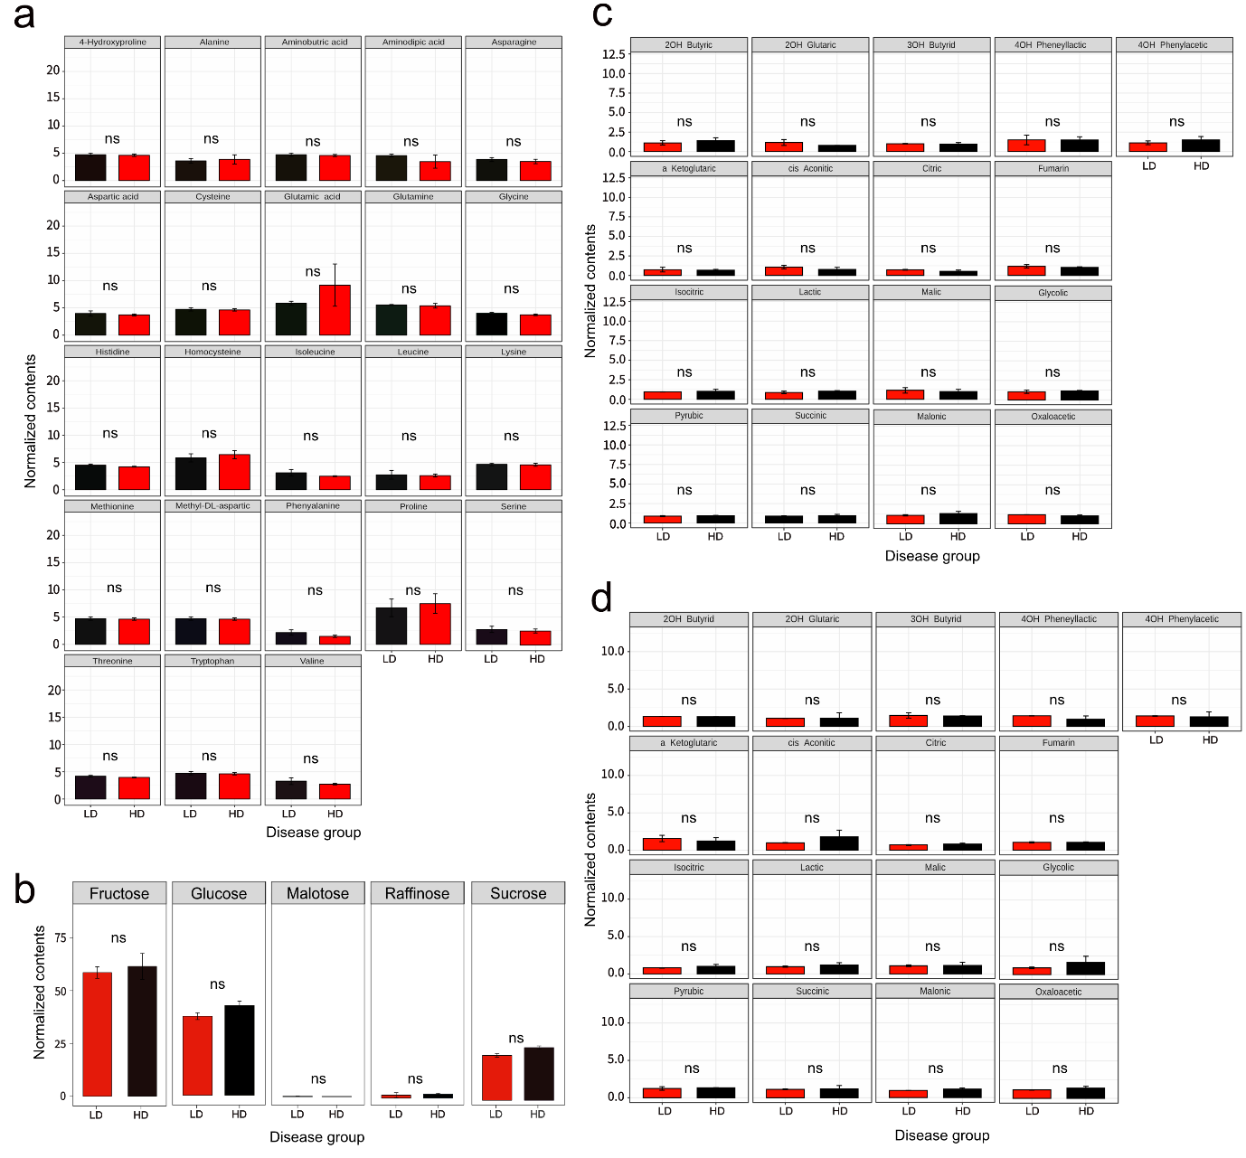
Figure S1 Chemical constituents of strawberry flower exudate. a Content of 23 types of amino acids in the strawberry ovary (n = 3, 8 independent experiments). Normalized concentrations of amino acids were tested by independent t-test (p value < 0.05). b sugar contents (n = 3, 8 independent experiments). c Organic acid contents of strawberry flower petals (n = 3, 8 independent experiments) and d ovary (n = 3, 8 independent experiments).
Figure S2 Biolog phenotype array for nitrogen utilization and bacterial growth. Biolog plates (n = 3, 3 independent experiments) were inoculated with strain SP6C4 (OD_{600nm} 0.2) in 0.2% carrageenan and incubated at 28°C for 3 days. Redox dye mix MA was added when the second or the fourth wells in a row turned yellow and a color change to dark purple was observed at 37°C. The color was assayed at 600 nm. a PM1 plate for carbon sources, all intensity data presented in Supplementary Table 1. b PM3B plate for nitrogen sources, all intensity data presented in Supplementary Table 2. c Growth of SP6C4 in basal medium amended or not with 0.02% amino acids. d Growth of strain SP6C4 with 0.2% amino acids. Bars represent standard error and star indicates statistically significant differences among treatments in Tukey's HSD (*P < 0.05, **P < 0.01, ***P < 0.001).

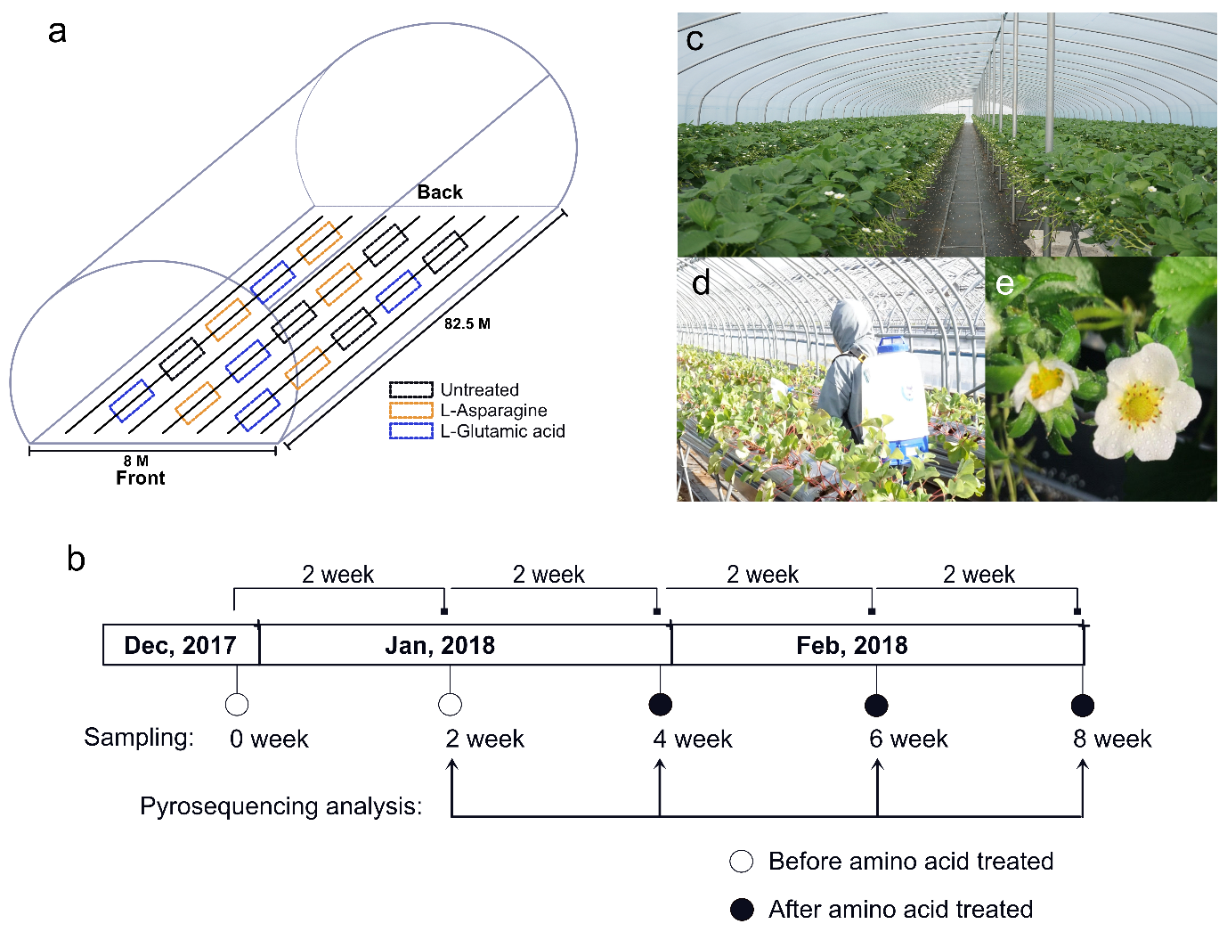
Figure S3 Experimental design in the strawberry greenhouse. a Layout of the 660 m² greenhouse with 15 plots of 1.5 X 3 m², consisting of five replicates each of three treatments (untreated control L-glutamic acid, L-asparagine) in a random block design. Each plot contained 100 strawberry plants. b L–Glutamic acid (2%) and L–asparagine (2%) were applied at weeks 4, 6 and 8 by sprayer (HP-2010, Korea, 1.5 L discharge capacity/min) and flowers were sampled for sequencing. c Strawberry greenhouse; d, e Flowers were sprayed, and samples were collected into a 50-mL Falcon tube (n = 5).

Figure S4 Gray mold and blossom blight disease incidence. Plants in the greenhouse (8 M wide X 82.5 M length; 660 m²) were arranged in 7 longitudinal rows, 3 of which were untreated; 2% L–asparagine and 2% L–glutamic acid were applied by sprayer (HP-2010, Korea, 1.5 L discharge capacity/min) at intervals of 2 weeks. Mean disease incidence of 5 independent plots ± SE; red letters in the legend indicate when amino acids were sprayed. a gray mold disease incidence, b Strawberry flower infected by Botrytis cinerea, with brown spots on petals and fruits covered by conidia c uninfected healthy flower. d Blossom blight disease incidence. e, f Strawberry flower and fruit infected by Cladosporium cladosporioides with dark leaf and calyx. g Detection of S. globisporus SP6C4 with the strain specific lanM gene by qRT-PCR. Strawberry flower samples were collected into 50 mL Falcon tubes, each with 3 flowers. DNA was extracted by with a Fast DNATM Spin Kit for Soil DNA extraction (n = 5, 15 independent experiments) and qRT-PCR was performed with the CFX connect real-time PCR detection system (Bioneer, Korea). h Circle size indicates S. globisporus SP6C4 population density and numbers in circles indicate sampling time. All data were tested by ANOVA with Tukey's HSD, Bars indicate the standard error and stars represent significance at *P < 0.05, **P < 0.01, ***P < 0.001 and ****P < 0.0001.
Figure S5 Dynamics of strawberry flower microbial communities as influenced by amino acids. a Alpha diversity calculated based on mean Pielous’s evenness using ANOVA (p = 0.023) b mean observed species using ANOVA (p = 4.60E-05). No significant differences were detected at p < 0.05 between groups. c Taxonomic profiles showing the microbial diversity with bar plots. Bar plots displaying the relative abundance at the family level by throughput 16S rRNA and taxonomic assignment conducted with the Silva database (http://www.arb-silva.de/) and a similarity of 97%.

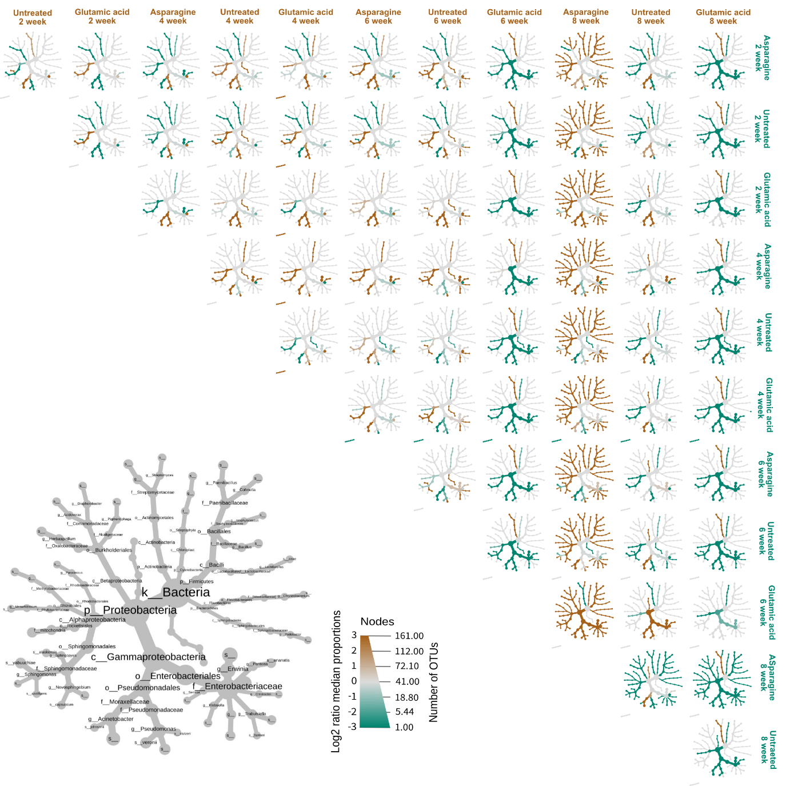
Figure S6 Metacoder analysis of the microbial composition of strawberry flowers among treatments (untreated, 2% L-glutamic acid, 2% L-asparagine). Trees were generated by using maximum likelihood to generate a phyloseq object in Phyloseq (version 3.10). The node color indicates significant changes in relative abundance (Log2 ratio).


Figure S7 Functional gene orthology profiles among untreated (green bar), L–asparagine (green bar), and L–glutamic acid (blue bar) treated strawberry flowers. Taxonomic abundance profiling comparing untreated and amino acid treated plants, bar plot shows abundance based on DESeq normalized with the KEGG database. Abundance was calculated using Log 2-fold change. All data had significance values of p_{adj} < 0.01 after correction for multiple tests.
Figure S8 Suppression of Fusarium wilt disease of tomato by strain SP6C4 with or without L-glutamic acid. a Scheme of the experiment and sampling times (yellow stars) for microbial diversity analyses by DNA sequence analysis, Plants were maintained in a growth chamber (light: 16 h, 28°C, RH 80%; dark: 8 h, 25°C, RH 80%). b seedlings at week 7. c Fusarium wilt disease progress over time, disease index was scored by using a scale of five grades. The data are presented as the mean ±SE, n = 3. d lanM gene copy number determined by qRT-PCR of rhizosphere soil DNA. Soil (0.5 g) was collected from the plant rhizosphere (three biological replicates), DNA was isolated by using a FastDNATM Spin kit (MP biomedicals, USA). e, f Phenotype of tomato seedlings at 7 weeks. Significant differences were analyzed by Tukey's HSD of all data; *P < 0.05, **P < 0.01, ***P < 0.001, ****P < 0.0001.

Figure S9 Comparison of the tomato rhizosphere microbiome at the family level. a Sequencing analysis with the DADA2 package and taxonomic assignment were performed with Greengenes database with a similarity cutoff ≤ 98%. The top 10 OTUs are shown in the bar plots. b Non-metric multidimensional scaling (NMDS) of rhizosphere microbial community in tomato. Green and blue circles in the plot are 95% confidence limit of samples. Each point symbolizes a different sample’s community (n = 26).

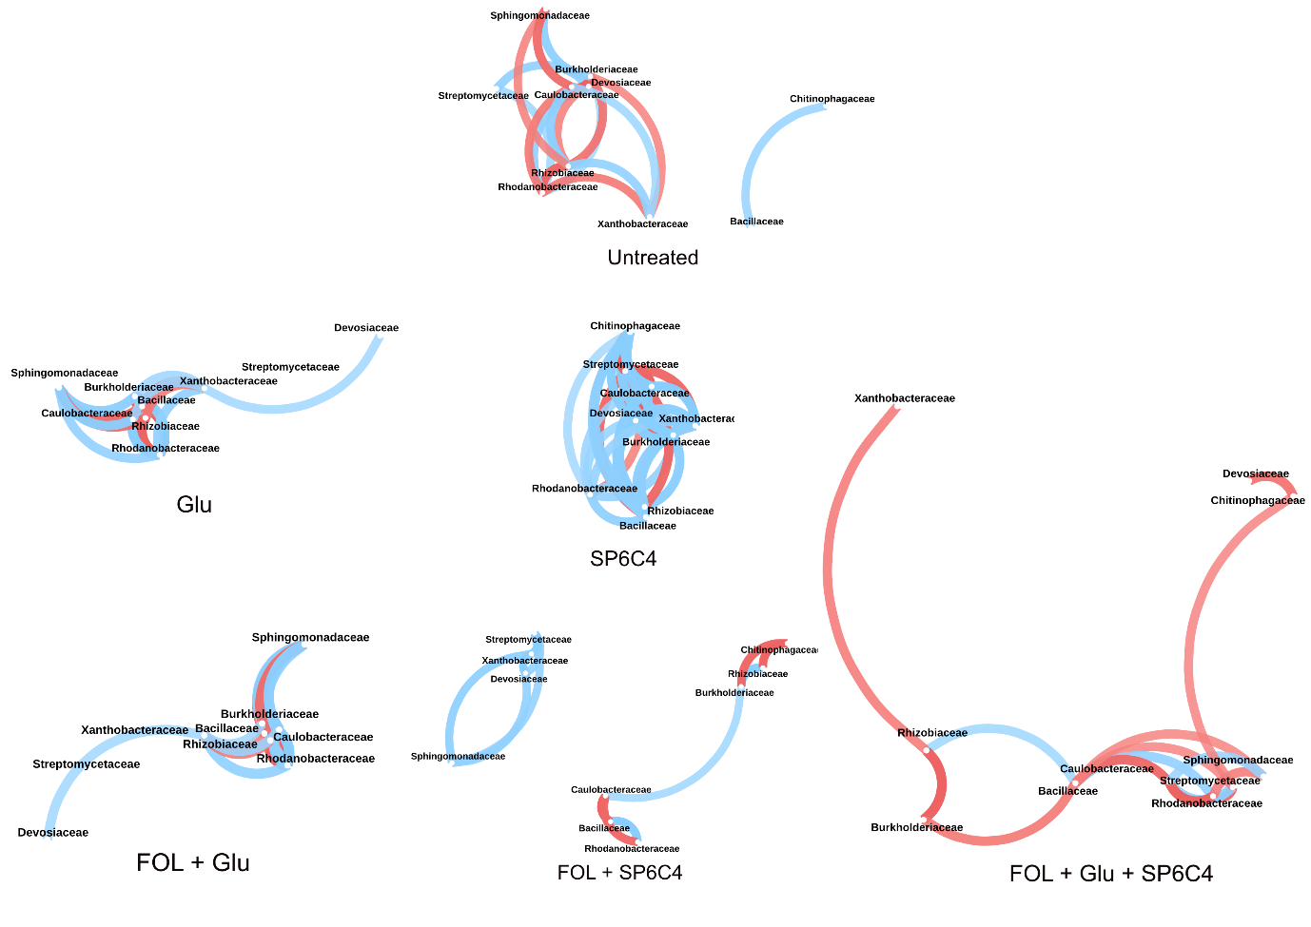 Figure S10 Co–occurrence networks among the top 10 OTUs in the tomato rhizosphere based on lanM gene copy number. Co–occurrence patterns are based on Spearman analyses and connections indicate a strong significant correlation (Spearman’s ρ > 0.8). Positive correlations are shown as blue lines and negative correlations are indicated by red lines.

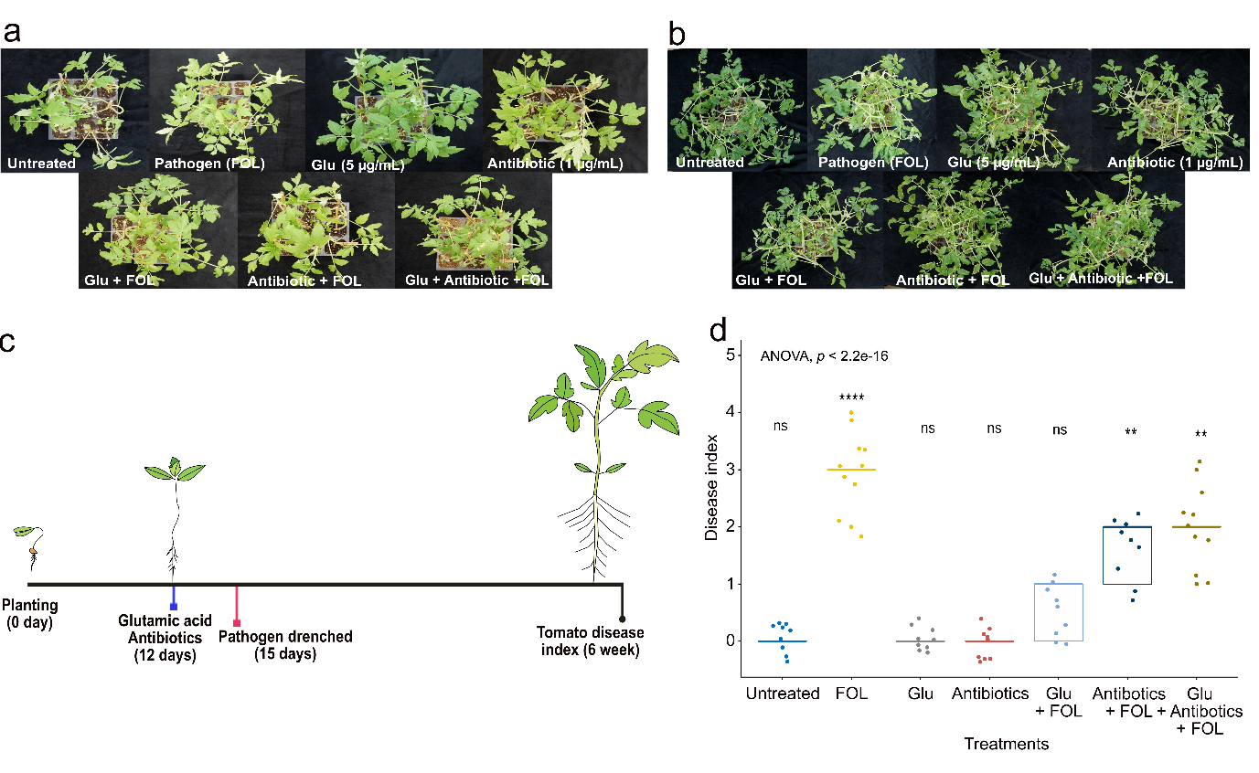
Figure S11 Microbial engineering with L–glutamic acid for control of Fusarium wilt disease of tomato. Tomato grown on autoclaved soil with 0.1% Hoagland’s solution (n = 9 independent replicates). a Tomato plants before treatment. b Plants after treatment. c After 12 days, plants were drenched with 50 mL of L–glutamic acid (5 µg/mL). Six hours later, antibiotics (erythromycin and clindamycin, 10 µg/mL each) were added to the soil. At 15 days, plants were inoculated with 10 mL of FOL conidia (10⁵ cfu/mL). d Disease index were scored (see Materials and Methods). e qPCR of the lanM gene with rhizosphere DNA samples, which was performed in TOYOBO SYBR green master mix (n=5, independent technical replications). The lanM gene copy number was calculated as described by Kim et al. (7) and compared with that of the untreated control by t-test. The experiment included 9 plants in each of 7 treatments. Error bars represent mean ±SE (*P < 0.05, **P < 0.01, ***P < 0.001, ****P < 0.0001). Results of Fusarium wilt disease severity were scored on a scale of 0-5 and analyzed by ANOVA with Tukey's HSD.

Figure S12 Microbial engineering with L–glutamic acid (5 µg/mL) for control of strawberry gray mold disease. Strawberry plants were chilled at - 2°C for one month and transplanted into plastic pots (10 cm diam.) with autoclaved soil. a At flowering (12 days), L - glutamic acid (5 µg/mL) and antibiotics (erythromycin and clindamycin, 10 µg/mL each) were applied. Three days later, conidia of the gray mold pathogen B. cinerea (10⁵ cfu/mL) were sprayed onto the flower surface. b Infected strawberry flowers were counted to determine disease incidence (n = 30). Error bars represent mean ±SE (*P < 0.05, **P < 0.01, ***P < 0.001, ****P < 0.0001). Strawberry gray mold disease severity was compared by ANOVA and calculated by Tukey's HSD.

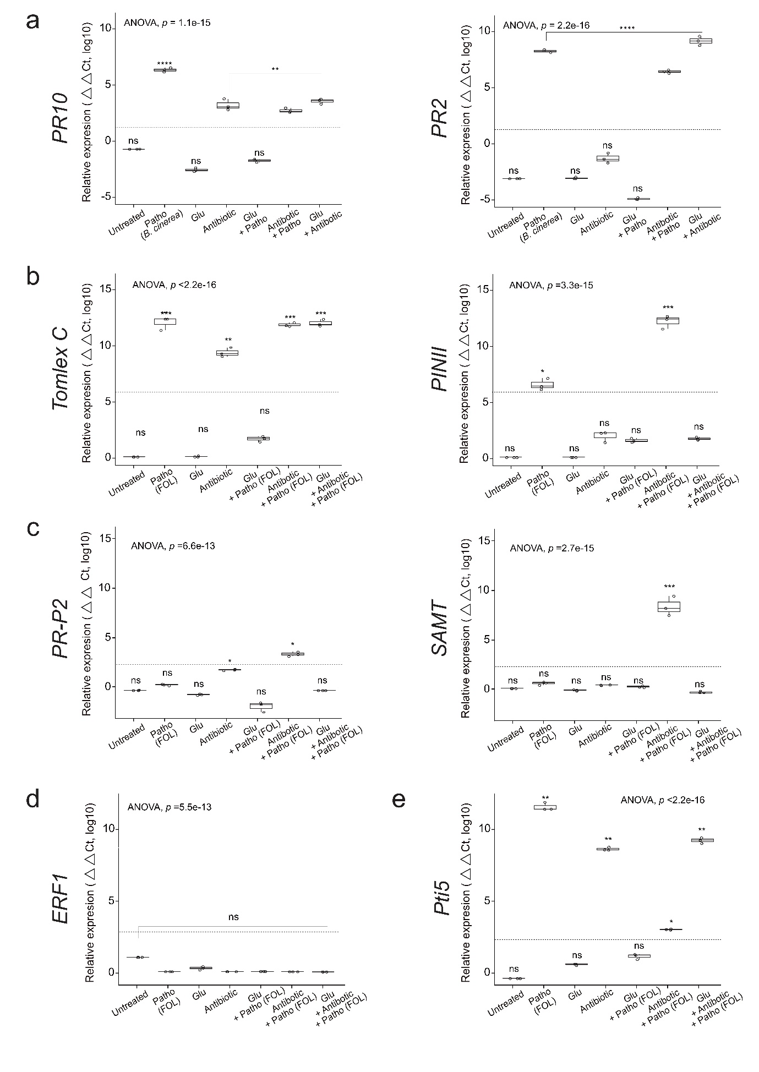
Figure S13 Relative expression of ISR-related and PAMP marker genes in the strawberry flower and tomato rhizosphere as determined by qRT-PCR. a Relative expression level of JA-responsive (left) and SA-responsive genes (right) in strawberry. Untreated control received 50 mL of 0.1% Hoagland’s solution and treated flowers were sprayed with L-glutamic acid (5 µg/mL) and antibiotics (erythromycin and clindamycin: each at 10 µg/mL). After 3 days, a stock of B. cinerea conidia (10⁵ cfu/mL in strawberry) was sprayed on the flower surface and FOL (10⁵ cfu/mL in tomato) was inoculated at soil. Flower samples were collected into 2-mL bead tubes 5 weeks later and RNA was extracted by a one-step extraction method (n = 5). qPCR was performed with cDNA in a SYBR green Mastermix and included three technical replications. Gene expression was calculated by the △△ct method using relative to GAPDH in strawberry. b Expression levels of the JA reporter genes. c Expression levels of the SA reporter genes. d, e Expression levels of the ET and PAMP genes. Gene expression was analyzed by qPCR and relative expression levels were calculated by △△ct method using tubulin as a housekeeping gene in tomato. Data represent means ± SE (n = 5, three technical repeats) and stars indicate statistically significant differences by ANOVA with Tukey's HSD test (*P < 0.05, **P < 0.01, ***P < 0.001 and ****P < 0.0001.).

