Supporting Information for
Effective detection of phenylalanine optically using pyridine based sensor
Vijayakumar Sathya,ª Venkatesan Srinivasadesikan,^{b} Shyi-Long Lee,^{c} Vediappen Padmini*ª
ªDepartment of Organic Chemistry, School of Chemistry, Madurai Kamaraj University, Madurai-625021, Tamilnadu, India.
^{b}Division of Chemistry, Department of Sciences and Humanities, Vignan's Foundation for Science, Technology and Research, Vadlamudi, Guntur, 522 213,Andhra Pradesh, India.
^{c}Department of Chemistry and Biochemistry, National Chung-Cheng University, Chia-Yi, 621, Taiwan.
E-mail: padmini.chem@mkuniversity.org
CONTENT
- Preparative protocol for probe
- ¹H NMR spectrum for the synthesized probe
- ¹³C NMR spectrum for the synthesized probe
- ESI-Mass Spectra the synthesized probe
- UV-Visible and emission spectral characterization for synthesized probe
- Effect of pH
- Stoichiometry determination through Jobs’ plot
- Colorimetric and Fluorimetric detection of PA
- Determination of Quantum yield for probe
- Real sample analysis of phenylalanine human biofluids by standard addition method
- Test strip method
- Competitive experiment with PA
- Determination of Limit of Detection (LOD)
- B-H plot
- DFT studies
- References

- Preparative protocol for probe
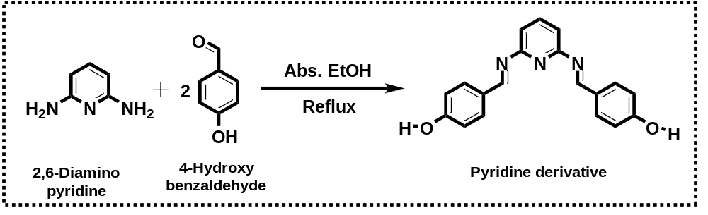
Scheme.1. Preparation of the probe

.
FigureS1: ¹H NMR spectrum of probe in CDCl₃
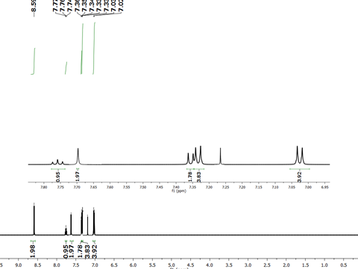

FigureS2: ¹³C NMR spectrum of probe in CDCl₃
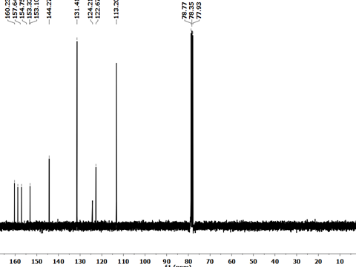

Figure.S3: ESI-Mass Spectrumof the probe
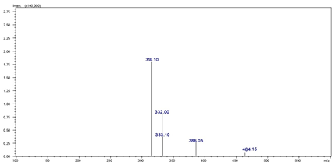
Figure.S4: Mass Spectrum of probe with phenylalanine
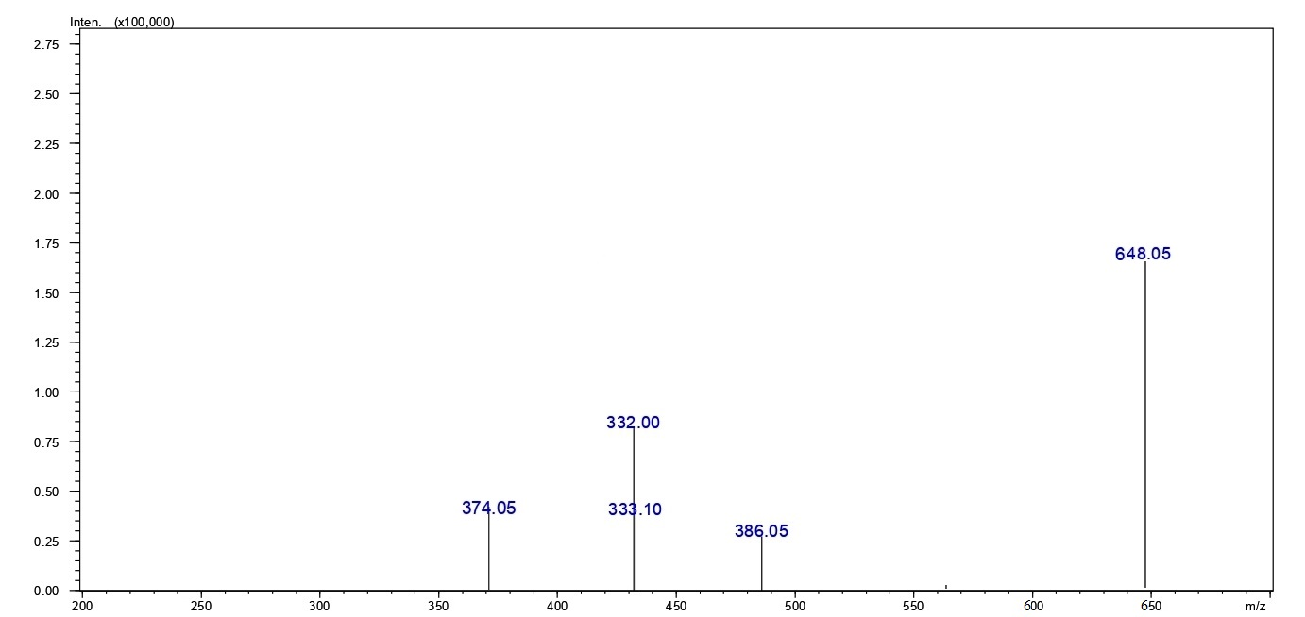

Figure S5. Effect of pH on fluorescent intensity of probe with PA
Figure S7.Job’s plot for the determination of stoichiometry between the probe & PA.^{[1]}

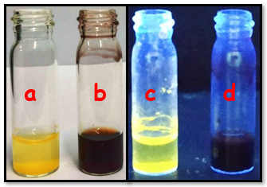
Figure S8a. Colorimetric and fluorimetric response of probe (a) & (c) and probe + PA (b) & (d) at pH 7.2.
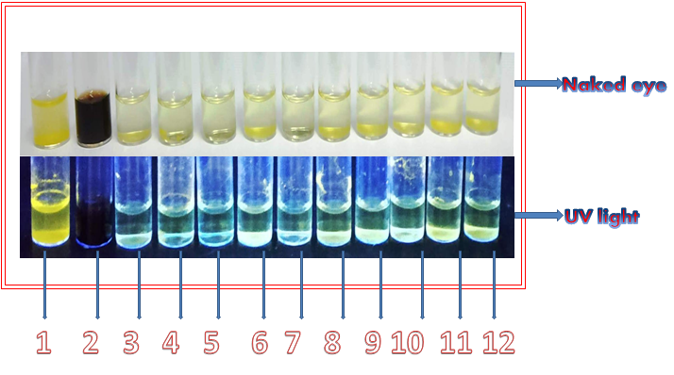
Figure.S8b: Colorimetric and fluorimetric response of PAunder naked eye as well
as UV lamp detection.

- 1 - Probe | - 7 - Probe + Ascorbic Acid
- 2 - Probe + phenylalanine | - 8 - Probe + Cysteine
- 3 - Probe + Leucine | - 9 - Probe + Tryptophan
- 4 - Probe + Asparagine | - 10 - Probe + Alanine
- 5 - Probe + Urea | - 11 – Probe + Glutamine
- 6 - Probe + Creatinine | - 12 – Probe + Albumin
9. Determination of quantum yield for the pyridine derivative
The fluorescence quantum yield (ɸ) has been determined for probe by the equation shown below. Rhodamine 6G was as a standard in ethanol, the quantum yield is 0.95. The probe concentration is 1x10⁻⁶M and the integrated area is determined from the absorption spectrum. The calculated quantum yield is 0.87. ^{[2]}
ɸ_{u} =ɸ_{s}F_{u}A_{s}ɳ_{u}²
F_{s}A_{u}ɳ_{s}²

10. Real sample analysis for phenylalanine in human biofluids
Human biofluids such as blood and urine are used for the real sample test following standard addition method. Separation of serum from the biofluids was effected by centrifuging in REMI centrifuge with 2,000 rpm in 1hr time interval. After that the blood serum was kept at 0°C before testing.
Initially, a known concentration of probe (5µM) was added into the human serum and urine samples. Then, different concentrations of phenylalanine like 20 nM, 50 nM, 100 nM, 200 nM, 300 nM, 400 nM, 500 nM, 20 µM, 50 µM, 100 µM, 200 µM, 300 µM, 400 µM and 500 µM are spiked into the blood and urine sample. Which was incubated for 15-20mins. The results were then recorded. ^{[3]}
Table 10.1: Detection of phenylalanine in human serum of blood sample
Sample  (blood) | Amount of phenylalanine determined  in PBS (pH=7.2) | Fluorescent intensity determined in in PBS (pH=7.2) | Amount of phenylalanine spiked in human serum | Fluorescent intensity  determined in human serum | Recovery (in %)
 | 50 nM | 195 | 50 nM | 190 | 97
 | 100 nM | 182 | 100 nM | 188 | 103
 | 200 nM | 174 | 200 nM | 177 | 102
 | 300 nM | 166 | 300 nM | 168 | 101
 | 400 nM | 152 | 400 nM | 158 | 104
 | 500 nM | 148 | 500 nM | 150 | 101
 | 50 µM | 137 | 50 µM | 139 | 101
 | 100 µM | 123 | 100 µM | 125 | 102
 | 200 µM | 105 | 200 µM | 109 | 104
 | 300 nM | 97 | 300 nM | 100 | 103
 | 400 nM | 73 | 400 nM | 75 | 103
 | 500 µM | 52 | 500 µM | 51 | 98

Table 10.2: Detection of phenylalanine in human serum of urine sample
Sample  (urine) | Amount of phenylalanine determined  in PBS (pH=7.2) | Fluorescent intensity determined in in PBS (pH=7.2) | Amount of phenylalanine spiked in human urine | Fluorescent intensity  determined in human urine | Recovery (in %)
 | 50 nM | 195 | 50 nM | 185 | 95
 | 100 nM | 182 | 100 nM | 186 | 102
 | 200 nM | 174 | 200 nM | 176 | 101
 | 300 nM | 166 | 300 nM | 172 | 104
 | 400 nM | 152 | 400 nM | 161 | 106
 | 500 nM | 148 | 500 nM | 153 | 103
 | 50 µM | 137 | 50 µM | 142 | 104
 | 100 µM | 123 | 100 µM | 125 | 102
 | 200 µM | 105 | 200 µM | 109 | 104
 | 300 nM | 97 | 300 nM | 99 | 102
 | 400 nM | 73 | 400 nM | 72 | 99
 | 500 µM | 52 | 500 µM | 53 | 102
 | 50 nM | 195 | 50 nM | 185 | 95
 | 100 nM | 182 | 100 nM | 186 | 102

Recovery (%) = [Fluorescent intensity of phenylalanine added/ Fluorescent intensity of phenylalanine determined] X 100.
- Test strip method

Figure. S11. Photographs of test strips detections (a) Probe; (b) Probe + other interfering
biomolecules ; (c) Probe + PA under the UV lamp.

- Competitive experiment with PA

Figure.S12: Competitive experiments for the fluorescence quenching effect of probe with
phenylalanine in presence of other competitors.^{[4]}
 | Probe + PA | 7. | Probe + PA + Cysteine
 | Probe + PA + Leucine | 8. | Probe + PA + Tryptophan
 | Probe + PA + Asparagine | 9. | Probe + PA + Alanine
 | Probe + PA + Urea | 10. | Probe + PA + Glutamine
 | Probe + PA + Creatinine | 11. | Probe + PA + Albumin
 | Probe + PA + Ascorbic Acid
- Determination of Limit of Detection (LOD)

Figure.S13: Linear range for the selective detection of PA.^{[5]}

- B-H plot
Figure. S14. B-H plot of probe with analyte.

- DFT studies
Table. Frontier Molecular Orbital diagram obtained at B3LYP/6-31g(d,p) in gas phase
Probe
HOMO | 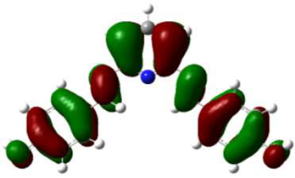 | HOMO-1 | 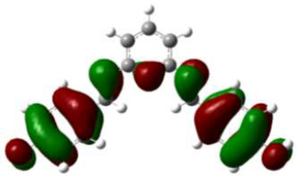
LUMO | 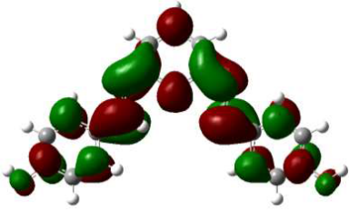 | LUMO+1 | 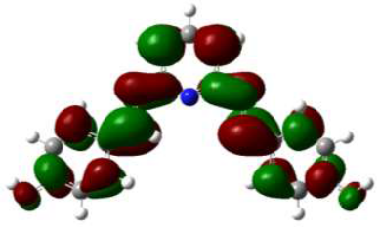
Complex
HOMO | 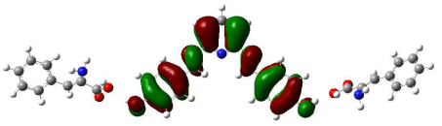 | HOMO-1 | 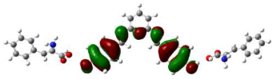
LUMO | 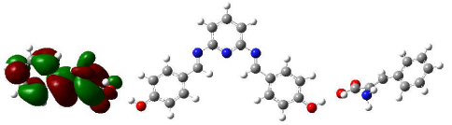 | LUMO+1 | 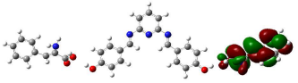
LUMO+2 | 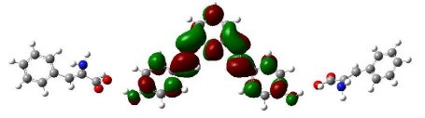

- References
- K. Ponnuvel, J. Ramamoorthy, G. Sivaraman, V. Padmini, ChemistrySelect, 2018, 3, 12150 –12154.
- D. Magde, R. Wong, P.G. Seybold, Photochemistry and Photobiology, 2002, 75, 327-334.
- W. He, Z. Hu, RSC. Adv., 2016, 6, 59073-59080.
- A. Shrivastava, B.G. Vipin, Chronicles of Young Scientists, 2011, 2, 21-25.
- A. D. Arulraj, A. Vijayan, M. Vasantha, Spectrochim Acta A, 2015,148, 355–361.

