Supplementary Figures
Genome-wide meta-analysis of ADHD symptoms in the adult general population reveals distinct genetics of inattention and hyperactivity-impulsivity

Supplementary Figure 1. GWAS meta-analysis quantile-quantile plots of the ADHD total symptom, inattention, hyperactivity-impulsivity domain scores, and individual ADHD symptoms. 2
Supplementary Figure 2. Regional association plots of genome-wide significant variants of ADHD total symptom score. 3
Supplementary Figure 3. Regional association plots of genome-wide significant variants of inattention domain score. 4
Supplementary Figure 4. Regional association plots of genome-wide significant variants of hyperactivity-impulsivity domain score. 5
Supplementary Figure 5. GWAS meta-analysis quantile-quantile plots of the ADHD total symptom, inattention, hyperactivity-impulsivity domain scores in females and males. 6
Supplementary Figure 6. MiXeR bivariate modeling results for inattention and hyperactivity-impulsivity domain scores, ADHD diagnosis, and educational attainment. 7
Supplementary Figure 7. Distributions of the ADHD total symptom (purple), inattention (red), and hyperactivity-impulsivity (blue) domain scores in the Estonian Biobank (EstBB) and in the Norwegian Mother, Father and Child Cohort Study (MoBa) 8
Supplementary Figure 8. Distributions of the ADHD inattention domain items' scores in the Estonian Biobank (EstBB) and in the Norwegian Mother, Father and Child Cohort Study (MoBa) 9
Supplementary Figure 9. Distributions of the ADHD hyperactivity-impulsivity domain items' scores in the Estonian Biobank (EstBB) and in the Norwegian Mother, Father and Child Cohort Study (MoBa) 10

Supplementary Figure 1. GWAS meta-analysis quantile-quantile plots of the ADHD total symptom, inattention, hyperactivity-impulsivity domain scores, and individual ADHD symptoms.
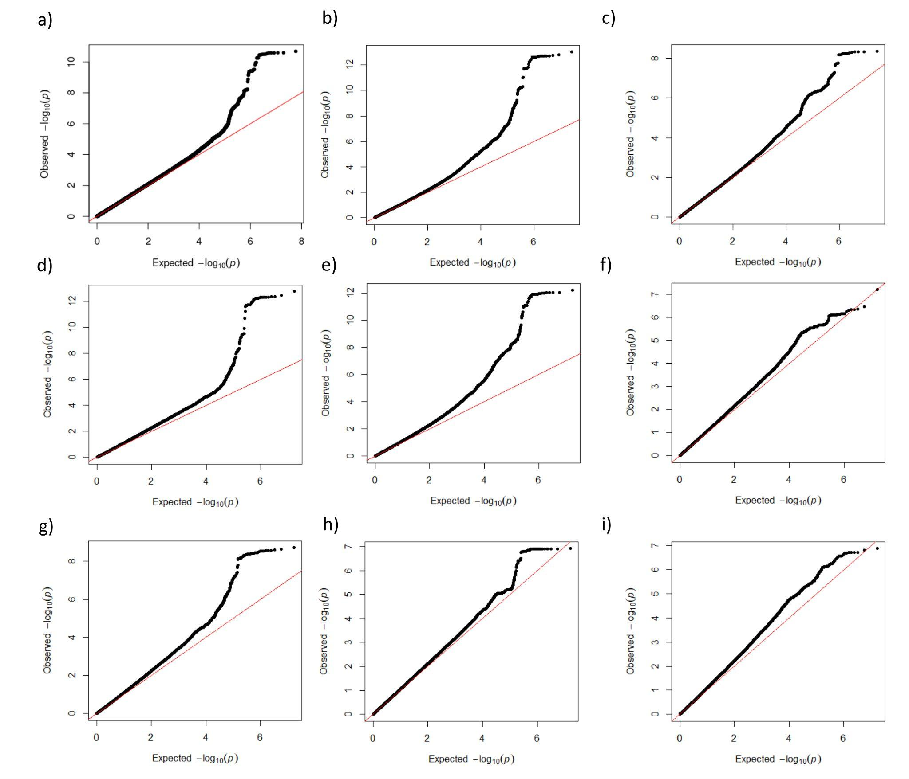
Note: Phenotypes – a) ADHD total symptom score; b) inattention domain score; c) hyperactivity-impulsivity domain score; d) „How often do you have trouble wrapping up the final details of a project, once the challenging parts have been done?“ e) „How often do you have difficulty getting things in order when you have to do a task that requires organization?“ f) „How often do you have problems remembering appointments or obligations“ g) „When you have a task that requires a lot of thought, how often do you avoid or delay getting started?“ h) „How often do you fidget or squirm with your hands or feet when you have to sit down for a long time?“ i) „How often do you feel overly active and compelled to do things, like you were driven by a motor?“

Supplementary Figure 2. Regional association plots of genome-wide significant variants of ADHD total symptom score.
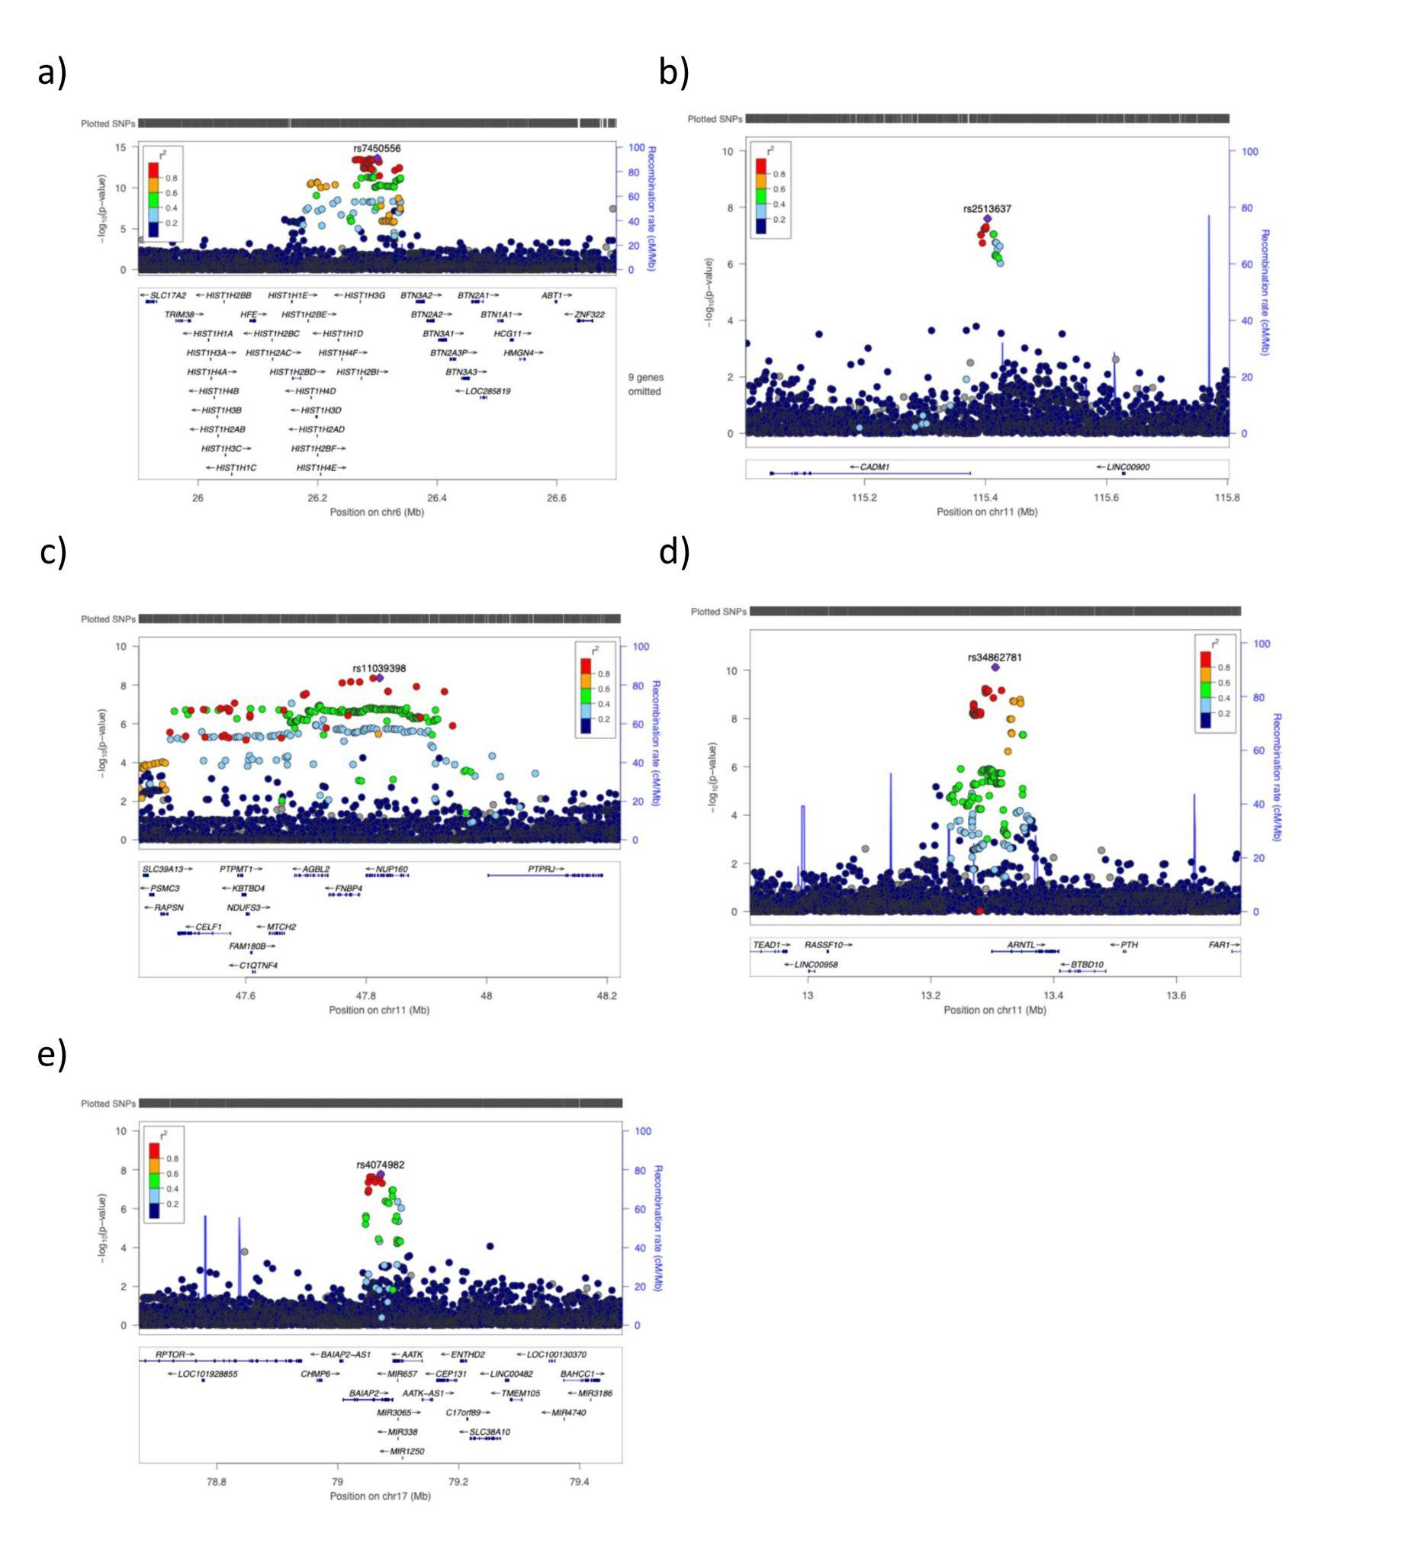
Note: a)-e) Regional plots showing the five lead variants significantly associated with the ADHD total symptom score. Plots were created using the LocusZoom tool (locuszoom.org). The y axis represents −log10(P-values) for association of variants with ADHD total symptom score and the x axis represents the chromosomal positions of the variants. Each lead variant is shown as a purple diamond in each of the five lead variants defined.

Supplementary Figure 3. Regional association plots of genome-wide significant variants of inattention domain score.
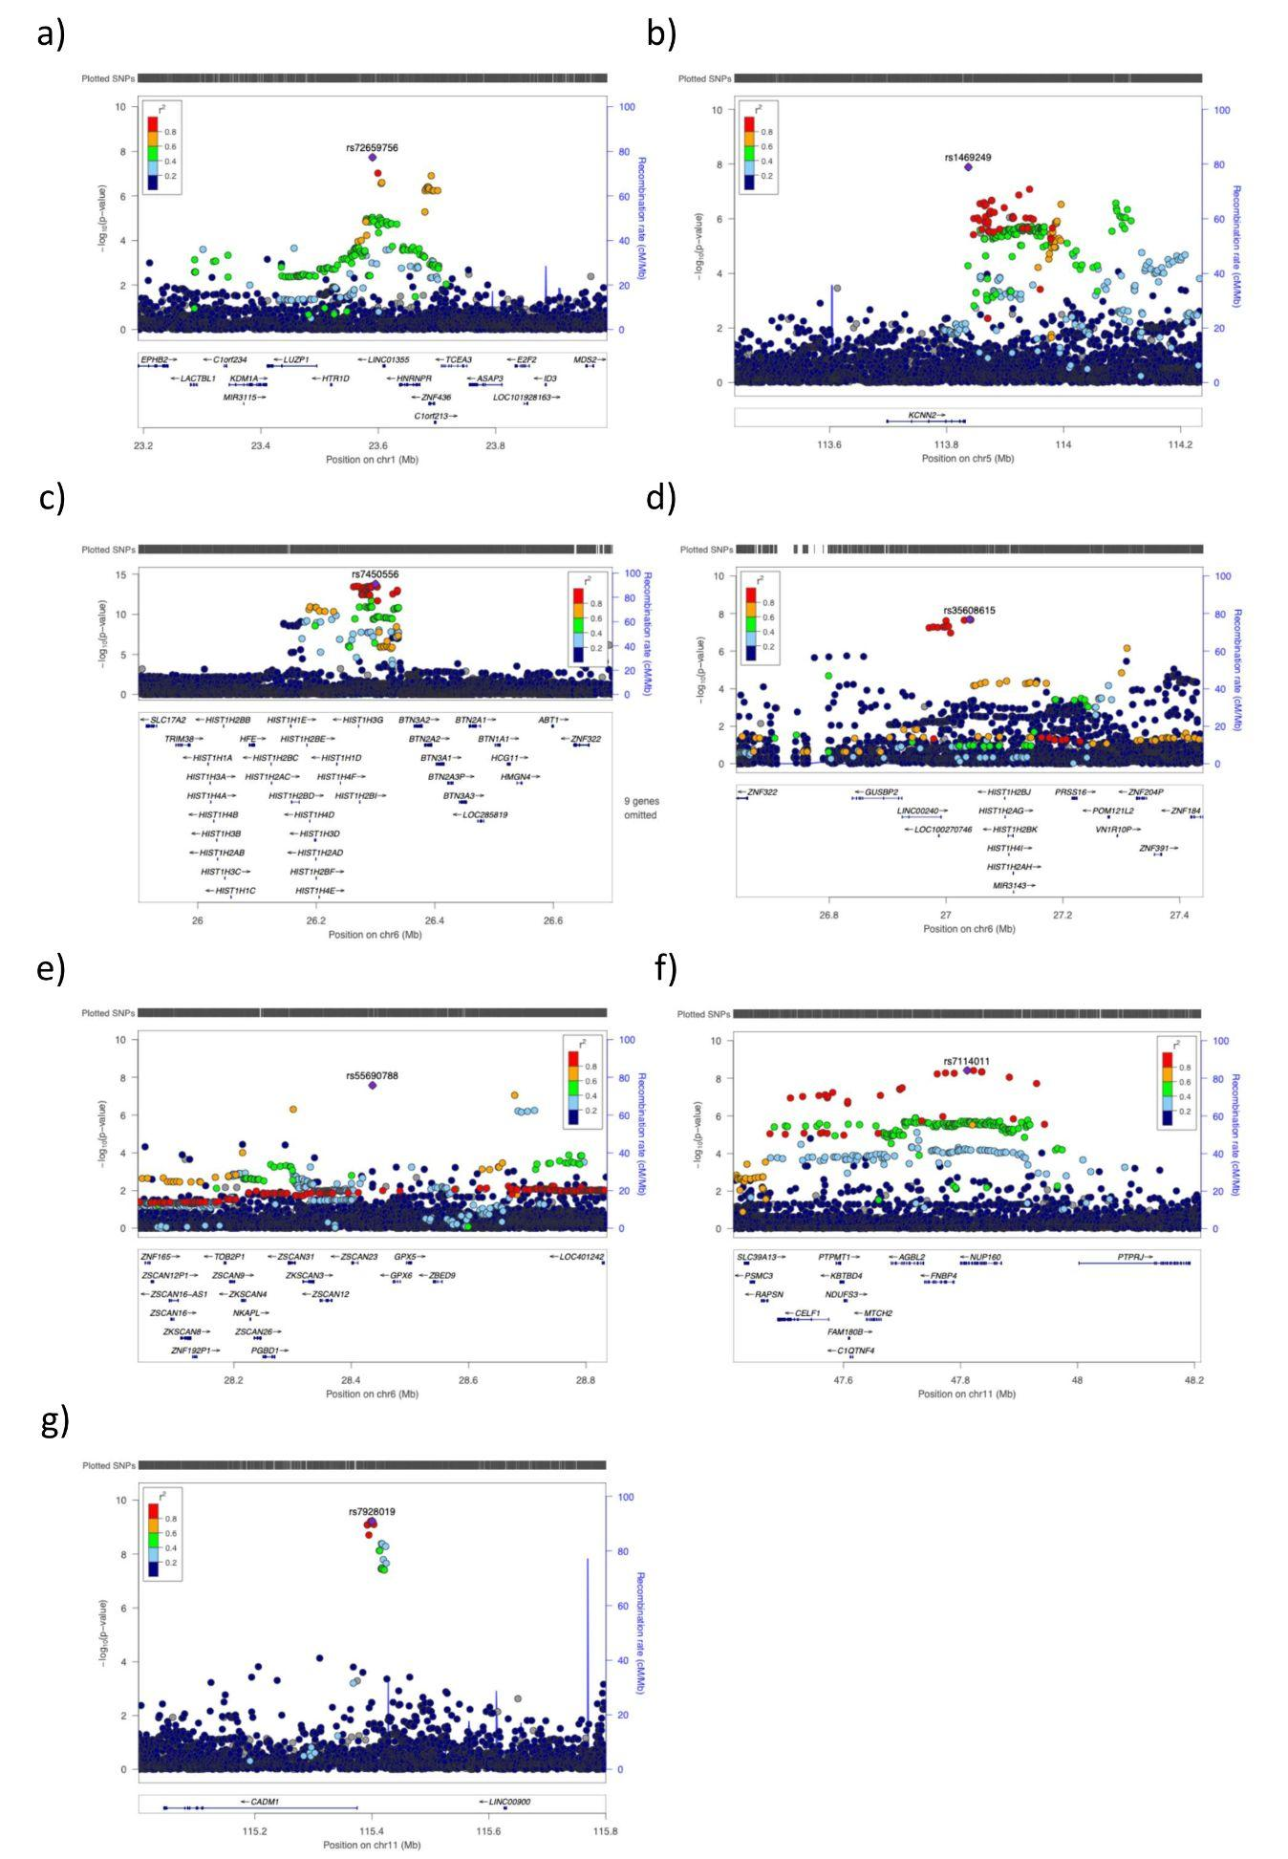
Note: a)-g) Regional plots showing the seven lead variants significantly associated with inattention domain score. Plots were created using the LocusZoom tool (locuszoom.org). The y axis represents −log10(P-values) for association of variants with inattention domain score and the x axis represents the chromosomal positions of the variants. Each lead variant is shown as a purple diamond in each of the seven lead variants defined.

Supplementary Figure 4. Regional association plots of genome-wide significant variants of hyperactivity-impulsivity domain score.
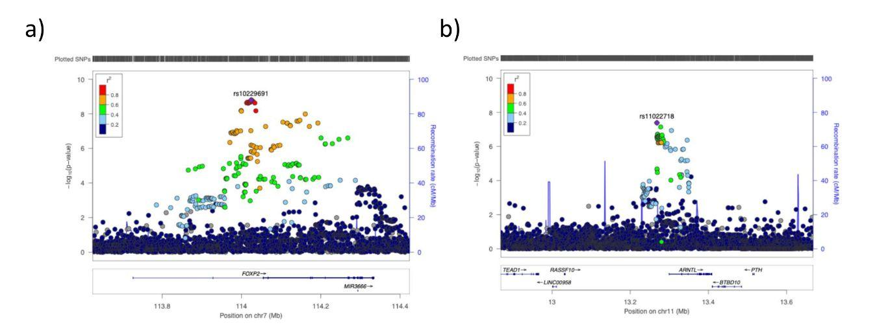
Note: a), b) Regional plots showing the two lead variants significantly associated with hyperactivity-impulsivity domain score. Plots were created using the LocusZoom tool (locuszoom.org). The y axis represents −log10(P-values) for association of variants with hyperactivity-impulsivity domain score and the x axis represents the chromosomal positions of the variants. Each lead variant is shown as a purple diamond in each of the two lead variants defined.

Supplementary Figure 5. GWAS meta-analysis quantile-quantile plots of the ADHD total symptom, inattention, hyperactivity-impulsivity domain scores in females and males.
Females (n=95,986) Males (n=45,519)
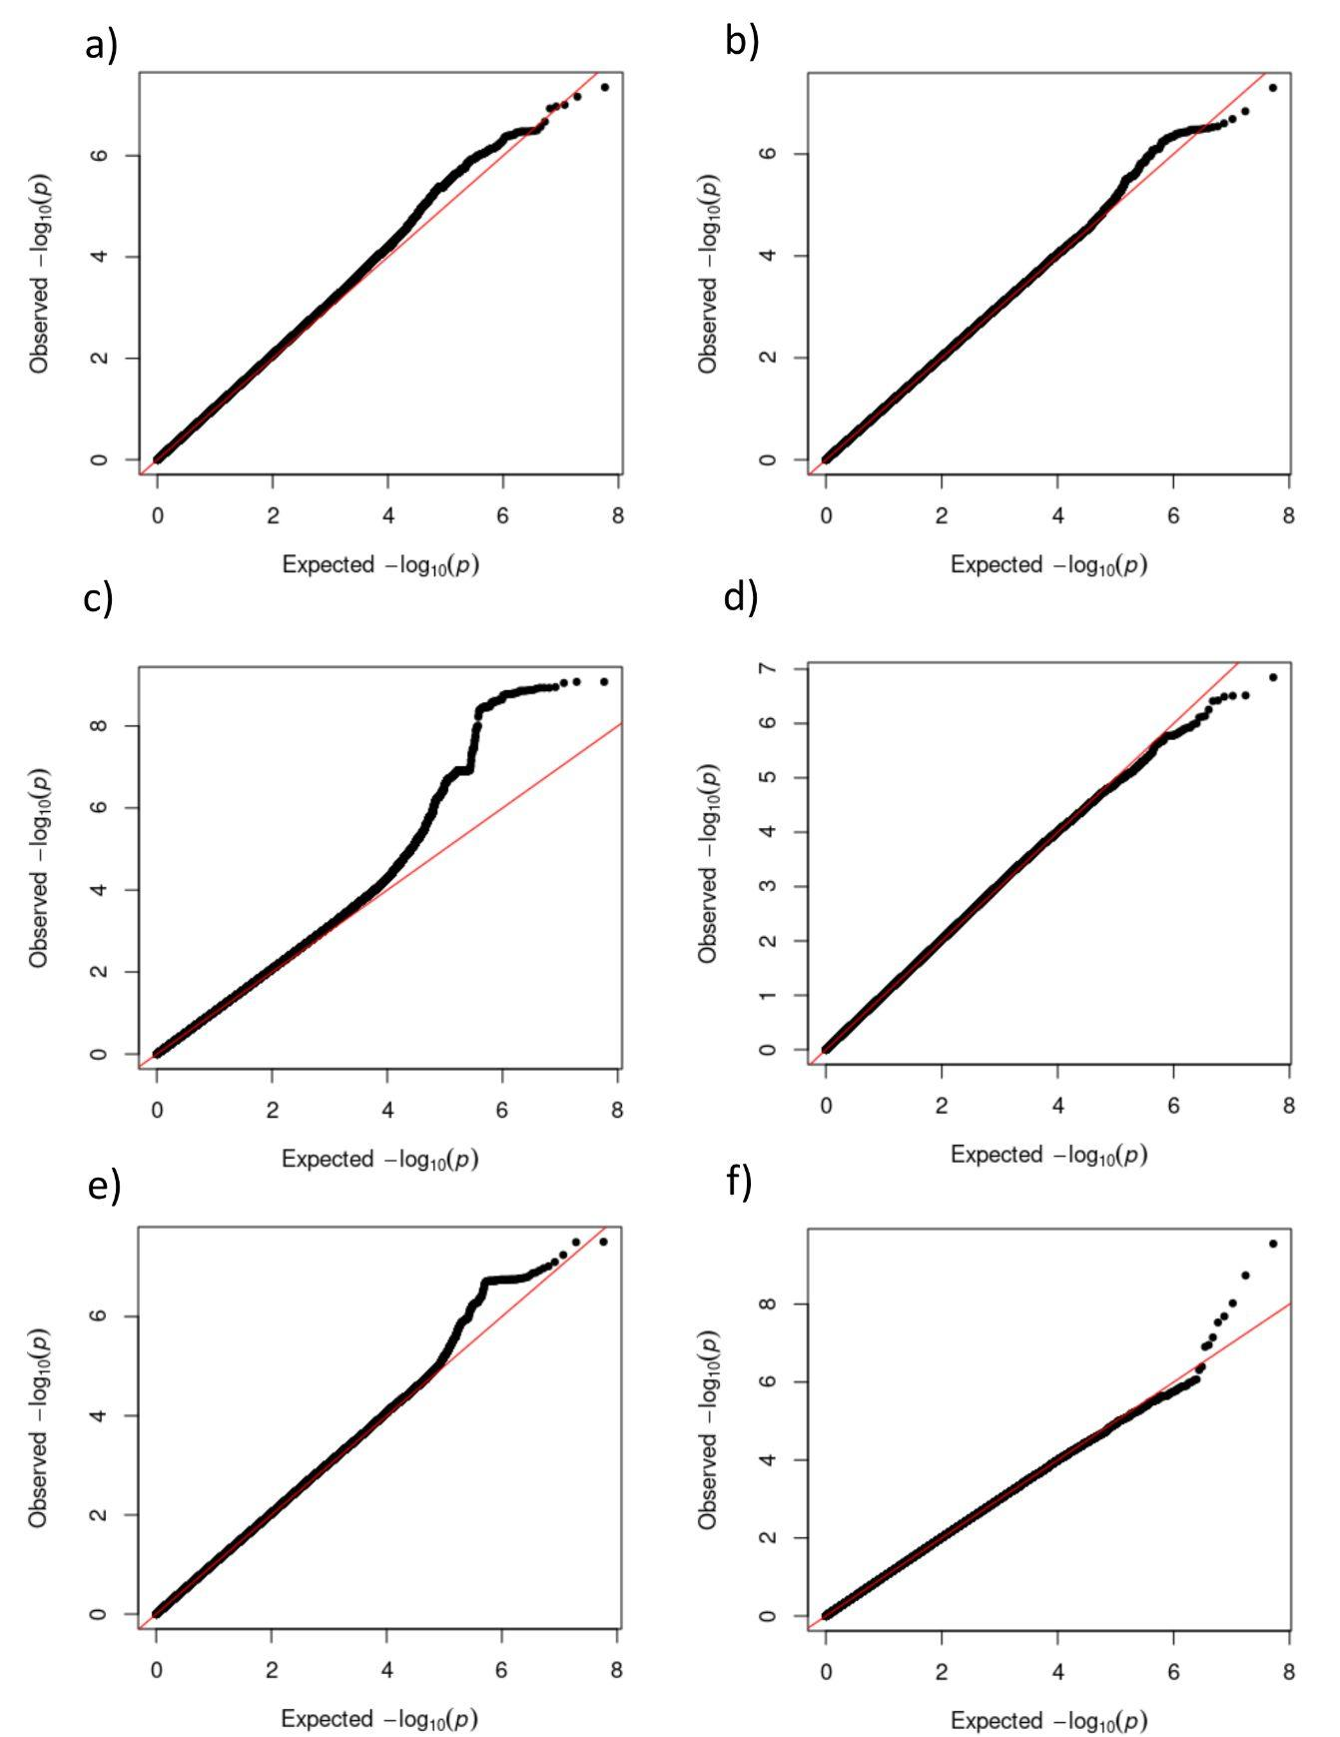
Note: Phenotypes – a) ADHD total symptom score in females; b) ADHD total symptom score in males; c) inattention domain score in females; d) inattention domain score in males; e) hyperactivity-impulsivity domain score in females; f) hyperactivity-impulsivity domain score in males

Supplementary Figure 6. MiXeR bivariate modelling results for inattention and hyperactivity-impulsivity domain scores, lifetime ADHD diagnosis, and educational attainment.
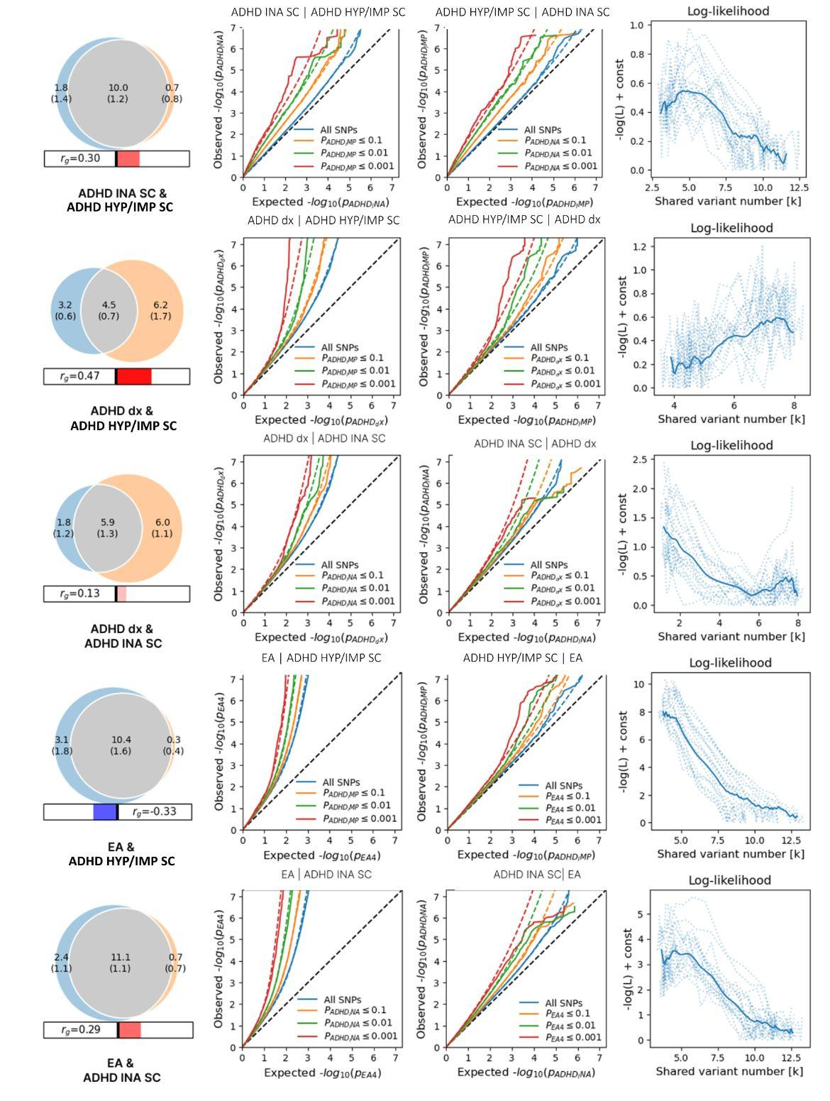
Note: ADHD dx - attention-deficit/hyperactivity disorder diagnosis; ADHD HYP/IMP SC - hyperactivity-impulsivity domain score; ADHD INA SC - inattention domain score; EA - educational attainment; r_{g} - genetic correlation between phenotypes.

Supplementary Figure 7. Distributions of the ADHD total symptom (purple), inattention (red), and hyperactivity-impulsivity (blue) domain scores in the Estonian Biobank (EstBB) and in the Norwegian Mother, Father and Child Cohort Study (MoBa).
EstBB (n=77,276) MoBa (n=64,229)
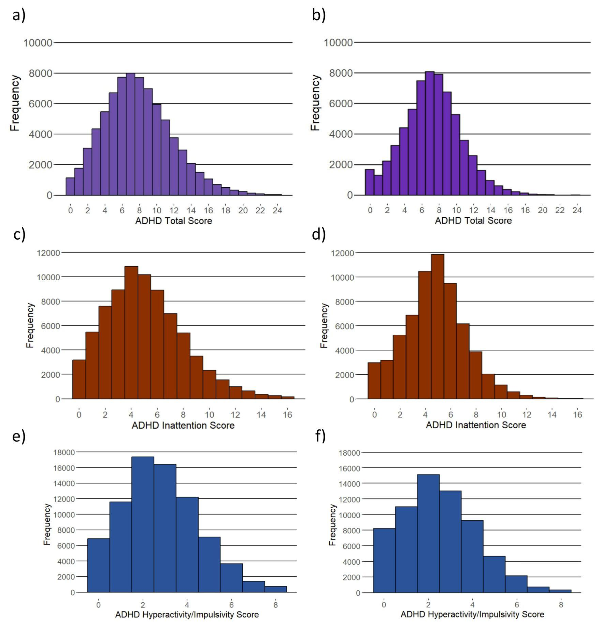
Note: a) Distribution of ADHD total symptom scores in EstBB; b) Distribution of ADHD total symptom scores in MoBa; c) Distribution of inattention domain scores in EstBB; d) Distribution of inattention domain scores in MoBa; e) Distribution of hyperactivity-impulsivity domain scores in EstBB; f) Distribution of hyperactivity-impulsivity domain scores in MoBa

Supplementary Figure 8. Distributions of inattention domain items' scores in the Estonian Biobank (EstBB) and in the Norwegian Mother, Father and Child Cohort Study (MoBa).
EstBB (n=77,276) MoBa (n=64,229)
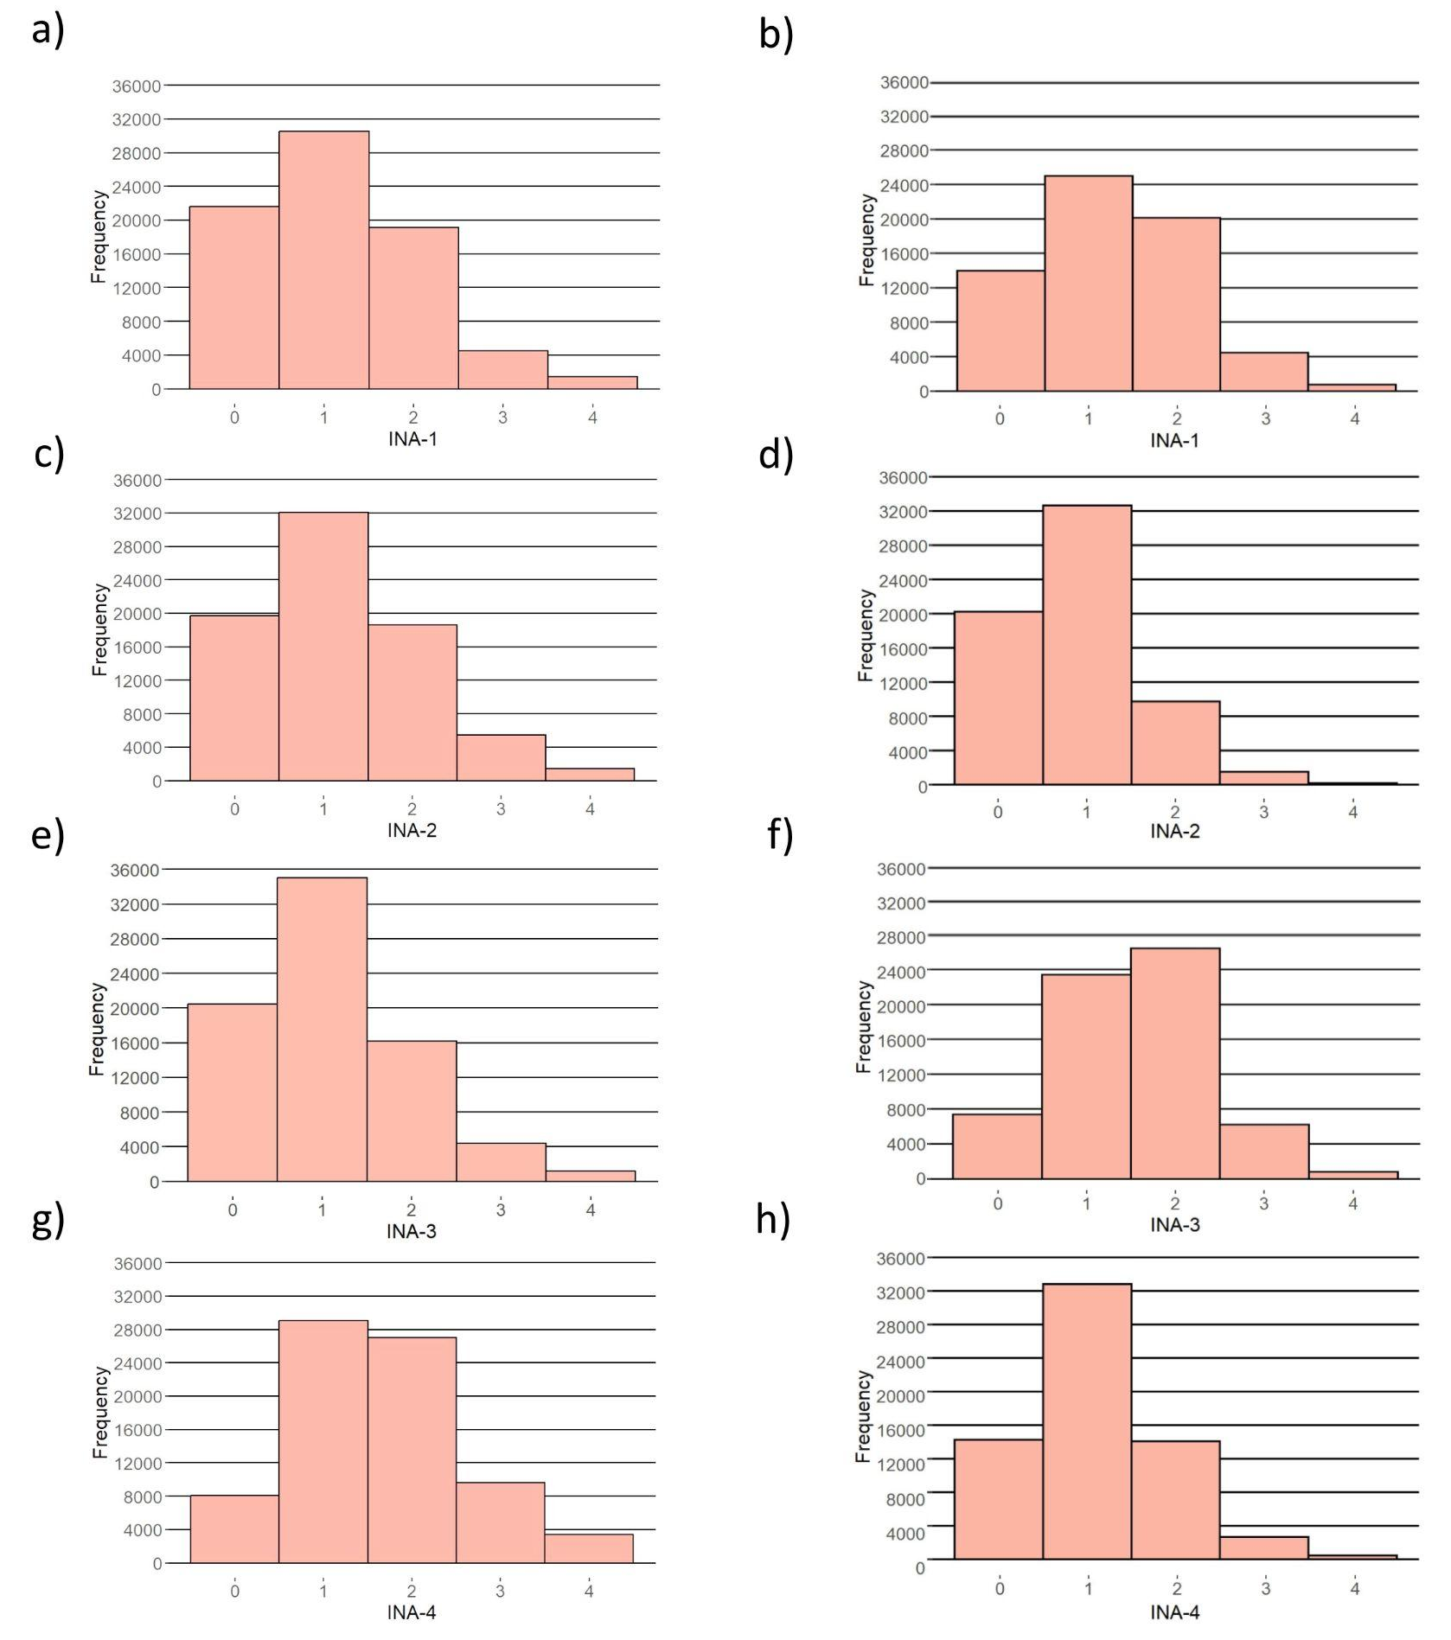
Note: a) Distribution of INA-1 scores in EstBB; b) Distribution of INA-1 scores in MoBa; c) Distribution of INA-2 scores in EstBB; d) Distribution of INA-2 scores in MoBa; e) Distribution of INA-3 scores in EstBB; f) Distribution of INA-3 scores in MoBa; g) Distribution of INA-4 scores in EstBB; h) Distribution of INA-4 scores in MoBa; INA-1 – „How often do you have trouble wrapping up the final details of a project, once the challenging parts have been done?“; INA-2 – „How often do you have difficulty getting things in order when you have to do a task that requires organization?“; INA-3 – „How often do you have problems remembering appointments or obligations“; INA-4 – „When you have a task that requires a lot of thought, how often do you avoid or delay getting started?“

Supplementary Figure 9. Distributions of hyperactivity-impulsivity domain items' scores in the Estonian Biobank (EstBB) and in the Norwegian Mother, Father and Child Cohort Study (MoBa).
EstBB (n=77,276) MoBa (n=64,229)
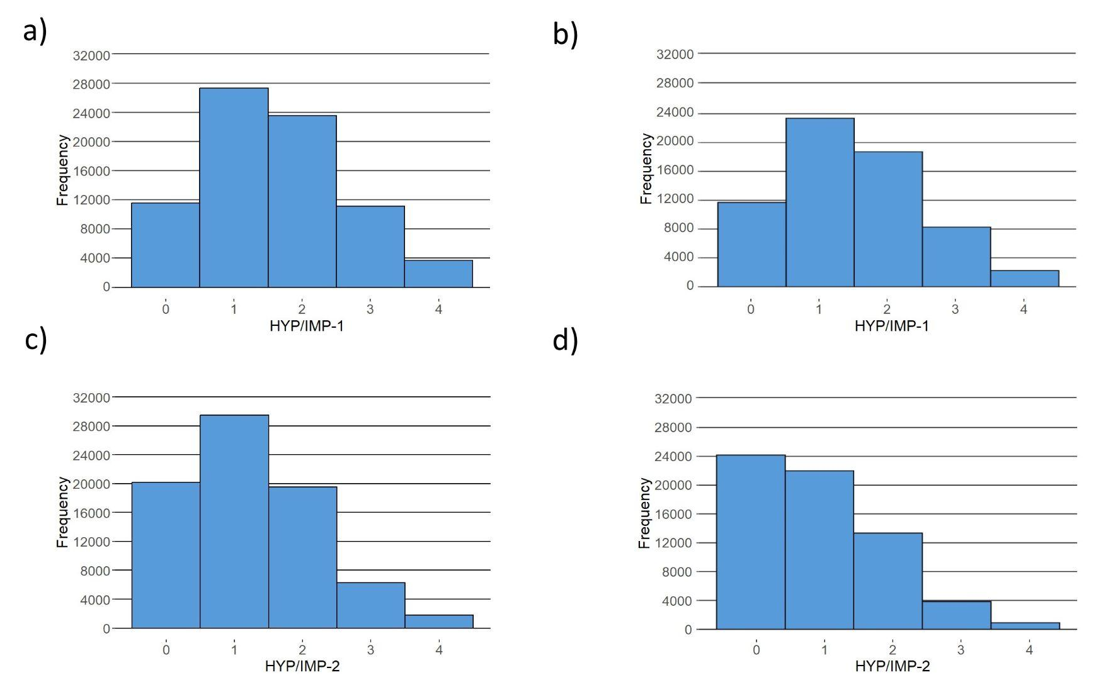
Note: a) Distribution of HYP/IMP-1 scores in EstBB; b) Distribution of HYP/IMP-1 scores in MoBa; c) Distribution of HYP/IMP-2 scores in EstBB; d) Distribution of HYP/IMP-2 scores in MoBa; HYP/IMP-1 – „How often do you fidget or squirm with your hands or feet when you have to sit down for a long time?“; HYP/IMP-2 – „How often do you feel overly active and compelled to do things, like you were driven by a motor?“.

