Extended Data
Genome-wide meta-analysis of ADHD symptoms in the adult general population reveals distinct genetics of inattention and hyperactivity-impulsivity

Extended Data Table 1. Association results for the lead variants in the genome-wide association meta-analysis of adult ADHD symptom scores.
Phenotype | rsID | CHR | Position | EA | NEA | MAF (EUR) | P-VALUE | BETA | SE | Prioritised gene(s) | Reasons for prioritisation
Total  symptom score | rs7450556 | 6 | 26299900 | T | C | 0.45 | 2.58e-14 | 0.0280 | 0.0037 | H4C8, HIST1H2BE | Nearest gene, HIST1H2BE has a coding variant in high LD with the lead variant
Total  symptom score | rs34862781 | 11 | 13305263 | A | G | 0.44 | 7.6e-11 | -0.0236 | 0.0036 | ARNTL/  BMAL1 | Nearest gene, biological role, mice evidence
Total  symptom score | rs11039398 | 11 | 47822217 | T | C | 0.29 | 4.28e-09 | 0.0237 | 0.0040 | FNBP4 | Nearest gene, biological role
Total  symptom score | rs2513637 | 11 | 115403577 | A | T | 0.16 | 2.53e-08 | 0.0287 | 0.0051 | CADM1 | Nearest gene, associated previously with ADHD, mice evidence
Total  symptom score | rs4074982 | 17 | 79070972 | T | G | 0.27 | 1.7e-08 | -0.0226 | 0.0040 | BAIAP2 | Nearest gene, associated previously with ADHD, mice evidence
Inattention domain  score | rs72659756 | 1 | 23590183 | T | C | 0.09 | 1.86e-08 | -0.0338 | 0.0060 | HTR1D | Nearest gene, biological role
Inattention domain  score | rs1469249 | 5 | 113837198 | A | G | 0.20 | 1.3e-08 | -0.0255 | 0.0045 | KCNN2 | Nearest gene, biological role
Inattention domain  score | rs7450556 | 6 | 26299900 | T | C | 0.45 | 1.7e-14 | 0.0280 | 0.0037 | H4C8, HIST1H2BE | Nearest gene, HIST1H2BE has a coding variant in high LD with the lead variant
Inattention domain  score | rs35608615 | 6 | 27040402 | C | G | 0.11 | 2.05e-08 | -0.0345 | 0.0062 | H2BC11 | Nearest gene
Inattention domain  score | rs55690788 | 6 | 28436145 | C | T | 0.08 | 2.66e-08 | -0.0392 | 0.0070 | ZSCAN23 | Nearest gene
Inattention domain  score | rs7114011 | 11 | 47811309 | C | A | 0.29 | 3.81e-09 | 0.0237 | 0.0040 | FNBP4 | Nearest gene, biological role
Inattention domain  score | rs7928019 | 11 | 115400922 | A | G | 0.16 | 5.95e-10 | 0.0320 | 0.0052 | CADM1 | Nearest gene, associated previously with ADHD, mice evidence
Hyperactivity-  impulsivity domain  score | rs10229691 | 7 | 114024179 | A | G | 0.36 | 1.6e-09 | 0.0219 | 0.0036 | FOXP2 | Nearest gene, consistently reported with ADHD, mice evidence
Hyperactivity-  impulsivity domain  score | rs11022718 | 11 | 13268144 | T | C | 0.20 | 4.06e-08 | 0.0246 | 0.0045 | ARNTL/  BMAL1 | Nearest gene, biological role, mice evidence

Note: Positions are based on GRCh37. rsID - lead variant, CHR - chromosome, EA - effect allele, NEA - non-effect allele, MAF (EUR) - minor allele frequency in non-Finnish European population, P-VALUE - p-value, BETA - effect size, SE - standard error of the effect size, LD - linkage disequilibrium, ADHD - attention-deficit/hyperactivity disorder.

Extended Data Figure 1. GWAS meta-analysis Manhattan plots of individual adult ADHD symptoms.
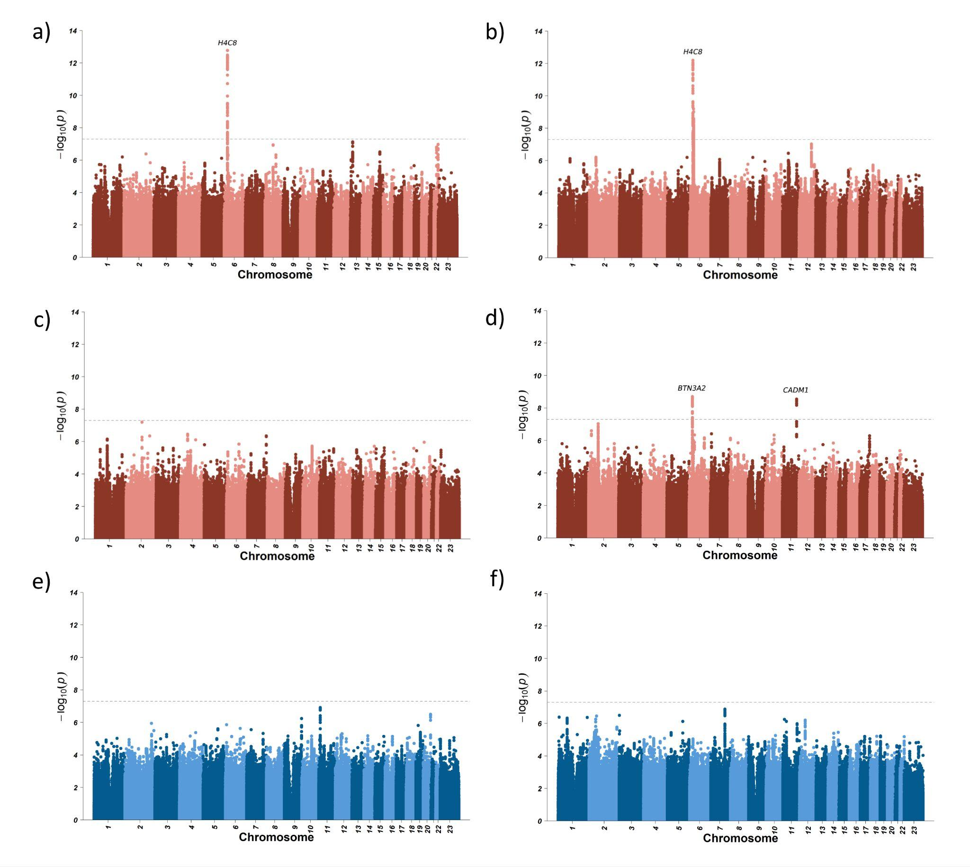
Note: Items – a) „How often do you have trouble wrapping up the final details of a project, once the challenging parts have been done?“ b) „How often do you have difficulty getting things in order when you have to do a task that requires organization?“ c) „How often do you have problems remembering appointments or obligations“ d) „When you have a task that requires a lot of thought, how often do you avoid or delay getting started?“ e) „How often do you fidget or squirm with your hands or feet when you have to sit down for a long time?“ f) „How often do you feel overly active and compelled to do things, like you were driven by a motor?“; Dashed line represents the genome-wide significance threshold of the association p-value 5x10-8.

Extended Data Figure 2. GWAS meta-analysis Manhattan plots of adult ADHD total symptom (purple), inattention (red), and hyperactivity-impulsivity (blue) domain scores in females and males.

Females (n=95,986) Males (n=45,519)
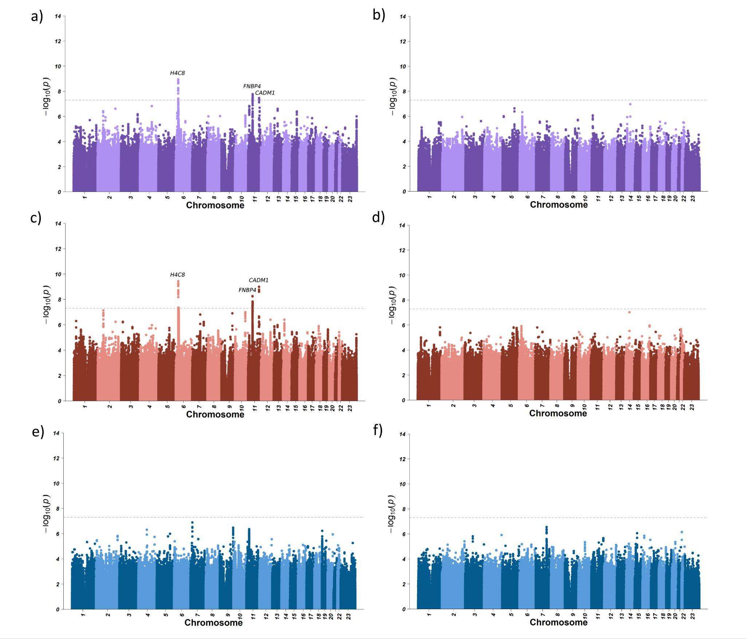
Note: Phenotypes – a) GWAS results ADHD total symptom score in females; b) GWAS results of ADHD total symptom score in males; c) GWAS results of inattention domain score in females; d) GWAS results of inattention domain score in males; e) GWAS results of hyperactivity-impulsivity domain score in females; f) GWAS results of hyperactivity-impulsivity domain score in males; Dashed line represents the genome-wide significance threshold of the association p-value 5x10-8.

Extended Data Figure 3. Tissue enrichment plots of adult ADHD total symptom, inattention, and hyperactivity-impulsivity domain scores.
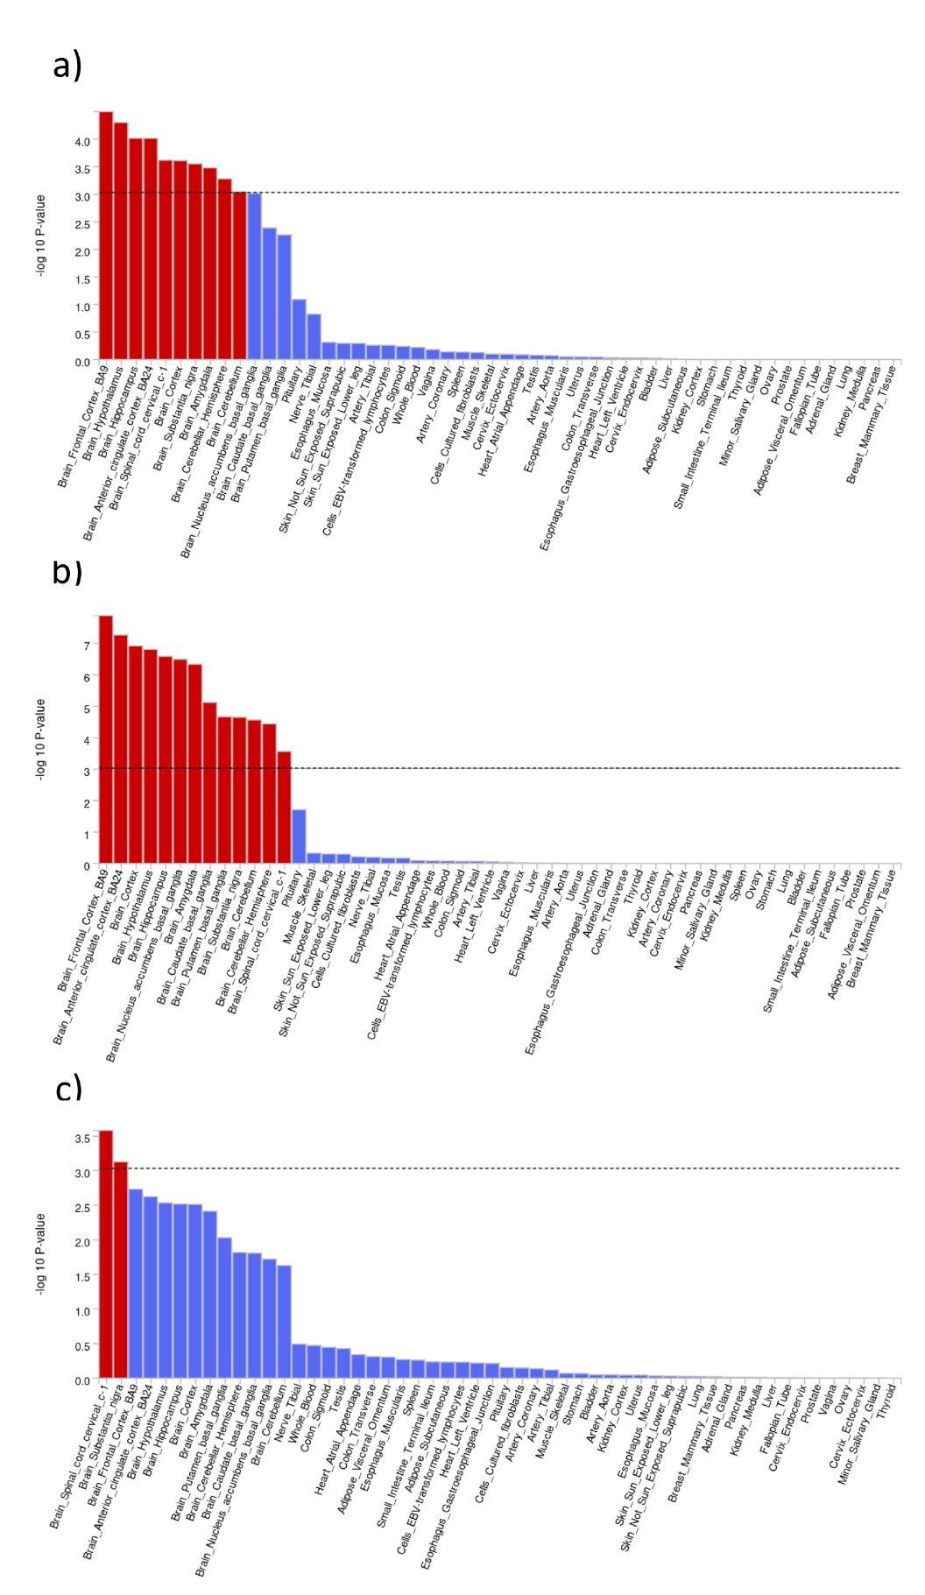
Note: Tissue enrichment analyses with MAGMA. Red bars and the black dashed line indicate Bonferroni threshold, set to p=0.05/54. a) Tissue enrichment results of ADHD total symptom score, b) Tissue enrichment results of inattention domain score, c) Tissue enrichment results of hyperactivity-impulsivity domain score; BA9 - Brodmann area 9; BA24 - Brodmann area 24.
Extended Data Figure 4. Phenome-wide associations between polygenic score for adult ADHD total symptom score, and ICD-10 diagnosis history in Estonian Biobank (N=125,148).
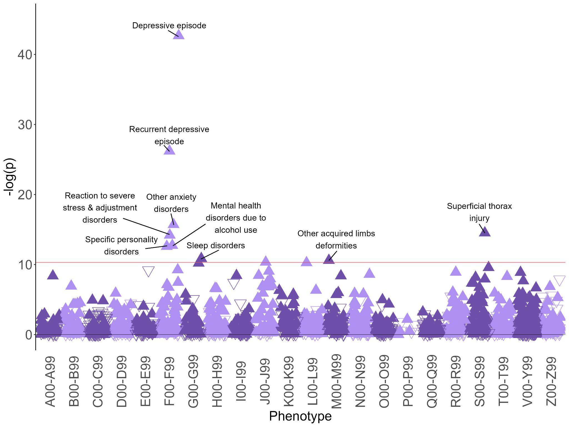
Note: All significant results are labelled. Upwards arrow indicates increased risk; downwards empty arrow indicates reduced risk; red line represents significance threshold at 0.05/1698. Phenotypes are ICD-10 (International Statistical Classification of Diseases and Related Health Problems 10th Revision) categories: A00-B99 - Certain infectious and parasitic diseases, C00-D48 - neoplasms, D50-D89 - Diseases of the blood and blood-forming organs and certain disorders involving the immune mechanism, E00-E90 - Endocrine, nutritional and metabolic diseases, F00-F99 - Mental and behavioural disorders, G00-G99 - Diseases of the nervous system, H00-H59 - Diseases of the eye and adnexa, H60-H95 - Diseases of the ear and mastoid process, I00-I99 - Diseases of the circulatory system, J00-J99 - Diseases of the respiratory system, K00-K93 - Diseases of the digestive system, L00-L99 - Diseases of the skin and subcutaneous tissue, M00-M99 - Diseases of the musculoskeletal system and connective tissue, N00-N99 - Diseases of the genitourinary system, O00-O99 - Pregnancy, childbirth and the puerperium, P00-P96 - Certain conditions originating in the perinatal period, Q00-Q99 - Congenital malformations, deformations and chromosomal abnormalities, R00-R99 - Symptoms, signs and abnormal clinical and laboratory findings, not elsewhere classified, S00-T98 - Injury, poisoning and certain other consequences of external causes, V01-Y98 - External causes of morbidity and mortality, Z00-Z99 - Factors influencing health status and contact with health services.

