Supplementary Materials

The latitudinal biogeography of inter kingdom networks between phytoplankton and zooplankton communities in coastal marine ecosystems
Authors: Zheng Zhang†, Hongjun Li†, Wenli Shen, Xiongfeng Du, Ziyan Wei, Shuzhen Li, Kai Feng, Ye Deng∗

†These authors contributed equally to the work.

Supplementary Figures
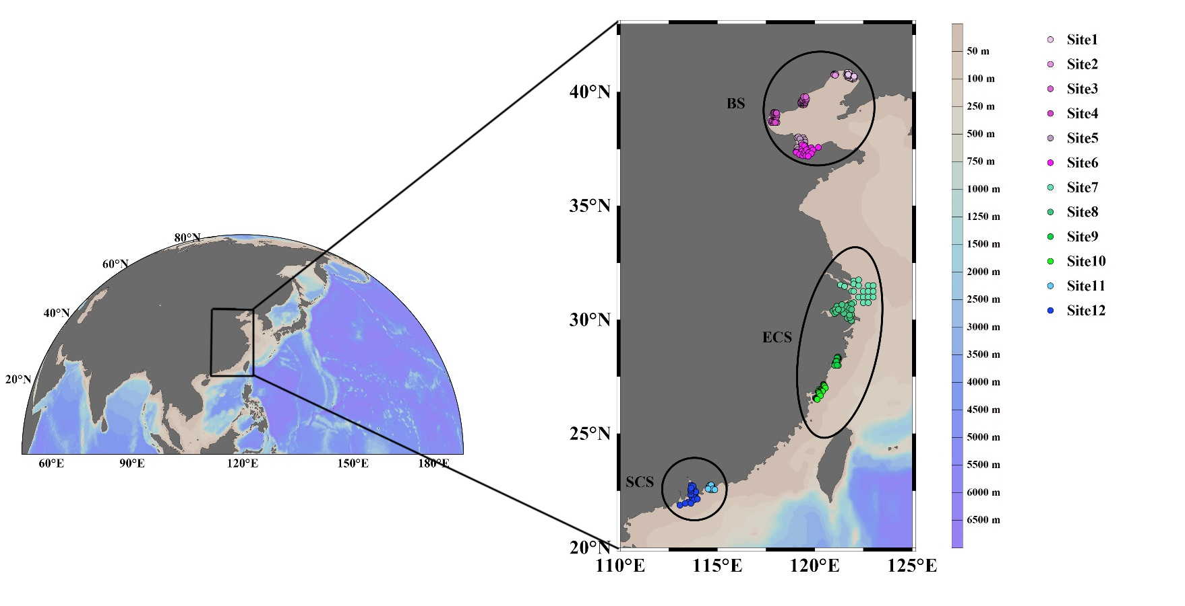
Fig S1. Locations of the 12 sampling sites along the coast of China. (BS) Bohai Sea, (ECS) East China Sea, (SCS) South China Sea.

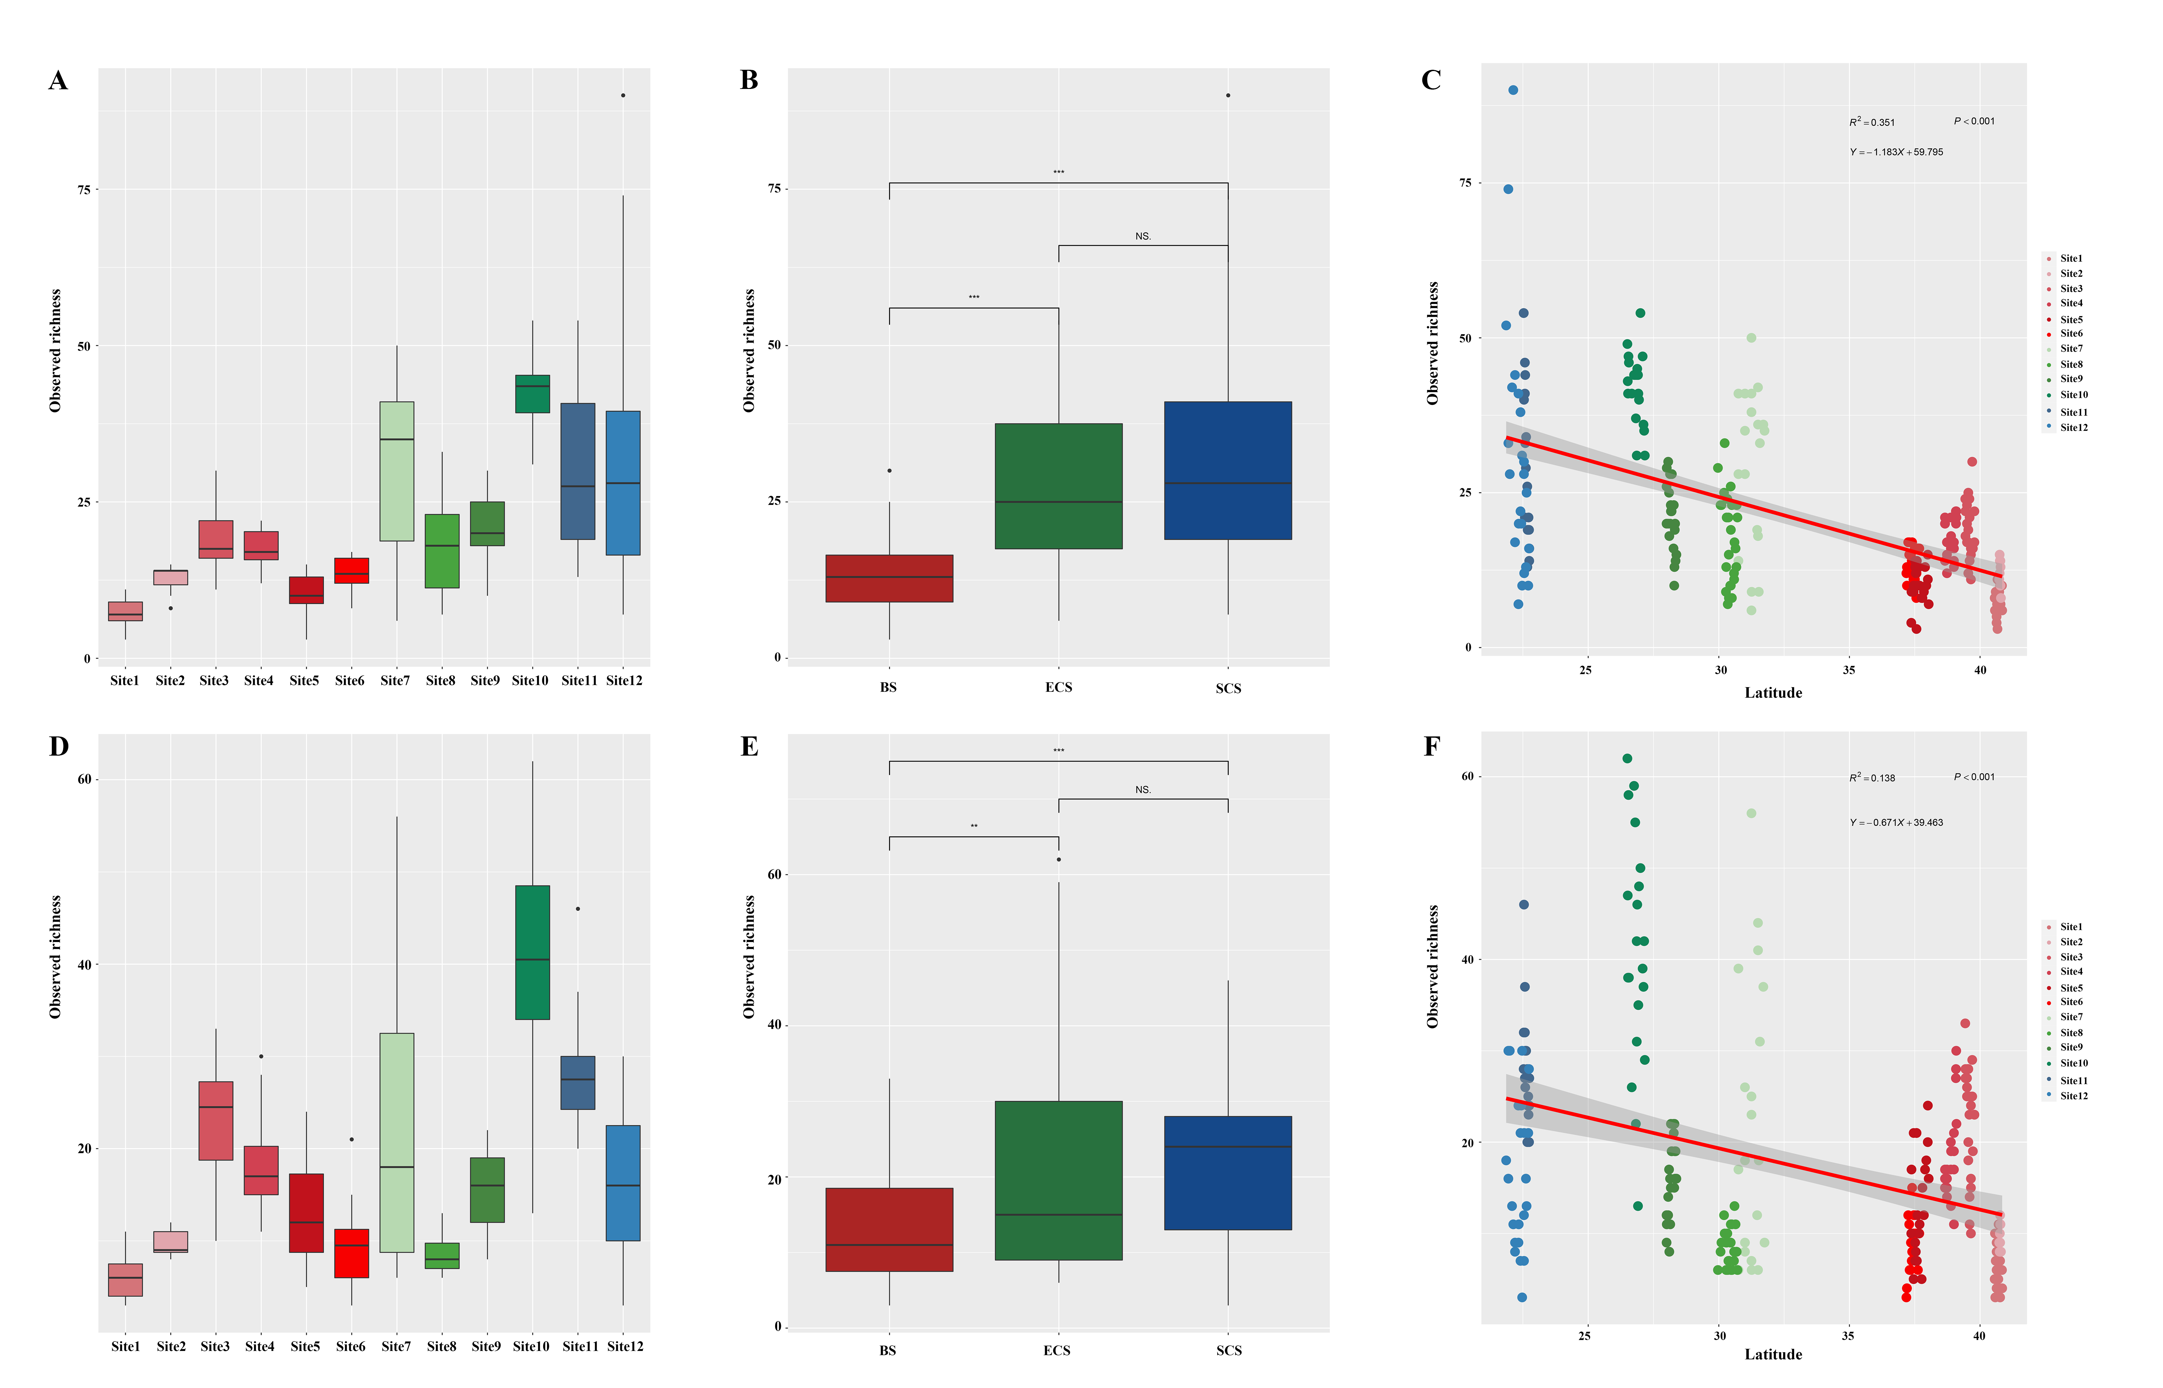
Fig S2. Boxplots showing the variations in observed richness of zooplankton and phytoplankton species along the coast of China. (A, B, C: zooplankton; D, E, F: phytoplankton). Observed richness in different sites with significant difference (Kruskal-Wallis test) were displayed in Table S2 (p-value < 0.05). Comparison of the observed richness between each site. (A and D) and each sampling region (B and E). Distribution of zooplanktonic and phytoplanktonic species based on lm fitting along the 13,000 km (C and F). **, P<0.01; ***, P<0.001. The observed richness was plotted across latitude gradient for zooplankton (C) and phytoplankton (F). The fitting lines denote the ordinary least-squares linear regressions and shown with their 95% confidential regions and the significance of adjusted R-squares.

Fig S3. Drivers of zooplanktonic and phytoplanktonic β-diversity in coastal ecosystem. Distance-decay relationship for both zooplankton (orange) and phytoplankton (blue) Communities in all sites. The line denoted the ordinary least squares linear regression. The slope of zooplankton plot was 0.074, and the slope of phytoplankton plot was 0.047, and both slopes were significantly greater than zero, indicating significant patterns of distance-decay relationship.

Fig S4. Canonical correlation analysis (CCA) showing spatial (red arrows) and environmental (blue arrows) factors that influenced zooplankton (A) and phytoplankton (C) community assembly. All points are colored according to sampling sites. Variation partitioning analysis of the relative importance of spatial distance (SPAT) and environmental variables (ENV) to variation in coastal zooplankton (B) and phytoplankton (D) β-diversity.
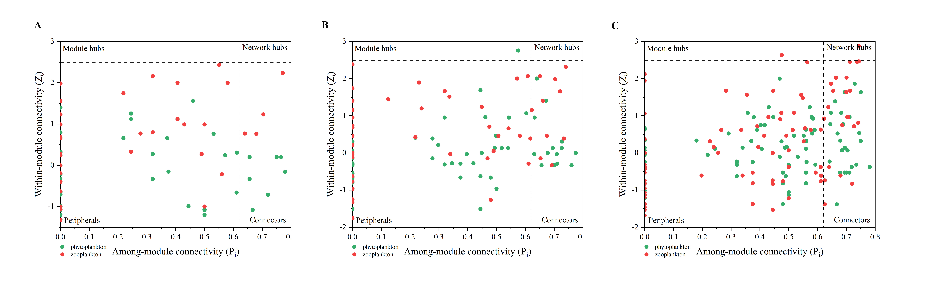
Fig S5. Modular roles of zooplanktonic and phytoplanktonic species based on Z_{i}‒P_{i} value for regional IDEN in three sampling regions. (A) BS; (B) ECS; (C) SCS.

Supplementary Tables
Table S1. Environmental variables of 12 sample sites of Chines coastal bays and estuaries. DO, dissolved oxygen; COD, chemical oxygen demand; NO2-N, nitrite nitrogen; NO3-N, nitrate nitrogen; NH4-N, ammonium nitrogen.
 | Shuangtaizi River Estuary (Site1) | Jinzhou Bay (Site2) | Luan River Estuary-Beidai River (Site3) | Bohai Bay (Site4) | Yellow River Estuary (Site5) | Laizhou Bay (Site6) | Changjiang River Estuary (Site7) | Hangzhou Bay (Site8) | Yueqing Bay (Site9) | Mindong coastal (Site10) | Daya Bay (Site11) | Pearl River Estuary (Site12)
Latitude (°N) | 40.5600-40.8469 | 40.7331-40.7989 | 39.4333-39.7833 | 38.6569-39.0965 | 37.3667-38.0333 | 37.1795-37.6741 | 30.7500-31.7500 | 29.9658-30.7117 | 27.9997-28.3753 | 26.5001-27.1665 | 22.5285-22.7446 | 21.8593-22.7337
Longitude (°E) | 121.6169-122.0331 | 120.9797-121.0789 | 119.2917-119.5900 | 117.7667-118.0667 | 119.0333-119.5167 | 119.0458-120.1809 | 121.3192-123.0003 | 120.9356-121.8969 | 121.0218-121.2174 | 119.6467-120.5499 | 114.5187-114.8625 | 113.0819-113.9995
Sampling time | 08/08/2017 | 08/13/2017 | 08/09/2017-08/26/2017 | 08/07/2017-08/24/2017 | 08/01/2017-08/03/2017 | 08/04/2017-08/17/2017 | 08/01/2017-08/25/2017 | 08/05/2017-08/28/2017 | 08/03/2017-08/09/2017 | 08/20/2017-10/01/2017 | 08/09/2017-08/13/2017 | 08/01/2017-08/20/2017
Depth (m) | 1.9-13 | 8-10 | 3.5-15.2 | 5.5-14.5 | 2-17.8 | 2.7-14.8 | 1.7-51.5 | 3.5-83 | 3.5-67.8 | 5.2-31 | 6.3-21 | 1.3-31
pH | 7.8592^{b} | 7.8475^{b} | 7.9671^{bc} | 8.1120^{d} | 8.0715^{cd} | 8.0540^{cd} | 7.7115ª | 7.9915^{cd} | 8.0186^{cd} | 7.9693^{cd} | 8.2689e | 8.0258^{cd}
Precipitation | 505.1978ª | 505.9450ª | 536.7600^{ab} | 513.4550ª | 584.184^{bc} | 594.6600^{c} | 1290.467e | 1384.328^{f} | 1433.058^{f} | 1406.783e | 1196.940^{d} | 1598.147^{g}
Temperature | 12.8081ª | 12.7907^{ab} | 13.1839^{ab} | 13.3445^{b} | 13.6512^{b} | 13.7067^{b} | 18.8041^{c} | 19.0912^{c} | 20.8742^{d} | 22.1123^{d} | 25.6338e | 25.6560e
Salinity | 30.7530^{cd} | 31.1641^{cd} | 31.3846^{cd} | 29.2985^{cd} | 29.0378^{cd} | 30.1730^{cd} | 25.6841^{bc} | 15.6356ª | 27.4561^{c} | 31.6550^{d} | 33.8641^{d} | 20.8432^{ab}
COD (mg/L) | 2.2374^{f} | 1.8075^{ef} | 1.3221^{cde} | 1.9615^{f} | 1.2616^{bcde} | 1.2712b^{cde} | 0.8837^{abcd} | 2.3346^{f} | 0.7295^{ab} | 0.6033ª | 0.7978^{abc} | 1.3195de
DO (mg/L) | 10.5640^{f} | 5.9608^{c} | 8.1675e | 7.2545de | 6.6680^{cd} | 6.7330^{cd} | 4.1573^{ab} | 6.8103^{cd} | 7.1571de | 6.5956de | 3.5144ª | 4.7170^{b}
Pb (mg/L) | 0.0002ª | 0.0011ª | 0.0007ª | 0.0012ª | 0.0014ª | 0.0008ª | 0.0006ª | 0.4836^{d} | 0.2266^{b} | 0.2558^{c} | 0.0008ª | 0.0007ª
As (mg/L) | 0.0040ª | 0.0021ª | 0.0017ª | 0.002098ª | 0.001186ª | 0.0024ª | 0.001635ª | 1.6263^{d} | 0.8733^{b} | 0.7064^{c} | 0.0017ª | 0.002033ª
Cu (mg/L) | 0.0038ª | 0.0021ª | 0.0011ª | 0.002025ª | 0.001713ª | 0.0029ª | 0.000913ª | 2.1578^{d} | 1.1266^{b} | 0.2878^{c} | 0.0007ª | 0.001341ª
Zn (mg/L) | 0.0299ª | 0.0187ª | 0.0141ª | 0.0088ª | 0.0154ª | 0.0217ª | 0.0043ª | 6.1736^{b} | 0.0045ª | 4.9272^{b} | 0.0045ª | 0.0064ª
NO₂-N (mg/L) | 0.0908^{bcd} | 0.0196ª | 0.0037ª | 0.1564^{d} | 0.0316^{ab} | 0.0182ª | 0.0109ª | 0.0045ª | 0.0533^{abc} | 0.0325ª | 0.0112ª | 0.1062^{cd}
NO₃-N (mg/L) | 0.2367^{ab} | 0.2046^{ab} | 0.0366ª | 0.1762^{ab} | 0.1557^{ab} | 0.1793^{ab} | 0.3956^{b} | 1.4194^{c} | 0.2189^{ab} | 0.1056^{ab} | 0.0410ª | 1.0600^{c}
NH₄-N (mg/L) | 0.0332^{abcd} | 0.0021ª | 0.0250^{abc} | 0.0657^{d} | 0.0485^{bcd} | 0.0544^{bcd} | 0.0226^{ab} | 0.0167^{ab} | 0.0272^{abcd} | 0.0288^{ab} | 0.0158^{ab} | 0.0617^{cd}
Chlorophyll-a (μg/L) | 0.2168ª | 6.4415^{cde} | 3.2791^{abcd} | 8.7490e | 1.5040^{ab} | 2.4347^{abc} | 1.1102ª | 1.1500ª | 4.1666^{abcd} | 2.1879^{ab} | 7.4444de | 5.5362^{bcde}
Different superscript letters indicate significant difference.

Table S2. The Kruskal-Wallis test of the observed richness in different sites.

zooplankton |  |  |  |  | phytoplankton
Comparison | Z | P.unadj | P.adj |  | Comparison | Z | P.unadj | P.adj
Site1 - Site2 | -2.2204 | 0.0264 | 1.0000 |  | Site1 - Site2 | -1.7978 | 0.0722 | 1.0000
Site1 - Site3 | -5.5741 | 0.0000 | 0.0000 |  | Site1 - Site3 | -7.1188 | 0.0000 | 0.0000
Site1 - Site4 | -4.9955 | 0.0000 | 0.0000 |  | Site1 - Site4 | -5.6266 | 0.0000 | 0.0000
Site1 - Site5 | -1.3524 | 0.1762 | 1.0000 |  | Site1 - Site5 | -3.4689 | 0.0005 | 0.0345
Site1 - Site6 | -3.0262 | 0.0025 | 0.1634 |  | Site1 - Site6 | -1.7166 | 0.0860 | 1.0000
Site1 - Site7 | -7.0862 | 0.0000 | 0.0000 |  | Site1 - Site7 | -5.1605 | 0.0000 | 0.0000
Site1 - Site8 | -4.8867 | 0.0000 | 0.0001 |  | Site1 - Site8 | -1.4076 | 0.1592 | 1.0000
Site1 - Site9 | -6.0687 | 0.0000 | 0.0000 |  | Site1 - Site9 | -4.8469 | 0.0000 | 0.0001
Site1 - Site10 | -9.6162 | 0.0000 | 0.0000 |  | Site1 - Site10 | -9.0564 | 0.0000 | 0.0000
Site1 - Site11 | -7.1532 | 0.0000 | 0.0000 |  | Site1 - Site11 | -7.8066 | 0.0000 | 0.0000
Site1 - Site12 | -6.9424 | 0.0000 | 0.0000 |  | Site1 - Site12 | -4.7820 | 0.0000 | 0.0001
Site2 - Site3 | -2.2441 | 0.0248 | 1.0000 |  | Site2 - Site3 | -3.8845 | 0.0001 | 0.0068
Site2 - Site4 | -1.9264 | 0.0541 | 1.0000 |  | Site2 - Site4 | -2.8378 | 0.0045 | 0.2998
Site2 - Site5 | 1.0170 | 0.3092 | 1.0000 |  | Site2 - Site5 | -1.0945 | 0.2737 | 1.0000
Site2 - Site6 | -0.3353 | 0.7374 | 1.0000 |  | Site2 - Site6 | 0.3212 | 0.7480 | 1.0000
Site2 - Site7 | -3.6156 | 0.0003 | 0.0198 |  | Site2 - Site7 | -2.4612 | 0.0138 | 0.9139
Site2 - Site8 | -1.6401 | 0.1010 | 1.0000 |  | Site2 - Site8 | 0.6790 | 0.4971 | 1.0000
Site2 - Site9 | -2.7506 | 0.0059 | 0.3926 |  | Site2 - Site9 | -2.1735 | 0.0297 | 1.0000
Site2 - Site10 | -5.6597 | 0.0000 | 0.0000 |  | Site2 - Site10 | -5.6089 | 0.0000 | 0.0000
Site2 - Site11 | -3.7735 | 0.0002 | 0.0106 |  | Site2 - Site11 | -4.7004 | 0.0000 | 0.0002
Site2 - Site12 | -3.3686 | 0.0008 | 0.0499 |  | Site2 - Site12 | -2.0588 | 0.0395 | 1.0000
Site3 - Site4 | 0.2972 | 0.7663 | 1.0000 |  | Site3 - Site4 | 1.1136 | 0.2654 | 1.0000
Site3 - Site5 | 3.8471 | 0.0001 | 0.0079 |  | Site3 - Site5 | 3.2161 | 0.0013 | 0.0858
Site3 - Site6 | 2.2162 | 0.0267 | 1.0000 |  | Site3 - Site6 | 4.9236 | 0.0000 | 0.0001
Site3 - Site7 | -1.7400 | 0.0819 | 1.0000 |  | Site3 - Site7 | 1.5678 | 0.1169 | 1.0000
Site3 - Site8 | 0.7809 | 0.4349 | 1.0000 |  | Site3 - Site8 | 5.6889 | 0.0000 | 0.0000
Site3 - Site9 | -0.6759 | 0.4991 | 1.0000 |  | Site3 - Site9 | 1.9641 | 0.0495 | 1.0000
Site3 - Site10 | -4.2052 | 0.0000 | 0.0017 |  | Site3 - Site10 | -2.2284 | 0.0259 | 1.0000
Site3 - Site11 | -1.9656 | 0.0493 | 1.0000 |  | Site3 - Site11 | -1.2134 | 0.2250 | 1.0000
Site3 - Site12 | -1.3919 | 0.1639 | 1.0000 |  | Site3 - Site12 | 2.1941 | 0.0282 | 1.0000
Site4 - Site5 | 3.3987 | 0.0007 | 0.0447 |  | Site4 - Site5 | 2.0129 | 0.0441 | 1.0000
Site4 - Site6 | 1.8372 | 0.0662 | 1.0000 |  | Site4 - Site6 | 3.6477 | 0.0003 | 0.0175
Site4 - Site7 | -1.9505 | 0.0511 | 1.0000 |  | Site4 - Site7 | 0.4348 | 0.6637 | 1.0000
Site4 - Site8 | 0.4406 | 0.6595 | 1.0000 |  | Site4 - Site8 | 4.2807 | 0.0000 | 0.0012
Site4 - Site9 | -0.9344 | 0.3501 | 1.0000 |  | Site4 - Site9 | 0.7992 | 0.4242 | 1.0000
Site4 - Site10 | -4.3108 | 0.0000 | 0.0011 |  | Site4 - Site10 | -3.1998 | 0.0014 | 0.0908
Site4 - Site11 | -2.1634 | 0.0305 | 1.0000 |  | Site4 - Site11 | -2.2023 | 0.0276 | 1.0000
Site4 - Site12 | -1.6228 | 0.1046 | 1.0000 |  | Site4 - Site12 | 0.9912 | 0.3216 | 1.0000
Site5 - Site6 | -1.5615 | 0.1184 | 1.0000 |  | Site5 - Site6 | 1.6348 | 0.1021 | 1.0000
Site5 - Site7 | -5.3493 | 0.0000 | 0.0000 |  | Site5 - Site7 | -1.5781 | 0.1145 | 1.0000
Site5 - Site8 | -3.1730 | 0.0015 | 0.0996 |  | Site5 - Site8 | 2.1405 | 0.0323 | 1.0000
Site5 - Site9 | -4.3744 | 0.0000 | 0.0008 |  | Site5 - Site9 | -1.2382 | 0.2157 | 1.0000
Site5 - Site10 | -7.7095 | 0.0000 | 0.0000 |  | Site5 - Site10 | -5.2127 | 0.0000 | 0.0000
Site5 - Site11 | -5.4715 | 0.0000 | 0.0000 |  | Site5 - Site11 | -4.1616 | 0.0000 | 0.0021
Site5 - Site12 | -5.1381 | 0.0000 | 0.0000 |  | Site5 - Site12 | -1.0908 | 0.2754 | 1.0000
Site6 - Site7 | -3.7878 | 0.0002 | 0.0100 |  | Site6 - Site7 | -3.2129 | 0.0013 | 0.0867
Site6 - Site8 | -1.5127 | 0.1303 | 1.0000 |  | Site6 - Site8 | 0.4024 | 0.6874 | 1.0000
Site6 - Site9 | -2.7939 | 0.0052 | 0.3437 |  | Site6 - Site9 | -2.8927 | 0.0038 | 0.2520
Site6 - Site10 | -6.1480 | 0.0000 | 0.0000 |  | Site6 - Site10 | -6.8475 | 0.0000 | 0.0000
Site6 - Site11 | -3.9517 | 0.0001 | 0.0051 |  | Site6 - Site11 | -5.7527 | 0.0000 | 0.0000
Site6 - Site12 | -3.5230 | 0.0004 | 0.0282 |  | Site6 - Site12 | -2.7816 | 0.0054 | 0.3570
Site7 - Site8 | 2.5145 | 0.0119 | 0.7868 |  | Site7 - Site8 | 3.8183 | 0.0001 | 0.0089
Site7 - Site9 | 1.0398 | 0.2984 | 1.0000 |  | Site7 - Site9 | 0.3591 | 0.7195 | 1.0000
Site7 - Site10 | -2.3603 | 0.0183 | 1.0000 |  | Site7 - Site10 | -3.6346 | 0.0003 | 0.0184
Site7 - Site11 | -0.2649 | 0.7911 | 1.0000 |  | Site7 - Site11 | -2.6255 | 0.0087 | 0.5710
Site7 - Site12 | 0.3947 | 0.6931 | 1.0000 |  | Site7 - Site12 | 0.5415 | 0.5882 | 1.0000
Site8 - Site9 | -1.4417 | 0.1494 | 1.0000 |  | Site8 - Site9 | -3.4884 | 0.0005 | 0.0321
Site8 - Site10 | -5.0239 | 0.0000 | 0.0000 |  | Site8 - Site10 | -7.6828 | 0.0000 | 0.0000
Site8 - Site11 | -2.7198 | 0.0065 | 0.4312 |  | Site8 - Site11 | -6.4858 | 0.0000 | 0.0000
Site8 - Site12 | -2.1911 | 0.0284 | 1.0000 |  | Site8 - Site12 | -3.3891 | 0.0007 | 0.0463
Site9 - Site10 | -3.4286 | 0.0006 | 0.0400 |  | Site9 - Site10 | -4.0378 | 0.0001 | 0.0036
Site9 - Site11 | -1.2793 | 0.2008 | 1.0000 |  | Site9 - Site11 | -3.0049 | 0.0027 | 0.1753
Site9 - Site12 | -0.6766 | 0.4987 | 1.0000 |  | Site9 - Site12 | 0.1768 | 0.8597 | 1.0000
Site10 - Site11 | 2.0324 | 0.0421 | 1.0000 |  | Site10 - Site11 | 0.9122 | 0.3617 | 1.0000
Site10 - Site12 | 2.8359 | 0.0046 | 0.3016 |  | Site10 - Site12 | 4.3008 | 0.0000 | 0.0011
Site11 - Site12 | 0.6569 | 0.5112 | 1.0000 |  | Site11 - Site12 | 3.2367 | 0.0012 | 0.0798
red means the P<0.05

Table S3. CCA of spatial and environmental factors for zooplankton and phytoplankton communities
Constrained factors |  | Zooplankton |  | Phytoplankton
 |  | F | P | F | P
Spatial factors | PCNM1 | 9.285 | 0.001 | 5.422 | 0.001
Spatial factors | PCNM2 | 7.851 | 0.001 | / | /
Spatial factors | PCNM3 | 6.618 | 0.005 | 4.891 | 0.001
Spatial factors | PCNM4 | 3.539 | 0.003 | 2.406 | 0.002
Spatial factors | PCNM6 | 4.208 | 0.019 | / | /
Spatial factors | PCNM10 | 4.903 | 0.001 | / | /
Spatial factors | PCNM12 | 7.261 | 0.001 | / | /
Spatial factors | PCNM14 | / | / | 4.984 | 0.001
Spatial factors | PCNM15 | 3.830 | 0.012 | 9.764 | 0.001
Spatial factors | PCNM16 | 8.237 | 0.003 | / | /
Environmental factors | pH | 2.928 | 0.001 | 8.027 | 0.001
Environmental factors | NH4N | 6.575 | 0.001 | 3.696 | 0.033
Environmental factors | NO3N | 7.280 | 0.001 | / | /
Environmental factors | COD | 7.529 | 0.001 | 6.205 | 0.001
Environmental factors | DO | 8.396 | 0.001 | 3.397 | 0.001
Environmental factors | Pb | 6.221 | 0.001 | 2.863 | 0.012
Environmental factors | Cu | 7.825 | 0.001 | 4.206 | 0.001
Environmental factors | Zn | 5.253 | 0.001 | / | /
 | Salinity | 6.945 | 0.001 | 4.147 | 0.005

∗ Correspondence: yedeng@rcees.ac.cn

