Supplementary Figures
Figure S1. AKT
Figure S2. p-AKT

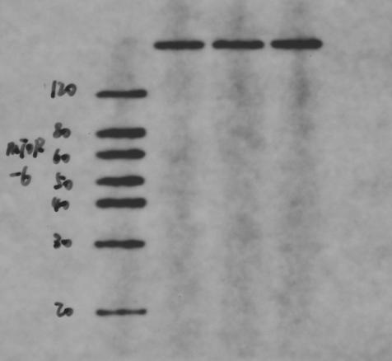
Figure S3. mTOR(figure2B)
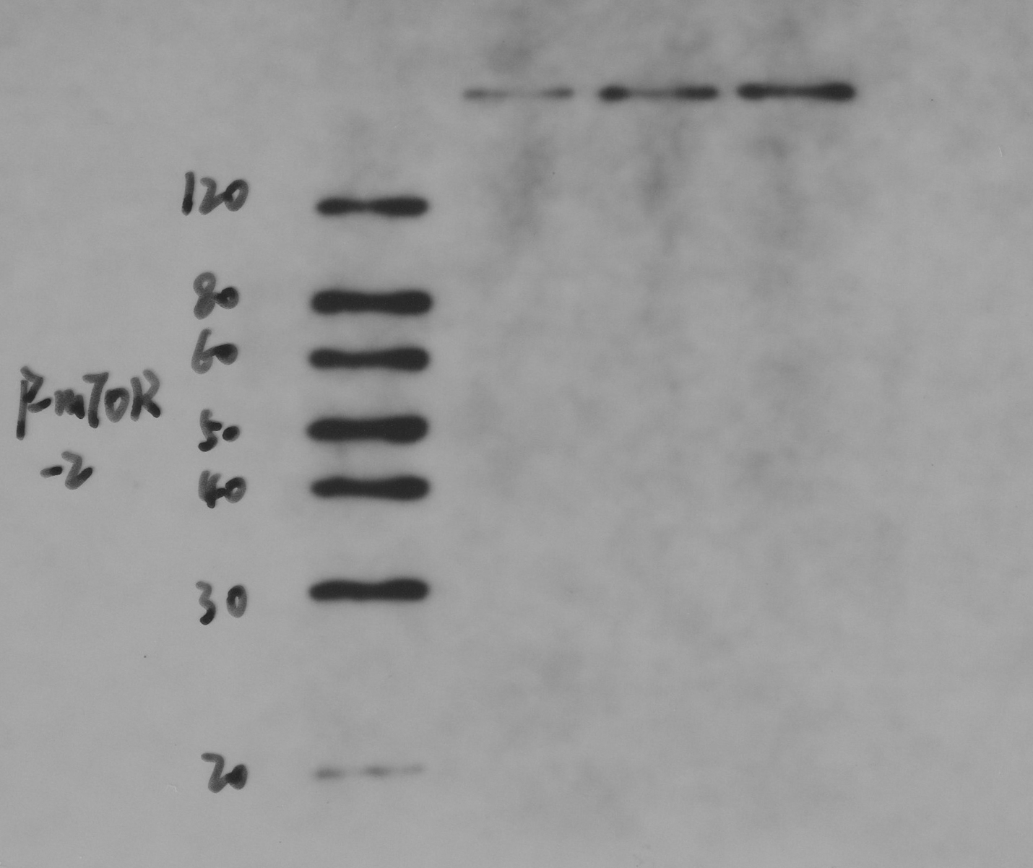
Figure S4. p-mTOR(figure 2B)
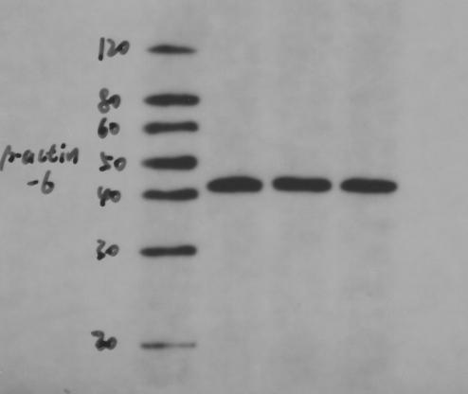
Figure S5. β-actin(figure2B)
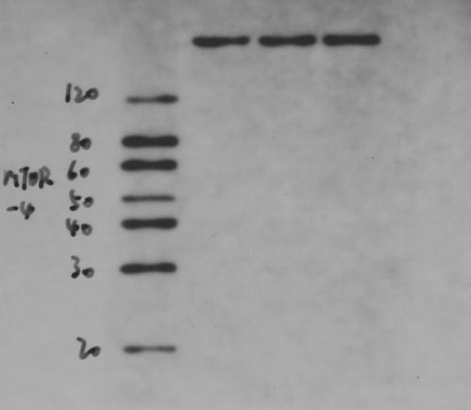
Figure S6. mTOR(figure2C)

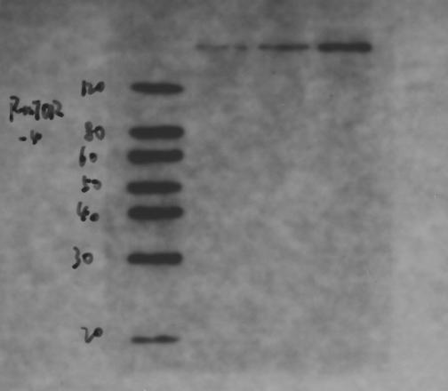
Figure S7. p-mTOR(figure2C)
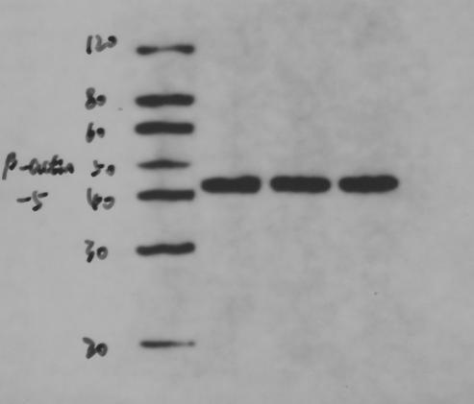
Figure S8. β-actin(figure2C)
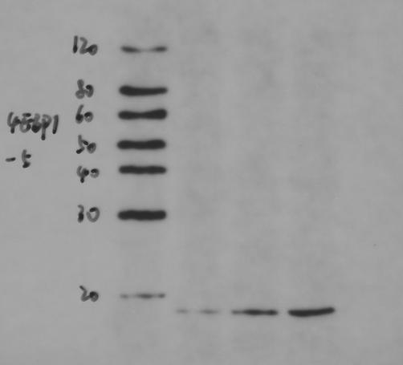
Figure S9. 4EBP1
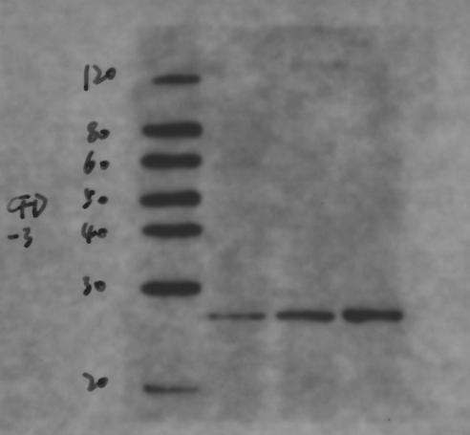
Figure S10 .CFD

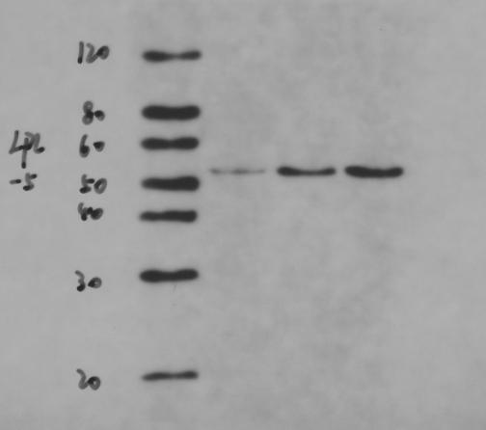
Figure S11. LPL
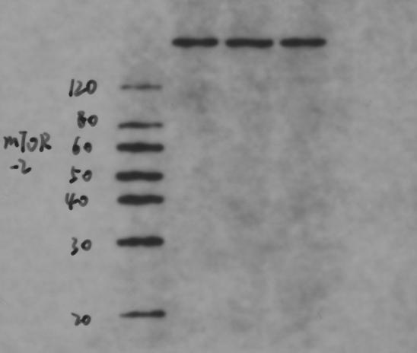
Figure S12. mTOR
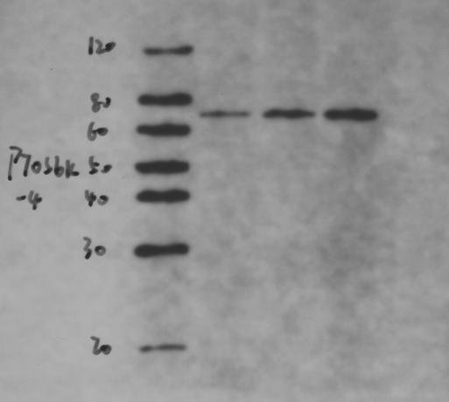
Figure S13. P70S6K
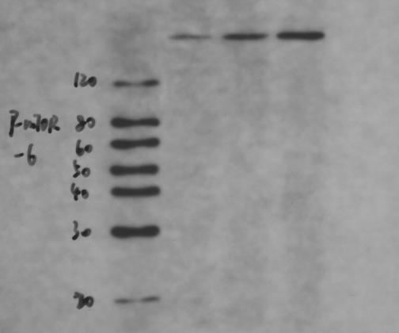
Figure S14. p-mTOR
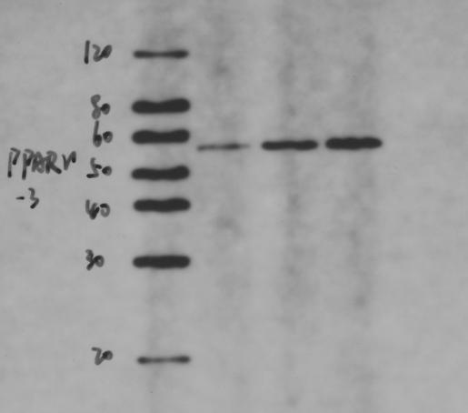
Figure S15. PPARγ
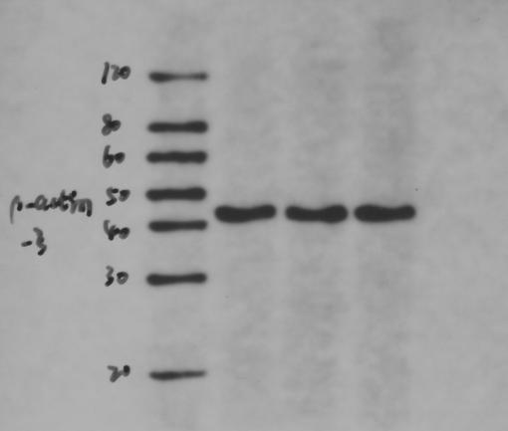
Figure S16. β-ACTIN

