Supplementary Files

Supplementary Tables
Supplementary Table 1 First month characteristics of the participants in the treatment groups 2
Supplementary Table 2 Third month characteristics of the participants in the treatment groups 3
Supplementary Table 3 Sixth month characteristics of the participants in the treatment groups 4

Supplementary Figures
Supplementary Figure 1 Individual trajectories of dysphagia severity following balloon dilation 5
Supplementary Figure 2 Individual trajectories of dysphagia severity following bougie dilation 6
Supplementary Figure 3 Individual trajectories of dysphagia severity following incisional therapy 7

Supplementary Table 1 First month characteristics of the participants in the treatment groups
Characteristic | Group |  |  |  | P-value¹
 | Total  (N=75) | Balloon Dilation  (N=25) | Bougie  (N=25) | Incisional  (N=25)
Weight, kg | 73.64±9.25 | 71.44±9.17 | 74.64±8.90 | 74.84±9.65 | 0.350
BMI, kg/m² | 25.31 (23.39, 27.88) | 24.22 (26.65, 27.07) | 27.43 (24.58, 28.43) | 25.73 (23.39, 27.86) | 0.102
Stricture Diameter, mm | 7.0 (5.0, 9.0) | 6.00 (5.00, 7.00) | 6.00 (5.00, 6.00) | 9.00 (8.50, 10.00) | <0.001
Dysphagia Severity |  |  |  |  | <0.001
Food Aspiration | 14 (18.7%) | 5 (20.0%) | 9 (36.0%) | 0 (0%)
Water Aspiration | 47 (62.7%) | 19 (76.0%) | 16 (64.0%) | 12 (48.0%)
Occasional Aspiration | 13 (17.3%) | 1 (4.0%) | 0 (0%) | 12 (48.0%)
Oral Problems | 1 (1.3%) | 0 (0%) | 0 (0%) | 1 (4.0%)
EQ Score | 11.0 (10.0, 12.0) | 12.00 (11.00, 13.00) | 11.00 (10.00, 12.00) | 11.00 (10.00, 12.00) | 0.035
Health Score | 40.0 (40.0, 40.45) | 40.00 (37.50, 42.73) | 40.00 (35.00, 40.45) | 40.45 (40.00, 45.00) | 0.059
¹: One-way ANOVA test, Kruskal-Wallis Test, Fisher–Freeman–Halton exact test.
Continuous data are presented as mean ± standard deviation or median (Q₁, Q₃).
Categorical data are presented as frequencies and percentages.

Supplementary Table 2 Third month characteristics of the participants in the treatment groups
Characteristic | Groups |  |  |  | P-value¹
 | Total (N=75) | Balloon dilation (N=25) | Bougie dilation (N=25) | Incisional therapy (N=25)
Weight, kg | 74.68 ± 9.07 | 72.00 ± 8.80 | 76.24 ± 8.87 | 75.80 ± 9.27 | 0.193
BMI, kg/m² | 25.73 (23.81, 28.13) | 24.31 (22.69, 27.25) | 27.76 (25.28, 29.36) | 26.35 (23.85, 27.92) | 0.043
Stricture diameter, mm | 10.00 (9.00, 13.00) | 10.00 (9.00, 10.00) | 9.00 (8.50, 10.00) | 14.00 (12.00, 15.00) | <0.001
Dysphagia severity |  |  |  |  | <0.001
Food aspiration | 3 (4.0%) | 0 (0.0%) | 3 (12.0%) | 0 (0.0%)
Water aspiration | 17 (22.7%) | 8 (32.0%) | 9 (36.0%) | 0 (0.0%)
Occasional aspiration | 39 (52.0%) | 17 (68.0%) | 13 (52.0%) | 9 (36.0%)
Oral problems | 13 (17.3%) | 0 (0.0%) | 0 (0.0%) | 13 (52.0%)
Minimum problems | 3 (4.0%) | 0 (0.0%) | 0 (0.0%) | 3 (12.0%)
EQ score | 9.00 (8.00, 9.00) | 8.00 (8.00, 9.00) | 9.00 (9.00, 10.00) | 8.00 (7.00, 9.00) | <0.001
Health score | 60.00 (55.00, 60.00) | 60.00 (55.00, 60.00) | 55.56 (52.50, 60.00) | 60.00 (60.00, 70.00) | <0.001
¹: One-way ANOVA test, Kruskal-Wallis Test, Fisher–Freeman–Halton exact test.
Continuous data are presented as mean ± standard deviation or median (Q₁, Q₃).
Categorical data are presented as frequencies and percentages.

Supplementary Table 3 Sixth month characteristics of the participants in the treatment groups
Characteristic | Groups |  |  |  | P-value¹
 | Total (N=75) | Balloon dilation (N=25) | Bougie dilation (N=25) | Incisional therapy (N=25)
Weight, kg | 75.51 ± 8.94 | 72.72 ± 8.74 | 77.12 ± 8.80 | 76.68 ± 8.98 | 0.160
BMI, kg/m² | 26.06 (23.94, 28.67) | 24.68 (23.00, 27.45) | 27.76 (25.54, 29.69) | 26.72 (23.85, 28.24) | 0.044
Stricture diameter, mm | 15.00 (13.00, 16.00) | 14.00 (13.00, 15.00) | 14.00 (13.00, 15.00) | 16.00 (16.00, 17.00) | <0.001
Dysphagia severity |  |  |  |  | <0.001
Water aspiration | 2 (2.7%) | 0 (0.0%) | 2 (8.0%) | 0 (0.0%)
Occasional aspiration | 5 (6.7%) | 0 (0.0%) | 5 (20.0%) | 0 (0.0%)
Oral problems | 31 (41.3%) | 16 (64.0%) | 10 (40.0%) | 5 (20.0%)
Minimum problems | 31 (41.3%) | 9 (36.0%) | 8 (32.0%) | 14 (56.0%)
Within Normal Limits | 6 (8.0%) | 0 (0.0%) | 0 (0.0%) | 6 (24.0%)
EQ score | 7.00 (6.00, 8.00) | 7.00 (6.00, 8.00) | 8.00 (7.00, 9.00) | 6.00 (6.00, 7.00) | <0.001
Health score | 75.00 (70.00, 85.00) | 75.00 (70.00, 85.00) | 75.00 (65.00, 75.00) | 85.00 (75.00, 90.00) | <0.001
¹: One-way ANOVA test, Kruskal-Wallis Test, Fisher–Freeman–Halton exact test.
Continuous data are presented as mean ± standard deviation or median (Q₁, Q₃).
Categorical data are presented as frequencies and percentages.

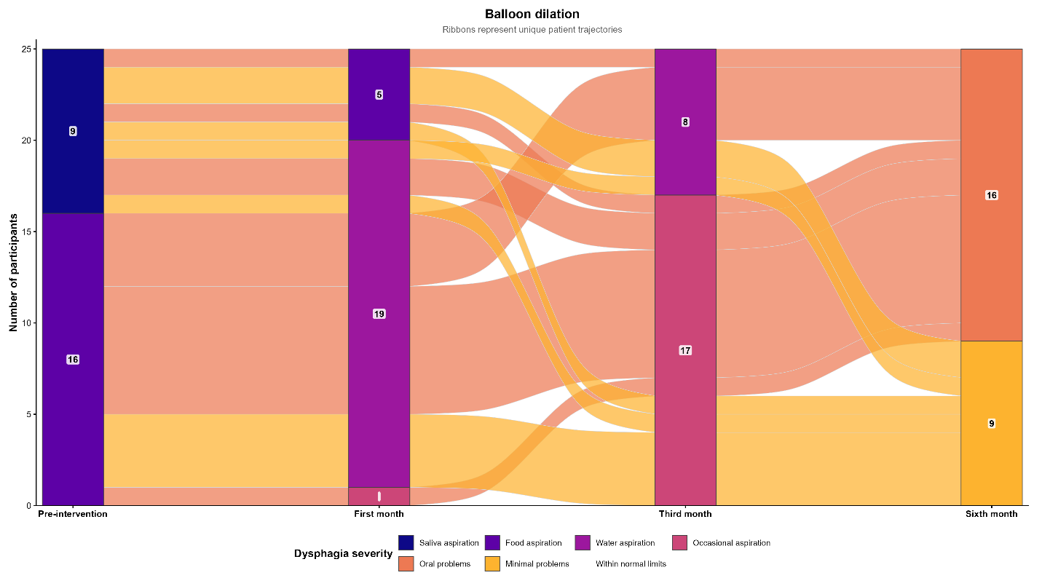
Supplementary Figure 1 Individual trajectories of dysphagia severity following balloon dilation.
Alluvial diagram showing transitions in dysphagia severity from pre-intervention to 1, 3, and 6 months among patients treated with balloon dilation. Each vertical segment represents the number of patients within a dysphagia category at the corresponding assessment, with numerical labels indicating patient counts. Connecting ribbons represent individual patient trajectories between consecutive assessments, and colors correspond to dysphagia severity categories.

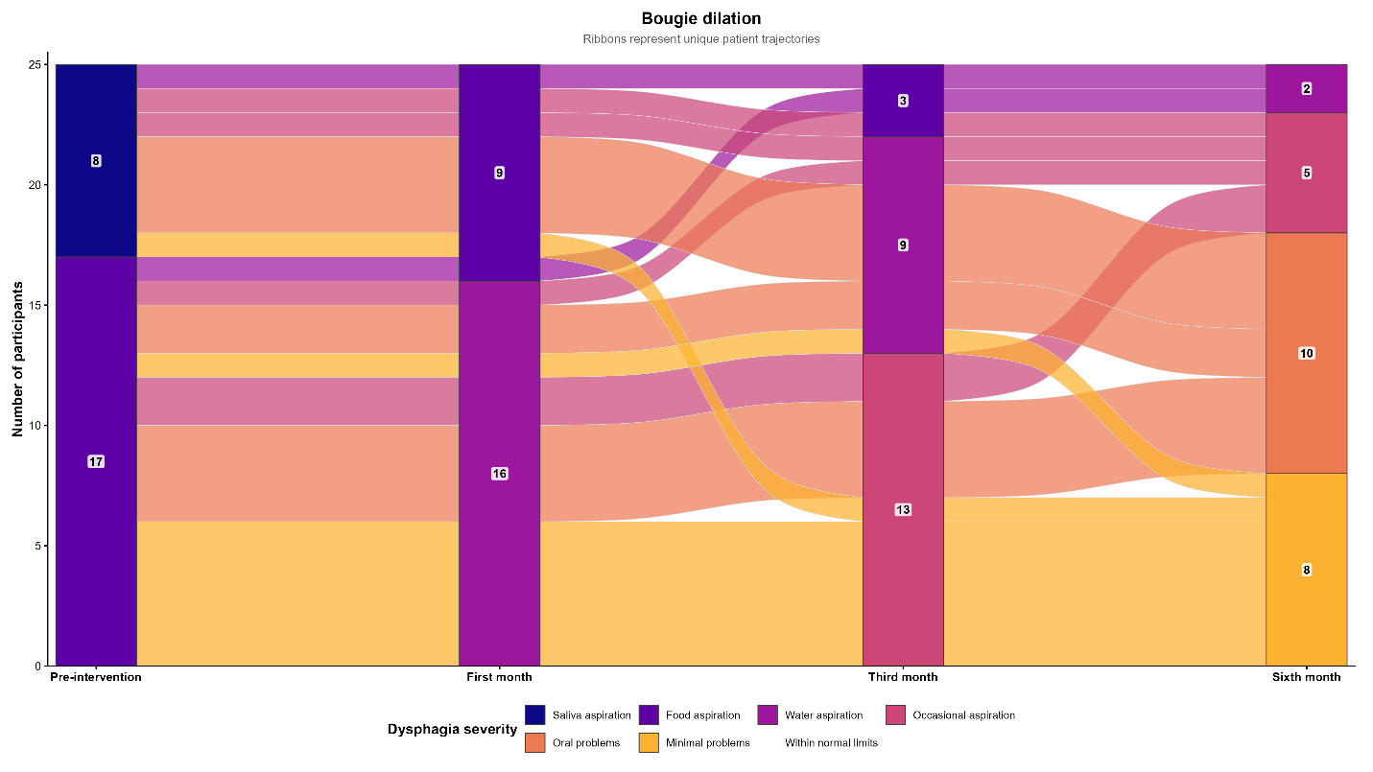
Supplementary Figure 2 Individual trajectories of dysphagia severity following bougie dilation.
Alluvial diagram showing transitions in dysphagia severity from pre-intervention to 1, 3, and 6 months among patients treated with bougie dilation. Each vertical segment represents the number of patients in each dysphagia category at the corresponding assessment, with numerical labels indicating patient counts. Connecting ribbons represent individual patient trajectories between consecutive assessments, and colors correspond to dysphagia severity categories.
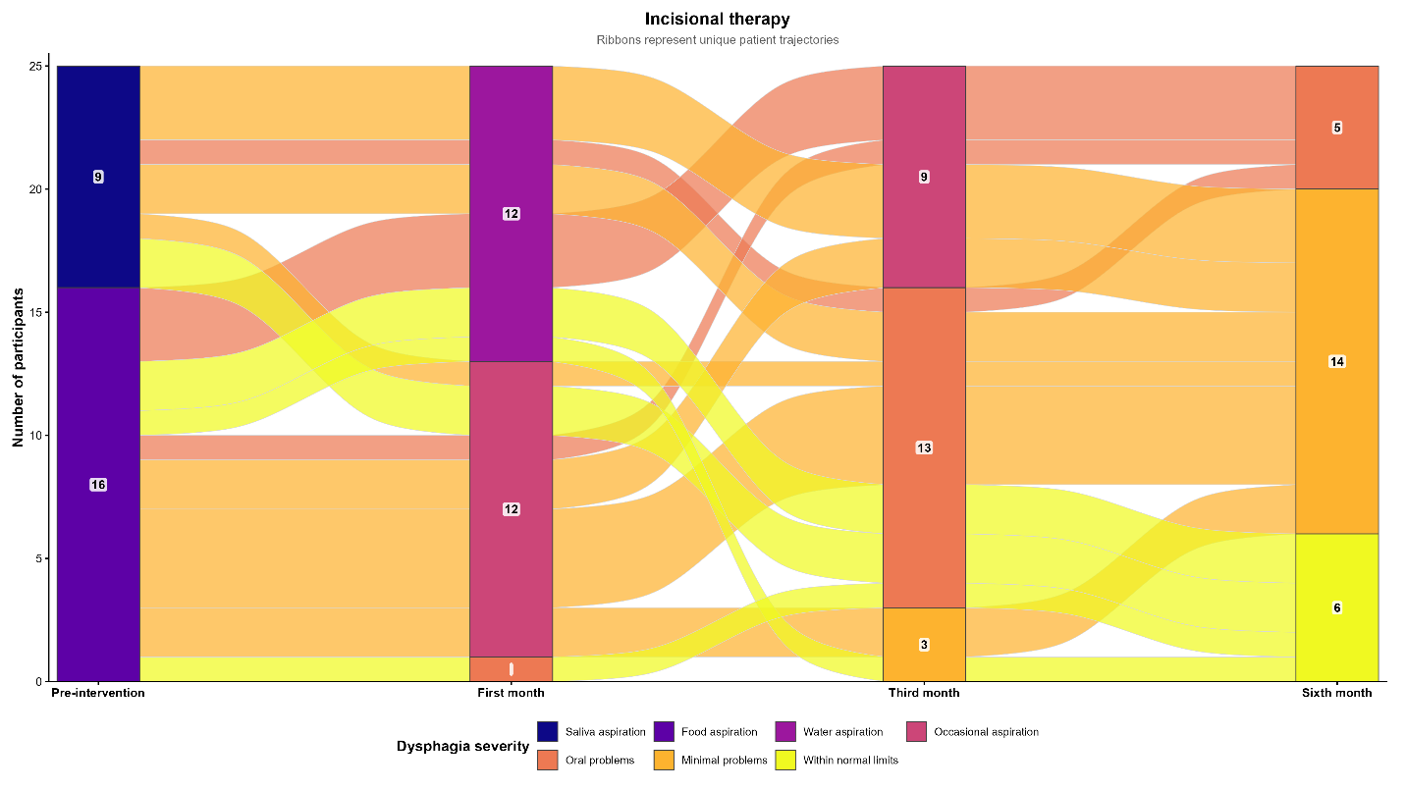
Supplementary Figure 3 Individual trajectories of dysphagia severity following incisional therapy.
Alluvial diagram showing transitions in dysphagia severity from pre-intervention to 1, 3, and 6 months among patients treated with incisional therapy. Each vertical segment represents the number of patients in each dysphagia category at the corresponding assessment, with numerical labels indicating patient counts. Connecting ribbons depict individual patient trajectories between consecutive assessments, and colors correspond to dysphagia severity categories.

