Supplementary Information for

Assessing technological pathways for a circular PET management in Switzerland integrating MFA, LCA and TEA

Soline Corre^{a, b*}, Gabriel Magnaval^{b,c}, Oktay Boztasª, Manuele Margni^{b,c}, François Maréchal^{a, b}
ªEPFL, IPESE, rue de l’industrie, 17, Sion, 1950, Valais, Switzerland
^{b}Polytechnique Montreal, CIRAIG, Department of Chemical Engineering, 2500 Chem. De Polytechnique, Montreal, Canada
^{c}HES-SO Valais-Wallis, CIRAIG, Rue de l’Industrie 21, Sion, Switzerland
* corresponding author details: soline.corre@epfl.ch

Aim of this document
This document compiles detailed methodologies and background data definitions related to the analysis of various technological pathways for PET management in Switzerland.

Complementary results are also displayed, including sensitivities and further analysis.

Table of Contents
S-M1. Methods – Background data definition 3
S-M1.1 Nomenclature 3
S-M1.2 PET end-use and waste quantities per sector 3
S-M1.3 Downcycling specificities 4
S-M1.4 Collection rates 4
S-M1.5 Distribution of material flows among the various technologies 5
S-M2. LCA and TEA methodologies 6
S-M2.1 Functional Unit and system boundaries 6
S-M2.2 CAPEX, OPEX, and TOTEX calculation method 8
S-M2.3 OPEX details 9
S-M2.4 CAPEX details 9
S-M2.5 Impact scores calculation method 10
S-R1. Results 11
S-R1.1 TOTEX and CC impact scores of FU1 under open and closed-loop assumptions 11
S-R1.2 EQ, FU, HH, and WU Impact Scores 12
S-R1.3 Detailed MFA of PET-based apparel and household textiles in Switzerland 13
S-R1.4 Coupling between collection rates and technological share in the treatment mix 13
S-R1.5 Circularity of the system along the pareto 14
S-R1.6 Slopes of the pareto frontier 14
S-R1.7 Pareto fronts for EQ, HH, WU and FU impact scores 15
S-R1.8 MFA and detailed contribution of the flows on the KPIs of the clusters of the pareto 16
S-R1.9 Parallel coordinates illustrating the technical configurations and results on KPIS of clusters of the Pareto 17
References 18

S-M1. Methods – Background data definition

S-M1.1 Nomenclature
Category | Nomenclature | vPET Associated | vPET Nomenclature
Food bottles | PET_FB | vPET (packagings) | vPET
Food PTTs | PET_PTTS | vPET (packagings) | vPET
Consumer non-food bottles | PET_CN_FB | vPET (packagings) | vPET
Consumer non-food PTTs | PET_CN_PTTS | vPET (packagings) | vPET
Non-consumer packaging C&I - hospitality - bottles | PET_NCP_HB | vPET (packagings) | vPET
Apparel | PET_T_APP | vPET (textiles) | vPET_T
Household textiles | PET_T_HOUS | vPET (textiles) | vPET_T
Technical textiles - textile flooring | PET_T_FLO | vPET (textiles) | vPET_T
Technical textiles - textile furniture | PET_T_FUR | vPET (textiles) | vPET_T
Technical textiles - other technical textiles | PET_T_OTH | vPET (textiles) | vPET_T

Table 1: Name and nomenclature of the different end-use and PET waste categories considered in this study [1]. V-PET is for virgin-PET.

S-M1.2 PET end-use and waste quantities per sector
Category | End use and waste PET [kg/pers/yr]
Food bottles | 4.02
Food PTTs | 1.25
Consumer non-food bottles | 2.47
Consumer non-food PTTs | 0.95
Non-consumer packaging C&I - hospitality - bottles | 2.17
Apparel | 2.12
Household textiles | 0.85
Technical textiles - textile flooring | 0.69
Technical textiles - textile furniture | 0.52
Technical textiles - other technical textiles | 1.64

Table 2: Quantities of PET used and PET waste per sector, expressed in kg/pers/yr, in Switzerland, in 2026 (due to the relatively short lifetime of most PET products - ranging from a few weeks to a few months [2], [3], [1], stock accumulation is considered negligible and therefore not included in the MFA [4], [5])

S-M1.3 Downcycling specificities

Waste PET in [Category] | rPET out [Category] | Cascade [%]
PET_FB | PET_FB | 72%
 | PET_PTTS | 17%
 | PET_CN_FB | 7%
 | PET_TO_INC/OTHER | 4%
PET_PTTS | PET_CN_FB | 8%
 | PET_CN_PTTS | 16%
 | PET_NCP_HB | 10%
 | PET_T_APP | 26%
 | PET_T_HOUS | 6%
 | PET_T_FUR | 3%
 | PET_TO_INC/OTHER | 31%
PET_CN_FB | PET_PTTS | 2%
 | PET_CN_FB | 55%
 | PET_T_APP | 24%
 | PET_T_HOUS | 3%
 | PET_TO_INC/OTHER | 16%
PET_CN_PTTS | PET_T_APP | 59%
 | PET_TO_INC/OTHER | 41%
PET_NCP_HB | PET_FB | 43%
 | PET_NCP_HB | 21%
 | PET_T_APP | 14%
 | PET_TO_INC/OTHER | 22%

Table 3: Decomposition of the downcycling cascade for the mechanical recycling unit.
The downcycling cascade was adapted from the work of Klotz et al. [6].

S-M1.4 Collection rates

Category | Actual collection rate [%] | Maximum achievable (or prospective) collection rate [%]
Food bottles | 82% | 98%
Food PTTs | 15% | 89%
Consumer non-food bottles | 6% | 57%
Consumer non-food PTTs | 7% | 81%
Non-consumer packaging C&I - hospitality - bottles | 88% | 89%
Apparel | 34% | 89%
Household textiles | 34% | 89%
Technical textiles - textile flooring | 50% | 89%
Technical textiles - textile furniture | 50% | 89%
Technical textiles - other technical textiles | 0% | 89%

Table 4: Decomposition of the downcycling cascade for the mechanical recycling unit.
The prospective collection rates were adapted from the Klotz et al. [6].

S-M1.5 Distribution of material flows among the various technologies
The collected material flows can be distributed among various technologies or treatment pathways, depending on the characteristics of the waste stream. The routing of material flows by sector is presented in Table 5 . A value of 1 indicates that the waste can be treated via the given pathway, whereas 0 indicates otherwise.

Category | Incineration (with or without CCS) | Mechanical Recycling | Methanolysis | Glycolysis | Export | Enzymatic hydrolysis
Food bottles | 1 | 1 | 1 | 1 | 0 | 1
Food PTTs | 1 | 1 | 1 | 1 | 0 | 1
Consumer non-food bottles | 1 | 1 | 1 | 1 | 0 | 1
Consumer non-food PTTs | 1 | 1 | 1 | 1 | 0 | 1
Non-consumer packaging C&I - hospitality - bottles | 1 | 1 | 1 | 1 | 0 | 1
Apparel | 1 | 0 | 1 | 1 | 1 | 1
Household textiles | 1 | 0 | 1 | 1 | 1 | 1
Technical textiles - textile flooring | 1 | 0 | 1 | 1 | 0 | 1
Technical textiles - textile furniture | 1 | 0 | 1 | 1 | 0 | 1
Technical textiles - other technical textiles | 1 | 0 | 1 | 1 | 0 | 1

Table 5: Routing of material flows by sector among the considered waste treatment pathways.

S-M2. LCA and TEA methodologies

S-M2.1 Functional Unit and system boundaries

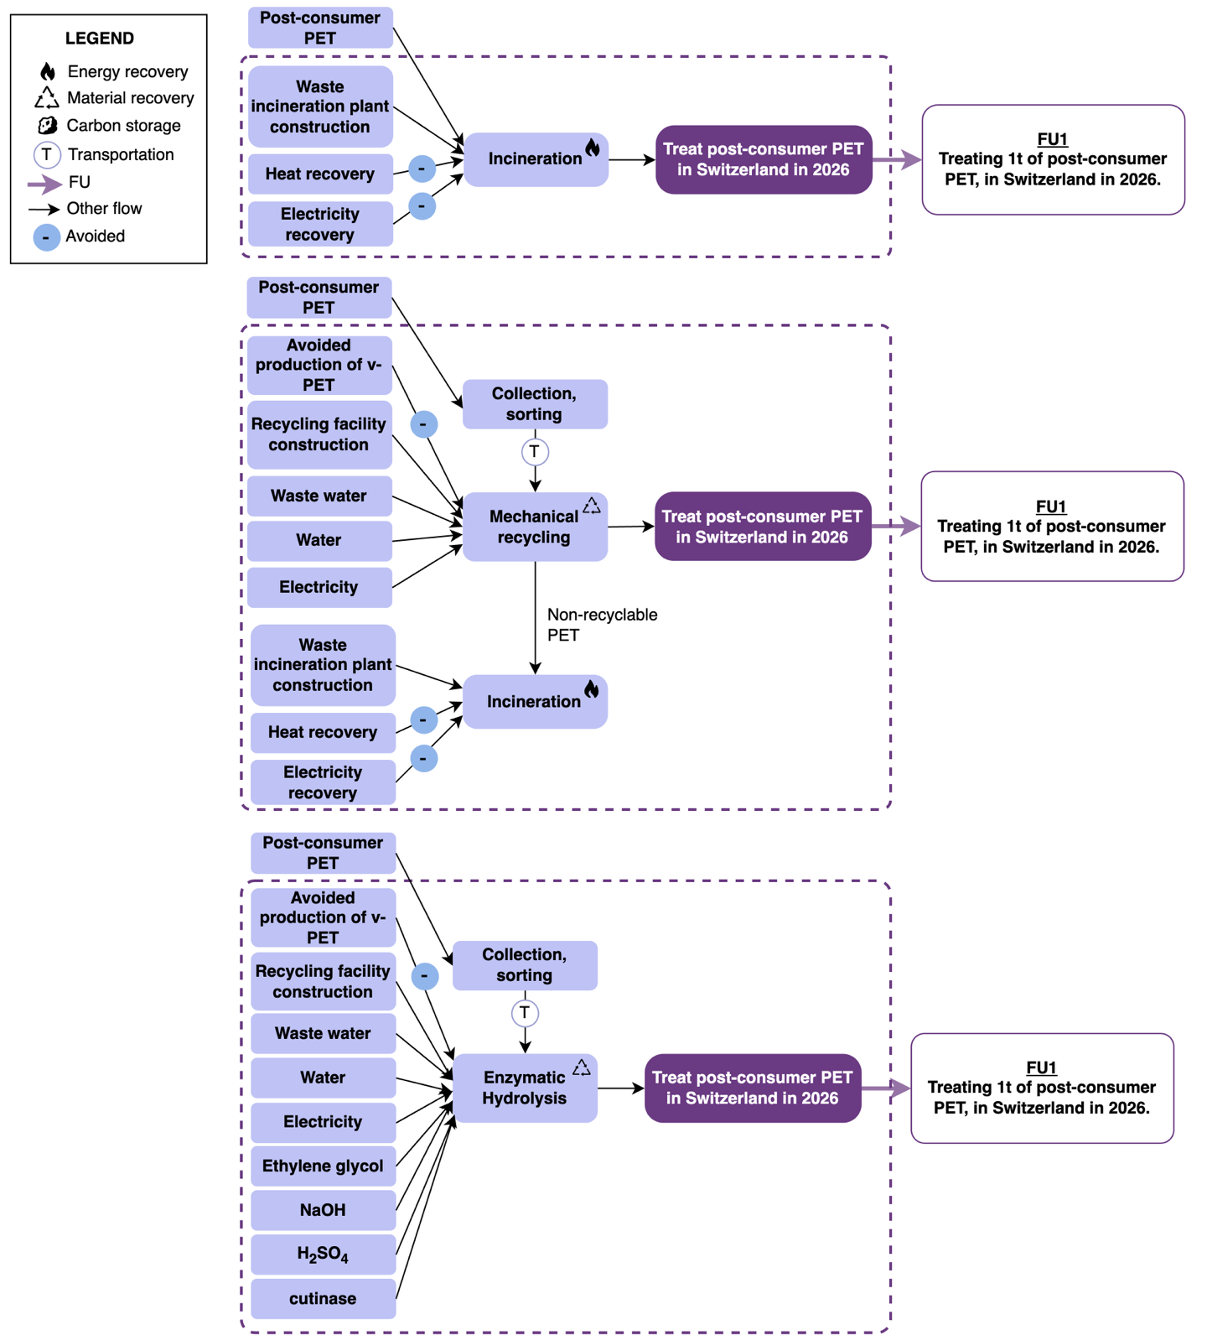
The processes trees corresponding to each waste treatment pathway considered using FU1, treating 1t of post-consumer PET, in Switzerland in 2026, is displayed in Figure 1.
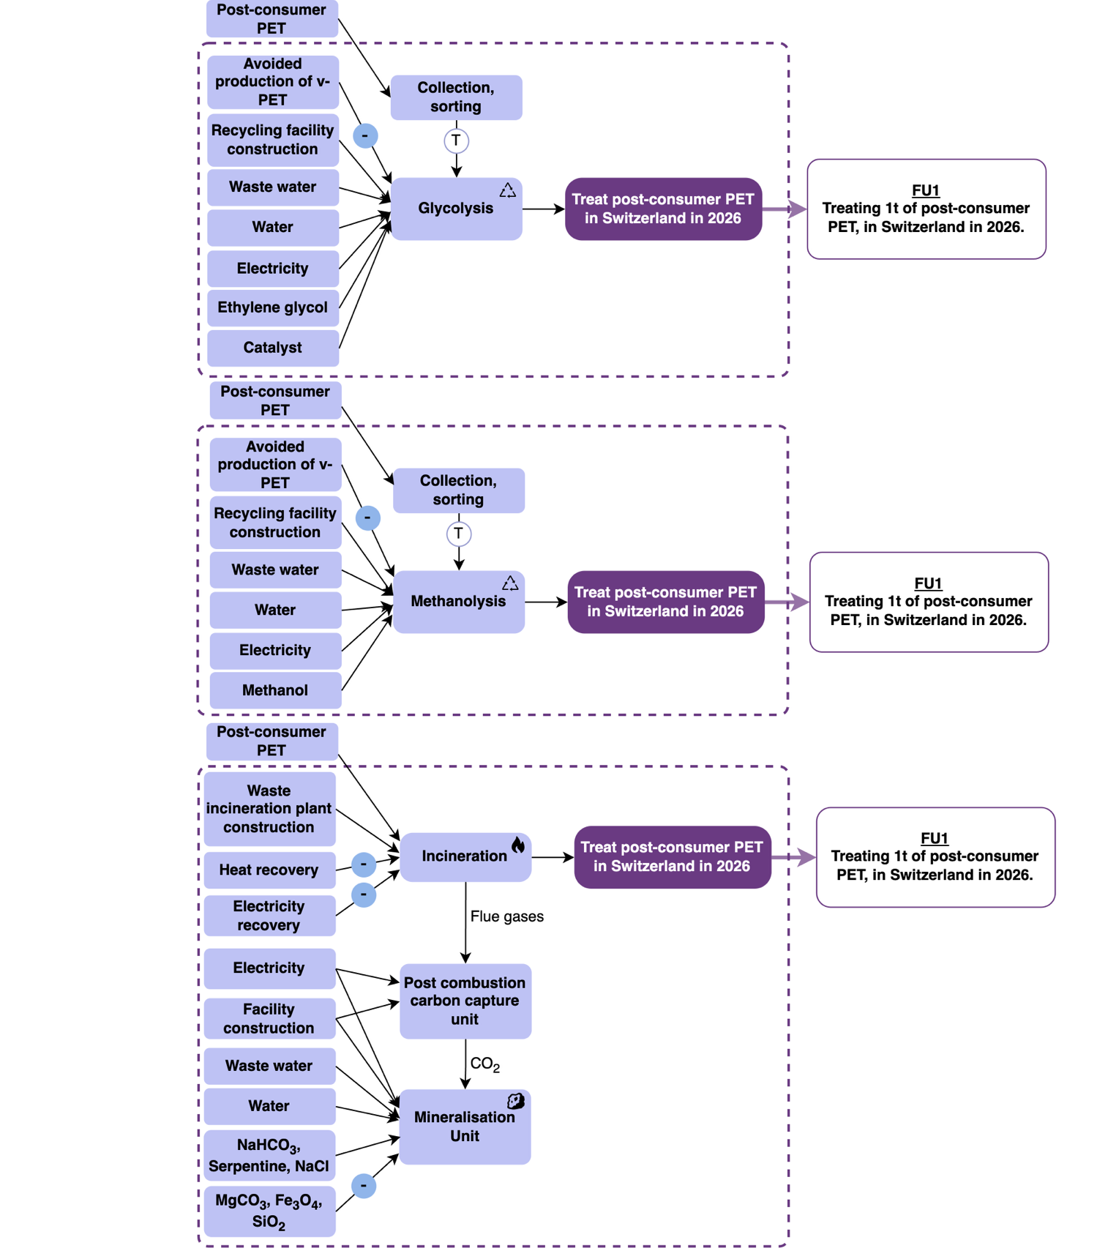
Figure 1: System boundaries of the LCA – FU1 for each treatment pathway considered.
The functional unit (FU2) for the system considered is the annual per capita consumption of PET across the packaging and textile sectors in Switzerland in 2026, including the management of the resulting waste streams.

The system boundary is defined from cradle to grave, as diplayed in Figure 2, encompassing PET production, product use, and end-of-life management with downcycling mechanisms.

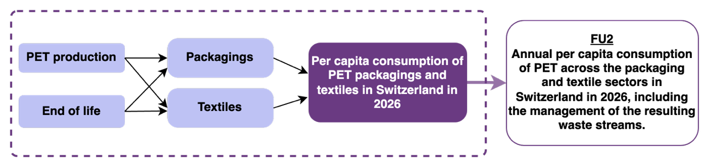
Figure 2: System boundaries of the LCA – FU2.

S-M2.2 CAPEX, OPEX, and TOTEX calculation method
The total costs, or TOTEX (in €/year), are defined as the sum of the capital expenditure (CAPEX) and operational expenditure (OPEX), as presented in Equations (1 to 3). The economic assessment methodology is based on Turton et al. [7] and Sinnot et al. [8].
$$CAPEX = \sum_{u ∈ U}{ } \frac{i {\left(1 + i\right)}^{N}}{{\left(1 + i\right)}^{N} - 1} \left( c_{u}^{\text{inv}} f_{u} \right) (1)$$
Where:
$f_{u}^{\text{min}}y_{u}≤f_{u}≤f_{u}^{\text{max}}y_{u} ∀u∈U$ (2)
$$\text{OPEX}=\left(\sum_{r∈R}{c_{r}^{+}\dot{m_{r}^{+}}}+\sum_{r∈R}{c_{r}^{-}\dot{m_{r}^{-}}}+\sum_{u∈U}{c_{u}^{\text{op}}f_{u}}+c_{e}^{+}\dot{E^{+}}-c_{e}^{-}\dot{E^{-}}\right)t^{\text{op}} \left(3\right)$$
where, for the CAPEX:
- u ∈ U are the technologies considered
- N is the lifetime or expected project lifetime in years,
- i is the interest rate,
- c^{inv} is u the fixed investment cost of unit u, in CHF.
The CAPEX is constrained by the sizing factors f ^{min} _{u} and f^{max}, which ensure that the selected technology is neither oversized nor undersized, taking u into account the associated costs and material flows. CAPEX calculation for the waste treatment plants includes the cost of all the equipment used in the process (pumps, heat exchangers, columns, etc.), as well as bulk item (piping, valves, etc.).

And where, for the OPEX:
- c⁺_{r} /c⁻_{r} is the specific cost of purchasing/selling the resource r (in CHF/kg or CHF/kWh),
- multiplied by the flow of the given resource m ̇ ⁺_{r} /m ̇ ⁻_{r} , which represents the mass flow of resource r consumed/produced.
- u is the operating specific cost of a unit per mass flow,
- c⁺_{e} /c⁻ _{e} is the price for purchased/sold electricity (CHF/kWh),
- t^{op} (h/year) is the total operating time of the plant.

S-M2.3 OPEX details
The detailed costs considered for mass and energy flows are displayed in Table 6.

Flow | OPEX | Unit | Reference
PET | 1300 | €/t | [9]
rPET | 1300 | €/t | [9]
Electricity | 0.085 | €/kWh | [10]
MeOH | 600 | €/t | [11]
Natural Gas | 1.152 | €/MJ | [12]
Water | 2 | €/t | [13]
DMT | 1600 | €/t | [14]
EG | 960 | €/t | [15], [16]
Waste Water | 2 | €/t | [17]
H2SO4 | 120 | €/t | [16]
NaOH | 610 | €/t | [16]
TPA | 1150 | €/t | [16]
Catalyst (l1,3-Dimethylurea) | 68300 | €/t | [18]
BHET | 1900 | €/t | [19]
Cutinase | 15000 | €/t | [16]
Serpentine | 0.024 | €/kg | [20]
MgCO3 | -0.200 | €/kg | [21]
SiO2 | -0.050 | €/kg | [20]
Magnetite | -0.030 | €/kg | [21]
NaCl | 0.120 | €/kg | [22]
NaHCO3 | 0.375 | €/kg | [23]
Transport (truck) | 0.2 | €/m3/km | [24]
Transport (train) | 0.001 | €/m3/km | [24]
Heat | 0.17 | CHF/kWh | [25]
CO₂ tax | 120 | €/t | [26]

Table 6: Market costs and selling prices of feedstock and products.

S-M2.4 CAPEX details
The detailed costs considered for installations are displayed in Table 7.

Waste treatment installation | CAPEX | Unit | Reference
Mechanical recycling | 386 | €/ton_{PET treated} | [27], [24]
Incineration | 86.47 | €/ton_{PET treated} | [24]
Incineration with CCS and serpentine mineralisation | 1490 | €/ton_{PET treated} | [24], [28], [20], [29]
Methanolysis | 667 | €/ton_{PET treated} | This work.
Enzymatic hydrolysis | 1144 | €/ton_{PET treated} | This work.
Glycolysis | 504 | €/ton_{PET treated} | This work.
Separate collection | 130 | €/ton_{PET treated} | [30]

Table 7: CAPEX of the installations.

S-M2.5 Impact scores calculation method
Environmental impacts were quantified following a matrix-based LCA formulation, in which the life cycle inventory of each technology was assembled in a technology matrix $A$. Because the reference flow’s units of the modeled technologies may differ from the units used in ecoinvent, a scaling vector (s) was applied to ensure unit consistency between the technology model and the LCI data. (f) is the final demand vector representing the functional unit (Equations 4 and 5).

$$As=f \left(4\right)$$

$$s=A^{-1}f \left(5\right)$$

This matrix was combined with an impact characterization matrix $B$, based on Ecoinvent life cycle inventory data (elementary flow matrix, before scaling), yielding a vector (g) containing the final impact scores of the system, as displayed in Equation (6).

$$g=B\text{. }A^{-1}.f \left(6\right)$$

2-M3 Modeling of PET treatment, recycling technologies, and utility systems
This section describes the PET processing technologies that were studied and modeled. The distribution of material flows among the various technologies is shown in Figure 3. Mass and energy balance for each technology, and detailed Aspen Plus models for depolymerization units are available in SI_modeling and SI_data_technologies.

2.3.1 Separated collection rates
Current and achievable collection rates were used to evaluate alternative PET technological pathways. Baseline values represent actual collection rates in Switzerland [1], whereas achievable values correspond to prospective collection rates reported in the literature [6].

2.3.2 Waste incineration with point-source carbon capture and mineralization
Incineration is particularly suited for the PET fractions that are difficult to sort separately or recycle, such as textiles or contaminated streams. The process is modeled in Aspen® Plus v11. Following combustion of the feedstock, the resulting ash is separated from the flue gas stream for disposal [31], [28]. A post-combustion carbon capture unit is also considered, using monoethanolamine membranes, enabling the recovery of 90% of the CO₂ present in the flue gases [31], [32]. To illustrate a storage pathway that keeps carbon within the economy (the minerals produced can be used in construction), recovered CO₂ is subsequently mineralized using serpentine, providing a pathway for long-term fossil-based carbon storage [20], [29].

2.3.3 Mechanical recycling unit
Mechanical recycling allows the plastic to be recycled without altering its structure, as there is no chemical reaction. This technology is suitable only for packaging PET waste streams and requires sorting to prevent contamination by other plastics and impurities [6]. Compared to chemical recycling processes, this process operates at reduced temperatures, resulting in lower energy consumption [33]. Mechanical recycling consists of several stages, and the process used in this work follows these steps: shredding, washing, milling, float-sink separation, mechanical and thermal drying, wind shifting, milling, and extrusion [34], [35], [36].

2.3.4 Chemical recycling
The chemical recycling routes studied rely on the depolymerization of PET into its primary monomers and repolymerisation of them [37], [30]. These processes are applicable to all types of PET wastes, as they can handle contaminated and multi-material wastes [38], [39]. Three conversion pathways are considered in this study and were first modeled in Aspen® Plus v11: enzymatic hydrolysis, glycolysis, and methanolysis. Detailed process descriptions, including process flow diagrams, Aspen models, and mass balance diagrams, are provided in SI_modeling and SI_data_technologies [8], [40]. Prior to depolymerization, PET waste in the form of postconsumer plastic bale is mechanically pretreated into small flakes.

Enzymatic PET depolymerisation
Enzymatic PET depolymerization is modeled using esterase-type enzymes (cutinase) catalyzing the hydrolysis of PET into terephthalic acid (TPA) and ethylene glycol (EG), following Reaction 1 (R1) [41], [42], [43]. Depolymerisation occurs at 68 °C and 1 bar, close to the PET glass transition temperature to enhance polymer chain mobility and ensure enzyme accessibility [44], [45]. Sodium hydroxide is added to maintain appropriate pH conditions and solubilize TPA. Unreacted PET is recovered by filtration and recycled, while the enzyme is separated by ultrafiltration. TPA is recovered by acidification using sulfuric acid, crystallization, and drying, whereas EG is purified by distillation [16].

$PET (s)+ 2 H_{2}O (l) \underset{→}{cutinase} TPA (s)+ EG (aq)+ unreacted PET (s)$ (R1)

Recovered TPA and EG were subsequently repolymerized into PET via esterification to form bis(2-hydroxyethyl) terephthalate (BHET), followed by polycondensation under vacuum to increase molecular weight, yielding 0.9 t of recycled PET for each ton of waste PET treated [46].

Glycolysis
Glycolysis is a depolymerization process in which PET reacts with EG to produce BHET, following Reaction 2 (R2). The process is modeled using three reactors in series with an EG/PET ratio of 4 to enhance PET conversion [37]. The reaction operates at approximately 220 °C, allowing partial vaporization of EG that is subsequently recovered and recycled to the reactors. A catalyst is used to reduce reaction time (≈20 min) and achieve PET-to-BHET conversion above 80% [47], [48], [37].

$PET\left(s\right)+EG\left(l\right)\underset{→}{1,3-DMUZn{\left(OAc\right)}_{2}}BHET\left(s\right)+oligomers$ (R2)

In addition to BHET, minor by-products such as acetaldehyde, diethylene glycol (DEG), and water are formed. Product separation is modeled using flash separation and distillation, enabling the recovery of EG, BHET, and residual PET. BHET is subsequently purified by crystallization, filtration, and drying, reaching a purity of approximately 98% before repolymerization [49], [50], [46], [37].

Methanolysis
Methanolysis is a transesterification process in which PET reacts with methanol (MeOH) to produce dimethyl terephthalate (DMT) and EG, following (R3) [37], [51]. The reaction occurs at 260°C, 3 bar, and is modeled in the presence of methanol vapor at elevated temperature, allowing the continuous removal of volatile products and thereby shifting the reaction equilibrium toward monomer formation [52]. The methanol-to-PET mass ratio is 4:1.
$$\text{P}ET\left(s\right)+2MeOH\left(l\right)→DMT\left(s\right)+EG\left(l\right)\left(R3\right)$$
Volatile reaction products are separated through flash separation and distillation, enabling the recovery and purification of EG, DMT, and MeOH. Methanol is recycled to the reactor, while DMT is purified by crystallization, followed by filtration and drying. Recovered DMT and EG were subsequently repolymerized into PET via transesterification followed by polycondensation [53]. In this process and via glycolysis, 0.87 t of recycled PET is produced for each ton of PET treated.

S-R1. Results

S-R1.1 TOTEX and CC impact scores of FU1 under open and closed-loop assumptions
To compare the economic and environmental performance of the different end-of-life technologies, the treatment technologies were first evaluated using the initial functional unit (FU1), corresponding to the treatment of 1 t of post-consumer PET, under an open-loop assumption where all rPET produced is negative (Figure 2 and 3 of the main text and left bar of Figure 2 - top and bottom - of this document).
Another functional unit is then introduced and analysed here, corresponding to the treatment of 1 t of post-consumer PET, while assuming a closed-loop system where all unproduced r-PET is substituted by v-PET. It enables the assessment of the technologies under a fully circular management scenario (right bar of Figure 2, top and bottom).
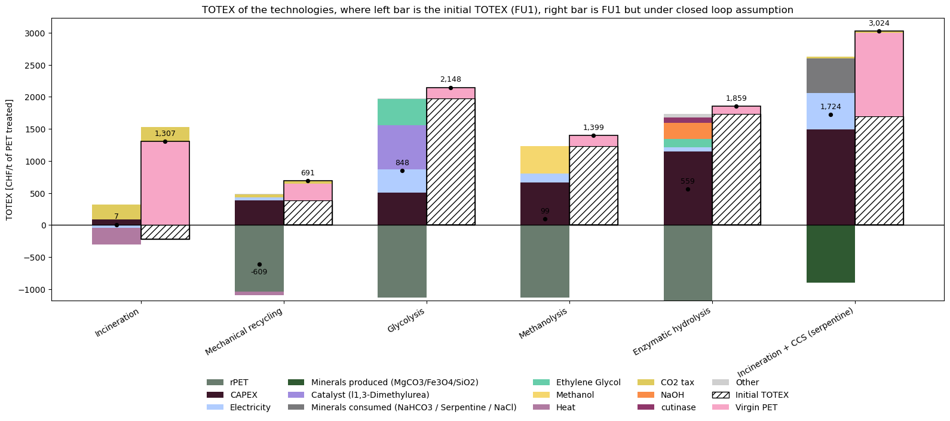
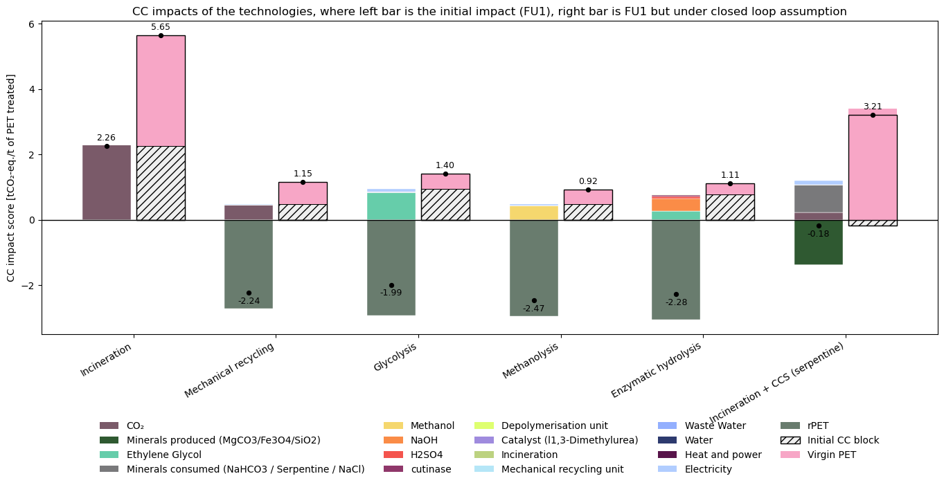

Figure 2: Comparison of the TOTEX (top figure) and CC impact scores (bottom figure) of each treatment technologies treating 1t of PET, under open (left bar) or closed (right bar) loop assumption.
As discussed in the main document, under the open-loop assumption, incineration is the least costly option (7 €/FU), while mechanical recycling shows negative costs (-609 €/FU) driven by r-PET revenues. Under the closed-loop assumption, the ranking shifts as unrecovered PET must be compensated by v-PET imports. Mechanical recycling remains the most cost-effective option (691 €/FU), being twice cheaper than incineration (1,307 €/FU), whose material losses translate into a significant v-PET substitution cost. Depolymerisation routes show higher TOTEX (1,399 to 2,148 €/FU) but remain in a comparable range to incineration, reflecting a compensation for the processing costs due to v-PET production. Incineration with CCS reaches 3,024 €/FU, combining high CAPEX and OPEX with the full v-PET cost of unrecovered material. Overall, accounting for material losses penalises energy recovery routes and shifts the economic advantage toward closed-loop recycling pathways.
Exactly the same shift occurs for CC impact scores between the open and closed loop assumptions.

S-R1.2 EQ, FU, HH, and WU Impact Scores
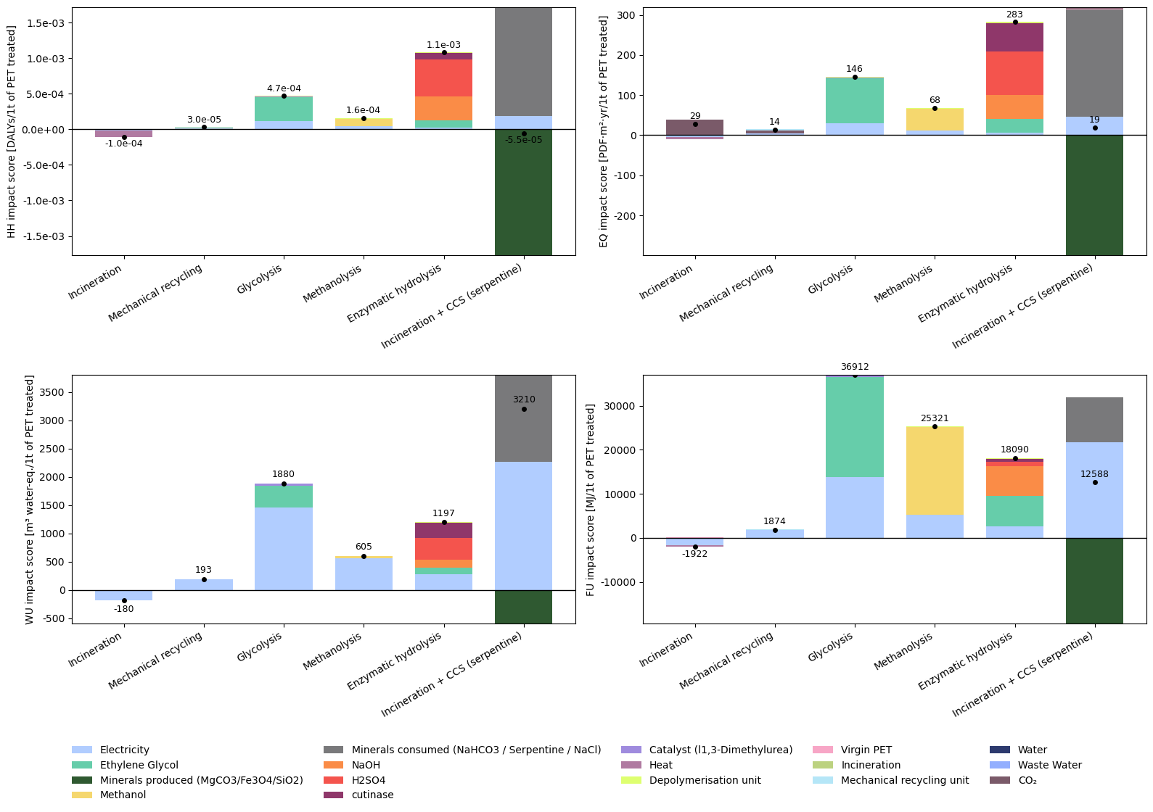

Figure 3: HH, EQ, WU, and FU impact scores of each treatment technology studied. Results are per ton of PET treated.

S-R1.3 Detailed MFA of PET-based apparel and household textiles in Switzerland

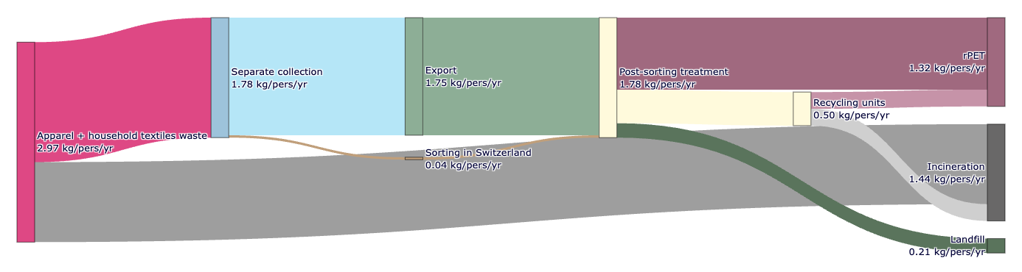
Figure 4: MFA of apparel and household textile waste treatment and management in Switzerland. Data are adapted from [54] and presented in kg/pers/yr (FU2).

S-R1.4 Coupling between collection rates and technological share in the treatment mix
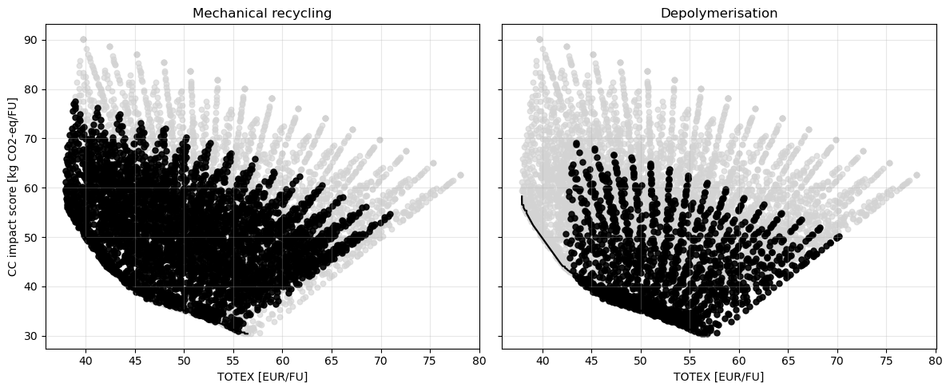
Figure 5: Pareto front representing CC impact scores vs TOTEX, where, in black: (on the right): share of PET treated via mechanical recycling >30% and separately collected > 50%; (on the left): share of PET treated via depolymerisation >30% and separately collected > 50%.

S-R1.5 Circularity of the system along the pareto
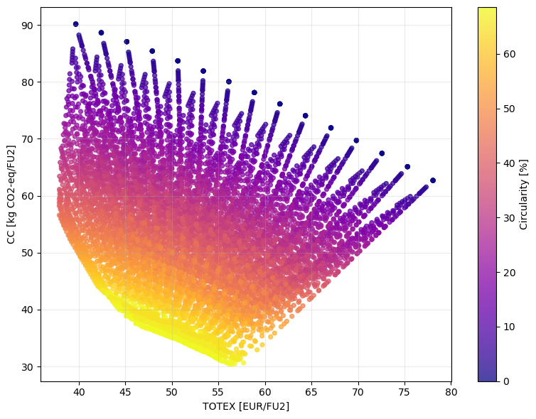
Figure 6: Representation of the circularity of the system along the pareto front.

S-R1.6 Slopes of the pareto frontier
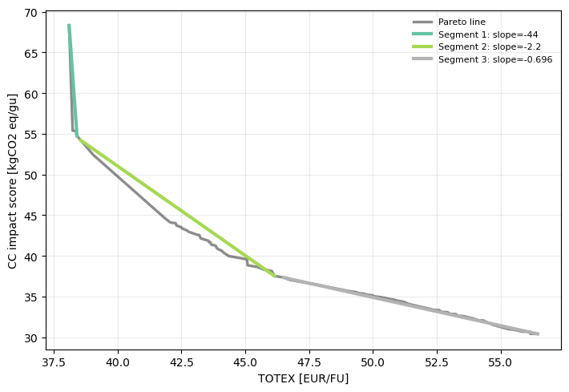
Figure 7: Representation of the three slopes along the Pareto front, each one indicating the appearance of a new technology in the treatment mix (dark green is mechanical recycling, light green is depolymerisation, and grey is point source carbon capture on incinerators).

S-R1.7 Pareto fronts for EQ, HH, WU and FU impact scores

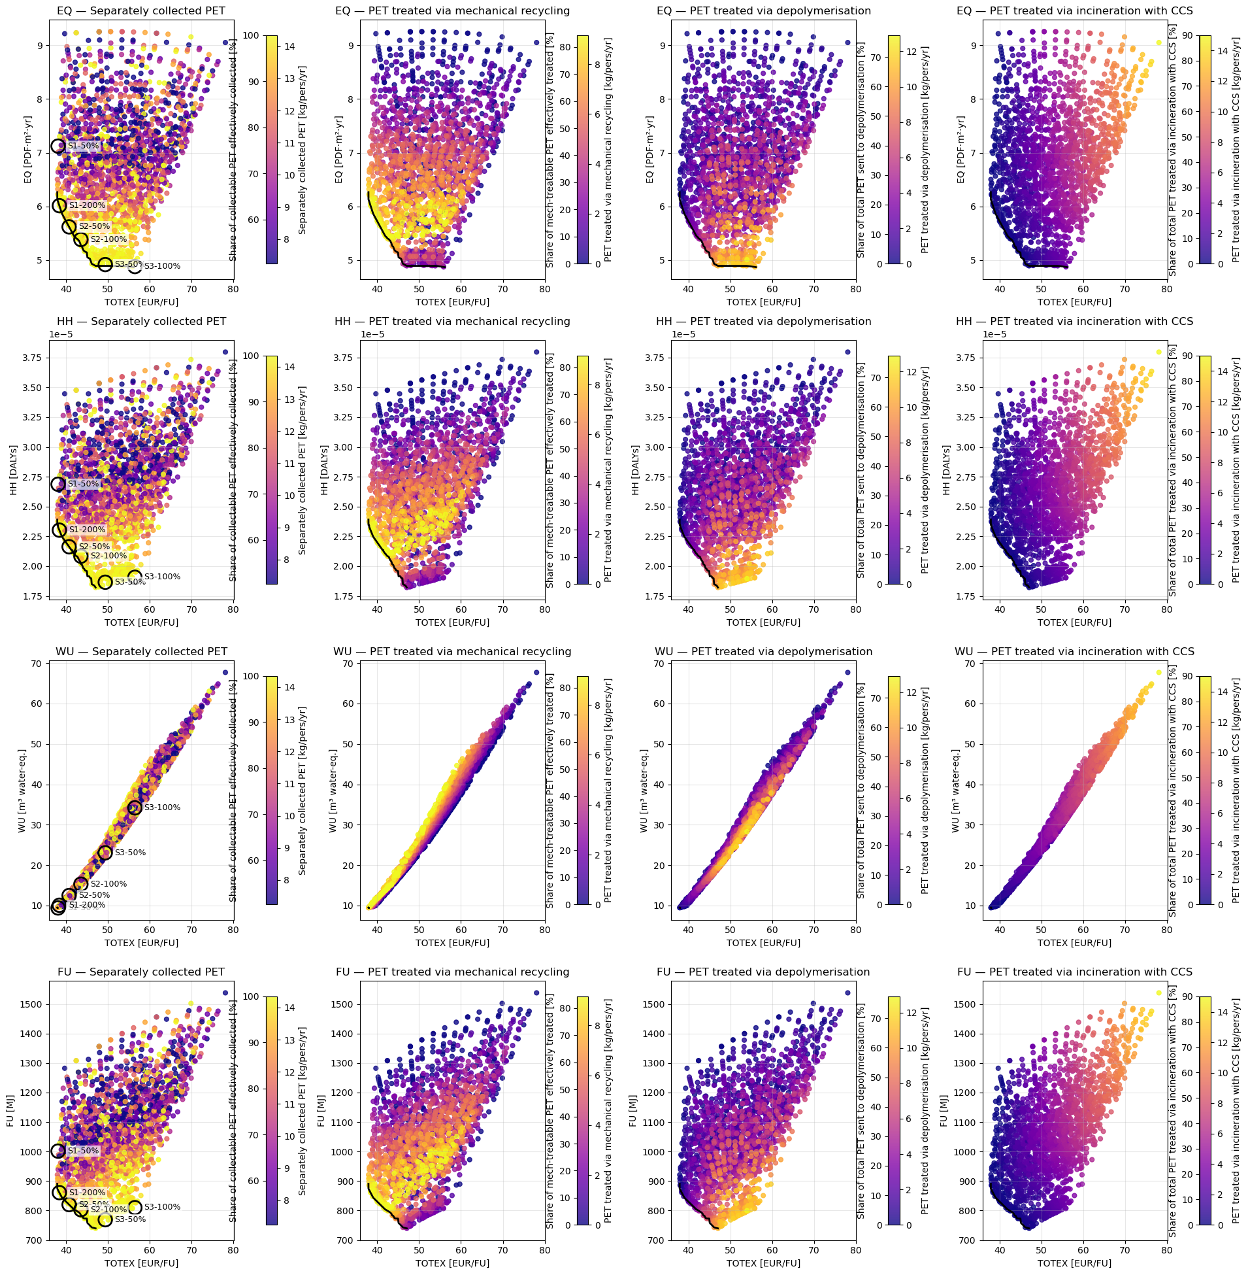
Figure 8: Pareto front of different PET treatment system configurations, for ecosystem quality (EQ), human health (HH), water use (WU), and fossil and nuclear energy use (FU) impact scores. Technical configurations, underlying the dynamics of the Pareto, are illustrated as follow: the first column represents the fraction of the PET separately collected with the configurations considered for the CC-TOTEX Pareto along the Pareto frontier in the main text. The second column represents the fraction of PET separately collected treatable via mechanical recycling and effectively treated via this pathway, the third column represents the fraction of PET separately collected treated via depolymerisation, and d) represents the fraction of PET treated via incineration with CCS. For collection, 100% means 100% of the separately collectable PET is effectively collected – considering prospective collection rates.
.

S-R1.8 MFA and detailed contribution of the flows on the KPIs of the clusters of the pareto

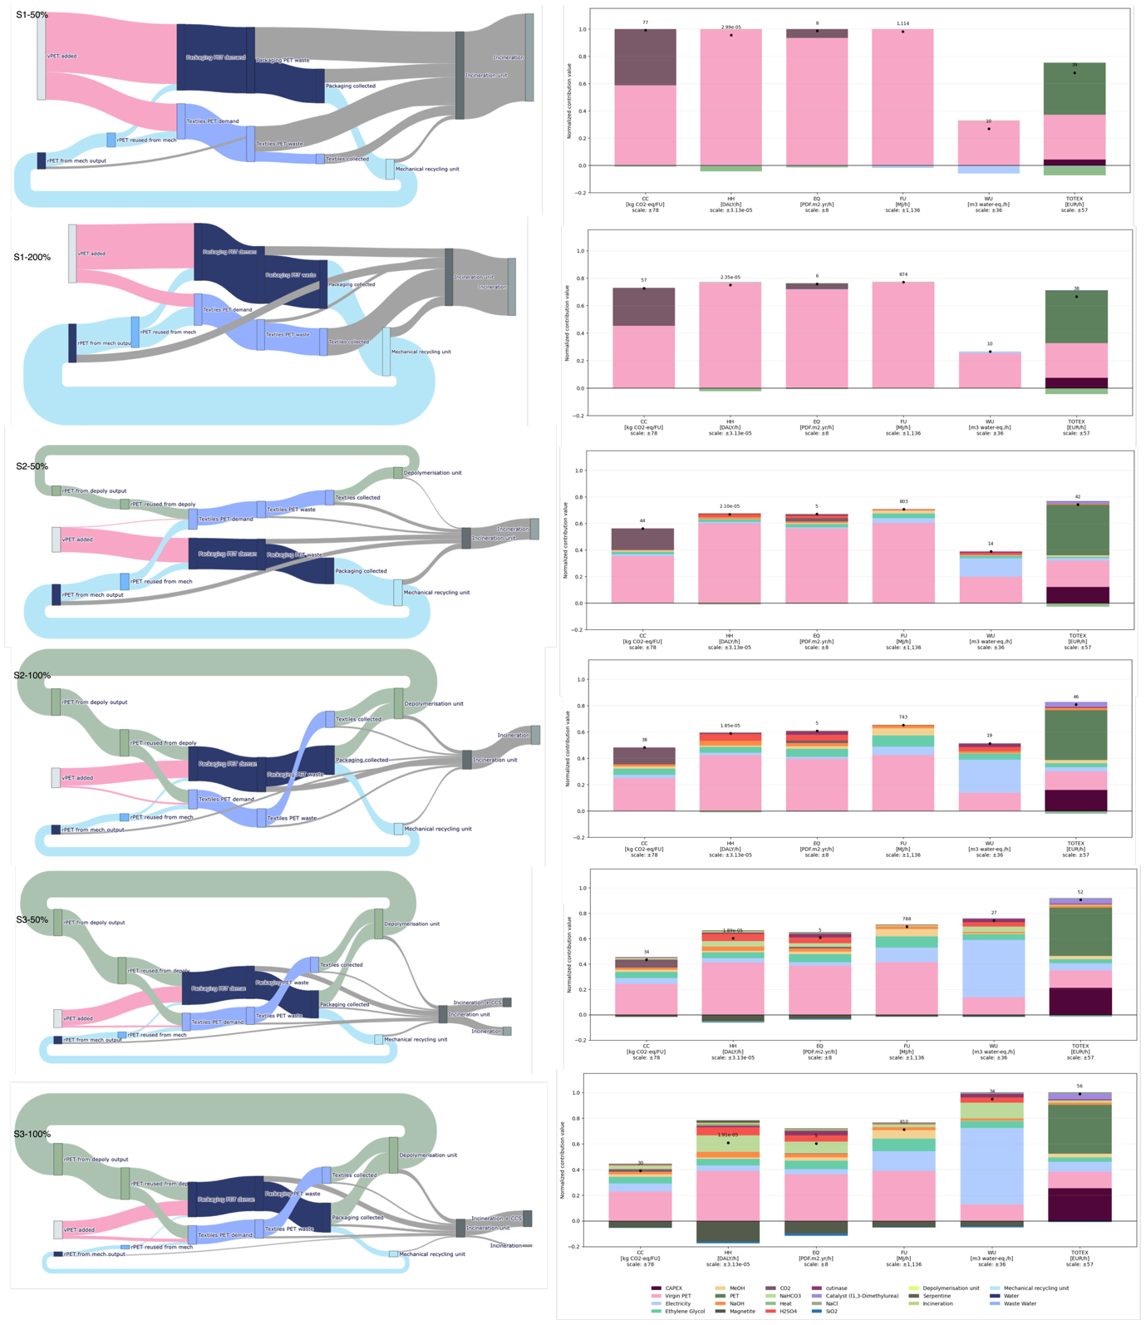
Figure 9: Representation of the MFAs and streams distribution for each KPI (impact scores and TOTEX) for each cluster of solution along the Pareto (S1, 2, and 3).

S-R1.9 Parallel coordinates illustrating the technical configurations and results on KPIS of clusters of the Pareto
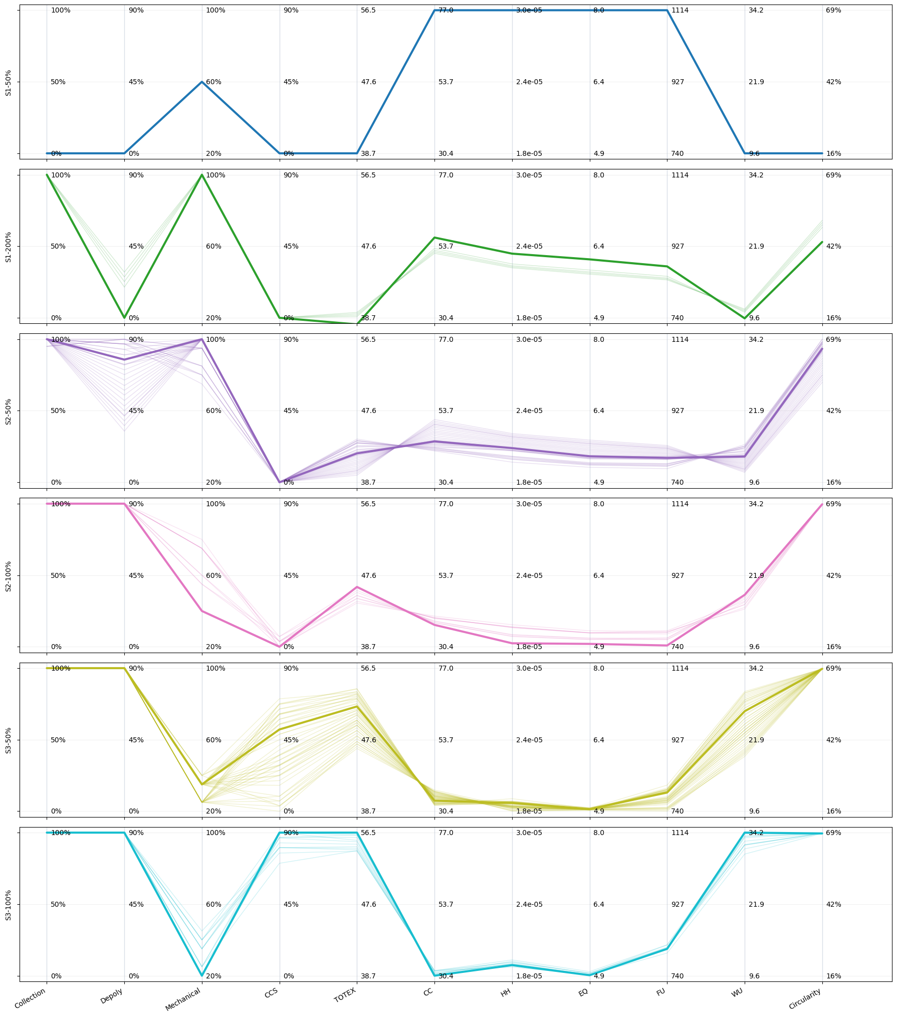
Figure 10: Parallel coordinate plots representing the technical configurations of the system and the corresponding KPI results (impact scores, circularity, and TOTEX) for each solution cluster along the Pareto front (S1, S2, and S3). The bold line represents the centroid of each cluster, whose material flow analysis (MFA) and KPI results are presented in Figure 9. The thin lines correspond to the other solutions within the cluster. Their dispersion in the parallel coordinate plots indicates whether a given technological option is a strong constraint or, conversely, allows greater flexibility for achieving the KPIs.

References

[1] M. Klotz and M. Haupt, “A high-resolution dataset on the plastic material flows in Switzerland,” Data in Brief, vol. 41, p. 108001, Apr. 2022, doi: 10.1016/j.dib.2022.108001.
[2] Amadei, A., Venturelli, S. and Manfredi, S., Plastics materials flows in the EU-27 and their environmental impacts: unveiling the European plastic value chain. LU: Publications Office of the European Union, 2025. Accessed: Jan. 14, 2026. [Online]. Available: https://data.europa.eu/doi/10.2760/6579757
[3] R. Geyer, J. R. Jambeck, and K. L. Law, “Production, use, and fate of all plastics ever made,” Sci. Adv., vol. 3, no. 7, p. e1700782, Jul. 2017, doi: 10.1126/sciadv.1700782.
[4] P. H. Brunner, Practical handbook of material flow analysis. in Advanced methods in resource and waste management, no. 1. Boca Raton, FL: CRC/Lewis, 2004. doi: 10.1201/9780203507209.
[5] M. Klotz and M. Haupt, “A high-resolution dataset on the plastic material flows in Switzerland,” Data in Brief, vol. 41, p. 108001, Apr. 2022, doi: 10.1016/j.dib.2022.108001.
[6] M. Klotz, M. Haupt, and S. Hellweg, “Potentials and limits of mechanical plastic recycling,” J of Industrial Ecology, vol. 27, no. 4, pp. 1043–1059, Aug. 2023, doi: 10.1111/jiec.13393.
[7] R. Turton, R. C. Bailie, W. B. Whiting, and J. A. Shaeiwitz, Analysis, Synthesis and Design of Chemical Processes. Pearson Education, 2008.
[8] G. P. Towler and R. Sinnott, Principles, practice and economics of plant and process design, vol. 2nd ed. Butterworth-Heinemann. 2012.
[9] Business Analitiq, “PET (Polyethylene Terephthalate) price index.” Accessed: May 04, 2026. [Online]. Available: https://businessanalytiq.com/procurementanalytics/index/pet-price-index/
[10] SFOE, “Energie-Dashboard Bundesamt für Energie.” Accessed: May 04, 2026. [Online]. Available: https://www.energiedashboard.admin.ch/preise/strom
[11] Business Analitiq, “Methanol price index.” Accessed: May 04, 2026. [Online]. Available: https://businessanalytiq.com/procurementanalytics/index/methanol-price-index/
[12] “Energie-Dashboard Bundesamt für Energie.” Accessed: May 04, 2026. [Online]. Available: https://www.energiedashboard.admin.ch/preise/gas
[13] “Eidgenössisches Departement für Wirtschaft, Bildung und Forschung WBF - Preisüberwachung.” Accessed: May 04, 2026. [Online]. Available: https://www.preisvergleiche.preisueberwacher.admin.ch/?z=5&i=34&c=1&term=sion&name=Sion
[14] “Dimethyl Terephthalate Price - Historical & Current.” Accessed: May 04, 2026. [Online]. Available: https://www.intratec.us/solutions/primary-commodity-prices/commodity/dimethyl-terephthalate-prices
[15] Echemi, “Ethylene glycol Price List in Global Market - ECHEMI,” Market Price & Insight. Accessed: May 04, 2026. [Online]. Available: https://www.echemi.com/pip/ethylene-glycol-eg-pid_Seven2471.html
[16] A. Singh et al., “Techno-economic, life-cycle, and socioeconomic impact analysis of enzymatic recycling of poly(ethylene terephthalate),” Joule, vol. 5, no. 9, pp. 2479–2503, Sep. 2021, doi: 10.1016/j.joule.2021.06.015.
[17] “Eidgenössisches Departement für Wirtschaft, Bildung und Forschung WBF - Preisüberwachung.” Accessed: May 04, 2026. [Online]. Available: https://www.preisvergleiche.preisueberwacher.admin.ch/?z=5&i=34&c=1&term=sion&name=Sion
[18] Thermo Fisher Scientific, “1,3-Dimethylurea, 98%.” Accessed: May 04, 2026. [Online]. Available: https://www.thermofisher.com/order/catalog/product/116910010
[19] “Global r-BHET Market Share and Ranking, Overall Sales and Demand Forecast 2025-2031.” Accessed: May 04, 2026. [Online]. Available: https://qyresearch.in/report-details/8712364
[20] R. Castro-Amoedo, J. Granacher, M. A. Daher, and F. Maréchal, “On the role of system integration of carbon capture and mineralization in achieving net-negative emissions in industrial sectors,” Energy Environ. Sci., vol. 16, no. 10, pp. 4356–4372, 2023, doi: 10.1039/D3EE01803B.
[21] L.-C. Pasquier, G. Mercier, J.-F. Blais, E. Cecchi, and S. Kentish, “Technical & economic evaluation of a mineral carbonation process using southern Québec mining wastes for CO2 sequestration of raw flue gas with by-product recovery,” International Journal of Greenhouse Gas Control, vol. 50, pp. 147–157, Jul. 2016, doi: 10.1016/j.ijggc.2016.04.030.
[22] “Honeywell 31434-1KG - NATRIUMCHLORID, 1 KG,” Der LOLAB Chemikalien-Shop. Accessed: May 04, 2026. [Online]. Available: https://shop-lolab.de/natriumchlorid/flk.31434.1000.pb
[23] ChemAnalyst, “Sodium Bicarbonate Price Trend and Forecast.” Accessed: May 04, 2026. [Online]. Available: https://secure.livechatinc.com/customer/action/open_chat?license_id=13070841&group=0&embedded=1&widget_version=3&unique_groups=0&organization_id=67a959db-fb12-45b4-a56b-5ab9c693cc62&use_parent_storage=1&x-region=us-south1
[24] R. Castro-Amoedo, J. Granacher, I. Kantor, A. Dahmen, A. Barbosa-Povoa, and F. Maréchal, “On the role of system integration in plastic waste management,” Resources, Conservation and Recycling, vol. 201, p. 107295, Feb. 2024, doi: 10.1016/j.resconrec.2023.107295.
[25] B. de la communication-W. & multimédia – webmaster@lausanne.ch, “Chaleur - tarifs,” Site officiel de la Ville de Lausanne. Accessed: May 04, 2026. [Online]. Available: https://www.lausanne.ch/vie-pratique/energies-et-eau/services-industriels/professionnels/les-offres/chaleur?tab=tarifs
[26] FOEN, “CO₂ levy for businesses,” Federal Office for the Environment. Accessed: Jun. 30, 2026. [Online]. Available: https://www.bafu.admin.ch/en/co2-levy-businesses
[27] M. Larrain et al., “Techno-economic assessment of mechanical recycling of challenging post-consumer plastic packaging waste,” Resources, Conservation and Recycling, vol. 170, p. 105607, Jul. 2021, doi: 10.1016/j.resconrec.2021.105607.
[28] M.-B. Hägg, A. Lindbråthen, X. He, S. G. Nodeland, and T. Cantero, “Pilot Demonstration-reporting on CO2 Capture from a Cement Plant Using Hollow Fiber Process,” Energy Procedia, vol. 114, pp. 6150–6165, Jul. 2017, doi: 10.1016/j.egypro.2017.03.1752.
[29] W. J. J. Huijgen, R. N. J. Comans, and G.-J. Witkamp, “Cost evaluation of CO2 sequestration by aqueous mineral carbonation,” Energy Conversion and Management, vol. 48, no. 7, pp. 1923–1935, Jul. 2007, doi: 10.1016/j.enconman.2007.01.035.
[30] T. Uekert et al., “Technical, Economic, and Environmental Comparison of Closed-Loop Recycling Technologies for Common Plastics,” ACS Sustainable Chem. Eng., vol. 11, no. 3, pp. 965–978, Jan. 2023, doi: 10.1021/acssuschemeng.2c05497.
[31] S. Corre, M. E. Gorete Ribeiro Domingos, D. Florez-Orrego, G. Magnaval, M. Margni, and F. Maréchal, “Life cycle assessment and techno-economic comparison of methane production routes from sewage sludge: Incineration vs. Hydrothermal Gasification and Anaerobic Digestion,” Energy Conversion and Management, vol. 341, p. 120015, Oct. 2025, doi: 10.1016/j.enconman.2025.120015.
[32] A. M. De Almeida, R. M. Cavalcante, and A. F. Young, “Comparative Analysis of MEA Absorption and Membrane Separation for FCCU CO₂ Capture: Process Simulation and Techno-Economic Evaluation,” Energy Fuels, p. acs.energyfuels.6c00473, Apr. 2026, doi: 10.1021/acs.energyfuels.6c00473.
[33] P. Quicker, “Status, potentials and risks of Chemical recycling of waste plastics,” FOEN, Cologne, 2023.
[34] M. Larrain et al., “Techno-economic assessment of mechanical recycling of challenging post-consumer plastic packaging waste,” Resources, Conservation and Recycling, vol. 170, p. 105607, Jul. 2021, doi: 10.1016/j.resconrec.2021.105607.
[35] R. Meys, F. Frick, S. Westhues, A. Sternberg, J. Klankermayer, and A. Bardow, “Towards a circular economy for plastic packaging wastes – the environmental potential of chemical recycling,” Resources, Conservation and Recycling, vol. 162, p. 105010, Nov. 2020, doi: 10.1016/j.resconrec.2020.105010.
[36] M. Brouwer, “The impact of collection portfolio expansion on key performance indicators of the Dutch recycling system for Post-Consumer Plastic Packaging Waste, a comparison between 2014 and 2017,” Waste Management, 2019.
[37] A. McNeeley and Y. A. Liu, “Assessment of PET Depolymerization Processes for Circular Economy. 1. Thermodynamics, Chemistry, Purification, and Process Design,” Ind. Eng. Chem. Res., vol. 63, no. 8, pp. 3355–3399, Feb. 2024, doi: 10.1021/acs.iecr.3c04000.
[38] S. Tanaka, T. Kuragano, and J.-C. Choi, “Low-temperature Catalytic Methanolysis of Polyesters Promoted by Abundant Methyl Esters,” J. Jpn. Petrol. Inst., vol. 68, no. 5, pp. 195–201, Sep. 2025, doi: 10.1627/jpi.68.195.
[39] M. Crippa and B. Morico, “PET depolymerization: a novel process for plastic waste chemical recycling,” vol. 179, pp. 215–229, 2020, doi: https://doi.org/10.1016/B978-0-444-64337-7.00012-4.
[40] D. Dardor, D. A. Florez Orrego, C. Terrier, M. E. G. Ribeiro Domingos, M. Lopez, and F. Maréchal, “ROSMOSE: A web-based optimization tool to aid decision-making for the design and operation of industrial and urban energy systems,” Proceedings of ECOS 2023, 2023.
[41] N. F. S. Khairul Anuar et al., “An Overview into Polyethylene Terephthalate (PET) Hydrolases and Efforts in Tailoring Enzymes for Improved Plastic Degradation,” IJMS, vol. 23, no. 20, p. 12644, Oct. 2022, doi: 10.3390/ijms232012644.
[42] F. Kawai, T. Kawabata, and M. Oda, “Current State and Perspectives Related to the Polyethylene Terephthalate Hydrolases Available for Biorecycling,” ACS Sustainable Chem. Eng., vol. 8, no. 24, pp. 8894–8908, Jun. 2020, doi: 10.1021/acssuschemeng.0c01638.
[43] K. Oda and A. Wlodawer, “Development of Enzyme-Based Approaches for Recycling PET on an Industrial Scale,” Biochemistry, p. acs.biochem.3c00554, Jan. 2024, doi: 10.1021/acs.biochem.3c00554.
[44] G. Arnal et al., “Assessment of Four Engineered PET Degrading Enzymes Considering Large-Scale Industrial Applications,” ACS Catal., vol. 13, no. 20, pp. 13156–13166, Oct. 2023, doi: 10.1021/acscatal.3c02922.
[45] V. Kumar, R. Wimmer, and C. Varrone, “Efficient Bioprocess for Mixed PET Waste Depolymerization Using Crude Cutinase,” Polymers, vol. 17, no. 6, p. 763, Mar. 2025, doi: 10.3390/polym17060763.
[46] J.-P. Quentin, “PET ou polyéthylènetéréphtalate,” Techniques de l’ingenieur, vol. J6488V1, Oct. 2004.
[47] B. Liu, W. Fu, X. Lu, Q. Zhou, and S. Zhang, “Lewis Acid–Base Synergistic Catalysis for Polyethylene Terephthalate Degradation by 1,3-Dimethylurea/Zn(OAc)₂ Deep Eutectic Solvent,” ACS Sustainable Chem. Eng., vol. 7, no. 3, pp. 3292–3300, Feb. 2019, doi: 10.1021/acssuschemeng.8b05324.
[48] L.-H. Wang, S. Lan, Z.-B. Huang, J.-Y. Yang, J.-H. Gong, and P.-Q. Yuan, “Reaction kinetic model of glycolysis of polyethylene terephthalate,” Chemical Engineering Science, vol. 309, p. 121463, May 2025, doi: 10.1016/j.ces.2025.121463.
[49] H. Yao, D. Yan, X. Lu, Q. Zhou, Y. Bao, and J. Xu, “Solubility determination and thermodynamic modeling of bis-2-hydroxyethyl terephthalate (BHET) in different solvents,” Chinese Journal of Chemical Engineering, vol. 45, pp. 294–300, May 2022, doi: 10.1016/j.cjche.2021.03.024.
[50] J. Konidis, “Design of Direct Heated Rotary Dryers,” Master’s Thesis, Concordia University, Montreal.
[51] W. T. Lang, S. A. Mehta, M. M. Thomas, D. Openshaw, E. Westgate, and G. Bagnato, “Chemical recycling of polyethylene terephthalate, an industrial and sustainable opportunity for Northwest of England,” Journal of Environmental Chemical Engineering, vol. 11, no. 5, p. 110585, Oct. 2023, doi: 10.1016/j.jece.2023.110585.
[52] F. Barla, T. Showalter, H.-C. Su, J. Jones, and Bobe, “Methods for recycling cotton and polyester fibers from waste textile,” US2020/0407530A1
[53] K. Tomita and H. Ida, “Studies on the formation of poly(ethylene terephthalate): 2. Rate of transesterification of dimethyl terephthalate with ethylene glycol,” Polymer, vol. 14, no. 2, pp. 55–60, Feb. 1973, doi: 10.1016/0032-3861(73)90096-7.
[54] Quantis, Sur mandat de l’Office fédéral de l’environnement (OFEV), “Flux de textiles usagés en Suisse.” Mar. 2024.

