Geographic pattern of phytoplankton community and their drivers in lakes of middle and lower reaches of Yangtze River floodplain, China

Zhe Xiao^{1,2} · Hua Li³ · Xiao-Chuang Li^{2*} · Ren-Hui Li^{3,4} · Shou-Liang Huo² · Gong-Liang Yu^{3*}
¹School of Environmental and Chemical Engineering, Shanghai University, Shanghai 200444, China
²State Key Laboratory of Environmental Criteria and Risk Assessment, Chinese Research Academy of Environmental Sciences, Beijing 100012, China
³Key Laboratory of Algal Biology, Institute of Hydrobiology, Chinese Academy of Sciences, Wuhan, Hubei 430072, China
⁴College of Life and Environmental Science, Wenzhou University, Wenzhou, Zhejiang 325035, China

Supplementary materials
Including 9 figures and 1 table.

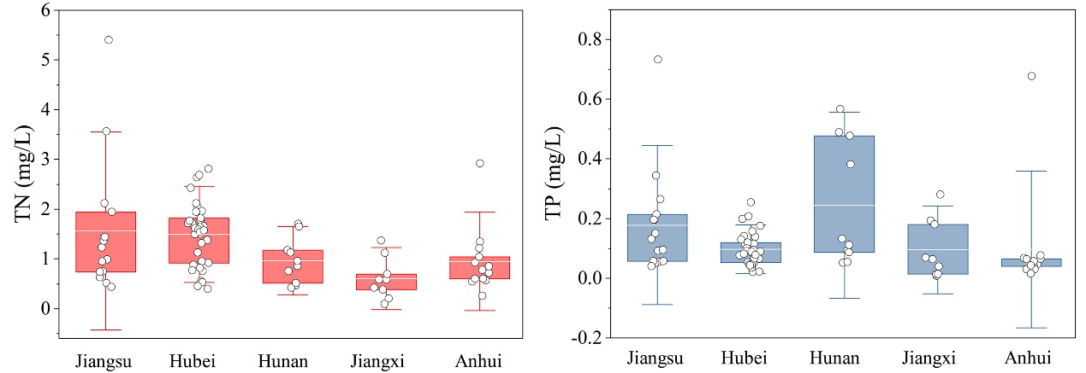
Figure S1. Total nitrogen (TN) and total phosphorus (TP) in lakes within MLYR floodplain.

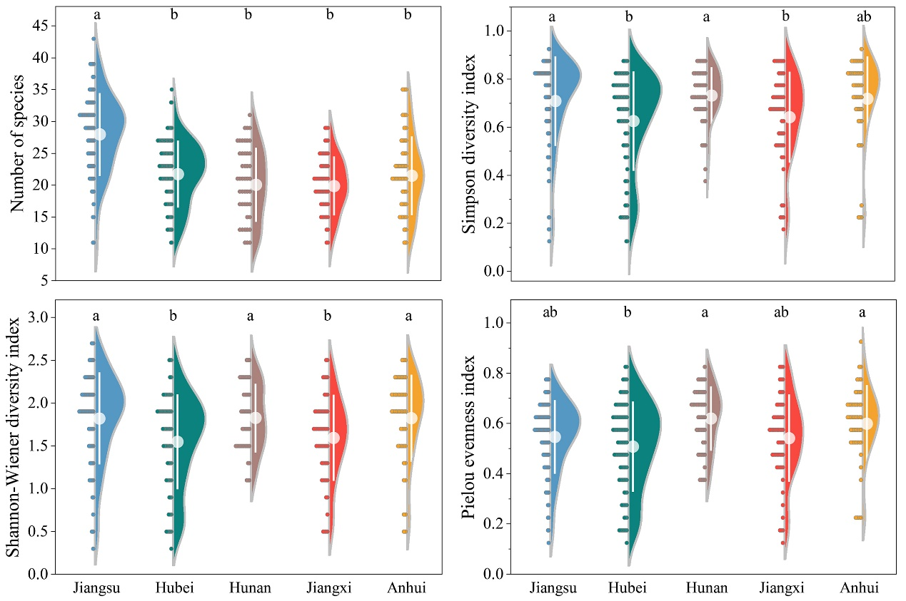
Figure S2. Phytoplankton diversity based on the taxonomic compositions, including the number of species, Simpson diversity index, Shannon-Wiener diversity index, and Pielou evenness index. Letters above bars indicate a significant difference at the P< 0.05 level according to Mann-Whitney U test.
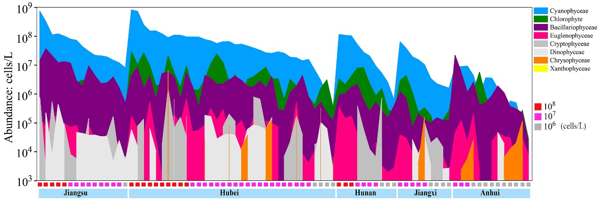
Figure S3. Phytoplankton abundance at phylum level.

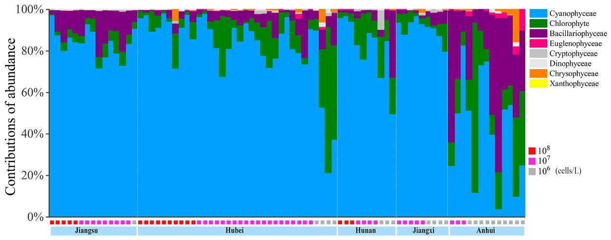
Figure S4. Relative contributions of phytoplankton abundance at phylum level.

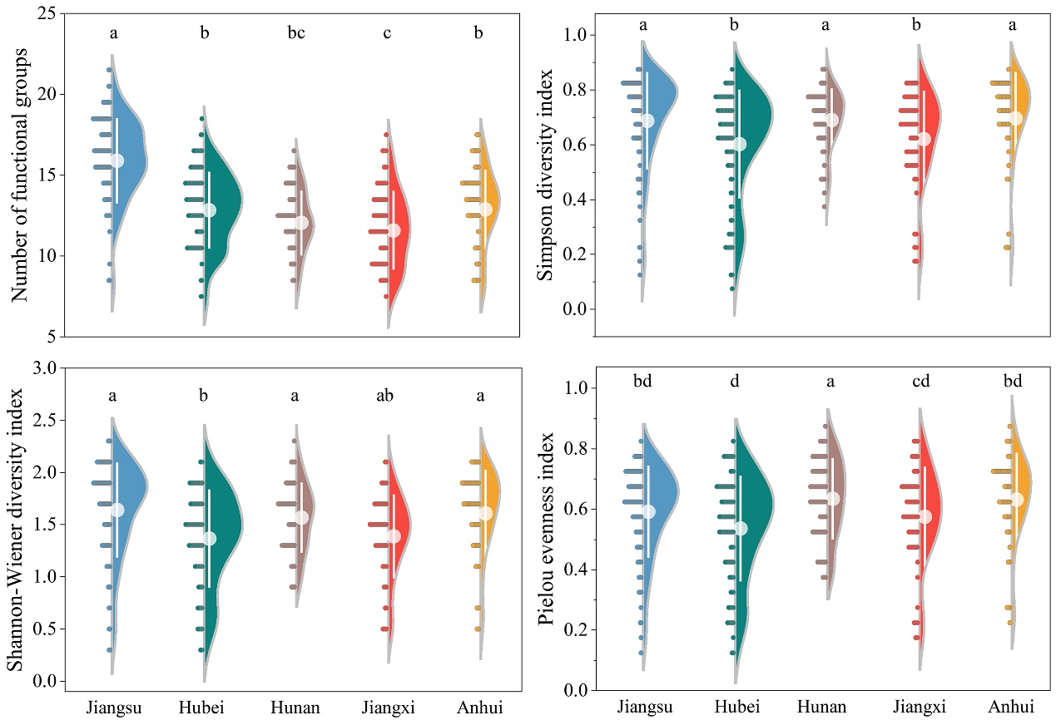
Figure S5. Phytoplankton diversity based on the functional compositions, including the number of species, Simpson diversity index, Shannon-Wiener diversity index, and Pielou evenness index. Letters above bars indicate a significant difference at the P< 0.05 level according to Mann-Whitney U test.

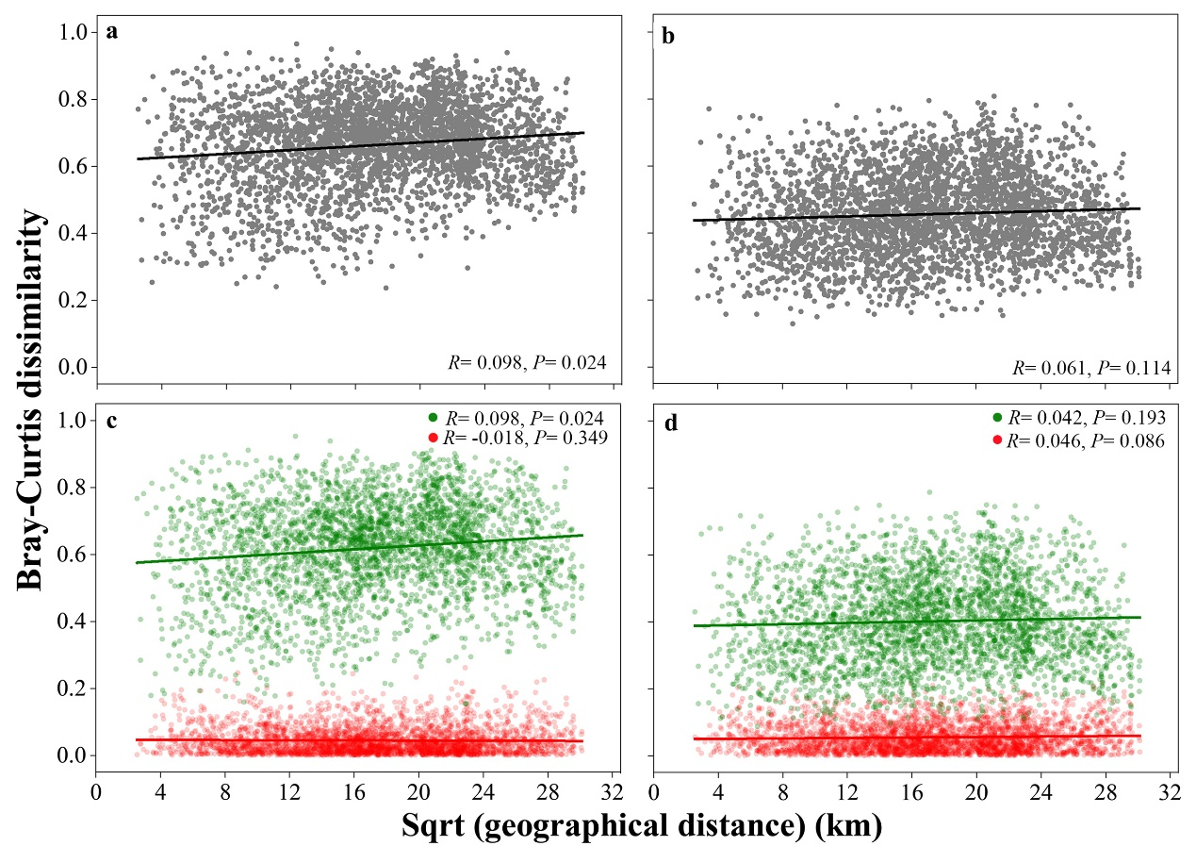
Figure S6. Spearman’s rank correlations between the Bray–Curtis dissimilarity of phytoplankton community and geographic distance, including the total beta-diversity, and the turnover (red dots) and richness (green dots) components of beta-diversity for taxonomic (a, c) and functional composition (b, d) of phytoplankton community.

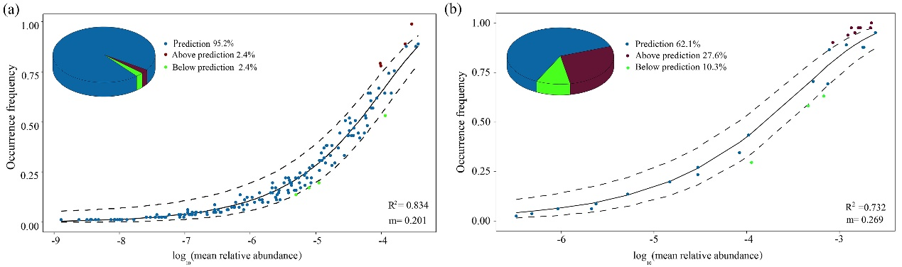
Figure S7. Fit of the neutral model based on the taxonomic (a) and functional compositions (b) of phytoplankton community. Occurrence frequencies of different infrageneric taxa (n=397) or functional groups (n=29) treated as a function of mean relative abundance in the whole 81 lakes. The predicated occurrence frequency is shown as a solid line, and dashed lines represent 95% confidence intervals around the model prediction. The value of m indicates the immigration rate of species, and R² indicates the overall fit to the neutral model.

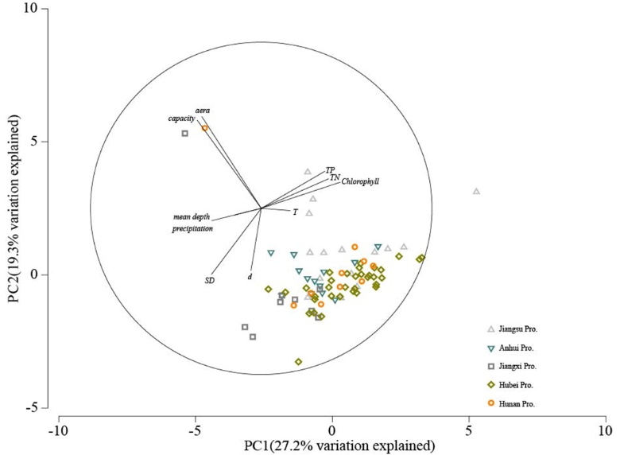
Figure S8. Principal Component Analysis (PCA) ordination plot of local environments.

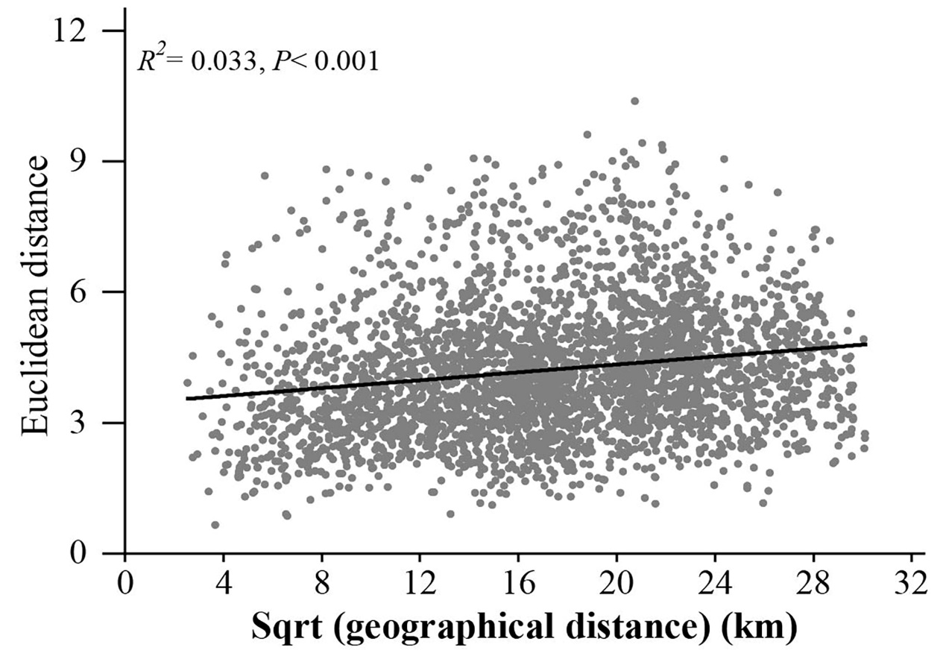
Figure S9. Spearman’s rank correlations between the Euclidean distance of local environments and geographic distance.

Table S1. Information on the studied 81 lakes in Yangtze River basin.
Lakes | Abbreviations of lakes in Fig. 1 | Longitude° | Latitude° | Province | T | SD | Mean depth | Aera | Capacity | Surface colleting area | runoff coefficient ^{[15]} | Annual runoff | Precipitation | Hydraulic retention time | Chlorophyll | Sampling sites
 |  |  |  |  | (°C) | (m) | (m) | (km2) | (10⁸*m³) | (km²) |  | (m³*10⁸) | (mm) | (d) | (mg/L)
Lake Gaoyou | GY | 119.296 | 32.853 | Jiangsu | 28.1 | 0.21 | 1.4 | 674.0 | 9.706 |  |  | 99.1 ^{[10]} | 1053.5 ^{[16]} | 35.7 | 35.69 | 11
Lake Luoma | LM | 118.187 | 34.089 | Jiangsu | 26.3 | 0.38 | 3.3 | 260.0 | 8.580 | 4900 ^{[21]} | 0.25 | 11.7 | 953 ^{[16]} | 267.7 | 22.18 | 7
Lake Yangcheng | YC | 120.771 | 31.435 | Jiangsu | 31.0 | 0.73 | 2.3 | 119.0 | 2.714 |  |  | 11.7 ^{[8]} | 1238 ^{[16]} | 84.7 | 28.61 | 8
Lake Changdang | CD | 119.554 | 31.627 | Jiangsu | 33.5 | 0.25 | 1.1 | 89.0 | 0.979 |  |  |  | 1358.8 ^{[16]} | 55.7 ^{[13]} | 97.80 | 5
Lake Shijiu | SJ | 118.907 | 31.462 | Jiangsu | 32.0 | 0.53 | 4.1 | 210.4 | 8.584 | 18600 ^{[1]} | 0.40 | 87.9 | 1181 ^{[16]} | 35.6 | 21.63 | 5
Lake Baima | BM | 119.134 | 33.277 | Jiangsu | 26.7 | 1.04 | 1.0 | 108.0 | 1.048 | 950 ^{[1]} | 0.25 | 2.5 | 1056.5 ^{[16]} | 152.9 | 1.38 | 5
Lake Cheng | C | 120.808 | 31.216 | Jiangsu | 26.6 | 0.35 | 1.8 | 45.0 | 0.824 | 810 ^{[21]} | 0.40 | 4 | 1238 ^{[16]} | 75.1 | 5.92 | 3
Lake Ge | G | 119.806 | 31.616 | Jiangsu | 31.9 | 0.12 | 1.2 | 146.5 | 1.743 |  |  | 14.4 ^{[4]} | 1358.8 ^{[16]} | 44.2 | 567.38 | 6
Lake Hongze | HZ | 118.685 | 33.310 | Jiangsu | 28.4 | 0.20 | 1.8 | 1576.9 | 27.911 | 156000 ^{[1]} | 0.25 | 412 | 1056.5 ^{[16]} | 24.7 | 23.66 | 16
Lake Kuncheng | KC | 120.743 | 31.588 | Jiangsu | 22.6 | 0.39 | 1.8 | 18.0 | 0.320 | 324 ^{[21]} | 0.40 | 1.6 | 1238 ^{[16]} | 73.1 | 14.52 | 3
Lake Weishan | WSh | 117.254 | 34.614 | Jiangsu | 28.3 | 0.47 | 1.5 | 1097.6 | 16.025 | 30453 ^{[1]} | 0.25 | 57.5 | 755 ^{[16]} | 101.7 | 37.36 | 7
Lake Gucheng | GC | 118.929 | 31.280 | Jiangsu | 31.7 | 0.43 | 1.6 | 24.5 | 0.382 | 465 ^{[2]} | 0.40 | 2.2 | 1181 ^{[16]} | 63.4 | 63.84 | 5
Lake Shaobo | SB | 119.447 | 32.605 | Jiangsu | 28.9 | 0.20 | 1.1 | 77.0 | 0.847 |  |  | 240.0 ^{[3]} | 1053.5 ^{[16]} | 1.3 | 23.63 | 4
Lake Yuandang | YD | 120.888 | 31.069 | Jiangsu | 31.7 | 1.00 | 1.4 | 12.9 | 0.178 |  |  |  | 1238 ^{[16]} | 75.1 ^{Lake Cheng} | 6.99 | 2
Lake Sanjiu | SJi | 119.799 | 31.376 | Jiangsu | 32.0 | 0.17 | 1.9 | 23.2 | 0.429 |  |  |  | 1237.3 ^{[16]} | 44.2 ^{Lake Ge} | 85.06 | 3
Lake Anfeng | AF | 116.679 | 32.286 | Anhui | 26.2 | 0.40 | 2.7 | 36.4 | 0.972 | 388 ^{[1]} | 0.25 | 0.9 | 893.4 ^{[17]} | 394.4 | 8.42 | 3
Lake Longgan | LG | 116.179 | 29.953 | Anhui | 30.8 | 0.58 | 3.8 | 316.2 | 11.952 | 5511 ^{[1]} | 0.40 | 35.1 | 1594.1 ^{[17]} | 124.3 | 41.54 | 6
Lake Qili | QL | 118.222 | 32.925 | Anhui | 22.9 | 0.25 | 1.6 | 38.5 | 0.616 | 850 ^{[23]} | 0.25 | 2.4 | 1115.3 ^{[17]} | 93.7 | 7.62 | 4
Lake Baidang | BD | 117.378 | 30.804 | Anhui | 23.3 | 0.37 | 3.1 | 39.7 | 1.214 | 775 ^{[1]} | 0.40 | 4.2 | 1365.7 ^{[17]} | 105.5 | 10.54 | 3
Lake Chengdong | CDo | 116.387 | 32.334 | Anhui | 24.0 | 0.52 | 1.5 | 120.0 | 1.800 | 2128 ^{[1]} | 0.25 | 6.8 | 1274.6 ^{[17]} | 96.6 | 8.20 | 5
Lake Chengxi | CX | 116.207 | 32.345 | Anhui | 27.3 | 0.29 | 2.7 | 199.0 | 5.373 | 1840 ^{[22]} | 0.25 | 5.9 | 1274.6 ^{[17]} | 332.4 | 2.00 | 2
Lake Huayuan | HY | 117.843 | 33.001 | Anhui | 22.6 | 0.40 | 1.4 | 34.0 | 0.459 | 875 ^{[1]} | 0.25 | 2.4 | 1115.3 ^{[17]} | 69.8 | 9.36 | 3
Lake Huangda | HD | 116.420 | 30.001 | Anhui | 28.5 | 0.50 | 3.9 | 463.1 | 18.246 | 5974 ^{[1]} | 0.40 | 38.1 | 1594.1 ^{[17]} | 174.8 | 11.00 | 8
Lake Jiaogang | JG | 116.601 | 32.599 | Anhui | 25.9 | 1.10 | 0.4 | 40.0 | 0.176 | 400 ^{[1]} | 0.25 | 0.9 | 893.4 ^{[17]} | 71.4 | 8.20 | 3
Lake Nvshan | NS | 118.081 | 32.969 | Anhui | 28.5 | 0.50 | 1.7 | 104.6 | 1.789 | 4215 ^{[1]} | 0.25 | 11.8 | 1115.3 ^{[17]} | 55.3 | 8.20 | 2
Lake Pogang | PG | 117.167 | 30.650 | Anhui | 22.0 | 0.27 | 1.5 | 60.0 | 0.912 | 346 ^{[1]} | 0.40 | 2.2 | 1594.1 ^{[17]} | 151.3 | 42.08 | 3
Lake Wabu | WB | 116.893 | 32.400 | Anhui | 26.8 | 0.77 | 2.4 | 163.0 | 3.945 | 800 ^{[1]} | 0.25 | 1.8 | 893.4 ^{[17]} | 799.9 | 33.33 | 5
Lake Wuchang | WC | 116.683 | 30.273 | Anhui | 27.0 | 0.83 | 3.4 | 100.5 | 3.447 | 1084 ^{[1]} | 0.45 | 7.8 | 1594.1 ^{[17]} | 161.3 | 15.93 | 5
Lake Chenjia | CJ | 116.366 | 28.659 | Jiangxi | 31.2 | 0.43 | 5.5 | 22.0 | 1.199 | 48 ^{[1]} | 0.45 | 0.3 | 1589 ^{[18]} | 1458.8 | 31.51 | 3
Lake Chi | Ch | 115.687 | 29.790 | Jiangxi | 29.2 | 2.04 | 2.8 | 80.4 | 2.251 | 360 ^{[1]} | 0.45 | 2.6 | 1575 ^{[18]} | 316.0 | 2.20 | 4
Lake Junshan | JS | 116.332 | 28.551 | Jiangxi | 25.3 | 2.19 | 4.0 | 192.5 | 7.700 | 615 ^{[1]} | 0.45 | 4.4 | 1589 ^{[18]} | 638.8 | 1.43 | 9
Lake Nanbei | NB | 116.223 | 29.683 | Jiangxi | 28.2 | 0.47 | 4.7 | 24.7 | 1.150 |  |  |  | 1575 ^{[18]} | 42.4 ^{Lake Pogang} | 62.15 | 3
Lake Sai | S | 115.883 | 29.683 | Jiangxi | 29.4 | 0.75 | 2.2 | 61.3 | 1.374 | 961 ^{[1]} | 0.40 | 6.1 | 1575 ^{[18]} | 82.2 | 4.58 | 4
Lake Taibo | TB | 116.728 | 30.019 | Jiangxi | 29.7 | 0.38 | 5.5 | 6.4 | 0.352 | 665 ^{[1]} | 0.40 | 4.2 | 1575 ^{[18]} | 30.6 | 29.05 | 3
Lake Xinmiao | XM | 116.159 | 29.348 | Jiangxi | 9.1 | 0.27 | 5.2 | 47.8 | 2.499 |  |  |  | 1575 ^{[18]} | 42.4 ^{Lake Poyang} | 10.36 | 2
Lake Zhu | Z | 116.652 | 29.141 | Jiangxi | 28.5 | 0.56 | 5.7 | 80.8 | 4.622 | 374 ^{[14]} | 0.40 | 2.9 | 1936 ^{[18]} | 581.7 | 2.37 | 5
Lake Poyang | PY | 116.366 | 29.117 | Jiangxi | 24.8 | 0.49 | 5.1 | 2933.0 | 149.583 | 162000 ^{[1]} | 0.50 | 1287.1 | 1589 ^{[18]} | 42.4 | 4.21 | 30
Lake Lu | L | 114.199 | 30.217 | Hubei | 30.4 | 0.60 | 2.7 | 40.2 | 1.085 | 463 ^{[1]} | 0.40 | 2.2 | 1161.4 ^{[19]} | 180.1 | 18.00 | 2
Lake Hou | H | 114.281 | 30.732 | Hubei | 28.8 | 0.90 | 2.2 | 16.2 | 0.356 | 157 ^{[2]} | 0.40 | 0.7 | 1161.4 ^{[19]} | 185.8 | 79.10 | 3
Lake Niushan | NSh | 114.551 | 30.321 | Hubei | 29.9 | 0.84 | 4.7 | 45.5 | 2.129 |  |  |  | 1161.4 ^{[19]} | 292.4 ^{Lake Liangzi[1,19]} | 31.11 | 5
Lake Ci | Ci | 115.047 | 30.217 | Hubei | 32.4 | 0.50 | 1.8 | 4.3 | 0.076 | 62.8 ^{[24]} | 0.40 | 0.4 | 1446.1 ^{[19]} | 69.0 | 96.06 | 2
Lake Chang | Cha | 112.450 | 30.447 | Hubei | 29.2 | 0.75 | 1.9 | 129.1 | 2.453 | 2265 ^{[1]} | 0.30 | 5.4 | 791.8 ^{[19]} | 165.8 | 35.70 | 6
Lake Xiliang | XL | 114.054 | 29.955 | Hubei | 33.1 | 0.50 | 1.9 | 72.1 | 1.377 | 827 ^{[1]} | 0.40 | 5.5 | 1677.1 ^{[19]} | 91.4 | 139.40 | 5
Lake Dongxicha | DXC | 113.679 | 30.809 | Hubei | 31.5 | 1.27 | 1.6 | 24.3 | 0.389 | 148 ^{[1]} | 0.35 | 0.5 | 1027.4 ^{[19]} | 283.8 | 8.52 | 3
Lake Daye | DY | 115.099 | 30.100 | Hubei | 30.9 | 0.73 | 2.3 | 68.7 | 1.580 | 1106 ^{[1]} | 0.45 | 7.2 | 1446.1 ^{[19]} | 80.1 | 29.00 | 5
Lake Baoan | BA | 114.717 | 30.253 | Hubei | 29.3 | 0.43 | 3.4 | 48.0 | 1.632 | 243 ^{[1]} | 0.45 | 1.6 | 1446.1 ^{[19]} | 372.3 | 57.97 | 3
Lake Wang | W | 115.339 | 29.868 | Hubei | 32.6 | 0.70 | 3.7 | 42.3 | 1.565 | 5310 ^{[1]} | 0.45 | 34.6 | 1446.1 ^{[19]} | 16.5 | 5.70 | 3
Lake Zhangdu | ZD | 114.698 | 30.648 | Hubei | 30.5 | 1.65 | 1.2 | 35.2 | 0.422 | 514 ^{[1]} | 0.45 | 2.7 | 1161.4 ^{[19]} | 57.1 | 4.40 | 3
Lake Tangxun | TX | 114.344 | 30.434 | Hubei | 32.1 | 0.48 | 1.9 | 36.6 | 0.677 | 261 ^{[9]} | 0.45 | 1.4 | 1161.4 ^{[19]} | 176.5 | 29.50 | 4
Lake Yezhu | YZ | 114.075 | 30.866 | Hubei | 28.7 | 0.30 | 2.3 | 26.6 | 0.612 | 320 ^{[1]} | 0.45 | 1.5 | 1027.4 ^{[19]} | 148.9 | 68.07 | 3
Lake Sanshan | SS | 114.777 | 30.311 | Hubei | 29.0 | 0.72 | 2.8 | 24.3 | 0.680 | 243 ^{[2]} | 0.45 | 1.4 | 1248.3 ^{[19]} | 177.4 | 24.23 | 3
Lake Wu | Wu | 114.495 | 30.803 | Hubei | 31.3 | 1.23 | 2.6 | 21.2 | 0.551 | 562 ^{[1]} | 0.45 | 2.9 | 1161.4 ^{[19]} | 69.4 | 34.38 | 3
Lake Wushan | Ws | 115.587 | 29.917 | Hubei | 32.8 | 0.30 | 3.1 | 16.1 | 0.499 |  |  |  | 1396.5 ^{[19]} | 242.3 ^{Lake Zhupo} | 175.95 | 2
Lake Shangjin | Sj | 112.509 | 29.637 | Hubei | 29.5 | 0.28 | 2.3 | 18.6 | 0.428 | 90 ^{[2]} | 0.30 | 0.3 | 1154 ^{[19]} | 520.5 | 130.71 | 2
Lake Zhupo | ZP | 115.390 | 29.830 | Hubei | 29.4 | 0.30 | 4.5 | 17.7 | 0.797 | 212 ^{[2]} | 0.40 | 1.2 | 1446.1 ^{[19]} | 242.3 | 107.83 | 3
Lake Niulang | NL | 111.963 | 29.834 | Hubei | 30.6 | 0.32 | 2.3 | 15.9 | 0.366 | 251 ^{[1]} | 0.35 | 1 | 1154 ^{[19]} | 133.5 | 99.22 | 3
Lake Tongjia | TJ | 114.166 | 30.790 | Hubei | 28.9 | 1.22 | 5.9 | 6.6 | 0.389 | 420 ^{[1]} | 0.40 | 2 | 1161.4 ^{[19]} | 71.0 | 18.47 | 2
Lake Chong | Cho | 112.263 | 29.934 | Hubei | 27.2 | 0.73 | 1.3 | 13.9 | 0.181 | 124 ^{[2]} | 0.30 | 0.4 | 1154 ^{[19]} | 164.9 | 30.08 | 2
Lake Zhongxiangnan | ZXN | 112.629 | 31.142 | Hubei | 29.8 | 0.23 | 1.7 | 13.7 | 0.233 | 198 ^{[1]} | 0.25 | 0.4 | 791.8 ^{[19]} | 212.5 | 214.14 | 2
Lake Ce | Ce | 115.161 | 30.253 | Hubei | 32.9 | 0.38 | 2.1 | 11.8 | 0.248 | 320 ^{[2]} | 0.40 | 1.8 | 1396.5 ^{[19]} | 50.2 | 112.12 | 3
Lake Huama | Hm | 114.993 | 30.267 | Hubei | 32.9 | 0.70 | 1.8 | 10.3 | 0.185 | 291 ^{[1]} | 0.40 | 1.5 | 1248.3 ^{[19]} | 45.1 | 29.19 | 2
Lake Yu | Y | 112.086 | 30.063 | Hubei | 28.2 | 0.40 | 1.4 | 7.0 | 0.098 | 311 ^{[2]} | 0.30 | 1.1 | 1154 ^{[19]} | 32.5 | 63.66 | 2
Lake Hong | Ho | 113.375 | 29.873 | Hubei | 28.5 | 1.51 | 1.9 | 344.4 | 6.578 |  |  | 37.4 ^{[14]} | 1154 ^{[19]} | 64.2 | 2.24 | 6
Lake Futou | FT | 114.202 | 29.997 | Hubei | 32.2 | 0.70 | 2.9 | 114.7 | 3.326 | 1238 ^{[1]} | 0.40 | 8.3 | 1677.1 ^{[19]} | 146.3 | 10.40 | 3
Lake Hanyangdong | HYD | 114.388 | 30.569 | Hubei | 33.2 | 0.31 | 1.6 | 34.4 | 0.550 | 117 ^{[7]} | 0.40 | 0.5 | 1161.4 ^{[19]} | 401.8 | 228.64 | 3
Lake Chidong | ChD | 115.402 | 30.122 | Hubei | 33.7 | 0.46 | 3.5 | 26.8 | 0.938 | 553 ^{[1]} | 0.40 | 3.1 | 1396.5 ^{[19]} | 110.4 | 75.45 | 6
Lake Taibai | TBa | 115.807 | 29.961 | Hubei | 31.9 | 0.35 | 3.2 | 33.5 | 1.058 | 960 ^{[1]} | 0.40 | 5.4 | 1396.5 ^{[19]} | 71.5 | 100.07 | 2
Lake Yuni | YN | 112.098 | 29.800 | Hubei | 30.0 | 0.32 | 2.0 | 16.5 | 0.330 | 152 ^{[1]} | 0.30 | 0.5 | 1154 ^{[19]} | 240.9 | 96.97 | 5
Lake Shangshe | SSh | 114.237 | 30.132 | Hubei | 27.0 | 0.42 | 2.1 | 11.9 | 0.250 | 53 ^{[25]} | 0.40 | 0.2 | 1161.4 ^{[19]} | 456.1 | 99.21 | 3
Lake Huanggai | HG | 113.545 | 29.705 | Hubei | 28.7 | 0.67 | 3.2 | 82.1 | 2.660 | 1677 ^{[1]} | 0.40 | 11.2 | 1677.1 ^{[19]} | 86.7 | 59.43 | 2
Lake San | Sa | 113.901 | 29.939 | Hubei | 29.4 | 0.95 | 7.6 | 13.8 | 1.049 |  |  |  | 1154 ^{[19]} | 520.5 ^{Lake Shangjin} | 20.07 | 2
Lake Bajiao | BJ | 113.184 | 29.443 | Hunan | 33.0 | 0.38 | 3.0 | 12.3 | 0.369 | 114.5 ^{[1]} | 0.35 | 0.6 | 1510.2 ^{[20]} | 224.5 | 51.43 | 2
Lake Beimin | BMi | 111.876 | 29.715 | Hunan | 24.4 | 0.50 | 2.8 | 14.5 | 0.406 | 1340 ^{[1]} | 0.50 | 10.3 | 1536 ^{[20]} | 14.4 | 32.03 | 2
Lake Yueyangnan | YYN | 113.117 | 29.336 | Hunan | 32.2 | 0.61 | 5.4 | 12.0 | 0.648 | 150 ^{[1]} | 0.35 | 0.8 | 1510.2 ^{[20]} | 295.7 | 39.97 | 2
Lake Shanpo | SP | 112.030 | 29.433 | Hunan | 30.7 | 0.16 | 2.6 | 26.0 | 0.676 | 40 ^{[11]} | 0.50 | 0.3 | 1536 ^{[20]} | 822.5 | 35.11 | 3
Lake Datong | DT | 112.510 | 29.211 | Hunan | 32.5 | 0.48 | 2.9 | 114.2 | 3.300 |  |  | 229.5 ^{[7]} | 1597.6 ^{[20]} | 5.2 | 21.72 | 6
Lake Huarongdong | HRD | 112.646 | 29.368 | Hunan | 28.0 | 0.51 | 3.5 | 23.2 | 0.812 | 110.26 ^{[5]} | 0.40 | 0.7 | 1510.2 ^{[20]} | 423.4 | 65.47 | 3
Lake Maoli | ML | 111.954 | 29.413 | Hunan | 27.0 | 0.86 | 3.5 | 36.8 | 1.288 | 381 ^{[6]} | 0.50 | 2.9 | 1536 ^{[20]} | 162.1 | 16.11 | 3
Lake Liuye | LY | 111.750 | 29.070 | Hunan | 27.2 | 0.45 | 2.4 | 24.0 | 0.571 | 305 ^{[1]} | 0.50 | 2.3 | 1536 ^{[20]} | 90.6 | 7.67 | 3
Lake Anle | AL | 112.189 | 28.826 | Hunan | 30.5 | 0.26 | 4.2 | 30.0 | 1.260 |  |  |  | 1536 ^{[20]} | 90.6 ^{Lake Liuye} | 46.12 | 3
Lake Dongting | DTi | 112.946 | 29.319 | Hunan | 28.2 | 0.37 | 6.4 | 2432.5 | 155.437 | 263000 ^{[1]} | 0.35 | 1390.1 | 1510.2 ^{[20]} | 40.8 | 7.00 | 30
Note: Information on the surface collecting area and runoff coefficient was absent in some lakes, including Lake Yuandang, Lake Sanjiu, Lake Nanbei, Lake Xinmiao, Lake Niushan, Lake Wushan, Lake San, Lake Anle, as well, information on annual runoff could not be obtained from published research articles, thus their hydraulic retention time was acquired and shared with their connected lakes.

References in Table S1

[1]Yang G.S. 2019. Report of lake Survey in China [M]. Science Press, pp261-446.
[2] He F.B. 2015. A study on the ecosystem health assessment of eastern shallow lakes—the case of lake in Hubei province [D]. Chongqing Jiaotong University, China, pp10-13.
[3]Zhang Y. 2016. Study the Gaobao Shaobo lake embankment westland plant diversity and regional resources [D]. Nanjing Agriculture University, China, pp8-9.
[4] Xiong C.H. 2016. Studies on community structure of macro-zoobenthos and its relationship with environmental factors in Lake Gehu [D]. Shanghai Ocean University, China, pp7-8.
[5] Wu X.L. 2014. The research on basic ecological functions of Huarong East Lake National Wetland Park [D]. Central South University of Forestry and Technology, China, pp10-11.
[6]Lei D. 2020. Water conservation capacity and its valuation of Moso Bamboo Forest along the shore of West Mauri Lake, Hunan Province. Word Bamboo and Rattan 18: 29-42.
[7] Bai K.Y. 2019. Lake eutrophication simulation and evaluation system based on 3S technology [D]. Huazhong University of Science and Technology, China, pp11-12.
[8] https://wenku.baidu.com/view/e1b57d4ef7ec4afe04a1df71?fr=xueshu
[9] Zhuang Y.H. 2013. Simulation of spatial-temporal changes of complex non-point source loads under rapid urbanization [D]. Wuhan University, China, pp21-22.
[10] Sun W.H., Han L.X. 2019. Pollution source appointment for the control section in Gaoyou Lake based on water quantity and water quality model. Environmental Protection Science. 5: 52-57.
[11] Research Group on Increasing Culture Technology of Semper Lake. 1989. A survey report on the natural resources of Semper Lake. Inland Fisheries 4: 13-14.
[12] Lu X.P., Zhang J.L., Xia Z.C. 2017. Monitoring of water ecology of Shijiu and Gucheng lakes in Nanjing and restoration measures. China Water Resources, Forum of Aquatic Ecological Civilization.
[13] Wu F. 2005. Study on the pollution characteristics and its control of Changdang Lake [D]. HoHai University, China, p19.
[14] Zhou M., Zhang M.,Wan B.H. 2021. Spatial distribution characteristics and assessment of pollutants in the profile sediments of Zhuhu Lake. Jiangxi Science 39: 263-274.
[15] https://www.osgeo.cn/map/mf135
[16] http://jssslt.jiangsu.gov.cn/art/2014/7/11/art_51453_6179710.html
[17]http://slt.ah.gov.cn/ssltOldFiles/attachment/swj/files/20161123/6361549110534519678505035.pdf
[18] https://max.book118.com/html/2019/0529/7005115143002030.shtm
[19] http://slt.hubei.gov.cn/bsfw/cxfw/szygb/201911/t20191129_1549966.shtml
[20]http://slt.hunan.gov.cn/slt/xxgk/tjgb/201810/7657158/files/7b85ad6985d84b75957cbd820078ebca.pdf
[21]https://baike.baidu.com/item/%E9%AA%86%E9%A9%AC%E6%B9%96/1125413?fr=aladdin
[22]https://baike.baidu.com/item/%E5%9F%8E%E8%A5%BF%E6%B9%96/3116383?fr=aladdin
[23]https://baike.baidu.com/item/%E4%B8%83%E9%87%8C%E6%B9%96/998380?fr=aladdin
[24] https://baike.baidu.com/item/%E7%A3%81%E6%B9%96/5326351?fr=aladdin
[25]https://baike.baidu.com/item/%E4%B8%8A%E6%B6%89%E6%B9%96/6392203?fr=aladdin

