Supplementary Table 1. Working definitions for resources for sharing participant-level data
Term | Definition | Approach to harmonization | Data types
Platform¹ | Combines big data tools and infrastructure. Major investment to continuously store, manage, mine big data sets (e.g. OMICs, imaging data). | Retrospective or prospective | May be limited to 1 data type or include various prespecified data types
Registry² | Collection of data physically stored in an assigned location. Low level of investment needed. Data generally entered or uploaded using the same case report form/data dictionary and focus on a particular disease, condition, or exposure. | Prospective | Generally limited to 1 specific data type
Dataverse³ | Open source web application to share, preserve, cite, and explore research data of various types and with varying objectives. | Data is in its original form and not harmonized | Any
Datahub⁴ | Data store that is an integration point for multiple datasets with different structures. Data are physically moved and stored together, however access permissions vary by data contributor. | Generally involves harmonization of data | Any
Data lake⁴ | Central repository or pool of raw and untransformed data of any data type for an undefined purpose and requires other add-on tools to search or operationalize the data. Requires a low-level of investment. | Data is in its original form and not harmonized | Any
Data warehouse⁵ | Data management tool that contains structured, filtered data that has already been processed and refined for a specific purpose allowing end users to perform further analytics. | No harmonization | Any
Data federation⁶ | Technology wherein the data stored in different data sources are made accessible as one integrated virtual database and can be queried, transformed and accessed by data consumers. Data federation is a subset of data virtualization. | Data federation involves transformation, cleansing, and at times, the enrichment of data | Any
Data virtualization⁴ | Data virtualization evolved from data federation with additional features and functionalities. According to different software developers, data virtualization has several capabilities beyond data federation including advanced security, query processing, and data transformation features. | Same as data federation | Any
Data catalogue⁷ | Website with linkages to available datasets or platforms. | No harmonization | Does not host data

Supplementary Note 1. Google and Google Scholar Search Terms for COVID-19-related platforms and registries

(coronavirus OR COVID‐19 OR :severe acute respiratory syndrome” OR coronavirus-2019 OR nCoV OR 2019nCoV OR 2019‐novel CoV OR corona vir* OR coronavir* OR neocorona vir* OR neocoronavir* OR COVID OR COVID19 OR nCov 2019 OR nCov 19 OR SARS‐CoV‐2 OR SARS‐CoV2 OR SARSCoV2 OR SARSCoV‐2 SARS coronavirus 2 OR SARS‐like coronavirus OR Severe Acute Respiratory Syndrome Coronavirus‐2) AND (database oOR databases OR repository OR repositories OR registry OR registries OR platform OR platforms)

Supplementary Note 2. Natural Language Processing Strategy & Source Code
Natural language processing (NLP) was applied to the Covid-19 Open Research (CORD-19) Dataset¹ to identify additional COVID-19-related data sharing platforms and repositories. NLP was conducted in a Jupyter Notebook environment using R. We singled out titles in the CORD-19 database with desired relatability to the publication using the keywords: registry, registries, database, databases, platform, platforms, repository, repositories, IPD-MA, individual participant data meta-analysis, and data dashboard.
NLP was a useful approach to dealing with the CORD-19 resources in English as well as different languages because processing this data through automation is difficult to do without an understanding of the way humans speak and write naturally. By matching proper nouns and nouns to the root of the sentence, we identified citations in the CORD-19 database that stated the name of the database or registry. We matched appositional modifiers to the target search terms to pick up any missed items that the initial algorithm did not pick up, due to the format the title was written in its respective language.
The NLP R source code was as follows:
#Resources
#https://universaldependencies.org/en/dep/index.html
#https://universaldependencies.org/u/pos/
#https://nlp.stanford.edu/software/dependencies_manual.pdf

#code to single out titles with search terms
import csv
import os
import json
from collections import defaultdict
import spacy
cord_uid_to_text = defaultdict(list)
with open("metadata.csv", encoding="utf-8") as f_in:
reader = csv.DictReader(f_in)
for column in reader:
title = column['title']
abstract = column['abstract']
cord_uid = column['cord_uid']
title.lower()
if "registry" in title:
print(title + "\n")
elif "database" in title:
print(title + "\n")
elif "databases" in title:
print(title + "\n")
elif "registries" in title:
print(title + "\n")
elif "platform" in title:
print(title + "\n")
elif "platforms" in title:
print(title + "\n")
elif "repository" in title:
print(title + "\n")
elif "repositories" in title:
print(title + "\n")
elif "ipd-ma" in title:
print(title + "\n")
elif "data dashboard" in title:
print(title + "\n")
elif "individual participant data meta-analysis" in title:
print(title + "\n")

# with title : + "\n" + title + "\n"
#Code to match a proper noun (title of database) to the root of the sentenc
import csv
import os
import json
from collections import defaultdict
import spacy
terms = ["registry", "registries", "database", "databases", "platform", "pl
"ipd-ma", "data dashboard", "individual participant data meta-analy
cord_uid_to_text = defaultdict(list)
parser = spacy.load("en_core_web_lg")
with open("parsed_metadata.csv", encoding="utf-8") as f_in:
reader = csv.DictReader(f_in)
for column in reader:
title = column['title']
cord_uid = column['cord_uid']
pdoc = parser(title)
for token in pdoc:
if token.pos_ == "PROPN" and token.dep_ == "ROOT":
print(cord_uid)
else:
next

#code to match any appositional modifiers to specific target terms
import csv
import os
import json
from collections import defaultdict
import spacy
terms = ["registry", "registries", "database", "databases", "platform", "pl
"ipd-ma", "data dashboard", "individual participant data meta-analy
cord_uid_to_text = defaultdict(list)
parser = spacy.load("en_core_web_lg")
with open("parsed_metadata.csv", encoding="utf-8") as f_in:
reader = csv.DictReader(f_in)
for column in reader:
title = column['title']
cord_uid = column['cord_uid']
pdoc = parser(title)
for token in pdoc:
if token.dep_ == "appos":
if token.orth_ in terms:
print(title)

Supplementary Note 3. REDCap Questionnaire for COVID-19 Data Sharing Resources
https://drive.google.com/file/d/15_R5kTimpNByDM07scBzX1ymOnfz-IU1/view?usp=sharing

Supplementary Note 4. Quantitative evaluation of adherence of platforms for sharing participant-level COVID-19 data to the FAIR Principles
We limited the quantitative evaluation to registries for participant-level clinical data because we could not apply the same metrics for resources for sharing different data types. For example, participant-level clinical registries are necessarily restricted access due to the sensitive nature of the data whereas databases for sharing pathogen OMICs data are open access. When comparing resources for sharing these data types, the difference in access to data does not mean that one resource is less accessible than the other. While discipline-specific FAIR criteria should be developed using a diverse panel of experts and stakeholders, we applied the aforementioned guidance to indicators used by the FAIRshake tool⁸ algorithm to better align the tool’s evaluation with the specific concerns that we thought would be most important to end users of registries of clinical data. None of the registries that collect and harmonize COVID-19 participant-level clinical data had been assigned a DOI prior to our review of the registries. Eighteen of the registries were assigned a DOI by FAIRsharing as part of our evaluation. Seventeen of the registries that we contacted to assign a DOI did not respond to these inquiries and we could not quantify their FAIRness.

Below, we review the criteria used to create the preliminary rubric for evaluating registries’ for sharing participant-level clinical COVID-19 data adherence to the FAIR principles. These draft criteria will be presented to the Research Data Alliance, an international network of individuals and groups working to improve FAIR data. Blue text indicates metrics from the WHO team’s Excel file. Green text is used for metrics from the FAIR Data Maturity Model Specification and Guidelines 2020.⁹ Text with a strikethrough indicates text that was removed from the corresponding indicator in the source file.
Preliminary criteria for the application of the FAIR assessment rubric
Findable
- PID (unique & persistent identifier) for the data (RDA-F1-01D / RDA-F1-02D)
Does the repository provide PIDs for the datasets therein?
Value: Values will be the same for all the COVID-19 resources we assessed as it isn’t clear (in a machine-actionable manner) what kind of PID they use, as we don't have data access. This means all the registries will fail this indicator.
- Annotation with metadata (RDA-F2-01M)
This is the only thing that could differ between resources: the quality / quantity of metadata annotation.
We can consider 3 levels:
i) nothing -> fail
ii) minimum (contact, description, ? to be defined) -> medium
iii) rich (? to be defined)
This could also be the sum of the criteria filled out in the WHO survey.
Value: Consider the metric as a success for every registry, as this was a criterion to enter them in FAIRsharing (a minimum set of metadata must be required to be inserted into FAIRsharing).
- PID (unique & persistent identifier) for the metadata (RDA-F1-01M / RDA-F1-02M)
Does the metadata from the repository are assigned a unique & persistent identifier?
Value: Values will be the same for all the COVID-19 resources because they have a PID for metadata in FAIRsharing.
- Link between PID_data & PID_metadata (RDA-F3-01M)
Does the metadata include the unique & persistent identifier of the data?
Value: this will always give a failure (PID_data: FAIL ; PID_metadata: FAIL) .
- Findable on search engines (RDA-F4-01M)
Are the registries findable on search engines? (we can check if they are marked up with Schema.org
Did not assess whether the registers were present on portals or institutional websites.
Value: every registry gave a success except "European Renal Association COVID-19 Database" (when searching on Google, can't find https://www.eracoda.org/ link, but I can access thanks to FAIRsharing link or others websites that redirect to the link).

Accessible
- Standard protocol and secured standard protocol (https, ftps) (RDA-A1-04M / RDA-A1.1-01M)
Is the metadata accessible via standard protocols such as HTTPS and FTPS?
Value: Values are the same for all the registries, as they can be accessible by https website.
- Authentication secure (RDA-A1.2-01D)
Is sensitive data accessible by secure authentication?
Value: Consider REDCap secure (=success). For registries we don’t know if there is an authentication (REDCap is not used), assigned a “Not Clear” value for these cases.
- Metadata accessibility on the long term (RDA-A2-01M)
Will the metadata be accessible in the long term even if the resource disappears?
Value: Values will be the same for all the COVID-19 resources because all the resources have a PID for metadata on FAIRsharing.
- Contact information (no correspondence with RDA)
Is there any contact information available on the website (not sure that we should make a distinction between a “registry contact” and a PI contact: a registry contact is better for sustainability but there is a chance that these rapidly emerging resources will disappear just as quickly and, in this case, a PI contact is better).
“Registry email”
“PI email(s)”
“Registry contact email(s)”
Value: Marked as successful only if one of these criteria is met.
- Contact information valid (no correspondence with RDA)
In the context of this type of repository, it is important that the contact responds. The WHO team sent a survey to the contact and they received or not an answer. I think we can only consider “responded to survey.”
“Responded to survey with detailed questions about data types, sharing, and governance”
“Notes from investigator on how to access data”
Value: Marked as successful if “Responded to survey with detailed questions about data types, sharing, and governance” is met.
- Data access (RDA-A1-01M)
Is there a clear description of the access to the data?
“Link to description of how to access data”
“Link to clearly specified governance mechanism for reviewing data access requests”
“Link to clearly specified criteria for reviewing data access requests”
“Criteria for reviewing data access requests (from REDCap)”
“Who controls access to the data”
Value: Ignored “Criteria for reviewing data access requests (from REDCap).” Averaged the other 4 criteria (green: 1 ; red: 0 ; yellow: 0,5).
Removed the “who controls access to the data”, it doesn’t bring anything.
- Data sharing (no correspondence with RDA)
Is the data shared? As raw data is not directly accessible, here we can assess if some summary / reports / data dashboard / scientific articles are available.
“Data sharing status”
“Investigator explanation for why data won't be shared (write N/A if data will be shared)”
“Is there a data dashboard / articles / reports available?”
Value: Ignored “Investigator explanation for why data won't be shared (write N/A if data will be shared)”. Marked as successful only if one of the two criteria is met.
Interoperable
- Use of a controlled vocabulary (RDA-I1-01D)
Does the data use a knowledge representation expressed in a standardised format? It can be assumed here that the use of forms to insert patient data allows the use of a controlled vocabulary.
“Link to COVID-19 CRF or data dictionary”
Value: Success only if one of the two criteria is met.
- Use of a FAIR controlled vocabulary (RDA-I2-01M / RDA-I2-01D)
Does the data use a knowledge representation expressed in a FAIR standardised format? We can remove OMICS standards and Imaging data standards because not appropriate for these registries.
“What formal standards does the platform apply for human OMICs data access?”
“Connection between CRF and existing standards (e.g., ICD 9-11, CDASH, SNOMED, LOINC)”
“Uses ISARIC/WHO CRF (case report form)?”
“Clinical-epidemiological standards used by registry”
“OMICs data shardards used by registry”
“Imaging data standards used by registry”
Value: no known standard could be identified in the registries (except for the Extracorporeal Life Support Organization Registry which uses a Clinical-epidemiological standard)
Removed OMICS and imaging standards as we only look at registries.
Removed the connexion between CRF and existing standard (removed from WHO spreadsheet + doublon with the use of clinical-epidemiological standards used by the registry).
- Data contextualisation (related resources) (RDA-I3-01M)
Are there links to platforms in the same field to contextualise the register? Are there links to clinical trials on ClinicalTrials.gov ?
“Links to related platforms”
Value: success if yes, failure if no.
Reusable
- Licence (RDA-R1.1-01M)
Is there a clear and accessible licence for re-use?
“Data usage license”
Value: success if yes, failure if no. Yes if found a link “terms of use”, “terms of service”, “copyright notice” on the corresponding website
- Source of data (no correspondence with RDA)
Does metadata include provenance information ?
“Who can enter data? (anyone, registered users of the platform, the platform hosts)”
“How is data entered? (can data be uploaded? Is this through a REDCap data entry platform, etc?)”
Value: I averaged the 2 criteria.
- Use of community standard (RDA-R1.3-01M, RDA-R1.3-01D / RDA-R1.3-02M / RDA-R1.3-02D)
Does data and metadata comply with a community standard ? Is data and metadata expressed in compliance with a machine-understandable community standard ?
These are the results of: “Use of a FAIR controlled vocabulary”. Almost all registries missed meeting this criterion.
Value: Took the same results as the “Use of a FAIR controlled vocabulary” criteria (meaning failure for most of the registries). I just improved the score of the “except for the Extracorporeal Life Support Organization Registry” and “Discovery VIRUS COVID-19”, as one standard is not sufficient to meet this criteria.
Supplementary Figure 1. Registry and platform-specific linkages between data types
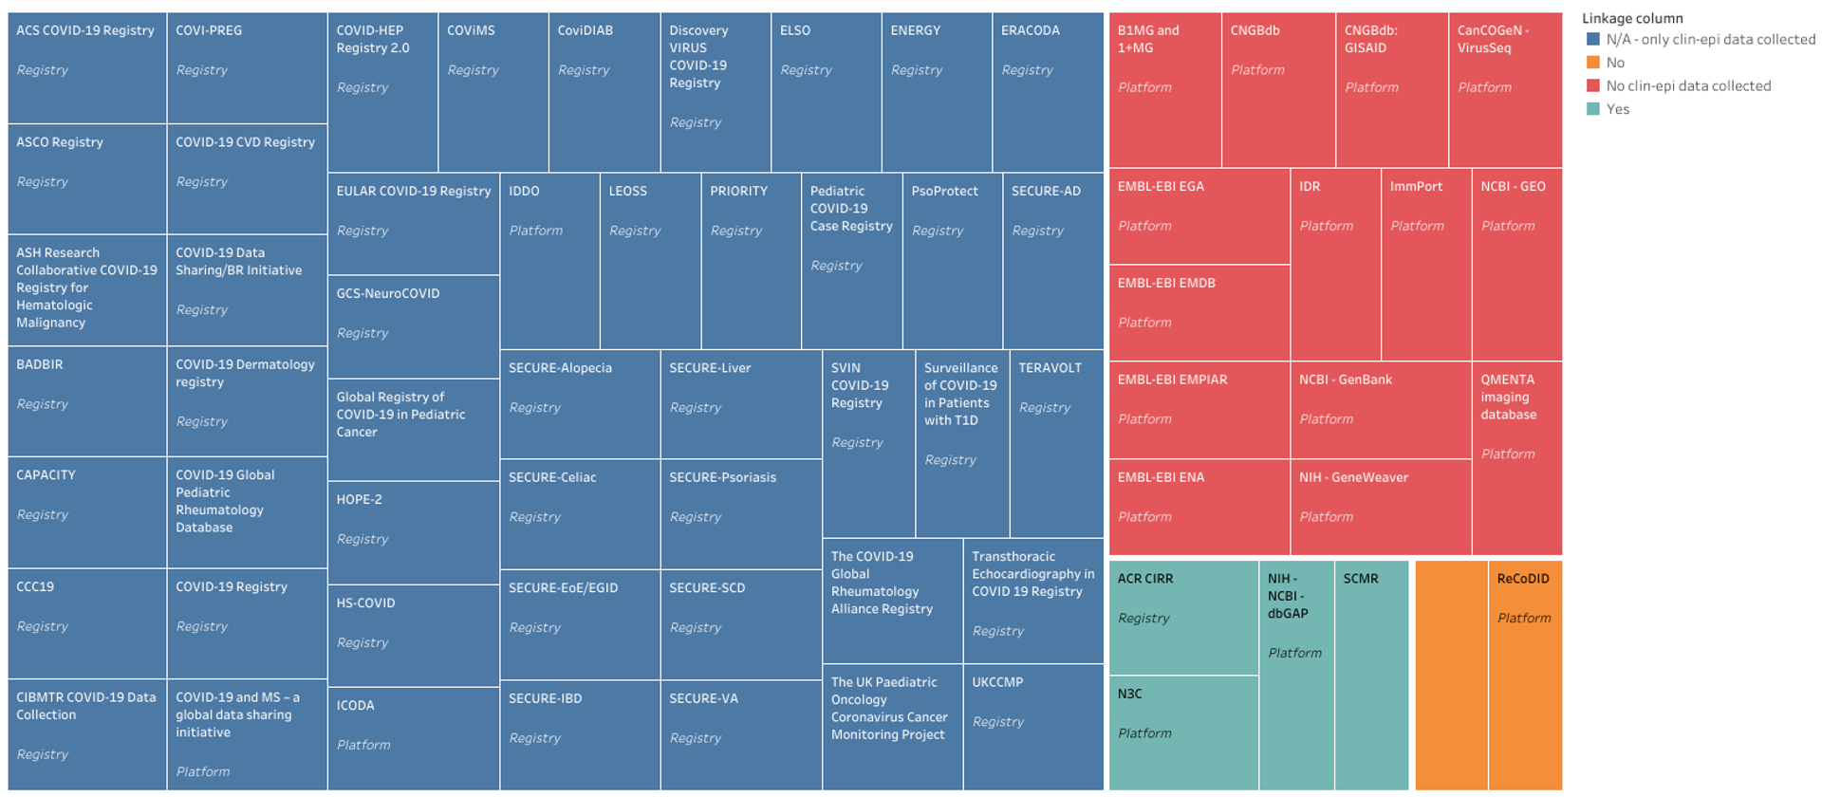

Supplementary Figure 2. Summary distribution of platforms and registries for sharing participant-level COVID-19-related health data
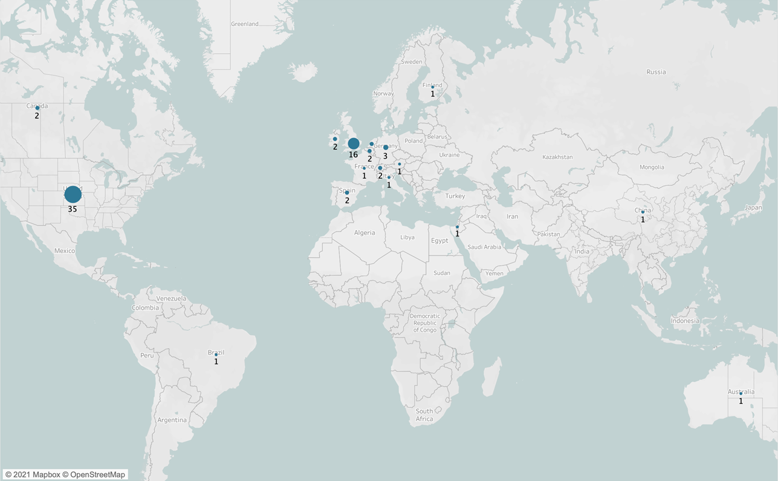
*Circle size is proportional to the number of registries or platforms for collecting, harmonizing, sharing COVID-19

Supplementary Figure 3. Distribution of platforms and registries for sharing participant-level COVID-19-related health data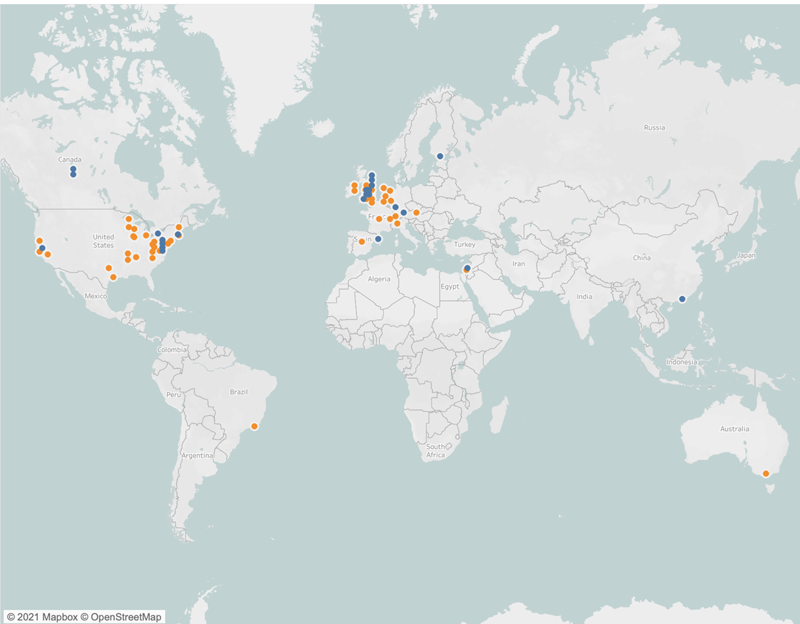
Blue circles represent the location of platforms. Orange circles represent the location of registries.
Supplementary Table 2. Potential data sharing resources identified through application of NLP to CORD-19 database
No. | Title of citation for potential tool | Assessment of utility as resource for collecting, harmonizing and sharing COVID-19 participant-level data
1 | OutbreakTools: A new platform for disease outbreak analysis using the R software | Does not collect, harmonize, share COVID-19 participant-level data
2 | Erratum: A biomimetic hybrid nanoplatform for encapsulation and precisely controlled delivery of theranostic agents | Does not collect, harmonize, share COVID-19 participant-level data
3 | Corrigendum: A coral-on-a-chip microfluidic platform enabling live-imaging microscopy of reef-building corals | Does not collect, harmonize, share COVID-19 participant-level data
4 | Project OPUS: Development and evaluation of an electronic platform for pain management education of medical undergraduates in resource-limited settings | Does not collect, harmonize, share COVID-19 participant-level data
5 | A Self-Assembling Ferritin Nanoplatform for Designing Classical Swine Fever Vaccine: Elicitation of Potent Neutralizing Antibody | Does not collect, harmonize, share COVID-19 participant-level data
6 | Amikacin pharmacokinetic/pharmacodynamic in intensive care unit: a prospective database | Does not collect, harmonize, share COVID-19 participant-level data
7 | An Optimizing Multi-platform Source-to-source Compiler Framework for the NEURON MODeling Language | Does not collect, harmonize, share COVID-19 participant-level data
8 | LitCovid: an open database of COVID-19 literature | Does not collect, harmonize, share COVID-19 participant-level data
9 | DRDOCK: A drug repurposing platform integrating automated docking, simulations and a log-odds-based drug ranking scheme | Does not collect, harmonize, share COVID-19 participant-level data
10 | Trialstreamer: a living, automatically updated database of clinical trial reports | Does not collect, harmonize, share COVID-19 participant-level data
11 | REPP: A robust cross-platform solution for online sensorimotor synchronization experiments | Does not collect, harmonize, share COVID-19 participant-level data
12 | SARS Grid--an AG-based disease management and collaborative platform | Does not collect, harmonize, share COVID-19 participant-level data
13 | COVIDScholar: An automated COVID-19 research aggregation and analysis platform | Does not collect, harmonize, share COVID-19 participant-level data
14 | LitCovid: an open database of COVID-19 literature | Duplicate (8)
15 | DBCOVP: A database of coronavirus virulent glycoproteins | Does not collect, harmonize, share COVID-19 participant-level data
16 | Telehealth Training During the COVID-19 Pandemic: A Feasibility Study of Large Group Multiplatform Telesimulation Training | Does not collect, harmonize, share COVID-19 participant-level data
17 | Nanoplatforms for mRNA Therapeutics | Does not collect, harmonize, share COVID-19 participant-level data
18 | Covid-19 Disease Simulation using GAMA platform | Does not collect, harmonize, share COVID-19 participant-level data
19 | BioDynaMo: a general platform for scalable agent-based simulation | Does not collect, harmonize, share COVID-19 participant-level data
20 | COVID-19 Disease Map, building a computational repository of SARS-CoV-2 virus-host interaction mechanisms | Does not collect, harmonize, share COVID-19 participant-level data
21 | ERACODA: the European database collecting clinical information of patients on kidney replacement therapy with COVID-19 | Registry that collects participant-level longitudinal clin-epi data about patients on kidney replacement therapy with COVID-19, harmonizes the data, but does not share the participant-level data
22 | The National Gene Vector Biorepository's Pharm/Tox Database | Does not collect, harmonize, share COVID-19 participant-level data
23 | MMDB: annotating protein sequences with Entrez's 3D-structure database | Does not collect, harmonize, share COVID-19 participant-level data
24 | FSDB: A frameshift signal database | Does not collect, harmonize, share COVID-19 participant-level data
25 | National Sample Vital Registration System: A sustainable platform for COVID-19 and other infectious diseases surveillance in low and middle-income countries | Does not collect, harmonize, share COVID-19 participant-level data
26 | Virus-CKB: an integrated bioinformatics platform and analysis resource for COVID-19 research | Does not collect, harmonize, share COVID-19 participant-level data
27 | Pathosphere.org: pathogen detection and characterization through a web-based, open source informatics platform | Does not collect, harmonize, share COVID-19 participant-level data (website is not available)
28 | RNAcentral 2021: secondary structure integration, improved sequence search and new member databases | Does not collect, harmonize, share COVID-19 participant-level data
29 | Infectome: A platform to trace infectious triggers of autoimmunity | Does not collect, harmonize, share COVID-19 participant-level data
30 | CoVDB: a comprehensive database for comparative analysis of coronavirus genes and genomes | Does not collect, harmonize, share COVID-19 participant-level data
31 | SARS-CoV-2 RECoVERY: A multi-platform open-source bioinformatic pipeline for the automatic construction and analysis of SARS-CoV-2 genomes from NGS sequencing data | Does not collect, harmonize, share COVID-19 participant-level data
32 | The de.NBI / ELIXIR-DE training platform - Bioinformatics training in Germany and across Europe within ELIXIR | Does not collect, harmonize, share COVID-19 participant-level data
33 | McQ - An open-source multiplexed SARS-CoV-2 quantification platform | Does not collect, harmonize, share COVID-19 participant-level data
34 | Architectured Therapeutic and Diagnostic Nanoplatforms for Combating SARS-CoV-2: Role of Inorganic, Organic, and Radioactive Materials | Does not collect, harmonize, share COVID-19 participant-level data
35 | Covid19db: An online database of trials of medicinal products to prevent or treat COVID-19, with a specific focus on drug repurposing | Does not collect, harmonize, share COVID-19 participant-level data
36 | DatAC: A visual analytics platform to explore climate and air quality indicators associated with the COVID-19 pandemic in Spain | Does not collect, harmonize, share COVID-19 participant-level data
37 | VIDA: a virus database system for the organization of animal virus genome open reading frames | Does not collect, harmonize, share COVID-19 participant-level data
38 | MoonProt 3.0: an update of the moonlighting proteins database | Does not collect, harmonize, share COVID-19 participant-level data
39 | CVTree update: a newly designed phylogenetic study platform using composition vectors and whole genomes | Does not collect, harmonize, share COVID-19 participant-level data
40 | PhEVER: a database for the global exploration of virus–host evolutionary relationships | Does not collect, harmonize, share COVID-19 participant-level data
41 | ELM—the database of eukaryotic linear motifs | Does not collect, harmonize, share COVID-19 participant-level data
42 | IMG/VR: a database of cultured and uncultured DNA Viruses and retroviruses | Does not collect, harmonize, share COVID-19 participant-level data
43 | SPRINT: a Cas13a-based platform for detection of small molecules | Does not collect, harmonize, share COVID-19 participant-level data
44 | BiteOscope, an open platform to study mosquito biting behavior | Does not collect, harmonize, share COVID-19 participant-level data
45 | Publisher Correction: Image Data Resource: a bioimage data integration and publication platform | Does not collect, harmonize, share COVID-19 participant-level data
46 | Trialstreamer: A living, automatically updated database of clinical trial reports | Duplicate (10)
47 | ThermoMutDB: a thermodynamic database for missense mutations | Does not collect, harmonize, share COVID-19 participant-level data
48 | CEN-tools: an integrative platform to identify the contexts of essential genes | Does not collect, harmonize, share COVID-19 participant-level data
49 | Early results of the Axium MicroFX for Endovascular Repair of IntraCranial Aneurysm (AMERICA) study: a multicenter prospective observational registry | Does not collect, harmonize, share COVID-19 participant-level data
50 | CustusX: an open-source research platform for image-guided therapy | Does not collect, harmonize, share COVID-19 participant-level data
51 | Neurologic manifestations in hospitalized patients with COVID-19: The ALBACOVID registry | Does not collect, harmonize, share COVID-19 participant-level data (closed study)
52 | icumonitoring.ch: a platform for short-term forecasting of intensive care unit occupancy during the COVID-19 epidemic in Switzerland | Does not collect, harmonize, share COVID-19 participant-level data
53 | [TCMATCOV--a bioinformatics platform to predict efficacy of TCM against COVID-19] | Does not collect, harmonize, share COVID-19 participant-level data
54 | Cellinker: a platform of ligand-receptor interactions for intercellular communication analysis | Does not collect, harmonize, share COVID-19 participant-level data
55 | SECURE-Psoriasis: A de-identified registry of psoriasis patients diagnosed with COVID-19 | Registry that collects participant-level cross-sectional clin-epi data about patients with psoriasis and COVID-19, harmonizes the data, but does not share the participant-level data
56 | CMAUP: a database of collective molecular activities of useful plants | Does not collect, harmonize, share COVID-19 participant-level data
57 | Commentary: The MISAGO registry: a rapid-exchange superficial femoral artery stent for a rapidly expanding field | Does not collect, harmonize, share COVID-19 participant-level data
58 | PolarProtDb: a database of transmembrane and secreted proteins showing apical-basal polarity | Does not collect, harmonize, share COVID-19 participant-level data
59 | SILK flow diverter for complex intracranial aneurysms: a Canadian registry | Does not collect, harmonize, share COVID-19 participant-level data
60 | LncExpDB: an expression database of human long non-coding RNAs | Does not collect, harmonize, share COVID-19 participant-level data
61 | Rapidemic, a versatile and label-free DNAzyme-based platform for visual nucleic acid detection | Does not collect, harmonize, share COVID-19 participant-level data
62 | Donut PCR: a rapid, portable, multiplexed, and quantitative DNA detection platform with single-nucleotide specificity | Does not collect, harmonize, share COVID-19 participant-level data
63 | DREIMT: a drug repositioning database and prioritization tool for immunomodulation | Does not collect, harmonize, share COVID-19 participant-level data
64 | Comprehensive mapping of local and diaspora scientists: a database and analysis of 63951 Greek scientists | Does not collect, harmonize, share COVID-19 participant-level data
65 | PFDB: a generic protein family database integrating the CATH domain structure database with sequence based protein family resources | Does not collect, harmonize, share COVID-19 participant-level data
66 | COVID-19 management in heart transplanted recipients: registry of Almazov National Medical Research Centre | Does not collect, harmonize, share COVID-19 participant-level data (closed study)
67 | Ubiquitous Health Profile (UHPr): a big data curation platform for supporting health data interoperability | Does not collect, harmonize, share COVID-19 participant-level data
68 | WiFiMon: A mobility analytics platform for building occupancy monitoring and contact tracing using wifi sensing: Poster abstract | Does not collect, harmonize, share COVID-19 participant-level data
69 | List N: Disinfectants for Use Against SARS-CoV-2 [database] | Does not collect, harmonize, share COVID-19 participant-level data
70 | Neurologic manifestations associated with COVID-19: a multicentre registry | Registry that collects participant-level longitudinal clin-epi data about patients with neurological conditions and COVID-19, harmonizes the data, and shares this data. Has several prospective cohorts including adult and pediatric cohorts
71 | Propedia: a database for protein-peptide identification based on a hybrid clustering algorithm | Does not collect, harmonize, share COVID-19 participant-level data
72 | icumonitoring.ch: a platform for short-term forecasting of intensive care unit occupancy during the COVID-19 epidemic in Switzerland | Duplicate (52)
73 | [TCMATCOV--a bioinformatics platform to predict efficacy of TCM against COVID-19] | Duplicate (53)
74 | Cellinker: a platform of ligand-receptor interactions for intercellular communication analysis | Duplicate (54)
75 | Covigie, a platform for caregivers and care team coordinators | Does not collect, harmonize, share COVID-19 participant-level data
76 | SECURE-Psoriasis: a de-identified registry of psoriasis patients diagnosed with COVID-19 | Duplicate (55)
77 | Global Hidradenitis Suppurativa COVID-19 Registry: a registry to inform data-driven management practices | Registry that collects participant-level cross-sectional clin-epi data about patients with hidradenitis suppurativa and COVID-19, harmonizes the data, but does not share the participant-level data
78 | COVID-19 pandemic: Coroner's database of death inquiries with clinical epidemiology and total and excess mortality analyses in the District of Kildare March to June 2020 | Does not collect, harmonize, share COVID-19 participant-level data
79 | AgAcademy: a modal platform for scaling up e-learning in Indian agriculture in COVID times | Does not collect, harmonize, share COVID-19 participant-level data
80 | CGAP: a new comprehensive platform for the comparative analysis of chloroplast genomes | Does not collect, harmonize, share COVID-19 participant-level data
81 | METAGENOTE: a simplified web platform for metadata annotation of genomic samples and streamlined submission to NCBI’s sequence read archive | Does not collect, harmonize, share COVID-19 participant-level data
82 | ViPR: an open bioinformatics database and analysis resource for virology research | Does not collect, harmonize, share COVID-19 participant-level data
83 | outbreaker2: a modular platform for outbreak reconstruction | Does not collect, harmonize, share COVID-19 participant-level data
84 | MRPrimerV: a database of PCR primers for RNA virus detection | Does not collect, harmonize, share COVID-19 participant-level data
85 | Anticovid, a comprehensive open-access real-time platform of registered clinical studies for COVID-19 | Does not collect, harmonize, share COVID-19 participant-level data
86 | The Brighton Collaboration standardized template for collection of key information for risk/benefit assessment of a Modified Vaccinia Ankara (MVA) vaccine platform | Does not collect, harmonize, share COVID-19 participant-level data
87 | COVID-19 and its sequelae: a platform for optimal patient care, discovery and training | Does not collect, harmonize, share COVID-19 participant-level data
88 | Reference sequence (RefSeq) database at NCBI: current status, taxonomic expansion, and functional annotation | Does not collect, harmonize, share COVID-19 participant-level data
89 | FragMAX: the fragment-screening platform at the MAX IV Laboratory | Does not collect, harmonize, share COVID-19 participant-level data
90 | opvCRISPR: One-pot visual RT-LAMP-CRISPR platform for SARS-cov-2 detection | Does not collect, harmonize, share COVID-19 participant-level data
91 | PURY: a database of geometric restraints of hetero compounds for refinement in complexes with macromolecular structures | Does not collect, harmonize, share COVID-19 participant-level data
92 | HIT-COVID, a global database tracking public health interventions to COVID-19 | Does not collect, harmonize, share COVID-19 participant-level data
93 | A collection of designed peptides to target SARS-Cov-2 – ACE2 interaction: PepI-Covid19 database | Does not collect, harmonize, share COVID-19 participant-level data
94 | SPDB: a specialized database and web-based analysis platform for swine pathogens | Does not collect, harmonize, share COVID-19 participant-level data
95 | MarkerDB: an online database of molecular biomarkers | Does not collect, harmonize, share COVID-19 participant-level data
96 | ROBOCOV: An affordable open-source robotic platform for COVID-19 testing by RT-qPCR | Does not collect, harmonize, share COVID-19 participant-level data
97 | Neurological manifestations associated with COVID-19: a multicentric registry | Duplicate (70)
98 | The spectrum of COVID-19-associated dermatologic manifestations: an international registry of 716 patients from 31 countries | Registry that collects participant-level cross-sectional clin-epi data about patients with dermatologic conditions and COVID-19, harmonizes the data, and shares this data
99 | ADPriboDB 2.0: an updated database of ADP-ribosylated proteins | Does not collect, harmonize, share COVID-19 participant-level data
100 | COVID-19 Disease Map, a computational knowledge repository of SARS-CoV-2 virus-host interaction mechanisms | Does not collect, harmonize, share COVID-19 participant-level data
101 | RAPPID: a platform of ratiometric bioluminescent sensors for homogeneous immunoassays | Does not collect, harmonize, share COVID-19 participant-level data
102 | DockCoV2: a drug database against SARS-CoV-2 | Does not collect, harmonize, share COVID-19 participant-level data
103 | Covid19Risk.ai: An open source repository and online calculator of prediction models for early diagnosis and prognosis of Covid-19 | Does not collect, harmonize, share COVID-19 participant-level data
104 | Virus taxonomy: the database of the International Committee on Taxonomy of Viruses (ICTV) | Does not collect, harmonize, share COVID-19 participant-level data
105 | COVIDep: a web-based platform for real-time reporting of vaccine target recommendations for SARS-CoV-2 | Does not collect, harmonize, share COVID-19 participant-level data
106 | A2A: a platform for research in biomedical literature search | Does not collect, harmonize, share COVID-19 participant-level data
107 | DPL: a comprehensive database on sequences, structures, sources and functions of peptide ligands | Does not collect, harmonize, share COVID-19 participant-level data
108 | ViruSurf: an integrated database to investigate viral sequences | Does not collect, harmonize, share COVID-19 participant-level data
109 | DescribePROT: database of amino acid-level protein structure and function predictions | Does not collect, harmonize, share COVID-19 participant-level data
110 | CoV3D: a database of high resolution coronavirus protein structures | Does not collect, harmonize, share COVID-19 participant-level data
111 | CORDITE: the curated CORona Drug InTERactions database for SARS-CoV-2 | Does not collect, harmonize, share COVID-19 participant-level data
112 | Pfam: The protein families database in 2021 | Does not collect, harmonize, share COVID-19 participant-level data
113 | Propedia: a database for protein–peptide identification based on a hybrid clustering algorithm | Duplicate (71)
114 | AlzGPS: a genome-wide positioning systems platform to catalyze multi-omics for Alzheimer’s drug discovery | Does not collect, harmonize, share COVID-19 participant-level data
115 | Swab-Seq: A high-throughput platform for massively scaled up SARS-CoV-2 testing | Does not collect, harmonize, share COVID-19 participant-level data
116 | Engineering organoids: a promising platform to understand biology and treat diseases | Does not collect, harmonize, share COVID-19 participant-level data
117 | Aging Atlas: a multi-omics database for aging biology | Does not collect, harmonize, share COVID-19 participant-level data
118 | COVeAGE-DB: A database of age-structured COVID-19 cases and deaths | Does not collect, harmonize, share COVID-19 participant-level data
119 | Validation of the Provincial Transfer Authorization Centre database: a comprehensive database containing records of all inter-facility patient transfers in the province of Ontario | Does not collect, harmonize, share COVID-19 participant-level data
120 | COVID-19 Variants Database: A repository for Human SARS-CoV-2 Polymorphism Data | Tool that obtains data from the National Genomics Data Center (NGDC), Global Initiative on Sharing All Influenza Data (GISAID), and National Center for Biotechnology Information (NCBI) Genbank to help ​​visualize the variants in the SARS-CoV-2 viral genome
121 | OxCOVID19 Database: a multimodal data repository for better understanding the global impact of COVID-19 | Does not collect, harmonize, share COVID-19 participant-level data
122 | VIRsiRNAdb: a curated database of experimentally validated viral siRNA/shRNA | Does not collect, harmonize, share COVID-19 participant-level data
123 | Guide to Immunopharmacology: a database to boost immunology education, research and therapy | Does not collect, harmonize, share COVID-19 participant-level data
124 | GESS: a database of global evaluation of SARS-CoV-2/hCoV-19 sequences | Platform that obtains data from GISAID that allows users to browse, search and download single nucleotide variants at any individual or multiple SARS-CoV-2 genomic positions, or within a chosen genomic region or protein, or in a certain country/area of interest
125 | DBatVir: the database of bat-associated viruses | Does not collect, harmonize, share COVID-19 participant-level data
126 | H2V: a database of human genes and proteins that respond to SARS-CoV-2, SARS-CoV, and MERS-CoV infection | Does not collect, harmonize, share COVID-19 participant-level data
127 | SARS2020: An integrated platform for identification of novel coronavirus by a consensus sequence-function model | Does not collect, harmonize, share COVID-19 participant-level data
128 | The baculovirus expression vector system: A commercial manufacturing platform for viral vaccines and gene therapy vectors | Does not collect, harmonize, share COVID-19 participant-level data
129 | CAPACITY-COVID: a European registry to determine the role of cardiovascular disease in the COVID-19 pandemic | Registry that collects participant-level longitudinal clin-epi data about patients with cardiovascular complications and COVID-19, harmonizes the data, and shares this data
130 | Viral nanoparticles and virus‐like particles: platforms for contemporary vaccine design | Does not collect, harmonize, share COVID-19 participant-level data
131 | VirOligo: a database of virus-specific oligonucleotides | Does not collect, harmonize, share COVID-19 participant-level data
132 | AVPdb: a database of experimentally validated antiviral peptides targeting medically important viruses | Does not collect, harmonize, share COVID-19 participant-level data

Supplementary Table 3. Application of FAIRshake¹ algorithm to registries for sharing COVID-19-related participant-level clinical data
 | ASCO | COVID-19 CVD Registry | COVID-HEP Registry | COVID-19 Dermatology registry | Discovery VIRUS COVID-19 | Extracorporeal Life Support Organization Registry | Pregnancy CoRonavIrus Outcomes RegIsTrY | COVID-19 Global Rheumatology Alliance | SECURE-Cirrhosis Registry | ASH Research Collaborative COVID-19 Registry for Hematologic Malignancy | Coronavirus and MS Reporting Database | HIV and COVID-19 Registry | Coronavirus and Celiac Disease Reporting Database | Coronavirus and Psoriasis Reporting Registry | SECURE-Sickle Cell Disease Registry | Coronavirus and Atopic Dermatitis (AD) / Alopecia Reporting Database | MS Global Data-Sharing Initiative | The European Renal Association COVID-19 Database
FINDABLE
PID (unique & persistent identifier) for the data
Annotation with metadata
PID (unique & persistent identifier) for the metadata
Link between PID_data & PID_metadata
Is the repository findable on search engine?
ACCESSIBLE
Standard protocol (http, ftp, smtp)
Secured standard protocol (https, ftps)
Authentication secure (Redcap is considered as secure)
Metadata accessibility long term
Contact information (registry or PI email)
Contact information valid
DATA ACCESS: Link to description of how to access data
DATA ACCESS: Link to clearly specified governance mechanism for reviewing data access requests
DATA ACCESS: Link to clearly specified criteria for reviewing data access requests
DATA SHARING: Is/will the data be shared
DATA SHARING: Is there a data dashboard / articles / reports available ?
INTEROPERABLE
USE OF A CONTROLLED VOCABULARY: Link to COVID-19 CRF or data dictionary
USE OF A CONTROLLED VOCABULARY: Uses ISARIC/WHO CRF (case report form)?
USE OF A CONTROLLED VOCABULARY: Clinical-epidemiological standards used by registry
Data contextualisation (related resources): Links to related platforms
REUSABLE
License
SOURCE OF DATA: Information about who can enter data (anyone, registered users of the platform, the platform hosts)
SOURCE OF DATA: Information about how is data entered (can data be uploaded? Is this through a REDCap data entry platform, etc?)
Use of community standard
Green: the FAIR criteria are met; Red: the FAIR criteria are not met; Yellow: insufficient information

Supplementary Table 4. Summary of principles from health data sharing frameworks
General domain | 7 GloPID-R Principles of Sharing Data in Public Health Emergencies¹⁰ | COVID-19 NCS Data Sharing Principles¹¹ | International Code of Conduct for Data Sharing in Genomic Research¹² | GA4GH Framework for responsible sharing of genomic and health related data¹³ | CARE Principles for Indigenous Data Governance¹⁴
Collaboration |  | Work collaboratively to actively share data to allow the scientific community to pool expertise, draw fresh insights, increase collective understanding. | Responsibility (Responsible governance should be shared between funders, generators and users of data. Investments in databases require coordination, strategy and long-term core funding. Mechanisms for building interoperability should be encouraged and appropriate management anticipated. Capacity building and recognition of all the data generators contributes to best practice.) | Education & training (Dedicate education and training resources so as to advance data sharing and data management and to constantly improve data quality and integrity.)
FAIR data | Accessible (Data pertaining to PHEs should be shared with as few restrictions, either technical or legal, as possible. Providers of data should clearly indicate what, if any, conditions are in place, and for how long they apply.), FAIRness (The provision and use of data must be done in such a way that ensures fair treatment of all parties involved and recognition of their contributions. Further, any use of data should respect and acknowledge the provider and/or origin of the data and terms under which that data can be accessed and should reflect international commitments to benefits sharing.) | Ensure all data and associated code and tools generated through the studies are Findable, Accessible, Interoperable and Reusable (FAIR). Make research outputs, observations, code and tools generated from the studies open-source, rapidly and freely accessible as a public good. | Accessible (Facilitation of both the deposit of data and secure access to data are the foundations of data sharing. Curators of databases should promote sharing to generate maximum value. Harmonization of deposit, access procedures and use promotes accessibility, equity and transparency.)
Ethical | Sharing of data must be done in accordance with applicable ethical and legal standards, ensuring beneficence and respect for confidentiality, the privacy of individuals and the dignity of communities. This is essential for building the trust of the public and all stakeholders. Additional attention should be given to respect for, and alignment with, cultural norms. | Consent (Ensure unconsented data is accessed through secure platforms accredited or working towards accreditation by the UK Statistics Authority to comply standards established according to Digital Economy Act requirements, or working towards this status, which allows insights to be generated whilst maintaining privacy and data security) | Integrity (Mutual respect between all stakeholders is founded on personal and professional integrity. Prevention of harms and anticipation of public concerns and scientific needs through foresight mechanisms encourage the development of common, prospective policies. Sanctions for breach of this Code or of other legal or ethical obligations must be clear.) | Risk-Benefit Analysis (Consider the realistic harms and benefits of data sharing on and with individuals, families and communities, including opportunity costs associated with both sharing and not sharing data. Conduct data sharing with a view towards minimizing harms and maximizing benefits to not just those who contribute their data, but also to society and health care systems as a whole.) Security (Establish proportionate data security measures that mitigate the risk of unauthorized access, data loss and misuse.) | All data sharing should protect the privacy of individuals and the dignity of communities, while simultaneously respecting the imperative to improve public health through the most productive use of data.
Community engagement | Equitable (data should be made available to all interested parties during a PHE at no cost, or at a cost recovery level only. This approach will help to ensure that all parties, including data providers and data users, have equal access to the data needed to collaborate and collectively deliver benefits to communities affected by a health emergency.) | Demonstrate active and ongoing engagement with patients and the public in the design, development and governance of their activities, to provide assurance that these activities are in the public interest. | Accountability (Inter-agency co-operation and funding fosters streamlined and efficient monitoring and good governance. Provisions should be made for ongoing public engagement that is tailored to the nature of the database and local cultures.) |  | Equitable (Any approach to the sharing of data should recognise and balance the needs of researchers who generate and use data, other analysts who might want to reuse those data, and communities and funders who expect health benefits to arise from research.)
Transparent governance | The process for sharing data and facilitating access should be clearly explained, outlining how and when the data can and cannot be shared and defining the associated descriptors of the data. | Be transparent in the use of personal data and respect the privacy and confidentiality of individuals, complying with legal requirements and ethical expectations at all times. | Key policies on publications, intellectual property, and industry involvement should be public. Websites that are accessible to the general public serve to provide feedback on progress and general results. | Develop clearly defined and accessible information on the purposes, processes, procedures and governance frameworks for data sharing.
Compliance with data protection laws |  | Transparent use of personal data; respect the privacy and confidentiality of individuals (repeat of above) | Security (Trust and the promotion of data sharing rely on data management and security mechanisms and also on oversight of their functioning. Mechanisms for identifying and tracking data generators and users should be international.) | Privacy, Data protection, Confidentiality (Comply with applicable privacy and data protection regulations at every stage of data sharing).
Evaluate platform utility |  | Demonstrate value for money by using existing UK infrastructure and research investments as far as possible and using open competitions where necessary to develop new infrastructure capability. |  | Accountability (Put in place systems for data sharing that respect this Framework.Track the chain of data access and/or exchange to its source. Develop processes to identify and manage conflicts of interest. Implement mechanisms for handling complaints related to data misuse; for identifying, reporting and managing breaches; and for instituting appropriate sanctions.) | Efficient (Any approach to data sharing should improve the quality and value of research and increase its contribution to improving public health. Approaches should be proportionate and build on existing practice and reduce unnecessary duplication and competition.)
Quality | The minimum quality standard of data must be ensured by the provider while data users must also ensure that data processing, analysis and interpretation are conducted with an equal or greater application of quality standards. Appropriate and recognised data standards should be adhered to, while all relevant metadata, methodology, assumptions and experimental details should be provided with the data. This will ensure that any work conducted from the data takes into account the context in which the data was originally produced. |  | Irrespective of the discipline, scientists involved in data sharing should be bona fide researchers. Proof of academic or other recognized peer reviewed standing is essential. Harmonization of data collection and archiving methods and tools ensures validation of scientific quality. Collaboration promotes efficiency, sustainability and comparability. | Data quality & security (Store and process the data collected, used and transferred in a way that is accurate, verifiable, unbiased, proportionate, and current, so as to enhance their interoperability and replicability and also preserve their long-term searchability and integrity. Ensure feedback mechanisms on the utility, quality, security, and accuracy of data, and their annotations, with a view to improving quality and interoperability and appropriate re-use by others.)
Timely | Timely
CARE=Collective benefit, Authority to control, Responsibility, Ethics; GA4GH=Global Alliance for Genomics and Health; GloPID-R, Global Research Collaboration for Infectious Disease Preparedness; NCS=National Core Studies.

References

1 Dash, S., Shakyawar, S. K., Sharma, M. & Kaushik, S. Big data in healthcare: management, analysis and future prospects. Journal of Big Data 6, 54, doi:10.1186/s40537-019-0217-0 (2019).
2 Gliklich, R. & Dreyer, N. in Registries for Evaluating Patient Outcomes: A User's Guide (eds Gliklich RE & Dreyer NA) (Agency for Healthcare Research and Quality, 2010).
3 King, G. A Comparative Review of Various Data Repositories, <https://dataverse.org/blog/comparative-review-various-data-repositories> (2017).
4 Data Hub vs Data Lake vs Data Virtualization, <https://www.marklogic.com/product/comparisons/data-hub-vs-data-lake/> (2021).
5 What Is a Data Warehouse?, <https://www.oracle.com/sg/database/what-is-a-data-warehouse/> (2021).
6 Allemang, D. & Hendler, J. in Semantic Web for the Working Ontologist (Second Edition) (eds Dean Allemang & Jim Hendler) 51-60 (Morgan Kaufmann, 2011).
7 Data Catalog, <https://old.nnlm.gov/data/thesaurus/data-catalog> (
8 Clarke, D. J. B. et al. FAIRshake: Toolkit to Evaluate the FAIRness of Research Digital Resources. Cell Systems 9, 417-421, doi:https://doi.org/10.1016/j.cels.2019.09.011 (2019).
9 FAIR Data Maturity Model. Specification and Guidelines (1.0). (2020).
10 Group, G.-R. D. S. W. Principles of data sharing in public health emergencies. (Global Research Collaboration for Infectious Disease Preparedness (GloPID-R) 2018).
11 COVID-19 National Core Studies Data Sharing Principles, <https://www.hdruk.org/covid-19/covid-19-national-core-studies/ncs-data-sharing-principles/> (2021).
12 Knoppers, B. M. et al. Towards a data sharing Code of Conduct for international genomic research. Genome Medicine 3, 46, doi:10.1186/gm262 (2011).
13 Knoppers, B. M. Framework for responsible sharing of genomic and health-related data. HUGO J 8, doi:10.1186/s11568-014-0003-1 (2014).
14 Carroll, S. R. et al. The CARE Principles for Indigenous Data Governance. Data Science Journal 18, 43, doi:http://doi.org/10.5334/dsj-2020-043 (2020).

