Supplementary Tables
Table S1. Univariable Cox regression analysis of TIICs with OS for female patients in TCGA
Characteristics | Hazard.Ratio | CI95 | P.Value
B cells naive | 0.026 | 0-64.325 | 0.36
B cells memory | 55.394 | 0.019-159800.725 | 0.323
Plasma cells | 0.778 | 0.052-11.596 | 0.855
T cells CD8 | 1.125 | 0.04-31.494 | 0.945
T cells CD4 naive | / | / | /
T cells CD4 memory resting | 0.128 | 0.008-1.997 | 0.143
T cells CD4 memory activated | 0.774 | 0.002-280.378 | 0.932
T cells follicular helper | 17.935 | 0.006-57379.132 | 0.483
T cells regulatory Tregs | 44.97 | 0.076-26696.993 | 0.243
T cells gamma delta | 0.006 | 0-783365.203 | 0.589
NK cells resting | 0.286 | 0-639492.721 | 0.867
NK cells activated | 0.617 | 0-4462.391 | 0.915
Monocytes | 0.077 | 0-217.283 | 0.528
Macrophages M0 | 3.211 | 0.488-21.147 | 0.225
Macrophages M1 | 4.927 | 0.092-262.843 | 0.432
Macrophages M2 | 1.039 | 0.041-26.113 | 0.981
Dendritic cells resting | 0.116 | 0.004-3.048 | 0.196
Dendritic cells activated | 132.623 | 1.12-15703.463 | 0.045
Mast cells resting | 0.012 | 0-4.473 | 0.142
Mast cells activated | 82816.094 | 0-20364819411663 | 0.251
Eosinophils | 2.335 | 0-1.02717657907191e+23 | 0.975
Neutrophils | 11.23 | 0-2055610429.052 | 0.803

Table S2. Univariable Cox regression analysis of TIICs with OS for male patients in TCGA
Characteristics | Hazard.Ratio | CI95 | P.Value
B cells naive | 0.173 | 0-1253.651 | 0.699
B cells memory | 0 | 0-56.98 | 0.12
Plasma cells | 0.446 | 0.028-7.204 | 0.57
T cells CD8 | 0.107 | 0.004-3.014 | 0.189
T cells CD4 naive | / | / | /
T cells CD4 memory resting | 1.733 | 0.095-31.775 | 0.711
T cells CD4 memory activated | 34.451 | 0.013-88179.443 | 0.377
T cells follicular helper | 0.024 | 0-350.486 | 0.446
T cells regulatory Tregs | 0.063 | 0-184.553 | 0.497
T cells gamma delta | 383364.492 | 2.428-60522748381.642 | 0.035
NK cells resting | 128.018 | 0-194411830.42 | 0.504
NK cells activated | 37622.459 | 1.95-725918757.323 | 0.036
Monocytes | 0 | 0-6.909 | 0.111
Macrophages M0 | 1.588 | 0.262-9.623 | 0.615
Macrophages M1 | 33.439 | 0.204-5493.063 | 0.178
Macrophages M2 | 5.406 | 0.256-114.293 | 0.278
Dendritic cells resting | 0.057 | 0.001-3.613 | 0.176
Dendritic cells activated | 3.905 | 0.003-5938.277 | 0.716
Mast cells resting | 0.741 | 0.002-312.963 | 0.923
Mast cells activated | 127892.949 | 1.061-15420616131.403 | 0.049
Eosinophils | 869494331.7 | 0-3.85579514707205e+22 | 0.199
Neutrophils | 0.687 | 0-670294.865 | 0.957

Supplementary Figures
Figure S1. Associations of CCR2 (A), LCP2 (B) and PTPRC (C) expression with age and TNM stage in female patients with LUAD. Associations of BTK (D) and CCR2 (E) expression with age and TNM stage in male patients with LUAD.

Figure S2. The effect of CCR2 (A), LCP2 (B) and PTPRC (C) expression on immune cell infiltration in female patients with LUAD.

Figure S3. The effect of BTK (A) and CCR2 (B) expression on immune cell infiltration in male patients with LUAD.

Figure S1
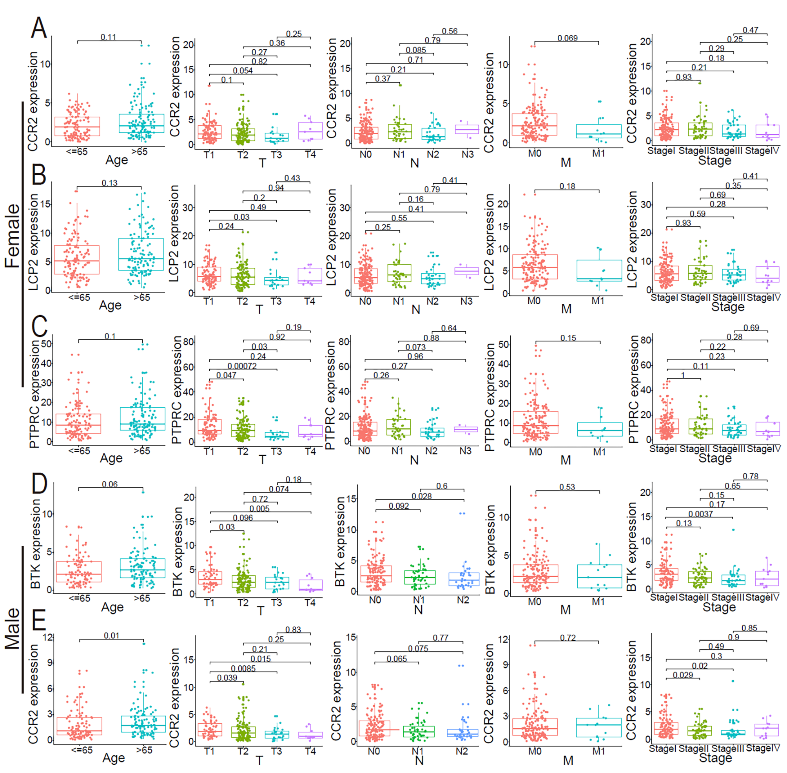

Figure S2

Figure S3
