Supplementary Information for
Multiscale antiwear tribofilm evolutionary pathways: from entropy-driven atomic mixing to mesoscale growth
Shaoli Jiang^{1*}, Takuya Kuwahara^{2*}, Maria-Isabel de Barros Bouchet^{3*}, Jean Michel Martin³, Janet S. S. Wong⁴, Kazuya Kuriyagawa¹, Théo Yamana¹, Tasuku Hamaguchi⁵, Daisuke Unabara⁵, Koji Yonekura^{5,6}, Koshi Adachi¹, Motoyuki Murashima^{1*}

¹Department of Mechanical Systems Engineering, Tohoku University, Sendai 980-8579, Japan
²Department of Mechanical Engineering, Osaka Metropolitan University, 1-1 Gakuen-cho, Naka-ku, 599-8531 Sakai, Japan
³Ecole Centrale de Lyon, CNRS, ENTPE, LTDS, UMR5513, 69130 Ecully, France
⁴Department of Mechanical Engineering, Imperial College London, London SW7 2AZ, UK
⁵Institute of Multidisciplinary Research for Advanced Materials, Tohoku University, 2-1-1 Katahira, Aoba-cu, Sendai, 980-8577, Japan
⁶Biostructural Mechanism Laboratory, RIKEN SPring-8 Center, Kouto, Hyogo 679-5148, Japan.

* Corresponding author email:
jiang.shaoli.d1@tohoku.ac.jp (Shaoli Jiang)
kuwa@omu.ac.jp (Takuya Kuwahara)
maria-isabel.de-barros@ec-lyon.fr (Maria-Isabel de Barros Bouchet)
motoyuki.murashima.b3@tohoku.ac.jp (Motoyuki Murashima)

Supplementary Note 1. Tribofilm volumetric growth as a function of sliding cycles.
ZDDP tribofilm nucleation process is stress-dependent, and its growth rate ${ \text{Γ}}_{\text{growth rate}}$ (nm³/s) fits well to a stress-activated Arrhenius model¹:
$$\begin{aligned}{ \text{Γ}}_{\text{growth rate}}\text{= }{\text{Γ}}_{\text{0}}{\text{e}}^{\text{(-} \frac{\text{Δ}{\text{G}}_{\text{act}}}{{\text{k}}_{\text{B}}\text{T}}\text{)}}\#\left(\text{1}\right)\end{aligned}$$
Where the prefactor ${\text{Γ}}_{\text{0}}$depends on the effective attempt frequency and the molecular volume of the growth species $\text{Δ}{\text{G}}_{\text{act}}$ is the free activation energy of the rate-limiting reaction in the growth process, k_{B} is Boltzmann’s constant and T is absolute temperature. In the case of the orders of reactions for ZDDP tribofilm formation, its volume growth rate with an n^{th}-order model can be estimated with the formula below:
$$\begin{aligned} \frac{\text{1}}{{\text{[}\text{V}\text{]}}^{\text{n}\text{-1}}}\text{= }\frac{\text{1}}{\text{[}{\text{V}\text{]}}_{\text{0}}^{\text{n}\text{-1}}}\text{-(}\text{n}\text{-1)}\text{kt}\#\left(\text{2}\right)\end{aligned}$$
where V is the tribofilm volume (nm³), n is the order of reaction, t is the sliding time, and k is the reaction constant, the constant [V]₀ is the initial volume, and it is zero at time t = 0.
In this study, glassy tribofilm growth on the 52100-steel surface, induced by the combination of PAO+ZDDP (secondary, Zn: 500 ppm) saw a high-quality fit with n = 0.25 ± 0.08, suggesting a complex fractional reaction pathway that agrees with the literatures ^{1, 2}.

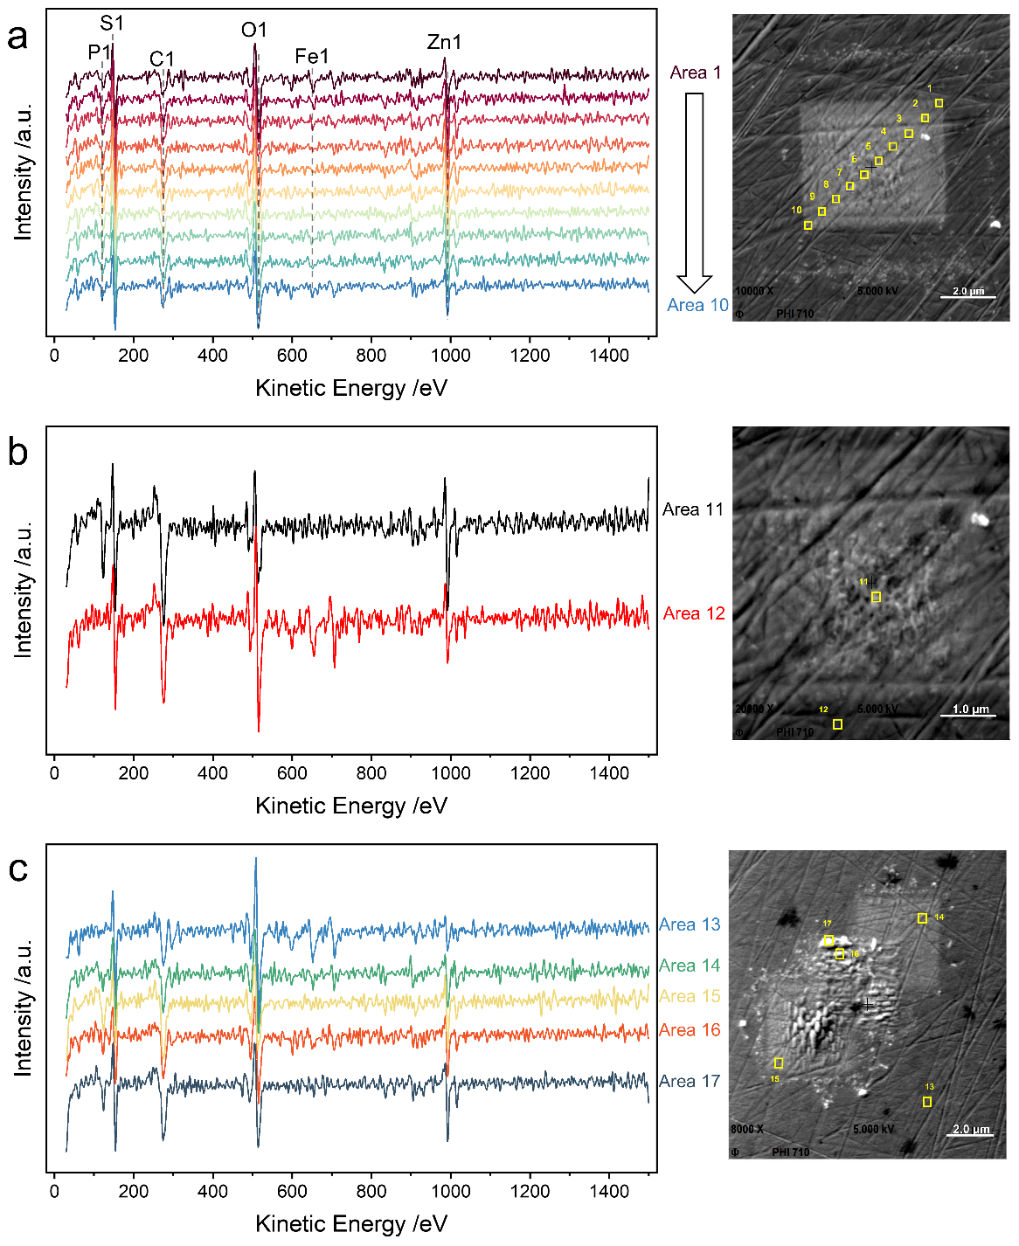
Supplementary Figure 1. AES survey spectra with corresponding sampling locations on tribofilms formed via three protocols (a–c). Left panels show the AES survey spectra acquired from the specific analyzed regions (Area 1-17) marked in the corresponding SEM images on the right.

Supplementary Note 2. STEM-EDX spectra of tribofilm and EDX peak overlap.
A platinum protective layer was deposited on tribofilms during FIB process. It is mainly composed of C and Pt elements while results of STEM-EDX mappings suggest it contains phosphorus and sulfur (see Fig. S2). Since the peak of P-Kα line overlaps with the Pt-Mα and Mβ lines, located at nearly 2.0 keV, the software misidentifies platinum as phosphorus (see Fig. S3b). Furthermore, Ti Kα peak was observed at 4.2 keV with high intensity, which arises from the TEM grid. In other three different positions, the contents of Zn and O were higher than other elements. The presence of carbon in the platinum protective layer originates from the CVD technique used for depositing platinum.
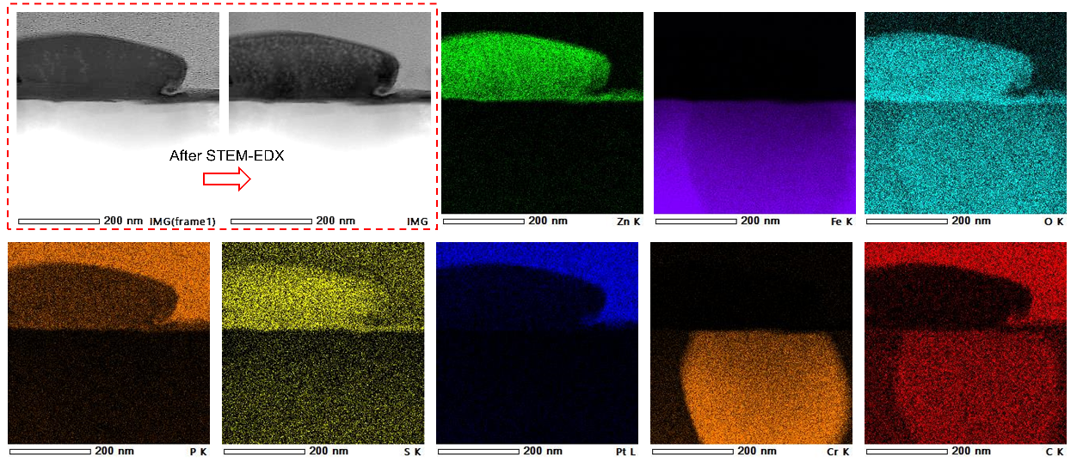
Supplementary Figure 2. STEM-EDX mapping of tribopad.
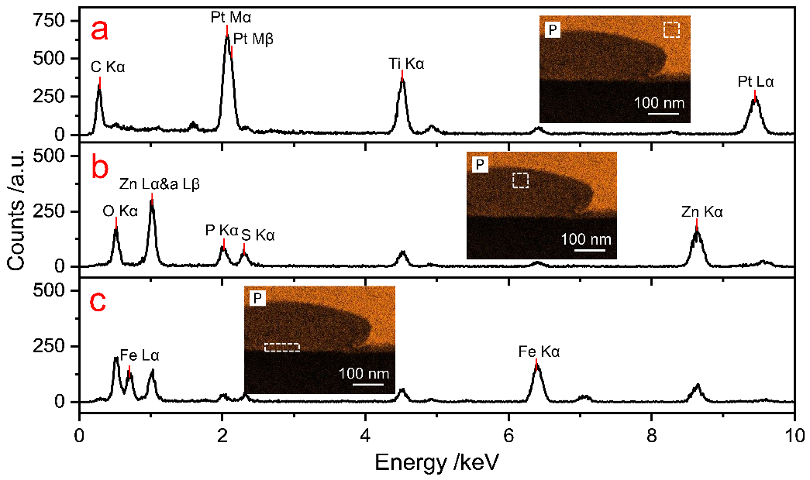
Supplementary Figure 3. EDX spectra obtained from different regions of ZDDP tribofilm. Measured regions include (a) the platinum coating layer, (b) tribofilm bulk and (c) the interface near the steel substrate (see their positions in the inserted P mapping image).

Supplementary Note 3. Limitations of identifying crystals within tribofilm via the power spectra with d-spacing
The power spectrum was obtained from the specific domain (indicated by the left red dashed rectangle) within the HRTEM image via Fast Fourier Transform (FFT) analysis, as displayed in the right highlighted inset in Fig. S4. While such FFT patterns can provide critical information about interplanar spacings (d-spacings) and hence achieve crystal identification³. Relying solely on a single set of local diffraction features suggests ambiguity. Furthermore, potential crystalline species within the ZDDP tribofilm (e.g., Zn/Fe oxides, sulfides and phosphates) exhibit overlapping or closed d-spacings. Hence, it might be reliable to identify these observed crystals based solely on d-spacings here.
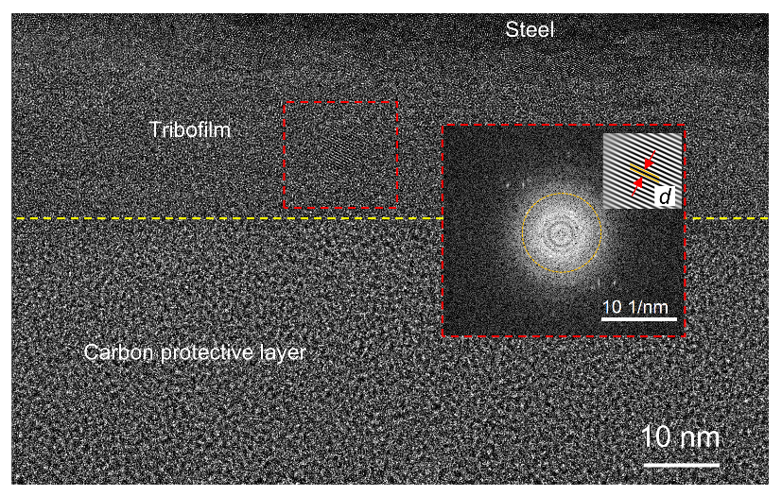
Supplementary Figure 4. HRTEM image of the tribofilm, featuring a specific region with its corresponding power spectrum and the lattice fringe.

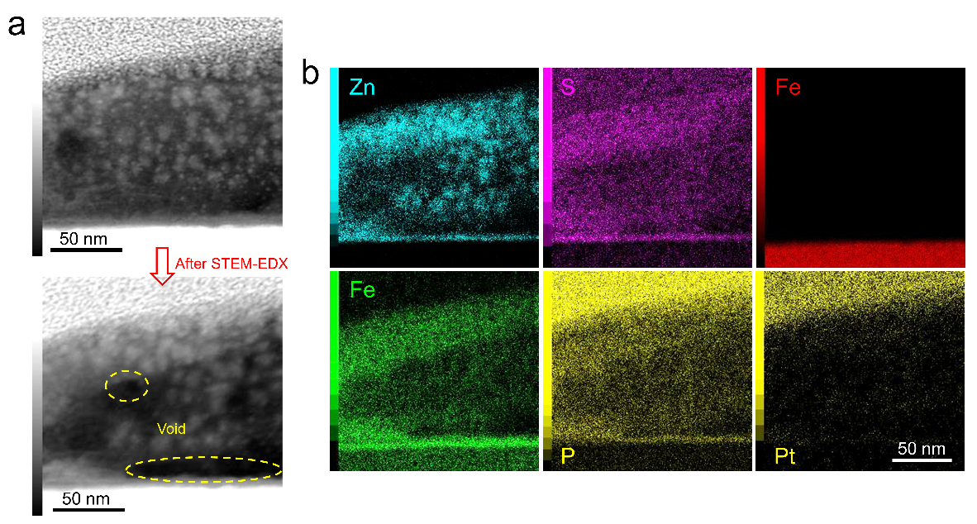
Supplementary Figure 5. Severe radiation damages of ZDDP tribofilms observed from STEM-EDX mappings with longer acquisition time. (a) High-angle annular dark-field (HAADF) images of tribofilm acquired before and after STEM-EDX analysis, showing obvious void (material loss) and (b) obtained mappings on Zn, O, Fe, S, P/Pt elements.

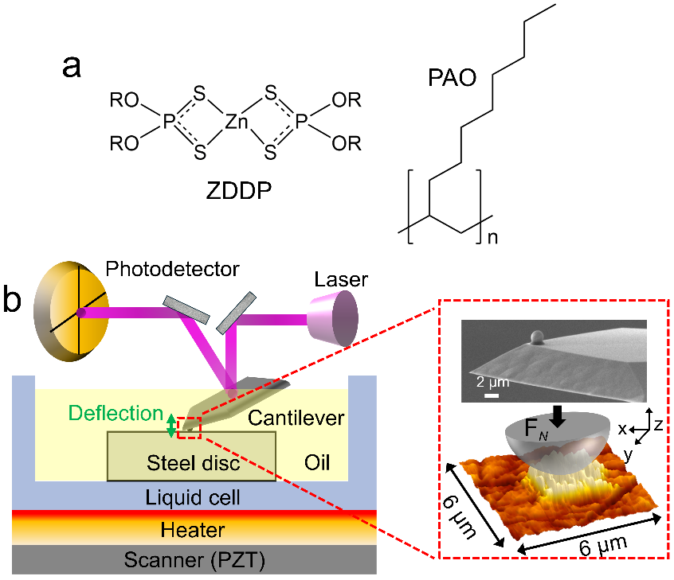
Supplementary Figure 6. (a) Molecular structure of ZDDP and PAO4 base oil, (b) the schematics illustrating the main components of in situ AFM experiments.

Supplementary Note 4. Discussion on selection of AFM cantilevers
Unlike AFM cantilevers with a sharp tip of a few dozen nanometers radius used widely in many studies^{1, 4, 5}, silicon dioxide cantilevers of spherical probe (φ2 μm) were used in this work (see cantilever properties in Supplementary Table 1 and SEM images in Supplementary Figure 7). AFM cantilevers with a sharp tip suffer from several drawbacks. Firstly, significant deviations of the contact radius (< 25%) may occur during manufacturing, which would result in change in geometry when tips of radius R ≈ 10 - 100 nm are used⁶. Hence, estimates of initial contact pressure based on Hertzian theory will be less accurate. In addition, tribofilms formed by sliding nanocontacts using sharp AFM tip (to achieve so-called single asperity contact) may be partially removed even within a single scanning cycle due to the wear⁷, especially during the early stages of tribofilm formation where the film is less durable. Finally, flattening effect of tip is more likely to occur due to wear and tear, leading to inaccurate analysis on the formation kinetics⁸.
Supplementary Table 1. Properties of cantilevers
 | CP-NCH-SiO-A
Rigidity modulus (GPa) | 51
Poisson ratio | 0.17
Spring constant (N/m) | 61-68
Resonant frequency (kHz) | 330
Length (μm) | 125
Width (μm) | 30
Thickness (μm) | 4
Length of tip (μm) | 2
Supplementary Figure 7. SEM of silicon dioxide AFM cantilevers with spherical tip. (Image courtesy of sQube®www.sqube.com).
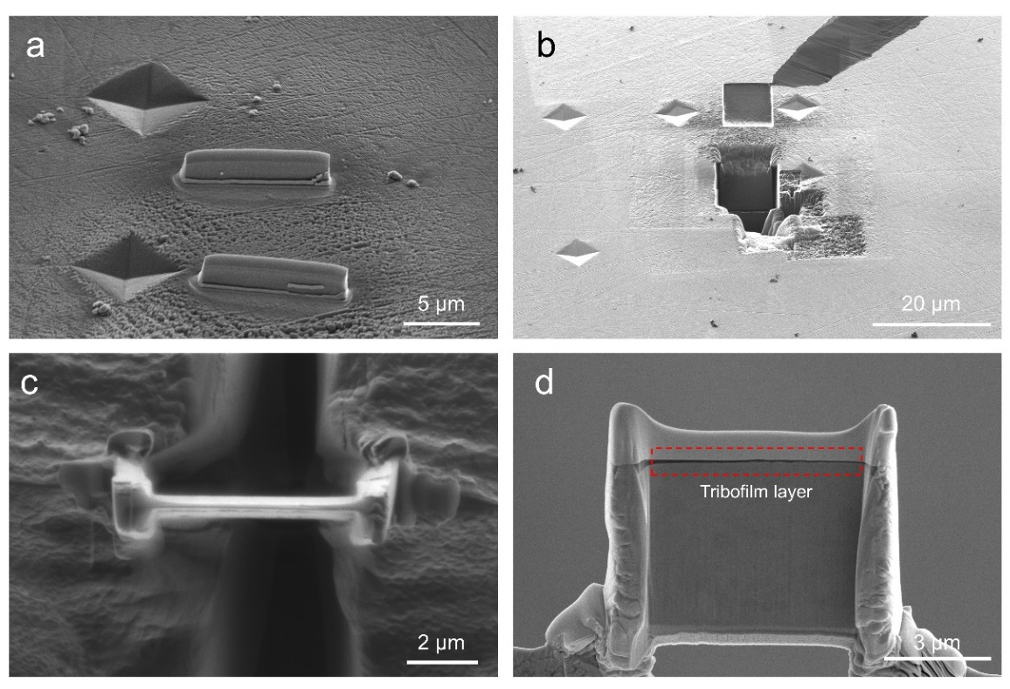
Supplementary Figure 8. Focused ion beam (FIB) processing procedures for TEM characterizations on tribofilms: (a) surface protection (coating). (b) lamela machining and & lift-out. (c) mounting and polishing. (d) the finally prepared lamella containing tribofilm layer.

Supplementary References
1. Gosvami N, Bares J, Mangolini F, Konicek A, Yablon D, Carpick R. Mechanisms of antiwear tribofilm growth revealed in situ by single-asperity sliding contacts. Science 348, 102-106 (2015).
2. Jiang S, Martin JM, Adachi K, Murashima M. When ZDDPs meet polar base oils: A microscopic view on tribofilms growth. Tribology International 220, 111892 (2026).
3. Zhang Q, Bai R, Peng B, Wang Z, Liu Y. FFT pattern recognition of crystal HRTEM image with deep learning. Micron 166, 103402 (2023).
4. Sato K, Watanabe S, Sasaki S. High friction mechanism of ZDDP tribofilm based on in situ AFM observation of nano-friction and adhesion properties. Tribology Letters 70, 94 (2022).
5. Liu Y, Mace A, Lee H, Camargo M, Gilbert JL. Single asperity sub-nano to nanoscale wear and tribocorrosion of wrought CoCrMo and additively manufactured CoCrMoW alloys. Tribology International 174, 107770 (2022).
6. Luan B, Robbins MO. The breakdown of continuum models for mechanical contacts. Nature 435, 929-932 (2005).
7. Zhang J, Ewen JP, Ueda M, Wong JS, Spikes HA. Mechanochemistry of zinc dialkyldithiophosphate on steel surfaces under elastohydrodynamic lubrication conditions. ACS applied materials & interfaces 12, 6662-6676 (2020).
8. Liu J, Notbohm JK, Carpick RW, Turner KT. Method for characterizing nanoscale wear of atomic force microscope tips. ACS nano 4, 3763-3772 (2010).

