Table S5. The CADD compounds with high structural similarity to the Mpro inhibitors.
PubChem CID | Compounds structure | Compounds Name | Groups | Inhibitor | FitDock
9871747 | 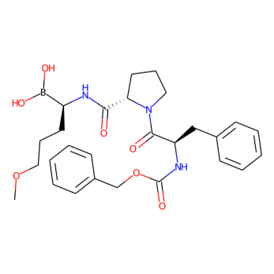 | Flovagatran | Investigational | MPI1 | Due to the unusual B atom in the compound, FitDock cannot recognize it
23304231 | 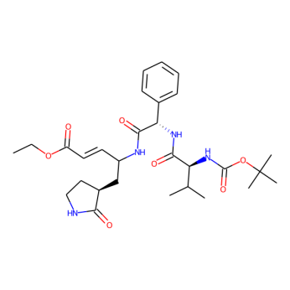 | DB04692 | Experimental | MPI6 | 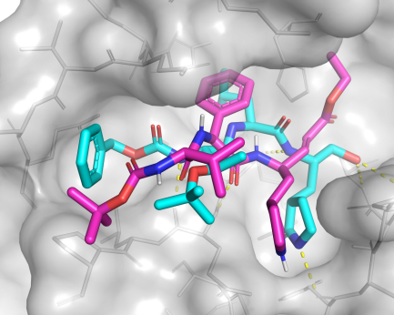
23727975 | 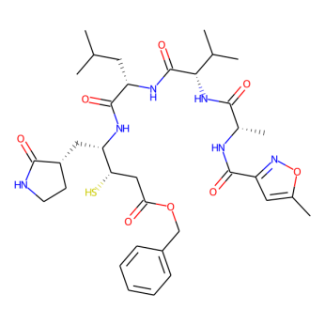 | NA | Research | N3 | 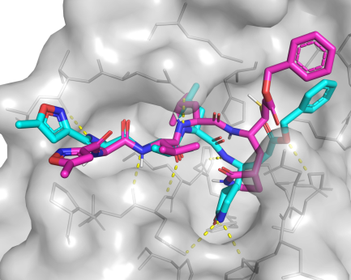
14238620 | 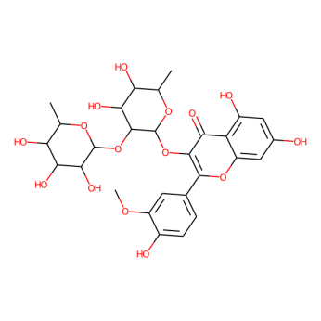 | Calendoflaside | Research | Myricetin | 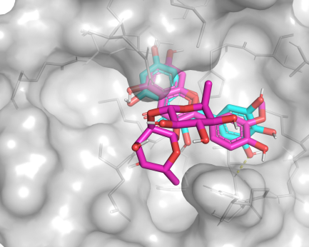
5280343 | 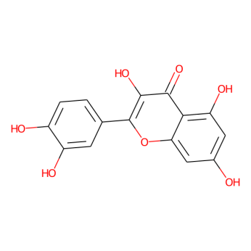 | Quercetin | Experimental | Myricetin | 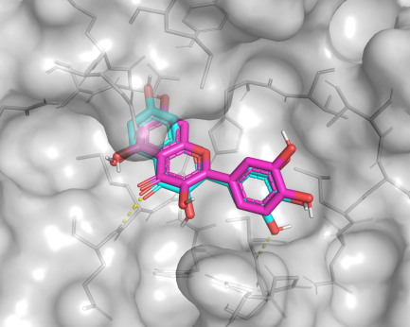
5280863 | 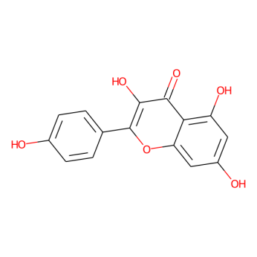 | Kaempferol | Research | Myricetin | 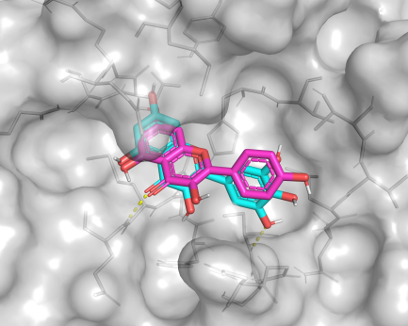
5281616 | 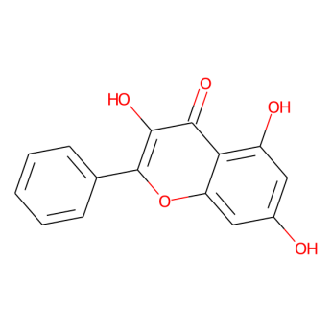 | Galangin | Research | Myricetin | 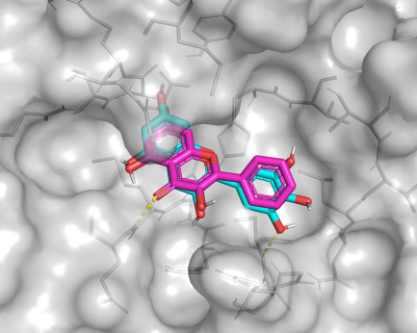
5281673 | 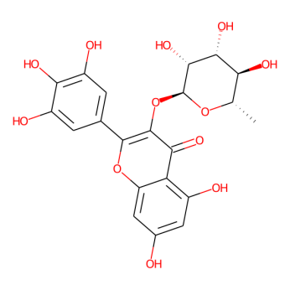 | Myricitrin | Research | Myricetin | 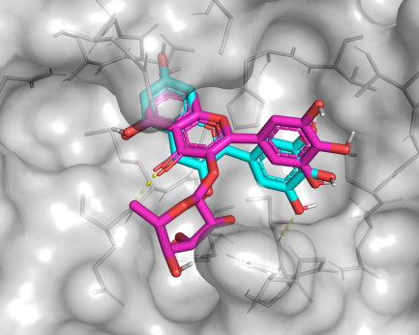
5281692 | 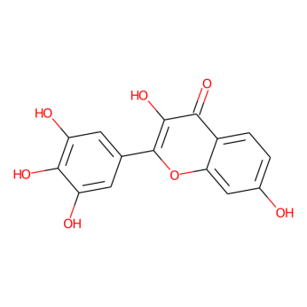 | Robinetin | Research | Myricetin | 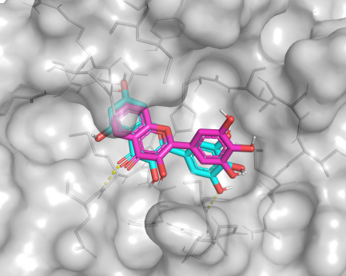
5481963 | 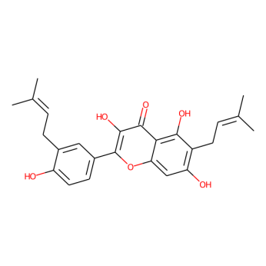 | Glyasperin A | Research | Myricetin | 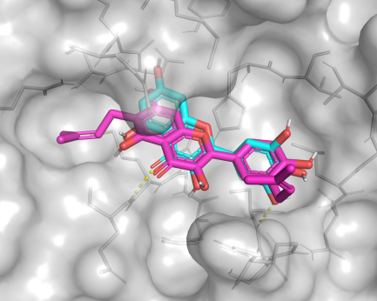
6918652 | 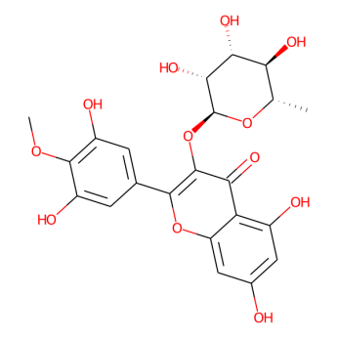 | Mearnsitrin | Research | Myricetin | 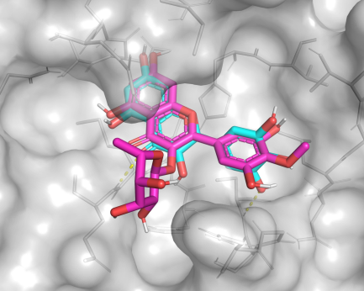
9866908 | 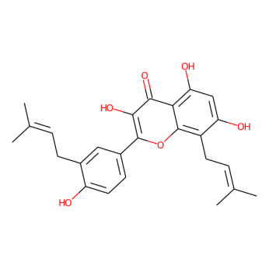 | Broussoflavonol F | Research | Myricetin | 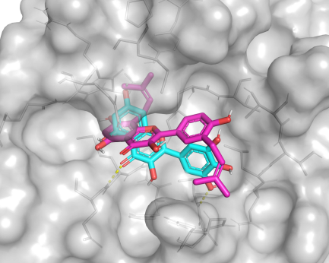
5281691 | 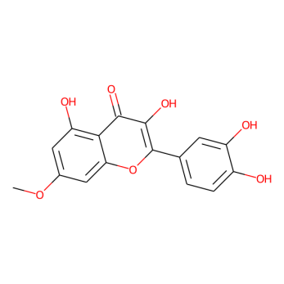 | Rhamnetin | Research | 7-O-methyl-myricetin | 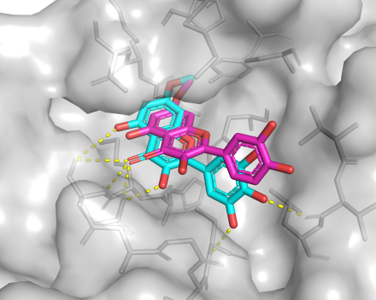
712316 | 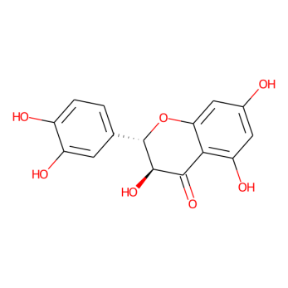 | (-)-taxifolin | Research | 7-O-methyl-dihydromyricetin | 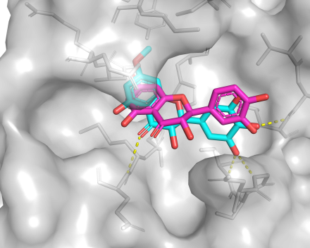
5281607 | 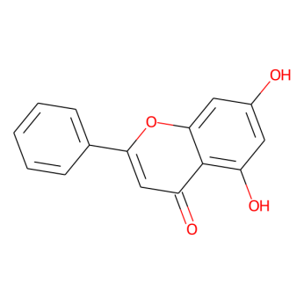 | Chrysin | Experimental | Baicalein | 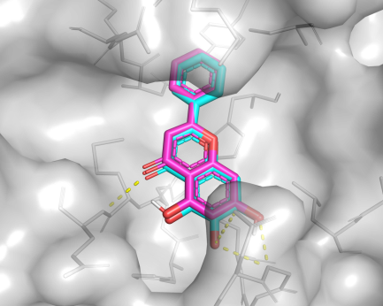
5281697 | 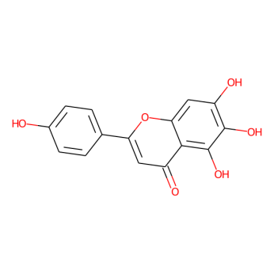 | Scutellarein | Research | Baicalein | 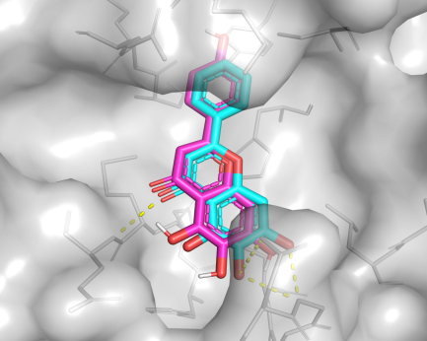
64982 | 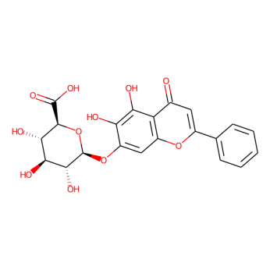 | Baicalin | Research | Baicalein | 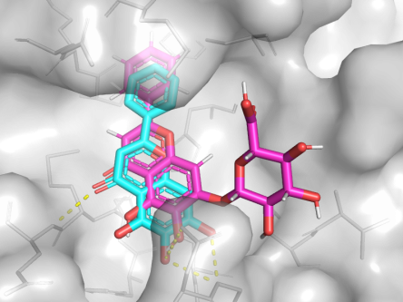
9924495 | 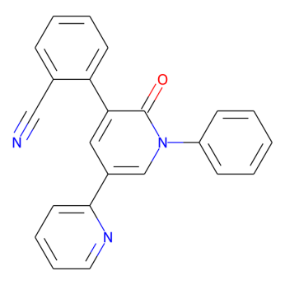 | Perampanel | Approved | COMPOUND4 | 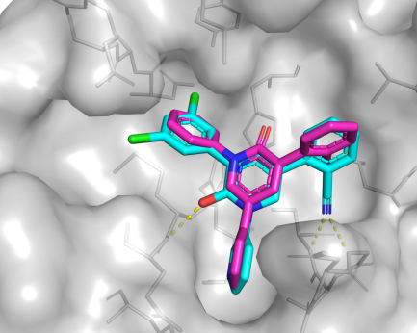
644196 | 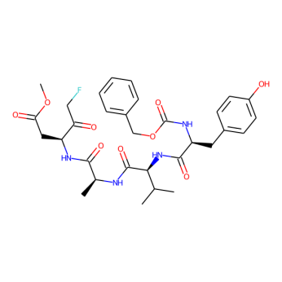 | Caspase-1 Inhibitor VI | Research | Z-VAD(OMe)-FMK | 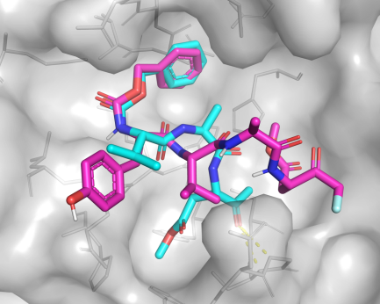
Note: The ‘Inhibitor’ in the table is the most similar inhibitor for each CADD compound, and the Tanimoto similarity between the CADD compound and inhibitor is greater than 0.5.

