Supplementary Materials
Development of the AI model
Unlike the conventional one-step mapping adopted by CycleGAN, we formulate the translation from white-light imaging (WLI) to virtual indigo carmine chromoendoscopy (ICC) as a structure-guided progressive evolution process, in which the image is incrementally transformed toward the target chromoendoscopic domain while preserving critical anatomical structures, including glandular architecture, vascular topology, and lesion boundaries. Specifically, given an input image $x_{0}∈X$, a discrete evolution trajectory $\{x_{t}\}_{t=0}^{T}$ is constructed, with the update process defined as:
$$x_{t+1}=x_{t}+G_{xy}\left(x_{t},C\left(x_{t}\right),t\right), t=0,…,T−1$$
where $C\left(x_{t}\right)$ denotes the structural prior, and $G_{xy}$ is the shared generator, with the final output given by $\hat{y}=x_{T}$. This process can be interpreted as executing a structurally constrained progressive style evolution path in the image space, whereby stain-related appearance, texture, and contrast are progressively introduced while preserving the underlying anatomical structures. To enforce cross-domain consistency, an inverse mapping path $G_{xy}$ simultaneously learned, forming a cycle-consistent translation framework.
The proposed model comprises two complementary modules (Figure S1). The first is a structure-aware encoding module that models tissue morphological invariance and enforces structural fidelity throughout the style translation process. The second is a progressive residual staining module that progressively enhances stain-related tissue contrast to emulate the gradual appearance changes observed during real staining, thereby producing visually more natural and structurally more consistent results.
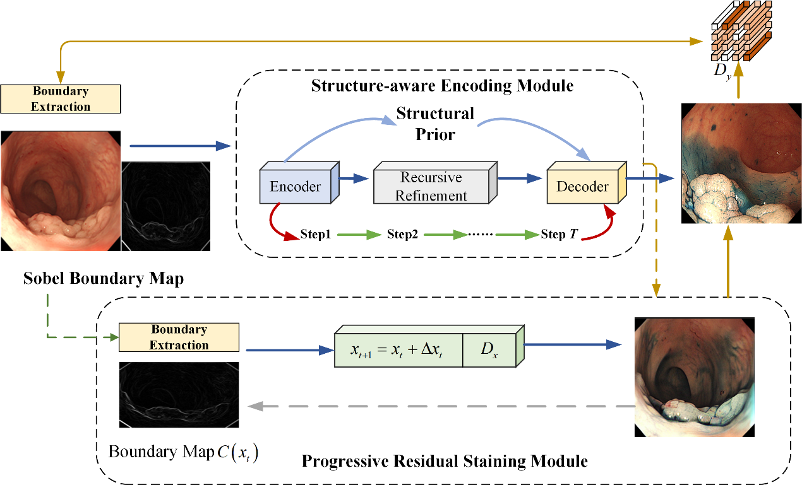
Figure S1. Architecture of the structure-guided multi-step generation model

All experiments were conducted on a single NVIDIA RTX 4090 GPU. The network was trained with the Adam optimizer at an initial learning rate of 2×10−4, linearly decayed to zero during training. All input images were uniformly resized to 256×256 pixels and normalized to the range [−1, 1]. The batch size was 2, and training ran for 400 epochs. For the multi-step generation process, we set T=5 to enable progressive mapping from WLI to virtual ICC images.

Outcomes measures
Fréchet Inception Distance (FID) is an image quality metric that quantifies the distributional similarity between virtual and real images based on feature space distances. It is computed using feature representations extracted from an intermediate layer of a pretrained convolutional neural network for both the virtual and real images. The core principle of FID is to measure the similarity between these two feature distributions using the Fréchet distance. A lower FID value indicates greater proximity in both location and shape between the feature distribution of virtual images and that of real images, reflecting higher image quality. Conversely, a higher FID value suggests lower quality, as the generated feature distribution deviates further from the real distribution.
Colorfulness Score (CF) is a widely used metric for quantifying color richness in image processing. It evaluates the diversity and visual appeal of an image by computing the dispersion and saturation of its color distribution. In addition to reflecting image vividness, CF provides important quantitative evidence for image quality assessment. In the context of virtual staining, CF effectively measures the color expressiveness of virtual images. To comprehensively evaluate the virtual staining performance on WLI, we computed CF for all virtual ICC images and used the mean value as the overall assessment metric. To quantify the discrepancy in color richness between virtual and real ICC images, we adopted the ∆CF metric, defined as the absolute difference between the CF values of the virtual and corresponding real images. A smaller ∆CF indicates a smaller difference in color richness and thus closer color expressiveness between the virtual and real images.
Structural Similarity Index (SSIM) is a perceptual metric that quantifies image quality in accordance with the human visual system. It assesses the structural similarity between two images by computing the local means, variances, and covariance within sliding windows. The metric integrates three independent components, namely luminance, contrast, and structure, to provide a holistic evaluation of perceived similarity. This multi-dimensional design enables SSIM to better approximate human visual perception compared with traditional error-based measures. The SSIM index ranges from －1 to 1, with larger values indicating stronger perceptual resemblance between the two images. A value of 1 is obtained when the two images are exactly identical.

Table S1. Comparative results with representative algorithms across participating hospitals.
Comparison | Hospitals | FID↓ | CF↑ | ∆CF↓ | SSIM↑
DDColor | WCHSCU | 90.57 | 41.11 | 4.45 | 0.207
DDColor | CPH | 99.15 | 42.14 | 10.67 | 0.232
DDColor | NCH | 119.09 | 38.39 | 6.48 | 0.209
CycleGAN | WCHSCU | 108.33 | 39.47 | 2.81 | 0.140
CycleGAN | CPH | 105.11 | 38.21 | 6.73 | 0.174
CycleGAN | NCH | 131.30 | 33.33 | 1.42 | 0.153
UNSB | WCHSCU | 112.21 | 27.80 | 8.86 | 0.149
UNSB | CPH | 81.84 | 25.88 | 5.58 | 0.171
UNSB | NCH | 111.55 | 24.21 | 7.70 | 0.147
ILVR | WCHSCU | 152.47 | 60.73 | 24.07 | 0.142
ILVR | CPH | 174.17 | 59.40 | 27.93 | 0.144
ILVR | NCH | 194.47 | 55.47 | 23.56 | 0.139
SD | WCHSCU | 144.99 | 60.21 | 23.55 | 0.155
SD | CPH | 157.94 | 59.47 | 28.00 | 0.176
SD | NCH | 163.32 | 55.48 | 23.57 | 0.160
Ours | WCHSCU | 91.28 | 56.98 | 0.32 | 0.147
Ours | CPH | 80.38 | 60.81 | 9.34 | 0.187
Ours | NCH | 84.04 | 55.91 | 4.00 | 0.166
FID, Fréchet Inception Distance; CF, Colorfulness Score; SSIM, Structural Similarity Index; WCHSCU, West China Hospital, Sichuan University; CPH, Cangxi People's Hospital; NCH, Nanchong Central Hospital.

