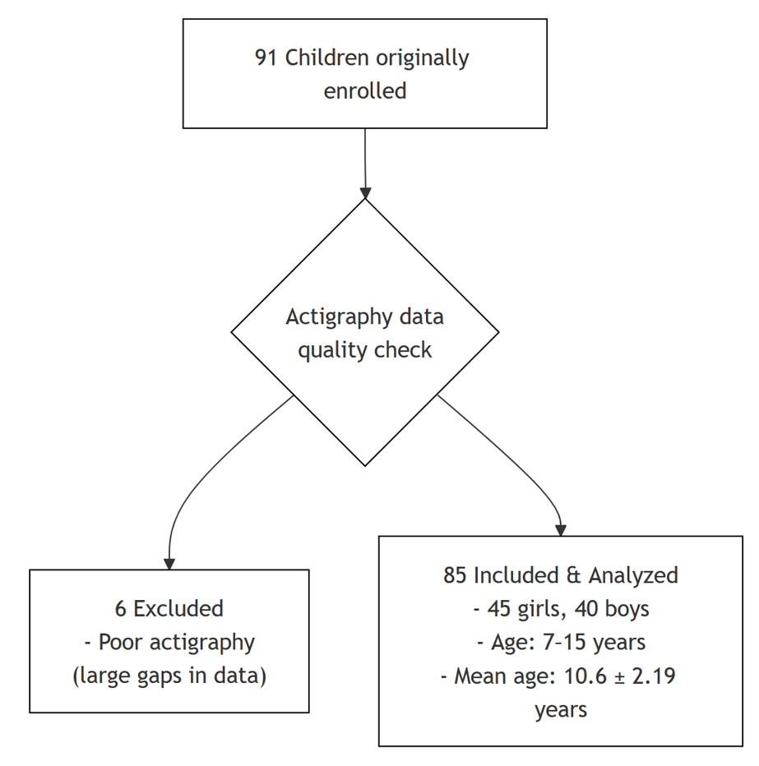

Supplemental Figure S1. Participant flow diagram from initial enrollment to final analysis based on actigraphy data quality criteria.

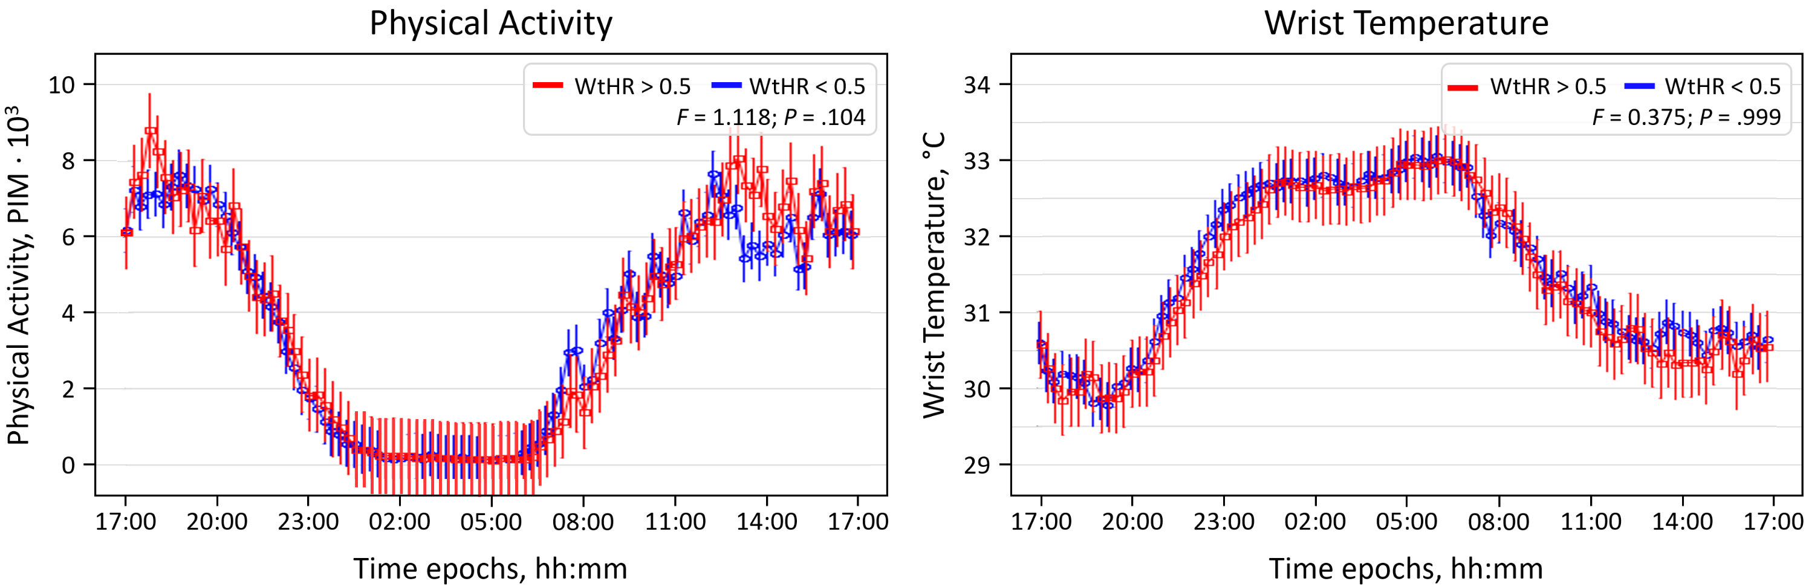
Supplementary Figure S2. Lack of association between physical activity or wrist temperature and central adiposity in school-aged children. Twenty-four-hour patterns of physical activity (PA) (left) and wrist temperature (right) stratified by waist-to-height ratio (WtHR) clinical thresholds (< 0.5 vs. > 0.5). While nominal P values indicated transiently higher activity in the WtHR > 0.5 group between 13:00 and 14:00 (P = .027-.003), these differences did not persist after correction for multiple testing (q > 0.05). Notably, these transient, unsustained PA fluctuations are insufficient to account for the systematic, pervasive circadian light dysregulation (reduced morning and elevated nocturnal exposure) observed in children with higher WtHR. Thus, the light-environment interface rather than physical activity or thermal rhythms remains the primary behavioral correlate of central adiposity in this cohort.

