Supplementary materials

Production of phenylpyruvic acid by engineered L-amino acid deaminase from Proteus mirabilis

Cong Gao^{a,b}, Jia Liu^{a,b}, Bin Yang^{a,b}, Wei Song^{c}, Guipeng Hu^{c}, Liming Liu^{a,b}, Jing Wu^{c*}

ªState Key Laboratory of Food Science and Technology, Jiangnan University, Wuxi 214122, China;
^{b}International Joint Laboratory on Food Safety, Jiangnan University, Wuxi 214122, China;
^{c}School of Pharmaceutical Science, Jiangnan University, Wuxi 214122, China

*Corresponding author e-mail: wujing@jiangnan.edu.cn (Jing Wu).

This doc file includes:
Supplementary Figure 1.
Supplementary Table 1 to 3.

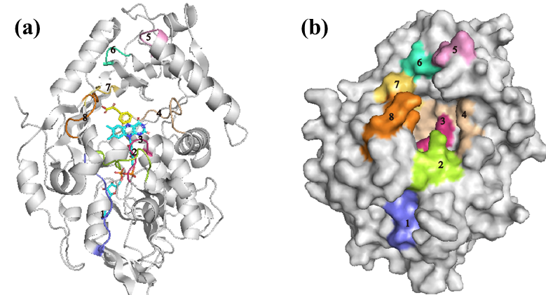
Supplementary Figure 1. Analysis of the loop structure around the product. (a) M0 is shown in cartoon representation. (b) M0 is shown in surface representation. Structural analysis revealed that loops 2, 5, 7 and 8 are located at the substrate tunnel entrance. Loop 3 plays an important role in the tunnel, and loop 4 located near the product binding site. Loop 1 and 6 were not the composition of the channels and pockets through the analysis of the structure, and are supposed to have no effects on the release of the product.

Supplementary Table 1. The primers in the site-directed mutagenesis.
Primer | Sequence (5’-3’)
L-pmAAD-S | CGCGGATCCATGAACATTTCAAGGAGAAAGCTAC
L-pmAAD-A | CCGCTCGAGTTACTTCTTAAAACGATCCAAACTAA
V411A-For | TTGGGGTGCCGTTGCTAGTCCAACATTTG
V411A-Rev | CAAATGTTGGACTAGCAACGGCACCCCAA
S412A-For | GGGTGCCGTTGTGGCTCCAACATTTGATG
S412A-Rev | CATCAAATGTTGGAGCCACAACGGCACCC
T414A-For | CGTTGTGAGTCCAGCTTTTGATGAATTAC
T414A-Rev | GTAATTCATCAAAAGCTGGACTCACAACG
F415A-For | TGTGAGTCCAACAGCTGATGAATTACCTA
F415A-Rev | TAGGTAATTCATCAGCTGTTGGACTCACA
E417A-For | TCCAACATTTGATGCTTTACCTATCATTT
E417A-Rev | AAATGATAGGTAAAGCATCAAATGTTGGA
T436A-For | GATTAACACGGCAGCTGTGTGGGGTATGA
T436A-Rev | TCATACCCCACACAGCTGCCGTGTTAATC
V437A-For | TAACACGGCAACAGCTTGGGGTATGACCG
V437A-Rev | CGGTCATACCCCAAGCTGTTGCCGTGTTA
Y97A-For | ATCAGGCCGTGCAGCTAGCCAAATTATTA
Y97A-Rev | TAATAATTTGGCTAGCTGCACGGCCTGAT
S98A-For | AGGCCGTGCATACGCTCAAATTATTAGTT
S98A-Rev | AACTAATAATTTGAGCGTATGCACGGCCT
S102A-For | CAGCCAAATTATTGCTTACCAAACATCAC
S102A-Rev | GTGATGTTTGGTAAGCAATAATTTGGCTG
Q104A-For | AATTATTAGTTACGCTACATCACCAGAAA
Q104A-Rev | TTTCTGGTGATGTAGCGTAACTAATAATT
T105A-For | TATTAGTTACCAAGCTTCACCAGAAATCT
T105A-Rev | AGATTTCTGGTGAAGCTTGGTAACTAATA
S106A-For | TAGTTACCAAACAGCTCCAGAAATCTTCC
S106A-Rev | GGAAGATTTCTGGAGCTGTTTGGTAACTA
D144A-For | GTGTAGAAGCGCTGGCAGCGGAAAAAGCATTAGATAAAG
D144A-Rev | CTTTATCTAATGCTTTTTCCGCTGCCAGCGCTTCTACAC
E145A-For | GAAGCGCTGGCAGATGCGAAAGCATTAGATAAAGC
E145A-Rev | GCTTTATCTAATGCTTTCGCATCTGCCAGCGCTTC
V312A-For | TGGTACTTATGCCGCTGCACCACGTATCT
V312A-Rev | AGATACGTGGTGCAGCGGCATAAGTACCA
L336A-For | ATTTATGCACTTAGCTGGTGGCGGAGAGT
L336A-Rev | ACTCTCCGCCACCAGCTAAGTGCATAAAT
L341A-For | AGGTGGCGGAGAGGCTCCGTTGGAATTCT
L341A-Rev | AGAATTCCAACGGAGCCTCTCCGCCACCT

Supplementary Table 2. Comparison of V_{max} and K_{m} of the biotransformation with different PPA concentrations.
PPA concentration (mM) | 0 | 50 | 100 | 150 | 200
K_{m} (mM) | 60.4 | 83.6 | 100.8 | 120.5 | 143.2
V_{max} (mM/min) | 2.64 | 2.49 | 2.48 | 2.61 | 2.53

Supplementary Table 3. Product building energy of the wild type and its variants.
Mutant | Energy (kJ/mol)
M0 | -23.8
M1^{E145A} | -21.3
M1^{L341A} | -20.5
M2^{E145A/L341A} | -18.8

