Supplemental Tables S1. Latent class model fit comparison in 2008 (n = 2849)
Model | AIC | BIC | aBIC | Entropy | P value |  | Class Probability
 |  |  |  |  | LMR | BLRT | Class Probability
1 | 28771.741 | 28843.198 | 28805.069 | — | — | — | 1.00000
2 | 28292.709 | 28441.577 | 28362.143 | 0.952 | 0.0000 | 0.0000 | 0.46508/0.53492
3 | 27992.385 | 28218.665 | 28097.926 | 0.702 | 0.0000 | 0.0000 | 0.48543/0.36609/0.14847
4 | 27811.290 | 28114.981 | 27952.936 | 0.772 | 0.0000 | 0.0000 | 0.39733/0.23482/0.14461/0.22324
5 | 27645.264 | 28026.366 | 27823.015 | 0.817 | 0.0000 | 0.0000 | 0.30151/0.14988/0.18638/0.23693/0.12531

Supplemental Tables S2. Latent class model fit comparison in 2011 (n = 3440)
Model | AIC | BIC | aBIC | Entropy | P value |  | Class Probability
 |  |  |  |  | LMR | BLRT | Class Probability
1 | 36932.475 | 37006.194 | 36968.064 | — | — | — | 1.00000
2 | 36459.927 | 36613.507 | 36534.070 | 0.719 | 0.0000 | 0.0000 | 0.64622/0.35378
3 | 36243.209 | 36476.651 | 36355.907 | 0.671 | 0.0000 | 0.0000 | 0.13343/0.52703/0.33953
4 | 36124.828 | 36438.133 | 36276.082 | 0.718 | 0.0000 | 0.0000 | 0.21337/0.46163/0.13779/0.18721
5 | 36011.564 | 36404.731 | 36201.372 | 0.708 | 0.0015 | 0.0000 | 0.37297/0.10785/0.16570/0.23052/0.12297

Supplemental Tables S3. Latent class model fit comparison in 2014 (n = 2974)
Model | AIC | BIC | aBIC | Entropy | P value |  | Class Probability
 |  |  |  |  | LMR | BLRT | Class Probability
1 | 33511.469 | 33583.441 | 33545.312 | — | — | — | 1.00000
2 | 33223.687 | 33373.629 | 33294.194 | 0.610 | 0.0000 | 0.0000 | 0.32784/0.67216
3 | 33101.492 | 33329.403 | 33208.663 | 0.769 | 0.0008 | 0.0000 | 0.03396/0.31876/0.64728
4 | 33013.626 | 33319.507 | 33157.461 | 0.646 | 0.0467 | 0.0000 | 0.02959/0.36685/0.13988/0.46369
5 | 32934.249 | 33318.099 | 33114.747 | 0.680 | 0.0006 | 0.0000 | 0.04405/0.24109/0.27270/0.12811/0.31406

Supplemental Tables S4. Multinomial logistic regression analysis of transitions in multimorbidity patterns
Variable | Cardiometabolic | Respiratory | Hypertension–arthritis | Cataract–arthritis
Variable | OR (95% CI) | OR (95% CI) | OR (95% CI) | OR (95% CI)
Age group
60-74 | 1 | 1 | 1 | 1
75-89 | 1.230(1.042,1.451) | 1.626(1.299,2.035) | 1.252(0.955,1.642) | 1.192(0.951,1.493)
≥90 | 1.049(0.851,1.292) | 1.503(1.157,1.953) | 1.058(0.769,1.456) | 1.313(1.014,1.700)
Gender
Female | 1 | 1 | 1 | 1
Male | 0.775(0.658,0.913) | 1.315(1.075,1.609) | 0.708(0.546,0.917) | 1.047(0.852,1.288)
Education
Illiteracy | 1 | 1 | 1 | 1
Primary school | 1.486(1.260,1.754) | 1.115(0.911,1.364) | 1.137(0.883,1.465) | 1.227(0.995,1.514)
Junior high school and above | 2.314(1.867,2.886) | 1.328(0.992,1.777) | 0.769(0.490,1.207) | 1.742(1.306,2.322)
Residence
Rural | 1 | 1 | 1 | 1
Urban | 1.961(1.705,2.255) | 1.226(1.030,1.460) | 1.147(0.922,1.426) | 1.325(1.110,1.582)
Smoke
Non-smoker | 1 | 1 | 1 | 1
Smoker | 0.778(0.643,0.941) | 0.899(0.723,1.119) | 0.656(0.473,0.910) | 0.716(0.564,0.910)
Alcohol
Non-drinker | 1 | 1 | 1 | 1
Drinker | 0.587(0.482,0.715) | 0.836(0.673,1.040) | 0.721(0.528,0.986) | 0.924(0.738,1.157)
Exercise
No exercise | 1 | 1 | 1 | 1
Exercise | 1.353(1.175,1.558) | 1.221(1.023,1.457) | 1.173(0.937,1.468) | 1.194(0.996,1.432)
Married status
Unmarried | 1 | 1 | 1 | 1
Married | 0.975(0.805,1.181) | 0.975(0.805,1.181) | 0.940(0.736,1.201) | 1.001(0.819,1.222)
Economic status
Poor | 1 | 1 | 1 | 1
Fair | 1.120(0.924,1.356) | 1.299(0.999,1.690) | 1.341(0.953,1.885) | 1.192(0.921,1.542)
Rich | 1.443(1.158,1.873) | 1.974(1.460,2.669) | 1.879(1.275,2.769) | 1.628(1.201,2.206)
BMI
<18.5 | 1 | 1 | 1 | 1
18.5-23.0 | 1.203(1.009.1.435) | 0.851(0.706,1.027) | 1.173(0.919,1.497) | 0.747(0.619,0.901)
23.0-27.5 | 2.109(1.730,2.570) | 0.910(0.710,1.165) | 1.297(0.949,1.773) | 0.690(0.532,0.894)
≥27.5 | 2.660(1.970,3.592) | 1.034(0.662,1.615) | 1.918(1.184,3.108) | 0.721(0.443,1.174)
Non-multimorbidity is the reference group.
Supplemental Table S5. Sample characteristics (weighted means and proportions) by clusters of multimorbidity over time.
 | Baseline  N=8963 |  |  |  |  | 2011  N=6940 |  |  |  |  | 2014  N=4605
 | Cardiometabolic | Respiratory | Hypertension–arthritis | Cataract–arthritis | Non-Multimorbidity | Cardiometabolic | Respiratory | Hypertension–arthritis | Cataract–arthritis | Non-Multimorbidity | Multisystem | Respiratory–arthritis–cataract | Cardiometabolic | Non-Multimorbidity
Number n (%) | 1132  (12.63) | 669  (7.46) | 412  (4.60) | 636  (7.10) | 6114  (68.21) | 1588  (22.88) | 734  (10.58) | 474  (6.83) | 644  (9.28) | 3500  (50.43) | 101  (2.19) | 948  (20.59) | 1925  (41.80) | 1631  (35.42)
Number of diseases (mean) | 2.44 (2.41-  2.47) | 2.38 (2.34-  2.41) | 2.20  (2.16-  2.23) | 2.22 (2.19-  2.25) | 0.42 (0.41-  0.44) | 3.23 (3.17-  3.30) | 2.68 (2.61-  2.74) | 2.38 (2.33-  2.42) | 2.42 (2.35-  2.48) | 0.57 (0.55-  0.59) | 6.93 (6.74-  7.12) | 2.7 (2.64-  2.76) | 3.13 (3.08-  3.18) | 0.64 (0.62-  0.67)
Age(mean) | 80.7  (80.1-  81.3) | 84.3  (83.5-  85.1) | 83.0  (82.0-  84.0) | 84.0  (83.1-  84.9) | 83.0  (82.7-  83.3) | 79.0 (78.5-  79.4) | 81.9  (81.2-  82.6) | 80.6 (79.8-  81.5) | 81.7 (80.9-  82.6) | 82.0  (81.6-  82.4) | 75.3 (73.6-  76.9) | 78.8 (78.2-  79.4) | 77.6 (77.2-  78.0) | 77.7 (77.2-  78.2)
Gender(female,%) | 53.7 (50.8-  56.6) | 47.1 (43.3-  50.9) | 65.3 (60.7-  69.9) | 52.2 (48.3-  56.1) | 53.1 (51.8-  54.3) | 54.3 (51.8-  56.7) | 44.0 (40.4-  47.6) | 61.2 (56.8-  65.6) | 53.7 (49.9-  57.6) | 52.9 (51.2-  54.5) | 55.4 (45.8-  65.1) | 48.3 (45.1-  51.5) | 55.4 (53.2-  57.6) | 51.1 (48.6-  53.5)
Residence(rural,%) | 44.3 (41.4-  47.2) | 61.4 (57.7-  65.1) | 63.3 (58.7-  68.0) | 59.1 (55.3-  62.9) | 66.8 (65.6-  68) | 50.9 (48.5-  53.4) | 64.7 (61.3-  68.2) | 68.1 (63.9-  72.3) | 59.9 (56.2-  63.7) | 68.7 (67.2-  70.3) | 25.7 (17.2-  34.3) | 60.8 (57.7-  63.9) | 60.4 (58.2-  62.6) | 70.8 (68.5-  73.0)
Education  Illiteracy(%) | 43.8 (40.9-  46.7) | 55.0 (51.2-  58.8) | 63.3 (58.7-  68.0) | 53.9 (50.1-  57.8) | 58.5 (57.2-  59.7) | 49.4 (47.0-  51.9) | 53.8 (50.2-  57.4) | 61.0 (56.6-  65.4) | 53.3 (49.4-  57.1) | 57.0  (55.4-  58.6) | 40.6 (31.0-  50.2) | 48.8 (45.7-  52.0) | 51.1 (48.9-  53.4) | 51.4 (49.0-  53.9)
Primary school(%) | 35.0 (32.2-  37.8) | 32.9 (29.3-  36.4) | 30.3 (25.9-  34.8) | 31.8 (28.1-  35.4) | 31.4 (30.3-  32.6) | 33.3 (31.0-  35.6) | 36.0 (32.5-  39.4) | 31.9 (27.7-  36.1) | 32.6 (29.0-  36.2) | 32.7 (31.1-  34.2) | 31.7 (22.6-  40.8) | 37.6 (34.5-  40.6) | 34.2 (32.1-  36.3) | 36.5 (34.2-  38.9)
Junior high school and above(%) | 21.2 (18.8-  23.6) | 12.1 (9.6-  14.6) | 6.3 (4.0-  8.7) | 14.3 (11.6-  17.0) | 10.1 (9.3-  10.8) | 17.3 (15.4-  19.1) | 10.2 (8.0-  12.4) | 7.2 (4.8-  9.5) | 14.1 (11.4-16.8) | 10.3 (9.3-  11.4) | 27.7 (19.0-  36.5) | 13.6 (11.4-  15.8) | 14.7 (13.1-  16.3) | 12.0 (10.4-  13.6)
Smoker(%) | 16.2  (14.0-  18.3) | 20.8  (17.7-  23.9) | 12.4  (9.2-  15.6) | 16.8  (13.9-  19.7) | 21.8 (20.8-  22.9) | 17.4  (15.5-  19.2) | 24.7  (21.5-  27.8) | 16.0  (12.7-  19.3) | 21.1  (18.0-  24.3) | 23.3 (21.9-  24.7) | 17.8  (10.4-  25.3) | 25.1  (22.3-  27.9) | 20.4  (18.6-  22.2) | 25.6  (23.5-  27.7)
Drinker(%) | 13.3  (11.4-  15.3) | 19.1  (16.2-  22.1) | 13.1  (9.8-  16.4) | 18.7  (15.7-  21.7) | 21.2 (20.2-  22.3) | 16.0  (14.2-  17.8) | 20.2  (17.3-  23.1) | 20.5  (16.8-  24.1) | 21.1  (18.0-  24.3) | 22.9 (21.5-  24.3) | 14.9  (7.9-  21.8) | 23.4  (20.7-  26.1) | 19.2  (17.4-  20.9) | 24.5  (22.4-  26.6)
Exercise(%) | 45.8 (42.9-48.7) | 36.2 (32.5-  39.8) | 33.0 (28.5-  37.6) | 36.0 (32.3-  39.7) | 31.0 (29.8-  32.1) | 35.1 (31.7-  38.6) | 43.3 (40.9-  45.8) | 33.8 (29.5-  38.0) | 37.7 (34.0-  41.5) | 30.1 (28.5-  31.6) | 61.4 (51.9-  70.9) | 38.5 (35.4-  41.6) | 38.7 (36.5-  40.9) | 31.5 (29.3-  33.8)
Married status  (married,%) | 49.2 (46.3-  52.1) | 38.4 (34.7-  42.1) | 34.7 (30.1-  39.3) | 38.1 (34.3-  41.8) | 39.6 (38.4-  40.9) | 44.7 (41.1-  48.3 | 49.9 (47.5-  52.4) | 41.4 (36.9-  45.8) | 44.7 (40.9-  48.6) | 42.4  (40.7-  44.0) | 61.4 (51.9-  70.9) | 51.7 (48.5-  54.9) | 51.4 (49.1-  53.6) | 53.9 (51.5-  56.3)
Economic status  Rich(%) | 17.0 (14.8-  19.1) | 23.3 (20.1-  26.5) | 22.3 (18.3-  26.4) | 20.9 (17.8-  24.1) | 16.8 (15.8-  17.7) | 20.7 (17.8-  23.6) | 14.5 (12.8-  16.3) | 19.0 (15.5-  22.5) | 19.4 (16.4-  22.5) | 16.5 (15.3-  17.8) | 10.9 (4.8-  17.0) | 18.5 (16.0-  20.9) | 15.7 (14.1-  17.3) | 16.1 (14.3-  17.8)
Fair(%) | 67.9 (65.2-  70.7) | 65.8 (62.2-  69.4) | 67.7 (63.2-  72.2) | 66.8 (63.2-  70.5) | 69.6 (68.5-  70.8) | 71.3 (69.1-  73.5) | 65.1 (61.7-  68.6) | 67.9 (63.7-  72.1) | 67.2 (63.6-  70.9) | 70.1 (68.6-  71.7) | 67.3 (58.2-  76.5) | 67.5 (64.5-  70.5) | 70.7 (68.7-  72.7) | 70.0 (67.8-  72.2)
Poor(%) | 15.1 (13.0-  17.2) | 10.9 (8.5-  13.3) | 10.0 (7.1-  12.8) | 12.3 (9.7-  14.8) | 13.6 (12.7-  14.5) | 14.2 (12.5-  15.9) | 14.2 (11.6-  16.7) | 13.1 (10.0-  16.1) | 13.4 (10.7-  16.0) | 13.3 (12.2-  14.4) | 21.8 (13.7-29.8) | 14.0 (11.8-  16.2) | 13.6 (12.1-  15.1) | 13.9 (12.2-  15.6)
BMI(%)  <18.5 | 19.3 (17.0-  21.6) | 33.2 (29.6-  36.8) | 27.4 (23.1-  31.7) | 36.6 (32.9-  40.4) | 30.0 (28.8-  31.1) | 17.4 (15.6-  19.3) | 32.3 (28.9-  35.7) | 26.2 (22.2-  30.1) | 30.7 (27.2-  34.3) | 29.6 (28.1-  31.1) | 12.9 (6.3-  19.4) | 28.1 (25.2-  30.9) | 19.0 (17.2-  20.7) | 26.4 (24.3-  28.6)
18.5-23.0 | 42.1 (39.3-  45.0) | 45.7 (42.0-  49.5) | 48.3 (43.5-  53.1) | 44.8 (40.9-  48.7) | 48.9 (47.6-  50.1) | 46.0 (43.6-  48.5) | 45.9 (42.3-  49.5) | 49.6 (45.1-  54.1) | 46.9 (43.0-  50.7) | 49.6 (48.0-  51.3) | 35.6 (26.3-  45.0) | 49.4 (46.2-  52.6) | 47.8 (45.6-  50.1) | 50.6 (48.2-  53.1)
23.0-27.5 | 30.7 (28.1-  33.4) | 17.3 (14.5-  20.2) | 18.7 (14.9-  22.5) | 15.4 (12.6-  18.2) | 17.7 (16.7-  18.7) | 29.1 (26.9-  31.3) | 18.7 (15.8-  21.5) | 19.6 (16.0-  23.2) | 19.1 (16.1-  22.1) | 17.7 (16.5-  19) | 39.6 (30.1-  49.1) | 19.3 (16.8-  21.8) | 26.9 (24.9-  28.8) | 19.1 (17.2-  21.0)
≥27.5 | 7.8  (6.2-  9.3) | 3.7 (2.3-  5.2) | 5.6 (3.4-  7.8) | 3.1 (1.8-  4.5) | 3.5 (3.0-  3.9) | 7.4 (6.1-  8.7) | 3.1 (1.9-  4.4) | 4.6 (2.7  -6.5) | 3.3 (1.9-  4.6) | 3.0  (2.4-  3.6) | 11.9 (5.6-  18.2) | 3.3 (2.1-  4.4) | 6.3 (5.2-  7.4) | 3.9 (2.9-  4.8)
Hypertension (%) | 81.2  (78.9-  83.5) | 27.5 (24.1-  30.9) | 100.0 (100.0-  100.0) | 1.4 (0.5-  2.3) | 11.2 (10.4-  12) | 96.1 (95.1-  97) | 29.8 (26.5-  33.1) | 100.0 (100.0-  100.0) | 0.2 (0.1-  0.5) | 16.7 (15.4-  17.9) | 100.0 (100.0-  100.0) | 0.6 (0.1-  1.1) | 100.0 (100.0-  100.0) | 21.3 (19.3-  23.3)
Diabetes (%) | 17.9 (15.7-  20.2) | 1.5 (0.6-  2.4) | 3.2 (1.5-  4.8) | 3.9 (2.4-  5.4) | 0.8 (0.5-  1.0) | 19.9 (17.9-  21.9) | 0.0  (0.0-  0.0) | 0.0  (0.0-  0.0) | 2.2 (1.0-  3.3) | 0.3 (0.1-  0.5) | 51.5 (41.7-  61.2) | 6.0  (4.5-  7.5) | 13.0 (11.5-  14.5) | 0.6 (0.2-  1.0)
Respiratory (%) | 8.6 (6.9-  10.2) | 100.0 (100.0-  100.0) | 0.0  (0.0-  0.0) | 0  (0-  0) | 5.1  (4.6-  5.7) | 20.8 (18.8-  22.8) | 100.0 (100.0-  100.0) | 0.0  (0.0-  0.0) | 1.2 (0.4-  2.1) | 6.2 (5.4-  7.0) | 75.2 (66.8-  83.7) | 43.1 (40.0-  46.3) | 25.5 (23.5-  27.4) | 5.9 (4.8-  7.1)
Arthritis (%) | 17.1 (14.9-  19.3) | 56.1 (52.3-  59.8) | 100 (100-  100) | 89.6 (87.3-  92) | 13.2 (12.3-  14) | 29.4 (27.2-  31.6) | 51.6 (48.0-  55.3) | 100.0 (100.0-  100.0) | 71.9 (68.4-  75.4) | 15.7 (14.5-  16.9) | 77.2 (69.0-  85.4) | 61.3 (58.2-  64.4) | 49.4 (47.1-  51.6) | 16.9 (15.1-  18.7)
Weighted means and proportions have been obtained by the membership matrix

Supplemental Table S6. Percentage (row percentages) of participants moving from one cluster to another between baseline and 2011.
 | 2011 CLUSTERS
 | Respiratory | Cardiometabolic | Hypertension–arthritis | Cataract–arthritis | Non-multimorbidity | Died or  Lost to  Follow-up | Total
BASELINE CLUSTERS
Cardiometabolic,n | 18 | 629 | 17 | 41 | 0 | 427 | 1132
% | 1.6 | 55.6 | 1.5 | 3.6 | 0 | 37.7 | 100
Respiratory,n | 281 | 83 | 0 | 3 | 0 | 302 | 669
% | 42.0 | 12.4 | 0 | 0.4 | 0 | 45.1 | 100
Hypertension–arthritis,n | 5 | 52 | 206 | 0 | 0 | 149 | 412
% | 1.2 | 12.6 | 50 | 0 | 0 | 36.2 | 100
Cataract–arthritis,n | 32 | 65 | 33 | 249 | 0 | 257 | 636
% | 5.0 | 10.2 | 5.2 | 39.2 | 0 | 40.4 | 100
Non-multimorbidity,n | 398 | 759 | 218 | 351 | 3500 | 888 | 6114
% | 6.5 | 12.4 | 3.6 | 5.7 | 57.2 | 14.5 | 100
Total,n | 734 | 1588 | 474 | 644 | 3500 | 2023 | 8963
% | 8.2 | 17.7 | 5.3 | 7.2 | 39.0 | 22.6 | 100

Supplemental Table S7. Percentage (column percentages) of participants moving from one cluster to another between baseline and 2011.
 | 2011 CLUSTERS
 | Respiratory | Cardiometabolic | Hypertension–arthritis | Cataract–arthritis | Non-multimorbidity | Died or  Lost to  Follow-up | Total
BASELINE CLUSTERS
Cardiometabolic,n | 18 | 629 | 17 | 41 | 0 | 427 | 1132
% | 2.5 | 39.6 | 3.6 | 6.4 | 0 | 21.1 | 12.6
Respiratory,n | 281 | 83 | 0 | 3 | 0 | 302 | 669
% | 38.3 | 5.2 | 0 | 0.5 | 0 | 14.9 | 7.5
Hypertension–arthritis,n | 5 | 52 | 206 | 0 | 0 | 149 | 412
% | 0.7 | 3.3 | 43.5 | 0 | 0 | 7.4 | 4.6
Cataract–arthritis,n | 32 | 65 | 33 | 249 | 0 | 257 | 636
% | 4.4 | 4.1 | 7 | 38.7 |  | 12.7 | 7.1
Non-multimorbidity,n | 398 | 759 | 218 | 351 | 3500 | 888 | 6114
% | 54.2 | 47.8 | 46 | 54.5 | 100 | 43.9 | 68.2
Total,n | 734 | 1588 | 474 | 644 | 3500 | 2023 | 8963
% | 100 | 100 | 100 | 100 | 100 | 100 | 100

Supplemental Table S8. Percentage (row percentages) of participants moving from one cluster to another between 2011 and 2014.
 | 2014 CLUSTERS
 | Multisystem | Respiratory–arthritis–cataract | Cardiometabolic | Non-multimorbidity | Died or  Lost to  Follow-up | Total
2011 CLUSTERS
Respiratory,n | 5 | 267 | 178 | 0 | 284 | 734
% | 0.7 | 36.4 | 24.3 | 0 | 38.7 | 100
Cardiometabolic,n | 91 | 34 | 936 | 0 | 527 | 1588
% | 5.7 | 2.1 | 58.9 | 0 | 33.2 | 100
Hypertension–arthritis,n | 0 | 0 | 347 | 0 | 127 | 474
% | 0 | 0 | 73.2 | 0 | 26.8 | 100
Cataract–arthritis,n | 3 | 353 | 73 | 0 | 215 | 644
% | 0.5 | 54.8 | 11.3 | 0 | 33.4 | 100
Non-multimorbidity,n | 2 | 294 | 391 | 1631 | 1182 | 3500
% | 0.1 | 7.8 | 10.3 | 43.2 | 38.6 | 100
Total,n | 101 | 948 | 1925 | 1631 | 2335 | 6940
% | 1.5 | 13.7 | 27.7 | 23.5 | 33.6 | 100

Supplemental Table S9. Percentage (column percentages) of participants moving from one cluster to another between 2011 and 2014.
 | 2014 CLUSTERS
 | Multisystem | Respiratory–arthritis–cataract | Cardiometabolic | Non-multimorbidity | Died or  Lost to  Follow-up | Total
2011 CLUSTERS
Respiratory,n | 5 | 267 | 178 | 0 | 284 | 734
% | 5 | 28.2 | 9.2 | 0 | 12.2 | 10.6
Cardiometabolic,n | 91 | 34 | 936 | 0 | 527 | 1588
% | 90.1 | 3.6 | 18.6 | 0 | 22.6 | 22.9
Hypertension–arthritis,n | 0 | 0 | 347 | 0 | 127 | 474
% | 0 | 0 | 18 | 0 | 5.4 | 6.8
Cataract–arthritis,n | 3 | 353 | 73 | 0 | 215 | 644
% | 3 | 37.2 | 3.8 | 0 | 9.2 | 9.3
Non-multimorbidity,n | 2 | 294 | 391 | 1631 | 1182 | 3500
% | 2 | 31 | 20.3 | 100 | 50.6 | 50.4
Total,n | 101 | 948 | 1925 | 1631 | 2335 | 6940
% | 100 | 100 | 100 | 100 | 100 | 100

Supplemental Tables S10. Summary of multimorbidity count trajectory model fits (n = 4605)
Model | AIC | BIC | aBIC | Entropy | Log-Likelihood | Class Probability
1 | 44286.018 | 44318.193 | 44302.305 | — | -22138.009 | 1.00000
2 | 41031.608 | 41083.087 | 41057.666 | 0.660 | -20507.804 | 0.58393/0.41607
3 | 40081.487 | 40152.271 | 40117.317 | 0.747 | -20029.744 | 0.18480/0.15201/0.66319
4 | 40050.951 | 40141.040 | 40096.553 | 0.644 | -20011.476 | 0.55679/0.22910/0.02932/0.18480
5 | 40056.951 | 40166.345 | 40112.325 | 0.694 | -20011.476 | 0.18480/0.55679/0.02932/0.22910/0.00000

Supplemental Table S11. Multinomial logistic regression analysis of multimorbidity count trajectories
Variable | Moderate-Risk Rising Group  （N=8963） | High-Risk Rapidly Increasing Group  （N=8963）
Variable | OR (95% CI) | OR (95% CI)
Age group
60-74 | 1 | 1
75-89 | 1.183(0.993,1.409) | 1.421(1.125,1.795)
≥90 | 1.339(1019,1.760) | 1.245(0.849,1.825)
Gender
Male | 1 | 1
Female | 1.057(0.8671.289) | 1.430(1.100,1.859)
Education
Illiteracy | 1 | 1
Primary school | 1.050(0.871,1.264) | 1.284(0.997,1.653)
Junior high school and above | 1.103(0.838,1.453) | 1.986(1.410,2.799)
Residence
Rural | 1 | 1
Urban | 1.230(1.033,1.465) | 1.802(1.438,2.258)
Smoke
Non-smoker | 1 | 1
Smoker | 0.964(0.787,1.182) | 0.822(0.619,1.090)
Alcohol
Non-drinker | 1 | 1
Drinker | 0.832(0.683,1.013) | 0.668(0.505,0.882)
Exercise
No exercise | 1 | 1
Exercise | 1.362(1.143,1.624) | 1.952(1.557,2.446)
Married status
Unmarried | 1 | 1
Married | 0.915(0.769,1.089) | 1.236(0.978,1.562)
Economic status
Poor | 1 | 1
Fair | 1.089(0.868,1.367) | 1.085(0.806,1.456)
Rich | 1.512(1.26,2.029) | 1.781(1.214,2.614)
BMI
<18.5 | 1 | 1
18.5-23.0 | 1.038(0.858,1255) | 1.100(0.837,1.444)
23.0-27.5 | 1.316(1.034,1.674) | 2.119(1.544,2.908)
>27.5 | 1.189(0.793,1.781) | 1.891(1.147,3.115)
Low-Risk Stable Group is the reference group.

Supplemental Table S12. Sensitivity analysis of the association between multimorbidity and disability, stratified by age
 | Model1ª |  |  | Model2^{b}
Variable | HR(95%CI) | p-value |  | HR(95%CI) | p-value
Non-multimorbidity | REF |  |  | REF
Multimorbidity | 1.143(1.052,1.242) | 0.001 |  | 1.111(1.012,1.219) | 0.027
Condition counts
0 | REF |  |  | REF
1 | 0.978(0.894,1.070) | 0.633 |  | 0.848(0.772,0.931) | ＜0.001
2 | 1.107(0.998,1.229) | 0.054 |  | 1.065(0.949,1.196) | 0.284
≥3 | 1.183(1.036,1.351) | 0.013 |  | 0.972(0.835,1.131) | 0.716
Multimorbidity patterns
Baseline
Non-multimorbidity | REF |  |  | REF
Cardiometabolic | 1.163(1.027,1.315) | 0.017 |  | 0.915(0.794,1.054) | 0.219
Respiratory | 0.950(0.815.1.108) | 0.515 |  | 1.043(0.875,1.242) | 0.639
Hypertension–arthritis | 1.170(0.963,1.422) | 0.114 |  | 1.220(0.984,1.511) | 0.070
Cataract–arthritis | 0.961(0.819,1.127) | 0.916 |  | 1.034(0.862,1.237) | 0.721
2014
Non-multimorbidity | REF |  |  | REF
Multisystem | 2.026(1.347,3.047) | ＜0.001 |  | 2.874(1.832,4.510) | ＜0.001
Respiratory–arthritis–cataract | 1.974(1.669,2.336) | ＜0.001 |  | 2.051(1.700,2.473) | ＜0.001
Cardiometabolic | 1.792(1.555,2.064) | ＜0.001 |  | 2.016(1.721,2.363) | ＜0.001
Trajectory of Multimorbidity Count
Low-Risk Stable Group | REF |  |  | REF
Moderate-Risk Rising Group | 1.765(1.518,2.050) | ＜0.001 |  | 1.775(1.525,2.067) | ＜0.001
High-Risk Rapidly Increasing Group | 2.315(1.936,2.795) | ＜0.001 |  | 2.706(2.239,3.270) | ＜0.001
ª Adjusted for time
^{b} Additionally adjusted for age, sex, education, area of residence, marital status, smoking, drinking, exercise status, economic status, and BMI

Supplemental Table S13. Sensitivity analysis of the association between multimorbidity and all-cause mortality, stratified by age.
 | Model1ª |  |  | Model2^{b}
Variable | HR(95%CI) | p-value |  | HR(95%CI) | p-value
Baseline Non-multimorbidity | REF |  |  | REF
Baseline Multimorbidity | 1.163(1.083,1.248) | ＜0.001 |  | 1.359(1.264,1.461) | ＜0.001
Baseline Condition counts
0 | REF | ＜0.001 |  | REF | ＜0.001
1 | 0.910(0.840,0.984) | 0.019 |  | 1.000(0.924,1.083) | 0.996
2 | 1.167(1.069,1.274) | ＜0.001 |  | 1.347(1.233,1.472) | ＜0.001
≥3 | 1.024(0.910,1.151) | 0.697 |  | 1.388(1.231,1.565) | ＜0.001
Multimorbidity patterns
Baseline
Non-multimorbidity | REF | ＜0.001 |  | REF | ＜0.001
Cardiometabolic | 0.919(0.823,1.026) | 0.135 |  | 1.294(1.155,1.449) | ＜0.001
Respiratory | 1.586(1.411,1.782) | ＜0.001 |  | 1.611(1.433,1.812) | ＜0.001
Hypertension–arthritis | 1.053(0.893,1.241 | 0.542 |  | 1.179(0.999,1.390) | 0.051
Cataract–arthritis | 1.293(1.138,1.470) | ＜0.001 |  | 1.076(1.072,1.080) | ＜0.001
2014
Non-multimorbidity | REF | ＜0.001 |  | REF | ＜0.001
Multisystem | 2.193(1.459,3.294) | ＜0.001 |  | 3.449(2.276,5.226) | ＜0.001
Respiratory–arthritis–cataract | 2.626(2.198,3.136) | ＜0.001 |  | 2.764(2.312,3.306) | ＜0.001
Cardiometabolic | 2.427(2.071,2.844) | ＜0.001 |  | 2.882(2.455,3.383) | ＜0.001
Trajectory of Multimorbidity Count
Low-Risk Stable Group | REF | ＜0.001 |  | REF | ＜0.001
Moderate-Risk Rising Group | 1.944(1.604,2.355) | ＜0.001 |  | 2.048(1.689,2.483) | ＜0.001
High-Risk Rapidly Increasing Group | 2.006(1.592,2.529) | ＜0.001 |  | 2.588(2.044,3.276) | ＜0.001
ª Adjusted for time
^{b} Additionally adjusted for age, sex, education, area of residence, marital status, smoking, drinking, exercise status, economic status, and BMI

Supplemental Table S14. Sensitivity analysis of the association between multimorbidity and disability (exclude participants with multiply imputed data)
 | Model1ª |  |  | Model2^{b}
Variable | OR(95%CI) | p-value |  | 0R(95%CI) | p-value
Baseline Non-multimorbidity | REF |  |  | REF
Baseline Multimorbidity | 0.928(0.822,1.049) | 0.234 |  | 0.932(0.822,1.057) | 0.274
Baseline Condition counts
0 | REF |  |  | REF
1 | 1.110(0.980,1.257) | 0.102 |  | 1.154(1.015,1.311) | 0.028
2 | 0.958(0.822,1.118) | 0.588 |  | 0.970(0.828,1.135) | 0.700
≥3 | 0.995(0.816,1.213) | 0.957 |  | 1.040(0.847,1.277) | 0.707
Multimorbidity patterns
Baseline
Non-multimorbidity | REF |  |  | REF
Cardiometabolic | 1.003(0.840,1.197) | 0.977 |  | 1.077(0.895,1.295) | 0.433
Respiratory | 1.736(0.579,0.937) | 0.013 |  | 1.707(0.554,0.902) | 0.005
Hypertension–arthritis | 0.882(0.662,1.175) | 0.390 |  | 0.840(0.628,1.124) | 0.242
Cataract–arthritis | 1.050(0.842,1.309) | 0.667 |  | 1.037(0.828,1.299) | 0.751
2014
Non-multimorbidity | REF |  |  | REF
Multisystem | 2.161(1.338,3.488) | 0.002 |  | 3.012(1.772,5.118) | ＜0.001
Respiratory–arthritis–cataract | 1.965(1.621,2.381) | ＜0.001 |  | 1.954(1.582,2.415) | ＜0.001
Cardiometabolic | 1.954(1.662,2.296) | ＜0.001 |  | 2.030(1.697,2.429) | ＜0.001
Trajectory of Multimorbidity Count
Low-Risk Stable Group | REF |  |  | REF
Moderate-Risk Rising Group | 1.811(1.544,2.124) | ＜0.001 |  | 1.705(1.456,1.997) | ＜0.001
High-Risk Rapidly Increasing Group | 2.416(1.976, 2.955) | ＜0.001 |  | 2.535(2.069,3.106) | ＜0.001
ª Adjusted for time
^{b} Additionally adjusted for age, sex, education, area of residence, marital status, smoking, drinking, exercise status, economic status, and BMI

Supplemental Table S15. Sensitivity analysis of the association between multimorbidity and all-cause mortality (exclude participants with multiply imputed data)
 | Model1ª |  |  | Model2^{b}
Variable | HR(95%CI) | p-value |  | HR(95%CI) | p-value
Baseline Non-multimorbidity | REF |  |  | REF
Baseline Multimorbidity | 1.364(1.271,1.465) | ＜0.001 |  | 1.587(1.476,1.706) | ＜0.001
Baseline Condition counts
0 | REF | ＜0.001 |  | REF | ＜0.001
1 | 0.927(0.857,1.004) | 0.064 |  | 1.001(0.924,1.084) | 0.983
2 | 1.362(1.247,1.486) | ＜0.001 |  | 1.583(1.448,1.729) | ＜0.001
≥3 | 1.243(1.106,1.398) | 0.004 |  | 1.600(1.419,1.804) | ＜0.001
Multimorbidity patterns
Baseline
Non-multimorbidity | REF | ＜0.001 |  | REF | ＜0.001
Cardiometabolic | 1.138(1.019,1.270) | 0.022 |  | 1.582(1.413,1.773) | ＜0.001
Respiratory | 1.789(1.592,2.011) | ＜0.001 |  | 1.885(1.677,2.120) | ＜0.001
Hypertension–arthritis | 1.183(1.003,1.394) | 0.046 |  | 1.281(1.086,1.512) | 0.003
Cataract–arthritis | 1.472(1.296,1.673) | ＜0.001 |  | 1.511(1.330,1.718) | ＜0.001
2014
Non-multimorbidity | REF | ＜0.001 |  | REF | ＜0.001
Multisystem | 2.383(1.586,3.581) | ＜0.001 |  | 3.653(2.404,5.549) | ＜0.001
Respiratory–arthritis–cataract | 2.694(2.255,3.218) | ＜0.001 |  | 2.817(2.356,3.369) | ＜0.001
Cardiometabolic | 2.504(2.137,2.934) | ＜0.001 |  | 2.864(2.439,3.364) | ＜0.001
Trajectory of Multimorbidity Count
Low-Risk Stable Group | REF | ＜0.001 |  | REF | ＜0.001
Moderate-Risk Rising Group | 1.999(1.650,2.422) | ＜0.001 |  | 2.052(1.691,2.489) | ＜0.001
High-Risk Rapidly Increasing Group | 2.267(1.798,2.858) | ＜0.001 |  | 2.798(2.210,3.544) | ＜0.001

ª Adjusted for time
^{b} Additionally adjusted for age, sex, education, area of residence, marital status, smoking, drinking, exercise status, economic status, and BMI

Supplemental Table S16. Sensitivity analysis of the associations of multimorbidity trajectories and patterns with mortality and disability via the Fine-Gray competing risks model
 | Disabilityª |  |  | Mortalityª
Variable | sHR(95%CI) | p-value |  | sHR(95%CI) | p-value
Baseline Non-multimorbidity | REF |  |  | REF
Baseline Multimorbidity | 1.260(1.131,1.403) | ＜0.001 |  | 1.399(1.217,1.609) |  | ＜0.001
Baseline Condition counts
0 | REF |  |  | REF
1 | 1.154(1.032,1.291) | 0.012 |  | 1.274(1.103,1.471) |  | 0.001
2 | 1.324(1.154,1.520) | ＜0.001 |  | 1.602(1.347,1.904) |  | ＜0.001
≥3 | 1.396(1.180,1.653) | ＜0.001 |  | 1.480(1.164,1.880) |  | 0.001
Multimorbidity patterns
Baseline
Non-multimorbidity | REF |  |  | REF
Cardiometabolic | 1.415(1.216,1.647) | ＜0.001 |  | 1.416(1.149,1.744) |  | 0.001
Respiratory | 1.251(1.018,1.537) | 0.033 |  | 1.512(1.174,1.946) |  | 0.001
Hypertension–arthritis | 1.130(0.898,1.423) | 0.299 |  | 1.368(1.021,1.833) |  | 0.036
Cataract–arthritis | 1.117(0.903,1.382) | 0.307 |  | 1.295(0.994,1.687) |  | 0.055
2014
Non-multimorbidity | REF |  |  | REF
Multisystem | 2.032(1.492,2.766) | ＜0.001 |  | 3.145(2.046,4.834) |  | ＜0.001
Respiratory–arthritis–cataract | 1.780(1.562,2.028) | ＜0.001 |  | 2.669(2.242,3.178) |  | ＜0.001
Cardiometabolic | 1.732(1.550,1.937) | ＜0.001 |  | 2.733(2.342,3.190) |  | ＜0.001
Trajectory of Multimorbidity Count
Low-Risk Stable Group | REF |  |  | REF
Moderate-Risk Rising Group | 1.510(1.326,1.720) | ＜0.001 |  | 1.949(1.625,2.337) |  | ＜0.001
High-Risk Rapidly Increasing Group | 1.883(1.595,2.223) | ＜0.001 |  | 2.361(1.876,2.970) |  | ＜0.001
ª Adjusted for age, sex, education, area of residence, marital status, smoking, drinking, exercise status, economic status, and BMI.

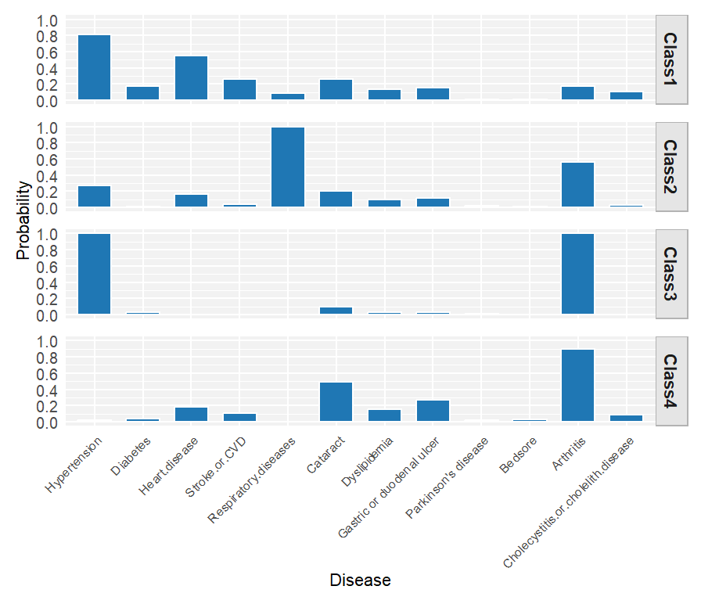Supplemental Figure S1. Chronic disease probability across four latent multimorbidity classes (2008)

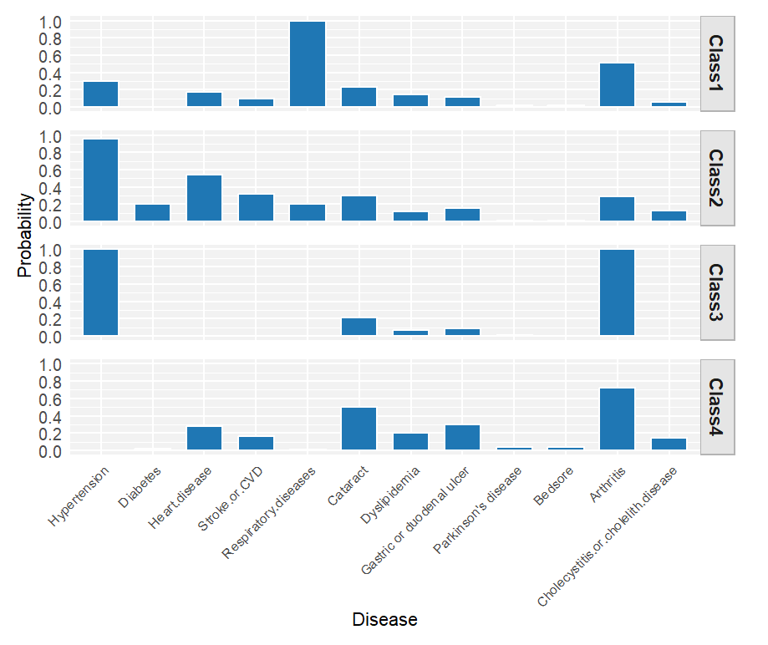Supplemental Figure S2. Chronic disease probability across four latent multimorbidity classes (2011)

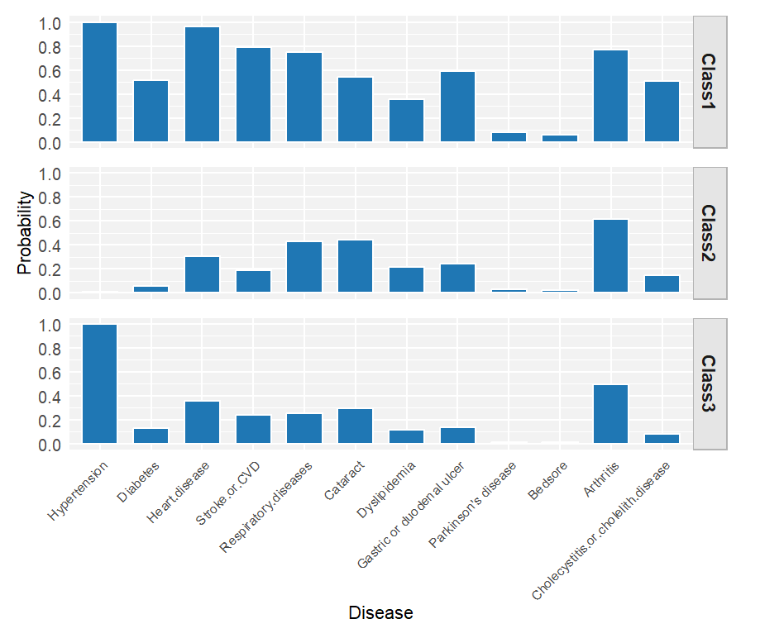
Supplemental Figure S3. Chronic disease probability across three latent multimorbidity classes (2014)

