Table S1. Variables included in the clustering procedure
Domain | Variable included in cluster analysis | Operational definition / coding
Cancer status | Active cancer | Active malignancy at the time of the index VTE event
Demographic characteristics | Age | Age at index VTE event
Demographic characteristics | Sex | Female or male
Cardiovascular comorbidities | Heart failure | History of heart failure documented in the medical record
Cardiovascular comorbidities | Arterial hypertension | History of arterial hypertension
Cardiovascular comorbidities | Diabetes mellitus | History of diabetes mellitus
Cardiovascular comorbidities | Cerebrovascular disease | History of stroke or cerebrovascular disease
Cardiovascular comorbidities | Atherosclerotic disease | History of coronary artery disease, peripheral artery disease, or other atherosclerotic cardiovascular disease
Cardiovascular comorbidities | Atrial fibrillation | History of atrial fibrillation
Other comorbidities | Chronic kidney disease | History of chronic kidney disease
Other comorbidities | Chronic obstructive pulmonary disease | History of COPD
Bleeding risk | High bleeding risk according to HAS-BLED | HAS-BLED score ≥3
Thrombotic history | History of VTE | Previous history of venous thromboembolism before the index event
Recent clinical exposures | Recent hospitalization | Hospitalization within the 3 months preceding the index VTE event
Recent clinical exposures | Recent surgery | Surgery within the 3 months preceding the index VTE event
Recent clinical exposures | Recent central venous catheter use | Central venous catheter use within the 3 months preceding the index VTE event
VTE: venous thromboembolism; COPD: chronic obstructive pulmonary disease. Sixteen variables reflecting patient clinical characteristics, comorbidities, and recent clinical exposures were included in the clustering procedure. Tumor site and oncologic treatments were intentionally excluded from the clustering process to ensure that the derived groups represented patient-level clinical phenotypes rather than oncologic categories.

Impact of censoring and truncated survival analysis
Across all clusters, a high proportion of patients were censored, indicating that most individuals did not experience the event of interest during follow-up. The proportion of deaths was highest in Cluster 3 (5.3%), followed by Cluster 2 (4.3%) and Cluster 1 (3.3%). As follow-up extended beyond 10 years, the number of patients at risk declined substantially across all groups, increasing the instability of survival estimates and limiting interpretability at later time points.
Table S2. Distribution of events and censoring by clinical cluster
Cluster | n | Deaths | Censored | Events, % | Censoring, %
1 | 367 | 12 | 355 | 3,3% | 96,7%
2 | 211 | 9 | 202 | 4,3% | 95,7%
3 | 76 | 4 | 72 | 5,3% | 94,7%
To minimize instability related to sparse numbers at risk during late follow-up, survival analyses were administratively truncated at 10 years. Within this time frame, survival estimates were considered more stable and clinically interpretable.

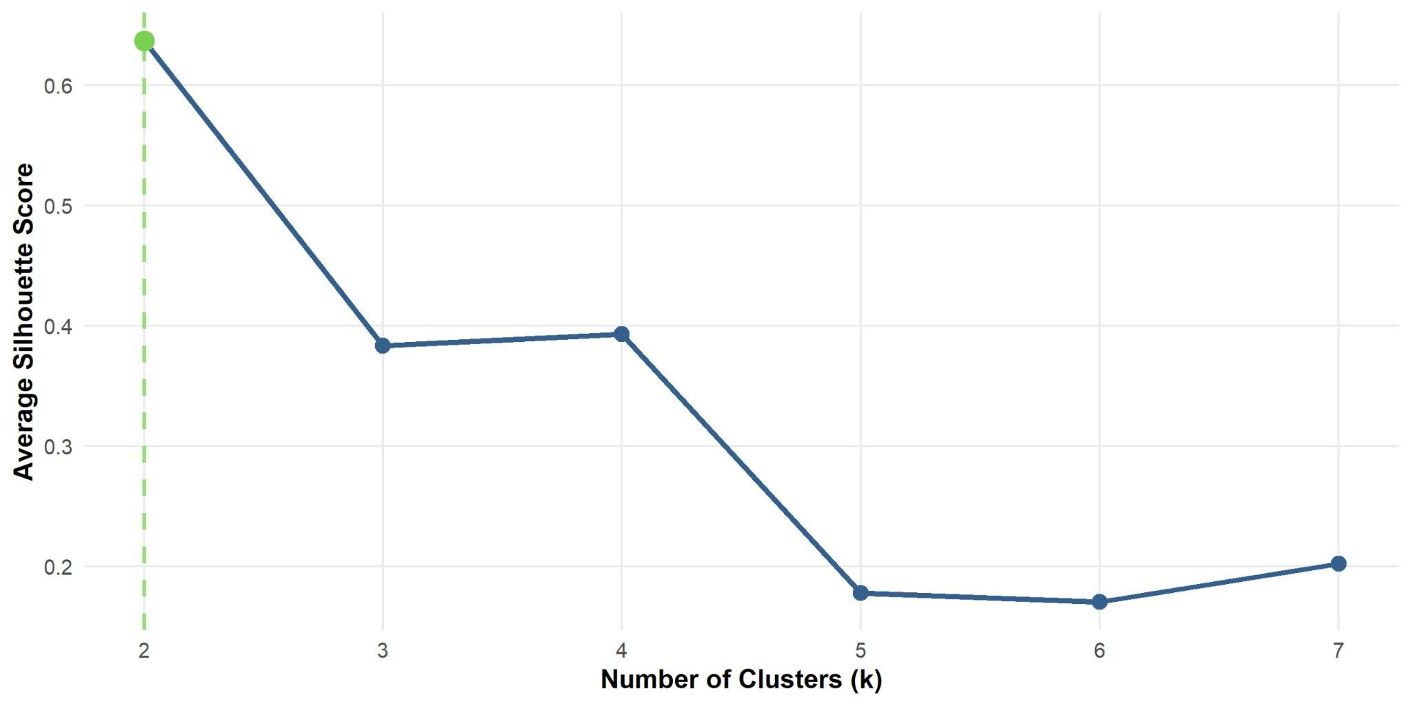

Figure S1. Average silhouette scores across candidate cluster solutions.
Average silhouette scores were calculated for cluster solutions ranging from k = 2 to k = 7 following multiple correspondence analysis and hierarchical clustering. The two-cluster solution showed the highest silhouette score; however, a three-cluster solution was selected for the final analysis because it provided greater clinical interpretability and allowed identification of clinically distinct phenotypes.
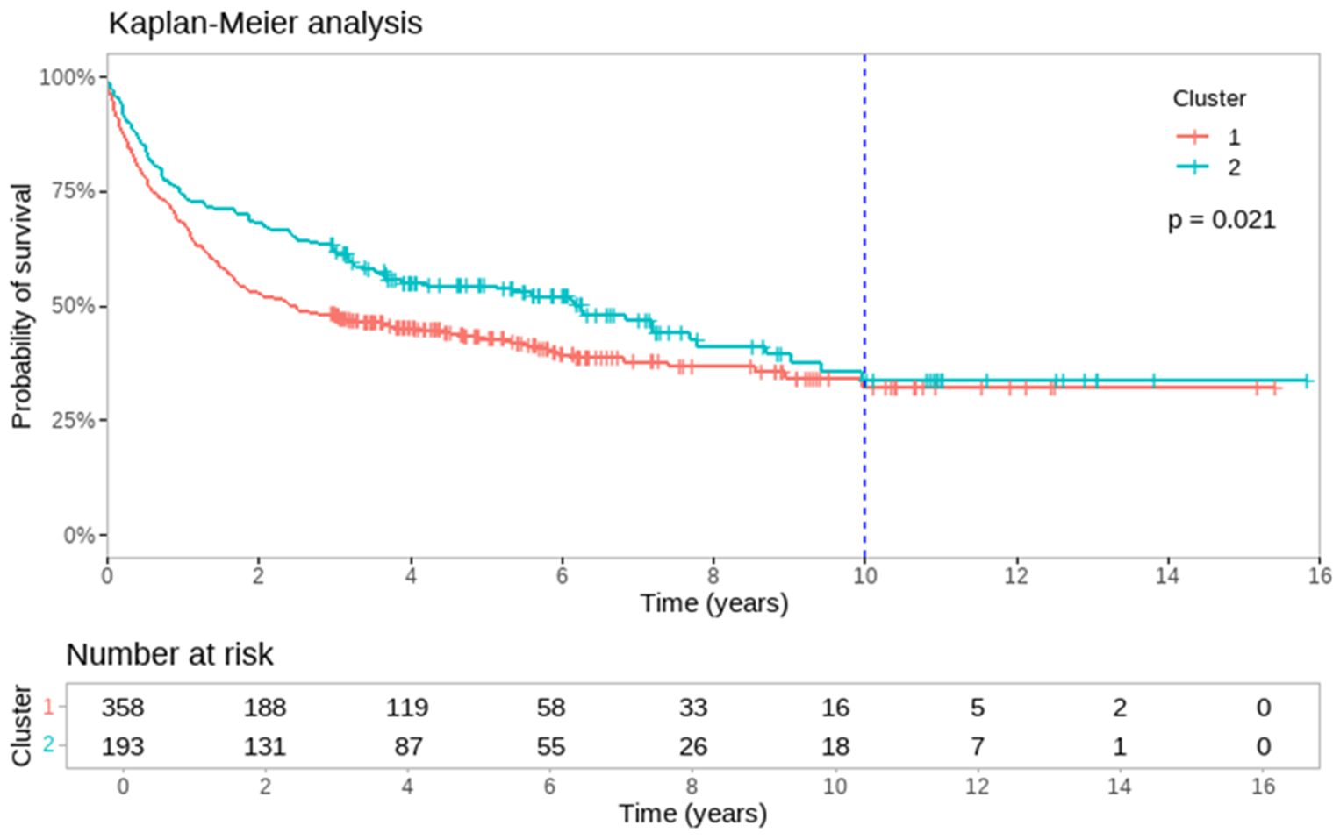Figure S2. Kaplan–Meier curves comparing survival between Clusters 1 and 2
Follow-up extended to 16 years, with a vertical reference line at 10 years indicating the time point beyond which the number of patients at risk declined markedly (Cluster 1: n = 16; Cluster 2: n = 18). Beyond this point, survival estimates should be interpreted with caution.

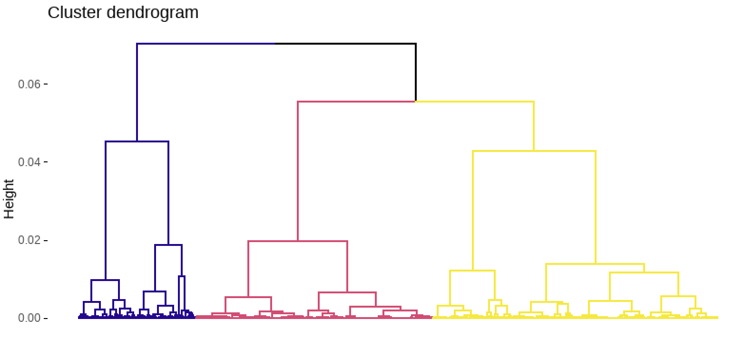
Figure S3. Hierarchical clustering dendrogram of clinical phenotypes.
Dendrogram derived from hierarchical clustering following multiple correspondence analysis, illustrating patient-level interrelationships and supporting the identification of three distinct clinical phenotypes.

