Supplementary material (Appendix)
Appendix Figure S1. Outcomes by mobilisation levels on the first postoperative day (patients independently mobile before fracture). (A) Median length of stay. (B) Non-home discharge and independent walking at discharge.
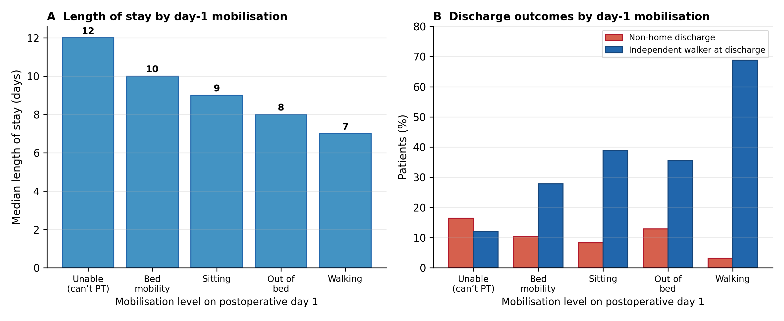
Appendix Figure S2. Recovery of ambulation among patients independently mobile before fracture. (A) Proportion walking before fracture, at postoperative day 3 and at discharge. (B) Discharge ambulation status by whether the patient was walking at postoperative day 3.
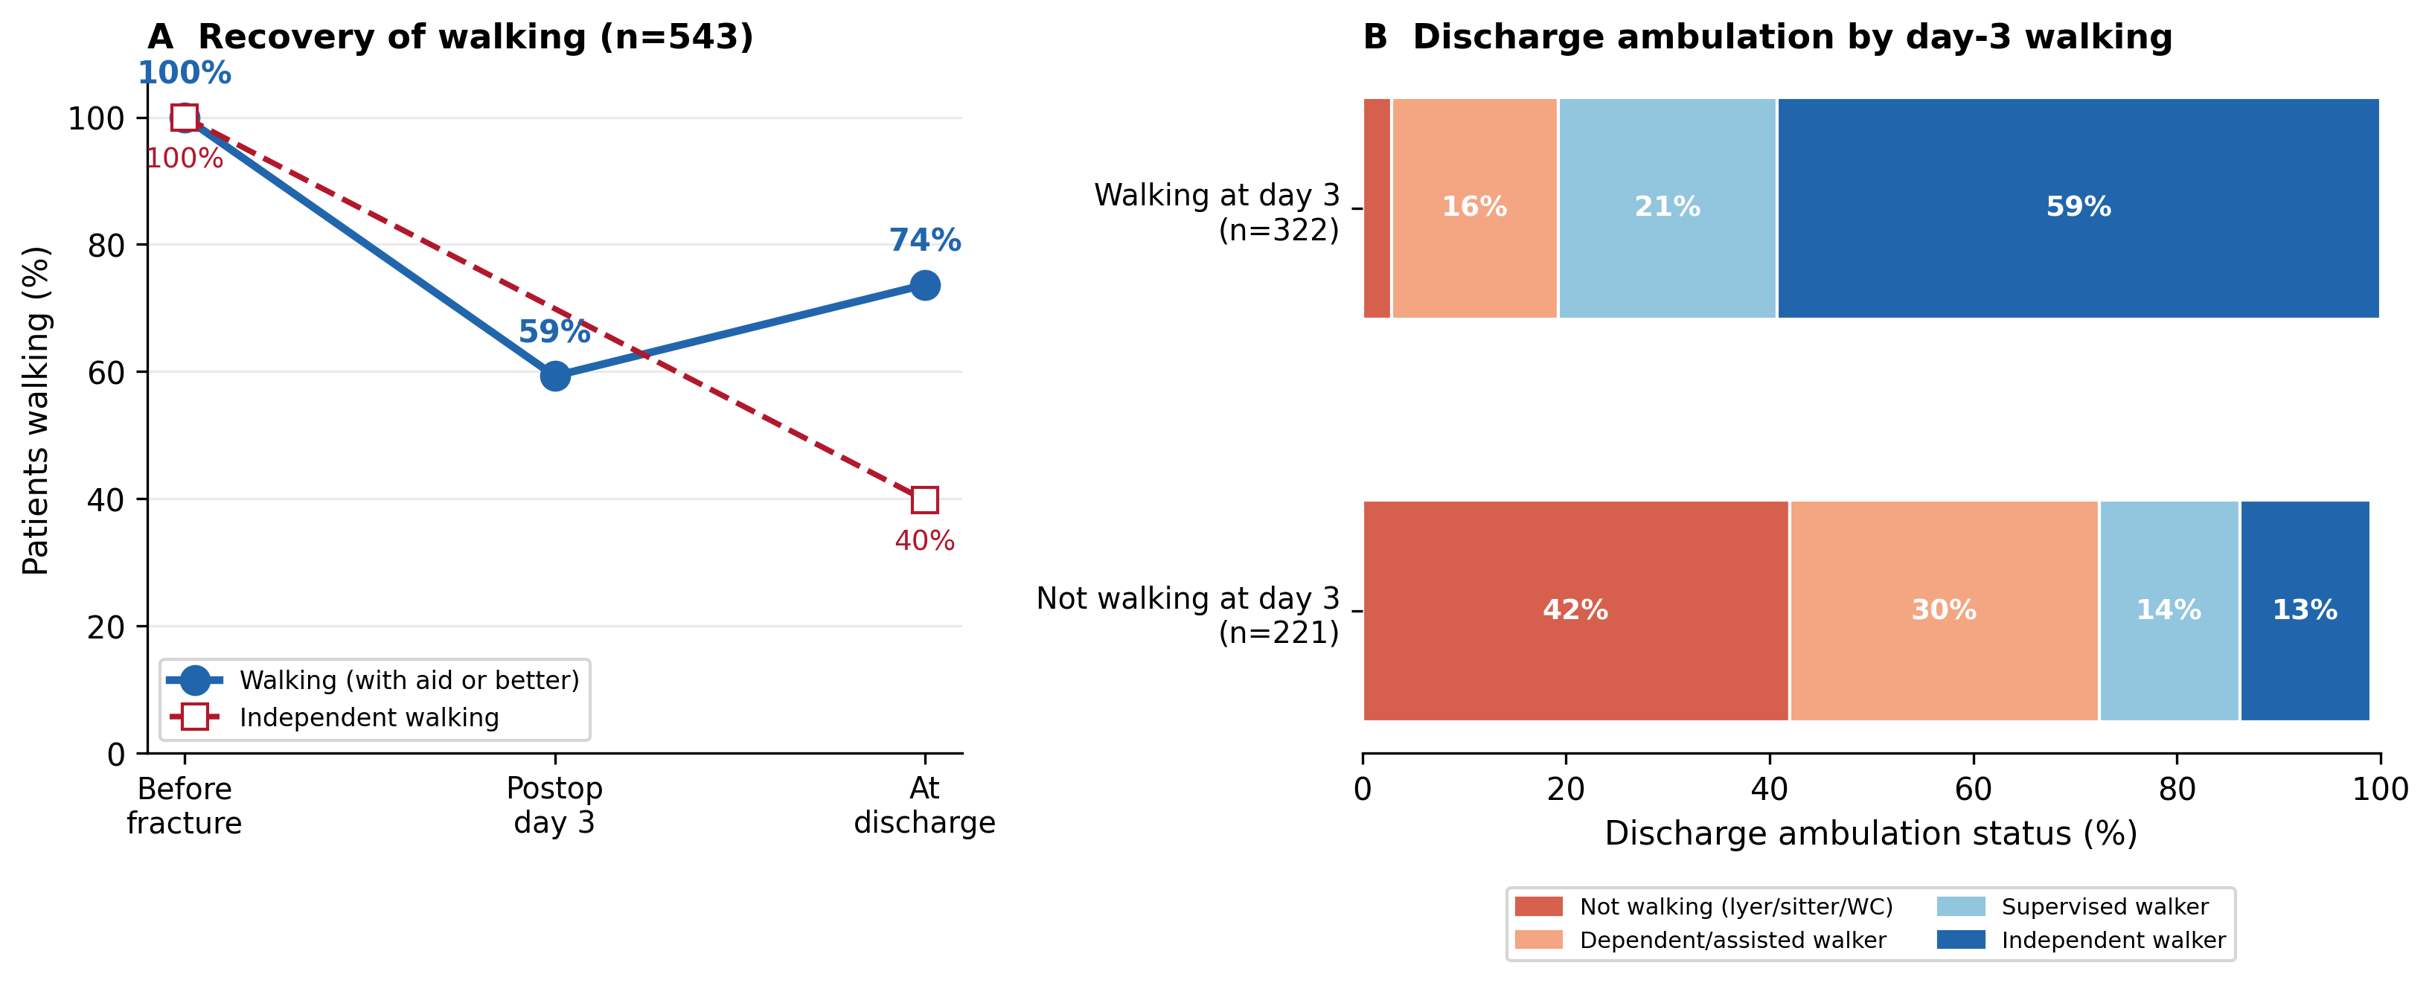

Appendix Table S1. Day-3 milestone (not mobilised by day 3) by number of risk factors present.

Number of risk factors | Patients, n | Not mobilised by day 3, n (%)
0 | 104 | 8 (8)
1 | 152 | 28 (18)
2 | 149 | 40 (27)
3 | 94 | 44 (47)
4 | 37 | 18 (49)
5 | 11 | 6 (55)
Risk factors: CFS ≥5, GNRI ≤98, haemoglobin <10 g/dL, postoperative delirium, polypharmacy (≥8 medications). Area under the ROC curve for the count 0.70. Offered as a bedside checklist, not a formal prediction instrument.

Appendix Table S2. Candidate predictors tested against time to functional mobilisation (Cox regression, n=547).
Candidate | Univariable HR  (95% CI) | Added to 5-factor model | Retained
GNRI ≤98 | 0.67 (0.56–0.80) | p=0.003 | Yes
Albumin <3.5 g/dL | 0.66 (0.53–0.83) | collinear with GNRI (r=0.90) | No
Sodium <135 mmol/L | 0.79 (0.62–1.02) | p=0.42 | No
Neutrophil-to-lymphocyte ratio | 0.99 (0.98–1.01) | p=0.96 | No
Lymphocyte-to-monocyte ratio | 1.13 (1.06–1.21) | p=0.12 | No
Hazard ratio below 1 indicates slower recovery. GNRI is derived from albumin and weight-for-height and was preferred as a validated composite nutritional index. Inflammatory ratios were computed from the white-cell differential. None of the additional candidates improved model discrimination (c-index 0.67).

Appendix Table S3. Care-process levers and early ambulation (patients independently mobile before fracture, n=547).
Care-process factor | Day-1 walking | Median days  to mobilisation | Cox HR  (95% CI)
Surgery ≤48 h of admission (n=456) | 25% | 2 | 1.37 (1.06–1.76)
Surgery >48 h (n=91) | 16% | 3 | reference
Regional (spinal) anaesthesia (n=432) | 26% | 2 | 1.42 (1.13–1.79)
General anaesthesia (n=115) | 13% | 3 | reference
Hazard ratio above 1 indicates faster recovery of mobilisation. Associations are unadjusted and susceptible to confounding by indication; presented as hypothesis-generating and consistent with ERAS principles.

