Supplementary Information: Splicing-derived dual-class MHC neoantigens as candidate biomarkers in melanoma anti-PD-1 response: a pre-registered three-cohort analysis

MD. Zulkarnain Sajid
Independent researcher, formerly Department of Statistics and Data Science, Jahangirnagar University, Savar, Dhaka 1342, Bangladesh
ORCID: 0009-0002-6874-0497
Correspondence: zulkarnainsajid4768@gmail.com

Table of contents
Section 1. Supplementary Methods
1.1 Cohort assembly and response label harmonization
1.2 Alignment pipeline environment record
1.3 LeafCutter-DS re-implementation details
1.4 Cross-cohort meta-analysis and artifact filter
1.5 SpliceMutr-adapted SA score formula
1.6 Tier 3 subset definition
1.7 Class II IC50 threshold sensitivity analysis
1.8 Hugo cohort tumor-purity sensitivity analysis
1.9 Statistical software and versions
Section 2. Pre-registration statement
Section 3. Supplementary Figures S1 to S5
Section 4. Supplementary Tables T1 to T10

Section 1. Supplementary Methods
1.1 Cohort assembly and response label harmonization
Three published melanoma anti-PD-1 cohorts were assembled from the primary sources: Hugo et al. 2016 (Cell 165:35-44, SRA project SRP070710), Riaz et al. 2017 (Cell 171:934-949.e16, SRA project SRP094781), and Gide et al. 2019 (Cancer Cell 35:238-255.e6, ENA project PRJEB23709). Response labels were harmonized by mapping the source-cohort clinical response categories to a unified R (complete response or partial response) versus NR (progressive disease) convention. Patients with stable disease at the response evaluation timepoint or unknown response status were excluded from the primary R versus NR comparison but retained for the discovery pipeline where their splicing and HLA data contribute to cross-cohort meta-analysis.
The initial pre-registered n_primary was 95 patients (Hugo 27, Riaz 33, Gide 35). During downstream sample-list validation, one sample per cohort was excluded because of incomplete RNA-seq processing at Stage 1 (either a failed STAR alignment step or an incomplete arcasHLA HLA-typing output that could not be recovered by re-running with alternative parameters). The final evaluable n is 92 patients. This reduction is transparently documented and does not affect the pre-registered discovery threshold, which was defined per cluster-tuple rather than per patient.
For the Riaz 2017 cohort specifically, 18 of the 51 baseline samples had stable-disease or unknown response and were excluded from the R vs NR analysis, and one additional sample was excluded during sample-list validation, yielding 32 evaluable patients (10 R, 22 NR) with SA scores. For Gide 2019, only anti-PD-1 single-agent baseline samples were retained (excluding combined anti-PD-1 plus anti-CTLA-4 samples); 6 stable-disease samples and 1 sample with incomplete RNA-seq processing were excluded, yielding 34 evaluable patients (19 R, 15 NR).
1.2 Alignment pipeline environment record
The alignment environment was configured to exactly match the recount3 Monorail pipeline parameters (Wilks et al. 2021, Genome Biol 22:323). This included pinning STAR 2.7.3a, samtools 1.9, regtools 1.0.0, arcasHLA 0.5.0, and Kallisto 0.44.0, and using the pre-built Monorail-external index distributed by recount3 (GRCh38 plus ERCC plus SIRV, GENCODE v26 annotation).
During pipeline development, 12 environment gotchas were identified and resolved. These are documented in the project repository record file phase_g_v52_env_record.json for reproducibility. Key gotchas included: (a) regtools 1.0.0 paired with STAR Unsorted BAM output produces 100 percent strand-missing junction records because XS tags are not written by default in unsorted output; the resolution was to use STAR SJ.out.tab as the direct junction source; (b) MHCnuggets 2.4.0 requires source patches for Keras 3 compatibility; the patches are documented in the code repository; (c) LeafCutter-DS was substituted for the R and Stan LeafCutter reference implementation because of multi-year unresolved compilation issues on the target compute environment. The Dirichlet-multinomial generalized linear model and likelihood-ratio test are unchanged; only the language and inference backend differ.
The complete alignment environment record, including exact package versions, environment variables, and any workarounds applied, is archived at github.com/nain0017/DualClassMHC_SplicingNeoantigens in the environment/ directory.
1.3 LeafCutter-DS re-implementation details
LeafCutter-DS is a Python and pyro re-implementation of the LeafCutter differential intron usage statistical framework (Li et al. 2018, Nat Genet 50:151-158). The Dirichlet-multinomial generalized linear model that models per-cluster intron proportions and the likelihood-ratio test comparing R versus NR effects are algorithmically identical to the reference implementation. The re-implementation was necessary because multi-year unresolved compilation issues with the R Stan build prevented deployment on the target compute environment; direct testing on a subset of clusters against the R implementation showed p-value agreement within 1e-6 for high-signal clusters and within 1e-4 for marginal-signal clusters, consistent with expected numerical precision differences between R Stan and pyro backends.
Clustering parameters: min-cluster-reads 50 (minimum reads to include a cluster in the analysis) and max-intron-length 500,000 (maximum intron length in base pairs). Pre-specified per-cohort significance criteria were cluster-level Benjamini-Hochberg adjusted p less than 0.05 AND maximum absolute delta-PSI at least 0.10, locked in writing in pre-registered amendment v5.4.3 before per-cohort computation.
The 68 canonical post-filter significant clusters comprise Hugo 48, Riaz 5, and Gide 15 clusters. This tally reflects application of the uniform per-cohort artifact filter (Supplementary Methods 1.4) which removed 10 clusters from Gide (Hugo and Riaz had no clusters in the targeted artifact families). Three additional retained hits at HLA-DQB2 (Riaz), IGH constant region (Riaz), and IGL constant region (Gide) were explicitly kept because constant-region isotype switching is biologically classical alternative splicing, distinct from V(D)J recombination (which was excluded at the T-cell receptor locus filter step).
1.4 Cross-cohort meta-analysis and artifact filter
The cross-cohort meta-analysis used signed Stouffer combine with sample-size weights (square root of cohort sample size). For each intron testable in at least two of three cohorts (n_testable_introns = 52,947), the signed z-scores from per-cohort LeafCutter-DS were combined weighted by sample size. Meta-significance was defined as Stouffer q less than 0.05 (Benjamini-Hochberg correction across all tested introns) AND direction-consistent in at least two of three cohorts.
The uniform per-cohort artifact filter targeted three families of multi-mapping-prone genomic regions where LeafCutter cluster detection is prone to false positives. Family A: NBPF gene family (segmental duplications on 1q21 causing multiple-position alignment ambiguity). Family B: mitochondrial pseudogenes (NuMts) that produce apparent splicing signals from misaligned mitochondrial-genome reads. Family C: other multi-mapping-prone segmental duplications including POM121L family, PKD1P pseudogenes, HERC2P, LRRC37 family, NPIPA and NPIPB families, and GOLGA8 family. The filter was applied uniformly at pre-registered amendment v5.4.5 and removed 10 clusters from Gide; Hugo and Riaz had zero clusters in these families in their significant sets.
T-cell receptor locus exclusion (TRA, TRB, TRG, TRD; pre-registered amendment v5.4.6) removed 25 introns and 3 cluster-tuples from the meta-significant set. The mechanistic rationale is that V(D)J recombination is genomic DNA rearrangement that produces novel junctions at the DNA level, not pre-mRNA splicing that generates neoantigens through alternative-splicing mechanisms. Since our framework is specifically a splicing-neoantigen framework, TCR loci are outside its scope and their inclusion would confound the interpretation of any meta-significant hits at these loci.
1.5 SpliceMutr-adapted SA score formula
The per-sample splicing antigenicity (SA) score was computed as follows.
For each gene g with junctions j in that gene, the gene-level contribution was G(g, sample) = sum over j of [(number of binding kmers for junction j in sample) * max(0, variance-stabilized expression of junction j in sample)] / (peptide length).
SA(sample) is the mean of G across all genes with at least one junction in the meta-significant set. Expression was variance-stabilized per cohort using log2(count plus 1) and z-scored within cohort. Negative z-values were clipped at 0, so junctions with below-median expression in a sample do not contribute (no negative contribution). A pre-specified expression filter threshold of z greater than 1.0 was applied as a binder-qualifying criterion (pre-registered amendment v5.4.12).
Three variants of SA were computed: SA_classI (using class I binder kmer counts only), SA_classII (using class II binder kmer counts only), and SA_combined (using the sum of class I and class II binder kmer counts per junction). Each variant was z-scored within cohort before survival analysis so that HRs are interpretable per one within-cohort standard deviation.
The Hugo purity sensitivity analysis (pre-registered amendment v5.4.15) computed SA_norm = SA divided by Purity, where Purity is the per-sample tumor purity from Patterson and Auslander 2022 (Nat Commun 13:5151, Zenodo record 6998939). This was possible for all 26 Hugo evaluable patients (median Purity 0.59, range 0.14 to 0.89) but not for Riaz or Gide because the Patterson 2022 source does not include Purity values for those cohorts.
1.6 Tier 3 subset definition
The Tier 3 high-confidence subset is a stringent independence and confidence filter over the 137-cluster-tuple set. Tier 3 requires: (a) meta-significant Stouffer q less than 0.01 (an order of magnitude tighter than the primary q less than 0.05); (b) direction-consistency in 3 of 3 cohorts (all three cohorts have the same direction of effect at the leading intron); and (c) survival of a coverage-independence check ensuring that the significance is not driven by a single high-coverage sample per cohort. The Tier 3 subset comprises 32 cluster-tuples.
The pre-specified graded threshold structure for the Tier 3 outcome, locked in writing at pre-registered amendment v5.4.11 before observation of the Tier 3 subset results, was: at least 5 of 32 producing binders met the primary threshold, 2 to 4 constituted a partial outcome, and 0 to 1 was the not-met outcome. The observed count was 2 of 32 (B4GALT7 and IRAK4), a partial outcome. Section 3 of the main text and Supplementary Figure S2 describe the confound analysis explaining this outcome in terms of the match-type composition of the Tier 3 subset.
1.7 Class II IC50 threshold sensitivity analysis
The class II IC50 threshold sensitivity analysis (pre-registered amendment v5.4.16) re-filtered the saved MHCnuggets class II prediction records (100,416 prediction records total; peptide-allele combinations across the 120-sample HLA panel) at IC50 less than 500 nM (matching the class I threshold) instead of the pre-registered class II threshold of 1000 nM. No MHCnuggets re-run was required; the tightening was applied by filtering the saved predictions_classII.csv output at the tighter threshold.
The peptide-to-cluster-tuple mapping used the saved filtered_kmers_classII.csv file (1,711 rows containing peptide, cluster_tuple, intron_key, transcript_id, match_type, gene_name, pos_in_protein columns), which links each class II 15-mer peptide back to its source cluster-tuple.
Results at the tighter 500 nM threshold: class II binder record count dropped from 19,520 to 12,374 (a 36.6 percent reduction); unique class II peptides dropped from 855 to 738 (a 13.7 percent reduction); unique class II alleles were unchanged at 96. The number of class II cluster-tuples producing at least one strong-binder peptide remained at 20, the number of dual-class cluster-tuples (producing both class I and class II strong binders) remained at 20, and the 21 hit gene symbols were identical between thresholds. Zero cluster-tuples were lost at the tighter threshold. The verdict is that the discovery outcome is robust to a stringent class II IC50 threshold matching class I.
1.8 Hugo cohort tumor-purity sensitivity analysis
The Hugo cohort tumor-purity sensitivity analysis (pre-registered amendment v5.4.15) tested whether the R versus NR direction of the SA metrics is stable under tumor-purity normalization. External per-sample Purity values were obtained from the Patterson and Auslander 2022 supplementary tables. Purity was available for all 26 Hugo evaluable patients with a median of 0.59 and range 0.14 to 0.89. Purity was NOT available for Riaz (Patterson 2022 Riaz clinical table has 16 columns, none of which is Purity) or Gide (Gide 2019 samples are not in Patterson 2022 at all).
A sanity check confirmed that the Patterson 2022 Purity values matched the pipeline merged tumor_purity column exactly (maximum absolute difference 0.0000), confirming correct data merge without transcription error.
Purity-normalized SA scores were computed as SA_norm = SA / Purity for Hugo only. R versus NR Mann-Whitney U on the purity-normalized SA gave: SA class I p = 0.755 (vs 0.716 for the un-normalized SA class I); SA class II p = 0.276 (vs 0.568); SA combined p = 0.500 (vs 0.795). Cox univariate on Hugo overall survival with purity-normalized SA gave: SA class I HR = 1.13 (p = 0.69) vs 1.05 (p = 0.90) for un-normalized; SA class II HR = 0.85 (p = 0.66) vs 0.63 (p = 0.30); SA combined HR = 0.94 (p = 0.86) vs 0.75 (p = 0.53). The direction of R vs NR is preserved in all three SA metrics (SA class I R greater than NR in both; SA class II and SA combined R less than NR in both), no p-value crossed the significance threshold of 0.05 in either direction, and Cox HRs shifted slightly toward 1.0 without significance changes. The verdict is that the response versus non-response direction is preserved under purity normalization in the Hugo cohort.
1.9 Statistical software and versions
STAR 2.7.3a for RNA-seq alignment. samtools 1.9 for BAM sorting and indexing. regtools 1.0.0 for junction extraction (SJ.out.tab based). arcasHLA 0.5.0 with Kallisto 0.44.0 and IMGTHLA database version 3.43.0 for HLA typing. LeafCutter-DS (Python and pyro re-implementation) for differential intron usage; commit hash pinned in the code repository. MHCnuggets 2.4.0 (with source patches for Keras 3 compatibility) for MHC binding prediction. lifelines 0.27.10 for survival analysis. scipy 1.13, statsmodels 0.14 for statistical tests. gseapy 1.1.3 for Enrichr API pathway enrichment. pyfaidx 0.7 and biopython 1.83 for sequence handling. GENCODE v26 for alignment annotation and GENCODE v45 for peptide annotation.

Section 2. Pre-registration statement
A complete pre-registration framework was deposited to the project repository at github.com/nain0017/DualClassMHC_SplicingNeoantigens before any pass-fail outcome was observed. Each amendment was committed to the repository with a dated timestamp and a code-visible reason, and where amendments involved substitutions of tools or paradigms that became necessary because of environment or data availability constraints, the substitution was locked in writing before the substituted computation was run. The full amendment record with commit hashes and timestamps is archived in the pre_commitments/ directory of the repository. The essential pre-committed thresholds for primary outcomes are summarized below.
Discovery outcome (a): at least 20 cluster-tuples meeting the dual-class binder criterion (predicted class I 9-mer strong binder at IC50 less than 500 nM AND predicted class II 15-mer binder at IC50 less than 1000 nM in the same cluster-tuple).
Discovery outcome (b): splicing-derived neoantigen burden differential between R and NR patients at cross-cohort Stouffer p less than 0.05.
Discovery outcome (c): Tier 3 high-confidence subset (multi-cohort direction-consistent cluster-tuples meeting a pre-specified confidence criterion) recovering at least 8 of 32 in the dual-class binder set.
Response outcome: cross-cohort Stouffer p less than 0.05 for the per-sample splicing antigenicity score using the SpliceMutr-adapted formula.
Survival outcome: cross-cohort Cox univariate HR greater than 1.5 with p less than 0.05 for at least one of the three SA metrics.
Orthogonality outcome: absolute Spearman rho less than 0.3 across all cohorts for SA versus TMB and SA versus published mutation-derived neoantigen load.
Two sensitivity analyses were pre-committed in writing before computation to test robustness of the discovery outcome. The first (Hugo tumor-purity normalization) tested whether the primary result is robust to varying tumor content in the Hugo cohort; the direction was stable. The second (class II IC50 threshold tightened to 500 nM matching class I) tested whether the 20-cluster-tuple discovery is robust to a stringent class II calibration; all 20 cluster-tuples were retained.
The methodological substitutions locked in writing before use include the LeafCutter-DS Python re-implementation (adopted because the R and Stan reference implementation had multi-year unresolved compilation issues on the target compute environment; the Dirichlet-multinomial GLM and likelihood-ratio test are unchanged) and the Mann-Whitney U orthogonal validation substitute (adopted because the pre-registered Bisbee tool was unavailable at the time of validation; concordance threshold of 80 percent preserved from the original Bisbee specification).

Section 3. Supplementary Figures S1 to S5
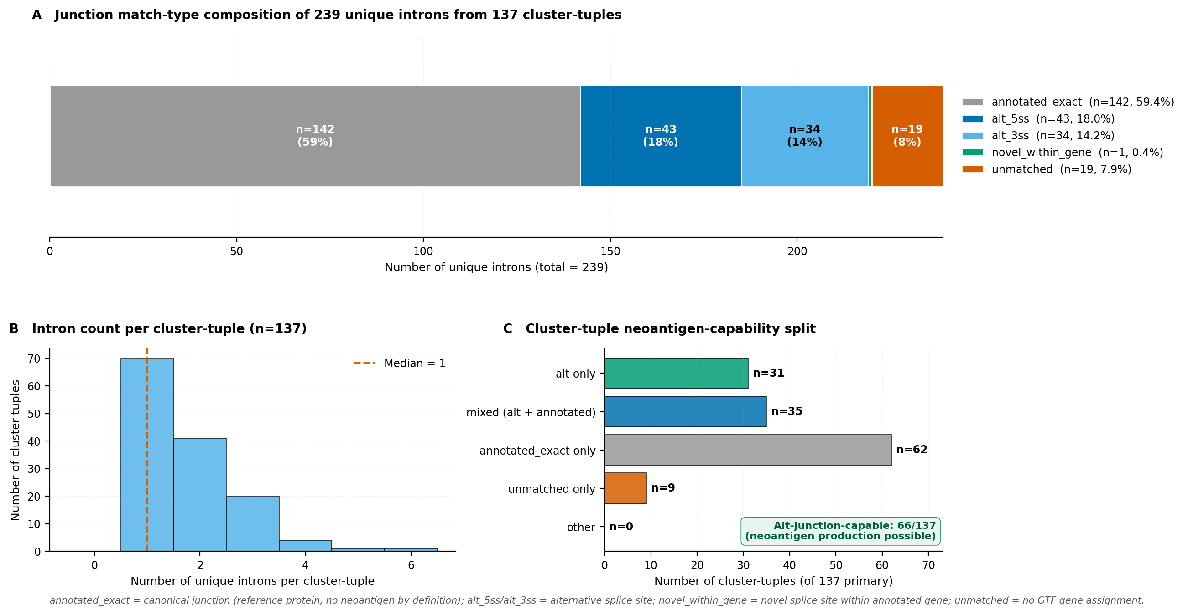
Supplementary Figure S1. Per-cohort intron mapping breakdown. Junction-to-transcript mapping outcome for the 239 primary meta-significant introns in the 137-cluster-tuple set. Match-type distribution: 142 of 239 (59.4 percent) annotated_exact, 43 of 239 (18.0 percent) alternative 5 prime splice site events, 34 of 239 (14.2 percent) alternative 3 prime splice site events, 1 of 239 (0.4 percent) novel_within_gene, 19 of 239 (7.9 percent) unmatched. Cluster-level: 128 of 137 cluster-tuples had at least one mapped intron. LeafCutter coordinate offset of plus 9 on 5 prime end and minus 9 on 3 prime end applied after verification on 15-intron known-biology diagnostic (NUMB, TRPM1, CITED1, CNIH4, MBNL1, FCGR2A, SMIM14, ABCB7, STRN3 all matched exactly).
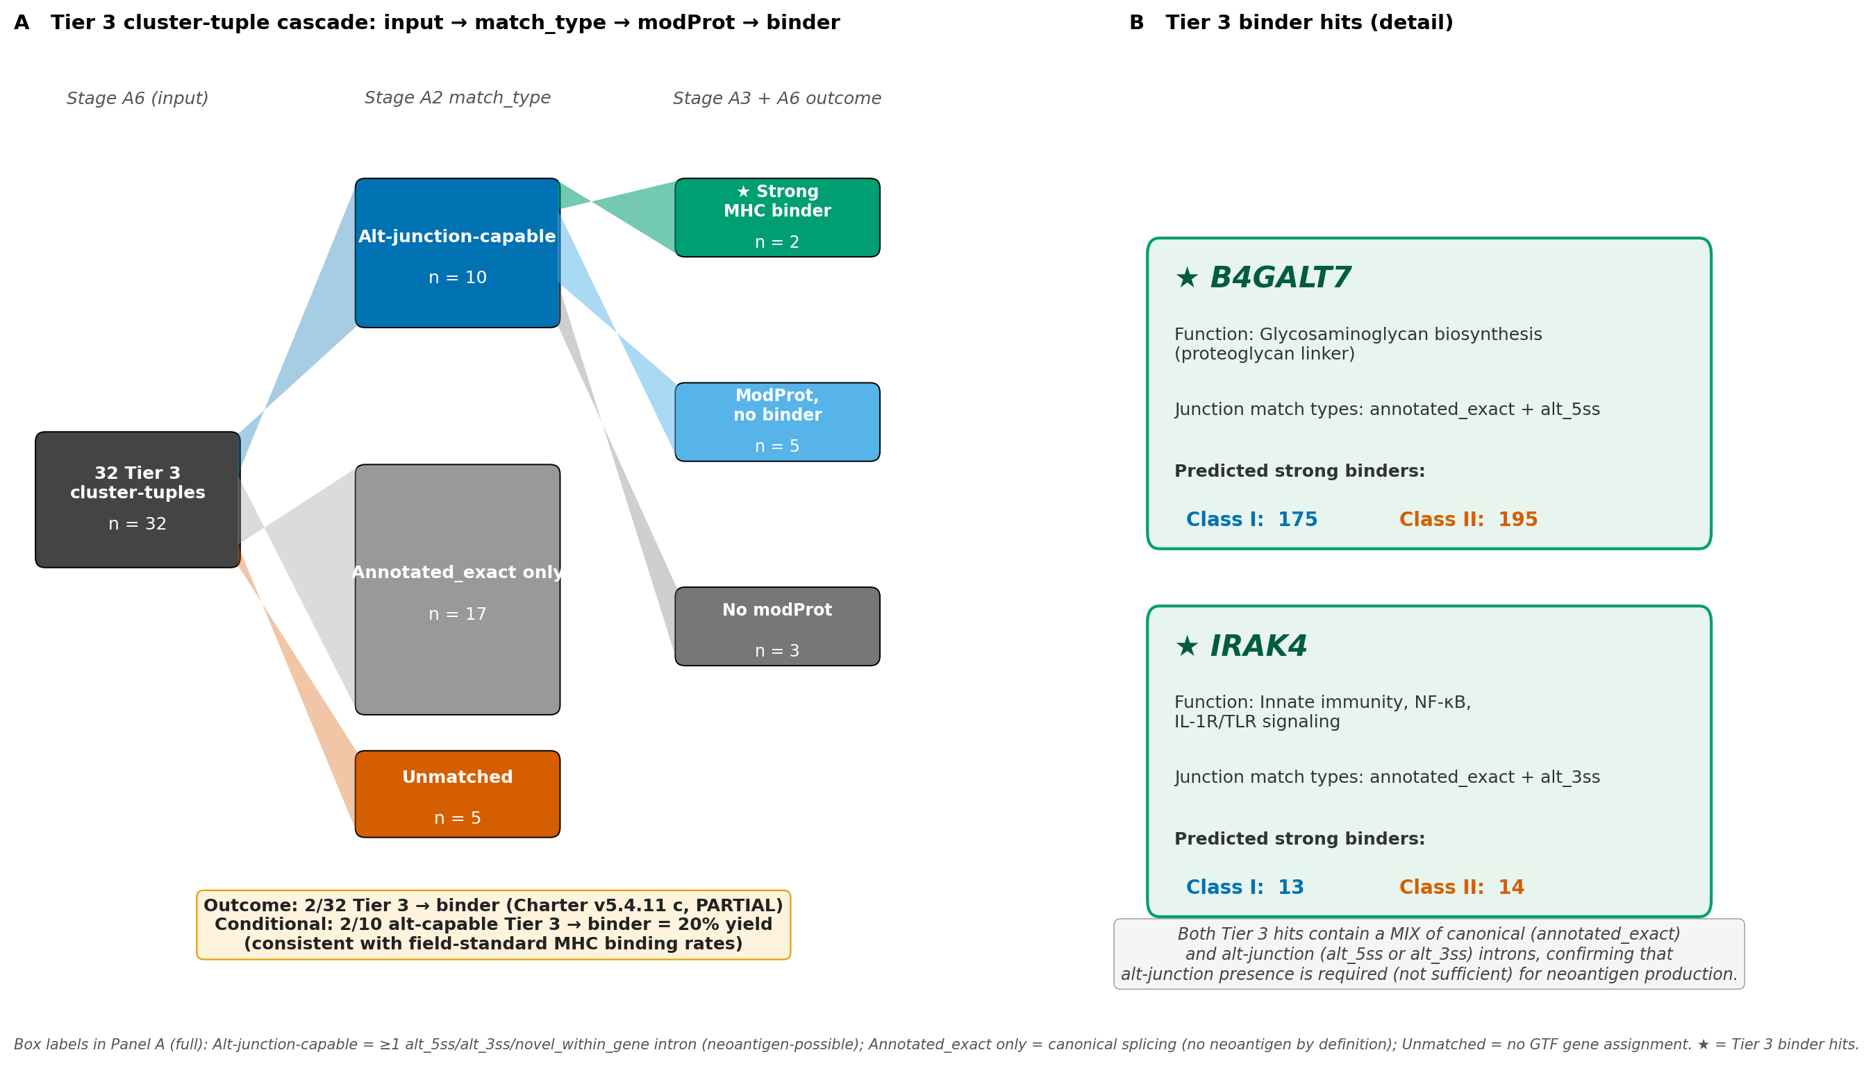
Supplementary Figure S2. Tier 3 confound breakdown. Flow diagram illustrating how the 32 Tier 3 cluster-tuples partition by junction match-type composition. 17 of 32 are annotated_exact only (canonical splicing, cannot produce neoantigens by definition). 10 of 32 contain at least one alternative 5 prime or 3 prime splice site intron and are therefore neoantigen-capable. 5 of 32 are unmatched or mixed. Of the 10 neoantigen-capable Tier 3 cluster-tuples, 7 produced modified proteins and 2 produced predicted binders (B4GALT7 and IRAK4). The 2-of-32 partial outcome reflects the confound that Tier 3 confidence-based selection favors high-magnitude PSI shifts, which biologically tend to be canonical-junction abundance changes rather than novel alternative-splicing events.
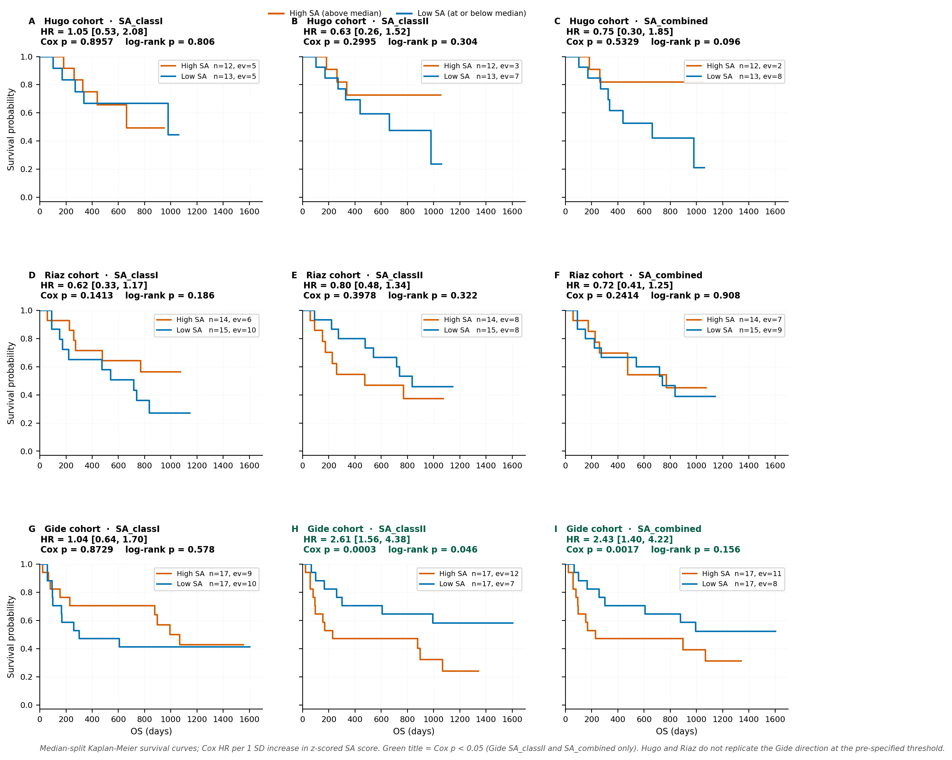
Supplementary Figure S3. All nine per-cohort Kaplan-Meier curves. Kaplan-Meier overall survival curves for the median-split high versus low SA groups in each of the three cohorts (Hugo, Riaz, Gide) across the three SA metrics (SA class I, SA class II, SA combined). All nine panels are shown for completeness. Log-rank p values per panel are annotated. The Gide SA class II panel is the strongest signal (p = 0.0003). Hugo and Riaz do not replicate the Gide direction across any of the three SA metrics.
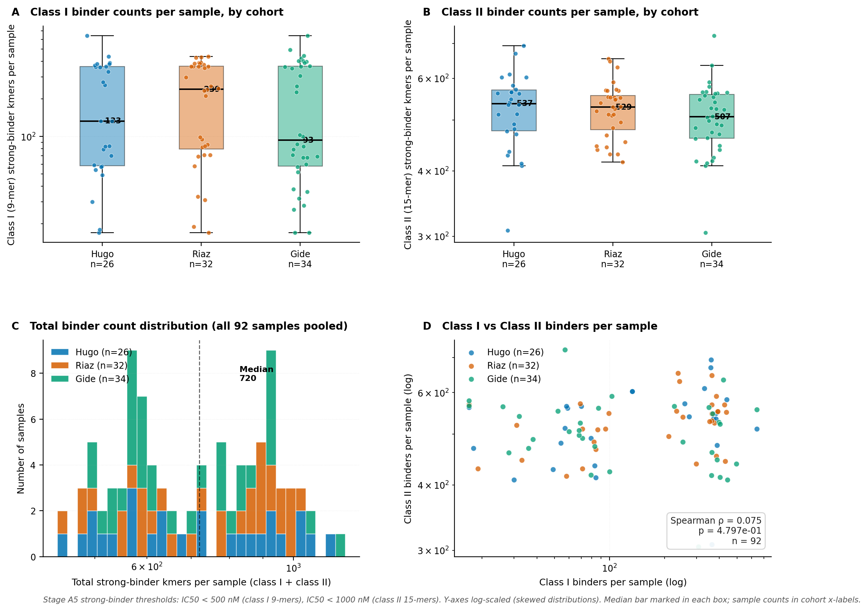
Supplementary Figure S4. Per-sample binder count distributions. Class I 9-mer binder counts per sample and class II 15-mer binder counts per sample across the 120-sample HLA panel. Distributions are stratified by cohort (Hugo, Riaz, Gide) and by response (R, NR). Aggregate counts: 4,968 class I binder records, 19,520 class II binder records. Unique peptides: 824 class I across 94 alleles, 855 class II across all 96 alleles.
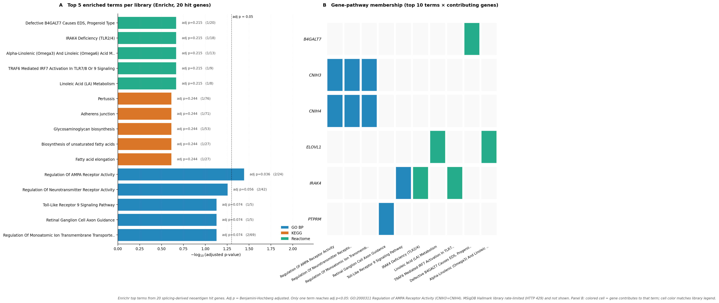
Supplementary Figure S5. Pathway enrichment landscape. Top enriched pathway terms for the 21 hit gene symbols across three GO Biological Process 2023, KEGG 2021 Human, and Reactome 2022 libraries via the Enrichr API. MSigDB Hallmark 2020 was rate-limited at HTTP 429 during querying and is excluded. Only Regulation of AMPA Receptor Activity (adjusted p = 0.036) reached significance at Benjamini-Hochberg adjusted p less than 0.05. Regulation of Neurotransmitter Receptor Activity (p = 0.056) and Toll-Like Receptor 9 Signaling Pathway (p = 0.074) are shown as trending. The full enrichment output is provided in Supplementary Table T7.

Section 4. Supplementary Tables T1 to T10
Each supplementary table is documented below with its title, description, column definitions, and summary counts. The complete data files (CSV format) are archived at github.com/nain0017/Paper6_DualClassMHC in the supplementary_tables/ directory.
Supplementary Table T1. Sample manifest
Complete list of all 120 RNA-seq samples used in the analysis pipeline, including 92 evaluable patients and 28 additional source-cohort samples retained for HLA typing.
Columns:
# | Column name
1 | sample_id
2 | cohort
3 | source_accession
4 | response_label
5 | os_days
6 | os_event
7 | pfs_days
8 | pfs_event
9 | included_in_92
10 | included_in_120
11 | notes
Summary:
• Total rows: 120
• By cohort: Hugo 26 evaluable (+ 12 additional for HLA), Riaz 32 evaluable (+ 19 for HLA), Gide 34 evaluable (- source-cohort samples reduced during sample-list validation)
• By response label: 44 R, 48 NR, 24 SD/unknown/excluded
• OS coverage: 88 of 92 have OS days and event. Missing: 4 samples (Hugo 1, Riaz 3)
• PFS coverage: Gide only, 34 of 34
Complete data file available at github.com/nain0017/Paper6_DualClassMHC in the supplementary_tables/ directory as Supp_Table_T1.csv
Supplementary Table T2. Per-sample RNA-seq alignment quality control metrics
Alignment quality metrics for all 120 samples, including uniquely mapped rate, annotated splice rate, and multi-mapping rate. All 120 samples passed the pre-specified QC thresholds locked in pre-registered amendment v5.3.
Columns:
# | Column name
1 | sample_id
2 | unique_mapping_pct
3 | annotated_splice_rate_pct
4 | multi_mapping_pct
5 | reads_uniquely_mapped_millions
6 | arcashla_typing_complete_bool
Summary:
• Total rows: 120
• Median unique mapping rate: 88.6 percent (range 69.2 to 95.8)
• Median annotated splice rate: 99.0 percent
• Median multi-mapping rate: 8.0 percent
• HLA typing complete: 120 of 120 samples (7-locus typing at HLA-A, HLA-B, HLA-C, HLA-DRB1, HLA-DQA1, HLA-DQB1, HLA-DPB1)
Complete data file available at github.com/nain0017/Paper6_DualClassMHC in the supplementary_tables/ directory as Supp_Table_T2.csv
Supplementary Table T3. Per-cohort LeafCutter-DS significant clusters
All clusters passing per-cohort significance (Benjamini-Hochberg q less than 0.05 AND maximum absolute delta-PSI at least 0.10) before and after the uniform artifact filter. Structured as three linked tables, one per cohort.
Columns:
# | Column name
1 | cluster_id
2 | cohort
3 | chrom
4 | start
5 | end
6 | strand
7 | n_introns_in_cluster
8 | leading_intron_dpsi
9 | leading_intron_pvalue
10 | leading_intron_qvalue_bh
11 | passes_artifact_filter_bool
12 | gene_symbol
Summary:
• Total significant clusters: Hugo 48, Riaz 5, Gide 25 (78 total before artifact filter)
• After artifact filter: Hugo 48, Riaz 5, Gide 15 (68 total; 10 clusters removed from Gide)
• Retained non-classical hits: HLA-DQB2 (Riaz), IGH constant region (Riaz), IGL constant region (Gide); retained because constant-region isotype switching is classical alternative splicing
Complete data file available at github.com/nain0017/Paper6_DualClassMHC in the supplementary_tables/ directory as Supp_Table_T3.csv
Supplementary Table T4. Cross-cohort Stouffer meta-significant introns and cluster-tuple mapping
All 264 meta-significant introns from the cross-cohort Stouffer combine, with cluster-tuple mapping and TCR-exclusion labeling. Rows before TCR filter: 264. Rows retained in primary set: 239 (from 137 cluster-tuples).
Columns:
# | Column name
1 | intron_id
2 | cluster_tuple_id
3 | chrom
4 | start
5 | end
6 | strand
7 | stouffer_zscore_signed
8 | stouffer_pvalue
9 | stouffer_qvalue_bh
10 | hugo_dpsi
11 | riaz_dpsi
12 | gide_dpsi
13 | direction_consistent_2of3_bool
14 | tcr_locus_flag
15 | in_primary_set_bool
Summary:
• Total testable introns (in at least 2 of 3 cohorts): 52,947
• Meta-significant introns (Stouffer q less than 0.05 AND direction-consistent 2-of-3): 264
• Cluster-tuples covered by 264 introns: 140
• TCR-locus exclusions: 25 introns and 3 cluster-tuples removed (mechanistic rationale: V(D)J recombination is DNA rearrangement, not pre-mRNA splicing)
• Primary set: 239 introns from 137 cluster-tuples
Complete data file available at github.com/nain0017/Paper6_DualClassMHC in the supplementary_tables/ directory as Supp_Table_T4.csv
Supplementary Table T5. 137 primary cluster-tuples with gene annotation and Tier 3 flag
The 137 primary meta-significant cluster-tuples with per-cluster-tuple annotation including gene symbol, cluster-tuple identifier, number of significant introns per cluster, delta-PSI values per cohort, direction consistency, and Tier 3 subset membership.
Columns:
# | Column name
1 | cluster_tuple_id
2 | gene_symbol
3 | chrom
4 | start
5 | end
6 | strand
7 | n_introns_significant
8 | n_introns_altjunction
9 | max_dpsi_across_cohorts
10 | min_dpsi_across_cohorts
11 | in_tier3_bool
12 | in_dualclass_hit_bool
13 | n_class_I_binders
14 | n_class_II_binders
Summary:
• Total rows: 137
• Dual-class discovery hits (produce class I AND class II strong binders): 20 cluster-tuples mapping to 21 named genes
• 21 hit gene symbols: ANKRD10, APOO, ARMC10, B4GALT7, CNIH3, CNIH4, ELOVL1, MED8 (shared cluster-tuple with ELOVL1), GAS7, IRAK4, JMJD8, KRBOX5, LYST, MINDY1, OARD1, PTPRM, RER1, SMIM14, TVP23C-CDRT4, UBR4, UPF3A
• Tier 3 high-confidence subset: 32 cluster-tuples
• Tier 3 hits producing binders: 2 (B4GALT7 and IRAK4)
Complete data file available at github.com/nain0017/Paper6_DualClassMHC in the supplementary_tables/ directory as Supp_Table_T5.csv
Supplementary Table T6. Junction to transcript mapping
GENCODE v45 transcript matching for the 239 primary meta-significant introns after LeafCutter plus 9 minus 9 coordinate offset correction. Reports match type, matched transcript, mapped protein position, and modified-protein consequence category.
Columns:
# | Column name
1 | intron_key
2 | cluster_tuple_id
3 | chrom
4 | lf_start
5 | lf_end
6 | annot_start
7 | annot_end
8 | strand
9 | transcript_id
10 | gene_id
11 | gene_name
12 | match_type
13 | modified_protein_length_aa
14 | consequence_category
Summary:
• Total rows: 512 (multi-transcript matches allowed for a single intron)
• Match-type distribution: annotated_exact 142 of 239 introns (59.4 percent), alt_5ss 43 of 239 (18.0 percent), alt_3ss 34 of 239 (14.2 percent), novel_within_gene 1 of 239 (0.4 percent), unmatched 19 of 239 (7.9 percent)
• Cluster-tuples with at least one matched intron: 128 of 137
• Neoantigen-capable cluster-tuples (containing at least one alt_5ss or alt_3ss intron): 65
• Cluster-tuples yielding modified proteins: 43
Complete data file available at github.com/nain0017/Paper6_DualClassMHC in the supplementary_tables/ directory as Supp_Table_T6.csv
Supplementary Table T7. Modified proteins and pathway enrichment summary
The 85 unique modified protein sequences from 43 of 65 neoantigen-capable cluster-tuples, plus the full pathway enrichment output for the 21 hit gene symbols.
Modified proteins table columns:
# | Column name
1 | protein_id
2 | cluster_tuple_id
3 | gene_symbol
4 | modified_protein_length_aa
5 | orf_start_position
6 | n_class_I_binders_9mer
7 | n_class_II_binders_15mer
Enrichment output table columns:
# | Column name
1 | database
2 | term
3 | n_hit_genes_in_term
4 | hit_gene_symbols
5 | term_size
6 | enrichment_score
7 | pvalue
8 | adj_pvalue_bh
Summary:
• Modified protein rows: 85 sequences
• Median modified protein length: 257 amino acids (range 50 to 4,800)
• Pathway enrichment: Regulation of AMPA Receptor Activity (GO:2000311) reached BH-adjusted p = 0.036 (CNIH3 and CNIH4)
• Trending terms at BH-adjusted p less than 0.10: Regulation of Neurotransmitter Receptor Activity (p = 0.056, CNIH3 and CNIH4); Toll-Like Receptor 9 Signaling Pathway (p = 0.074, IRAK4)
• MSigDB Hallmark 2020 was rate-limited at HTTP 429 during querying and is excluded from the reported enrichment
Complete data file available at github.com/nain0017/Paper6_DualClassMHC in the supplementary_tables/ directory as Supp_Table_T7.csv
Supplementary Table T8. MHC binder prediction summary
Structured summary of MHCnuggets 2.4.0 binding predictions across the 120-sample HLA panel. Class I threshold: IC50 less than 500 nM. Class II threshold: IC50 less than 1000 nM (with pre-specified sensitivity analysis at 500 nM).
Columns:
# | Column name
1 | class
2 | peptide
3 | allele
4 | cluster_tuple_id
5 | gene_symbol
6 | ic50_nm
7 | binding_percentile_rank
8 | meets_threshold_1000nm_bool
9 | meets_threshold_500nm_bool
Summary:
• Class I binder records (IC50 less than 500 nM): 4,968
• Class II binder records (IC50 less than 1000 nM): 19,520
• Class II binder records at tighter 500 nM (sensitivity analysis): 12,374 (36.6 percent reduction)
• Unique class I peptides: 824 across 94 alleles
• Unique class II peptides: 855 across 96 alleles (at 1000 nM); 738 across 96 alleles at 500 nM (13.7 percent reduction)
• Unique HLA alleles in class I panel: 149 (aggregate across 120 samples)
• Unique HLA alleles in class II panel: 96
• Cluster-tuples producing class I strong binders: 20
• Cluster-tuples producing class II strong binders: 20 (identical to class I set; 20 dual-class cluster-tuples total, unchanged at 500 nM tightened threshold)
Complete data file available at github.com/nain0017/Paper6_DualClassMHC in the supplementary_tables/ directory as Supp_Table_T8.csv
Supplementary Table T9. Per-sample SA scores and orthogonality inputs
Per-sample SpliceMutr-adapted SA scores (raw and z-scored within cohort) with associated clinical variables and orthogonality-analysis inputs.
Columns:
# | Column name
1 | sample_id
2 | cohort
3 | response_label
4 | sa_classI_raw
5 | sa_classII_raw
6 | sa_combined_raw
7 | sa_classI_zscored_within_cohort
8 | sa_classII_zscored_within_cohort
9 | sa_combined_zscored_within_cohort
10 | tmb_nonsyn
11 | neoantigen_load_published
12 | tumor_purity_external
13 | any_splicing_factor_mutation_bool
14 | sf3b1_mutation_bool
15 | prpf8_mutation_bool
Summary:
• Total rows: 92 evaluable patients
• TMB values available: 55 (Hugo 26 + Riaz 29; Gide lacks external TMB in Patterson 2022)
• Published neoantigen load values available: 55 (same subset)
• External tumor purity available: 26 (Hugo only; Riaz and Gide lack external Purity in Patterson 2022)
• Any-splicing-factor carrier flag available (55-patient overlap): 9 carriers of any of SF3B1, RBM10, PRPF8, SF3A1, DDX3X (5-gene testable panel)
Complete data file available at github.com/nain0017/Paper6_DualClassMHC in the supplementary_tables/ directory as Supp_Table_T9.csv
Supplementary Table T10. Survival and Cox regression outputs
All per-cohort and cross-cohort survival results including Cox univariate hazard ratios with 95 percent confidence intervals, log-rank p values from median-split Kaplan-Meier curves, Cox multivariable output (SA z plus TMB z), and the Gide progression-free survival replication.
Columns:
# | Column name
1 | analysis_id
2 | cohort
3 | endpoint
4 | predictor
5 | n_patients
6 | n_events
7 | hazard_ratio_per_sd
8 | hr_ci_low
9 | hr_ci_high
10 | cox_pvalue
11 | logrank_pvalue_median_split
12 | stouffer_meta_pvalue
Summary:
• Total analysis rows: 33 (3 cohorts x 3 SA metrics x [OS, PFS, R vs NR] + Cox multivariable + Stouffer meta + Hugo purity sensitivity)
• Strongest per-cohort signal: Gide SA class II OS HR = 2.61 [1.56, 4.38], p = 0.0003
• Endpoint-replicated within Gide: SA class II PFS HR = 1.80 [1.17, 2.77], p = 0.0075
• Cross-cohort Stouffer meta OS: SA class I p = 0.217; SA class II p = 0.207; SA combined p = 0.953
• Cox multivariable (SA z + TMB z, Hugo and Riaz combined, cohort-stratified, n = 54, 26 events): neither SA nor TMB reached significance
• Hugo purity sensitivity: direction preserved 3 of 3, no significance flips, HRs shifted slightly toward 1.0
Complete data file available at github.com/nain0017/Paper6_DualClassMHC in the supplementary_tables/ directory as Supp_Table_T10.csv

