Supporting Information for: From Single-Photon to Superradiant Light Emission in Dense WSe₂ Quantum Emitter Arrays
Frances Camille M. Wu,^{1,2,3} Shang-Hsuan Wu,^{1,3} Jadon Zheng,^{1,2,3} Kenneth A. Lin,^{1,2,3} Bin Fang,² Emanuel Tutuc,^{1,2,3} and Edward T. Yu^{*,1,2,3,4}

1 Chandra Family Department of Electrical and Computer Engineering, The University of Texas at Austin, Austin, TX 78758, United States
2 Center for Dynamics and Control of Materials, The University of Texas at Austin, Austin, TX 78712, United States
3 Microelectronics Research Center, The University of Texas at Austin, Austin, TX 78758, United States
4 Texas Materials Institute, The University of Texas at Austin, Austin, TX 78712, United States

*Corresponding Author: Edward T. Yu – Email: ety@ece.utexas.edu

Figure S1. a. Schematic diagram of the device fabrication process using nanosphere lithography technique. b. Photographs of the step-by-step process of the device fabrication – from drop-casting polystyrene spheres as patterning mask for lithography to WSe₂ monolayer transfer and wire bonding of electrical connections. c. Representative optical microscope image of 1L WSe₂ on a nanocavity patterned substrate.

Figure S2. a. AFM topographic images of 1L WSe₂ suspended on nanocavity arrays at different bias voltages: 0 V, 10 V, and 27.5 V. An increasing downward deflection is observed when the bias voltage is increased, as indicated by the darker regions in the AFM height images. b. The corresponding deflection profiles for the three different cavity sites, showing an average deflection of 2 nm at 10 V, and 3.5 nm at 27.5 V, which corresponds to a 0.1% and 0.3% increase in tensile strain, respectively.

AFM topographic images of 1L WSe₂ suspended on nanocavity arrays at different bias voltages and the corresponding deflection profiles for three different sites.

Figure S3. a. Photoluminescence intensity spectra of 1L WSe₂ on 185-nm diameter cavity arrays measured at 4 K at different excitation powers across three sites on the sample. b. Normalized intensity as a function of excitation power for the three different emitters (highlighted in yellow in part a.), showing a superlinear dependence of emitter intensity for excitation powers ≤ 5 µW, with slope k = 1.46 – 1.58, a characteristic of cooperative emission from few emitters. (cavity pitch: 370 nm, diameter: 185 nm).

Figure S4. a. Photoluminescence intensity spectra of 1L WSe₂ on 100-nm diameter cavity arrays measured at 4 K at different excitation powers across two sites on the sample. b. Normalized intensity as a function of excitation power for the two different emitters (highlighted in yellow in part a.), showing a superlinear dependence of emitter intensity for excitation powers ≤ 5 µW, with slope k = 1.34–1.56, a characteristic of cooperative emission from multiple emitters. (cavity pitch: 200 nm, diameter: 100 nm).

Figure S5. a. Emitter lifetime measurements for the three chosen emitters in Figure S3a. A long component of emitter lifetime of ~2 ns can be ascribed to Selenium-based defect emission. b. Second-order photon correlations measured for the three different emitters, revealing a strong antibunching behavior with g⁽²⁾(0) = 0.24 – 0.35. (cavity pitch: 370 nm, diameter: 185 nm).
Figure S6. a. Photoluminescence intensity spectra of 1L WSe₂ on 100-nm diameter cavities measured at different bias voltages at 4 K. It is apparent that the emitter at 1.63 eV showed a decrease in intensity as the applied voltage is increased from 0 V to 15 V due to exciton redistribution among localized emitters, where emitters can be turned off or on with gate voltage. b. Second-order correlation function of the emitter at 1.63 eV showing an initial photon bunching behavior at 0 V. The decrease in emitter intensity from V_{g} ≥ 10 V results in the degradation of photon bunching behavior. (cavity pitch: 200 nm, diameter: 100 nm).

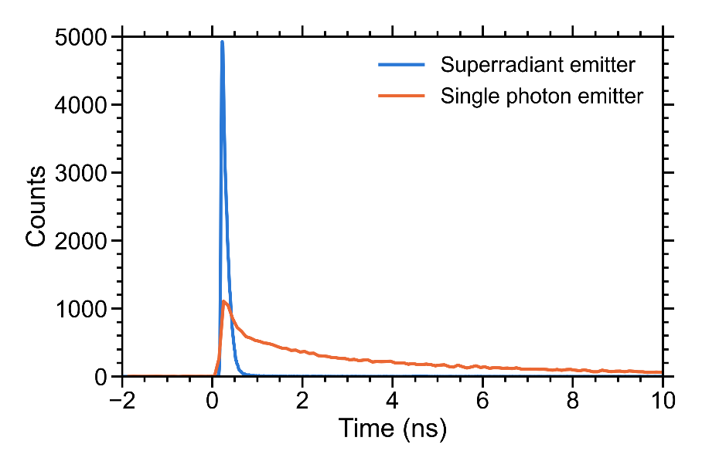

Figure S7. Time-resolved photoluminescence of a superradiant emitter (blue curve) and single photon emitter (red curve), showing an increase in emitter intensity and a significantly reduced lifetime of superradiant emitter as compared to that of single photon emitter.

Figure S8. Reversible control of emitter brightness at both positive and negative bias voltages shown in three different sites across the sample. Forward (a) and reverse (b) measurements of the photoluminescence revealed that the emitter brightness can be controlled to return to its original intensity.

