Supplementary Materials for "Before Issues Become Identity: When Political Sources Can Shape Public Opinion"

Organization. Sections A-B document samples, measurement, and the finite issue set. Section C provides numerical specifications for the article's pooled, country, and explicit-conflict models. Section D adds issue-level maps by respondent-source relationship. Sections E-I document cross-fitted baseline construction, response selection, relationship measurement, alternative U.S. cues, and headroom implementation. Sections J-L address salience measurement, population weighting, multiplicity, and precision. Section M reproduces the Brazilian instrument; Section N integrates the qualifications that remain in the supplement. The article reports the finite-issue, source-specific, stack-weighting, cross-national, and covariate-adjusted analyses in full.

A. Study Samples and Experimental Designs

This section documents recruitment, assignment, and balance for the two experiments underlying the harmonized data. The U.S. study is a secondary analysis of Barber and Pope (2019); the Brazilian study is original. These details support the article's internal-validity claims and define the limits of population generalization.

United States

The U.S. data come from Barber and Pope's (2019) representative YouGov survey of American adults, fielded in the end of January, 2017. The study assigned 1,300 respondents to control (N = 500), liberal Trump (N = 200), conservative Trump (N = 200), or congressional Republican cues (N = 400). Every respondent evaluated 10 policy proposals using support, oppose, and don't know responses.
Barber and Pope (2019, 42-43; online supplement, Sections 4-7 and Table A1) provide the U.S. wording, attributed positions, and original balance tests. The primary harmonized comparison uses control and conservative Trump. Trump approval scores of 4-5 define the ingroup, scores of 1-2 define the outgroup, and score 3 and missing values are excluded from the endpoint-group analysis.
The conservative-Trump arm matches the Brazilian design because the attributed source position remains ideologically consistent across items. The liberal-Trump and congressional-Republican arms change cue direction or source and enter the robustness analysis in Section H. This restriction supports the direct U.S.-Brazil comparison while preserving the broader U.S. evidence as a scope test.

Brazil

Sample and Fieldwork

The Brazilian data come from a self-administered online survey experiment fielded by Netquest between May 21 and June 17, 2025. The analytic sample contains 2,007 adults recruited from the company's nonprobability access panel. Panel members were previously enrolled and participated after receiving an invitation. The resulting sample is an opt-in quota sample. Its principal inferential purpose is to estimate randomized treatment contrasts within the achieved sample.
Recruitment used quotas for gender, age, region, education, and household income measured in minimum-wage categories. Fieldwork remained open through mid-June because the education and income quotas were difficult to complete. The education quota expanded from three broad bands to the full set of panel categories, and income was the hardest margin to reconcile with education and panel coverage. These decisions increased sociodemographic heterogeneity within an opt-in access panel. The analyses are unweighted.
Comparison with 2022 Census benchmarks using harmonized categories shows close gender composition and coverage of all adult age groups (mean age = 43.7 years). The Southeast is overrepresented, the North and Northeast are underrepresented, and education differs most clearly in the middle categories. Survey household-income bands also differ from the Census per capita household-income measure. These discrepancies limit population-level descriptive generalization. Randomized assignment identifies the internal treatment comparisons.

Experimental Assignment and Stimuli

Random assignment occurred at the respondent level. Participants were allocated to control (N = 590), a PT cue (N = 348), a Lula cue (N = 351), a Bolsonaro cue (N = 356), or a two-sided Lula-versus-Bolsonaro cue (N = 362). Assignment was between subjects: each participant remained in the same condition across all 13 policy items. The order of those items was randomized separately for each respondent. Holding the source constant within respondent avoids cross-source carryover and preserves enough observations in each arm for the source-by-identity comparisons developed in the article.
Control respondents received only the policy statement. The three single-source conditions added one sentence attributing a position to the Workers' Party caucus in the Chamber of Deputies, Lula, or Bolsonaro. The PT and Lula cues placed the named source on the liberal or progressive side of each issue; the Bolsonaro cue placed him on the conservative side. The two-sided condition named Lula and Bolsonaro simultaneously and assigned them opposing positions on the same issue. Across conditions, the policy statement and response options were held constant; only the source attribution changed. Respondents could support, oppose, or answer don't know.
Table 1 of the article lists the 13 Brazilian policy domains. Attributed positions follow documented source statements or governing records. The single-source arms provide the primary Brazilian contrasts; the two-sided arm provides the explicit-conflict extension. Figure A1 summarizes both assignment structures.
Fig. A1 Experimental Assignment in the U.S. and Brazilian Studies
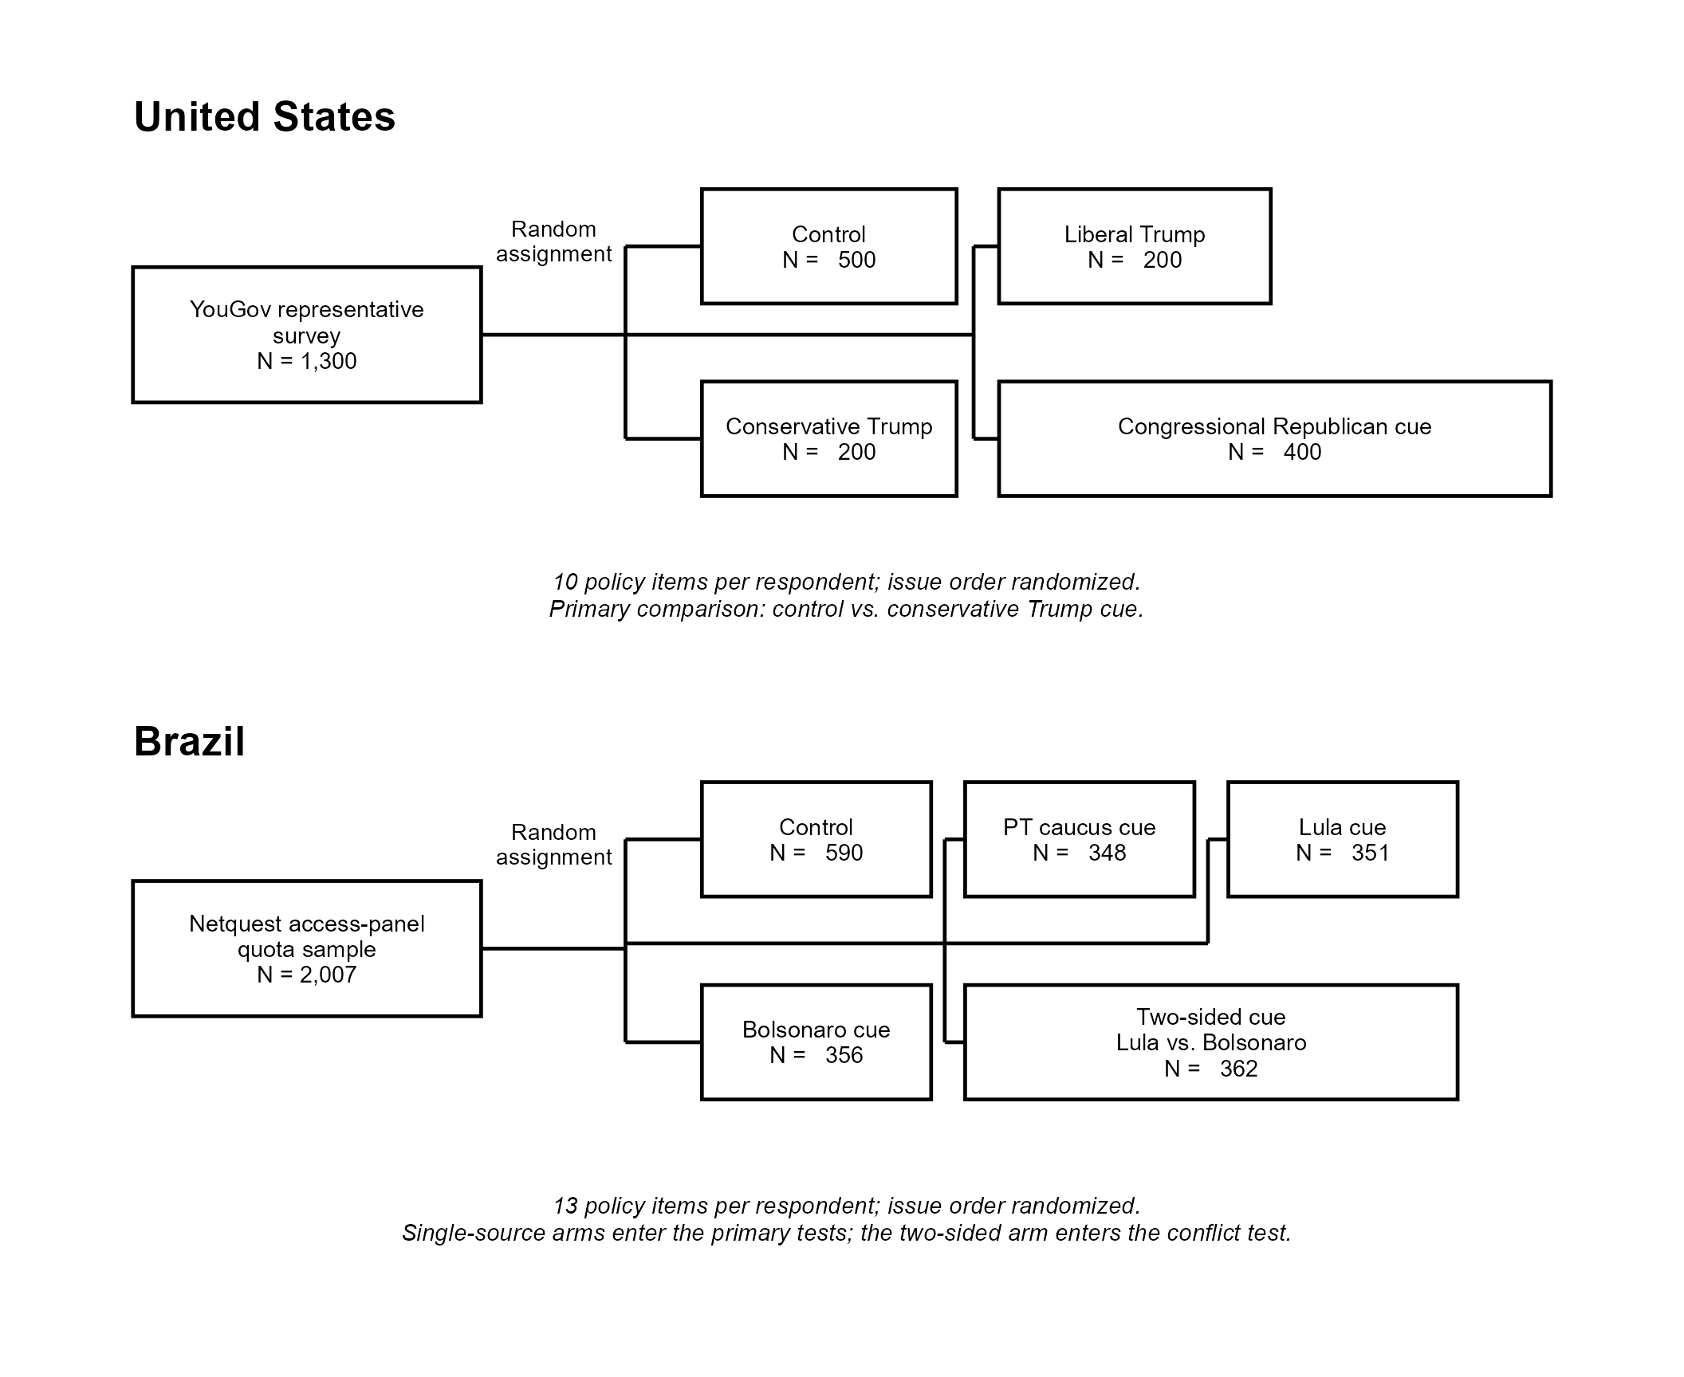
Note. U.S. sample sizes and design features follow Barber and Pope (2019) and their online supplement. Brazilian sample sizes are calculated from the original survey file. Assignment is between subjects in both studies, and issue order is randomized within respondent. The present article's U.S. primary comparison uses control and conservative Trump cues; its Brazilian primary comparisons use control and the three single-source cues, while the two-sided cue enters the complementary explicit-conflict analysis.

Sample Composition

Figure A2 compares the Brazilian quota sample with Census margins and documents the population-composition limits that motivate Section K. Random assignment remains the basis of the treatment contrasts.

Fig. A2 Composition of the Brazilian Sample Relative to the 2022 Census
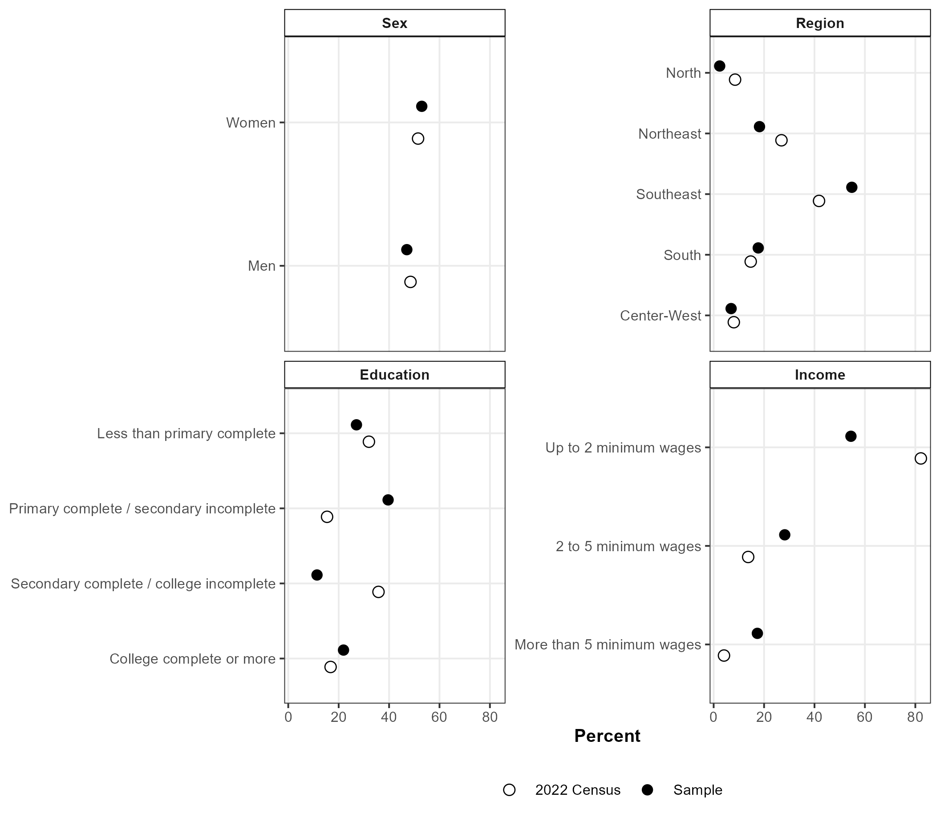
Note. Filled points report the experimental sample; hollow points report 2022 Census benchmarks. Census values come from IBGE/SIDRA Tables 10061 and 10300 and population totals by sex and region. Survey education categories are aggregated to official attainment categories. Income comparisons are approximate because the survey and Census use different income units.

Randomization Check

We assessed balance by comparing each Brazilian treatment arm with the control group on 14 pretreatment quantities: gender, age, five region indicators, education, income, political interest, left-right ideology, and feeling ratings for PT, Lula, and Bolsonaro. Figure A3 reports standardized mean differences (SMDs). Across the 56 treatment-covariate comparisons, 48 have absolute SMDs below 0.10 and 55 are below 0.15. Among the three single-source arms used in the primary Brazilian analysis, the largest absolute SMD is 0.128, for education in the Bolsonaro arm.
The largest imbalance occurs in the separate two-sided condition: the Northeast-region indicator differs from control by an SMD of 0.189. The same arm has a smaller Southeast-region difference (absolute SMD = 0.113). These values are consistent with finite-sample variation and remain relevant to the explicit-conflict estimates. The analysis preserves the randomized sample without balance-based exclusions or weights.

Fig. A3 Pretreatment Covariate Balance in the Brazilian Experiment
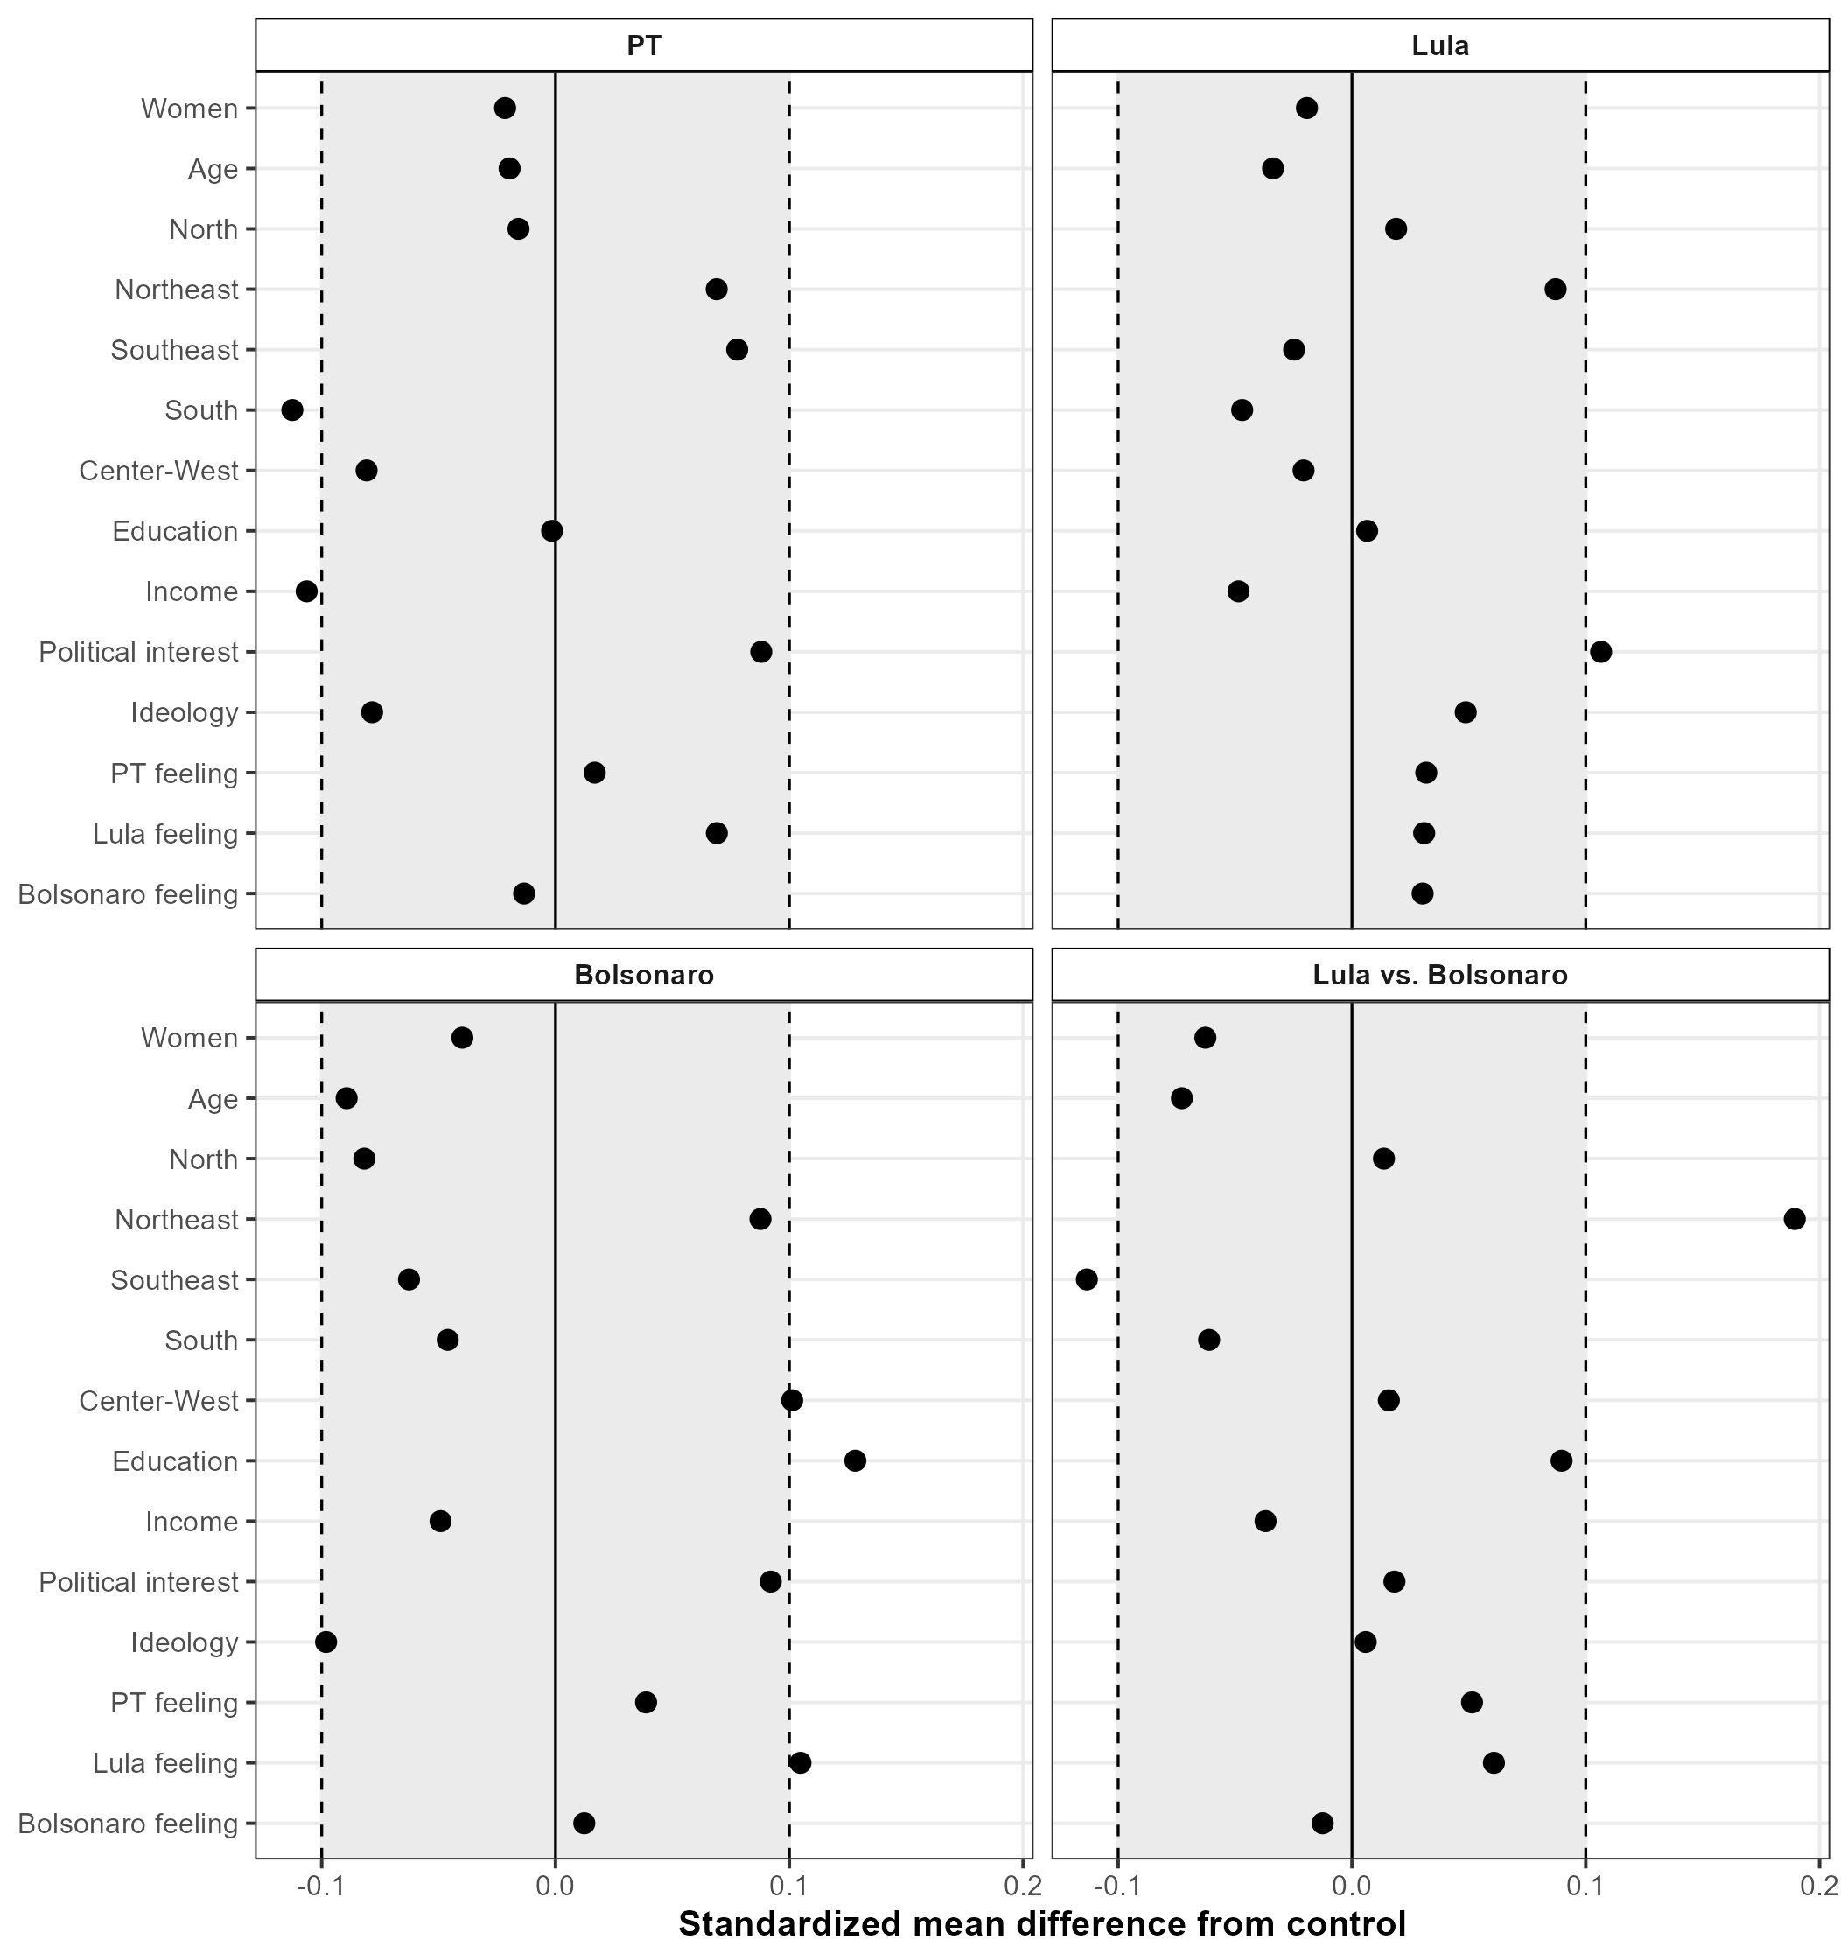
Note. Points are standardized mean differences between each treatment arm and control, calculated from one record per respondent. Region measures are binary indicators. Education, income, political interest, and ideology use the ordinal scales shown on the axis; invalid or non-substantive codes are treated as missing. The shaded band and dashed lines mark absolute SMDs of 0.10 as a conventional descriptive guide.

Taken together, the sample and balance diagnostics support the internal interpretation of the randomized comparisons and limit claims about population representativeness. The primary single-source arms display small pretreatment differences. Figure 9B in the article addresses the larger regional difference in the two-sided arm through covariate adjustment. Brazilian sampling deviations qualify external generalization; randomized assignment supports the within-sample cue-control contrasts.

B. Descriptive Composition of the Outcome and Issue-Level Moderators

This section describes the outcome and the three moderators, then maps issue-specific responsiveness against each one. The maps expose the finite issue set and identify cases that anchor or qualify the model-based results.

Measurement and Descriptive Composition

The outcome is binary relationship-consistent responsiveness among substantive answers. Responses are oriented toward the named source and reversed for outgroups, so a value of 1 records ingroup support or outgroup rejection of the source's position.
Unadjusted outcome means are 0.618 in Brazilian control stacks and 0.663 in Brazilian cue stacks; the corresponding U.S. means are 0.761 and 0.814. These quantities describe the stacked analytic outcome. Figures A4-A6 report issue-specific treatment-control contrasts with source and relationship adjustments and respondent-clustered uncertainty.
The independent variables represent distinct features of the issue environment. Issue salience is relative public search attention from the pairwise Google Trends procedure and is standardized within country; observed scores range from -1.26 to 1.47 in Brazil and from -1.34 to 1.41 in the United States. Uncertainty is the raw control-condition don't-know rate. It averages 21.1% across Brazilian issues (range: 10.5%-36.1%) and 15.3% across U.S. issues (range: 7.6%-22.2%) before within-country standardization in the models. Baseline alignment is the control-condition mean of the same relationship-consistent outcome within country, issue, source, and respondent-source relationship. For the descriptive plots only, those cells are averaged to the issue level: the resulting means average 63.6% in Brazil (range: 52.4%-73.3%) and 73.5% in the United States (range: 59.8%-80.8%).
For each issue, we estimate a treatment-control contrast from the primary single-source analysis with source and relationship fixed effects where applicable. Horizontal bars in Figures A4-A6 show plus or minus one respondent-clustered HC3 standard error. Twenty-two of the 23 issue effects are estimable. A technical survey error prevented recording of the conservative-Trump condition for the U.S. immigration item; the 200 affected records enter as structural missingness.

Issue Salience

Figure A4 shows negative unweighted correlations between salience and responsiveness in Brazil (-0.65), the United States (-0.44), and the 22 estimable issues combined (-0.48). Several high-salience issues have small effects, while some low-salience issues have larger effects. The map supports the direction of H1 within the observed issue set.

Fig. A4 Issue-Specific Responsiveness by Issue Salience
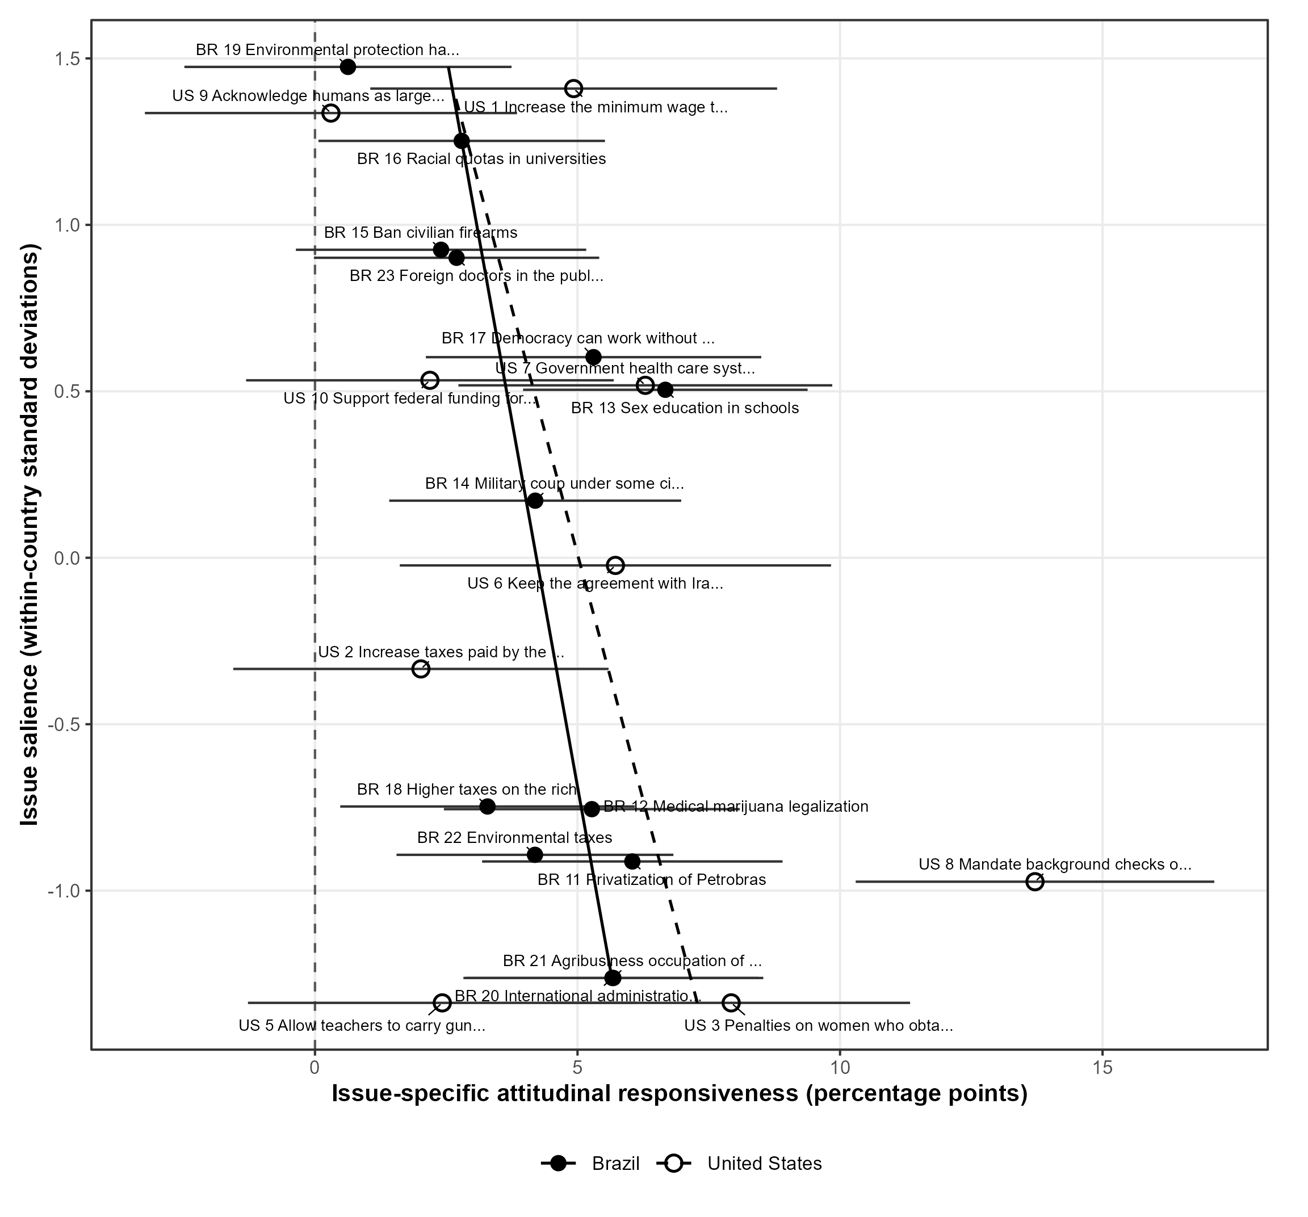
Note. The horizontal axis reports issue-specific treatment effects on theoretically consistent responsiveness in percentage points. Effects compare primary single-source cues with control and adjust for source and relationship where applicable. Horizontal bars are plus or minus one respondent-clustered HC3 standard error. The vertical axis reports pairwise Google Trends salience standardized within country. Filled points and solid fitted lines denote Brazil; hollow points and dashed lines denote the United States. Fitted lines are unweighted descriptive regressions. The U.S. immigration item enters as structural missingness because its conservative-Trump responses were unrecorded.

Responsiveness still varies widely among issues with similar salience. That dispersion limits predictive precision and matches the smaller, imprecise salience interaction in the multivariate model.

Issue Uncertainty

Figure A5 provides weak and negative descriptive evidence for H2. The unweighted correlations are -0.13 in Brazil, -0.34 in the United States, and -0.23 across the estimable issues. Highly uncertain items yield varied cue effects, while U.S. gun background checks combine the lowest control-condition don't-know rate with the largest estimated responsiveness. The pattern reinforces the model-based null. Nonresponse may reflect disengagement, difficulty, or trouble translating an unfamiliar proposal into a substantive position.

Fig. A5 Issue-Specific Responsiveness by Control-Condition Uncertainty
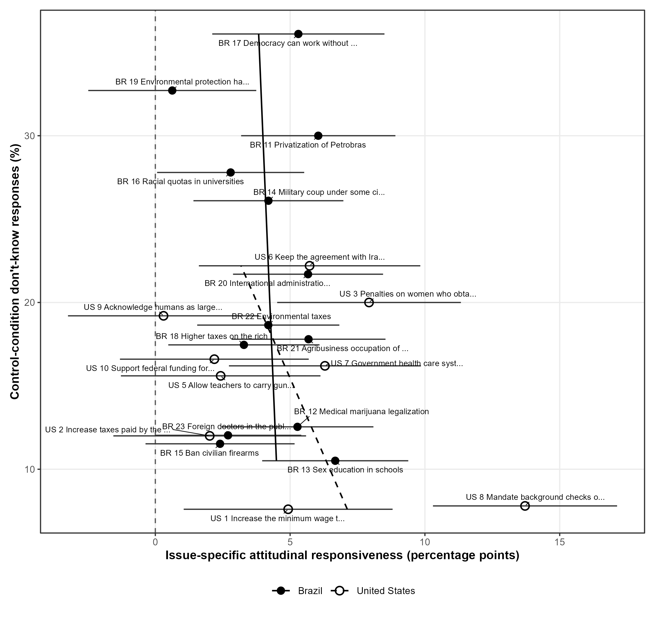
Note. The horizontal axis reports issue-specific treatment effects; bars are plus or minus one respondent-clustered HC3 standard error. The vertical axis is the control-condition don't-know percentage. Filled points and solid fitted lines denote Brazil; hollow points and dashed lines denote the United States. Effects use primary single-source comparisons and the applicable source and relationship adjustments. Fitted lines are descriptive regressions. The U.S. immigration item is structurally missing in the conservative-Trump arm.

Baseline Alignment

Figure A6 provides an important visual complement to H3. Issue-level responsiveness declines as mean baseline alignment increases in both countries. The unweighted correlation is -0.32 in Brazil, -0.86 in the United States, and -0.40 across the estimable issues. In the United States, climate change, Planned Parenthood, and teachers carrying guns combine high baseline alignment with small estimated effects. Gun background checks combine the lowest mean alignment with the largest effect. In Brazil, lower-alignment issues such as Amazon internationalization and agribusiness in forest areas also produce comparatively large estimates, although the country-level pattern is less steep and contains meaningful exceptions.

Fig. A6 Issue-Specific Responsiveness by Mean Baseline Alignment
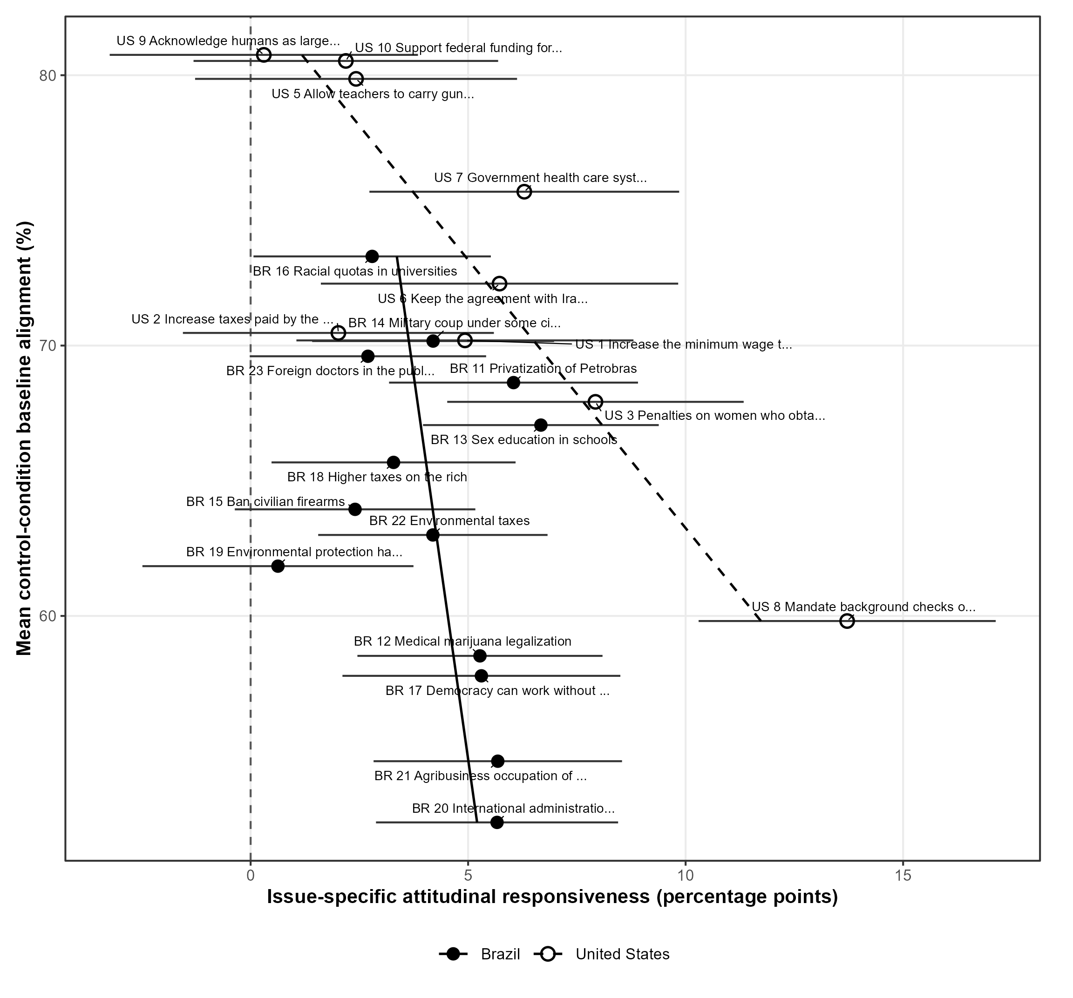
Note. The horizontal axis reports issue-specific treatment effects; bars are plus or minus one respondent-clustered HC3 standard error. The vertical axis reports mean control-condition baseline alignment. This display averages source-relationship cells within country-issue; the hypothesis models retain those cells and standardize baseline alignment within country. Filled points and solid fitted lines denote Brazil; hollow points and dashed lines denote the United States. Fitted lines are descriptive regressions. The U.S. immigration item is structurally missing in the conservative-Trump arm.

Across the finite issue set, salience and baseline alignment have negative descriptive slopes; uncertainty has a weak, negative slope. Salience has the steeper aggregated correlation. Baseline alignment remains stable in respondent-level multivariate models because it retains source-relationship variation. These plots visualize ordering among 22 estimable issues. The multivariate models estimate the moderators' independent contributions.

C. Model Specifications and Numerical Results

This section reports the estimand, analytic stacks, fixed effects, scaling, respondent-clustered inference, and the numerical quantities underlying Figures 3-5 in the article. It supplies reproducible model detail for the principal moderation results.

Estimand, Analytic Stack, and Model Choice

The unit is a respondent-issue-source observation. Each named cue is compared with its control stack, so Brazilian controls recur across PT, Lula, and Bolsonaro rows under a common respondent cluster; the U.S. stack uses control and conservative Trump. The binary outcome records support for an ingroup source or rejection of an outgroup source, with don't know excluded. Linear probability coefficients remain directly interpretable as percentage-point differences.
For moderator h, the simple specification can be summarized as follows, with the fixed effects included whenever they vary in the relevant analytic sample:

$$Y_{ijsg} = α + τT_{ijsg} + β_{h}X_{hjcsg}^{z} + θ_{h}(T_{ijsg} × X_{hjcsg}^{z}) + Γ_{j} + Δ_{s} + ρ_{g} + ε_{ijsg}$$

The coefficient of interest is theta_h, the percentage-point change in the treatment effect associated with a one-standard-deviation increase in moderator X_h. The multivariate model estimates all three moderator interactions jointly:

$$Y_{ijsg} = α + τT_{ijsg} + {∑_{h=1}}^{3}[β_{h}X_{hjcsg}^{z} + θ_{h}(T_{ijsg} × X_{hjcsg}^{z})] + Γ_{j} + Δ_{s} + ρ_{g} + ε_{ijsg}$$

Simple models estimate each moderator separately; the multivariate model tests their independent associations. Issue fixed effects absorb the salience and uncertainty main effects. Baseline alignment retains variation across source-relationship cells. The treatment interaction is the inferential target.
Salience and uncertainty are standardized within country. Baseline alignment is constructed in control country-issue-source-relationship cells and standardized within country. Applicable issue, source, and relationship fixed effects absorb average differences while preserving within-issue treatment contrasts.
Random assignment identifies each cue-control contrast within the observed experimental samples. The moderators are issue-level or source-relationship-level attributes. Their interaction coefficients characterize structured treatment-effect heterogeneity across the finite policy set; causal identification applies to cue assignment within those issues.

Respondent-Clustered HC3 Inference

All uncertainty estimates use respondent-clustered HC3 covariance, the finite-cluster adjustment, and t inference with clusters minus one degrees of freedom. Clustering retains dependence across repeated issues and duplicated Brazilian control stacks. The pooled, Brazilian, and U.S. models contain 26,164 observations/1,834 respondents, 21,058/1,237, and 5,106/597, respectively.

Pooled Models

Table A1 supplies the standard errors and intervals underlying Figure 3. Salience moves from -1.27 points in the simple model (SE = 0.63, p = .044) to -0.85 in the multivariate model (SE = 0.62, p = .168). Uncertainty is -0.44 and -0.10 points and is imprecise. Baseline alignment is stable at -3.30 and -3.19 points (both p < .001). The numerical comparison supports a robust H3 result, a specification-dependent H1 pattern, and no H2 support.

Table A1 Numerical Results Underlying Figure 3: Pooled Moderation Models
Model | H | Moderator | b (pp) | HC3 SE | 95% CI | p | Obs. | Clusters (df)
Simple | H1 | Issue salience | -1.27 | 0.63 | [-2.51, -0.04] | .044 | 26,164 | 1,834 (1,833)
Simple | H2 | Issue uncertainty | -0.44 | 0.75 | [-1.91, 1.02] | .554 | 26,164 | 1,834 (1,833)
Simple | H3 | Baseline alignment | -3.30 | 0.82 | [-4.90, -1.69] | <.001 | 26,164 | 1,834 (1,833)
Multivariate | H1 | Issue salience | -0.85 | 0.62 | [-2.06, 0.36] | .168 | 26,164 | 1,834 (1,833)
Multivariate | H2 | Issue uncertainty | -0.10 | 0.73 | [-1.54, 1.34] | .897 | 26,164 | 1,834 (1,833)
Multivariate | H3 | Baseline alignment | -3.19 | 0.82 | [-4.81, -1.58] | <.001 | 26,164 | 1,834 (1,833)
Note. b is the treatment-by-moderator interaction in percentage points for a one-standard-deviation increase in the moderator. HC3 SE is the respondent-clustered HC3 standard error. Brackets contain 95% confidence intervals. Two-sided p-values use a t distribution with degrees of freedom shown in parentheses after the number of clusters. Simple models estimate one moderator at a time; the multivariate model estimates all three interactions jointly. Models include issue, source, and respondent-source relationship fixed effects where applicable. The stacked observations are respondent-issue-source records, with inference clustered by respondent.

Country-Specific Models

Table A2 shows the same negative H3 direction in both countries. Brazilian baseline-alignment interactions are -2.56 points in the simple model and -2.46 in the multivariate model; U.S. estimates are -7.60 and -7.45. Salience and uncertainty remain imprecise in each country. Figure 9A in the article estimates the larger conservative-Trump magnitude directly.

Table A2 Numerical Results Underlying Figure 4: Country-Specific Moderation Models
Sample / model | H | Moderator | b (pp) | HC3 SE | 95% CI | p | Obs. | Clusters (df)
Brazil / Simple | H1 | Issue salience | -1.12 | 0.72 | [-2.54, 0.30] | .121 | 21,058 | 1,237 (1,236)
Brazil / Simple | H2 | Issue uncertainty | -0.22 | 0.88 | [-1.94, 1.50] | .803 | 21,058 | 1,237 (1,236)
Brazil / Simple | H3 | Baseline alignment | -2.56 | 0.92 | [-4.35, -0.76] | .005 | 21,058 | 1,237 (1,236)
Brazil / Multivariate | H1 | Issue salience | -0.84 | 0.71 | [-2.24, 0.56] | .240 | 21,058 | 1,237 (1,236)
Brazil / Multivariate | H2 | Issue uncertainty | 0.05 | 0.87 | [-1.65, 1.75] | .957 | 21,058 | 1,237 (1,236)
Brazil / Multivariate | H3 | Baseline alignment | -2.46 | 0.92 | [-4.27, -0.65] | .008 | 21,058 | 1,237 (1,236)
United States / Simple | H1 | Issue salience | -1.80 | 1.20 | [-4.15, 0.55] | .132 | 5,106 | 597 (596)
United States / Simple | H2 | Issue uncertainty | -1.47 | 1.16 | [-3.75, 0.81] | .205 | 5,106 | 597 (596)
United States / Simple | H3 | Baseline alignment | -7.60 | 2.07 | [-11.66, -3.53] | <.001 | 5,106 | 597 (596)
United States / Multivariate | H1 | Issue salience | -1.13 | 1.20 | [-3.49, 1.23] | .347 | 5,106 | 597 (596)
United States / Multivariate | H2 | Issue uncertainty | -0.33 | 1.15 | [-2.59, 1.93] | .772 | 5,106 | 597 (596)
United States / Multivariate | H3 | Baseline alignment | -7.45 | 2.12 | [-11.60, -3.29] | <.001 | 5,106 | 597 (596)
Note. Entries are country-specific treatment-by-moderator interactions in percentage points. HC3 standard errors are clustered by respondent; brackets contain 95% confidence intervals; two-sided p-values use cluster-minus-one degrees of freedom, reported in parentheses after the cluster count. Simple models estimate one moderator at a time, and multivariate models estimate all three jointly. Brazilian models include issue, source, and relationship fixed effects; U.S. models include issue and relationship fixed effects and use only the control and conservative Trump conditions. Observations are analytic respondent-issue-source rows.

Brazilian Single-Source and Explicit-Conflict Models

Table A3 compares Brazilian single-source and explicit-conflict models. Under explicit conflict, salience is -1.88 points in the simple model and -1.03 in the multivariate model; uncertainty is 0.29 and 0.72. Baseline alignment is -6.23 and -6.10 points (both p < .001), more than twice the single-source magnitude. The conflict analysis contains 7,090 observations from 660 respondents. Its directional camps use a different respondent subset from the single-source stack, so the comparison supports a stronger contextual pattern without treating the coefficients as identical-sample contrasts.

Table A3 Numerical Results Underlying Figure 5: Brazilian Single-Source and Explicit-Conflict Models
Design / model | H | Moderator | b (pp) | HC3 SE | 95% CI | p | Obs. | Clusters (df)
Single-source / Simple | H1 | Issue salience | -1.12 | 0.72 | [-2.54, 0.30] | .121 | 21,058 | 1,237 (1,236)
Single-source / Simple | H2 | Issue uncertainty | -0.22 | 0.88 | [-1.94, 1.50] | .803 | 21,058 | 1,237 (1,236)
Single-source / Simple | H3 | Baseline alignment | -2.56 | 0.92 | [-4.35, -0.76] | .005 | 21,058 | 1,237 (1,236)
Single-source / Multivariate | H1 | Issue salience | -0.84 | 0.71 | [-2.24, 0.56] | .240 | 21,058 | 1,237 (1,236)
Single-source / Multivariate | H2 | Issue uncertainty | 0.05 | 0.87 | [-1.65, 1.75] | .957 | 21,058 | 1,237 (1,236)
Single-source / Multivariate | H3 | Baseline alignment | -2.46 | 0.92 | [-4.27, -0.65] | .008 | 21,058 | 1,237 (1,236)
Explicit conflict / Simple | H1 | Issue salience | -1.88 | 1.04 | [-3.92, 0.15] | .070 | 7,090 | 660 (659)
Explicit conflict / Simple | H2 | Issue uncertainty | 0.29 | 1.16 | [-2.00, 2.57] | .804 | 7,090 | 660 (659)
Explicit conflict / Simple | H3 | Baseline alignment | -6.23 | 1.22 | [-8.61, -3.84] | <.001 | 7,090 | 660 (659)
Explicit conflict / Multivariate | H1 | Issue salience | -1.03 | 1.02 | [-3.03, 0.98] | .316 | 7,090 | 660 (659)
Explicit conflict / Multivariate | H2 | Issue uncertainty | 0.72 | 1.13 | [-1.49, 2.94] | .521 | 7,090 | 660 (659)
Explicit conflict / Multivariate | H3 | Baseline alignment | -6.10 | 1.22 | [-8.49, -3.71] | <.001 | 7,090 | 660 (659)
Note. Entries are treatment-by-moderator interactions in percentage points. Single-source models use the PT, Lula, and Bolsonaro cue-control stacks. Explicit-conflict models compare the two-sided condition with control among respondents with one unambiguous directional implication from their Lula and Bolsonaro evaluations. HC3 standard errors are clustered by respondent; brackets contain 95% confidence intervals; p-values use cluster-minus-one degrees of freedom. Models include issue fixed effects and applicable source or directional-group adjustments. Observation counts refer to analytic rows.

The numerical tables establish the hierarchy reported in the article: H3 is negative and stable across samples and designs; H1 has a negative pooled simple estimate and an imprecise multivariate estimate; pooled H2 coefficients are centered near zero. Random assignment identifies each cue-control contrast, while the moderators organize heterogeneity across a finite selected issue set.

D. Issue-Level Patterns by Respondent-Source Relationship

This section adds issue-level maps for ingroup and outgroup respondents. The maps identify policies that anchor subgroup tendencies and show how descriptive ordering varies across relationship pathways. Fitted lines summarize the small observed issue set; the hypothesis tests retain respondent-level observations and source-relationship cells.

Issue-Level Descriptive Patterns by Relationship

Figures A7-A9 estimate issue-specific treatment-control contrasts within each country and relationship group. They identify the issues anchoring subgroup tendencies. The fitted lines summarize the small observed issue set. A technical survey error leaves the U.S. immigration item structurally missing in the conservative-Trump arm.

Issue Salience

Figure A7 shows negative issue-level salience correlations in all panels: -0.40 and -0.47 for Brazilian ingroups and outgroups, and -0.17 and -0.73 in the United States. The strongest descriptive pattern appears among Trump outgroups; the U.S. ingroup panel is much flatter. Salience therefore describes an average issue environment whose relationship pathway varies.

Fig. A7 Issue-Specific Responsiveness by Salience and Respondent-Source Relationship
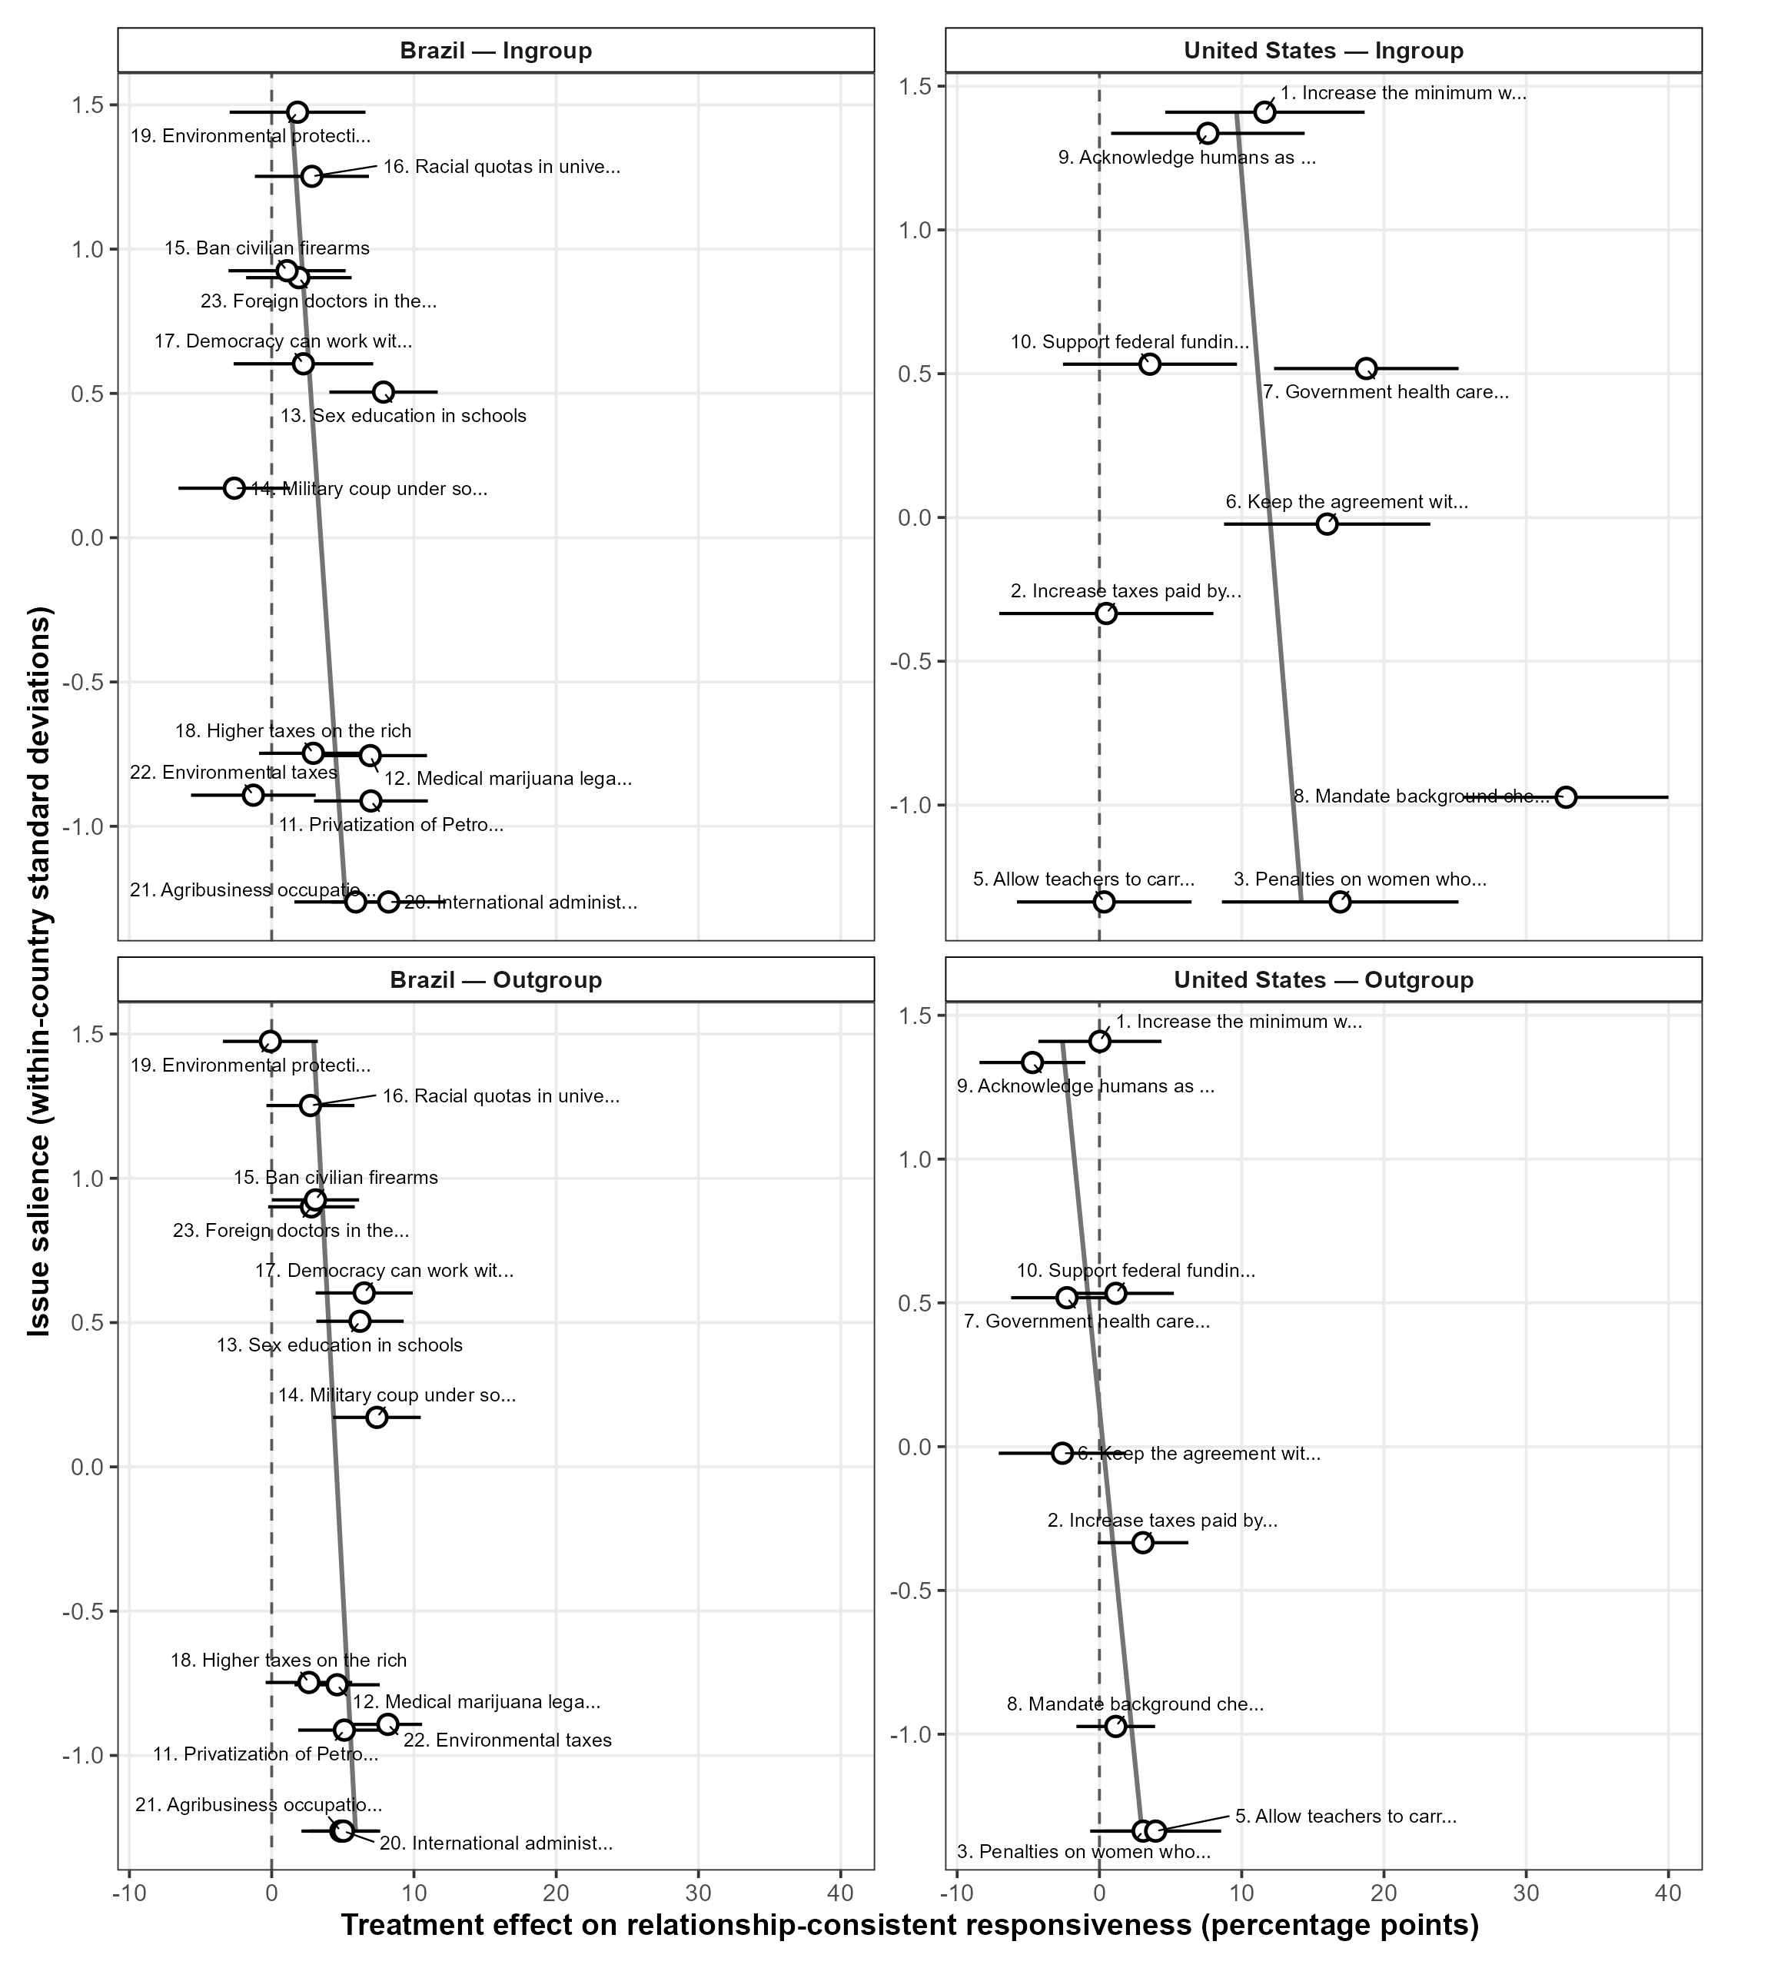
Note. Each point is an issue-specific treatment-control effect on relationship-consistent responsiveness within the indicated country and relationship. Bars are plus or minus one respondent-clustered HC3 standard error. The vertical axis reports pairwise Google Trends salience standardized within country. Brazilian effects adjust for source. Gray lines are unweighted descriptive regressions. The U.S. immigration item is structurally missing in the conservative-Trump arm.

No subgroup displays a positive salience slope, but the slope varies sharply across pathways. The pooled simple-model H1 result is therefore an average tendency across observed issues.

Issue Uncertainty

Figure A8 reinforces the H2 null. The correlations are -0.20 and -0.03 in Brazil and -0.21 and -0.33 in the United States for ingroups and outgroups, respectively. Both relationship pathways show weak or negative associations between nonresponse and cue responsiveness.
Fig. A8 Issue-Specific Responsiveness by Uncertainty and Respondent-Source Relationship
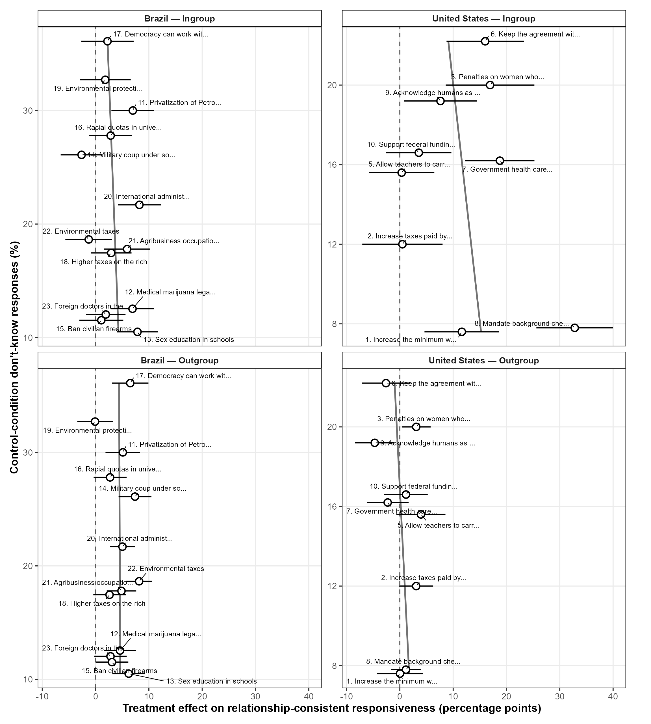
Note. The horizontal axis reports issue-specific effects; bars are plus or minus one respondent-clustered HC3 standard error. The vertical axis is the control-condition don't-know percentage. Effects are estimated within country and relationship; Brazilian estimates adjust for source. Gray lines are descriptive regressions. Don't-know responses define uncertainty and are excluded from the outcome. The U.S. immigration item is structurally missing.

Baseline Alignment

Figure A9 is the closest descriptive counterpart to the model split. Baseline-alignment correlations are -0.28 among Brazilian ingroups, -0.78 among U.S. ingroups, -0.41 among U.S. outgroups, and +0.15 among Brazilian outgroups. The positive Brazilian outgroup issue-level correlation coexists with a negative model coefficient because the model retains source-specific cells and respondent-level observations. Ecological issue rankings can diverge from the source-relationship measure of incorporation used in H3.

Fig. A9 Issue-Specific Responsiveness by Baseline Alignment and Respondent-Source Relationship
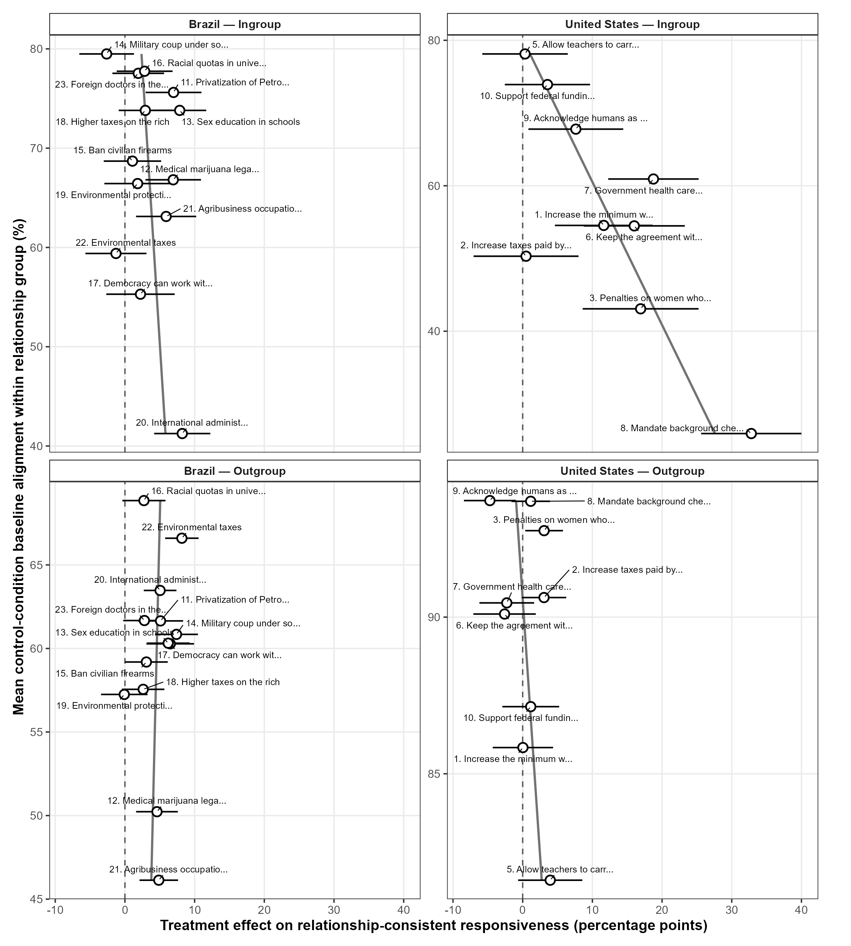
Note. The horizontal axis reports issue-specific effects; bars are plus or minus one respondent-clustered HC3 standard error. The vertical axis reports mean control-condition baseline alignment within country-issue-relationship groups, averaging relevant source cells. Figure A6 averages both relationship groups; the hypothesis models retain source-relationship cells. Brazilian effects adjust for source. Gray lines are descriptive regressions. The U.S. immigration item is structurally missing.

The issue maps qualify H1 as pathway-dependent, place uncertainty slopes near zero overall, and show where ecological issue rankings diverge from the source-relationship cells used for H3. They add policy-level detail to the relationship models reported in the article.

E. Cross-Fitted Baseline Alignment: Procedure and Full-Procedure Bootstrap

Figure 6A in the article evaluates H3 using baseline alignment estimates constructed independently of the observations used to estimate treatment-effect heterogeneity. The purpose of this procedure is to reduce the possibility that the same sample-specific noise influences both the baseline measure and the moderation estimate. This section explains the two-fold cross-fitting procedure and the bootstrap used to carry uncertainty from the construction of baseline alignment through the final moderation model.

Cross-Fitting and Bootstrap Procedure

The basic logic of cross-fitting is to use one part of the sample to construct the baseline-alignment measure and a different part to estimate its association with responsiveness. In simple terms, one part of the sample builds the measure, while the other part is evaluated using that independently constructed measure.
Respondents are randomly assigned to one of two folds within each country and randomized-assignment stratum. Fold assignment occurs at the respondent level, meaning that a respondent remains in the same fold across all policy issues and, in the Brazilian data, across all duplicated source stacks.
For each partition, the procedure follows four steps.
First, control respondents in Fold 1 are used to estimate baseline alignment within every country–issue–source–relationship cell. For example, a cell may represent Brazilian respondents classified as part of Lula’s ingroup when evaluating a particular policy issue. The control-group mean in that cell measures the extent to which respondents were already aligned with the position attributed to the source before receiving any source cue.
Second, these baseline estimates are assigned to the corresponding observations in Fold 2. Responsiveness is then modeled in Fold 2 using baseline values estimated entirely from Fold 1. Respondents in Fold 2 therefore do not contribute to the construction of the baseline measure used to analyze their outcomes.
Third, the roles of the folds are reversed. Control respondents in Fold 2 estimate baseline alignment, and the resulting values are used to estimate responsiveness in Fold 1.
Fourth, the two held-out samples are recombined. At that point, every respondent contributes to the outcome analysis, but each respondent’s baseline-alignment value was estimated using respondents from the other fold.
Baseline-alignment estimates are standardized within country after the first-stage cell means are calculated. The same simple and multivariate moderation models used in the main article are then estimated on the recombined cross-fitted sample.
Because the result of a two-fold procedure can depend partly on the particular random division of respondents, the complete cross-fitting procedure is repeated across 100 independent fold assignments. The reported point estimate is the average of the coefficients obtained from these 100 partitions. Averaging across repeated partitions reduces sensitivity to any single random split of the sample.
Cross-fitting makes the first-stage baseline estimate independent of the outcome observations to which it is applied, but baseline alignment remains an estimated quantity. Its sampling uncertainty must therefore be incorporated into the uncertainty of the final moderation coefficient.
The 95% confidence interval is obtained from 399 nonparametric bootstrap replications. In each replication, respondent clusters are resampled within country and randomized-assignment strata. The entire estimation procedure is then repeated from the beginning:

- respondents are assigned to folds;
- control-group baseline alignment is estimated within each country–issue–source–relationship cell;
- the baseline estimates are standardized within country;
- held-out outcome samples are constructed;
- the fold-specific samples are recombined; and
- the simple and multivariate moderation models are re-estimated.

The bootstrap therefore captures uncertainty from both stages of the analysis. It reflects variation in the control-group cell means used to construct baseline alignment as well as variation in the estimated interaction between treatment assignment and baseline alignment.
All respondents contribute to the analysis, but they do so through separate first-stage and outcome roles. Within each fold assignment, no respondent is used both to construct the baseline-alignment value and to estimate responsiveness using that same value.
This procedure provides the independently estimated first stage underlying Figure 6A. It also offers a stricter test of H3 by showing whether the baseline-alignment interaction persists when the moderator is constructed out of sample and uncertainty from every stage of the procedure is propagated into the final confidence interval.

F. Nonresponse, Response Selection, Three-Category Outcomes, and Intent-to-Treat Sensitivity

The harmonized outcome excludes don't-know responses in both countries. That complete-case estimand is appropriate for movement between the two substantive positions, but it can be distorted if the cue changes whether respondents provide a substantive answer. This section separates treatment effects on nonresponse from movement between positions and then defines an intent-to-treat (ITT) sensitivity that retains every observed respondent-issue response.
Figure A10 shows limited and heterogeneous response-selection effects after removing the structurally missing U.S. immigration item. In Brazil, the PT and Lula cues reduce don't-know selections among ingroups by 3.9 and 3.4 points, while Bolsonaro increases them by 2.3; outgroup estimates are smaller and mixed. In the United States, conservative Trump changes don't know by +0.4 points among ingroups and -1.0 among outgroups, with both intervals spanning zero. Correct treatment of the survey error yields small, mixed U.S. response-selection effects.

Fig. A10 Treatment Effects on Don't-Know and Valid Responses
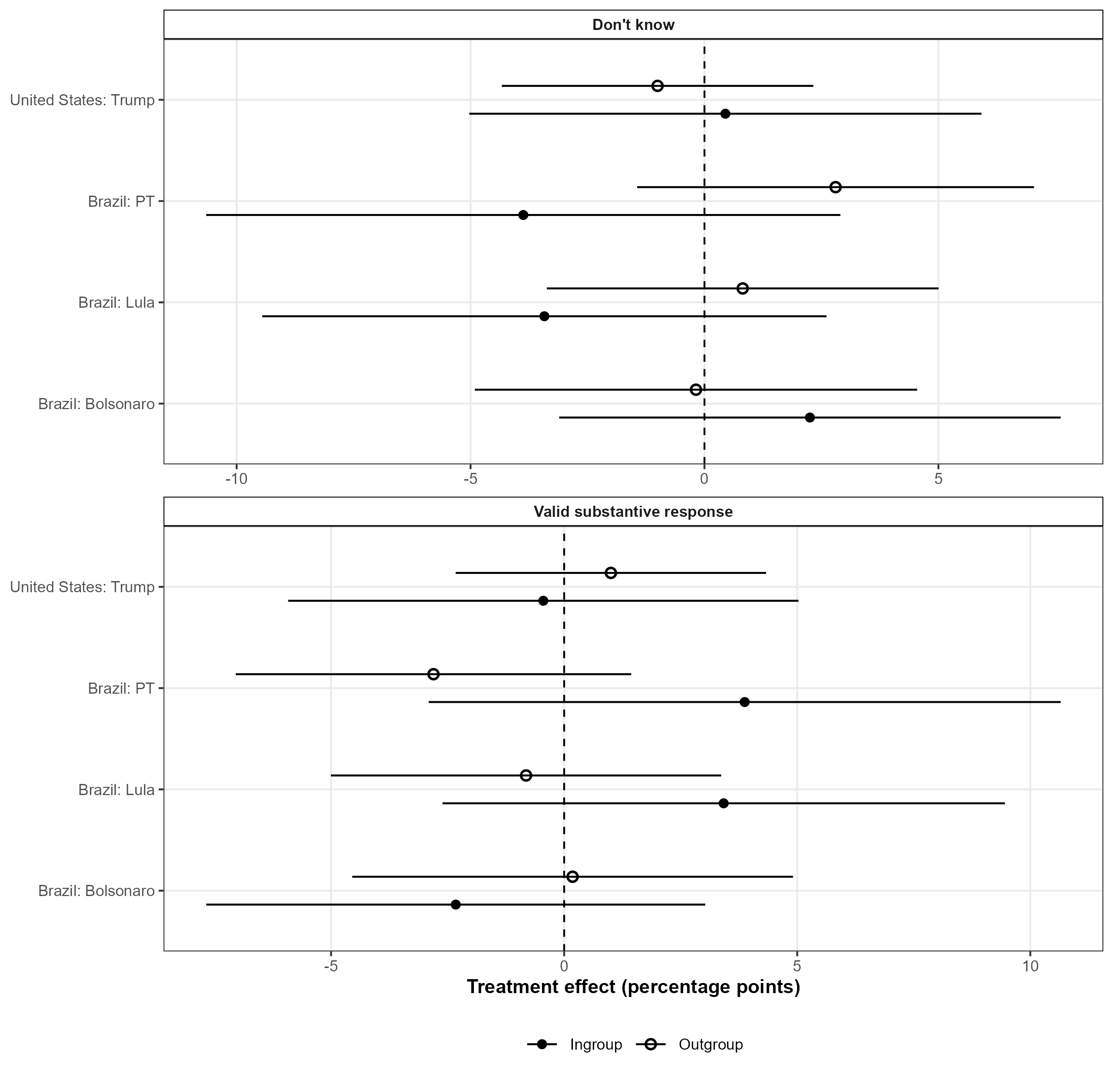
Note. Each point is the cue-control effect on selecting don't know or, equivalently, providing a valid substantive response, within country, source, and respondent-source relationship. Filled points denote ingroups and hollow points outgroups. Horizontal bars are respondent-clustered HC3 95% confidence intervals. Brazilian comparisons use PT, Lula, and Bolsonaro single-source cues; the U.S. comparison uses the conservative Trump cue. Models pool issues with applicable issue fixed effects. The two outcomes are complements. A technical survey error leaves 200 U.S. conservative-Trump immigration observations as structural missingness.

Figure A11 decomposes observed-item ITT responses into relationship-consistent, relationship-inconsistent, and don't know. In Brazil, most cue effects transfer responses between the substantive categories, with source- and relationship-specific exceptions. In the United States, conservative Trump primarily reallocates responses between substantive positions; corrected don't-know coefficients are small in both groups. The display locates the form of cue responsiveness.

Fig. A11 Three-Category Intent-to-Treat Effects
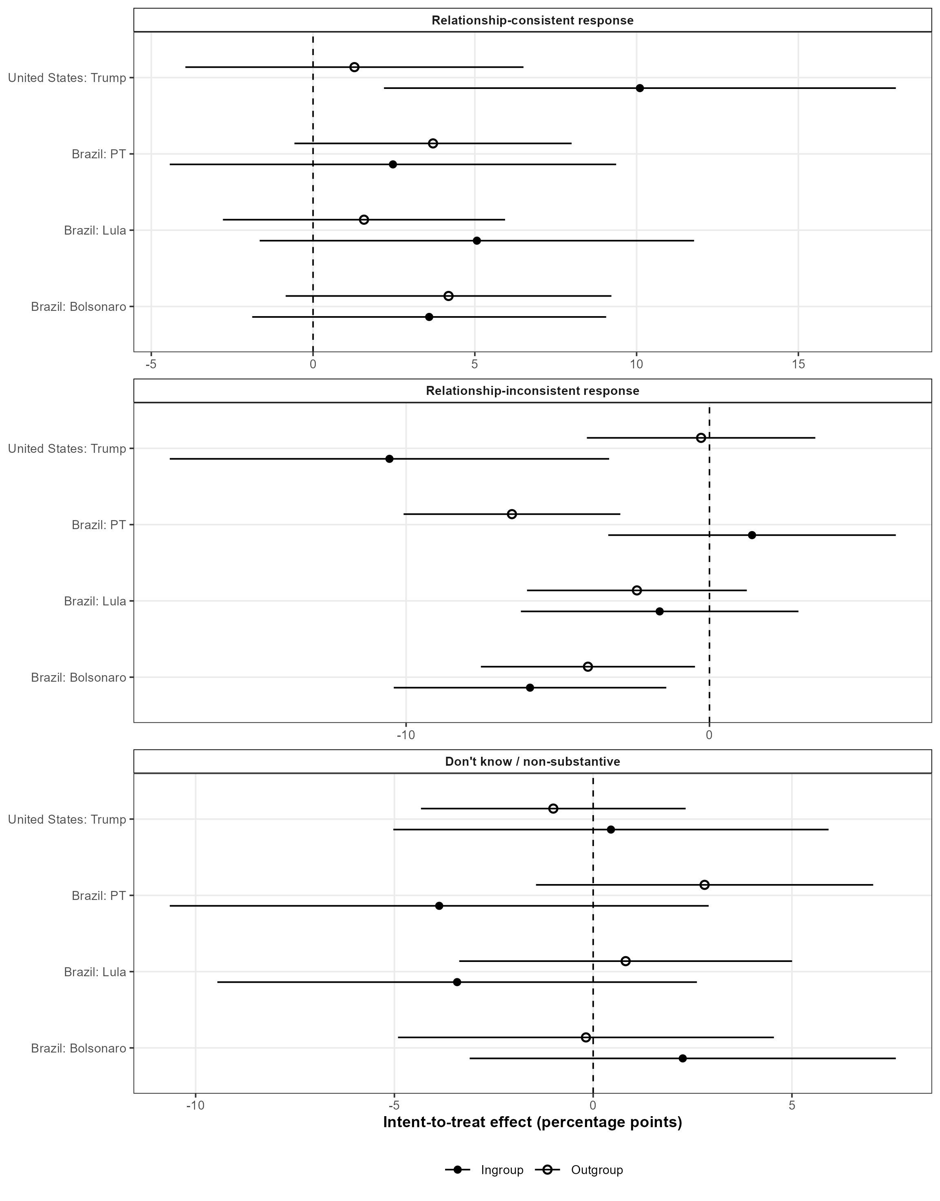
Note. Points are cue-control effects on three exhaustive outcomes among fielded observations: a relationship-consistent substantive response, the opposite substantive response, or don't know. Effects are estimated separately by source and relationship with issue fixed effects; lines are respondent-clustered HC3 95% confidence intervals. The conservative-Trump immigration records enter as structural missingness because the item was unrecorded.

Figure A12 codes observed don't know as zero relationship-consistent responsiveness and recomputes baseline alignment from control responses. H3 remains negative pooled (-2.19 points, p = .007) and in the United States (-5.25, p = .009); the Brazilian estimate is -1.54 (p = .096). H1 becomes -1.26 pooled (p = .029) and -1.46 in Brazil (p = .026). The Brazilian evidence is clearest for movement between substantive positions, while pooled and U.S. H3 extends to response selection.

Fig. A12 Substantive-Response and Intent-to-Treat Moderation Estimates
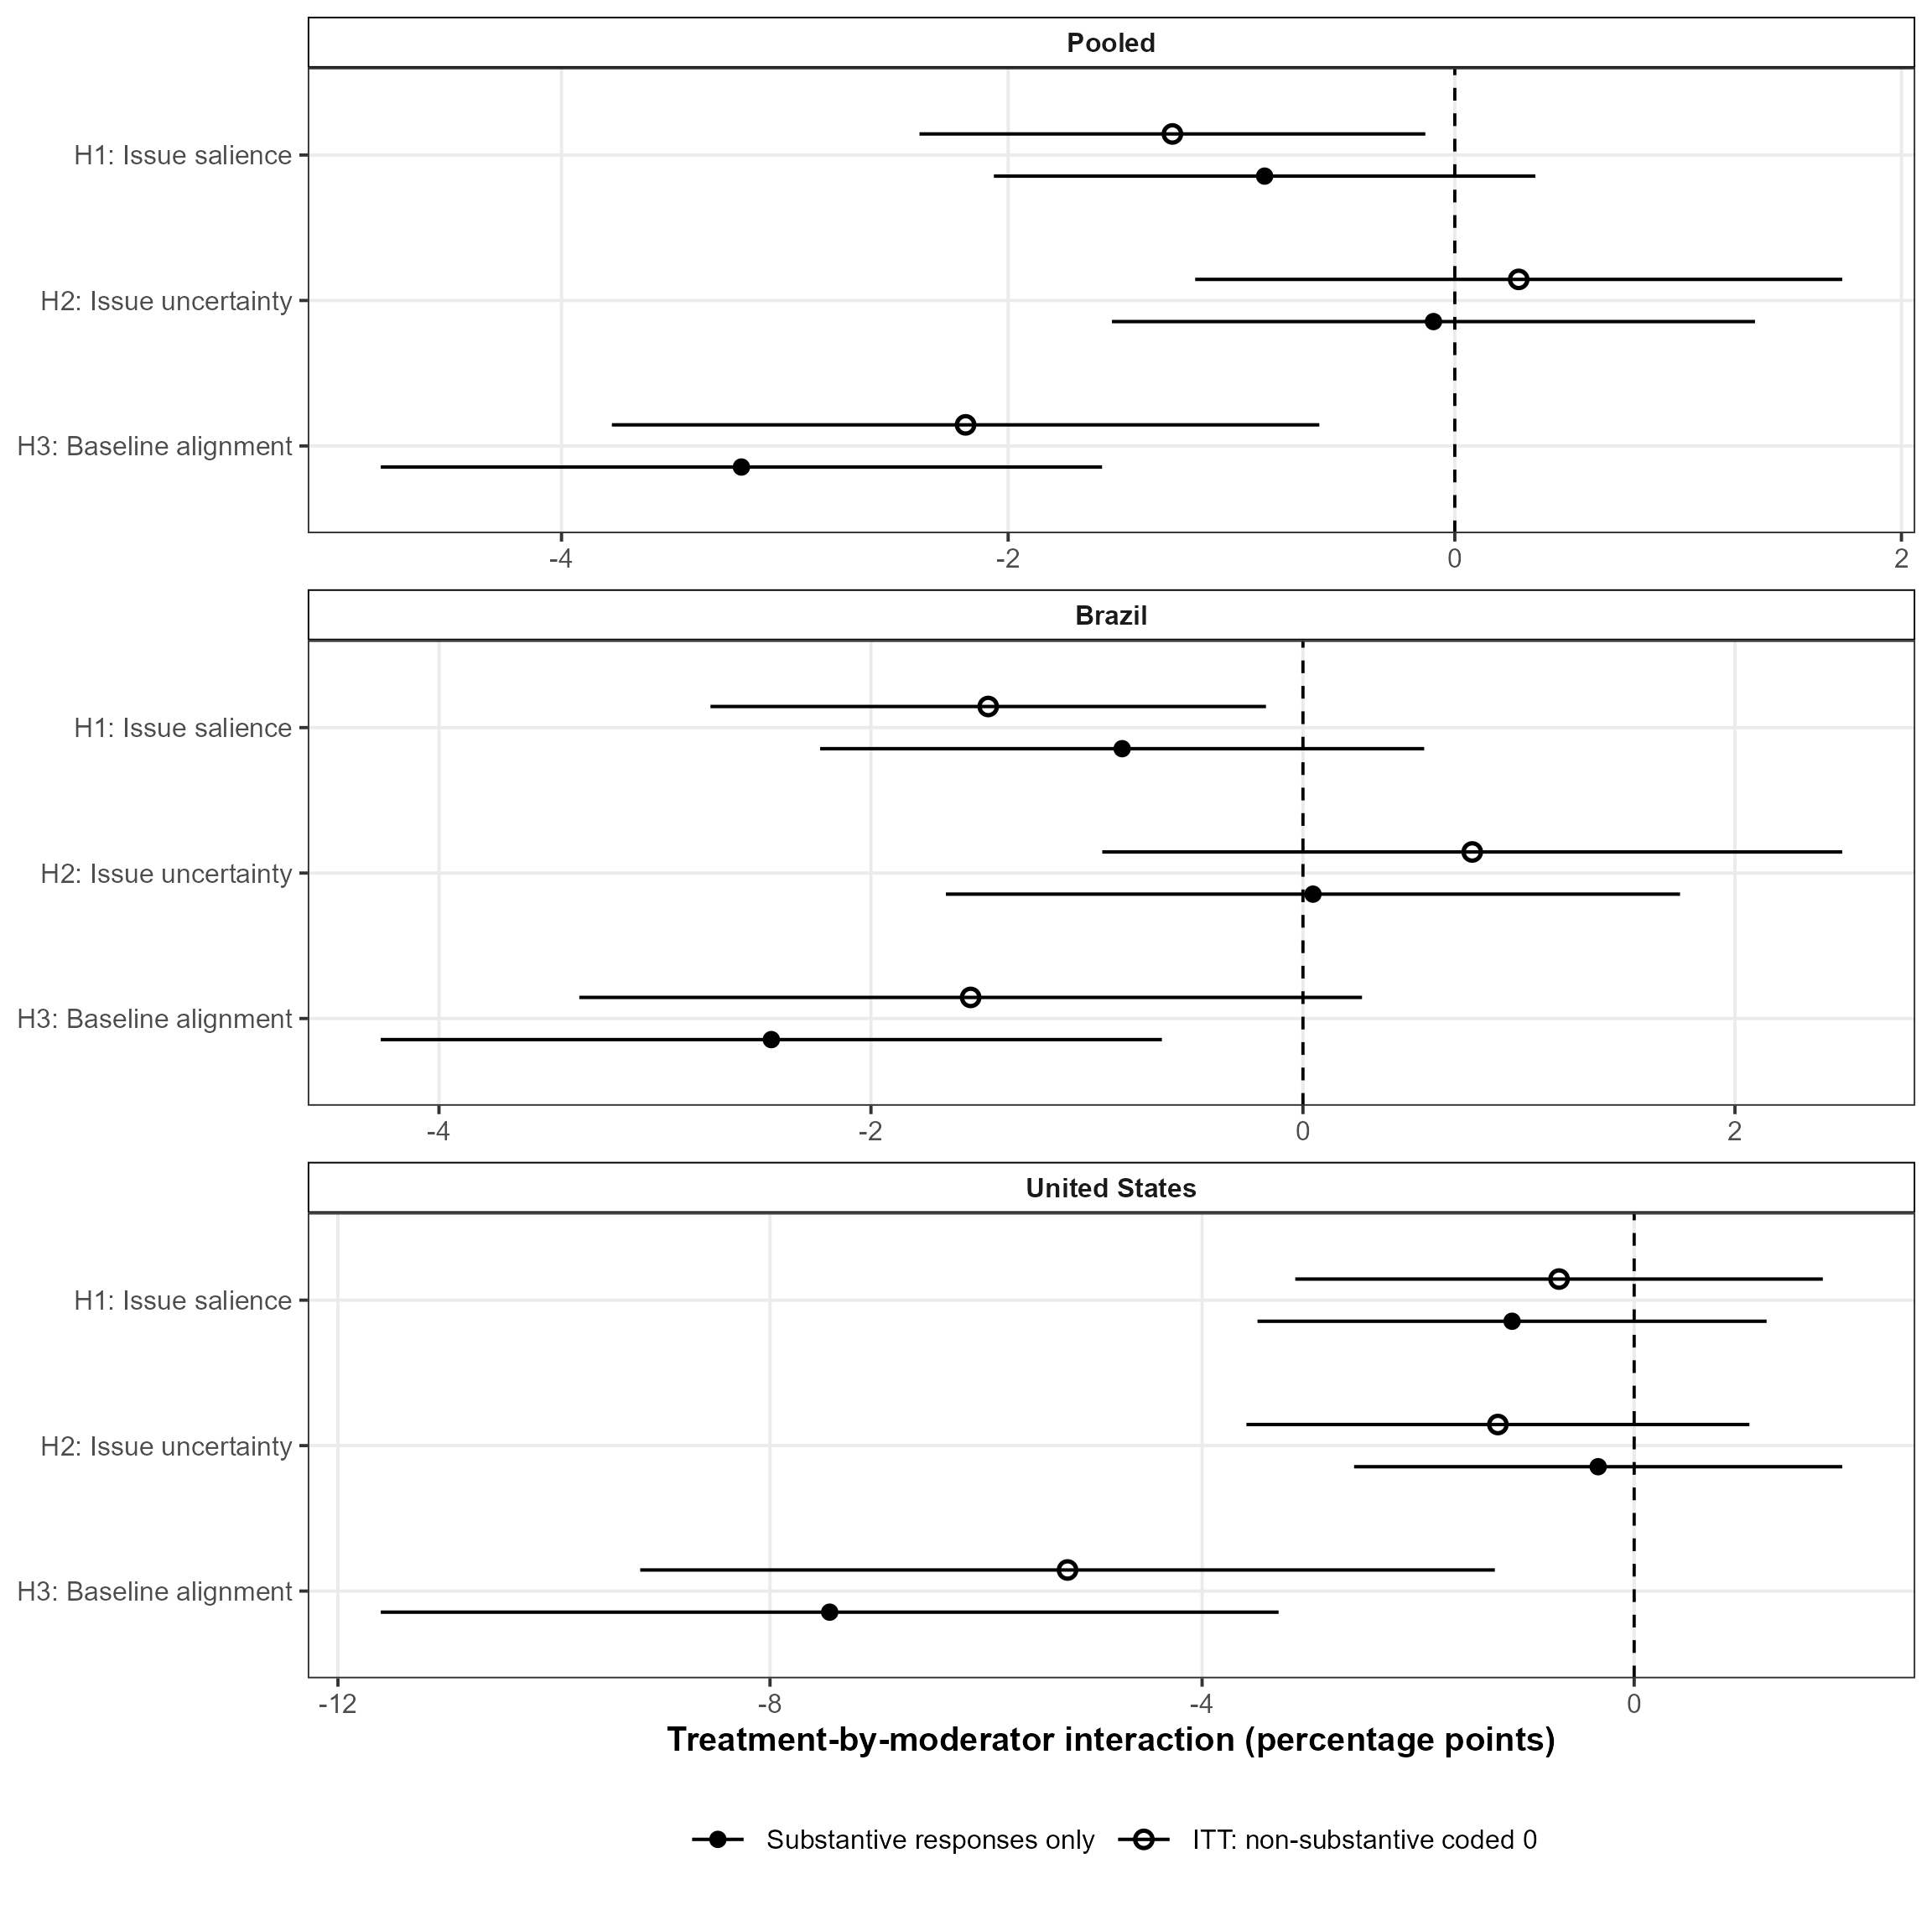
Note. Filled points reproduce the multivariate models among substantive responses. Hollow points report an observed-item ITT sensitivity that codes don't know as zero relationship-consistent responsiveness and recomputes control-condition baseline alignment using observed item responses. Horizontal bars are respondent-clustered HC3 95% confidence intervals. Both estimands retain the same randomized arms, relationship definitions, moderator standardization, interaction structure, and fixed effects. The unrecorded conservative-Trump immigration item is structural missingness and is excluded from both versions; coding it as don't know would incorrectly convert a survey-programming error into treatment-induced nonresponse.

Observed Nonresponse by Issue and Experimental Arm

Figure A13 reports observed don't-know rates in all 105 country-issue-arm cells. Brazilian rates vary more by issue than condition and retain a similar issue ranking across arms. U.S. rates are generally lower, with the Iran agreement producing the most nonresponse. The conservative-Trump immigration cell is labeled Survey error and excluded from don't-know calculations because no responses were recorded for its 200 assigned respondents.
Fig. A13 Observed Don't-Know Rates by Issue and Experimental Arm
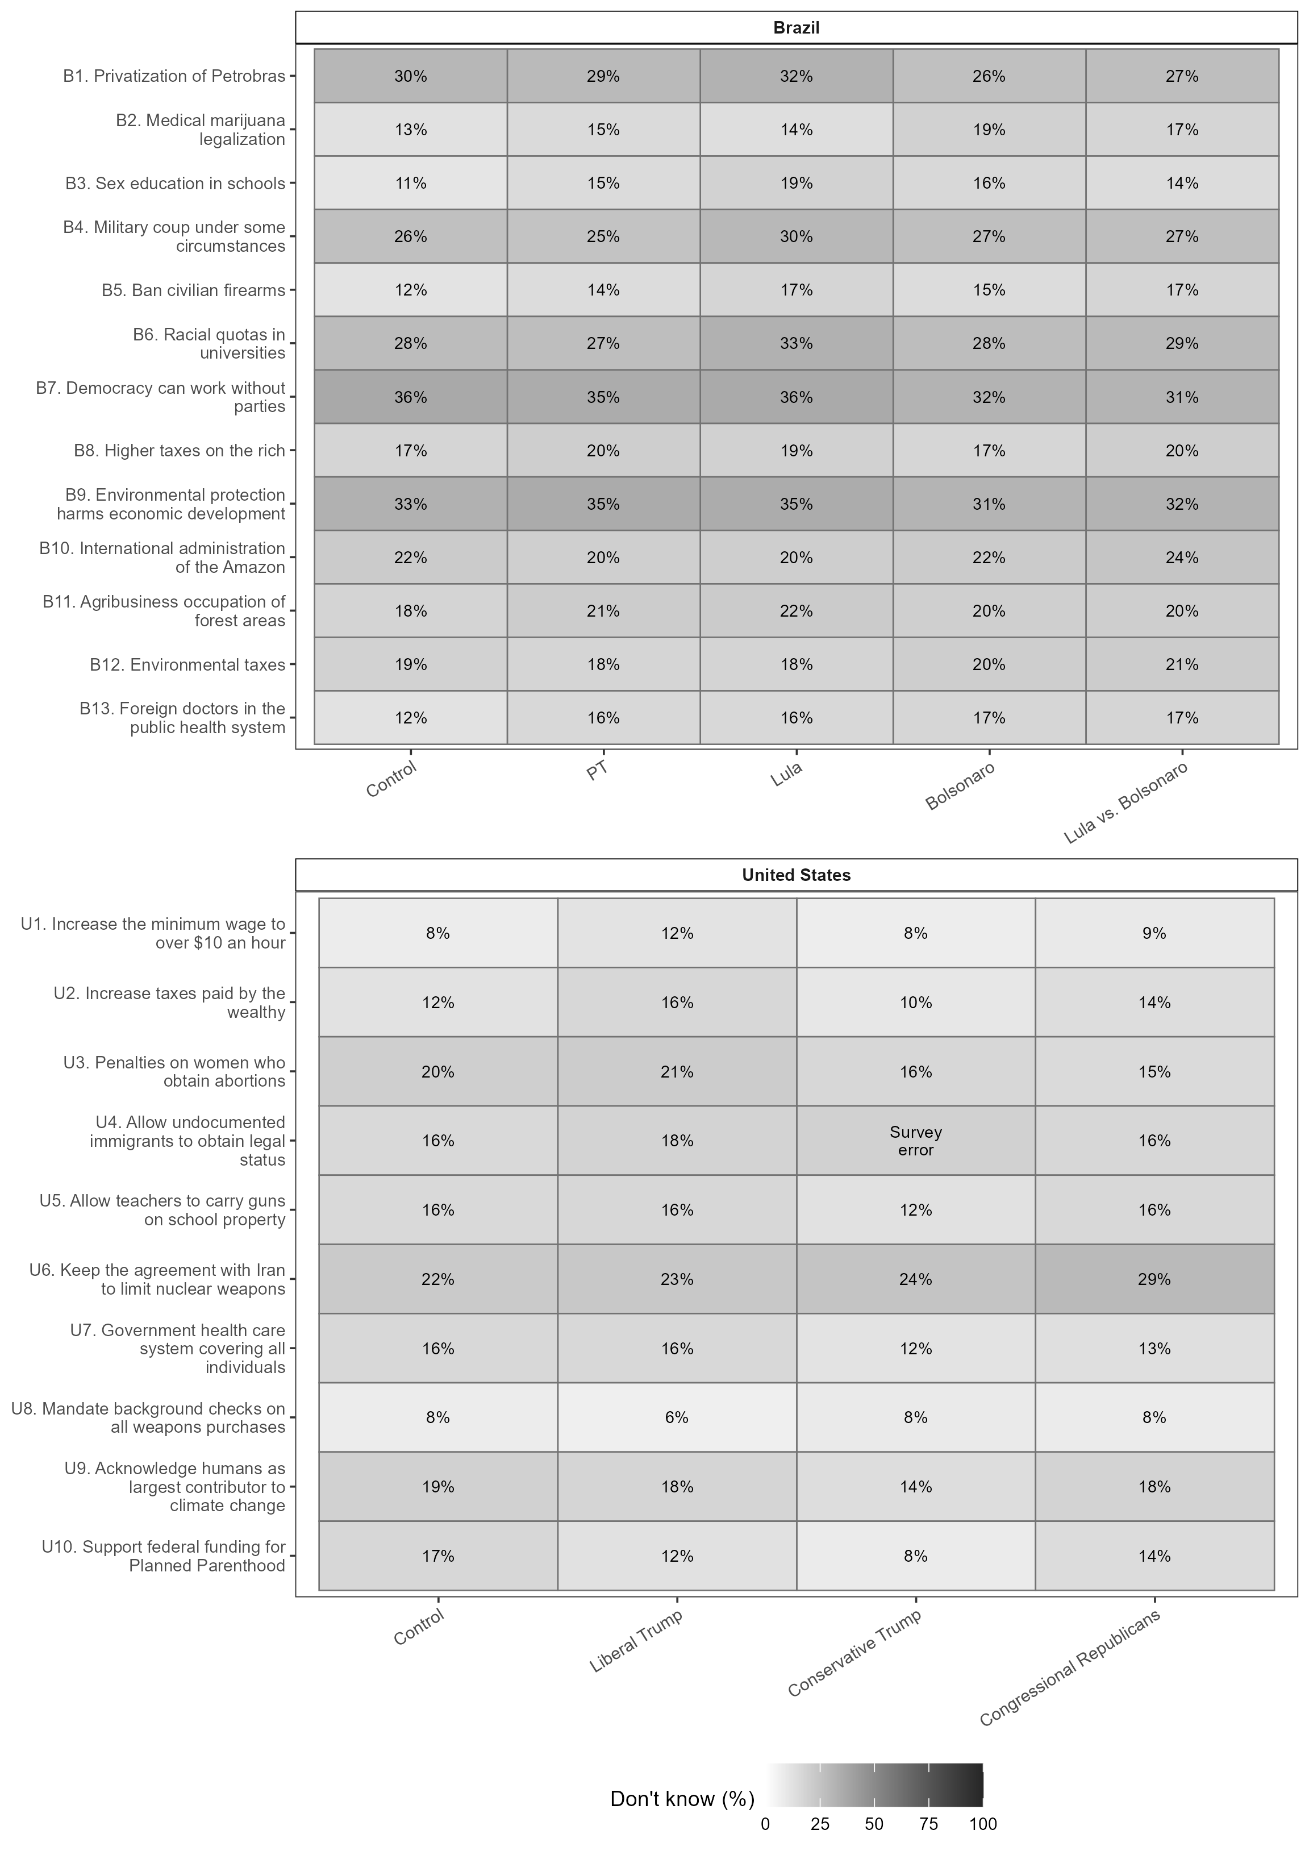
Note. Each cell reports the percentage selecting don't know among recorded responses for that country, issue, and arm. Rows identify 13 Brazilian and 10 U.S. items; columns identify control and every cue condition. Darker shading denotes higher nonresponse. The conservative-Trump immigration cell is labeled Survey error and excluded from the denominator. Any substantive response is the complement of the displayed rate.

Figures A14-A15 estimate item-specific cue-control changes in don't know and substantive response. Most intervals include zero and signs vary within arms. Response selection occurs in isolated issue-arm cells, but no common cross-item pattern explains H3.

Fig. A14 Brazilian Cue Effects on Item Response Selection
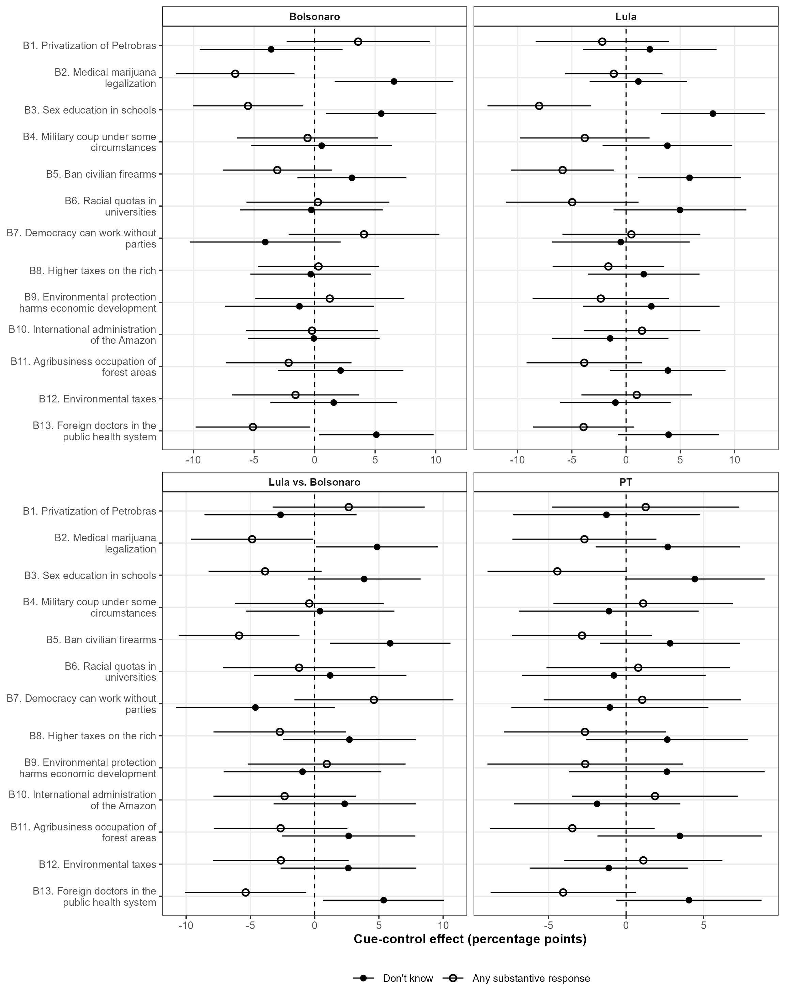
Note. Filled points are cue-control effects on selecting don't know; hollow points are the corresponding effects on providing any substantive response. Each panel is one Brazilian randomized cue condition, including the two-sided Lula-versus-Bolsonaro treatment. Horizontal bars are respondent-clustered HC3 95% confidence intervals from item-specific linear probability models. The complementary outcomes yield paired coefficients with equal magnitude and opposite sign. The unadjusted intervals serve as response-selection diagnostics.

Fig. A15 U.S. Cue Effects on Item Response Selection
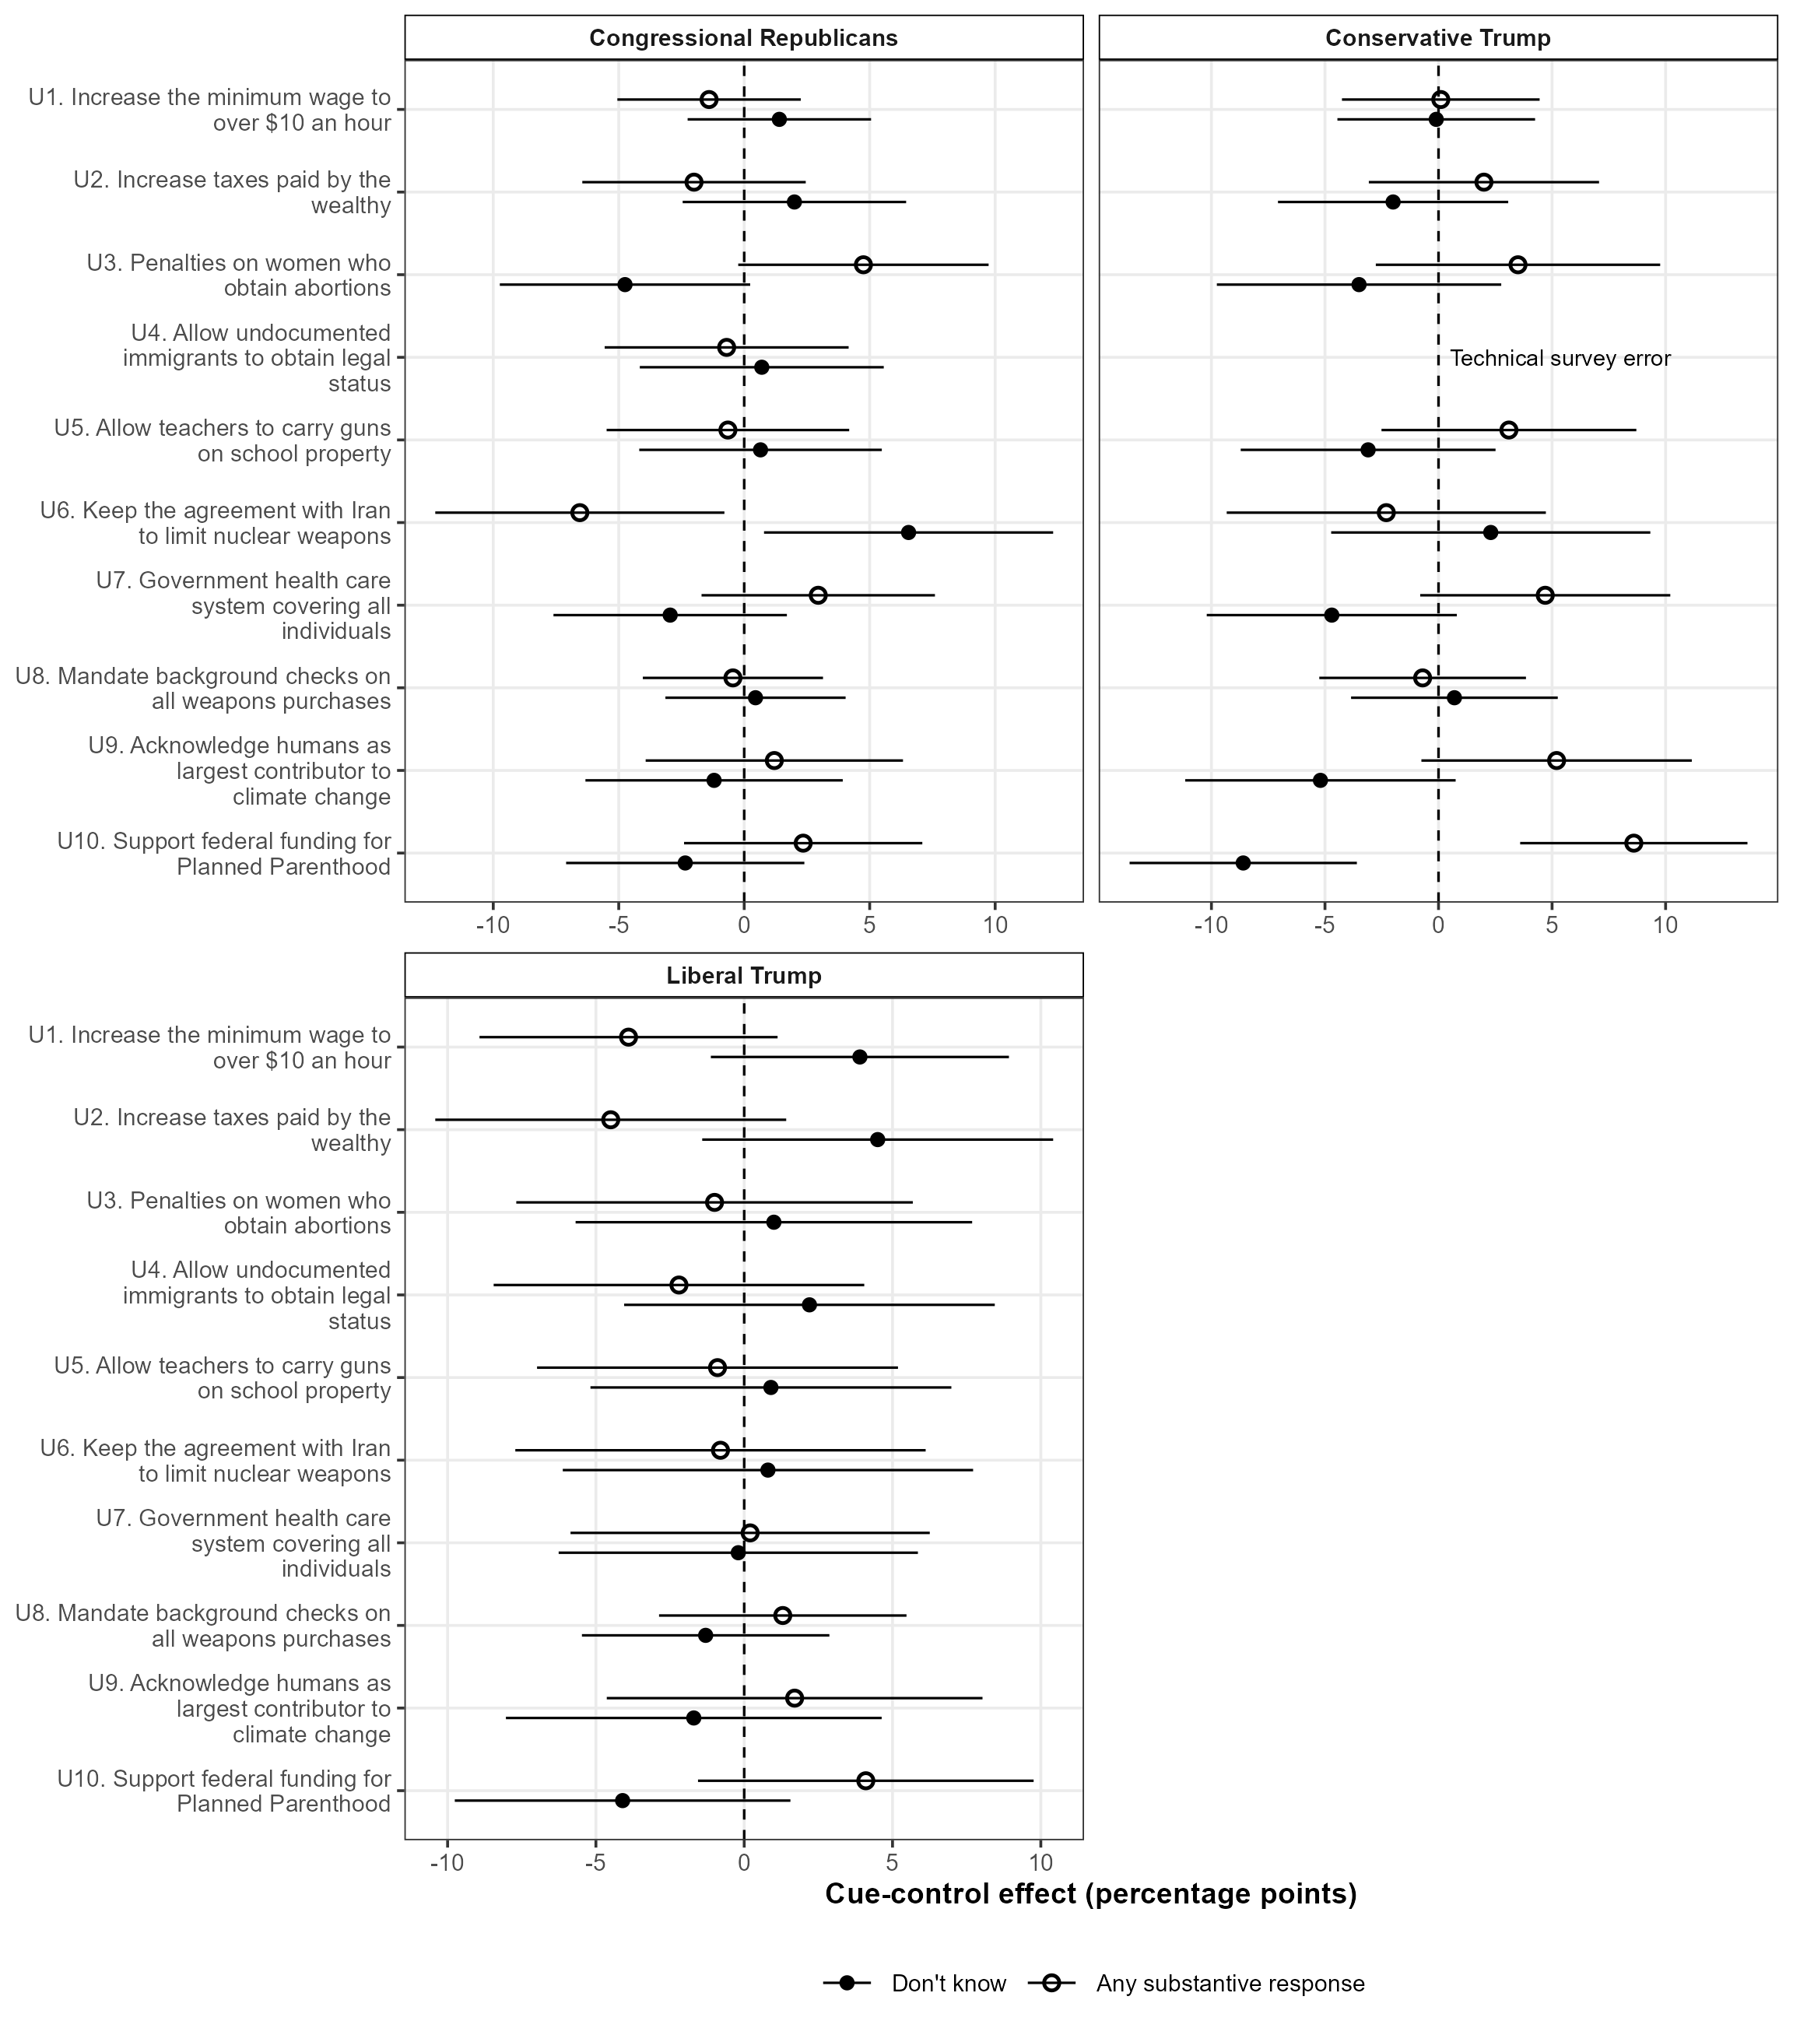
Note. Filled points are cue-control effects on selecting don't know; hollow points are effects on providing a substantive response. Panels show the congressional-Republican, conservative-Trump, and liberal-Trump conditions for applicable issues. Lines are respondent-clustered HC3 95% confidence intervals. The conservative-Trump immigration contrast is marked as a survey error and omitted. Alternative-arm estimates diagnose broader cue forms.

Issue-Level Three-Category Intent-to-Treat Effects

Figure A16 repeats the three-category decomposition by issue. Relationship-consistent and relationship-inconsistent responses account for most movement, while corrected nonresponse shifts remain small and mixed. The primary estimates therefore describe movement between substantive positions.

Fig. A16 Issue-Specific Three-Category Intent-to-Treat Effects
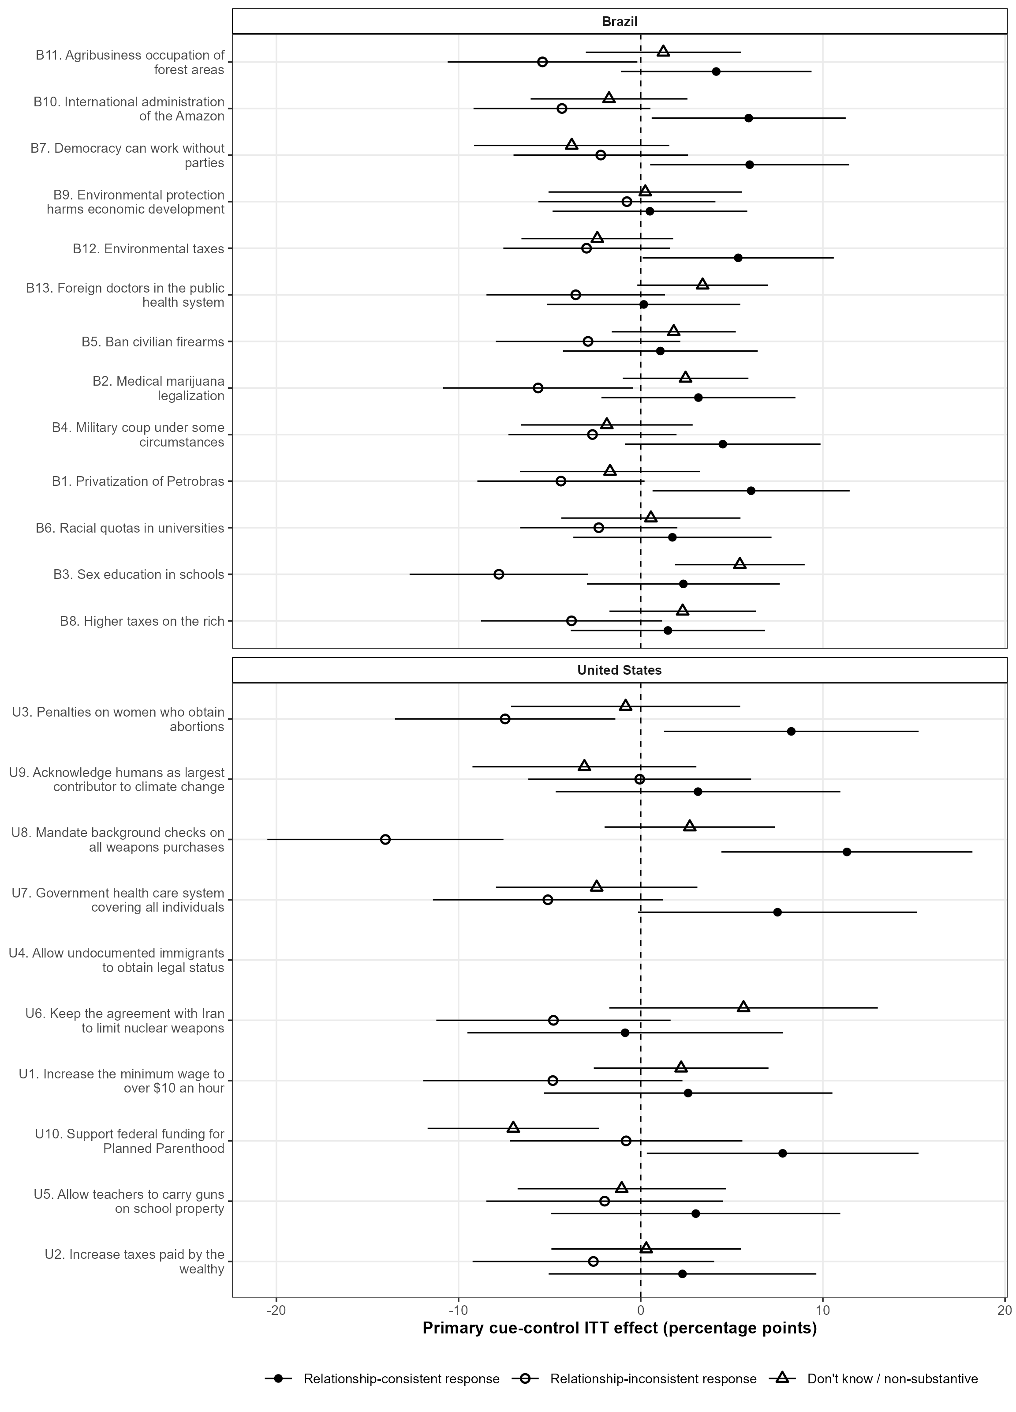
Note. Points are issue-specific primary cue-control effects on three mutually exclusive observed responses: relationship-consistent, relationship-inconsistent, and don't know. Brazilian models pool the PT, Lula, and Bolsonaro source stacks with source and relationship adjustments; the U.S. models use the conservative-Trump cue with relationship adjustment. Horizontal bars are respondent-clustered HC3 95% confidence intervals. The three estimates sum to zero within each estimable issue up to rounding. The empty U.S. immigration row records the technical survey error; no conservative-Trump ITT contrast is estimable for that item.

The response-selection analyses add source-, relationship-, and issue-level evidence to the ITT coefficients. They locate most movement between substantive positions, show limited corrected U.S. nonresponse shifts, and establish greater Brazilian sensitivity to outcome coding. The stronger ITT H1 coefficients also connect salience to opinion expression.

G. Respondent-Source Group Definitions and Continuous Affinity

The primary relationship groups deliberately exclude middle source evaluations: Brazilian scores of 7-10 define ingroups and 0-3 outgroups, while U.S. Trump approval of 4-5 and 1-2 defines the two groups. This creates substantively clear source relationships but raises concerns about arbitrary cutoffs and discarded middle-category respondents. Figures A17-A19 address both points.
Figure A17 shows stable H3 estimates under stricter endpoint groups, the primary cutoffs, and a broader Brazilian definition. The pooled estimates range from -2.31 to -3.19 points, the Brazilian estimates from -2.30 to -2.46, and the U.S. endpoint estimates from -7.45 to -8.06; every estimable interval excludes zero. The central result holds across the tested thresholds.

Fig. A17 Baseline-Alignment Sensitivity to Group Cutoffs
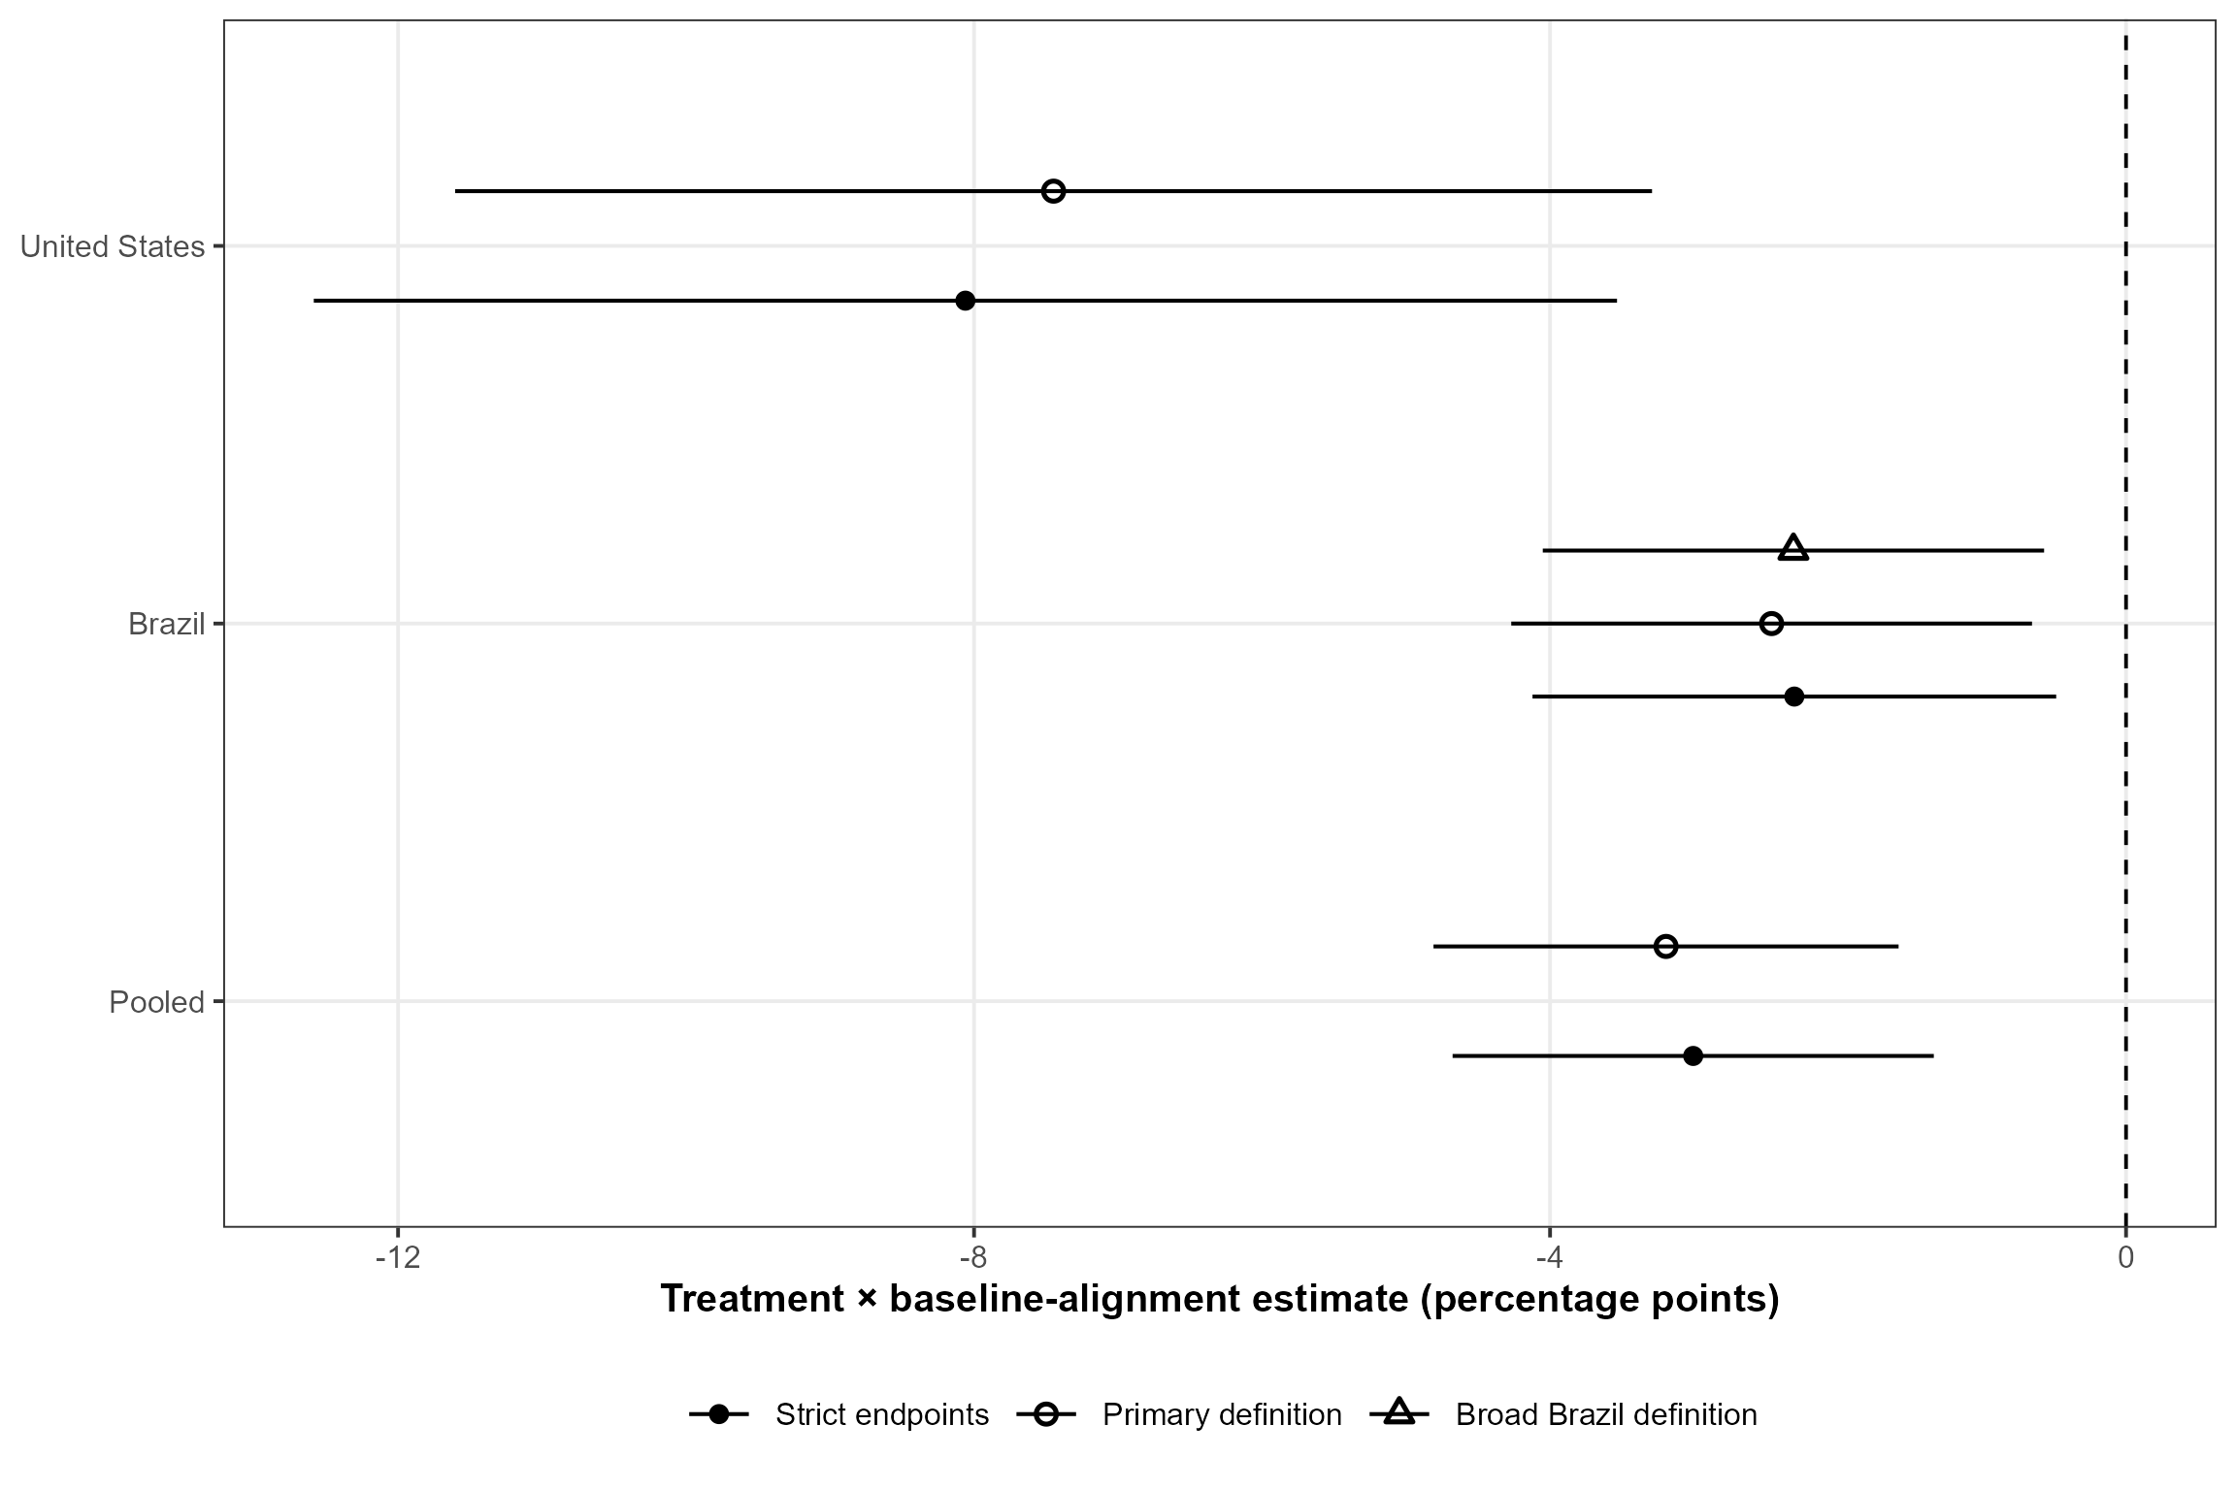
Note. Points are multivariate treatment-by-baseline interactions. Strict endpoints use Brazilian feeling scores of 0-2 versus 8-10 and U.S. Trump approval of 1 versus 5. The primary definition uses 0-3 versus 7-10 in Brazil and 1-2 versus 4-5 in the United States. The broad Brazilian definition uses 0-4 versus 6-10; no analogous U.S. estimate is shown because its five-point approval measure has only one midpoint. Baselines are reconstructed and standardized within country for each definition. Horizontal bars are respondent-clustered HC3 95% confidence intervals.

Figure A18 estimates the relationship-coefficient difference directly. The pooled outgroup-minus-ingroup H3 difference is +3.89 points (95% CI: 0.91, 6.87; p = .011), indicating a stronger ingroup constraint. The Brazilian difference is +3.04 (p = .060); the U.S. interval is wide. This comparison supplies uncertainty around the relationship asymmetry reported in the article.

Fig. A18 Formal Ingroup-Outgroup Difference in Baseline Moderation
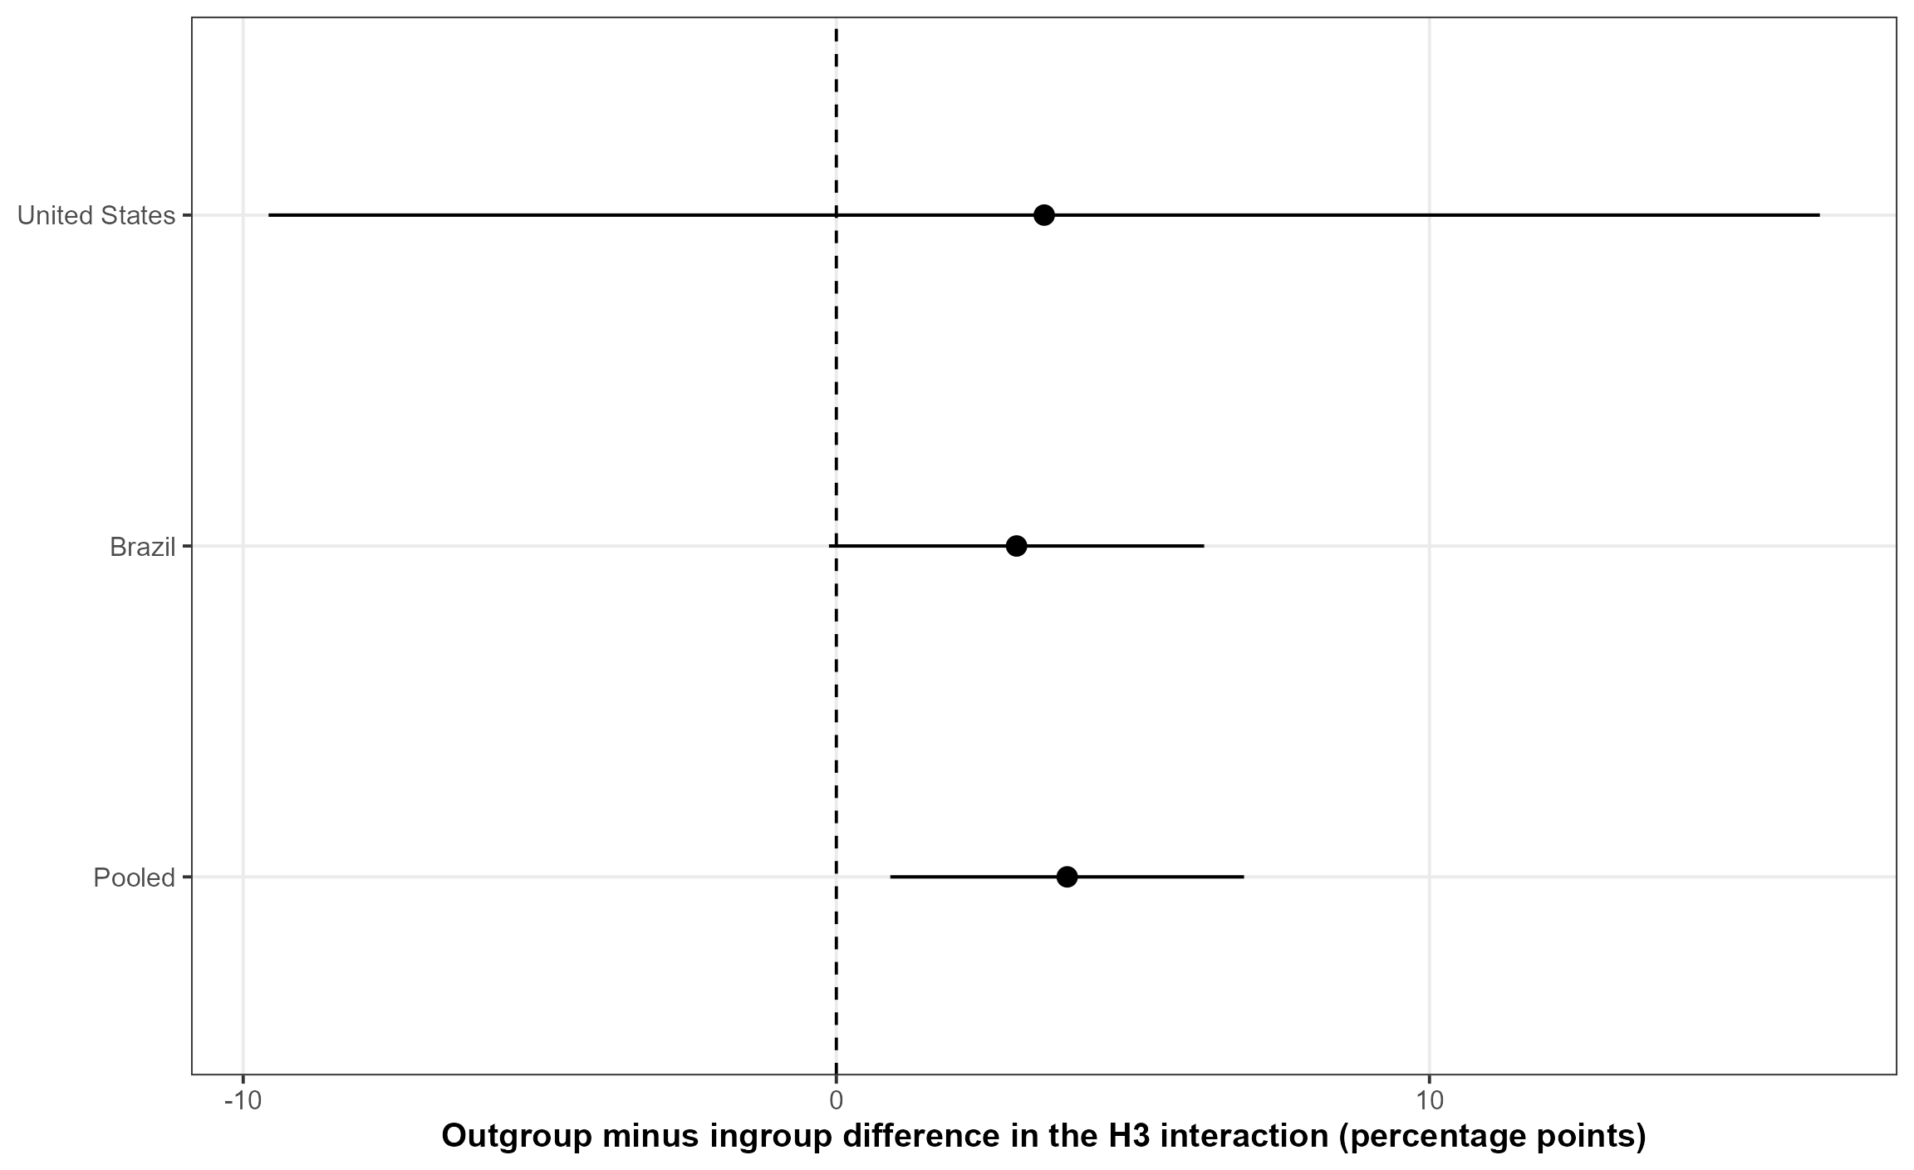
Note. Points are the three-way treatment-by-baseline-by-outgroup coefficients from multivariate linear probability models, with ingroups as the reference category. Positive values indicate that the negative treatment-by-baseline interaction is less negative among outgroups than ingroups. Models include the salience and uncertainty interactions, issue fixed effects, and source fixed effects where more than one source is present. Horizontal bars are respondent-clustered HC3 95% confidence intervals. Relationship groups and exclusions follow the primary specification.

Figure A19 retains middle-category respondents and models standardized source affinity. The treatment-by-affinity coefficient is positive pooled (+2.79 points, p = .001), in Brazil (+3.39, p < .001), and in the United States (+4.38, p = .032). Cues move opinion toward the attributed position more strongly as source evaluations improve. This analysis validates the directional coding; H3 remains the cell-level test of group-level issue incorporation.

Fig. A19 Continuous Source Affinity and Cue Following
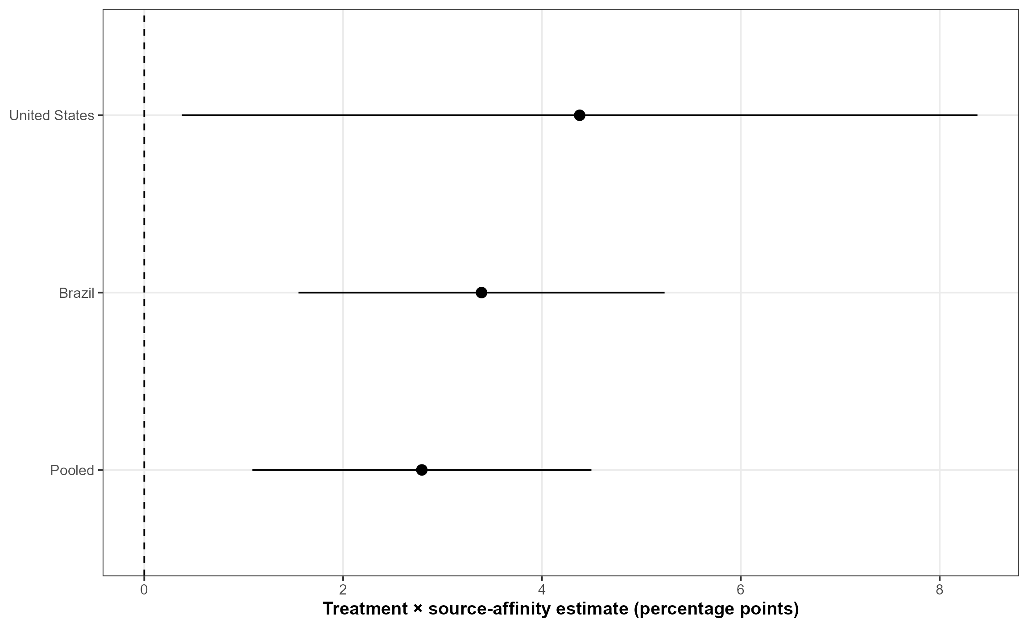
Note. Points are treatment-by-source-affinity interactions on support for the attributed source position. Source affinity is the pre-treatment PT, Lula, or Bolsonaro feeling thermometer in Brazil and Trump approval in the United States, standardized within country-source; all nonmissing values, including middle categories, are retained. Positive coefficients indicate that cue-induced movement toward the source position increases as affinity rises. Models include treatment interactions with salience and uncertainty and applicable issue and source fixed effects. Horizontal bars are respondent-clustered HC3 95% confidence intervals.

An Explicit Middle Relationship Category

Figure A20 retains the middle-category respondents and estimates cue effects on support for the attributed source position among outgroups, middle evaluators, and ingroups. Pooled effects progress from -3.97 points among outgroups (p < .001), through +1.10 among the middle category (p = .439), to +5.08 among ingroups (p = .001). Brazil shows the same ordered pattern (-4.60, +1.68, and +3.43 points). In the smaller U.S. groups, the ingroup effect remains positive (+11.8, p = .005), while the outgroup and middle estimates are imprecise. The discrete and continuous specifications recover the same source-relationship gradient; the middle group shows limited directional cue following.

Fig. A20 Cue Following with Outgroup, Middle, and Ingroup Categories
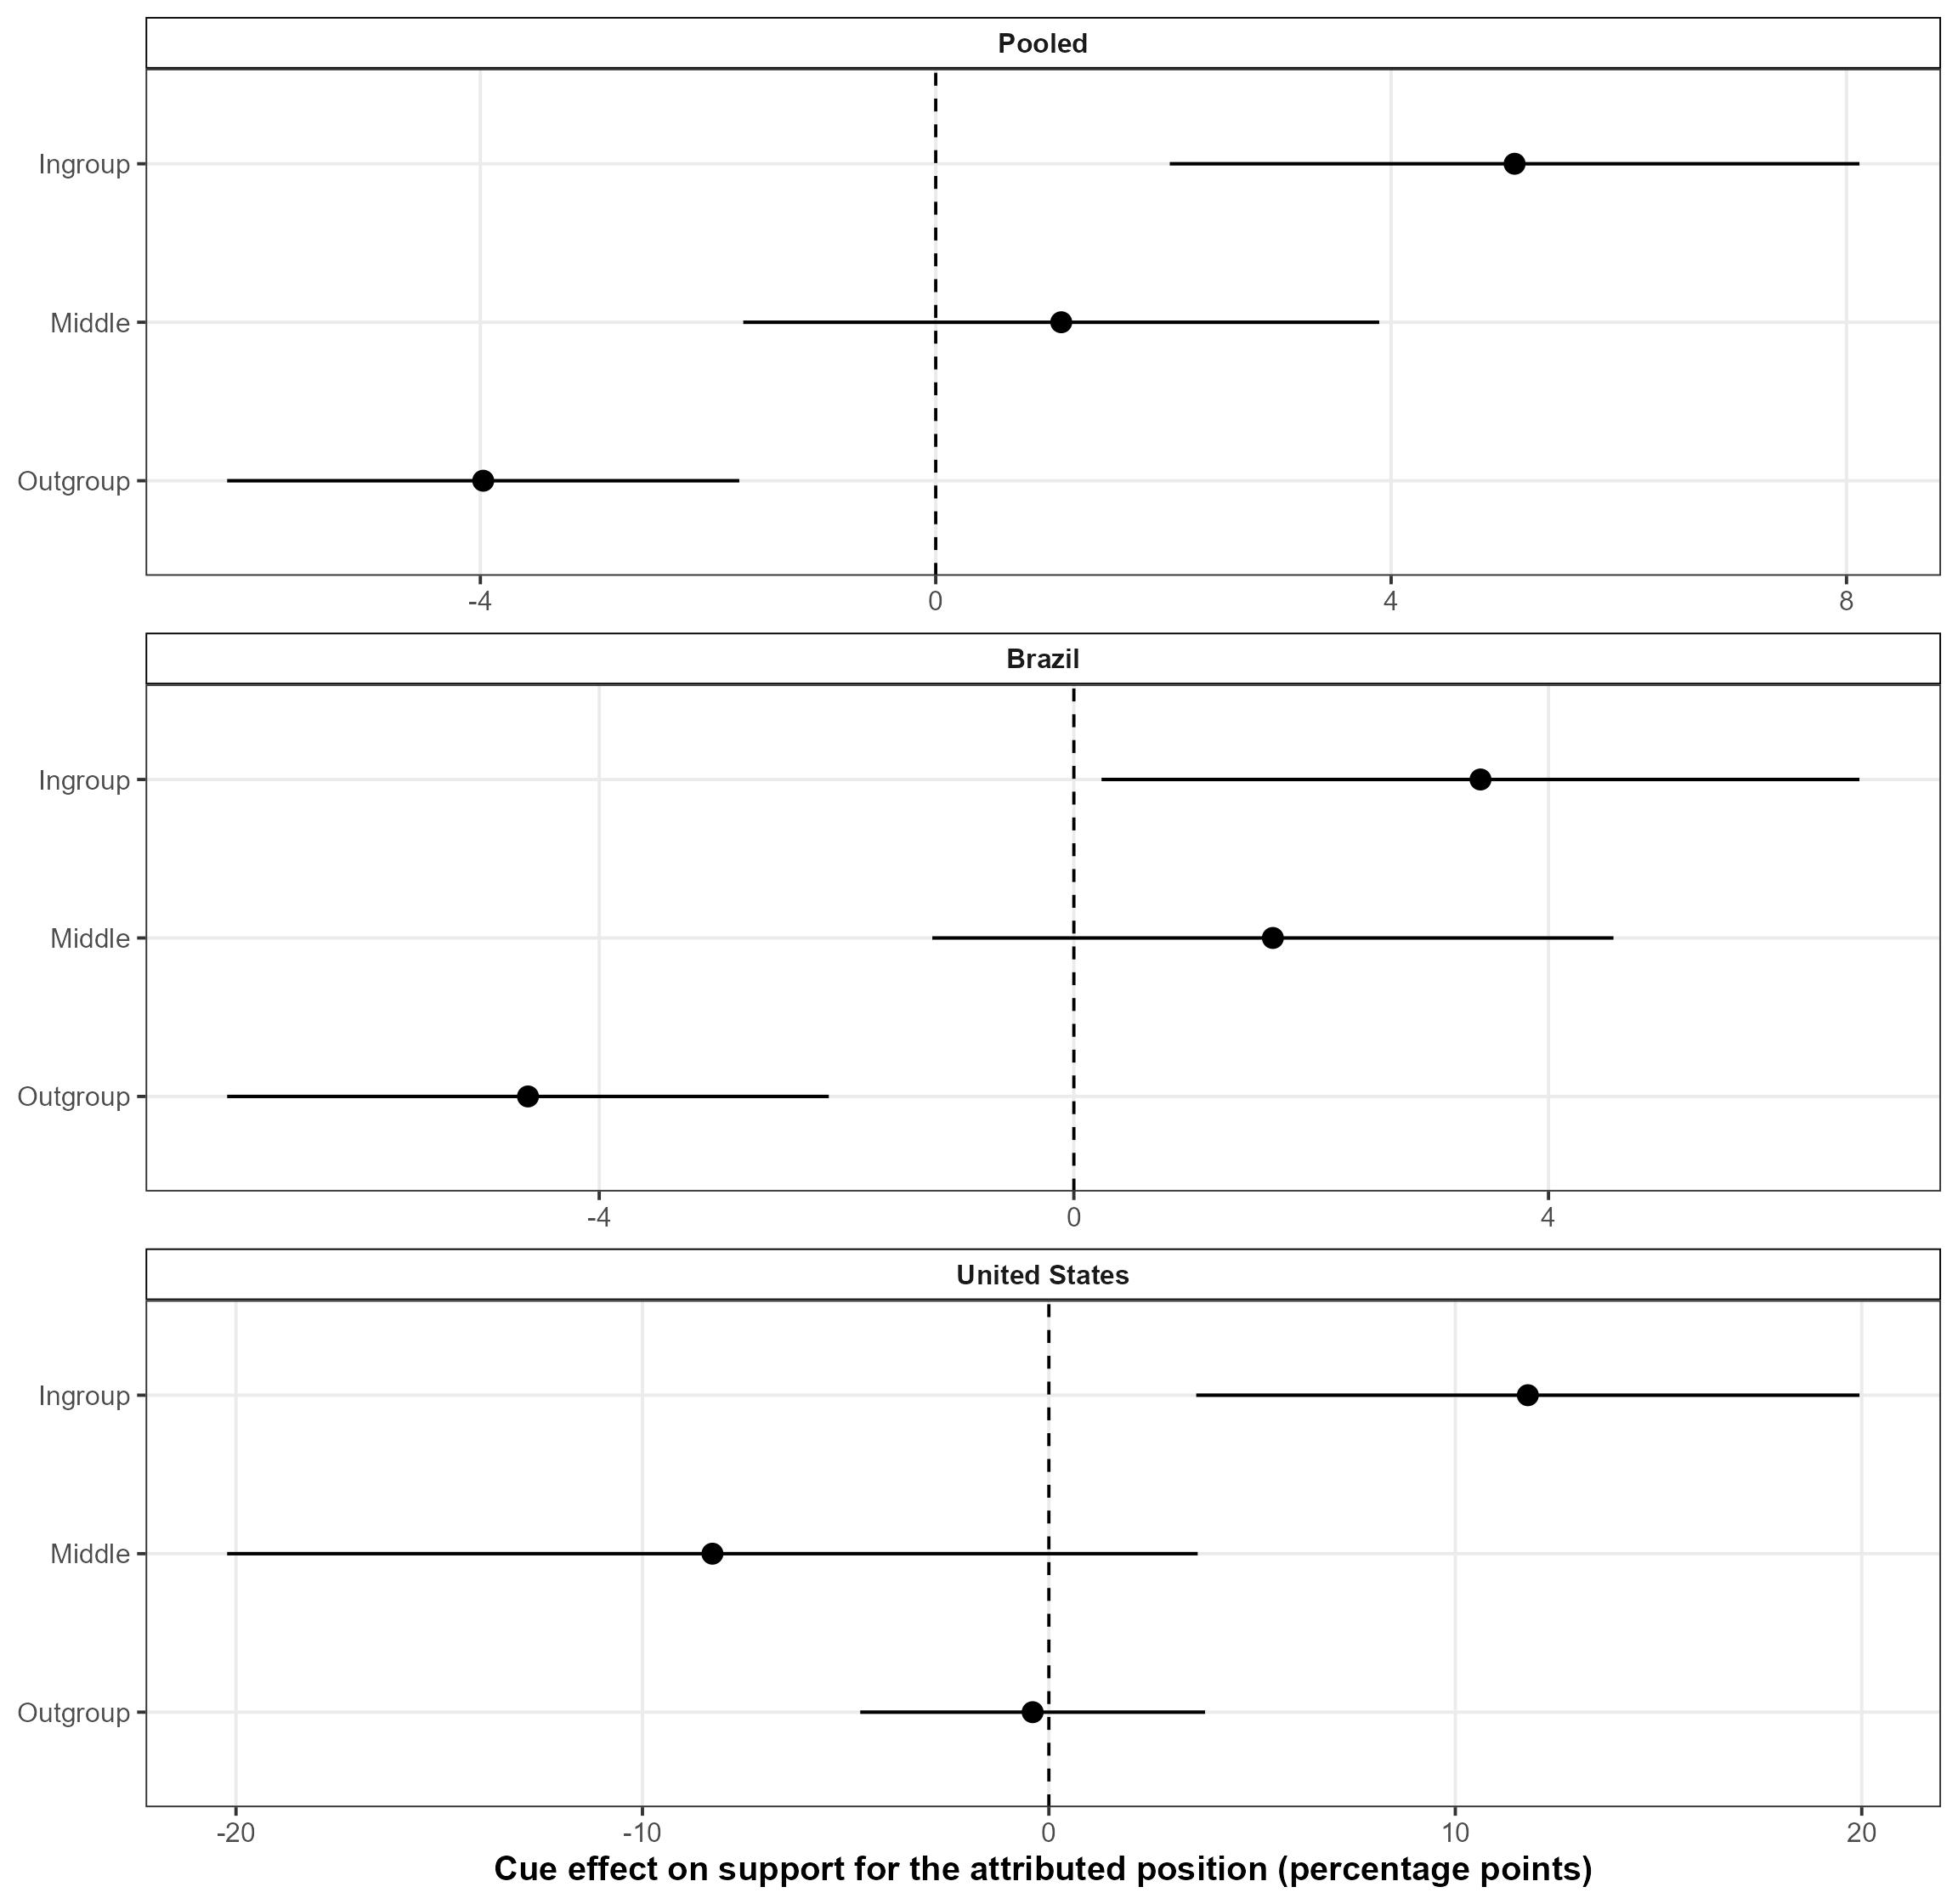
Note. Points are cue-control effects on support for the attributed source position among outgroups, middle evaluators, and ingroups. Brazil uses feeling scores of 0-3, 4-6, and 7-10; the United States uses Trump approval of 1-2, 3, and 4-5. Models pool applicable issues and include source fixed effects where needed; lines are respondent-clustered HC3 95% confidence intervals. This display tests the source-relationship gradient. H3 separately tests cell-level baseline alignment.

Section G contributes two measurement checks. Cutoff sensitivity preserves the negative H3 coefficient across endpoint definitions. Continuous affinity and the explicit middle category validate directional coding and recover a gradient from outgroup rejection to ingroup following. Together, they strengthen the relationship measure and characterize the stronger ingroup constraint.

H. Robustness to Alternative U.S. Cue Conditions

The primary U.S. analysis uses conservative Trump for direct comparison with the Brazilian cues. This section adds liberal Trump and congressional Republican conditions under the same outcome, moderators, models, and respondent-clustered inference. It tests how cue direction and source form affect H1-H3.

Directional Recoding and Nested Specifications

In the liberal Trump arm, Trump endorses the liberal position. Relationship-consistent responsiveness therefore uses liberal support for Trump ingroups and conservative support for Trump outgroups; approval continues to define the relationship groups.
The congressional Republican arm defines relationships from party identification. Attributed positions are coded item by item: congressional Republicans take the liberal side on abortion penalties and the conservative side on the other nine policies.
Figure A21 reports four nested samples: the primary comparison, primary plus liberal Trump, primary plus congressional Republicans, and all three cue arms. Controls are stacked for each included source, with a common respondent cluster. Baseline alignment is recomputed from the appropriately oriented control outcome and standardized within each stack.

Responsiveness Tests with Alternative Conditions

H1 remains unstable across the nested multivariate models: -1.13, +0.73, -0.88, and -0.14 points, with every interval including zero. Cue direction and source form change the sign without producing a stable independent salience pattern.
H2 coefficients run opposite the predicted positive direction in the expanded U.S. stack. Uncertainty is negative throughout and becomes precise after adding congressional Republicans (-1.56 points, p = .033) or both alternative arms (-1.27, p = .014). Low prior position availability can therefore impede translation of a mixed or collective cue into a relationship-consistent response.
H3 remains negative while its pooled magnitude changes with cue composition: -7.45 points in the primary model, -2.00 with liberal Trump, -3.54 with congressional Republicans, and -2.97 with both alternatives. The fully expanded estimate remains precise (p = .006). The large primary coefficient therefore describes the conventional personalized Trump cue, while the negative constraint extends to a broader cue set.
The attenuation has substantive content. Liberal Trump creates a counter-stereotypical leader-position pairing, and congressional Republicans change both the cue giver and the item-level direction. Pooling these arms broadens the political meaning of baseline alignment and weakens direct comparability with the conventional source map (Barber and Pope 2019; Cohen 2003; Nicholson 2012; Leeper and Slothuus 2014; Slothuus and Bisgaard 2021). Cue conventionality, personalization, and ideological legibility therefore enter as scope conditions.

Fig. A21 Responsiveness Models with Alternative U.S. Cue Conditions
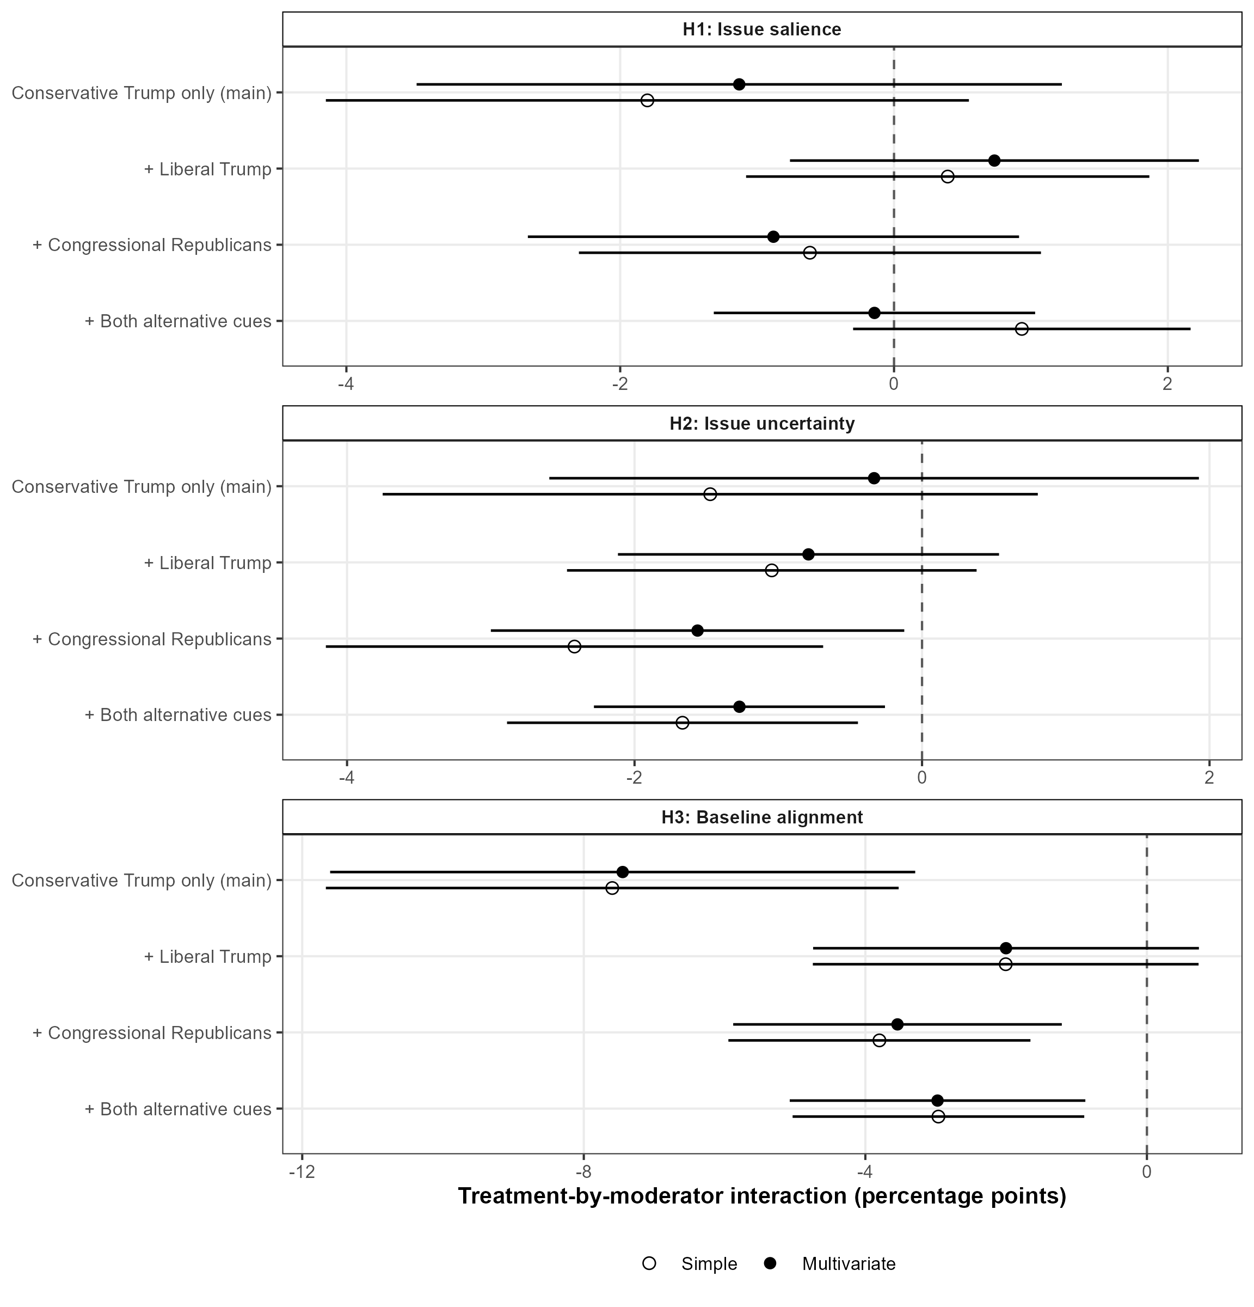
Note. Points are treatment-by-moderator interaction coefficients from the same linear probability models used for the article's U.S. hypothesis tests; horizontal bars are 95% confidence intervals. Hollow points report simple models and filled points report models containing salience, uncertainty, and baseline alignment jointly. Each row adds the named randomized condition to the control-plus-conservative-Trump benchmark. The outcome is oriented so that 1 always denotes relationship-consistent responsiveness: following an ingroup source or opposing an outgroup source. Liberal Trump positions are coded liberal on every issue. Congressional Republican positions are coded from the instrument item by item: liberal for opposition to abortion penalties and conservative for the other nine issues. Trump relationships use Trump approval; congressional Republican relationships use Republican versus Democratic identification. Models include the applicable issue, source, and relationship fixed effects. HC3 standard errors are clustered by respondent, including across duplicated control records. Moderators are standardized within each robustness stack.

Robustness by Respondent-Source Relationship

Figure A22 locates the expanded H3 pattern among ingroups. Their multivariate coefficients are -11.3 points in the primary model, -9.60 with liberal Trump, -9.80 with congressional Republicans, and -11.3 with both; every interval excludes zero. Outgroup coefficients approach zero as alternatives enter (-0.23, -0.86, and -0.30). The ingroup constraint is stable across conventional, reversed, and item-specific cue content, while outgroup moderation depends more heavily on the political mapping of the source.
The split also locates the H1-H2 departures. Liberal Trump produces a positive ingroup salience coefficient (+2.21 points, p = .093). Congressional Republican cues produce negative outgroup uncertainty estimates (-1.71, p = .028; -1.11 with both arms, p = .042). These patterns reinforce the role of source-position legibility.
Ingroup following and outgroup counter-mobilization consequently have different scope. Counter-stereotypical leader positions weaken the usual opposition map, and a collective congressional cue is less focal than Trump. The expanded outgroup result qualifies symmetric accounts of relationship-consistent responsiveness (Nicholson 2012; Barber and Pope 2019).

Fig. A22 Multivariate Responsiveness Models with Alternative U.S. Cues, by Relationship
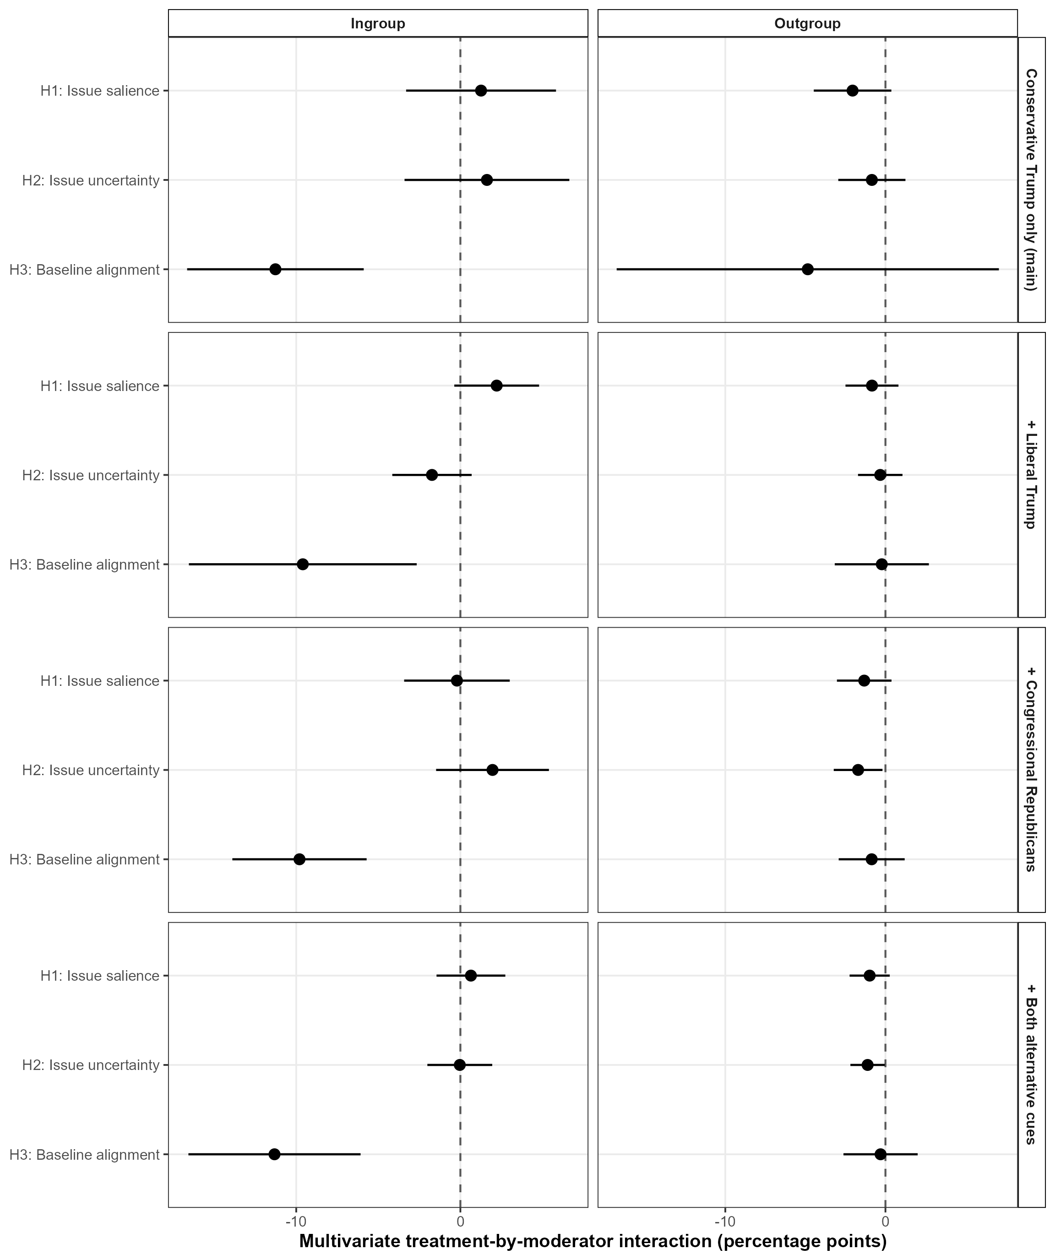
Note. Points are multivariate treatment-by-moderator interactions estimated separately for ingroups and outgroups; lines are 95% confidence intervals. Rows reproduce the nested condition sets in Figure A21. The dependent variable, directional recoding, source-specific control stacks, fixed effects, moderator standardization, and respondent-clustered HC3 inference match Figure A21. Trump relationships use approval; congressional Republican relationships use party identification.

The alternative U.S. arms preserve a negative, precise H3 coefficient in the full stack and a stable ingroup constraint across cue forms. They reduce the pooled magnitude and move the outgroup interaction toward zero. H1 varies across specifications, and H2 runs opposite its predicted direction. The conservative-Trump restriction supports direct cross-national comparison; the expanded models identify cue conventionality, personalization, and relationship pathway as boundaries on generalization.

I. Available Headroom: Construction and Measurement Scope

Figure 6B in the article reports responsiveness as a share of available binary movement. This section documents the transformation, the stability rule for cells near the upper boundary, and the measurement scope of the headroom estimand.

Theoretical Motivation

H3 concerns total additional alignment in the observed group distribution. High incorporation leaves fewer citizens available for binary movement. Headroom normalization measures proportional responsiveness among the remaining available cases (Taber and Lodge 2006; Druckman, Peterson, and Slothuus 2013; Boudreau and MacKenzie 2014). The normalized interaction identifies whether attenuation extends beyond population availability.

Estimation

The analysis uses the cross-fitted baselines from Section E. For each held-out observation, the transformed outcome subtracts the opposite-fold baseline and divides by one minus that baseline. Multivariate estimates average 100 partitions, and 399 respondent-cluster bootstrap replications refit baseline construction and the model. Cells with baseline one are undefined. The hollow points in Figure 6B of the article require at least 10 percentage points of headroom as a stability rule.

The harmonized outcome measures directional position change. Brazil's third response category records don't know, and the U.S. substantive response is binary. Comparable attitude-intensity measures would extend this analysis to changes within the relationship-consistent side of the response distribution.

J. Alternative Operationalizations of Issue Salience

Figure A23 rebuilds the pairwise Google Trends index with the field period, the pre-field period, a 14-day pre-field window plus fieldwork, and each search term separately. All pooled multivariate coefficients are negative (-0.72 to -1.21 points), and country estimates retain the sign. The intervals remain wide.
The observed H1 sign remains stable across temporal windows and keyword choices. Precision remains limited by the number of issues and the small coefficient magnitude.

Fig. A23 Responsiveness under Alternative Issue-Salience Measures
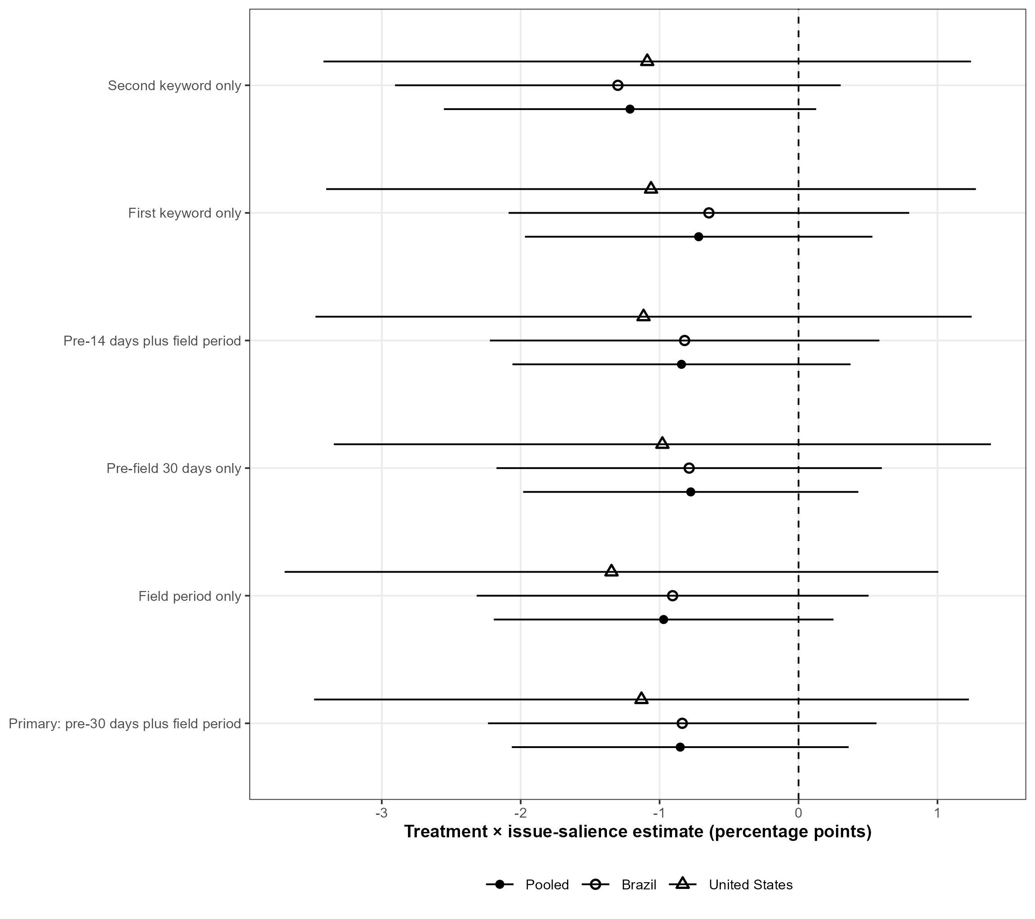
Note. Points are multivariate treatment-by-salience interactions after rebuilding the pairwise Google Trends index from the daily search-interest series used to construct the primary measure. The primary window begins 30 days before fieldwork and ends on the final field date. Alternatives use only field dates, only the preceding 30 days, the preceding 14 days plus fieldwork, or one of the two issue-specific search terms at a time. Every variant is recomputed from pairwise within-query log differences and standardized within country before model estimation. Horizontal bars are respondent-clustered HC3 95% confidence intervals. Outcome coding, samples, uncertainty and baseline interactions, and fixed effects match the main models.

Alternative salience measures therefore reinforce a modest negative association across the observed issues while preserving the article's cautious multivariate conclusion.

K. Population-Composition Weighting in Brazil

Random assignment identifies the primary unweighted Brazilian treatment contrasts within the achieved sample. The quota sample differs from Census benchmarks, especially by region and education. Figure A24 rakes respondents to the sex, region, four-category education, and three-category income margins shown in Figure A2, then repeats the multivariate models with untrimmed and 1st-99th percentile trimmed weights.
The untrimmed weights range from 0.028 to 24.9 and reduce the respondent-level effective sample size from 2,007 to about 593. H3 remains negative under untrimmed raking (-2.86 points) and trimming (-2.14), compared with -2.46 unweighted; the wider intervals include zero. H1 remains negative and H2 remains inconsistent with its predicted positive direction. Extrapolation from sparsely represented demographic cells produces the loss of precision.
This sensitivity addresses external validity. Raking aligns observed margins while preserving the opt-in origin of the Brazilian panel and its unmeasured selection limits. The weighted estimates support directional H3 stability and show wider uncertainty for population-targeted magnitudes. The unweighted experimental estimand remains the basis for causal inference within the achieved sample.

Fig. A24 Brazilian Moderation Estimates with Population-Composition Weights
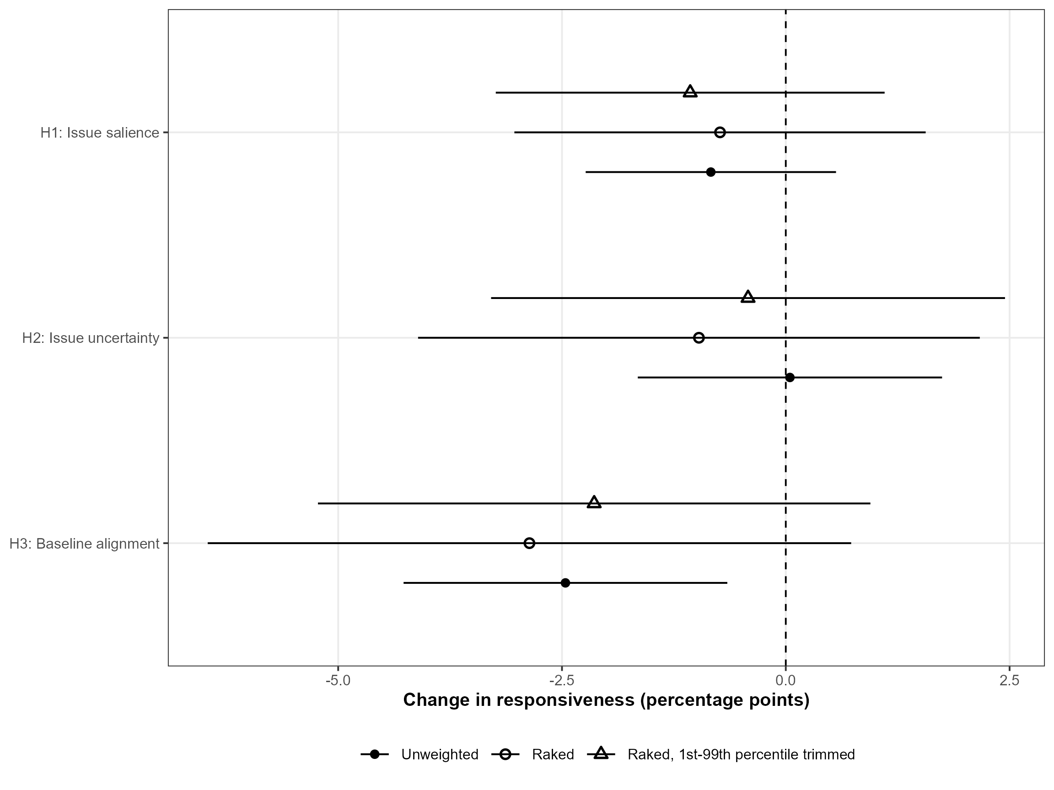
Note. Filled points are the unweighted Brazilian multivariate coefficients. Hollow circles use iterative raking weights that align the 2,007 respondents with 2022 Census margins for sex, region, four-category education, and three-category income; triangles trim those weights at the 1st and 99th percentiles and renormalize them. Horizontal bars are respondent-clustered HC3 95% confidence intervals from weighted linear probability models. Baseline alignment remains the control-condition measure used in the primary analysis. The weights address observed sample composition within an opt-in panel.

Population weighting preserves the negative Brazilian H3 point estimate and substantially widens its uncertainty. The sensitivity supports within-sample causal interpretation and cautious population generalization.

L. Multiplicity, Detectable Precision, and Subgroup Precision

The article evaluates three directional hypotheses in pooled and country-specific models. Figure A25 reports raw p-values and two adjustments across the nine multivariate country-by-hypothesis estimates. Pooled and U.S. H3 remain below .05 under the conservative Holm family-wise correction. Brazilian H3 remains below .05 under Benjamini-Hochberg control of the false discovery rate and has a Holm-adjusted p-value of approximately .054. Adjusted H1 and H2 country estimates remain imprecise. The broad correction locates the strongest family-wise evidence in pooled and U.S. baseline alignment.

Fig. A25 Multiplicity Adjustments for the Multivariate Hypothesis Tests
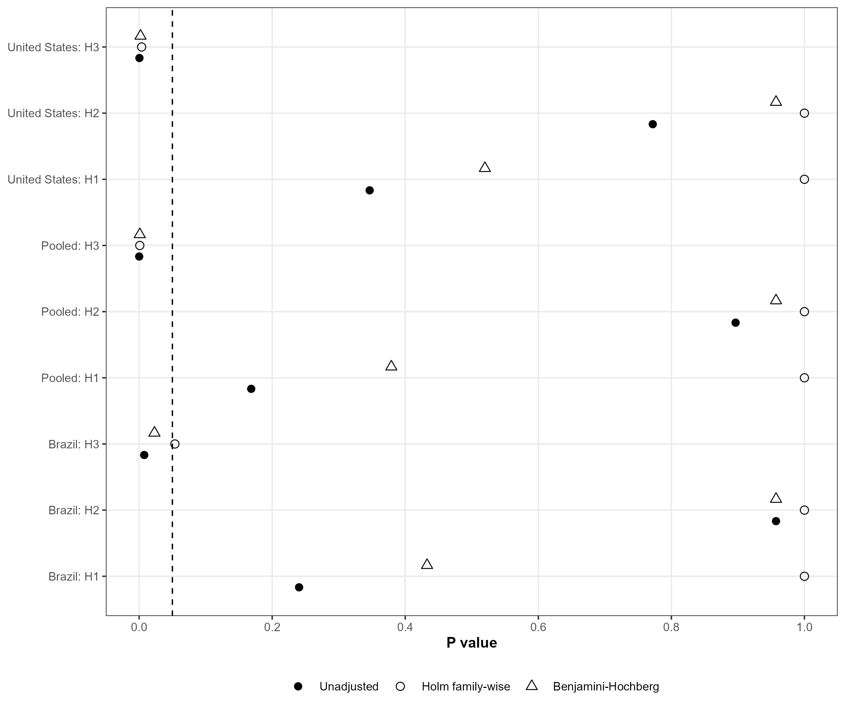
Note. Each row is one of the nine multivariate hypothesis tests formed by crossing H1-H3 with the pooled, Brazilian, and U.S. samples. Filled points are unadjusted two-sided p-values; hollow circles use Holm's family-wise error correction across all nine tests; triangles use the Benjamini-Hochberg false-discovery-rate correction. The vertical dashed line marks .05. Original p-values use respondent-clustered HC3 standard errors and cluster-minus-one t degrees of freedom. Adjustments change inferential thresholds; the underlying coefficients and confidence intervals remain fixed.

Figure A26 reports approximate minimum detectable interactions for 80% power at a two-sided .05 level, holding the observed standard errors fixed. The pooled models are sensitive to effects of roughly 1.7-2.3 percentage points, the Brazilian models to 2.0-2.6 points, and the U.S. models to 3.2-5.9 points. These quantities clarify the null results: country samples retain uncertainty about small salience or uncertainty interactions, especially in the United States. The observed H3 coefficients are large relative to achieved precision. The MDEs describe the realized design matrices and standard errors.

Fig. A26 Approximate Minimum Detectable Interaction Effects
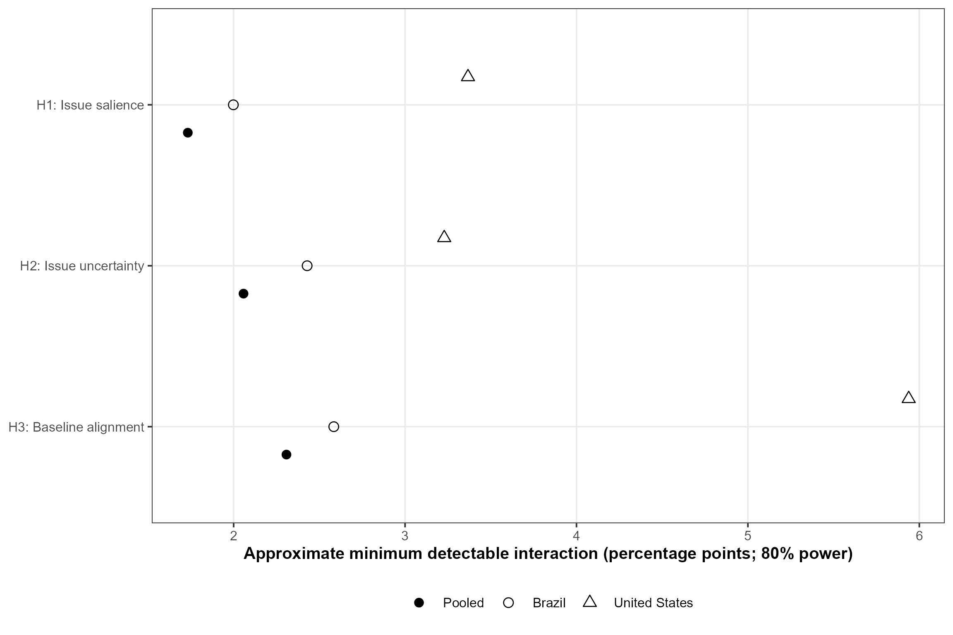
Note. Points report the two-sided .05 minimum detectable coefficient for 80% power, calculated as the observed respondent-clustered HC3 standard error multiplied by the sum of the 97.5th and 80th percentiles of the cluster-minus-one t distribution. Values are percentage-point treatment-by-moderator interactions. The calculation describes achieved precision conditional on the realized multivariate model, sample, and issue set.

Subgroup Precision and Three-Hypothesis Multiplicity

Figure A27 quantifies the precision available in the relationship splits. Approximate 80% minimum detectable interactions in the pooled models range from 3.0 to 3.9 points among ingroups and 1.9 to 2.7 among outgroups. Brazilian MDEs are similar. U.S. ingroup MDEs are 6.5-7.7 points, and the U.S. outgroup H3 MDE reaches 17.0 points because baseline-alignment moderation is weakly identified within that subgroup. These values show the equivalence range left open by split-sample estimates. Figure A18 supplies the formal comparison between ingroup and outgroup moderation.

Fig. A27 Approximate Minimum Detectable Interactions by Relationship Group
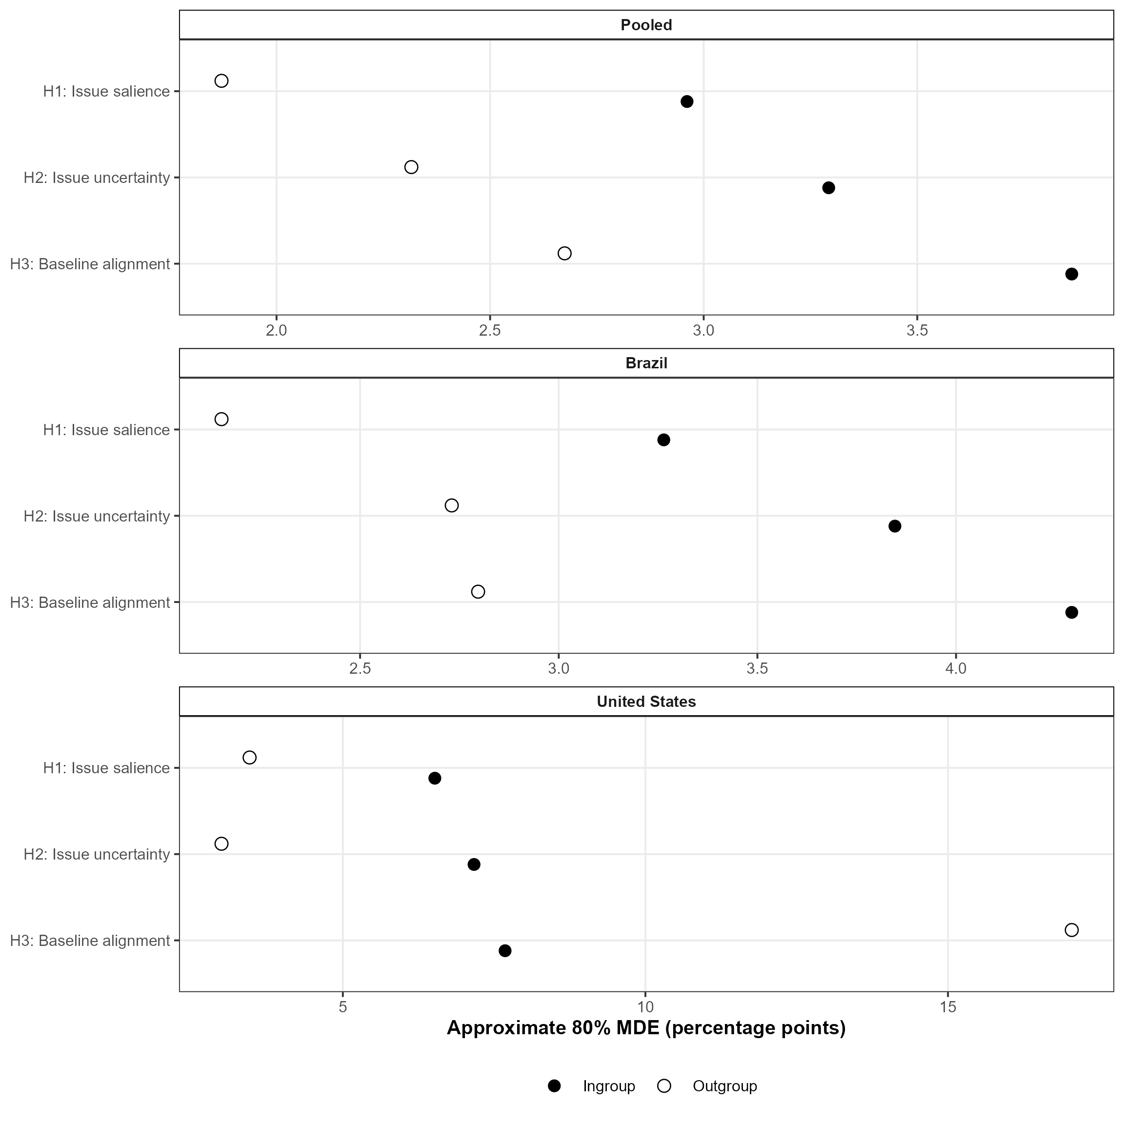
Note. Points report two-sided .05 minimum detectable treatment-by-moderator coefficients for 80% power, calculated from each realized multivariate model's respondent-clustered HC3 standard error and cluster-minus-one t degrees of freedom. Filled points denote ingroups and hollow points outgroups. Values are percentage points. These achieved-precision approximations are conditional on the realized design matrix.

Figure A28 narrows the correction family from nine country-by-hypothesis tests to three hypotheses within each sample. This change moves the Brazilian H3 Holm value from approximately .054 to .023. Pooled and U.S. H3 values remain below .001 and at .001; H1 and H2 remain above .05. The comparison shows that family definition affects the Brazilian threshold while preserving the ordering of the three moderators.

Fig. A28 Multiplicity Corrections within Each Three-Hypothesis Family
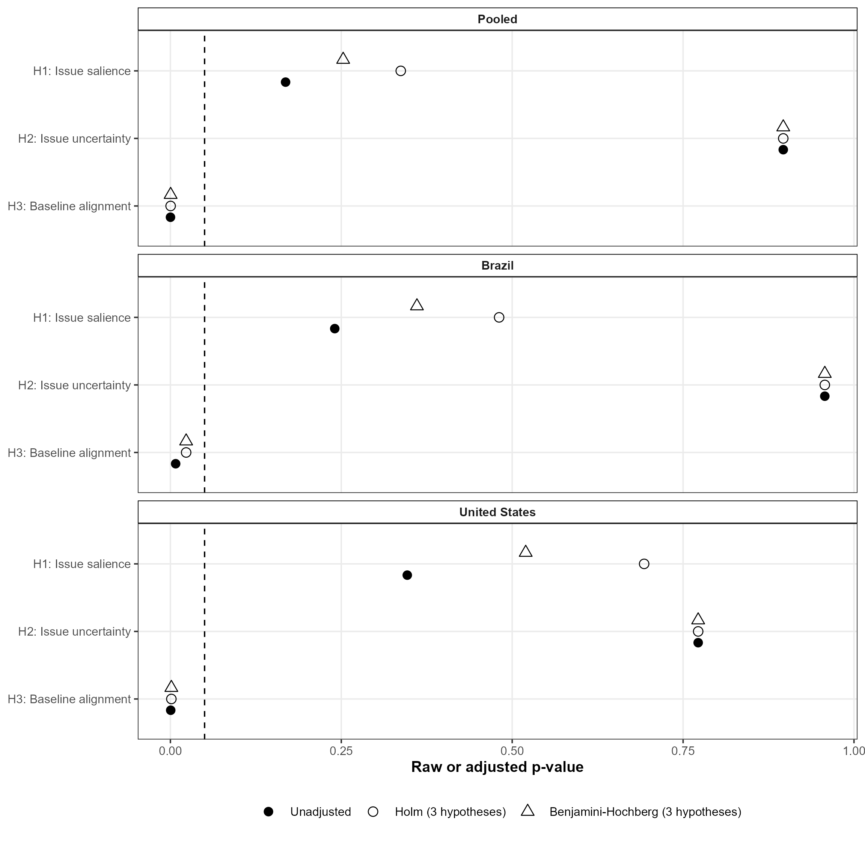
Note. Each panel contains the three multivariate H1-H3 tests for one sample. Filled circles are raw two-sided p-values, hollow circles apply Holm's family-wise correction across the three hypotheses within that sample, and triangles apply the Benjamini-Hochberg false-discovery-rate correction to the same family. The dashed vertical line marks .05. Corrections change the inferential threshold; coefficients and confidence intervals remain fixed. Figure A25 reports the stricter correction across all nine sample-by-hypothesis tests.

Together, multiplicity and achieved-precision analyses preserve the H3 ordering. The minimum detectable effects also define broad equivalence ranges for several country and relationship splits.

M. Full Brazilian Instrument and Experimental Procedures

The Brazilian experiment is original to this study and is documented in greater detail than the secondary U.S. analysis. Tables A4-A5 summarize the policy items, attributed positions, realized condition sizes, and analytic roles. Tables A6-A8 reproduce the complete Portuguese instrument, provide English translations, and report the item-level orientation used to construct the outcome. The U.S. wording and experimental documentation are reported in Barber and Pope (2019) and its online supplement, as noted in Section A.

Table A4 Brazilian Policy Items and Outcome Coding
No. | Original Portuguese policy statement | English translation | Liberal-coded response
1 | Privatização da Petrobrás. | Privatization of Petrobras. | Oppose
2 | Liberação do uso da maconha em tratamentos médicos. | Allowing marijuana for medical treatment. | Support
3 | Educação sexual nas escolas. | Sex education in schools. | Support
4 | Em certas circunstâncias, como quando há muito crime ou diante de muita corrupção, os militares devem ter o direito de tomar o poder através de um golpe de estado. | Under some circumstances, such as high crime or extensive corruption, the military should have the right to take power in a coup. | Oppose
5 | A proibição de venda de armas de fogo. | Banning the sale of firearms. | Support
6 | Adoção de cotas raciais. | Adoption of racial quotas. | Support
7 | Pode haver democracia sem que existam partidos políticos. | Democracy can exist without political parties. | Disagree
8 | Aumentar a quantidade de impostos pagos pelos ricos. | Increasing the amount of taxes paid by the wealthy. | Support
9 | A política ambiental atrapalha o desenvolvimento do Brasil. | Environmental policy hinders Brazil's development. | Disagree
10 | A Amazônia deve ser administrada por um conjunto de países e entidades internacionais, e não apenas de acordo com o interesse do Brasil. | The Amazon should be managed by a group of countries and international entities rather than solely according to Brazil's interests. | Support
11 | O agronegócio brasileiro precisa de mais espaço para produzir e deve ocupar áreas de floresta que hoje são preservadas. | Brazilian agribusiness needs more space and should occupy currently preserved forest areas. | Oppose
12 | Aumento de impostos para preservar o meio ambiente. | Increasing taxes to preserve the environment. | Support
13 | Contratação de médicos estrangeiros para o SUS, como vem fazendo o programa Mais Médicos. | Hiring foreign physicians for the public health system, as in the Mais Médicos program. | Support
Note. Control respondents saw the policy statement followed by a support/oppose or agree/disagree question. Treated respondents saw the same statement plus the attributed source position described in Table A5 before answering. Support, oppose, agree, disagree, and don't know were the available response categories as applicable. The final column records the response coded as liberal/progressive before the outcome is reoriented toward or away from the source. Item order was randomized within respondent. English translations accompany the original Portuguese wording, which is authoritative.

Table A5 Brazilian Experimental Conditions and Analytic Roles
Condition | N | Attributed position | Relationship measure | Use in this article
Control | 590 | No attributed source position | Reference arm for every Brazilian comparison | Primary and all robustness analyses
PT caucus cue | 348 | PT caucus supports the liberal-coded position | PT thermometer | Primary single-source stack
Lula cue | 351 | Lula supports the liberal-coded position | Lula thermometer | Primary single-source stack
Bolsonaro cue | 356 | Bolsonaro supports the conservative-coded position | Bolsonaro thermometer | Primary single-source stack
Lula vs. Bolsonaro | 362 | Lula supports the liberal position; Bolsonaro supports the conservative position | Lula and Bolsonaro thermometers | Explicit-conflict extension
Note. Counts are unique respondents (total N = 2,007). Assignment was between subjects and remained fixed across all 13 items. In the single-source conditions, the cue sentence stated that the named source supported or opposed the policy as indicated. The two-sided condition named Lula and Bolsonaro together. Feeling-thermometer scores were measured before assignment and the policy-response block. Primary group cutoffs are 7-10 for ingroups and 0-3 for outgroups; Section G reports alternatives.

Complete Fielded Wording

The policy block was introduced with the instruction: 'Agora gostaríamos de fazer uma pergunta sobre uma série de questões e políticas que podem surgir nos próximos meses. Por favor, indique se você apoia ou se opõe à afirmação.' Each participant saw only the wording for the assigned condition across all 13 items. Table A6 reproduces every Portuguese item-condition combination; Table A7 provides a direct English translation.

Table A6 Full Brazilian Instrument in Portuguese
Item | Condition | Exact Portuguese wording
1 | Controle | Privatização da Petrobrás. Você apoia ou se opõe à privatização da Petrobrás?
1 | PT | Privatização da Petrobrás. A bancada do PT na Câmara dos Deputados afirmou que se opõe a essa política. E você? Você apoia ou se opõe à privatização da Petrobrás?
1 | Lula | Privatização da Petrobrás. Lula afirmou que se opõe a essa política. E você? Você apoia ou se opõe à privatização da Petrobrás?
1 | Bolsonaro | Privatização da Petrobrás. Bolsonaro afirmou que apoia essa política. E você? Você apoia ou se opõe à privatização da Petrobrás?
1 | Lula vs. Bolsonaro | Privatização da Petrobrás. Lula afirmou que se opõe a essa política. Já Bolsonaro afirmou que apoia. E você? Você apoia ou se opõe à privatização da Petrobrás?
2 | Controle | Liberação do uso da maconha em tratamentos médicos. Você apoia ou se opõe a liberação do uso da maconha em tratamentos médicos?
2 | PT | Liberação do uso da maconha em tratamentos médicos. A bancada do PT na Câmara dos Deputados afirmou que apoia essa política. E você? Você apoia ou se opõe a liberação do uso da maconha em tratamentos médicos?
2 | Lula | Liberação do uso da maconha em tratamentos médicos. Lula afirmou que apoia essa política. E você? Você apoia ou se opõe a liberação do uso da maconha em tratamentos médicos?
2 | Bolsonaro | Liberação do uso da maconha em tratamentos médicos. Bolsonaro afirmou que se opõe a essa política. E você? Você apoia ou se opõe a liberação do uso da maconha em tratamentos médicos?
2 | Lula vs. Bolsonaro | Liberação do uso da maconha em tratamentos médicos. Lula afirmou que apoia essa política. Já Bolsonaro afirmou que se opõe. E você? Você apoia ou se opõe a liberação do uso da maconha em tratamentos médicos?
3 | Controle | Educação sexual nas escolas. Você apoia ou se opõe à educação sexual nas escolas?
3 | PT | Educação sexual nas escolas. A bancada do PT na Câmara dos Deputados afirmou que apoia essa política. E você? Você apoia ou se opõe à educação sexual nas escolas?
3 | Lula | Educação sexual nas escolas. Lula afirmou que apoia essa política. E você? Você apoia ou se opõe à educação sexual nas escolas?
3 | Bolsonaro | Educação sexual nas escolas. Bolsonaro afirmou que se opõe a essa política. E você? Você apoia ou se opõe à educação sexual nas escolas?
3 | Lula vs. Bolsonaro | Educação sexual nas escolas. Lula afirmou que apoia essa política. Já Bolsonaro afirmou que se opõe. E você? Você apoia ou se opõe à educação sexual nas escolas?
4 | Controle | Em certas circunstâncias, como quando há muito crime ou diante de muita corrupção, os militares devem ter o direito de tomar o poder através de um golpe de estado. Você apoia ou se opõe que em certas circunstâncias os militares tomem o poder através de um golpe de estado?
4 | PT | Em certas circunstâncias, como quando há muito crime ou diante de muita corrupção, os militares devem ter o direito de tomar o poder através de um golpe de estado. A bancada do PT na Câmara dos Deputados afirmou que se opõe a essa política. E você? Você apoia ou se opõe que em certas circunstâncias os militares tomem o poder através de um golpe de estado?
4 | Lula | Em certas circunstâncias, como quando há muito crime ou diante de muita corrupção, os militares devem ter o direito de tomar o poder através de um golpe de estado. Lula afirmou que se opõe a essa política. E você? Você apoia ou se opõe que em certas circunstâncias os militares tomem o poder através de um golpe de estado?
4 | Bolsonaro | Em certas circunstâncias, como quando há muito crime ou diante de muita corrupção, os militares devem ter o direito de tomar o poder através de um golpe de estado. Bolsonaro afirmou que apoia essa política. E você? Você apoia ou se opõe que em certas circunstâncias os militares tomem o poder através de um golpe de estado?
4 | Lula vs. Bolsonaro | Em certas circunstâncias, como quando há muito crime ou diante de muita corrupção, os militares devem ter o direito de tomar o poder através de um golpe de estado. Lula afirmou que se opõe a essa política. Já Bolsonaro afirmou que apoia. E você? Você apoia ou se opõe que em certas circunstâncias os militares tomem o poder através de um golpe de estado?
5 | Controle | A proibição de venda de armas de fogo. Você apoia ou se opõe à proibição de venda de armas de fogo?
5 | PT | A proibição de venda de armas de fogo. A bancada do PT na Câmara dos Deputados afirmou que apoia essa política. E você? Você apoia ou se opõe à proibição de venda de armas de fogo?
5 | Lula | A proibição de venda de armas de fogo. Lula afirmou que apoia essa política. E você? Você apoia ou se opõe à proibição de venda de armas de fogo?
5 | Bolsonaro | A proibição de venda de armas de fogo. Bolsonaro afirmou que se opõe a essa política. E você? Você apoia ou se opõe à proibição de venda de armas de fogo?
5 | Lula vs. Bolsonaro | A proibição de venda de armas de fogo. Lula afirmou que apoia essa política. Já Bolsonaro afirmou que se opõe. E você? Você apoia ou se opõe à proibição de venda de armas de fogo?
6 | Controle | Adoção de cotas raciais. Você apoia ou se opõe a adoção de cotas raciais?
6 | PT | Adoção de cotas raciais. A bancada do PT na Câmara dos Deputados afirmou que apoia essa política. E você? Você apoia ou se opõe a adoção de cotas raciais?
6 | Lula | Adoção de cotas raciais. Lula afirmou que apoia essa política. E você? Você apoia ou se opõe a adoção de cotas raciais?
6 | Bolsonaro | Adoção de cotas raciais. Bolsonaro afirmou que se opõe a essa política. E você? Você apoia ou se opõe a adoção de cotas raciais?
6 | Lula vs. Bolsonaro | Adoção de cotas raciais. Lula afirmou que apoia essa política. Já Bolsonaro afirmou que se opõe. E você? Você apoia ou se opõe a adoção de cotas raciais?
7 | Controle | Pode haver democracia sem que existam partidos políticos. Você concorda ou discorda que pode haver democracia sem que existam partidos políticos?
7 | PT | Pode haver democracia sem que existam partidos políticos. A bancada do PT na Câmara dos Deputados afirmou que discorda dessa afirmação. E você? Você concorda ou discorda que pode haver democracia sem que existam partidos políticos?
7 | Lula | Pode haver democracia sem que existam partidos políticos. Lula afirmou que discorda dessa afirmação. E você? Você concorda ou discorda que pode haver democracia sem que existam partidos políticos?
7 | Bolsonaro | Pode haver democracia sem que existam partidos políticos. Bolsonaro afirmou que concorda com essa afirmação. E você? Você concorda ou discorda que pode haver democracia sem que existam partidos políticos?
7 | Lula vs. Bolsonaro | Pode haver democracia sem que existam partidos políticos. Lula afirmou que discorda dessa afirmação. Já Bolsonaro afirmou que concorda. E você? Você concorda ou discorda que pode haver democracia sem que existam partidos políticos?
8 | Controle | Aumentar a quantidade de impostos pagos pelos ricos. Você apoia ou se opõe ao aumento da quantidade de impostos pagos pelos ricos?
8 | PT | Aumentar a quantidade de impostos pagos pelos ricos. A bancada do PT na Câmara dos Deputados afirmou que apoia essa política. E você? Você apoia ou se opõe ao aumento da quantidade de impostos pagos pelos ricos?
8 | Lula | Aumentar a quantidade de impostos pagos pelos ricos. Lula afirmou que apoia essa política. E você? Você apoia ou se opõe ao aumento da quantidade de impostos pagos pelos ricos?
8 | Bolsonaro | Aumentar a quantidade de impostos pagos pelos ricos. Bolsonaro afirmou que se opõe a essa política. E você? Você apoia ou se opõe ao aumento da quantidade de impostos pagos pelos ricos?
8 | Lula vs. Bolsonaro | Aumentar a quantidade de impostos pagos pelos ricos. Lula afirmou que apoia essa política. Já Bolsonaro afirmou que se opõe. E você? Você apoia ou se opõe ao aumento da quantidade de impostos pagos pelos ricos?
9 | Controle | A política ambiental atrapalha o desenvolvimento do Brasil. Você concorda ou discorda que a política ambiental atrapalha o desenvolvimento do Brasil?
9 | PT | A política ambiental atrapalha o desenvolvimento do Brasil. A bancada do PT na Câmara dos Deputados afirmou que discorda dessa afirmação. E você? Você concorda ou discorda que a política ambiental atrapalha o desenvolvimento do Brasil?
9 | Lula | A política ambiental atrapalha o desenvolvimento do Brasil. Lula afirmou que discorda dessa afirmação. E você? Você concorda ou discorda que a política ambiental atrapalha o desenvolvimento do Brasil?
9 | Bolsonaro | A política ambiental atrapalha o desenvolvimento do Brasil. Bolsonaro afirmou que concorda com essa afirmação. E você? Você concorda ou discorda que a política ambiental atrapalha o desenvolvimento do Brasil?
9 | Lula vs. Bolsonaro | A política ambiental atrapalha o desenvolvimento do Brasil. Lula afirmou que discorda dessa afirmação. Já Bolsonaro afirmou que concorda. E você? Você concorda ou discorda que a política ambiental atrapalha o desenvolvimento do Brasil?
10 | Controle | A Amazônia deve ser administrada por um conjunto de países e entidades internacionais, e não apenas de acordo com o interesse do Brasil. Você apoia ou se opõe a administração da Amazônia ser feita por um conjunto de países e entidades internacionais, e não apenas de acordo com o interesse do Brasil?
10 | PT | A Amazônia deve ser administrada por um conjunto de países e entidades internacionais, e não apenas de acordo com o interesse do Brasil. A bancada do PT na Câmara dos Deputados afirmou que apoia essa política. E você? Você apoia ou se opõe a administração da Amazônia ser feita por um conjunto de países e entidades internacionais, e não apenas de acordo com o interesse do Brasil?
10 | Lula | A Amazônia deve ser administrada por um conjunto de países e entidades internacionais, e não apenas de acordo com o interesse do Brasil. Lula afirmou que apoia essa política. E você? Você apoia ou se opõe a administração da Amazônia ser feita por um conjunto de países e entidades internacionais, e não apenas de acordo com o interesse do Brasil?
10 | Bolsonaro | A Amazônia deve ser administrada por um conjunto de países e entidades internacionais, e não apenas de acordo com o interesse do Brasil. Bolsonaro afirmou que se opõe a essa política. E você? Você apoia ou se opõe a administração da Amazônia ser feita por um conjunto de países e entidades internacionais, e não apenas de acordo com o interesse do Brasil?
10 | Lula vs. Bolsonaro | A Amazônia deve ser administrada por um conjunto de países e entidades internacionais, e não apenas de acordo com o interesse do Brasil. Lula afirmou que apoia essa política. Já Bolsonaro afirmou que se opõe. E você? Você apoia ou se opõe a administração da Amazônia ser feita por um conjunto de países e entidades internacionais, e não apenas de acordo com o interesse do Brasil?
11 | Controle | O agronegócio brasileiro precisa de mais espaço para produzir e deve ocupar áreas de floresta que hoje são preservadas. Você apoia ou se opõe a ideia de que o agronegócio precisa de mais espaço para produzir e deve ocupar áreas de floresta que hoje são preservadas?
11 | PT | O agronegócio brasileiro precisa de mais espaço para produzir e deve ocupar áreas de floresta que hoje são preservadas. A bancada do PT na Câmara dos Deputados afirmou que se opõe a essa política. E você? Você apoia ou se opõe a ideia de que o agronegócio precisa de mais espaço para produzir e deve ocupar áreas de floresta que hoje são preservadas?
11 | Lula | O agronegócio brasileiro precisa de mais espaço para produzir e deve ocupar áreas de floresta que hoje são preservadas. Lula afirmou que se opõe a essa política. E você? Você apoia ou se opõe a ideia de que o agronegócio precisa de mais espaço para produzir e deve ocupar áreas de floresta que hoje são preservadas?
11 | Bolsonaro | O agronegócio brasileiro precisa de mais espaço para produzir e deve ocupar áreas de floresta que hoje são preservadas. Bolsonaro afirmou que apoia essa política. E você? Você apoia ou se opõe a ideia de que o agronegócio precisa de mais espaço para produzir e deve ocupar áreas de floresta que hoje são preservadas?
11 | Lula vs. Bolsonaro | O agronegócio brasileiro precisa de mais espaço para produzir e deve ocupar áreas de floresta que hoje são preservadas. Lula afirmou que se opõe a essa política. Já Bolsonaro afirmou que apoia. E você? Você apoia ou se opõe a ideia de que o agronegócio precisa de mais espaço para produzir e deve ocupar áreas de floresta que hoje são preservadas?
12 | Controle | Aumento de impostos para preservar o meio ambiente. Você apoia ou se opõe ao aumento de impostos para preservar o meio ambiente?
12 | PT | Aumento de impostos para preservar o meio ambiente. A bancada do PT na Câmara dos Deputados afirmou que apoia essa política. E você? Você apoia ou se opõe ao aumento de impostos para preservar o meio ambiente?
12 | Lula | Aumento de impostos para preservar o meio ambiente. Lula afirmou que apoia essa política. E você? Você apoia ou se opõe ao aumento de impostos para preservar o meio ambiente?
12 | Bolsonaro | Aumento de impostos para preservar o meio ambiente. Bolsonaro afirmou que se opõe a essa política. E você? Você apoia ou se opõe ao aumento de impostos para preservar o meio ambiente?
12 | Lula vs. Bolsonaro | Aumento de impostos para preservar o meio ambiente. Lula afirmou que apoia essa política. Já Bolsonaro afirmou que se opõe. E você? Você apoia ou se opõe ao aumento de impostos para preservar o meio ambiente?
13 | Controle | Contratação de médicos estrangeiros para o SUS, como vem fazendo o programa Mais Médicos. Você apoia ou se opõe a contração de médicos estrangeiros para o SUS, como vem fazendo o programa Mais Médicos?
13 | PT | Contratação de médicos estrangeiros para o SUS, como vem fazendo o programa Mais Médicos. A bancada do PT na Câmara dos Deputados afirmou que apoia essa política. E você? Você apoia ou se opõe a contração de médicos estrangeiros para o SUS, como vem fazendo o programa Mais Médicos?
13 | Lula | Contratação de médicos estrangeiros para o SUS, como vem fazendo o programa Mais Médicos. Lula afirmou que apoia essa política. E você? Você apoia ou se opõe a contração de médicos estrangeiros para o SUS, como vem fazendo o programa Mais Médicos?
13 | Bolsonaro | Contratação de médicos estrangeiros para o SUS, como vem fazendo o programa Mais Médicos. Bolsonaro afirmou que se opõe a essa política. E você? Você apoia ou se opõe a contração de médicos estrangeiros para o SUS, como vem fazendo o programa Mais Médicos?
13 | Lula vs. Bolsonaro | Contratação de médicos estrangeiros para o SUS, como vem fazendo o programa Mais Médicos. Lula afirmou que apoia essa política. Já Bolsonaro afirmou que se opõe. E você? Você apoia ou se opõe a contração de médicos estrangeiros para o SUS, como vem fazendo o programa Mais Médicos?
Note. Wording is reproduced exactly as fielded. Conditions are control, PT caucus, Lula, Bolsonaro, and the two-sided Lula-versus-Bolsonaro cue. The response categories were Contra, À favor, and Não sei. Items 7 and 9 ask respondents whether they agree or disagree with the statement; for those items, the first two response categories correspond substantively to disagree and agree. Typographical features in the Portuguese questionnaire are retained to reproduce the instrument faithfully.

Table A7 English Translation of the Full Brazilian Instrument
Item | Condition | English translation
1 | Controle | Privatization of Petrobras. Do you support or oppose the privatization of Petrobras?
1 | PT | Privatization of Petrobras. The PT caucus in the Chamber of Deputies stated that it opposes this policy. What about you? Do you support or oppose the privatization of Petrobras?
1 | Lula | Privatization of Petrobras. Lula stated that he opposes this policy. What about you? Do you support or oppose the privatization of Petrobras?
1 | Bolsonaro | Privatization of Petrobras. Bolsonaro stated that he supports this policy. What about you? Do you support or oppose the privatization of Petrobras?
1 | Lula vs. Bolsonaro | Privatization of Petrobras. Lula stated that he opposes this policy. Bolsonaro, by contrast, stated that he supports this policy. What about you? Do you support or oppose the privatization of Petrobras?
2 | Controle | Allowing marijuana for medical treatment. Do you support or oppose allowing marijuana for medical treatment?
2 | PT | Allowing marijuana for medical treatment. The PT caucus in the Chamber of Deputies stated that it supports this policy. What about you? Do you support or oppose allowing marijuana for medical treatment?
2 | Lula | Allowing marijuana for medical treatment. Lula stated that he supports this policy. What about you? Do you support or oppose allowing marijuana for medical treatment?
2 | Bolsonaro | Allowing marijuana for medical treatment. Bolsonaro stated that he opposes this policy. What about you? Do you support or oppose allowing marijuana for medical treatment?
2 | Lula vs. Bolsonaro | Allowing marijuana for medical treatment. Lula stated that he supports this policy. Bolsonaro, by contrast, stated that he opposes this policy. What about you? Do you support or oppose allowing marijuana for medical treatment?
3 | Controle | Sex education in schools. Do you support or oppose sex education in schools?
3 | PT | Sex education in schools. The PT caucus in the Chamber of Deputies stated that it supports this policy. What about you? Do you support or oppose sex education in schools?
3 | Lula | Sex education in schools. Lula stated that he supports this policy. What about you? Do you support or oppose sex education in schools?
3 | Bolsonaro | Sex education in schools. Bolsonaro stated that he opposes this policy. What about you? Do you support or oppose sex education in schools?
3 | Lula vs. Bolsonaro | Sex education in schools. Lula stated that he supports this policy. Bolsonaro, by contrast, stated that he opposes this policy. What about you? Do you support or oppose sex education in schools?
4 | Controle | Under some circumstances, such as high crime or extensive corruption, the military should have the right to take power through a coup. Do you support or oppose the military taking power through a coup under some circumstances?
4 | PT | Under some circumstances, such as high crime or extensive corruption, the military should have the right to take power through a coup. The PT caucus in the Chamber of Deputies stated that it opposes this policy. What about you? Do you support or oppose the military taking power through a coup under some circumstances?
4 | Lula | Under some circumstances, such as high crime or extensive corruption, the military should have the right to take power through a coup. Lula stated that he opposes this policy. What about you? Do you support or oppose the military taking power through a coup under some circumstances?
4 | Bolsonaro | Under some circumstances, such as high crime or extensive corruption, the military should have the right to take power through a coup. Bolsonaro stated that he supports this policy. What about you? Do you support or oppose the military taking power through a coup under some circumstances?
4 | Lula vs. Bolsonaro | Under some circumstances, such as high crime or extensive corruption, the military should have the right to take power through a coup. Lula stated that he opposes this policy. Bolsonaro, by contrast, stated that he supports this policy. What about you? Do you support or oppose the military taking power through a coup under some circumstances?
5 | Controle | Banning the sale of firearms. Do you support or oppose banning the sale of firearms?
5 | PT | Banning the sale of firearms. The PT caucus in the Chamber of Deputies stated that it supports this policy. What about you? Do you support or oppose banning the sale of firearms?
5 | Lula | Banning the sale of firearms. Lula stated that he supports this policy. What about you? Do you support or oppose banning the sale of firearms?
5 | Bolsonaro | Banning the sale of firearms. Bolsonaro stated that he opposes this policy. What about you? Do you support or oppose banning the sale of firearms?
5 | Lula vs. Bolsonaro | Banning the sale of firearms. Lula stated that he supports this policy. Bolsonaro, by contrast, stated that he opposes this policy. What about you? Do you support or oppose banning the sale of firearms?
6 | Controle | Adoption of racial quotas. Do you support or oppose the adoption of racial quotas?
6 | PT | Adoption of racial quotas. The PT caucus in the Chamber of Deputies stated that it supports this policy. What about you? Do you support or oppose the adoption of racial quotas?
6 | Lula | Adoption of racial quotas. Lula stated that he supports this policy. What about you? Do you support or oppose the adoption of racial quotas?
6 | Bolsonaro | Adoption of racial quotas. Bolsonaro stated that he opposes this policy. What about you? Do you support or oppose the adoption of racial quotas?
6 | Lula vs. Bolsonaro | Adoption of racial quotas. Lula stated that he supports this policy. Bolsonaro, by contrast, stated that he opposes this policy. What about you? Do you support or oppose the adoption of racial quotas?
7 | Controle | Democracy can exist without political parties. Do you agree or disagree that democracy can exist without political parties?
7 | PT | Democracy can exist without political parties. The PT caucus in the Chamber of Deputies stated that it disagrees with this statement. What about you? Do you agree or disagree that democracy can exist without political parties?
7 | Lula | Democracy can exist without political parties. Lula stated that he disagrees with this statement. What about you? Do you agree or disagree that democracy can exist without political parties?
7 | Bolsonaro | Democracy can exist without political parties. Bolsonaro stated that he agrees with this statement. What about you? Do you agree or disagree that democracy can exist without political parties?
7 | Lula vs. Bolsonaro | Democracy can exist without political parties. Lula stated that he disagrees with this statement. Bolsonaro, by contrast, stated that he agrees with this statement. What about you? Do you agree or disagree that democracy can exist without political parties?
8 | Controle | Increasing the amount of taxes paid by the wealthy. Do you support or oppose increasing the amount of taxes paid by the wealthy?
8 | PT | Increasing the amount of taxes paid by the wealthy. The PT caucus in the Chamber of Deputies stated that it supports this policy. What about you? Do you support or oppose increasing the amount of taxes paid by the wealthy?
8 | Lula | Increasing the amount of taxes paid by the wealthy. Lula stated that he supports this policy. What about you? Do you support or oppose increasing the amount of taxes paid by the wealthy?
8 | Bolsonaro | Increasing the amount of taxes paid by the wealthy. Bolsonaro stated that he opposes this policy. What about you? Do you support or oppose increasing the amount of taxes paid by the wealthy?
8 | Lula vs. Bolsonaro | Increasing the amount of taxes paid by the wealthy. Lula stated that he supports this policy. Bolsonaro, by contrast, stated that he opposes this policy. What about you? Do you support or oppose increasing the amount of taxes paid by the wealthy?
9 | Controle | Environmental policy hinders Brazil's development. Do you agree or disagree that environmental policy hinders Brazil's development?
9 | PT | Environmental policy hinders Brazil's development. The PT caucus in the Chamber of Deputies stated that it disagrees with this statement. What about you? Do you agree or disagree that environmental policy hinders Brazil's development?
9 | Lula | Environmental policy hinders Brazil's development. Lula stated that he disagrees with this statement. What about you? Do you agree or disagree that environmental policy hinders Brazil's development?
9 | Bolsonaro | Environmental policy hinders Brazil's development. Bolsonaro stated that he agrees with this statement. What about you? Do you agree or disagree that environmental policy hinders Brazil's development?
9 | Lula vs. Bolsonaro | Environmental policy hinders Brazil's development. Lula stated that he disagrees with this statement. Bolsonaro, by contrast, stated that he agrees with this statement. What about you? Do you agree or disagree that environmental policy hinders Brazil's development?
10 | Controle | The Amazon should be administered by a group of countries and international entities, rather than solely according to Brazil's interests. Do you support or oppose the Amazon being administered by a group of countries and international entities rather than solely according to Brazil's interests?
10 | PT | The Amazon should be administered by a group of countries and international entities, rather than solely according to Brazil's interests. The PT caucus in the Chamber of Deputies stated that it supports this policy. What about you? Do you support or oppose the Amazon being administered by a group of countries and international entities rather than solely according to Brazil's interests?
10 | Lula | The Amazon should be administered by a group of countries and international entities, rather than solely according to Brazil's interests. Lula stated that he supports this policy. What about you? Do you support or oppose the Amazon being administered by a group of countries and international entities rather than solely according to Brazil's interests?
10 | Bolsonaro | The Amazon should be administered by a group of countries and international entities, rather than solely according to Brazil's interests. Bolsonaro stated that he opposes this policy. What about you? Do you support or oppose the Amazon being administered by a group of countries and international entities rather than solely according to Brazil's interests?
10 | Lula vs. Bolsonaro | The Amazon should be administered by a group of countries and international entities, rather than solely according to Brazil's interests. Lula stated that he supports this policy. Bolsonaro, by contrast, stated that he opposes this policy. What about you? Do you support or oppose the Amazon being administered by a group of countries and international entities rather than solely according to Brazil's interests?
11 | Controle | Brazilian agribusiness needs more space to produce and should occupy forest areas that are currently preserved. Do you support or oppose the idea that agribusiness needs more space to produce and should occupy currently preserved forest areas?
11 | PT | Brazilian agribusiness needs more space to produce and should occupy forest areas that are currently preserved. The PT caucus in the Chamber of Deputies stated that it opposes this policy. What about you? Do you support or oppose the idea that agribusiness needs more space to produce and should occupy currently preserved forest areas?
11 | Lula | Brazilian agribusiness needs more space to produce and should occupy forest areas that are currently preserved. Lula stated that he opposes this policy. What about you? Do you support or oppose the idea that agribusiness needs more space to produce and should occupy currently preserved forest areas?
11 | Bolsonaro | Brazilian agribusiness needs more space to produce and should occupy forest areas that are currently preserved. Bolsonaro stated that he supports this policy. What about you? Do you support or oppose the idea that agribusiness needs more space to produce and should occupy currently preserved forest areas?
11 | Lula vs. Bolsonaro | Brazilian agribusiness needs more space to produce and should occupy forest areas that are currently preserved. Lula stated that he opposes this policy. Bolsonaro, by contrast, stated that he supports this policy. What about you? Do you support or oppose the idea that agribusiness needs more space to produce and should occupy currently preserved forest areas?
12 | Controle | Increasing taxes to preserve the environment. Do you support or oppose increasing taxes to preserve the environment?
12 | PT | Increasing taxes to preserve the environment. The PT caucus in the Chamber of Deputies stated that it supports this policy. What about you? Do you support or oppose increasing taxes to preserve the environment?
12 | Lula | Increasing taxes to preserve the environment. Lula stated that he supports this policy. What about you? Do you support or oppose increasing taxes to preserve the environment?
12 | Bolsonaro | Increasing taxes to preserve the environment. Bolsonaro stated that he opposes this policy. What about you? Do you support or oppose increasing taxes to preserve the environment?
12 | Lula vs. Bolsonaro | Increasing taxes to preserve the environment. Lula stated that he supports this policy. Bolsonaro, by contrast, stated that he opposes this policy. What about you? Do you support or oppose increasing taxes to preserve the environment?
13 | Controle | Hiring foreign physicians for the public health system, as in the Mais Médicos program. Do you support or oppose hiring foreign physicians for the public health system, as in the Mais Médicos program?
13 | PT | Hiring foreign physicians for the public health system, as in the Mais Médicos program. The PT caucus in the Chamber of Deputies stated that it supports this policy. What about you? Do you support or oppose hiring foreign physicians for the public health system, as in the Mais Médicos program?
13 | Lula | Hiring foreign physicians for the public health system, as in the Mais Médicos program. Lula stated that he supports this policy. What about you? Do you support or oppose hiring foreign physicians for the public health system, as in the Mais Médicos program?
13 | Bolsonaro | Hiring foreign physicians for the public health system, as in the Mais Médicos program. Bolsonaro stated that he opposes this policy. What about you? Do you support or oppose hiring foreign physicians for the public health system, as in the Mais Médicos program?
13 | Lula vs. Bolsonaro | Hiring foreign physicians for the public health system, as in the Mais Médicos program. Lula stated that he supports this policy. Bolsonaro, by contrast, stated that he opposes this policy. What about you? Do you support or oppose hiring foreign physicians for the public health system, as in the Mais Médicos program?
Note. The Portuguese text in Table A6 is authoritative. 'PT caucus' translates a bancada do PT na Câmara dos Deputados. Support/oppose and agree/disagree wording follows the relevant Portuguese stem. Response categories correspond to oppose/disagree, support/agree, and don't know.

Table A8 Item-Level Attributed Positions and Outcome Orientation
Item | Policy | Liberal-coded response | PT | Lula | Bolsonaro | Two-sided cue
1 | Privatization of Petrobras. | Oppose | Oppose | Oppose | Support | Lula: Oppose; Bolsonaro: Support
2 | Allowing marijuana for medical treatment. | Support | Support | Support | Oppose | Lula: Support; Bolsonaro: Oppose
3 | Sex education in schools. | Support | Support | Support | Oppose | Lula: Support; Bolsonaro: Oppose
4 | Under some circumstances, such as high crime or extensive corruption, the military should have the right to take power through a coup. | Oppose | Oppose | Oppose | Support | Lula: Oppose; Bolsonaro: Support
5 | Banning the sale of firearms. | Support | Support | Support | Oppose | Lula: Support; Bolsonaro: Oppose
6 | Adoption of racial quotas. | Support | Support | Support | Oppose | Lula: Support; Bolsonaro: Oppose
7 | Democracy can exist without political parties. | Disagree | Disagree | Disagree | Agree | Lula: Disagree; Bolsonaro: Agree
8 | Increasing the amount of taxes paid by the wealthy. | Support | Support | Support | Oppose | Lula: Support; Bolsonaro: Oppose
9 | Environmental policy hinders Brazil's development. | Disagree | Disagree | Disagree | Agree | Lula: Disagree; Bolsonaro: Agree
10 | The Amazon should be administered by a group of countries and international entities, rather than solely according to Brazil's interests. | Support | Support | Support | Oppose | Lula: Support; Bolsonaro: Oppose
11 | Brazilian agribusiness needs more space to produce and should occupy forest areas that are currently preserved. | Oppose | Oppose | Oppose | Support | Lula: Oppose; Bolsonaro: Support
12 | Increasing taxes to preserve the environment. | Support | Support | Support | Oppose | Lula: Support; Bolsonaro: Oppose
13 | Hiring foreign physicians for the public health system, as in the Mais Médicos program. | Support | Support | Support | Oppose | Lula: Support; Bolsonaro: Oppose
Note. PT and Lula are assigned the liberal/progressive response on every item; Bolsonaro is assigned the conservative response. The two-sided condition names both sources and assigns opposing positions. This item-level consistency makes the conservative-Trump arm the direct U.S. comparison. Liberal Trump and congressional Republicans provide scope tests.

Measurement Order and Randomization

The Brazilian questionnaire measured political interest, ideological self-placement, and feeling thermometers for PT, Lula, PL, and Bolsonaro before assignment to the five experimental conditions and before the policy-response block. Respondents remained in the same condition across all 13 items, whose order was randomized separately for each participant. The source evaluations used to define ingroup, middle, and outgroup status therefore preceded both treatment exposure and policy outcomes.
Tables A4-A8 establish the policy statements, cue wording, response options, source positions, assignment structure, condition sizes, outcome orientation, and measurement order. PT and Lula occupy the liberal/progressive side of every Brazilian item; Bolsonaro occupies the conservative side. Pretreatment source evaluations define all respondent-source relationship categories.

N. Integrated Robustness Summary

Taken together, the supplementary analyses define three boundaries around the article's conclusions. The design documentation establishes assignment, measurement order, and the finite issue set. The estimand checks evaluate response selection, source-relationship coding, available headroom, and repeated source stacks. The generalization checks evaluate alternative U.S. cues, salience measurement, Brazilian population composition, multiplicity, and precision.
Across these boundaries, H1 retains a negative policy-level ordering with weaker respondent-level multivariate precision. H2 varies across actors and cue forms. H3 retains its negative ordering across response, relationship, cue, weighting, and multiplicity checks, with variation in magnitude and precision that defines the scope of the article's interpretation.

