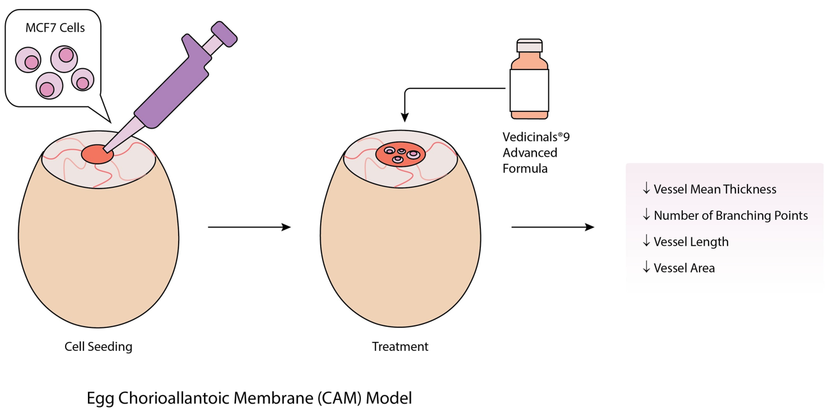
Graphical Abstract
Phytoceuticals Cocktail (Vedicinals ® 9 Advanced Formula)

