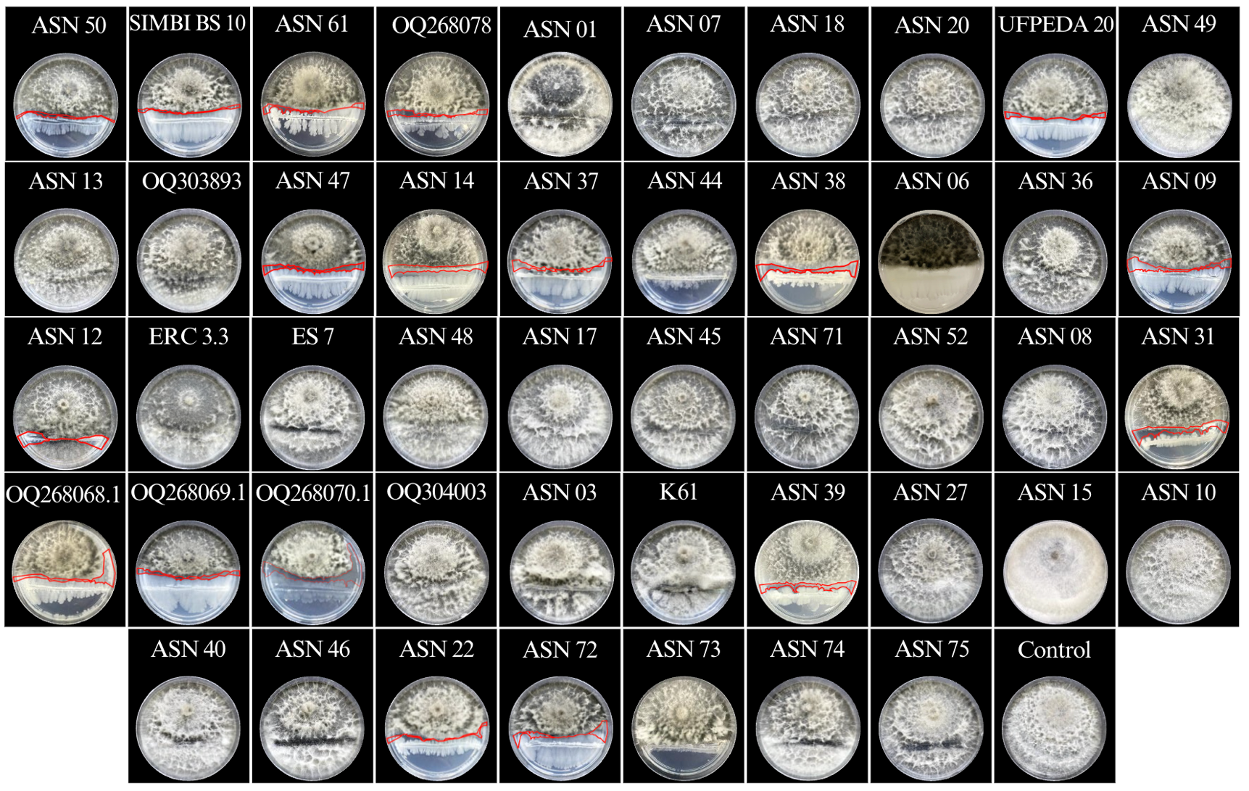
Supplementary Information 2 Antagonism of bacterial isolates against Macrophomina phaseolina (Mp) after 7 days of incubation in culture medium. The bacterial isolates used in the study were: Bacillus amyloliquefaciens (ASN 50; SIMBI BS10 CCT 7600; ASN 61 and OQ268078), B. cereus (ASN 01; ASN 07; ASN 18 and ASN 20), B. methylotrophicus (UFPEDA 20), B. pumilus (ASN 49 and ASN 13), B. safensis (OQ303893), B. siamensis (ASN 47), B. subtilis (ASN 14; ASN 37 and ASN 44), B. subtilis amyloliquefaciens (ASN 38; ASN 06; ASN 36 and ASN 09), B. licheniformis (ASN 12), Bacillus sp. (ERC 3.3 and ES7), B. tequilensis (ASN 48), B. thuringiensis (ASN 17 and ASN 45), B. thuringiensis aizawai (ASN 71), B. thuringiensis var. kurstaki (ASN 52 and ASN 08), B. velezensis (ASN 31; OQ268068.1; OQ268069.1 and OQ268070.1), B. wiedmanni (OQ304003), Serratia marcescens (ASN 03), Streptomyces griseoviridis (K61), Streptomyces violaceus (ASN 39), Pseudomonas putida reidholzensis (ASN 27), Pseudomonas fluorescens (ASN 15), Priestia aryabhattai (ASN 10 and ASN 40), Priestia megaterium (ASN 46 and ASN 22), B1 (ASN 72), B2 (ASN 73), B3 (ASN 74), B4 (ASN 75). The red lines indicate the inhibition halo.

