Extended Data Table 1 Percentage of material Composition based on CE-5 sample analyzed by machine learning of XRD pattern and previously analyzed Apollo sample (Fig. 1a)
Crystal | Composition | Percentage  （wt%, CE-5） | Percentage  （wt%, Apollo）
orthoproxyene | (Mg, Fe)SiO₃ | 19.66 | 2.49
augite | (Ca, Na)(Mg, Fe, Al, Ti)(Si, Al)₂O₆ | 15.08
plagioclase | NaAlSi₃O₈-CaAl₂Si₂O₈ | 8.75 | 35.59
silica (amorphous) | SiO₂ | 7.58 | 31.67
pyroxene | (Mg, Fe, Ca, Al, Ti)SiO₃ | 6.85 | -
troilite | FeS | 6.04 | -
olivine | (Mg, Fe)₂SiO₄ | 5.55 | 6.22
pigoenite | (Ca, Mg, Fe)(Mg, Fe)Si₂O₆ | 5.17 | 10.06
yeelimite | Ca₃(AlO₂)₃SO₄ | 3.89 | -
ilmenite | FeTiO₃ | 3.51 | 4.09
chromite | FeCr₂O₄ | 3.35 | 0.65
whitelockite | Ca₉(MgFe)(PO₄)PO₃OH | 3.05 | 0.42
pyrite | FeS₂ | 2.08 | -
rutile | TiO₂ | 1.75 | -
hapkeite | Fe₂Si | 1.65 | -
cristobalite | β-SiO₂ | 1.46 | 0.50
quartz | α-SiO₂ | 1.37 | 0.35
pyrrhotite | Fe_{1-x}S (x = 0~0.2) | 1.27 | -
zeolite  linde type L | Si₃₆O₇₂ | 1.20 | -

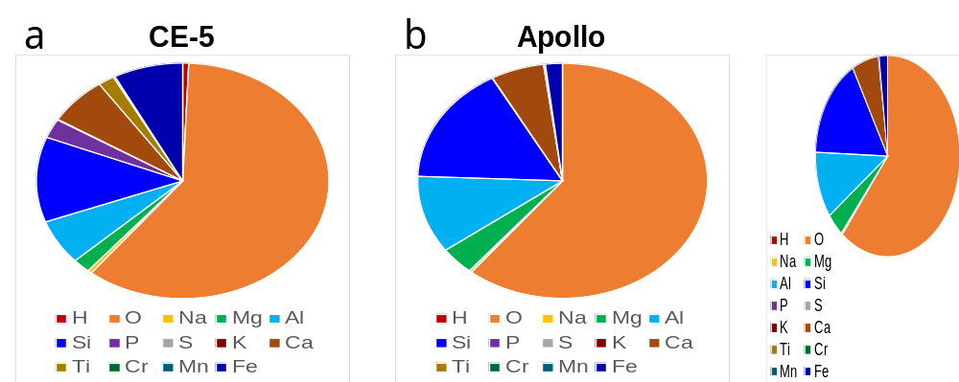
Extended Data Figure 1 | Element components of a) CE-5 sample analyzed by machine learning of XRD pattern and b) previously analyzed Apollo sample (Fig. 1a).

Extended Data Table 2 Element components of CE-5 sample analyzed by machine learning of XRD pattern and previously analyzed Apollo sample (Fig. 1a)
Element | Percentage  (CE-5, %) | Percentage  (Apollo, %)
H | 0.66 | 0
O | 60.07 | 60.82
Na | 0.46 | 0.29
Mg | 1.96 | 3.84
Al | 6.19 | 10.66
Si | 11.69 | 16.31
P | 2.63 | 0
S | 0.1 | 0
K | 0 | 0.05
Ca | 6.59 | 5.92
Ti | 1.8 | 0.17
Cr | 0.19 | 0
Mn | 0 | 0.03
Fe | 7.66 | 1.9

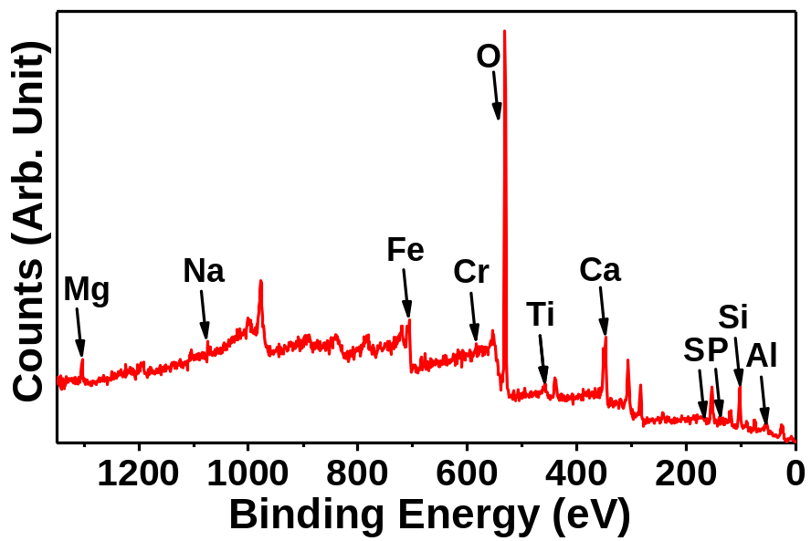
Extended Data Figure 2 | X-ray photoelectron spectroscopy (XPS) survey spectra of CE-5 sample, as C 1s peak at ~284.6 eV should be from the substrate, it was not be labeled.
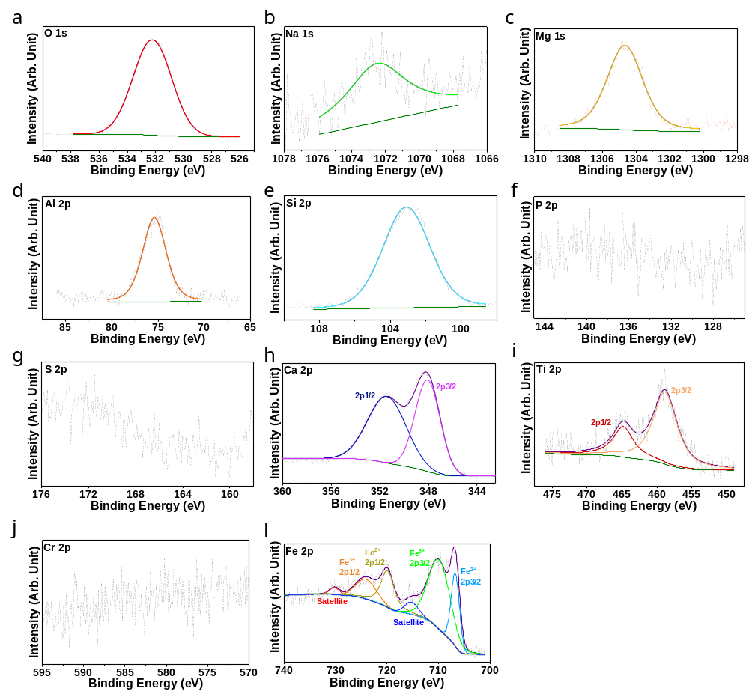
Extended Data Figure 3 | High resolution XPS spectra of a) O 1s, b) Na 1s, c) Mg 1s, d) Al 2p, e) Si 2p, f) P 2p, g) S 2p, h) Ca 2p, i) Ti 2p, j) Cr 2p, and l) Fe 2p of CE-5 sample.
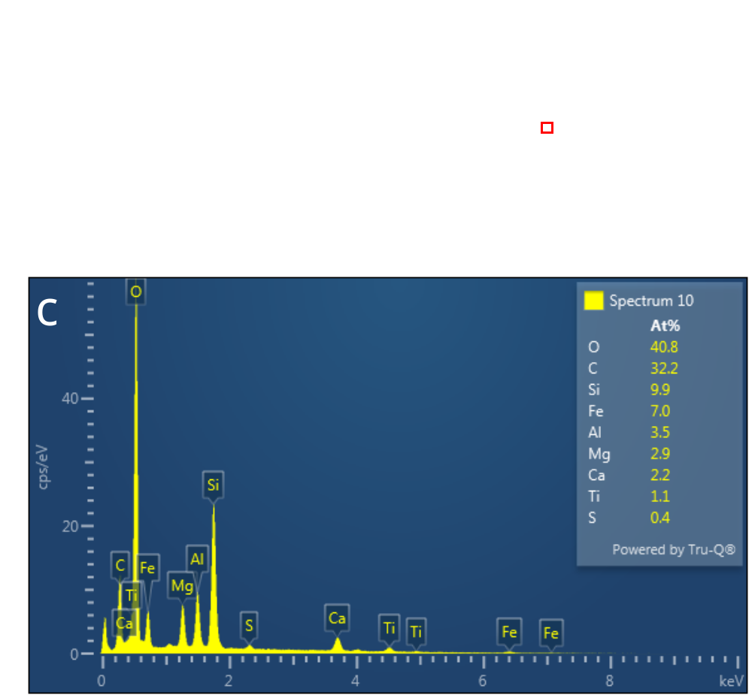
Extended Data Figure 4 | a) and b) Scanning electron microscopy (SEM) images of CE-5, c) energy dispersive X-ray spectroscopy (EDX) of selected area of CE-5 in (b), inset: element distribution, in which C element should be from the substrate.
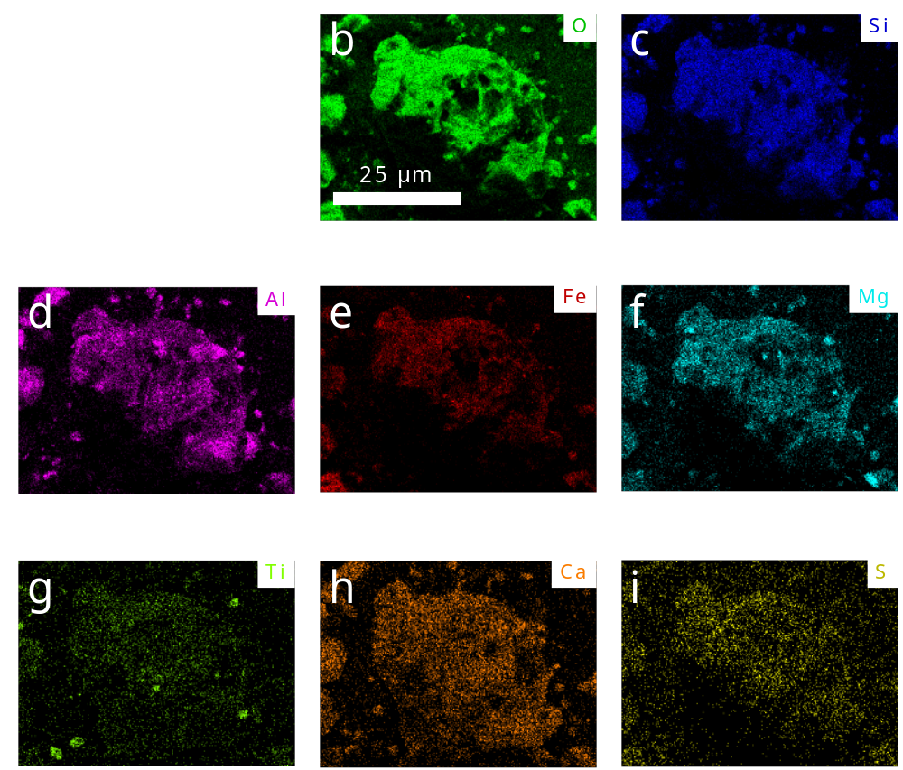
Extended Data Figure 5 | SEM-EDX elemental distribution maps of a) the CE-5 sample with b) O, c) Si, d) Al, e) Fe 2p, f) Mg, g) Ti, h) Ca, and i) S.
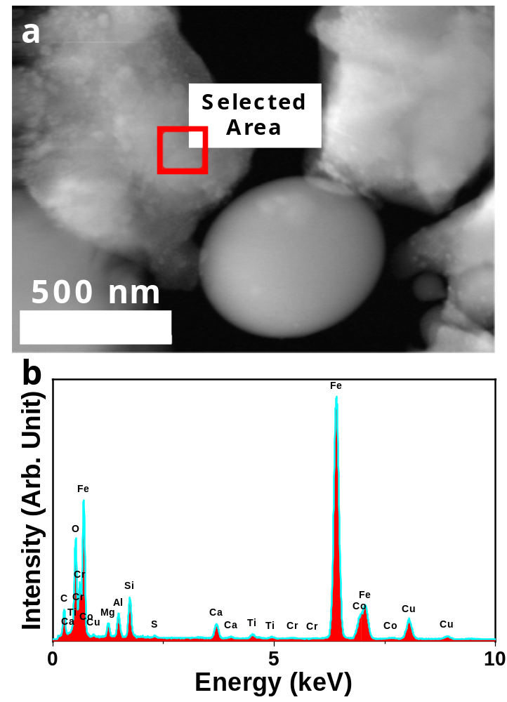
Extended Data Figure 6 | a) Dark-field TEM image and b) EDX spectra of selected area of a).
Extended Data Table 3 Element components through distinct measuring technology
 | XRD | SEM EDX | TEM EDX | XPS | ICP
H | 0.66 | 0ª | 0 | 0 | 0
O | 60.07 | 63.81 | 70.29 | 54.84 | 0
Na | 0.46 | 0 | 0 | 0.54 | 1.61
Mg | 1.96 | 2.95 | 5.38 | 1.46 | 10.33
Al | 6.19 | 4.02 | 7.76 | 10.62 | 13.29
Si | 11.69 | 10.99 | 10.13 | 17.33 | 0
P | 2.63 | 0 | 0.29 | 1.55 | 0
S | 0.1 | 0.27 | 0.36 | 0.97 | 0
K | 0 | 0 | 0.13 | 0 | 0
Ca | 6.59 | 2.41 | 1.08 | 5.64 | 24.26
Ti | 1.8 | 0.8 | 0.17 | 1.86 | 7.49
Cr | 0.19 | 0 | 0.03 | 0.23 | 0.43
Fe | 7.66 | 14.75 | 4.39 | 4.98 | 42.59
ªthe number ‘0’ represents none of the certain element was detected through this technology.
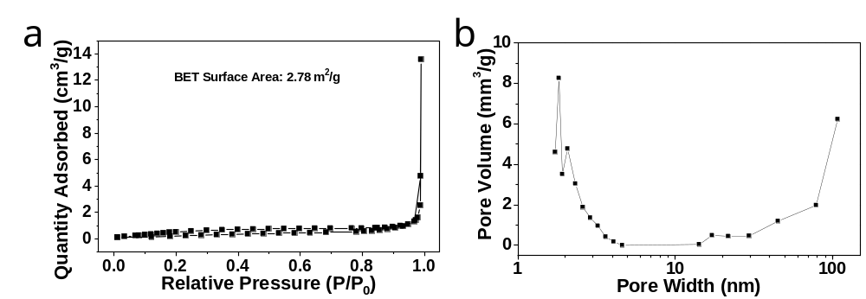
Extended Data Figure 7 | The Brunauer-Emmett-Teller (BET) analysis. a) surface area measured from nitrogen adsorption-desorption isotherms, and b) the corresponding pore size distribution of CE-5 sample. The measured BET surface area of 2.78 m²/g.

