Additional file 1 — Supplementary material
Delayed umbilical cord clamping and early maternal haematological outcomes: a calendar-time-adjusted cohort of 4,632 deliveries.
Contents: Supplementary Tables S1–S4; Supplementary Figures S1–S4; propensity-score model specification and covariate-balance diagnostics.

Supplementary tables
Supplementary Table S1. Four-level cord-clamping timing dose–response sensitivity analysis
Outcome | Timing category | N | Events | Estimate (95% CI) | P-value
Postpartum anaemia, Hb <10 g/dL | Delayed 30 s | 4,632 | 1,014 | 0.88 (0.77–0.99) | 0.040
Postpartum anaemia, Hb <10 g/dL | Delayed 60 s | 4,632 | 1,014 | 0.92 (0.80–1.05) | 0.218
Postpartum anaemia, Hb <10 g/dL | Delayed 120 s | 4,632 | 1,014 | 0.89 (0.73–1.09) | 0.256
Postpartum anaemia, Hb <11 g/dL | Delayed 30 s | 4,632 | 2,402 | 0.96 (0.90–1.03) | 0.245
Postpartum anaemia, Hb <11 g/dL | Delayed 60 s | 4,632 | 2,402 | 0.95 (0.88–1.01) | 0.118
Postpartum anaemia, Hb <11 g/dL | Delayed 120 s | 4,632 | 2,402 | 0.93 (0.84–1.03) | 0.149
Haemoglobin drop ≥2 g/dL | Delayed 30 s | 4,632 | 579 | 0.88 (0.70–1.09) | 0.245
Haemoglobin drop ≥2 g/dL | Delayed 60 s | 4,632 | 579 | 0.78 (0.62–0.98) | 0.033
Haemoglobin drop ≥2 g/dL | Delayed 120 s | 4,632 | 579 | 0.92 (0.69–1.22) | 0.553
Clinically recorded PPH | Delayed 30 s | 4,632 | 168 | 0.77 (0.48–1.21) | 0.256
Clinically recorded PPH | Delayed 60 s | 4,632 | 168 | 0.96 (0.63–1.48) | 0.860
Clinically recorded PPH | Delayed 120 s | 4,632 | 168 | 0.86 (0.49–1.49) | 0.586
Blood transfusion | Delayed 30 s | 4,630 | 28 | 0.23 (0.10–0.58) | 0.002
Blood transfusion | Delayed 60 s | 4,630 | 28 | 0.27 (0.10–0.75) | 0.011
Blood transfusion | Delayed 120 s | 4,630 | 28 | 0.20 (0.02–2.03) | 0.175
Reference group is immediate (0 s) clamping. Estimates are adjusted risk ratios (RR) from modified Poisson regression with robust standard errors and natural-cubic-spline calendar-time adjustment. The apparent transfusion benefit across delayed categories should be interpreted cautiously given only 28 events; it is concordant with the Firth-penalised primary transfusion model and remains consistent with no evidence of harm. Hb, haemoglobin; PPH, postpartum haemorrhage.
Supplementary Table S2. E-value for the primary IPTW estimate
Outcome | Method | RR | 95% CI | Point E-value | Limit E-value
Postpartum anaemia, Hb <10 g/dL | Stabilised IPTW | 1.01 | 0.88–1.16 | 1.13 | 1.00
The E-value is the minimum strength of association, on the risk-ratio scale, that an unmeasured confounder would need with both exposure and outcome to fully explain the observed estimate (VanderWeele & Ding, 2017). Because the primary confidence interval crosses the null, the limit E-value is 1.00 by construction; this reflects the near-null estimate rather than evidence of robustness against unmeasured confounding.
Supplementary Table S3. Data-quality summary and DCC adoption over time
Check / metric | Value
Total records | 4,644
Unique study identifiers | 4,644 (no duplicates)
Records with valid delivery date (calendar-adjusted analysis) | 4,632
Records excluded for missing delivery date | 12 (0.26%)
Records with a corrected implausible delivery date (retained) | 1 (0.02%)
Missing exposure (primary) | 0
Missing 6-hour postpartum haemoglobin | 0
Missing blood transfusion status | 2 (0.04%)
Postpartum anaemia (Hb <10 g/dL) events, adjusted cohort | 1,014
Postpartum haemorrhage events, adjusted cohort | 168
Blood transfusion events, adjusted cohort | 28
Vaginal deliveries, full cohort | 2,259
Caesarean deliveries, full cohort | 2,385
DCC ≥60 s adoption, 2022 | 10.2%
DCC ≥60 s adoption, 2023 | 40.3%
DCC ≥60 s adoption, 2024 | 62.3%
One record carried an implausible delivery date of 17 November 2002, more than 19 years before the 6 June 2022 – 31 December 2024 study window and inconsistent with the register; this was judged a data-entry error in the year field and the date was corrected to the intended 2022 admission and retained in the calendar-adjusted cohort (n = 4,632). The record was a caesarean delivery with delayed clamping and no anaemia, postpartum haemorrhage or transfusion, so neither its correction nor its exclusion materially affects the estimates. The remaining 12 excluded records had missing (blank) delivery dates and could not be placed on the calendar-time axis.
Supplementary Table S4. Propensity-score-matched sensitivity analysis (ATT)
Outcome | Matched estimate (95% CI) | P-value
Postpartum anaemia, Hb <10 g/dL | RR 0.93 (0.82–1.07) | 0.323
Postpartum anaemia, Hb <11 g/dL | RR 0.95 (0.88–1.02) | 0.135
Haemoglobin drop ≥2 g/dL | RR 0.94 (0.79–1.12) | 0.512
Clinically recorded PPH | RR 1.16 (0.80–1.69) | 0.438
Blood transfusion | RR 0.27 (0.08–0.98) | 0.046
6-hour postpartum Hb, g/dL | MD 0.06 (−0.03 to 0.15) | 0.199
Haemoglobin drop, g/dL | MD −0.01 (−0.07 to 0.05) | 0.781
Sensitivity analysis only. 1:1 nearest-neighbour matching (0.2 SD caliper on the logit of the propensity score) matched 1,467 pairs (2,934 episodes; 2,932 for transfusion, two records missing status); the estimand is the average treatment effect in the treated (ATT) and standard errors were clustered by matched set. Matching did NOT achieve calendar-time balance: the maximum residual covariate standardised mean difference was 0.18 (a calendar-time spline component). Three terms had absolute SMDs above 0.10: the propensity-score distance (0.15) and two calendar-time spline components (0.10 and 0.18). Under matching the primary anaemia estimate was non-significant (RR 0.93, 95% CI 0.82–1.07; p = 0.32) and broadly consistent with the balanced weighting and regression analyses; the nominally significant transfusion estimate rests on only 14 events. Because matching left residual secular-trend imbalance, these results are not interpreted as confirmatory; primary inference is based on the balanced weighting and regression analyses. RR, risk ratio; MD, mean difference.

Supplementary figures
Supplementary Figure S1. Covariate balance after stabilised IPTW (Love plot)
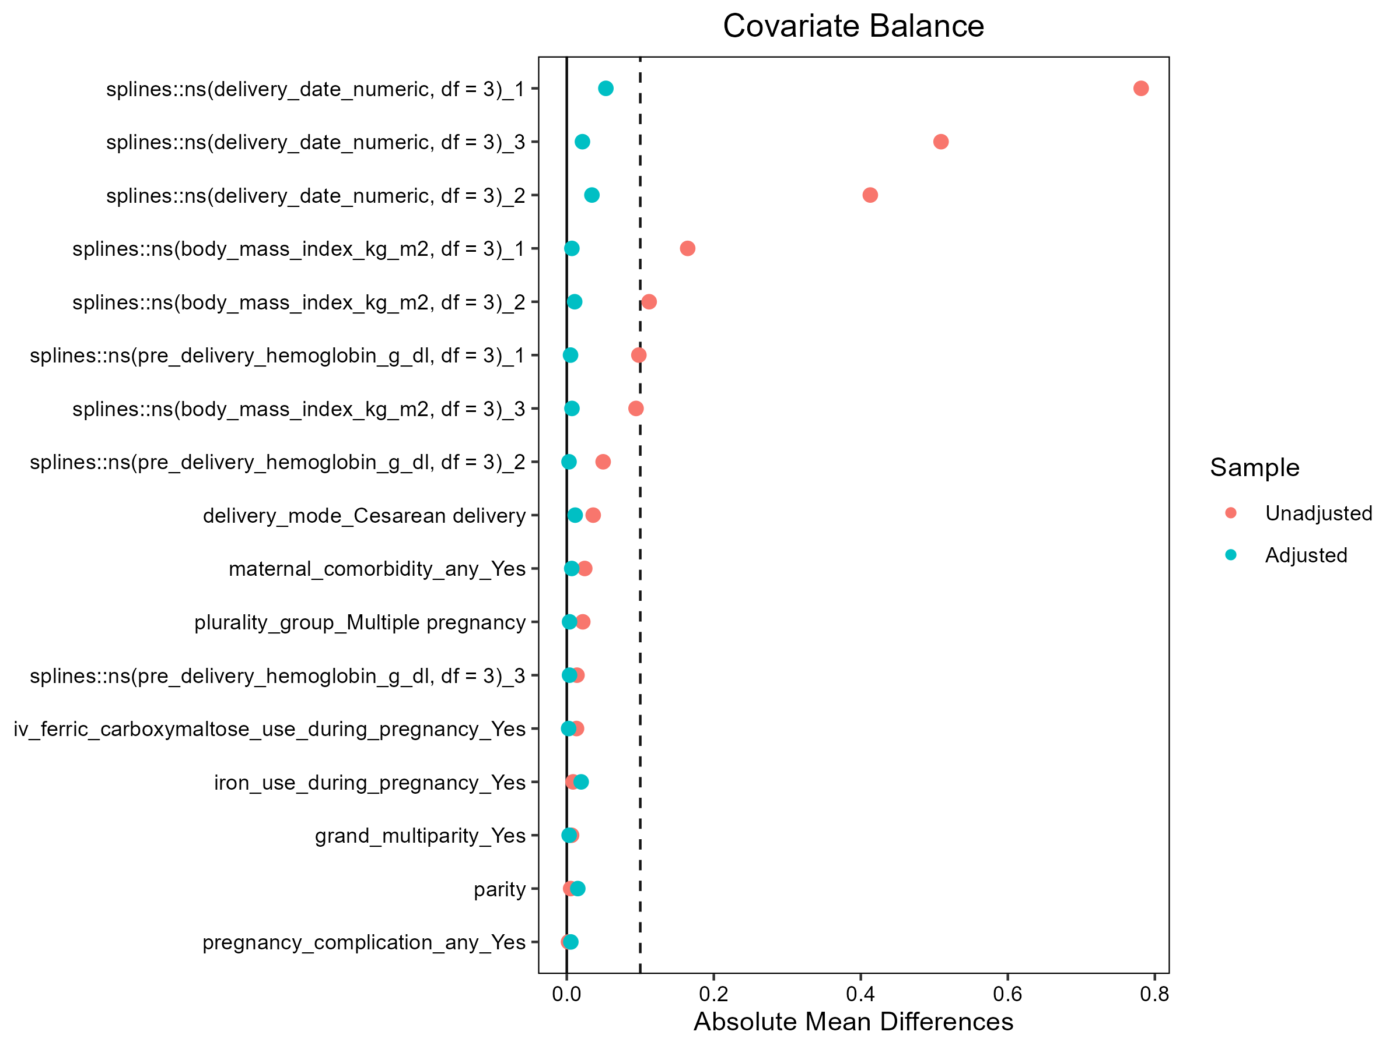
Absolute standardised mean differences for each covariate before and after stabilised, truncated inverse-probability-of-treatment weighting (weights computed after truncation at the 1st/99th percentiles). The dashed line indicates SMD = 0.10.
Supplementary Figure S2. Covariate balance after overlap weighting (Love plot)
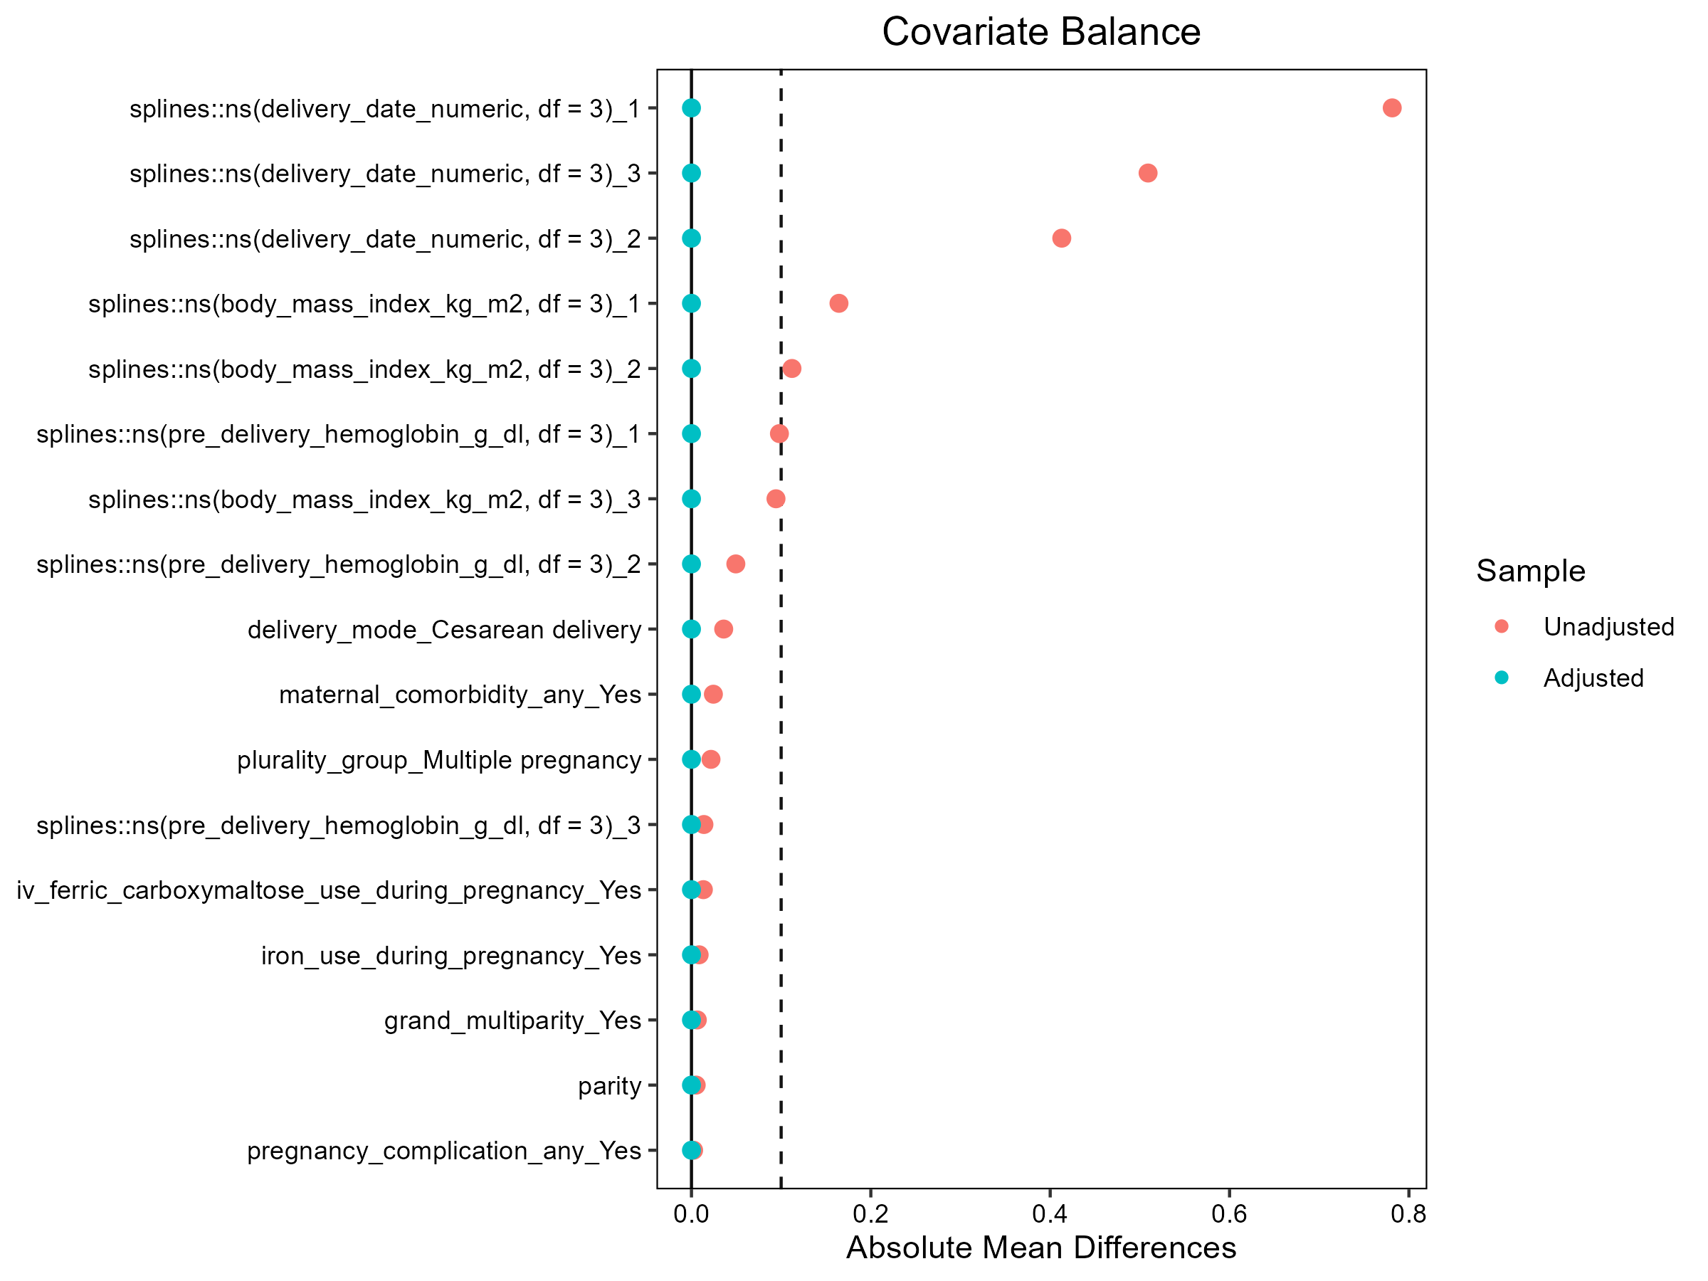
Standardised mean differences before and after overlap weighting. Overlap weighting achieved near-exact balance across retained covariates.
Supplementary Figure S3. Distribution of haemoglobin drop by cord-clamping group
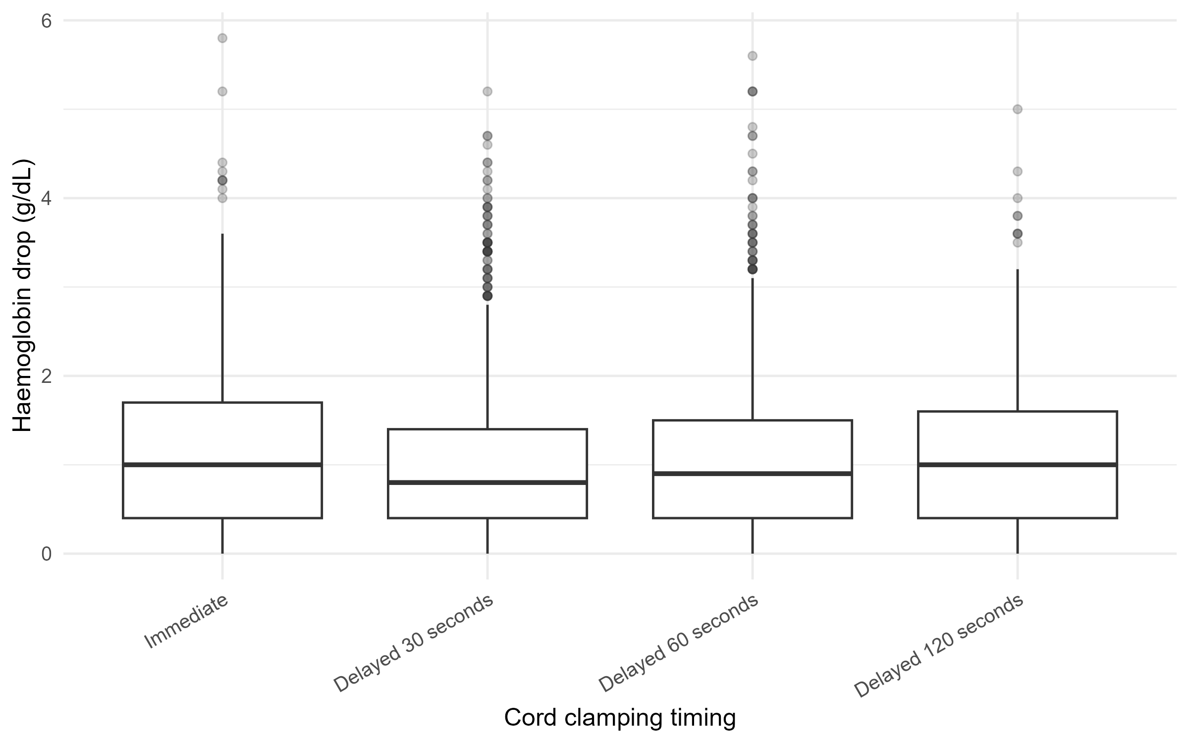
Subject-level distribution of pre-delivery to 6-hour haemoglobin drop by exposure group.
Supplementary Figure S4. Dose–response across four-level cord-clamping timing
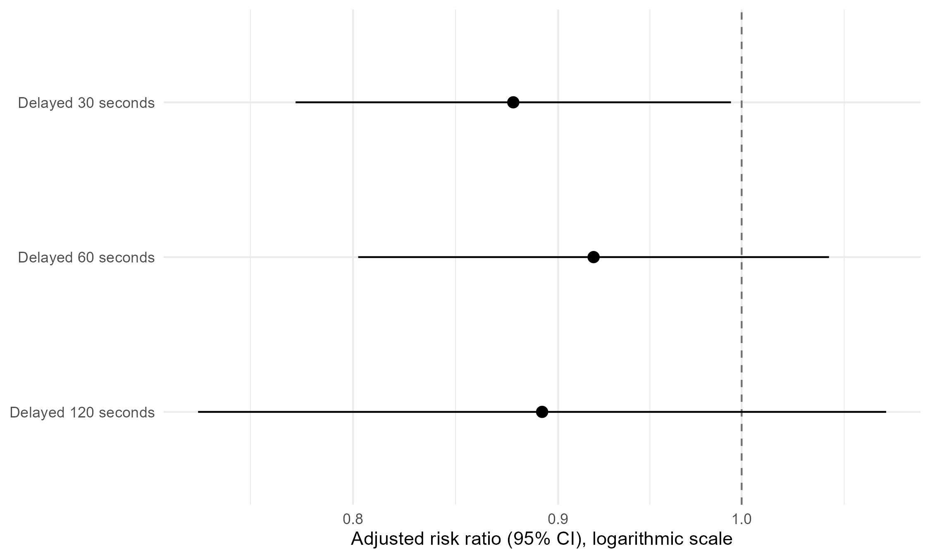
Adjusted risk ratios for postpartum anaemia (Hb <10 g/dL) across immediate, 30 s, 60 s and 120 s clamping; no monotonic dose–response was observed.

Propensity-score model and covariate-balance diagnostics
Propensity-score model. The propensity score was estimated by logistic regression of DCC ≥60 s (versus immediate/30-second clamping) on: pre-delivery haemoglobin, body mass index, parity, delivery mode, plurality, grand multiparity, iron use during pregnancy, intravenous ferric carboxymaltose use, any maternal comorbidity, any pregnancy complication, and calendar time. Pre-delivery haemoglobin, body mass index and calendar time were entered as natural cubic splines with three degrees of freedom. The same covariate set was used for stabilised IPTW (ATE), overlap weighting (ATO) and 1:1 nearest-neighbour matching (0.2 SD caliper; ATT).
Balance under weighting. After stabilised, truncated IPTW all covariates met the SMD <0.10 target; the largest residual SMD was 0.05, on a calendar-time spline component. Overlap weighting achieved near-exact balance across retained covariates (Figures S1–S2). The IPTW effective sample sizes were 2,350.0 in the immediate/30-second group and 1,113.3 in the DCC group (the latter a reduction of about 41% from 1,889 DCC episodes).
Balance under matching. 1:1 nearest-neighbour matching (0.2 SD caliper on the logit of the propensity score) matched 1,467 pairs (2,934 episodes). Most covariates met the SMD <0.10 target, but three terms did not: the propensity-score distance (0.15) and two calendar-time spline components (0.10 and 0.18). The maximum residual covariate SMD was 0.18 (a calendar-time spline component), indicating that matching did not fully remove secular-trend imbalance. Matched-analysis standard errors were clustered by matched set (MatchIt subclass); the corresponding estimand is the average treatment effect in the treated (ATT). The full matched balance table is provided with the reproducibility package.

