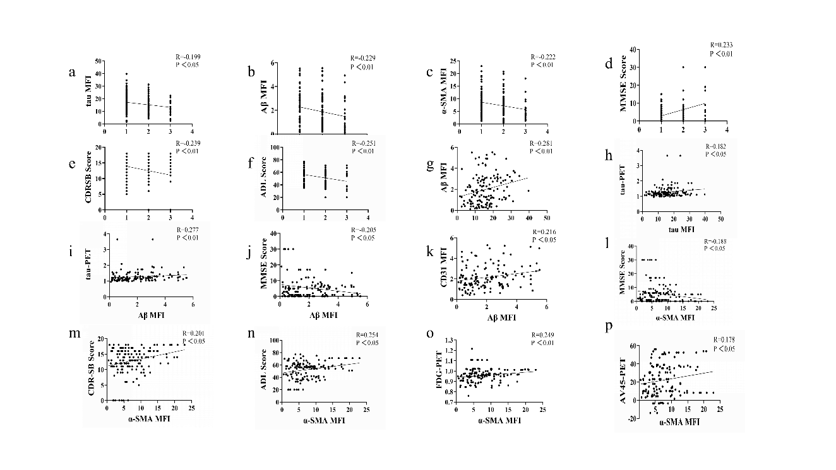Supplemental Figure 1. Representative scatter plots illustrating selected correlations between DCLN histological staining parameters and patient clinical features. Data were analysed using Pearson or Spearman correlation methods, where R denotes the correlation coefficient and P indicates the level of statistical significance. GC number was negatively correlated with tau MFI (r = −0.190, p < 0.05), Aβ MFI (ρ = −0.214, p < 0.05), α‑SMA MFI (ρ = −0.245, p < 0.01), CDR‑SB score (r = −0.188, p < 0.05), and ADCS‑ADL score (ρ = −0.252, p < 0.01), but positively correlated with MMSE score (ρ = 0.232, p < 0.01). tau MFI in DCLNs exhibited positive correlations with Aβ MFI (ρ = 0.281, p< 0.01) and tau‑PET signal (ρ = 0.182, p < 0.05). Aβ MFI was negatively correlated with MMSE score (r = −0.205, p < 0.05), and positively correlated with CD31 MFI (ρ = 0.216, p < 0.05) and tau‑PET (ρ = 0.277, p < 0.01). Similarly, α‑SMA MFI was negatively correlated with MMSE score (r = −0.188,p < 0.05) and positively correlated with CDR‑SB (ρ = 0.201, p < 0.05), ADL (ρ = 0.254, p < 0.05), FDG‑PET (ρ = 0.249, p < 0.01), and AV45‑PET (ρ = 0.178, p < 0.05).

