Supplementary
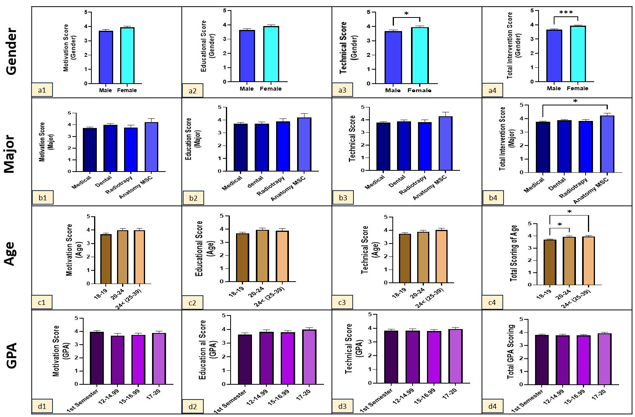
Supplementary Figure S1. Subgroup analysis of students' evaluation of the AI-assisted music-based educational intervention across motivational, educational, and technical domains.
Supplementary Figure S1. Detailed subgroup analysis of students' evaluation of the AI-assisted music-based educational intervention according to gender, academic discipline, age, and grade point average (GPA). The analysis was based on the Intervention Evaluation Questionnaire completed by students in the intervention group. The figure presents mean scores for the three questionnaire domains: (A) motivational outcomes, (B) perceived educational effectiveness, and (C) technical and instructional quality. Domain scores were compared according to (A1–A3) gender, (B1–B3) academic discipline, (C1–C3) age group, and (D1–D3) GPA category. Overall intervention scores for these subgroups are presented in Figure 4 of the main manuscript. Data are expressed as mean ± SEM. Statistical comparisons were performed using an independent-samples t-test for gender comparisons and one-way analysis of variance (ANOVA) followed by Tukey's multiple comparison test for comparisons among academic disciplines, age groups, and GPA categories. P < 0.05; P < 0.01; P < 0.001.

Supplementary Table S1. Open-ended questions and summary of students' responses to the AI-assisted music-based educational intervention
Open-ended question | Summary of students' responses
1. Compared with a conventional lecture, how would you rate your level of engagement with the AI-generated music-based educational clips? (Less / Similar / Greater) | Greater engagement (n=67); Similar engagement (n=29); Lower engagement (n=5).
2. Which component of the educational clips had the greatest impact on your learning? | Music (n≈61); Visual images/animations (n≈41); Voice narration (n≈11); Written text (n≈6); Combination of all components (music, images, narration, and text) (n≈10).
3. Do you have any suggestions for improving the educational clips? | No changes needed / Excellent as presented (n≈10); Add subtitles (n≈17); Modify the music style (n≈22); Improve pronunciation of scientific terms (n≈16); Enhance images and animations (n≈11); One respondent considered the clips overly entertaining (n=1).
4. In your opinion, what are the advantages and disadvantages of using artificial intelligence in education? | Advantages: Encourages educational creativity and innovation (n≈34); Reinforces complex concepts (n≈20); Facilitates learning (n≈17); No opinion (n≈5). Disadvantages: Potential scientific inaccuracies (n≈14); Preference for traditional instructor-led teaching (n≈5); May distract from scientific content (n≈3); Easy accessibility may reduce students' independent search skills (n≈3); AI is not yet sufficiently mature (n≈2); May become addictive (n≈2); No disadvantages reported (n≈2).
5. Would you like this educational approach to be used in other medical courses? If yes, which courses? | Histology/Anatomy (n≈49); Physiology (n≈21); Biochemistry (n≈18); All medical courses (n≈20); Medical Physics (n≈3); Medical Imaging (n≈1); As a classroom break activity (n≈2); No opinion (n≈2).
6. If you were to recommend these educational clips to your classmates, what score would you give them (1–10)? | Score 10 (n=17); Scores 9–9.5 (n=11); Scores 8–8.5 (n=21); Scores 7–7.5 (n=22); Scores 6–6.5 (n=13); Score 5 (n=4); Score 4 (n=2). Overall recommendation score: Mean = 7.79 ± 0.16 (IQR = 7.9).
7. Which group of students do you think would benefit most from this educational approach? | Auditory learners (n≈22); Students who enjoy music (n≈21); Suitable for most/all students (n≈18); Visual learners (n≈9); Students who have difficulty memorizing (n≈1); Students who lose attention during lectures (n≈1); No opinion (n≈1).
8. How could these educational clips be further personalized? | Greater student involvement in content creation (n≈28); Allow students to choose the music style (n≈20); No suggestions (n≈17); Allow students to choose the soundtrack (n≈9); Use students' voices (n≈6); Modify the selected music (n≈6); Student-written lyrics (n≈4); Add subtitles (n≈3); Allow students to select the topic (n≈2); Improve visual materials (n≈2); More engaging lyrics (n≈2); Adjustable playback speed (n≈1).
9. Did these clips create an emotional connection (e.g., enjoyment or surprise) with the topic of the diaphragm? Please explain. | Reported the clips were engaging (n≈45); Felt surprised (n≈9); Attractive images; Enjoyable musical rhythm; First experience with this type of learning; Looking forward to future clips; Humorous; Improved conceptual understanding; No emotional connection (n≈4); Partial emotional connection (n≈1).
10. What challenges do you think faculty members may encounter when implementing this teaching approach? | Time required for development (n≈43); Limited technical expertise (n≈30); Resistance to changing traditional teaching approaches (n≈8); Need for musical knowledge (n≈3); Need to ensure scientific accuracy (n≈3); No opinion (n≈2); Lack of motivation/interest (n≈1).
11. In one sentence, describe how these educational clips made you feel. | Enjoyable / Excellent / Unique (n≈40); Innovative teaching method (n≈19); Improved learning (n≈7); Reduced classroom fatigue and increased energy (n≈6); Could be improved further (n≈4); No particular feeling (n≈3); Negative feeling (n≈1); Appreciation toward the instructor (n≈8).

